Chladni’s Plates

Apparatus
set of Chladni’s plates (light metal plates held at the centre, in various shapes), violin bow or other bow, rosin for the bow, sand, salt shaker, tray, brush for clean up
The sand is kept in the salt shaker, so it is easy to shake evenly onto the plates.

Action
The students shake the sand into a thin (not solid) layer on the plates. Using the bow, they bow in long, even strokes, along the edge of a plate. A slow, steady stroke with the bow held almost vertical works well. This should produce standing wave patterns in the plate. The students can experiment with trying to find how many different patterns they can produce.
The students should also damp the plate while bowing. This is done by placing a finger firmly on the edge of the plate, while another student bows. This should change the pattern, drawing sand towards the finger.

The Physics
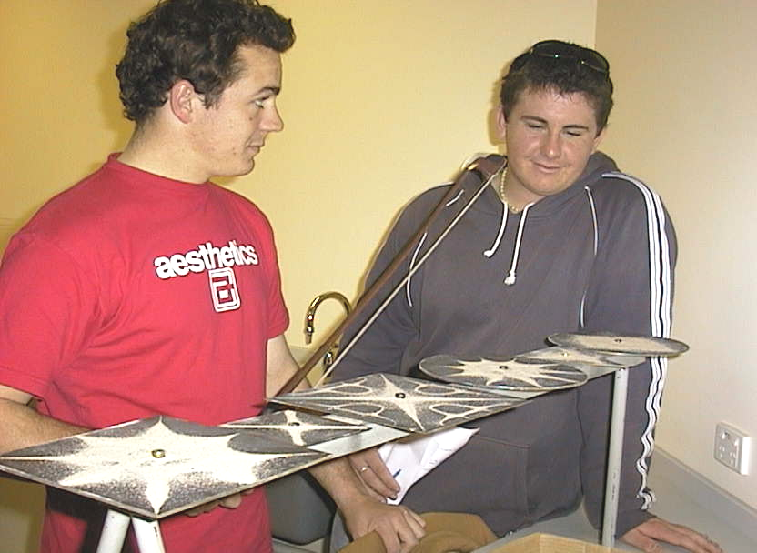
When you bow on the plate it will vibrate. The sand gathers in the nodes as it is shaken from the antinodes. The pattern depends on where you bow, and on the shape and size of the plate. The higher the harmonic, the more complex the pattern produced. Damping forces a node where you put your finger, changing the pattern.

Students at the Australian Catholic University producing patterns on a set of Chladni’s plates.

Accompanying sheet

Chladni’s Plates

Sprinkle some sand on one of the plates.

Bow firmly on the edge of a plate with long strokes.
What do you observe?
Explain what is happening here.

Use a finger to damp a spot on the edge of the plate while someone else bows.
Now what is happening, and why?

