Damped Oscillations

Apparatus
mass on spring hanging vertically from stand, bucket of water, stopwatch

Action
The students observe the oscillations of the mass on the spring in air. They should use the stop watch to time several periods and estimate a period from this. They then observe the oscillations when the mass is suspended in water. They should compare the periods of the oscillation in both cases, and how quickly the oscillations die out.
They can also experiment with their own joints, for example letting a knee swing freely.

The Physics
x
t
When the object is allowed to oscillate in air it takes a long time to stop, and the amplitude decreases very slowly. See top plot opposite. In water, the motion is strongly damped, and the oscillations decay and stop very quickly, as shown in the lower plot opposite. The damping makes little or no difference to the period.  Joints in the body are usually only slightly damped, and will swing freely for several oscillations. Muscles are heavily damped, and the lungs are close to critically damped.  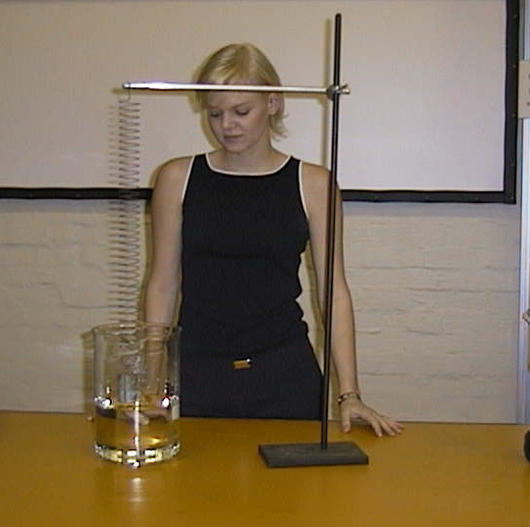 | x  t

The oscillations are quickly damped by the water.

Accompanying sheet

Damped Oscillations

Observe the oscillations of the spring-mass system in air.
Estimate the period of oscillation.

Now suspend the mass in the water.
Has the period of oscillation changed?
How has the motion changed?

Sketch amplitude vs time for the motion in air and the motion in water.

