Diffraction Patterns

Apparatus
laser, piece of pantyhose material in a single layer.

Action
The students shine the laser light through the material and observe the resulting pattern. They then stretch the material and observe how the pattern changes.

The Physics
The network of fine threads in the fabric forms a grating. When you shine the laser light through the fabric you see a diffraction pattern.
The spacing between the maxima in the pattern (bright spots) is inversely proportional to the grid spacing; d sinθ = mλ, can be used to find the grid spacing, d, given the angular separation, θ, of the maxima.
The diagrams show the fabric to the left and the diffraction pattern to the right.
pull
pull
pull
pull
When you stretch the fabric horizontally it also squeezes in vertically, the pattern will do the reverse of this, squeezing in horizontally and stretching vertically. When you stretch it vertically it will squeeze in vertically and stretch horizontally.

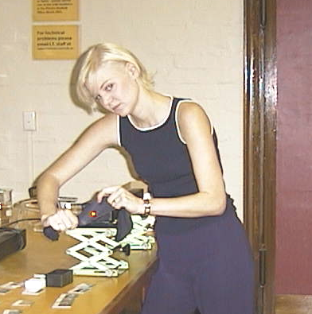

A piece of panty-hose material is used to make a diffraction pattern.

Accompanying sheet:

Diffraction Patterns

Shine the laser light through the fabric.

What sort of pattern do you see?

How does the pattern change when you stretch the fabric horizontally?
What about when you stretch it vertically?

