Lenses – Finding the Focal Length of a Convex Lens

Apparatus
convex lens, piece of paper, window or light source at opposite end of room or corridor

Action
A student holds the lens up towards the window, and holds a piece of paper on the other side of the lens. They then move the piece of paper towards and away from the lens until a focused image of the outside or a distant object such as a tree is formed. From the distance between the lens and the paper they can then find the focal length of the lens.

The Physics
Hold the lens up to the window and hold a piece of paper behind it (on the other side of the lens from the window). Move the paper until you get a sharp image of the world outside the windows (or distant object such as a tree). When you have a sharp image, you measure the distance between the lens and the image (paper). This distance is the focal length of the lens.
(Using $\frac{1}{f}=\frac{1}{o}+\frac{1}{i}$, and o = ∞ so that $\frac{1}{o}$ = 0, gives f = i )

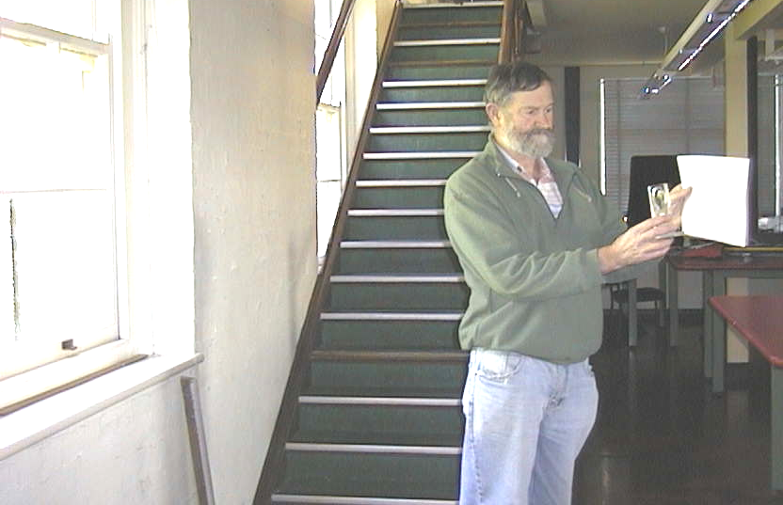

When the paper is held at a distance from the lens equal to the lens’s focal length, an image of the window forms on the paper.

Accompanying sheet

Lenses – Finding the Focal Length of a Convex Lens

Hold the lens up to the window and hold a piece of paper behind it
(on the other side of the lens from the window).

Move the paper until you get a sharp image of the world outside the windows,
or a distant object such as a tree.

What is the focal length of the lens?

