Resonance in a Tube

Apparatus
long plastic or glass tube, container of water, tuning forks

Action
The students strike the tuning fork and hold it at the top of the tube. They then raise and lower the tube and listen to the sound get louder and quieter. They should try to find the resonance length, and from this they can find the frequency which the tuning fork produces.

The Physics
The air in the tube will resonate when the length of the air column = ¼ nλ and λ is the wavelength of the sound produced. The upper end is a displacement antinode and the lower end is a node. Using v = f / λ, and the speed of sound in air, 340 m.s⁻¹, the students can calculate the frequency emitted by the fork.

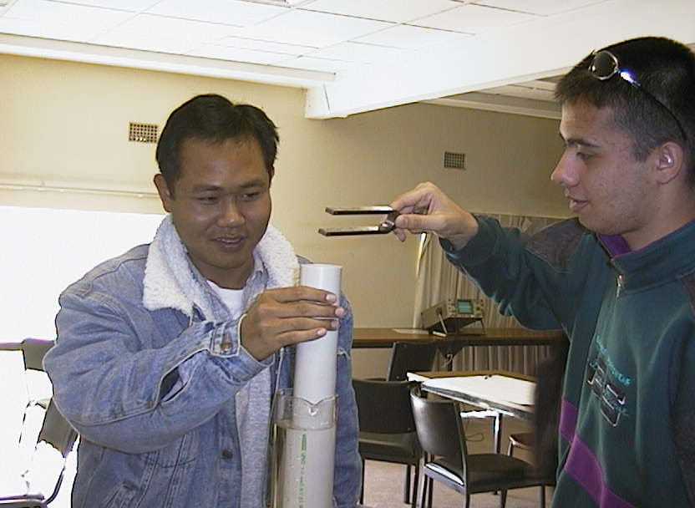

Students at the University of Sydney experimenting with the resonance in a tube activity. The student on the left is raising and lowering the tube, which is partly immersed in a cylinder of water. The student on the right strikes and holds the tuning fork.

Accompanying sheets:

Resonance in a Tube

Strike a tuning fork and hold it above the tube.
Vary the height of the tube with the fork above.
What do you observe?
Why?

Now try it again with the other tuning forks.
What relationship is there between the sound you hear
and the length of the pipe?

