Ripple Tank I – Making Waves

Apparatus
Ripple tank with various attachments for oscillator, e.g. point source, long bar source for plane waves, etc, stroboscope, ruler

Action
The students experiment with making different waves of different shape and frequency. Using the stroboscope to “freeze” the waves, they measure the wavelength of the waves. They should look at the effect on wave speed and wave length of varying the frequency.

The Physics
The point oscillator will produce circular wave fronts. The long rod oscillator produces plane waves. Changing the frequency changes the wavelength, λ, of the waves produced, but does not affect the speed. The speed depends only on the medium, which is not changing.

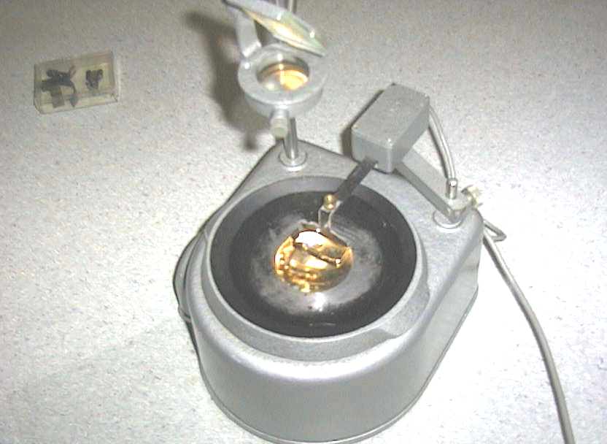

Accompanying sheet

Ripple Tank I – Making Waves

Experiment with the different oscillators.
What sort of shaped waves can you produce?

Using the stroboscope, try to measure the wavelength of the waves.
How does the wavelength change when you change the frequency?

Do you think the wave speed changes when you change the frequency?

