Single Slit Diffraction

Apparatus
laser with single slits of various sizes

Action
The students observe the diffraction pattern formed by passing the laser light through the single slit. They can experiment with the different slits, and arrive at a relationship between the fringe spacing and the slit width.

The Physics
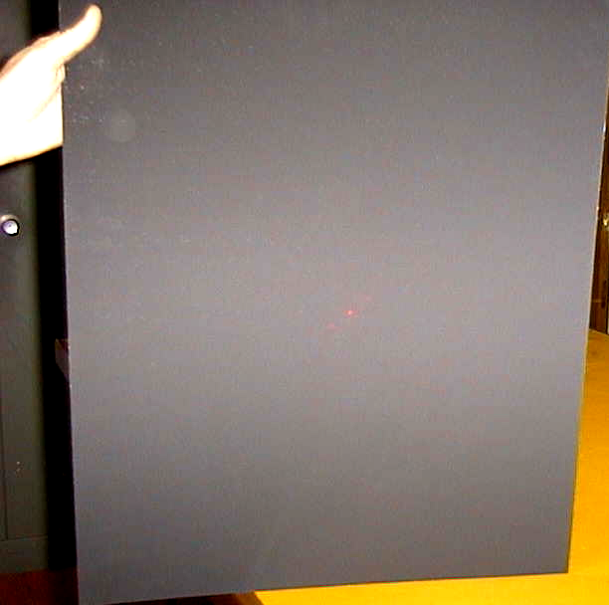
Diffraction patterns occur when light passes through a single slit. A diffraction pattern is an interference pattern due to the path difference between light arriving at a point from the left hand side of the slit and light arriving from the right hand side of the slit. A slit of width a will give a path difference of a sinθ for the two rays. The diffraction minima occur when the path difference is equal to a multiple of ½λ, i.e. where a sinθ = ½ mλ, so sinθ = ½ mλ/a. The wider the slit, the smaller the spacing between fringes will be.

Accompanying sheet

Single Slit Diffraction

What sort of pattern do you expect when waves (such as light)
pass through a single slit?

Shine the laser light through the single slit.
What sort of pattern do you observe? Why?
How does this match your prediction?

Try the other slits.
What effect does changing the slit width have on the pattern?

