Stress Lines

Apparatus
light source, such as overhead projector, sheets of Polaroid, piece of perspex with adjustable screws in it

Action
The students place a sheet of Polaroid on the light source, the perspex block above that sheet, and a second sheet above the block. They observe the Perspex block through the upper sheet of Polaroid, while rotating the sheet. They then adjust the screw in the block to see how the patterns of stress lines change.
They may also want to look at a pair of spectacles between the polaroids, as they often show patterns of stress around the edges of the lenses, particularly on old pairs which have been damaged or twisted.

The Physics
The molecules in the perspex are stretched by the applied stress, and align like the molecules in the sheets of polaroid. When viewed between two crossed polaroids, the light areas show where the material between the polaroids is rotating the polarisation axis of the light coming through the first polaroid. This is a very useful technique, and is called optical stress analysis. Engineers use it to look for stress in models of structures. You will probably be able to see stress lines in the lenses of a pair of spectacles, showing the lenses have been stressed to fit them into the frames, or where the lenses are stressed due to damage to the frames, for example by dropping or sitting on the glasses.
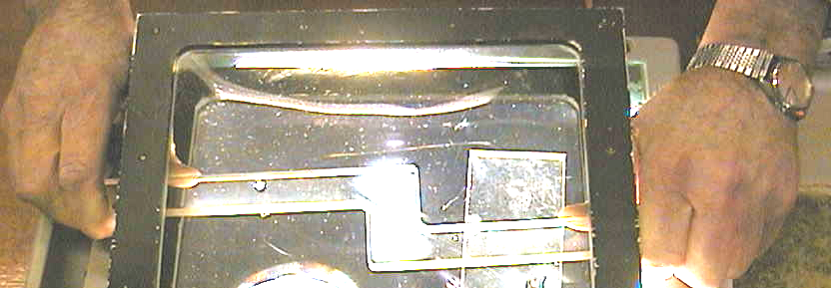

The areas under stress are visible as bright areas, letting the polarized light pass.

Accompanying sheet

Stress Lines

Examine the stressed Perspex between the sheets of Polaroid.
What happens when you increase the stress?

If someone in your group wears glasses,
ask them to let you see them between the sheets of Polaroid.
Can you see stress lines in the glasses?

Can you think of a way this effect might be useful?

