Total Internal Reflection

Apparatus
laser, length of fibre optic cable or large Perspex rods

Action
The students shine the light into the cable, and observe where it goes. They can experiment with bending the cable, and if it is a wide cable, with the angle of incidence of the beam onto the end of the cable.

The Physics
The light ray that enters the cable is totally internally reflected provided the incident angle, θ_{i}, is greater than the critical angle. Light is trapped inside the cable and almost none gets out the sides.
θ_{i}

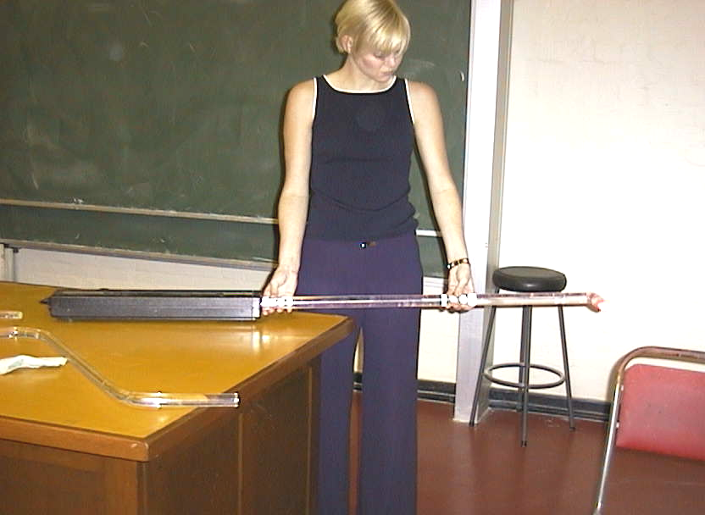

All the light from the laser exits the end of the Perspex rod.

Note: this can also be done using water rather than fibre optic cable or perspex

Accompanying sheet

Total Internal Reflection

Shine the light into the cable.

Can you see the light through the sides of the cable?
Where is the light going, and why?

What happens when you bend the cable?
(Be careful not to break it!)

Caution- do not look into the beam!!

