Tuning Forks and Beats

Apparatus
two tuning forks of similar frequency, or one tuning fork and one adjustable tuning fork

Action
The students strike one tuning fork and then the other. They listen for beats and describe what they hear and why they hear it. If you have an adjustable tuning fork they can adjust the frequency to see what effect this has on the beat frequency. They can also attempt to match the frequencies, at which point the beats disappear.
f₁

f₂

f_{beat}

The Physics
The beat frequency you hear from two notes is the difference between the frequencies of the two notes, f_{beat} = f₁ –f₂. The closer together the frequencies (notes), the fewer the beats. The further apart the notes, the faster the beats.

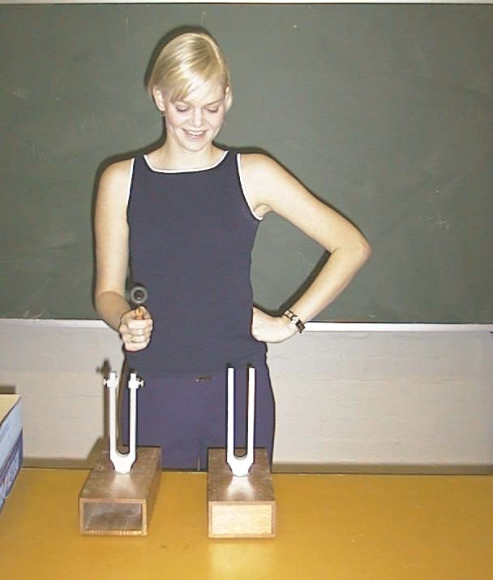
Musicians tune their instruments by sounding a known note, for example with a tuning fork, then adjusting their tuning until the frequency from their instrument is the same and no beats can be heard. This is what happens when the adjustable tuning fork produces the same frequency as the other tuning fork.

When the two tuning forks have similar frequencies beats can be heard.

Accompanying sheet

Tuning Forks and Beats

Strike one tuning fork, then the other.

Listen to the beats when both are sounding.

What happens when you adjust the frequency of one of the forks?
How do musicians use tuning forks to tune their instruments?

