Visualising Speech

Apparatus
microphone connected to oscilloscope.

Action.
The students speak, shout, sing and whistle into the microphone and observe the wave patterns produced.

The Physics
The higher the pitch the greater the frequency (the shorter the period) of the waveform, and the louder they shout the greater the amplitude. This demonstration goes well with the “look and listen” demonstration. They will observe that the waveforms they produce are not simple sinusoidal patterns when they speak or sing, but are complicated waveforms made up of many frequencies. A clear whistle gives a good approximation to a sinusoid.
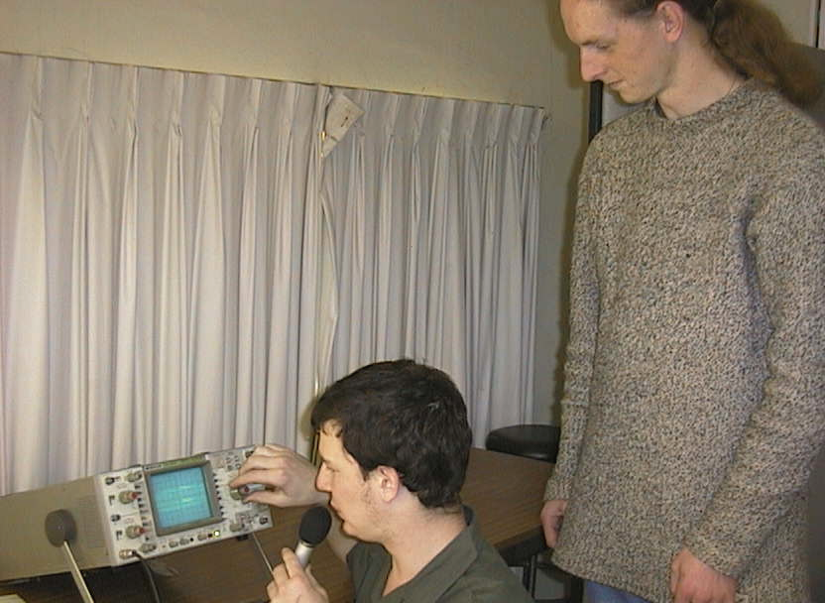

Students at the University of Sydney observing their “speech patterns”.

Accompanying sheet:

Visualising Speech.

A microphone is connected to the CRO.

As you speak into the microphone the CRO shows your speech as sound waves.
How do these signals compare with those from the signal generator?

How does the pattern change when you whistle, scream, whisper, sing or shout?

Tap the microphone gently. Why does a wave appear on the screen?

