Waves in Rubber Tubes

Apparatus
two very large rubber tubes, tied off at both ends, one filled with water and the other with air
It is easier to use if one end of each tube is tied to some fixed point, such as a post or wall.

Action
One student jerks the free end of each tube up and down to send a pulse along the tube. Other students observing the waves should be able to determine which tube is filled with water and which with air.

The Physics
Wave speed depends on tension and mass, and varies inversely with mass (linear density). The wave on the air filled tube travels much faster than that on the water filled tube.

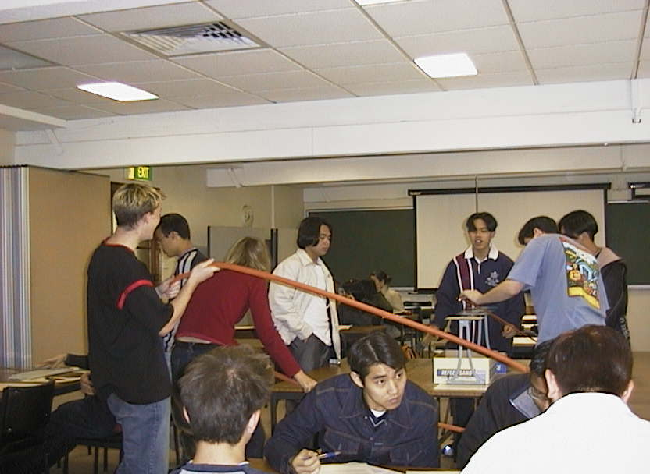
tubes

Students at the University of Sydney experimenting with the rubber tubes.

Accompanying sheet

Waves in Rubber Tubes

One group member sends a pulse down each tube while the others watch.
(Do not tell the others which tube is which!)

The rest of the group observe the waves
and determine which has air, and which has water in it.

Explain how you can tell.

