Workshop Tutorials for Introductory Physics
Solutions to MI3: Motion in a Plane

A. Review of Basic Ideas:

Projectile motion
A projectile is any body that is given an initial velocity and then follows a path determined by the effects of gravitational acceleration. A batted cricket ball, a thrown football, a package dropped from an airplane, and a bullet shot from a rifle are all projectiles. The path followed by a projectile is its trajectory.
To analyse this common type of motion, we start with an idealised model, representing the projectile as a single particle with an acceleration (due to gravity) that is constant in both magnitude and direction. We neglect the effects of air resistance and the curvature and rotation of the earth. Like all models, this one has limitations. Nevertheless, we can learn a lot from analysis of this simple model.
Notice that projectile motion is always described within a vertical plane determined by the direction of the initial velocity and acceleration, g. We will call this plane the xy-coordinate plane, with the x-axis horizontal and the y-axis vertically upward. The key to analysis of projectile motion is the fact that we can treat motion in the x and y directions separately. The x-component of acceleration is zero, and the y-component is constant and equal to -g. So we can think of projectile motion as a combination of horizontal motion with constant velocity and vertical motion with constant acceleration. The actual motion is the superposition of these separate motions.

Discussion questions
- Air resistance cannot be ignored in sky diving or parachuting, where air resistance is used to slow down a falling object. It is also important in any sport where the aim is to go very fast, for example Olympic cyclists wear special streamlined helmets.
- The curvature of the Earth needs to be allowed for in the launching of missiles and rockets, and the motion of anything that travels far above the Earth’s surface, for example satellites.
- The physical description does not change when you change your axes.

B. Activity Questions:
45º
<45º
>45º

- Projectile launcher
Maximum range (horizontal displacement) occurs for an angle of launch of 45º. Maximum height occurs for a vertical throw provided the initial speeds are the same.

- Marble ejecting trolley  The horizontal component of the marbles velocity is constant and is equal to the velocity of the trolley. The vertical component of velocity is not constant, as the marble is subject to acceleration due to gravity.  You could see the same effect by watching someone throwing a ball up and catching it again as they rode past you on a moving train. | v  v
drop
throw
- Drop and horizontal throw
The dropped ball has an initial velocity of zero while the thrown one has an initial horizontal velocity only.
The balls hit the ground at the same time (depends on vertical motion which is the same for both balls) but in different places (depends on horizontal motion which is different for the two balls).

C. Qualitative Questions:

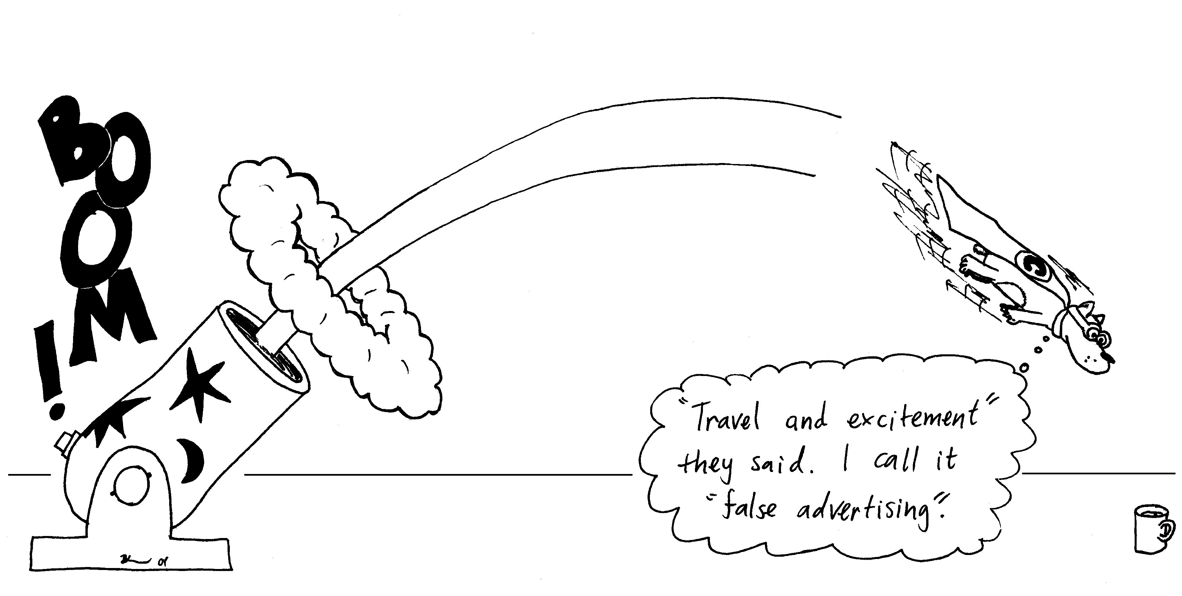
- Chuck’s speed has a horizontal component, which is constant if we ignore air resistance. The vertical component of his speed is not constant, it is a maximum (upwards) when he is ejected, a minimum (zero) at the top of his trajectory, and a maximum (downwards) just before he lands.
A
B
C
D
E
- His speed is greatest as he is ejected (A) and just before he lands (E).
- His speed is lowest at the top of his trajectory (horizontal only).
- His speed, the magnitude of his velocity, is the same at points A and E, and at B and D. His velocity is not the same at any two points because he is constantly accelerating towards the ground.
d and e. The direction of his acceleration is always downwards once he is ejected, until he lands, as gravity is the only force acting during his flight.

2. Dropping balls.
a. The balls hit the ground at the same time (depends on vertical motion which is the same for both balls) but in different places (depends on horizontal motion which is different for the two balls).
b. Brent's ball will also land next to him provided he doesn't change his horizontal velocity.
c. Brent should drop the ball before he reaches the bucket as the ball has a horizontal velocity which will continue to carry it forwards once he lets go of it.

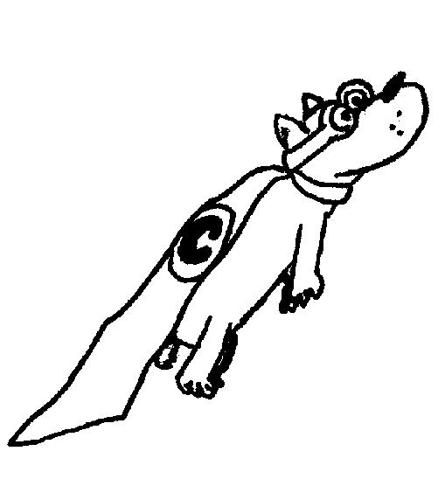
D. Quantitative Question:
θ = 45º
v_{y}
v_{x}
v = 20 m.s⁻¹

First separate his initial velocity into vertical and horizontal components:
v_{xi} = v_{o}cosθ = 20 m.s⁻¹ cos45º = 14 m.s⁻¹
v_{yi} = v_{o}sinθ = 20 m.s⁻¹ sin45º = 14 m.s⁻¹
v_{x} will be constant as there is no force in this direction.
The acceleration in y is due to gravity and is a = -9.8 m.s², taking down as the negative direction.
- Chuck will reach maximum height, y_{max}, when v_{y} = 0.
We can use v_{y}² = v_{yi}² + 2ay:
0 = (14 m.s⁻¹) ² + 2× -9.8 m.s⁻² × y_{max}, rearranging for y_{max} gives
y_{max} = -(14 m.s⁻¹) ² / 2× -9.8 m.s⁻² = 10 m.
(Note that we take down as the negative direction, so g = -9.8 m.s⁻²)
- The time he is in the air will be twice the time it takes to reach the maximum height.
We can use v = v_{i} + at, rearranging for t and setting v = 0, gives
t = -v_{i}/a = -14 m.s⁻¹ / -9.8 m.s⁻² = 1.43 s.
The total time of flight is 2 × 1.43 s = 2.9 s.
- The total distance Chuck is projected can be calculated using the x component of his velocity. He is in the air for a total of 2.9 s, moving with a horizontal velocity of 14 m.s⁻¹.
He travels a distance x = v_{x}t = 14 m.s⁻¹ × 2.9 s = 41 m.

