Workshop Tutorials for Introductory Physics
MI8: Momentum

A. Review of Basic Ideas:

Use the following words to fill in the blanks:
bus, specific, opposite, force, direction, mv, acceleration, third, conservation

Momentum
Momentum is one of those words that is used in different contexts. In politics you may hear about a political movement gaining momentum when it becomes more popular and powerful, while in physics it has a similar, but very _______ meaning. In physics the momentum of a body is the product of its mass and velocity, p = _____. Momentum is important because it tells you how hard something is going to hit you. If an object is coming towards you at 50 m.s⁻¹ it helps to know whether that object is an air molecule (momentum of around 10⁻²⁴ kg.m.s⁻¹) or a _____ (momentum around 10⁵ kg.m.s⁻¹), so you can take appropriate action. The more momentum an object has, the harder it hits. Like velocity, momentum is a vector, it has both magnitude and _______.
When Newton wrote his second law he didn’t actually write it as $\vec{F}$_{net} = m $\vec{a}$, which is how we usually remember it. He wrote it down as
$\vec{F}$ = $\frac{d}{\text{dt}}$$(m\vec{v})$= $\frac{d\vec{p}}{\text{dt}}$
which means that the force is the rate of change of the momentum with time. If the mass is constant then this reduces to F_{net} = ma, because the change in velocity with time is the ________. But sometimes the mass changes, for example a vehicle which burns fuel changes mass as it uses the fuel.
If no external ______ is acting on a system, then according to Newton’s second law its momentum is constant. This is called the law of _________ of momentum. Conservation laws are extremely useful for understanding how even quite complicated systems work.
Consider a cosmonaut making repairs on a space station. If she drifts away from the space station, how can she get back to it? There’s nothing to push against, so she can’t apply a force to the surrounding space and use a reaction force (Newton’s _____ law) to get back to the station. But she can use conservation of momentum, if she throws something in the _________ direction to the space station, then she must move towards the space station.

Discussion question
Is it possible to change the momentum of an object, say a tennis ball, without changing its speed or mass?

B. Activity Questions:

- Pendulum on Trolley
Swing the pendulum bob.
What happens to the trolley? Why does it behave like this?

- Balloons
Blow up a balloon, and do not tie off the neck.
Now let it go. What does the balloon do?
Explain what happens in terms of conservation of momentum.

- Newton’s Cradle – 2 steel balls
Swing one of the balls out and release it.
What happens when it hits the other ball?
What has happened to the momentum of the first ball?
What has happened to the momentum of the second ball?
Explain how this is also consistent with Newton’s third law- that for every action there is an equal and opposite reaction, which can be written as F_{AB} = - F_{AB}.

C. Qualitative Questions:

- Astronauts use a strong line to attach themselves to the outside of a space craft when they go outside. Draw a diagram showing what happens when an astronaut pulls on the line to get back to the space craft. How does the momentum of the astronaut change? How does the momentum of the space craft change? What about the astronaut and space craft combined?

- A group of students are designing a roller coaster. They want to be able to make it go faster along a straight, frictionless length of track. Brent suggests putting some water in the bottom half of the carriage and a plug in the bottom, which can be removed. His theory is that when the plug is removed the carriage will speed up. Rebecca tells him not to be silly, the carriage will slow down. Julia doesn’t think it will make any difference, but lets them go ahead and try it just to prove her point. Who is right and why?

D. Quantitative Question.

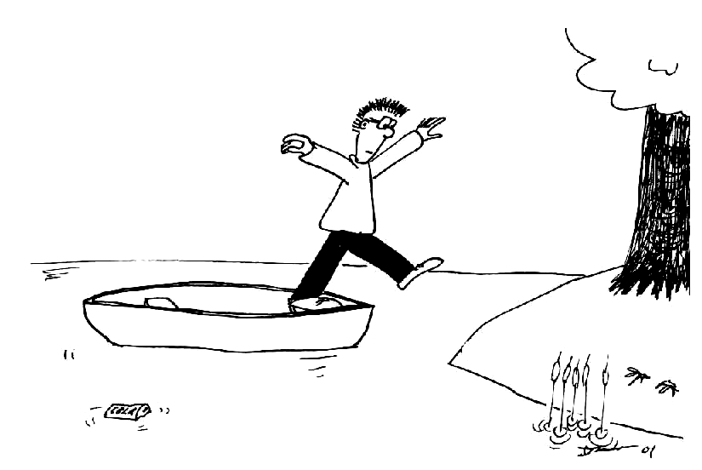
Brent is standing in a canoe and wishes to jump ashore without getting wet. The canoe has a mass of 60 kg and Brent has a mass of 70 kg. The canoe is 1 m from the shore. Brent jumps with a horizontal velocity of 2.5 m.s⁻¹ towards the shore.
- Draw a diagram showing the movement of Brent and the canoe.
- At what velocity does the canoe initially move away from Brent?

