Workshop Tutorials for Introductory Physics
Solutions to MI8: Momentum

A. Review of Basic Ideas:

Momentum
Momentum is one of those words that is used in different contexts. In politics you may hear about a political movement gaining momentum when it becomes more popular and powerful, while in physics it has a similar, but very specific meaning. In physics the momentum of a body is the product of its mass and velocity, p = mv. Momentum is important because it tells you how hard something is going to hit you. If an object is coming towards you at 50 m.s⁻¹ it helps to know whether that object is an air molecule (momentum of around 10⁻²⁴ kg.m.s⁻¹) or a bus (momentum around 10⁵ kg.m.s⁻¹), so you can take appropriate action. The more momentum an object has, the harder it hits. Like velocity, momentum is a vector, it has both magnitude and direction.
When Newton wrote his second law he didn’t actually write it as $\vec{F}$_{net} = m $\vec{a}$, which is how we usually remember it. He wrote it down as
$\vec{F}$ = $\frac{d}{\text{dt}}$$(m\vec{v})$= $\frac{d\vec{p}}{\text{dt}}$
which means that the force is the rate of change of the momentum with time. If the mass is constant then this reduces to F_{net} = ma, because the change in velocity with time is the acceleration. But sometimes the mass changes, for example a vehicle which burns fuel changes mass as it uses the fuel.
If no external force is acting on a system, then according to Newton’s second law it’s momentum is constant. This is called the law of conservation of momentum. Conservation laws are extremely useful for understanding how even quite complicated systems work.
Consider a cosmonaut making repairs on a space station. If she drifts away from the space station, how can she get back to it? There’s nothing to push against, so she can’t apply a force to the surrounding space and use a reaction force (Newton’s third law) to get back to the station. But she can use conservation of momentum, if she throws something in the opposite direction to the space station, then she must move towards the space station.

Discussion question
It is possible to change the momentum of an object, say a tennis ball, without changing its speed or mass. Momentum is a vector, like velocity, so you can change momentum by changing the direction a ball is moving but not the speed. For example, an elastic collision off a wall changes the direction but not speed.

B. Activity Questions:

- Pendulum on Trolley
When you raise the bob and hold the base still the total momentum of the pendulum-trolley system is zero. When you release the bob it swings down, gaining momentum. In order for momentum to be conserved the trolley must move the opposite way, which it does. As the pendulum swings back and forth the trolley will roll back and forth in the opposite direction, until friction eventually stops it.

- Balloons  When the balloon is released the air inside it rushes out because it is under pressure. The air comes out the neck of the balloon. For momentum to be conserved the balloon (and remaining air) must move in the opposite direction. This is what happens, and the balloon whizzes around the room, moving in the opposite direction to the air flow. | v_{balloon}  v_{air}

- Newton’s cradle – 2 steel balls  When the first ball (ball A) swings back and hits the second ball (B) it stops. The second ball swings out.  Momentum is conserved, so the change in momentum of ball A must be equal in magnitude and opposite in direction to the change in momentum of ball B. We can write this as Δp_{A} = - Δp_{B.} | A  B
We also know that $\vec{F}$= $\frac{d\vec{p}}{\text{dt}}$, so as the change in momentum, $\frac{d\vec{p}}{\text{dt}}$, of the two balls are equal in magnitude and opposite in sign, the forces acting on them must also be equal in magnitude and opposite in sign. This is equivalent to Newton’s third law which states that the force exerted by ball A on ball B must be equal and opposite to the force exerted by ball B on ball A, written as F_{AB} = - F_{AB}.

C. Qualitative Questions:
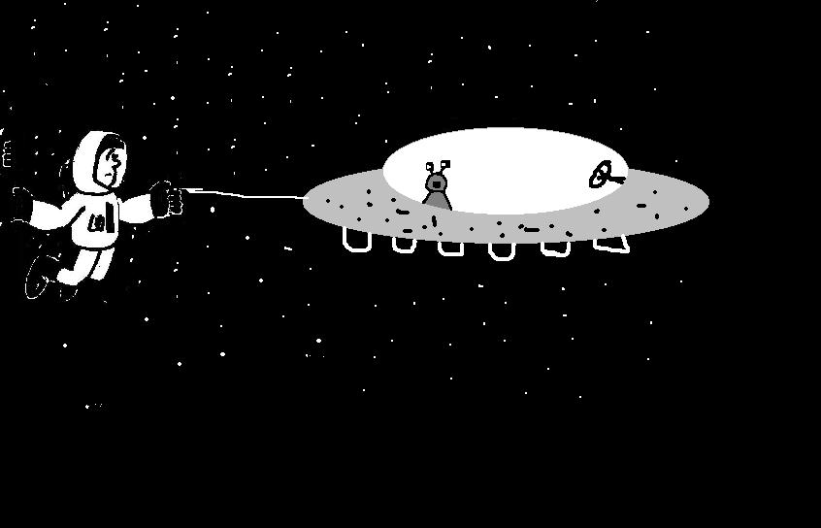
- Astronauts use a strong line to attach themselves to the space craft when they go outside. When an astronaut pulls on the line to get back to the space craft he moves towards the space ship and it moves towards him. He applies a force to the ship, via the rope. The ship applies a reaction force, equal in magnitude but opposite in direction, to the astronaut. | p  p
The rate of change of momentum is equal to the net force applied, and so assuming no other forces the change in momentum of the space ship is equal to that of the astronaut, and they move towards each other. As no external forces are acting the total change in momentum is zero. Note that the mass of the ship is much larger than the astronaut’s mass, hence the astronaut accelerates rapidly towards the ship, while the ship accelerates only slowly towards the astronaut.

2. Julia is correct. Pulling the plug will not change the speed of the roller-coaster. The water flows out with the same horizontal velocity as the roller coaster. Since no external horizontal forces are acting, the horizontal component of the momentum of both water and roller coaster are conserved, and the horizontal component of the roller coaster’s velocity does not change. | v  v  v  v  v  v

D. Quantitative Question.

The canoe has a mass of 60 kg and Brent has a mass of 70 kg. The canoe is 1 m from the shore. Brent jumps with a horizontal velocity of 2.5 m.s⁻¹ towards the shore.
- See diagram opposite.  - We can use conservation of momentum to find the velocity of the canoe.  p_{i} = p_{f.}  p_{i} = p_{B} + p_{C} = m_{B}v_{B} + m_{C}v_{C}  = 70 kg × 0 m.s⁻¹ + 60 kg × 0 m.s⁻¹ = 0 kg.m.s¹.  p_{f} = m_{B}v_{B} + m_{C}v_{C} = p_{i} = 0 kg.m.s¹.  so v_{C} = - m_{B}v_{B} / m_{C} = -70 kg × 2.5 m.s⁻¹ / 60 kg  v_{C} = -2.9 m.s⁻¹ | 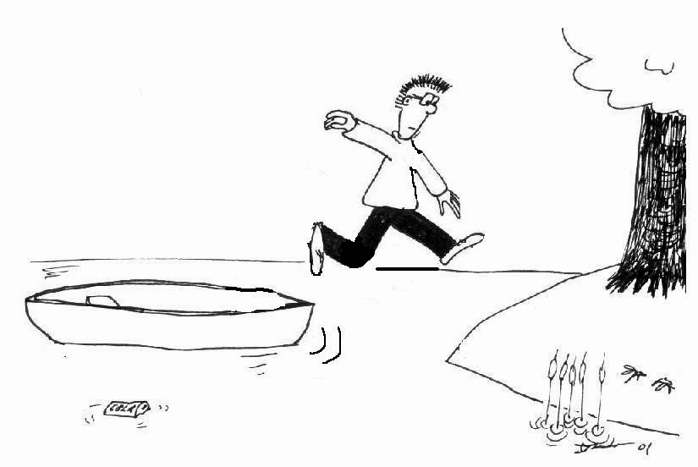  v_{B}  v_{C}

