Workshop Tutorials for Introductory Physics
MI10: Equilibrium

A. Review of Basic Ideas:

Use the following words to fill in the blanks:
vertical, pivot, force, shoulder, equilibrium, distance, torque, closer, dangerous.

Torque
When lifting a heavy object it is recommended to keep the back almost _______, lifting from the knees, rather than bending over and lifting from the waist. The concept of torque allows us to estimate forces on the spinal column when lifting objects and thus justify the above recommendation.
We can model the human spinal column as a pivoted rod. The _______ corresponds to the joint between the sacrum and the lowest lumbar vertebra.
The various muscles of the back are equivalent to a single muscle producing a force T, at a point two thirds up the spine. The sacrum exerts a _______ R on the spine.
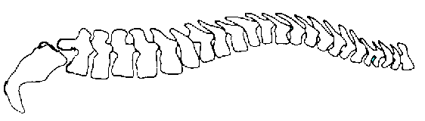  sacrum  Weight of upper body  Weight being lifted  T  pivot  R  12º | When you bend over to lift something with the spine horizontal, the force T acts at an angle of 12.0º to the horizontal.  The weight of the upper body, which is about 65% of your body weight, acts about halfway along the spine. The weight which you are lifting acts near the top of your spine, from where the _______ is.
If the spine is to be in _______, so there is no net torque or force, then the torque due to T must balance the torques due to the weights. These weights are about 0.5 m to 1 m away from the pivot point, so they will exert a large torque. (Remember that torque is force × _______). The force due to the muscles, T, must be large to balance these torques.
This force, T, has a large horizontal component which must be balanced for the spine to be in equilibrium. The force R of the sacrum on the spine acts through the pivot so it exerts no _______ about the pivot. It balances the horizontal component of R so the net force is zero. The forces T and R are large, and can damage the disk which separates the sacrum from the spine.
When you bend your knees to lift a weight, keeping your back straight, the weight of the body is almost directly over the pivot and hence exerts little or no torque. The _______ you hold the weight to your body, the smaller the torque that it will exert.
A 10 kg weight lifted against your body will exert a torque of only a few N. The same weight, lifted with the back horizontal, will exert a torque of around 100 N. To balance this torque, the muscles must exert a force of more than 1000 N! This is why lifting incorrectly is so _______, and results in so many back injuries.

Discussion questions
There is a disc between the sacrum and the spine. What effect will the force R have on this disc when you pick things up?
What would you need to do to a vertical spine to experience a similar force to one experienced when lifting incorrectly?

B. Activity Questions:

- Tools
On display are tools that use 'torque' in their design and application. Identify their pivots, axes of rotation and direction of forces on the tools.
Why is it easier to loosen a tight screw with a thick handled screw driver than a skinny one?

- The human body
On display are a few diagrams showing the use of torques around joints in the human body. Identify the pivot and direction of forces on the body parts shown

- Centre of mass and stability
Examine the various displays to get a feel for the centre of mass and stability.
Stand with your back against the wall and try to touch your toes. What happens, and why?

- Finding your own centre of mass
Use the two bathroom scales and the long plank to find your centre of mass.
Is it where you expect it to be? Is it different for other people in your group?

C. Qualitative Questions:

- You’re sitting with a friend at the Olympics and watching the pole vaulting, amazed at how high they can throw themselves. Your friend tells you that a good pole vaulter sends their centre of gravity under the bar. How is this possible? Use a diagram to explain your answer.

- "Sometimes I see a woman walking down the street with high heels and a two-ton bag, and I want to stop her and make her aware of what she is doing to her body," Dr. Jerome McAndrews, national spokesperson for the American Chiropractic Association.
- How does wearing high heels affect the posture? Draw diagrams showing the centre of mass and forces acting on the body when standing still, both flat footed and in high heels.
- What effects might long term wearing of high heels have that so annoy Dr McAndrews (and many other chiropractors)?

D. Quantitative Question:

The biceps muscle is connected from the shoulder (scapula) to the radius bone at a point around 5.0 cm from the elbow, as shown below. Its contractions flex the arm. The biceps muscle acts approximately vertically to pull the arm up. The weight of the hand and forearm is around 4.0 kg for a 70 kg person, and is typically around 35 cm long, with a centre of mass about halfway along.
- Show the pivot on the diagram.
- Mark where the force of the biceps is applied.
- Draw a diagram of the arm as a rod. Indicate the forces acting on it and the position of the pivot.
- Calculate the force exerted by the biceps of a 70 kg person holding their arm horizontally
- How would this force increase if they were holding a weight, such as a heavy handbag in their hand?
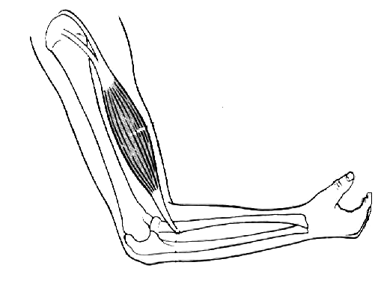
biceps muscle
humerus
radius
ulna

