Workshop Tutorials for Introductory Physics
Solutions to MI10: Equilibrium

A. Review of Basic Ideas:

Torque
When lifting a heavy object it is recommended to keep the back almost vertical, lifting from the knees, rather than bending over and lifting from the waist. The concept of torque allows us to estimate forces on the spinal column when lifting objects and thus justify the above recommendation.
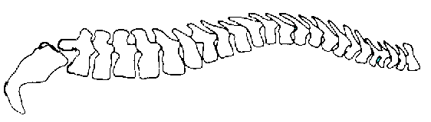
We can model the human spinal column as a pivoted rod. The pivot corresponds to the joint between the sacrum and the lowest lumbar vertebra. The various muscles of the back are equivalent to a single muscle producing a force T, at a point two thirds up the spine. The sacrum exerts a force R on the spine.
sacrum
Weight of upper body
Weight being lifted
T
pivot
R
12º
When you bend over to lift something with the spine horizontal, the force T acts at an angle of 12.0º to the horizontal.
The weight of the upper body, which is about 65% of your body weight, acts about halfway along the spine. The weight which you are lifting acts near the top of your spine, from where the shoulder is.
If the spine is to be in equilibrium, so there is no net torque or force, then the torque due to T must balance the torques due to the weights. These weights are about 0.5 m to 1 m away from the pivot point, so they will exert a large torque. (Remember that torque is force × distance). The force due to the muscles, T, must be large to balance these torques.
This force, T, has a large horizontal component which must be balanced for the spine to be in equilibrium. The force R of the sacrum on the spine acts through the pivot so it exerts no torque about the pivot. It balances the horizontal component of R so the net force is zero. The forces T and R are large, and can damage the disk which separates the sacrum from the spine.
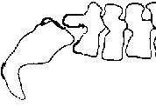
When you bend your knees to lift a weight, keeping your back straight, the weight of the body is almost directly over the pivot and hence exerts little or no torque. The closer you hold the weight to your body, the smaller the torque that it will exert. A 10 kg weight lifted against your body will exert a torque of only a few N. The same weight, lifted with the back horizontal, will exert a torque of around 100 N. To balance this torque, the muscles must exert a force of more than 1000 N! This is why lifting incorrectly is so dangerous, and results in so many back injuries.
R
T
20 kg
230kg

Discussion questions
The force T and the force R act in opposite directions on either side of the disk between the sacrum and the spine, pushing the sacrum and spine together. The forces push towards each other, thus compressing the disk.
To get an equivalent force on the disk when lifting vertically you would have to lift a weight more than 10 times as great.

B. Activity Questions:

- Tools
The forces shown are those applied by the hands of the person applying the tool, and the object which the tool is being applied to. A thick handled screwdriver is easier to use because you can apply a greater torque for the same applied force – just like having a longer lever.
F (object)
pivot
F (hands)
F (object)
F (hands)
pivot
F (object)
F (object)
F (hands)
F (hands)
pivot
F (hands)

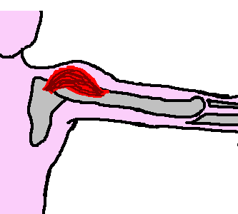
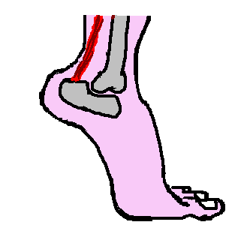
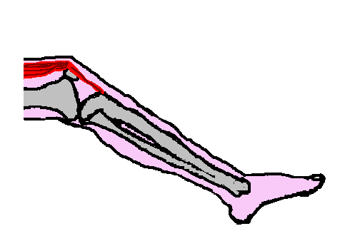
2. The human body
pivot
W_{arm}
T_{deltoid}
pivot
N_{ground}
W_{body}
T_{tendon}
pivot
W_{leg}
W_{foot}
T_{tendon}

3. Centre of mass
As long as the centre of mass is over the base, an object will be stable. When you try to touch your toes you lean back and put your bottom out. The wall behind you prevents this so you cannot touch your toes and maintain your balance.
scale
scale
centre of mass

4. Finding your own centre of mass
When the reading on the scales is the same, your centre of mass is half way between them. Your centre of mass should be about hip height for females, and a little higher for males.

C. Qualitative Questions:
centre of mass
centre of mass
below bar
- The centre of mass of the human body can be outside the body, for example if you touch your toes your centre of mass is outside your body. A high jumper bends their body so that the centre of mass is outside the body. It follows a curve through the air which passes below the bar.

- "Sometimes I see a woman walking down the street with high heels and a two-ton handbag”.
- Wearing high heels tips the body forward so that the centre of mass moves forward and the body becomes less stable. A body is most stable if the centre of mass lies near the centre of the area of contact of the feet with the floor. To keep the body upright, muscles have to do extra work and this puts a strain on the body. See diagram opposite.  - Long term wearing of high heels means that the constant strain could cause permanent damage. High heels have been linked to arthritis in the knees.  normal posture | W  W  W  tilt due to high heels – cannot balance  adjust posture to balance

D. Quantitative Question:
force from biceps
m_{arm}g
pivot
arm’s centre of mass

m_{sphere}g
pivot
bicep applies force here
x
X

a, b, c. see opposite.
- The biceps provide a force to counteract the weight of the arm. Considering torques about the pivot point (the elbow joint), in equilibrium τ_{biceps} = τ_{arm} so τ_{biceps} = F_{biceps}x.
τ_{arm} = m_{arm}gX = 4.0 kg × 9.8 m.s⁻² × ½(0.35 m) = 6.9 N.m.
So F_{biceps} = τ_{arm} / 0.05 m = 140 N.
- Holding a weight in the hand adds a large extra torque, as the distance from the hand to the pivot is large (35 cm). Even a small extra weight means the bicep has to apply a large extra force to keep the arm horizontal.

