Workshop Tutorials for Physics
MR1: Motion

A. Qualitative Questions:

- A person standing on the edge of a cliff, at some height above the ground below, throws one ball straight up with initial speed u and then throws another ball straight down with the same initial speed. Which ball, if either, has the larger speed when it hits the ground? Neglect air resistance.

- When a skydiver jumps out of a plane there are two forces acting on him – a constant force due to gravity and varying force due to air resistance. His acceleration is given by a = g – bv² where g is the acceleration due to gravity, v is his velocity and b is a constant (the co-efficient of drag). When he jumps from the plane he falls some thousands of feet before opening his parachute.
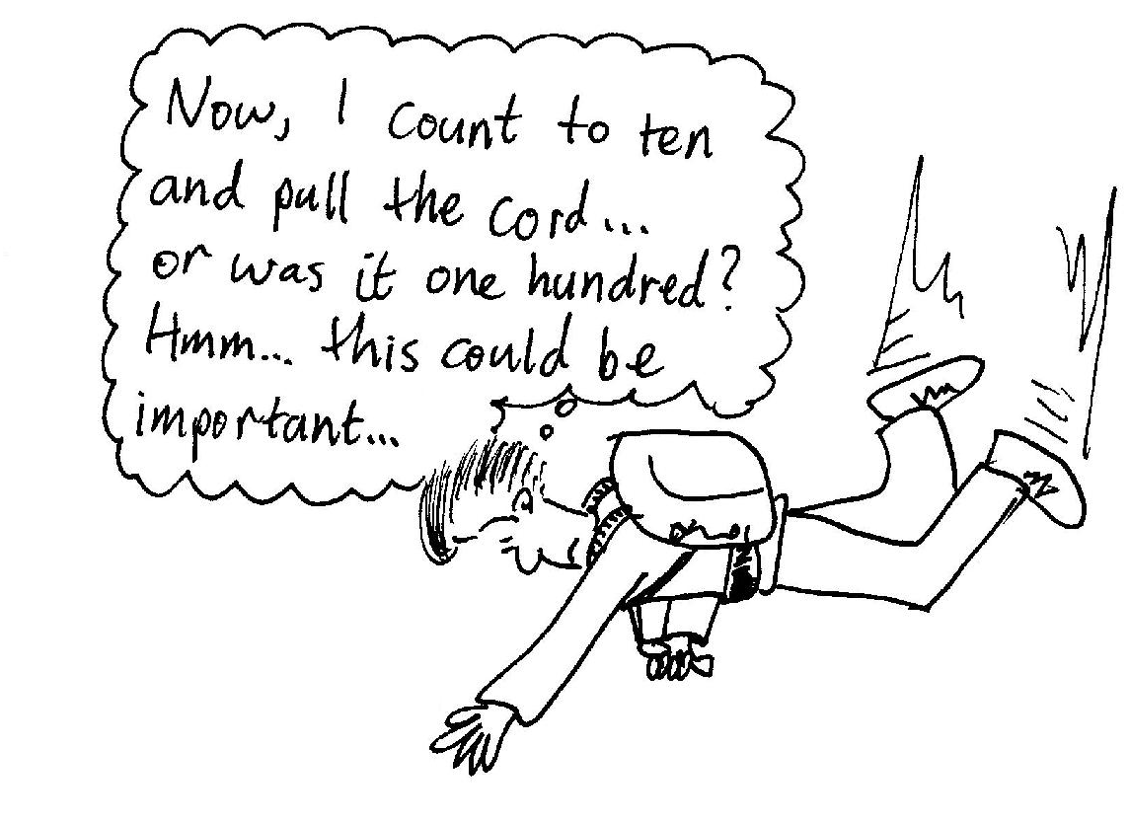
- What factors affect the value of b, the coefficient of drag?
- What happens to the value of b when he opens his parachute?
- Draw a sketch of the skydiver’s velocity as a function of time.
- Draw a sketch of the skydiver’s acceleration as a function of time.

B. Activity Questions:

- Accelerometer
Pull the accelerometer at a constant speed. What does it show? Why?
Now accelerate it forwards. What do you observe?
Allow the accelerometer to roll freely on a rough surface, for example the carpet. What does it show as it slows down?

- Pendulum
Watch the pendulum swinging back and forth.
Sketch plots of the bob’s position, velocity and acceleration with time.
Can you have a zero velocity but a non-zero acceleration?

- Acceleration due to gravity
Throw the ball straight up into the air, and catch it when it comes back down again.
Sketch the acceleration as a function of time.
Sketch the ball’s velocity and displacement with time.
Describe what happens in terms of the velocity and acceleration of the ball.

C. Quantitative Questions:

- Over the 2000 Christmas holiday period the NSW road toll was greater than that for all other states and territories combined, and was for 2001 more than double the toll for any other state. This has prompted calls from the community for the government to “do something about it”. One recent initiative has been to lower the speed limit in residential streets from 60 km.h⁻¹ to 50 km.h⁻¹, however getting motorists to obey the limits is an ongoing problem.
Your car will accelerate from 0 to 100 km.h⁻¹ in 12 seconds.
- Assuming a uniform acceleration, how long does it take you to reach 50 km.h⁻¹?
- How long does it take you to reach 60 km.h⁻¹?
- What distance do you travel in these times for accelerating to each speed limit?
- How much longer does it take to travel a distance of 5 km at the reduced speed limit compared to the previous limit, starting from rest and using maximum acceleration, without exceeding the speed limit?

- A student throws a ball with a speed of 15.0 m.s⁻¹ at an angle of 40.0° above the horizontal directly toward a wall as shown below. The wall is 10.0 m from the release point of the ball.
- How long is the ball in the air before it hits the wall?
- How far above the release point does the ball hit the wall?
- What are the horizontal and vertical components of its velocity as it hits the wall?
- When it hits, has it passed the highest point on its trajectory?

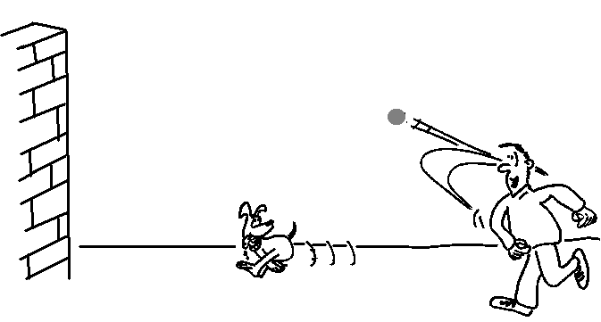
40º
10 m

