Workshop Tutorials for Physics
MR2: Using Vectors

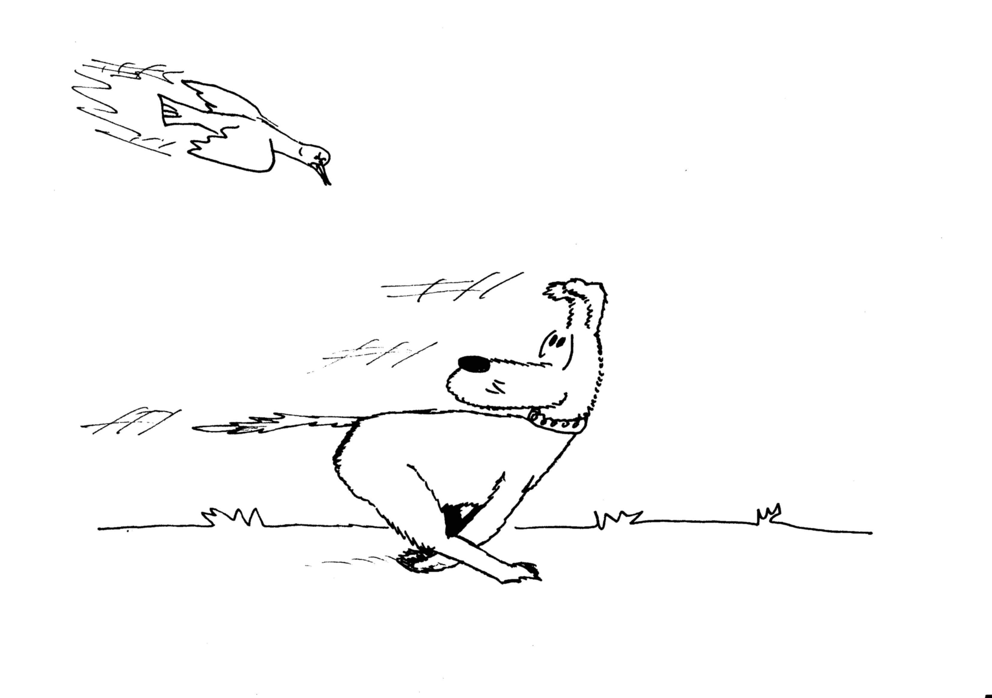
A. Qualitative Questions:

1. Barry the dog is running around the yard chasing birds, which he never catches.
- Can the magnitude of Barry’s displacement be less than the distance he has traveled?
- Can the displacement be more than the distance traveled?
Barry comes to rest in the yard, some distance from where he started.
- Can any component of his displacement vector be greater than the magnitude of the vector itself?
- How could a component have the same magnitude as the magnitude of his displacement vector?

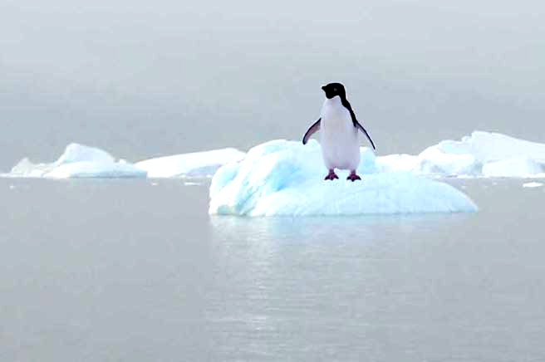
2. A penguin is floating on an iceberg. The iceberg drifts slowly towards the shore and bounces off at a gentle angle.
- Draw the path of the penguin.
- Draw the velocity vector of the penguin before the collision with the shore.
- Draw the velocity vector of the penguin after the collision with the shore.
- Draw the acceleration vector of the penguin during the collision.
- How would this acceleration vector look if the collision had been a head on one, with the iceberg (and penguin) bouncing back at 180º?

B. Activity Questions:

- Battleship
Describe how vectors are used to give positions in this game.
How else could you describe the position of a ship?

- Map
How are vectors used on the maps?
You should be able to find at least two examples.

- Vector Game
Appoint one group member to be a caller. Everyone else chooses a starting position and walks the vectors as called. When you get it wrong, you’re out!

- Mirrors and reflections
Look at your reflection in the mirror.
Move your right hand to the right. What does your reflection do?
Why is it that left and right are reversed in the mirror, but not up and down?

C. Quantitative Questions:

- A magpie has a position vector given by $\vec{R}$= 5t$\hat{i}$+(14 -7t+ t²)$\hat{j}$ where the unit vector $\hat{j}$ is in the vertical direction, upwards positive.
- Find the magpie’s instantaneous velocity as a function of time. Draw a sketch of the velocity vector at several times.
- Find the instantaneous acceleration as a function of time. Sketch the acceleration at several times.
- Describe the path of the bird, using a diagram. What do you think it might be doing?

- Brent is taking Rebecca for a ride in his new boat. They’re planing to go across from Cairns to one of the small islands of the Great Barrier Reef. Brent is very proud of his new boat, especially the autonavigation feature. He shows Rebecca how he can program in the coordinates. “I just punch in 6 km east and 2 km north, and we’ll be there in no time!”
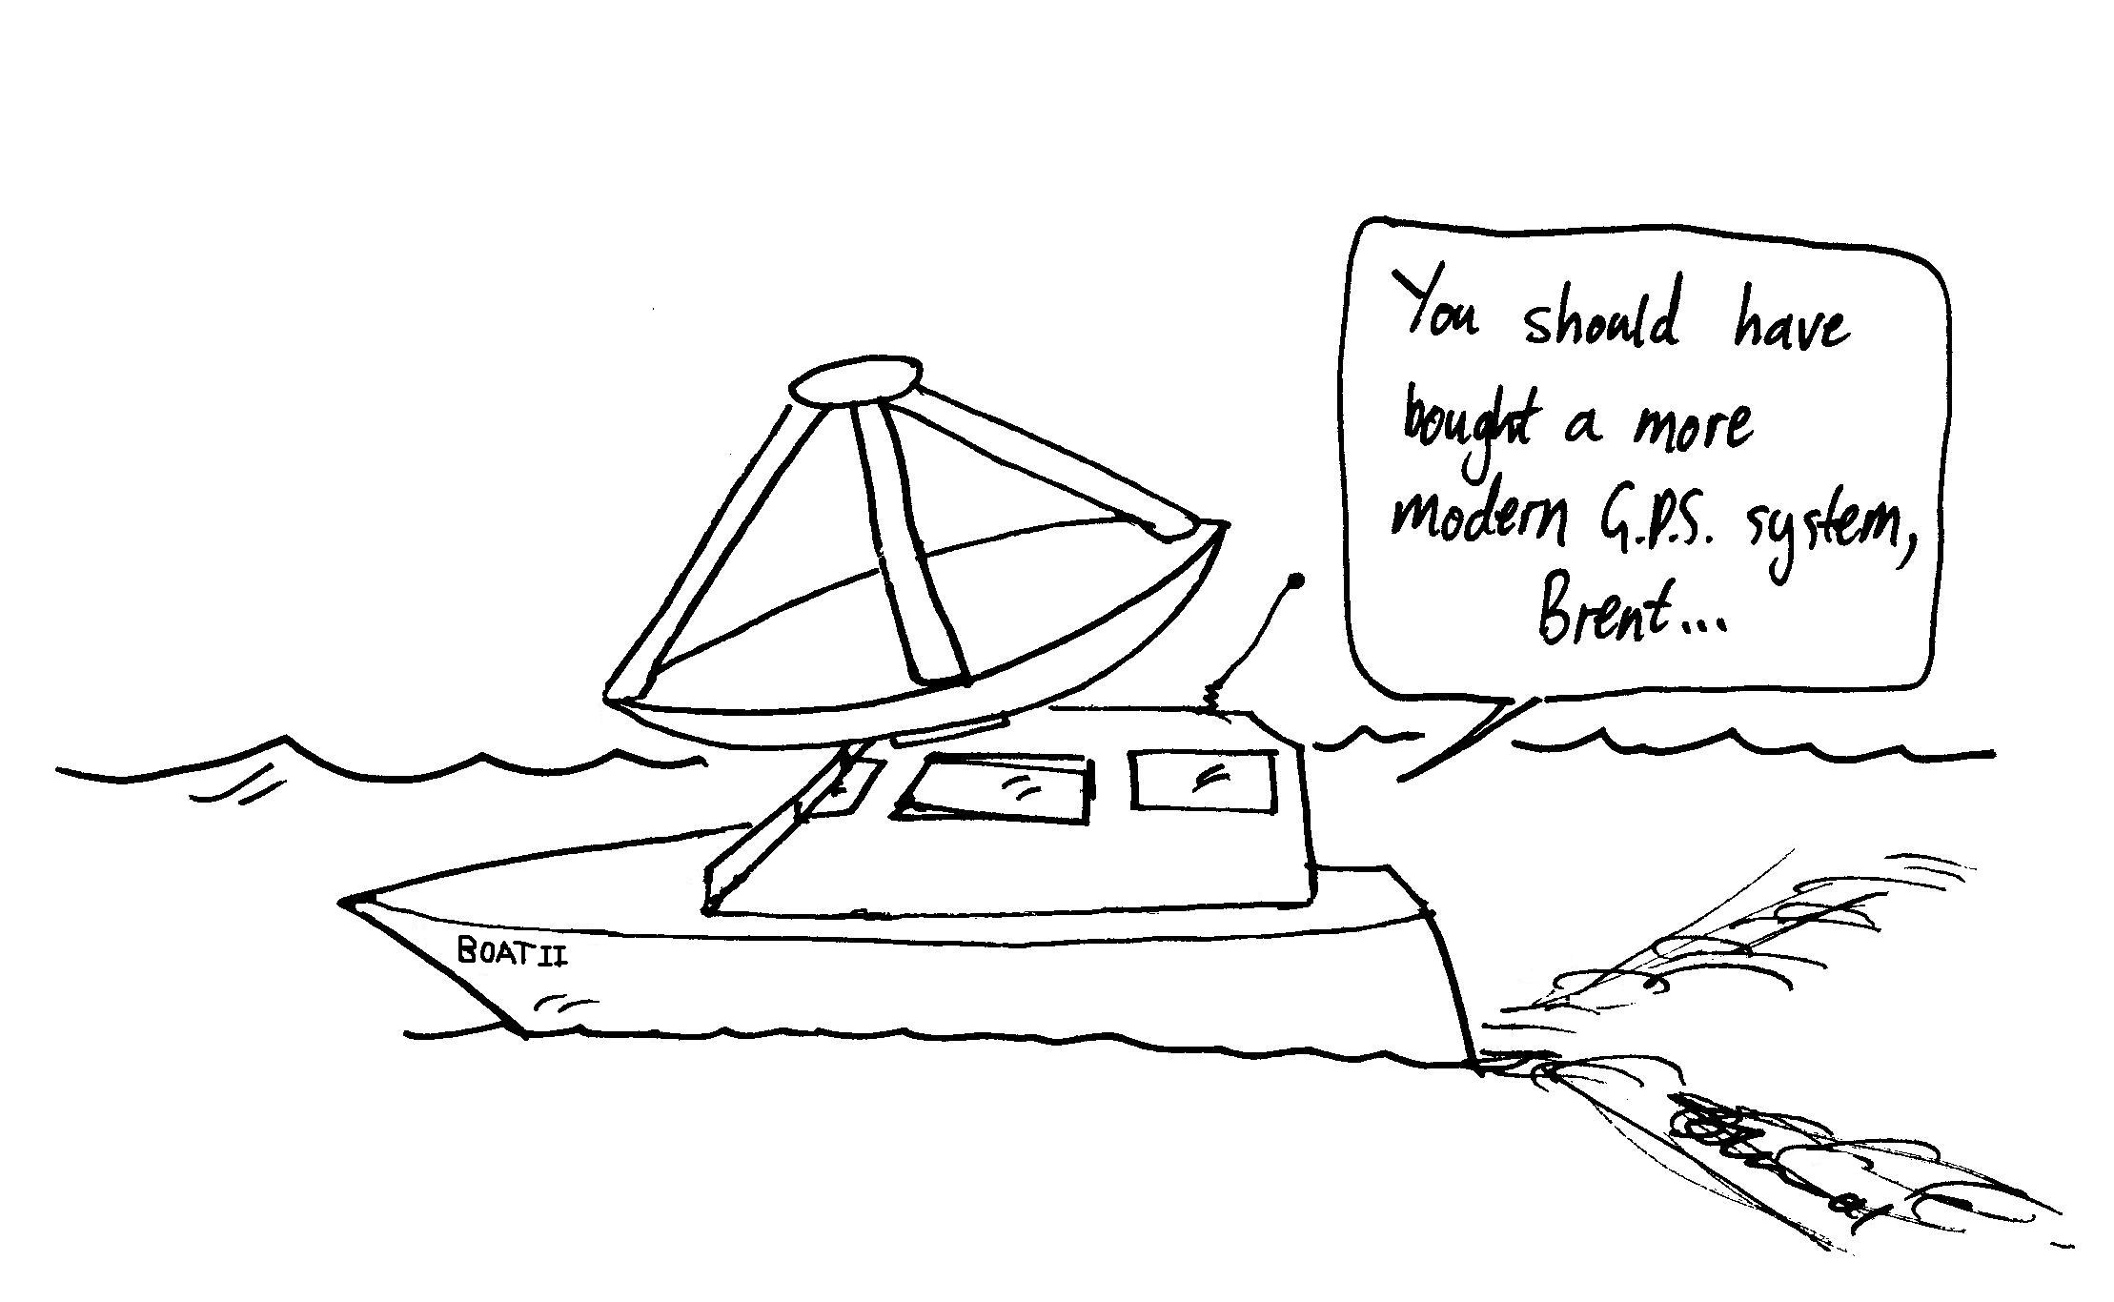
An hour and a half later the navigator beeps to say they are about to arrive. Rebecca looks around and sees the island due south of them.
“Okay, I’ll just reverse the instructions and we’ll go back to Cairns and start again” says Brent.
Another hour and a half later they end up 12km north of where they started.
“Did you allow for the current?” asks Rebecca.
- Draw a diagram showing their path.
- What is the velocity of the current?
- What is the magnitude and direction of the velocity of the boat relative to the water for the first hour and a half?
- What is the magnitude and direction of the velocity of the boat relative to the island for the first hour and a half?

