Workshop Tutorials for Physics
MR11: Rolling

A. Qualitative Questions:

- We often think of friction as an annoying force that must be overcome to move things around. However friction is necessary for walking, driving and even rolling a ball or using a yo-yo.
  - Draw a diagram showing the forces acting on a ball which is rolling down a hill.
  - How are the forces different for a ball sliding down a hill without rolling?
  - Sometimes when you try to accelerate a car too hard on a wet or slippery road the wheels spin and the car doesn’t move. Explain why this happens.

- In a lot of manufacturing industries it is important that all the items are of a similar size. A confectionery company is looking for a way to separate spherical lollies of the correct size from those that are too big or too small. One of their engineers suggests using a ramp at the end of the lolly making machine. He says that the different sized lollies will roll down at different speeds, so all they have to do is hold a container under the end of the ramp at the right time for the good lollies, and put the rubbish bin under it for the wrong sized lollies. Will this solution work? Explain your answer.
(Hint – think about the relationship between v, ω and the height the lollies drop through, h.)

B. Activity Questions:

- Rolling down a ramp
Experiment with releasing the balls on the two surfaces.
Why does one slide and the other roll?
Will a ball get to the bottom of a ramp quicker if the ramp is frictionless or if there is some friction? Explain your answer.

- A loaded race
Spheres, cylinders of various diameters and an inclined plane are available on the activity table.
Do all the cylinders roll down with same speed?
Do all the spheres roll down with same speed?
Try rolling them down the incline and try to explain why some of them roll down faster than the others.
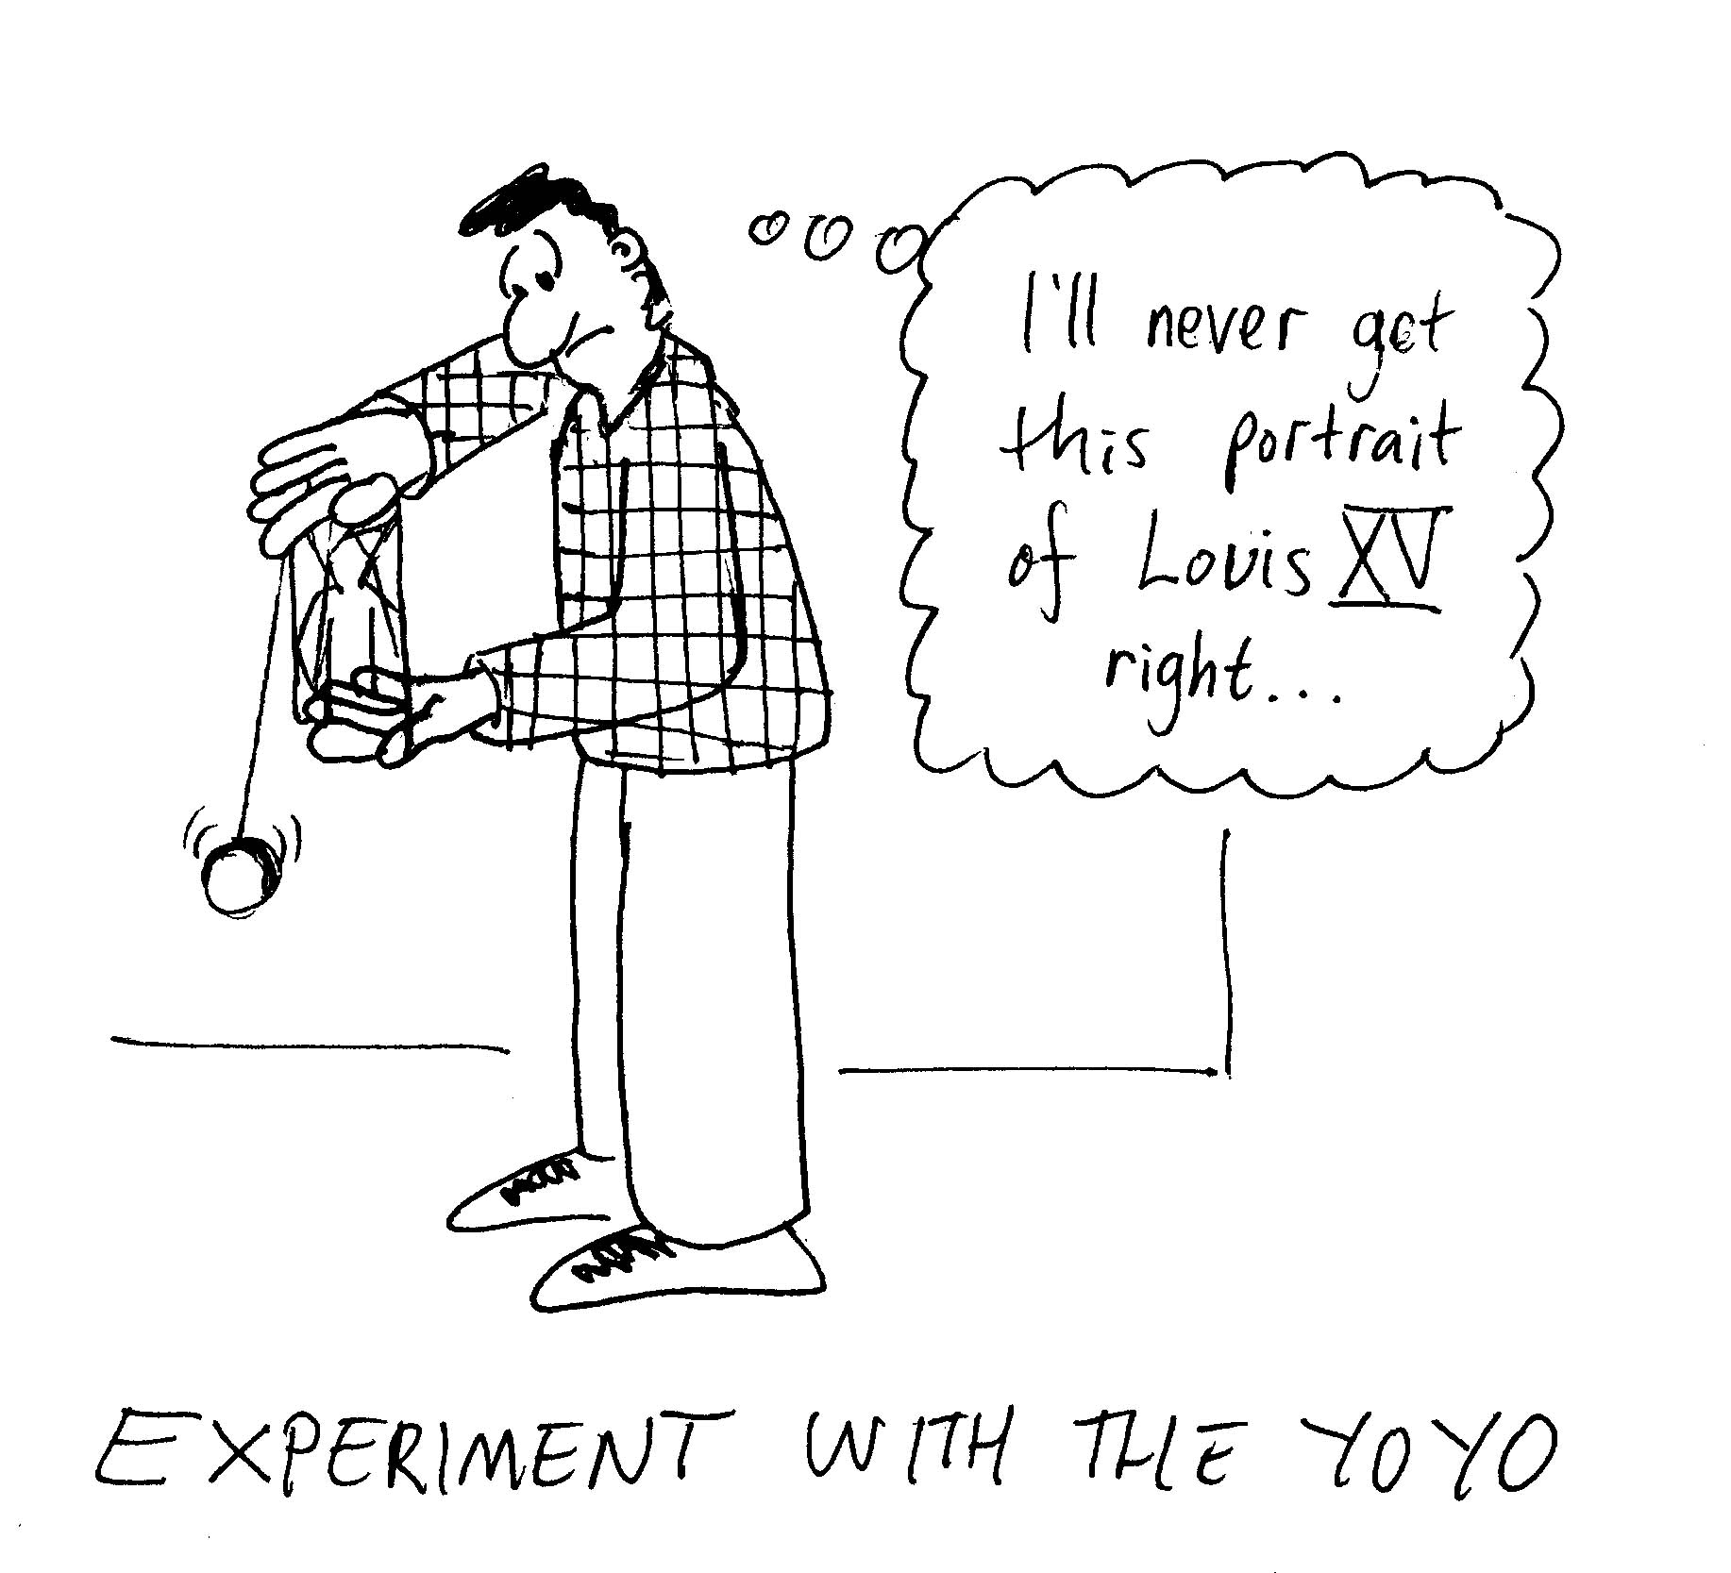
- Yo-yo
Experiment with the yo-yo.
Describe the energy conversions that occur as a yo-yo falls.
Why does a yo-yo come up again?
What provides the force to accelerate it back up?

C. Quantitative Question.

- A car is travelling at 60 km.h⁻¹ when the driver takes his foot off the accelerator and the car gradually rolls to a stop in 100 m. The wheels of the car are 75 cm in diameter.
- What is the linear acceleration of the car’s wheels?
- What is the angular acceleration of the wheels?
- If the rotational inertia of each wheel is 8 kg.m², what is the torque exerted on each wheel about its central axis? What is the source of this torque?

- The Olympic record for the one kilometre men’s cycling is one minute and 2.955 seconds, and is held by Lothar Thoms of Germany. If Lothar’s rear bicycle wheel had a diameter of 60 cm,
- What was the average linear speed of the centre of the wheel as seen by Lothar?
- What was the average linear speed of a point at the top of the wheel as seen by Lothar?
- What was the average linear acceleration of the centre of the wheel as seen by Lothar?
- What was the average linear acceleration of a point at the top of the wheel as seen by Lothar?
- Would a stationery spectator watching him go past see the same average linear velocity and acceleration of these points?
