Workshop Tutorials for Physics
MR13: Relativity

A. Qualitative Questions:

- Rebecca and a group of other physics students are doing a project on relativity. They are all in a train carriage moving at a constant velocity relative to the ground. Rebecca is wearing a special hat designed by Brent. The hat has infrared photo-sensors in it, one on either side of the hat, and a small buzzer and coil inside the hat. If light reaches both sensors at once the buzzer buzzes and the coil gives Rebecca a small electric shock, and she will take the hat off. She is standing right in the middle of the carriage.
Brent is going to observe the experiment from the platform at Redfern station.
When Julia (one of the students) sees Brent on the platform she presses a button which causes infrared light to be transmitted simultaneously by devices at each end of the carriage.
- Does light reach the two sensors on Rebecca’s hat at the same time in her reference frame? Will she take the hat off?
- What do Julia and the other students observe? Do they hear the buzzer? Do they see Rebecca take the hat off?
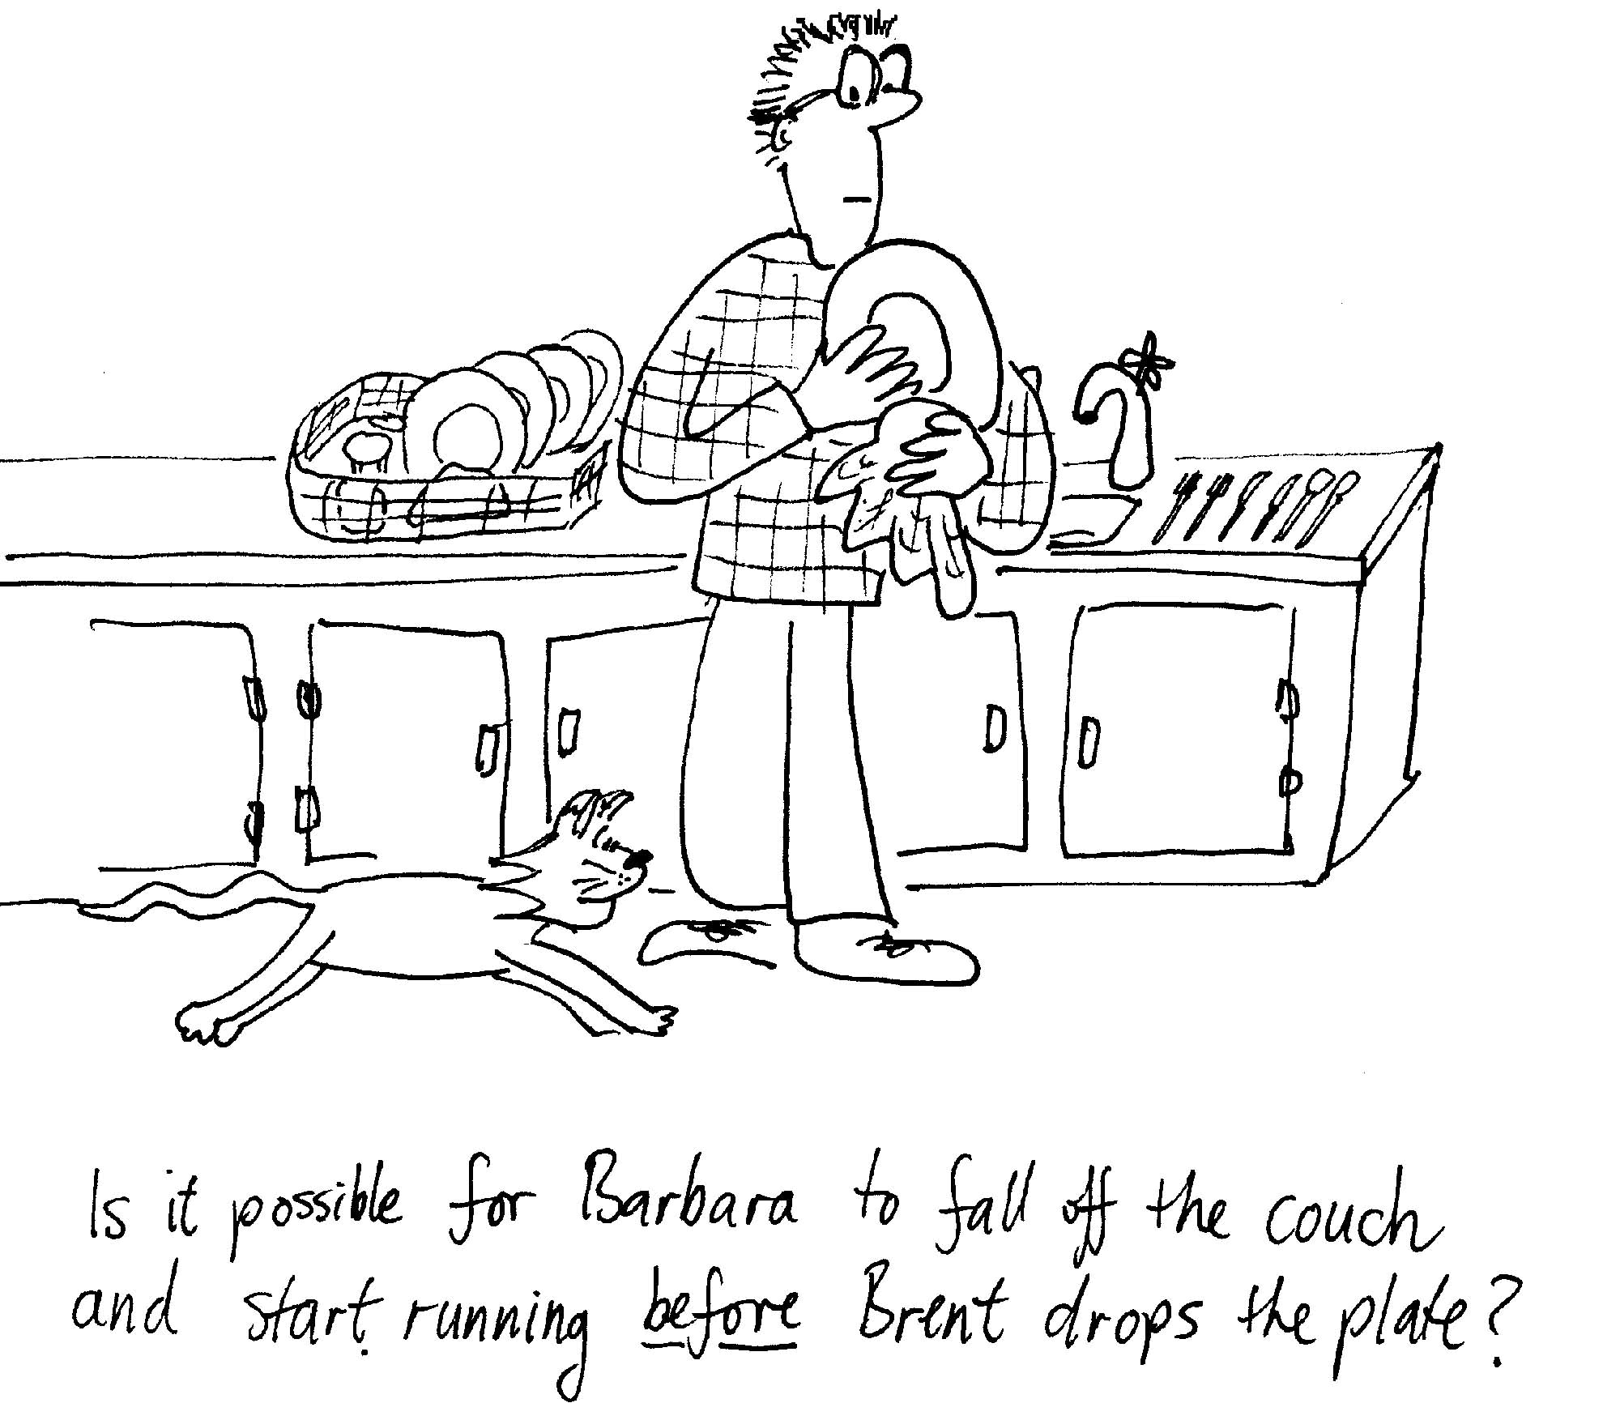
- What does Brent, standing on the platform, observe? Does the light from the two transmitters reach the sensors at the same time in his reference frame? Does he see Rebecca take her hat off? Explain why or why not.

- Brent drops a plate and it breaks, making a noise which frightens Barbara the cat, who falls off the edge of the couch and runs away. We know that events are not necessarily simultaneous in different reference frames, so is it possible for there to be a reference frame in which the cat falls off the couch before Brent drops the plate? Explain why or why not.

B. Activity Questions:

- Relativity and Electromagnetism
What happens when you move the magnet into the coil and out again?
What happens when you move the coil relative to the magnet instead?
Does it make any difference which one moves and which is stationary?

- Space-time diagram
A space-time diagram is useful for showing how things move in time.
How is this diagram different to the displacement diagrams you usually draw?
What does path A represent? What does path B represent?
Is it possible for an object to go from point P to point Q? Explain your answer.

- Minkowski diagrams
The diagram has two sets of axis, one for each of two reference frames. Frame S is stationery relative to the ground, and frame S’ is a frame moving relative to the ground along with an alien space craft at velocity v = 0.6c.
At time t = t’ = 0 the space craft passes FBI agent Fox Mulder. Fox is at the origin of the x and x’ axes.
6 ns later he turns on his mobile phone to make a call to his partner.
Mark the coordinates for each of these two events on the Minkowski diagram. Write down the x, t and x’, t’, coordinates for each event.
C. Quantitative Questions:
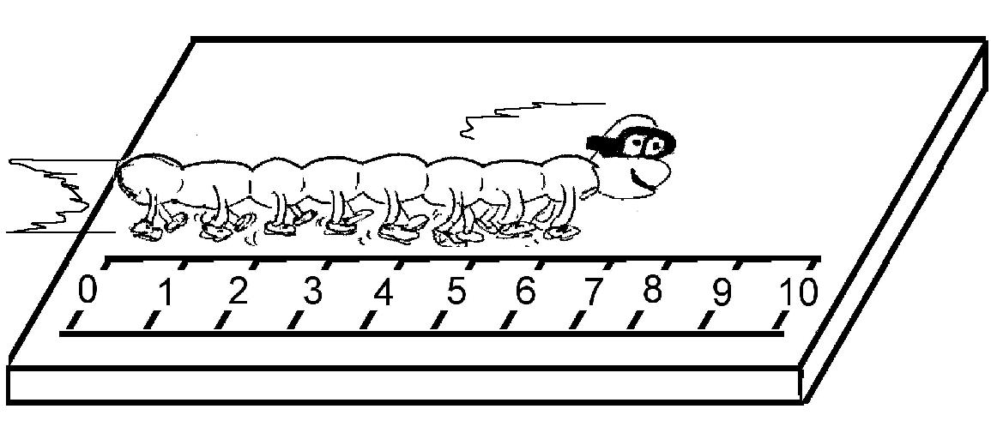
- A high speed centipede is running across a chopping block at velocity v when he is spotted by the butcher. The proper length of the centipede is 10 cm.
- What does proper length mean? How is it measured?
The butcher measures the length of the centipede to be 8cm, using a ruler inset into the chopping block.
- How fast is the centipede moving relative to the butcher?
The butcher, who wants to give the centipede a fair chance, holds two meat cleavers 9 cm apart. The instant the centipede’s tail is at point O, the butcher immediately swings both cleavers instantaneously and simultaneously down on the chopping block, one at point O the other 9 cm away, and immediately lifts them up again. (This is a butcher with very good reflexes.)
The butcher believes that as the centipede is 8cm long and the cleaver separation is 9 cm, the centipede should be safe. The centipede is not convinced, and is quite worried by the situation, as the cleavers approach at high velocity v.
- What is the separation of the cleavers from the point of view of the centipede?
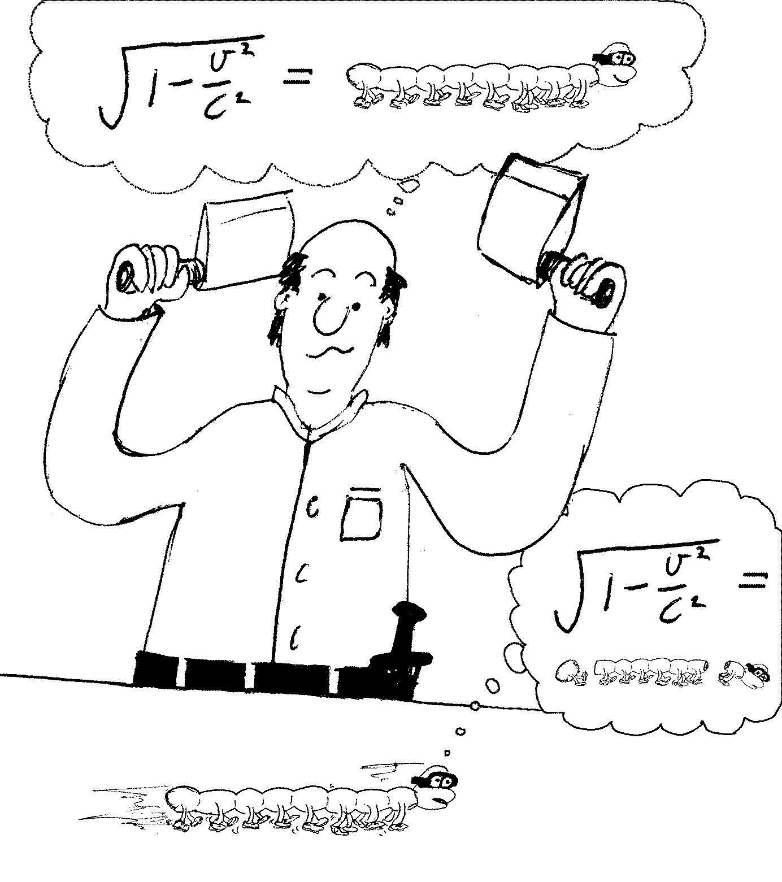
So from the butcher’s reference frame the centipede makes it, from the centipede’s reference frame, it’s going to messy. They can’t both be right.
Let the reference frame of the butcher be frame S, and that of the centipede be frame S*.
Let’s consider two events: cleaver A hitting the block and cleaver B hitting the block. These both happen at time t =0 according to the butcher.
- At what positions do these events happen in the butchers frame?
- Using the Lorentz transformations, at what time and position does event 1 (cleaver A hits the block) happen in the frame of the centipede, S*?
- At what time and position does event 2 (cleaver B hits the block) happen in the frame S*?
These two events are simultaneous from the point of view of the butcher, but they are not simultaneous from the frame of the centipede.
- Where is the centipede’s tail when cleaver A comes down in S*?
- Where is the centipede’s head when cleaver B comes down in S*?
- Is it the end for the super speedy centipede?

- A spaceship whose rest length is 350 m has a speed of 0.82 c with respect to an observer on Earth. A micrometeorite, also with a speed of 0.82 c with respect to the observer on Earth, passes the spaceship going in the opposite direction.
- How long does the micrometeorite take to pass the space ship according to an observer on Earth?
- What is the speed of the micrometeorite according to an observer on the space ship?
- How long does the micrometeorite take to pass the space ship according to an observer on the space ship?
- According to the observer on Earth, the kinetic energy of the micrometeorite is 12 GJ. What is the rest mass of the micrometeorite?
- What is the kinetic energy of the micrometeorite according to an observer on the space ship?

