Workshop Tutorials for Introductory Physics
PI1: Pressure

A. Review of Basic Ideas:

Use the following words to fill in the blanks:
9.8 m.s⁻², greater, force, 321 kN, perpendicular, 13.5 kPa, gauge

Under pressure
If the pressure of the air inside a car tyre is equal to atmospheric pressure, the tyre is flat. The pressure has to be ________ than atmospheric to keep the tyre firm, and the significant quantity is the pressure difference between the inside and outside. When we say that the pressure in a car tyre is 220 kPa, we mean that it is greater than atmospheric pressure (101 kPa) by this amount. This is called a _______ pressure. The total pressure, called the absolute pressure, is 321 kPa. A pressure of 321 kPa acting on a surface of 1.0 m² will produce a force of ________.
The compressed air, inside a car tyre, exerts an outward _________ on the inner surface of the car tyre. The direction of the outward force is always ________ to the inner surface of the car tyre. Thus at the top of the tyre the force is upwards and at the bottom it is downwards. This keeps all the surfaces of the car tyre firm.
The pressure difference, ΔP, between two points in a fluid is ΔP = ρgΔh where g is the acceleration due to gravity, ρ is the density of the fluid and Δh is the height difference between the two points. In human beings, there is a difference in pressure between the blood at the feet and the heart. In the reclining position, the head, heart and feet are at the same elevation and the pressures are the same. For a standing adult whose heart is 1.30 m above his feet the pressure difference is:
ΔP = ρ_{blood} g Δh
= 1060 kg.m⁻³ ×________ × 1.30 m
= 1.35 × 10⁴ Pa = ________
So the blood has to be "pumped uphill" from the feet to the heart. This is achieved by one-way valves and the squeezing of veins during walking. Note that this is a first approximation, the actual processes are much more complicated.

B. Activity Questions:

- Suction cups and Magdeburg plates
How can you make the suction cup stick to a surface?
Explain what happens when it sticks and when it fails to stick.
When are the Magdeburg plates hard to pull apart?
When are the Magdeburg plates easy to pull apart? Explain why.

- Hydrostatic paradox
Water is poured to the same level in each of the vessels shown below, all having the same base area. If the pressure is the same at the bottom of each vessel, the force experienced by the base of each vessel is the same. Why do the vessels have different weights when put on a scale? This apparently contradictory result is commonly known as the hydrostatic paradox. Use the activity to solve this issue.

- Squirting
Use the activity to show that 'a fluid exerts an outward force on the walls of its container'.
Observe the way water 'squirts' out of the holes. What can you say about the direction of the water just as it leaves the holes?
Push a drinking straw into the water and then put your finger over the top. Lift the straw out of the water. What happens? Why? Observe what happens when you undo the lid of the “watering bottle”. Explain your observations.

- Hollow tube and disc
Hollow tube and disk: Why does the disk fall away in air but stay attached to the tube when there is air in the tube and water outside the tube?

C. Qualitative Questions:

- You are about to set out on a scuba diving trip, and are having a medical check. The doctor measures your blood pressure to be a healthy 120/80 mmHg. The 120 mmHg is the maximum pressure at the peak of each pulse, called the systole, and the 80 mmHg is the lowest pressure between pulses, called the diastole.
- Given that normal atmospheric pressure is around 760 mmHg, why does blood spurt from a deep cut?
You check the weather report, and it’s going to be a fine weekend, with a high pressure front of 102kPa bringing warm weather. You pack up and head off. You check your tyre pressure when you fill up with petrol, and inflate them to 25 psi (17.2 kPa).
- Which of the pressures given above are absolute and which are gauge pressures?
You arrive at the diving class and are issued with instructions and equipment.
- Why does the diving instructor tell you not to hold your breath when surfacing?
- Why are you issued with lead belts and inflatable packets?

- The diagram shows a reservoir wall.
- Why is the wall thicker at the bottom than at the top?
- Two reservoirs of the same depth are to be joined to form a single much larger reservoir. Is it necessary to reinforce the dam wall?

D. Quantitative Question:
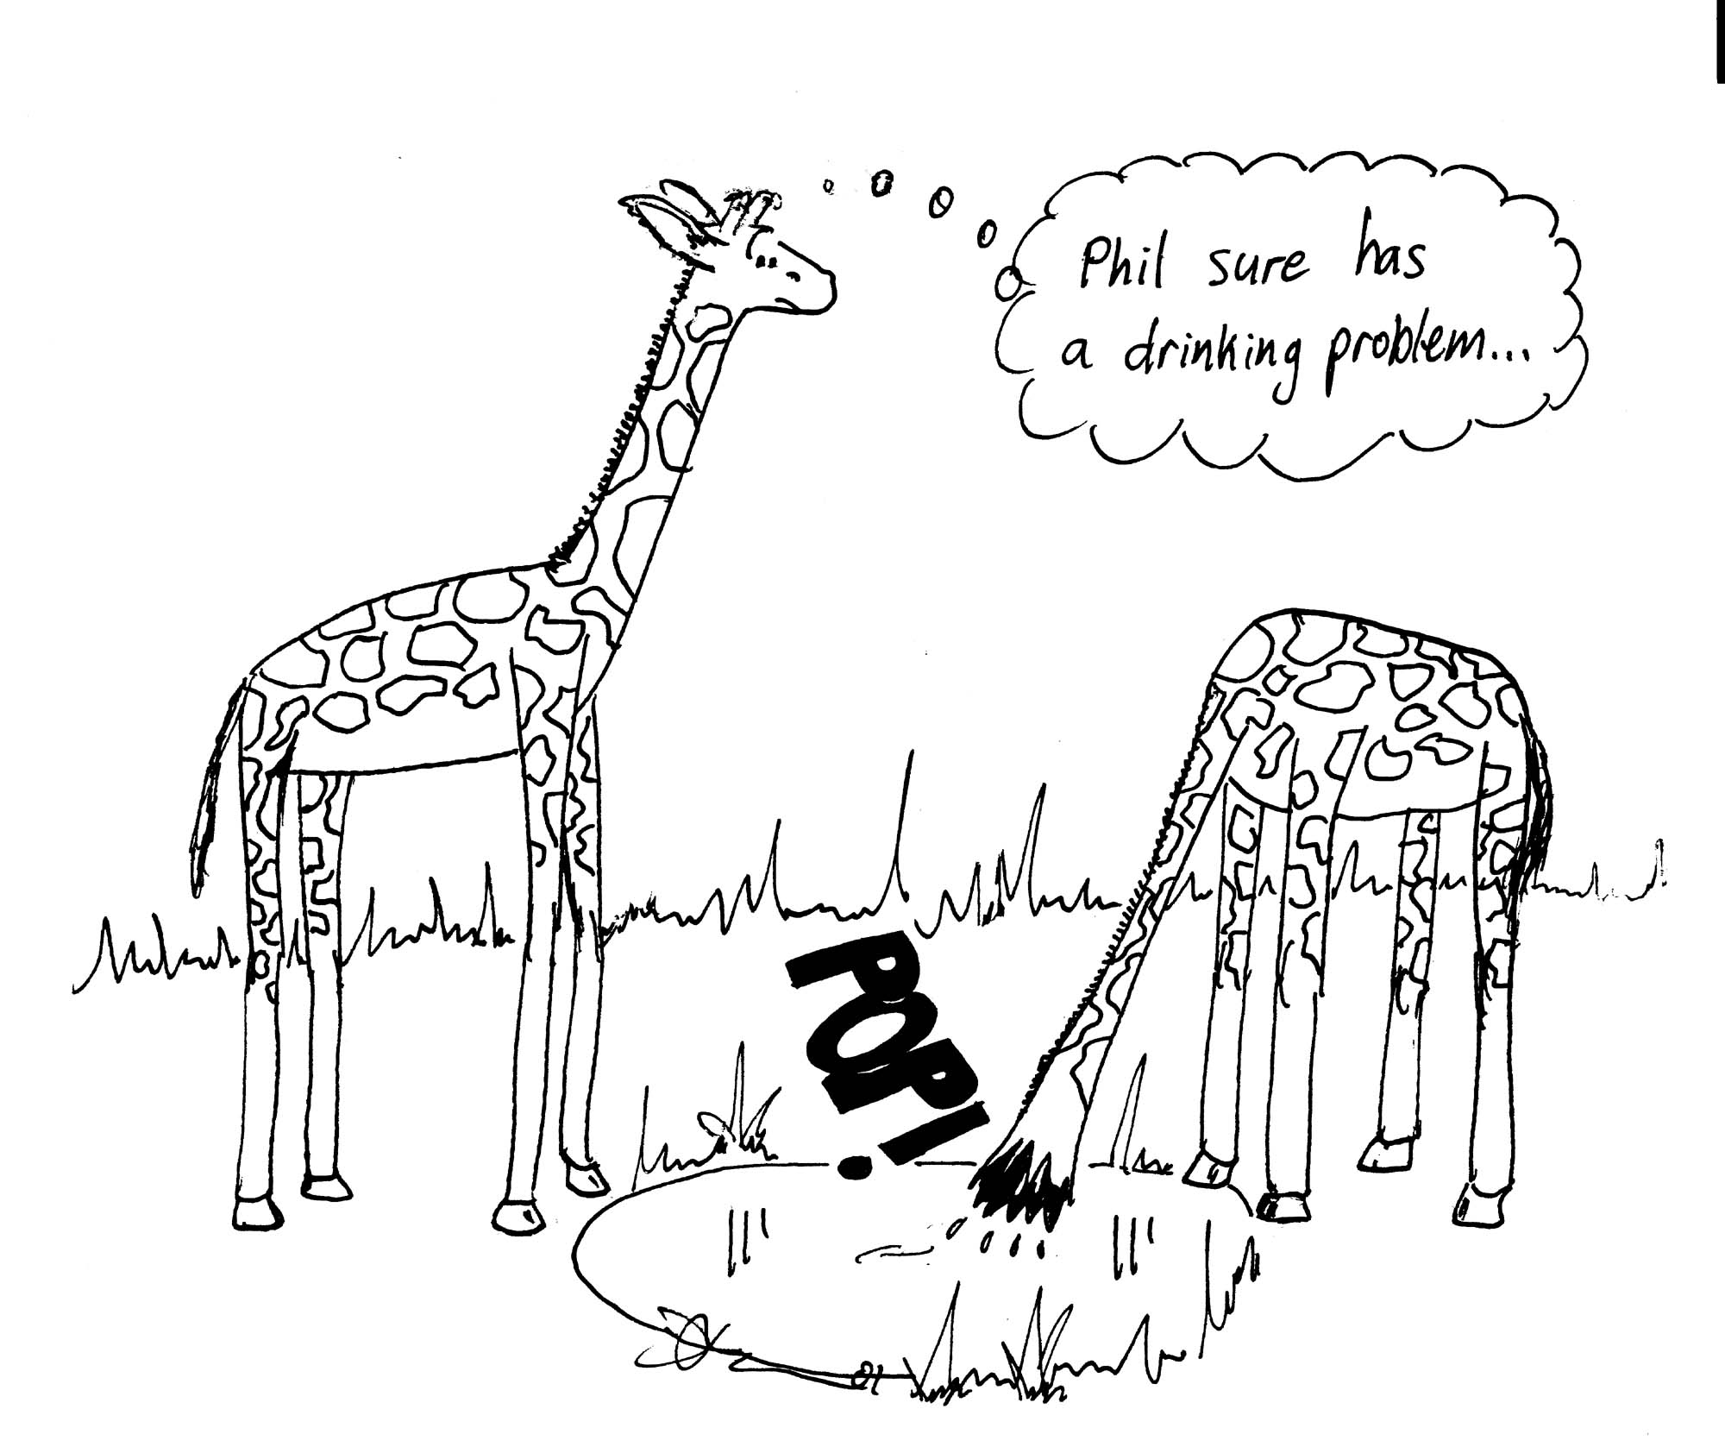
- If a giraffe is 5.0 m tall, with his heart at approximately half that height, what pressure does the heart need to produce to keep the brain supplied with oxygen?
- How does this pressure change when he drinks?
- Why do giraffes spread their front legs to drink? What would happen if they didn’t?

