Workshop Tutorials for Introductory Physics
PI4: Solids I – Stress, Strain and Elasticity

A. Review of Basic Ideas:

Use the following words to fill in the blanks:
hydraulic, stress, weaker, strain, elastic, shearing, fluid, Young’s, rigid, proportional, ultimate.

Stress and strain of solids
A _______ is something which can flow and changes shape to match the container that holds it. A solid does not flow but it can change shape. Many solids seem very ______, such as bones and bricks, while others we describe as elastic, like rubber bands and skin.
All solids are to some extent ______, in that they will change shape when a force is applied to them. When a rubber band or plank of wood is held secure at one end and pulled on from the other, it will stretch and get longer. The amount it stretches is _______ to the force applied, for some range of force. We use this linear relationship to define the _______ modulus, E, of a material:
F/A = E× ΔL/L
where F is the force applied along the length of the object, A is the cross sectional area of the object and L is its length. The applied pressure, F/A, is also known as the stress, and the response of the material, the change in length, ΔL/L is called the _______.
If you apply too great a force, either stretching or compressing, the object will break. The breaking force may be different for stretching and compressing. For example concrete can withstand a large compressive force, but will easily break under a tensile (stretching) force. The pressure at which a material will break is called the _______ strength.
When forces are applied which are not along the same line, bending or _______ occurs. Most materials are much _______ under shearing forces than compressing forces, and it is usually easier to break something by bending it rather than compressing it. We can describe the strength of a material to shearing forces by its shearing modulus, G. The shearing modulus is again defined using the _______ applied and the strain of the material:
F/A = G× Δx/L
where x is the amount the material bends from its original (equilibrium) position.
It is also possible to change the volume of a material by subjecting it to _______ pressure, by applying a uniform pressure, P, all over the surface using a fluid. The change in volume, V depends on the bulk modulus, B of the material, which is defined by
P = B× ΔV/V

F
ΔV
F
F
F
ΔL
Δx
F
F

F

F

Tensile stress
Shear stress
Hydraulic stress

B. Activity Questions:
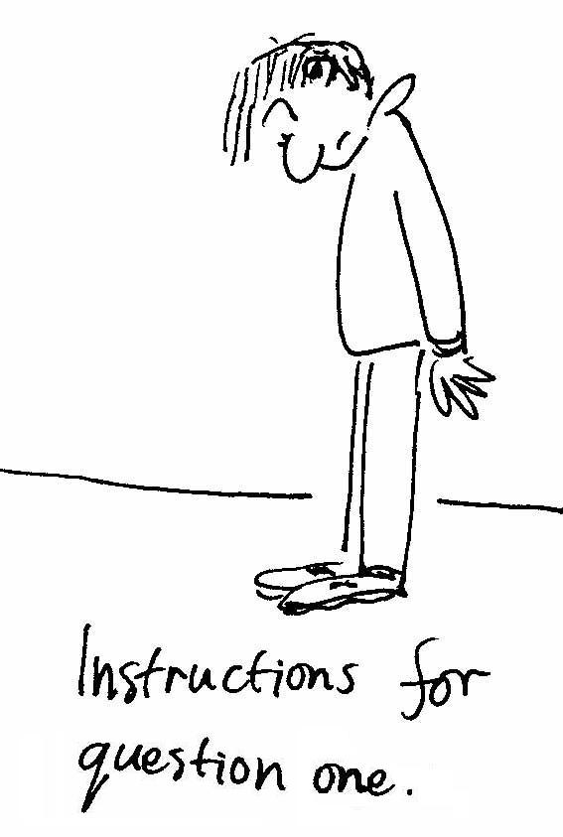
- Shoes
Look at your shoes.
While standing still, what forces are acting on the soles of your shoes? What sort of deformation would you expect to occur?
When you are walking what forces are acting on the soles of your shoes? What sort of deformation would you expect to occur?
Draw a diagram showing the forces and resulting deformations.

- Rubber bands
Which rubber band has the largest spring constant?
How could you estimate the elastic modulus of the rubber bands?
Cut a rubber band to form a strip, and hang a weight off it. What would happen if you cut the strip in half and hung a weight from it?
What if you joined two strips together in parallel?

- Breaking chalk
Can you break the chalk by compressing or stretching it?
What about by bending or twisting it?
What is the easiest way to break it and why?

C. Qualitative Questions:

- A squash match never begins until the ball is warm, because a cold squash ball bounces about as well as a cold sausage.
- Why does hitting the squash ball around for a few minutes warm it up?
- Why does the squash ball bounce better when it is warm?
- Explain in terms of elasticity why a well inflated basketball bounces better than a flat one?

2. Examine the stress-strain diagram below for bone and tendon.
- Which is the closer to Hookean?  - What does the graph tell you about the behaviour of bone and tendon under stress?  - Which has the larger Young’s modulus? Explain your answer. | strain  stress  bone  tendon

D. Quantitative Question:

A tibia (shin bone) is approximately 40cm long with an average cross sectional area of 3.0 cm².
Bone has a Young’s modulus of approximately 1.8×10¹⁰ Nm⁻², and an ultimate compression strength of 17 × 10⁷ N.m⁻².
- What is the total weight that the legs can support?
- If these were the legs of an 85 kg man, by how much would the tibias shorten when he gets out of bed in the morning and stands up?
- Why should you bend your knees when landing from a fall or jump?

