Workshop Tutorials for Introductory Physics
TI1: Temperature

A. Review of ideas in basic physics.

Use the following words to fill in the blanks:
freezing, warmer, digital, temperature, thermometer, equilibrium, water, boiling, 298 K, nett

Temperature
We often talk about objects being hot or cold. But hotness or coldness are relative and are not very accurate descriptors. A more accurate way of defining the hotness or coldness of an object is to measure its __________. To illustrate this point, consider what you feel when you step barefooted from a tiled area onto a carpeted area of a floor. The carpet will feel ________, especially on a cold day. Yet common sense should tell you that they are both at the same temperature.
To measure temperature we use a _________. Thermometers contain some material with a property that is dependent on temperature. For example, the thermometer may contain a liquid such as mercury which expands with increasing temperature and moves up a scale. Many _______ thermometers have a sensor made of a material whose electrical resistance varies with temperature.
Most importantly, if the thermometer is to read exactly the temperature of an object it must be in thermal ________ with that object. If two objects are in thermal equilibrium then there is no ________ flow of thermal energy between them. It is important to leave the thermometer in contact with the object whose temperature is to be measured for a long enough period of time until thermal equilibrium is reached.
We encounter temperature in everyday usage measured on a range of temperature scales. For example the Celsius scale is established by taking two fixed points; zero degrees, the _________ point of _______ and 100 degrees, the _______ point of water, and dividing the interval between into 100 equal divisions. In physics we use the Kelvin scale. On this scale 0 K equals minus 273.15 ºC; room temperature is ________ (often rounded to 300K) on the Kelvin scale.

B. Activity Questions:

- Thermometers
Examine the different thermometers on display.
What physical property do they use to measure temperature?
What would you use these thermometers for?

- Thermal Expansion of gases
Place the coin on top of the bottle.
Now cup your hands around the bottle and observe what happens.
Explain your observations.

- Thermal Expansion of liquids
Hold the beaker in your hands.
Explain what you observe.

- Thermal Expansion of solids - bimetallic strip
Heat the strip using the hairdryer or hot air gun.
What happens to the strip, and why?
Can you think of a use for such a strip?

C. Qualitative Questions:

1. There are different ways of measuring temperature depending on what you’re measuring the temperature of, and what temperature range you need to measure.
- Describe two different ways of measuring temperature. What physical properties do they rely on?
- Give examples of when you might use these methods.
- Why do you always have to hold the thermometer under your tongue for what seems like hours (but is usually about 30 seconds) when you have your temperature measured?

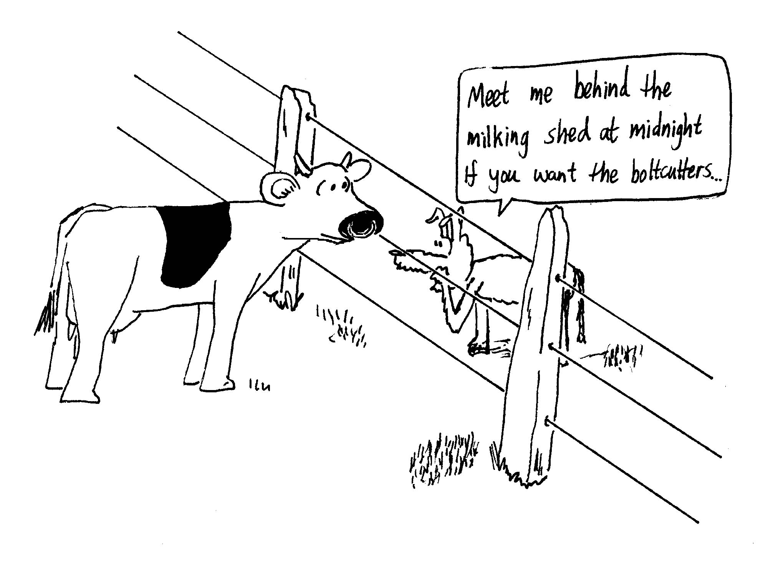

2. A farmer is stringing a wire fence in the middle of the day. He makes it nice and tight so that his cows can’t push through it.
- That night all the wires break. Why?
- How does running hot water over a jar make the lid easier to get off when both the jar and the lid are being heated?

C. Quantitative question.

You fill your petrol tank with 50 l of petrol [full] in the morning when the temperature is 20ºC. The car is left in the sun and the temperature in the car rises to 55ºC. The coefficient of volume expansion for petrol is β = 0.95 × 10⁻³ C⁻¹.
- How much petrol will overflow?
- If petrol is 98 ¢/litre, how much money have you wasted?

