Workshop Tutorials for Introductory Physics
TI3: Heat Transfer

A. Review of Basic Ideas:

Use the following words to fill in the blanks:
wetsuit, conduction, hot, sun, cold, radiation, flow, conducted, energy

Convection, conduction and radiation
Imagine a day at the beach, on a mild day with a maximum temperature of 25ºC. You find a nice sheltered spot in the dunes and lie on the sand for a while enjoying the sunshine. Even though it’s not a particularly hot day after a while you get quite warm. This seems odd, because heat flows from ________ regions to ________ regions, and as your skin temperature is warmer than the air, it seems odd that you are getting hotter. To understand why you are getting hotter you need to consider the heat transfer processes that are occurring. You get hot because you are absorbing radiation from the _______. This is one way in which heat can be transferred. All hot bodies radiate heat, in proportion to their temperature. You can absorb a lot of __________ from the sun when the weather is cold, and lose heat to the air by ____________, convection and radiation quite quickly. When this happens you don’t get hot even though you are absorbing a lot of radiation.
You decide to take a swim to cool off. When you get into the water it feels very cold, because your body quickly loses heat by conduction to the water. The water molecules in contact with your skin can absorb heat from your skin which is ___________ away by the water.
The movement of the water also helps you cool off quickly. The water molecules can absorb heat as they get close to your skin, increasing their own kinetic energy, and then move away taking that energy with them. Convection involves a _________ of material, while conduction and radiation involve a flow of _______ (heat), but not matter.
If you lie very still in a rock pool so that the water hardly moves you feel a little warmer after a while, because the water around you has warmed up a bit, and is not being moved away by convection. A __________ keeps you warm this way, by trapping a layer of water against your skin, and not letting it flow around. A wetsuit also works by decreasing conduction of heat.

B. Activity Questions:

Thermal conductivity.
Feel the different blocks. Which feels the coldest? Which feels the warmest?
Now measure their temperatures. Which is the warmest? Which is the coldest? Explain your observations.

“Stubby holder”
How does the stubby holder keep the can cool? Which process of heat transfer is affected?
Wetsuits worn when swimming in cold waters are effective in reducing heat loss from the body. A wetsuit is named so because it traps a layer of water. Explain why wearing a wetsuit keeps a swimmer warmer.

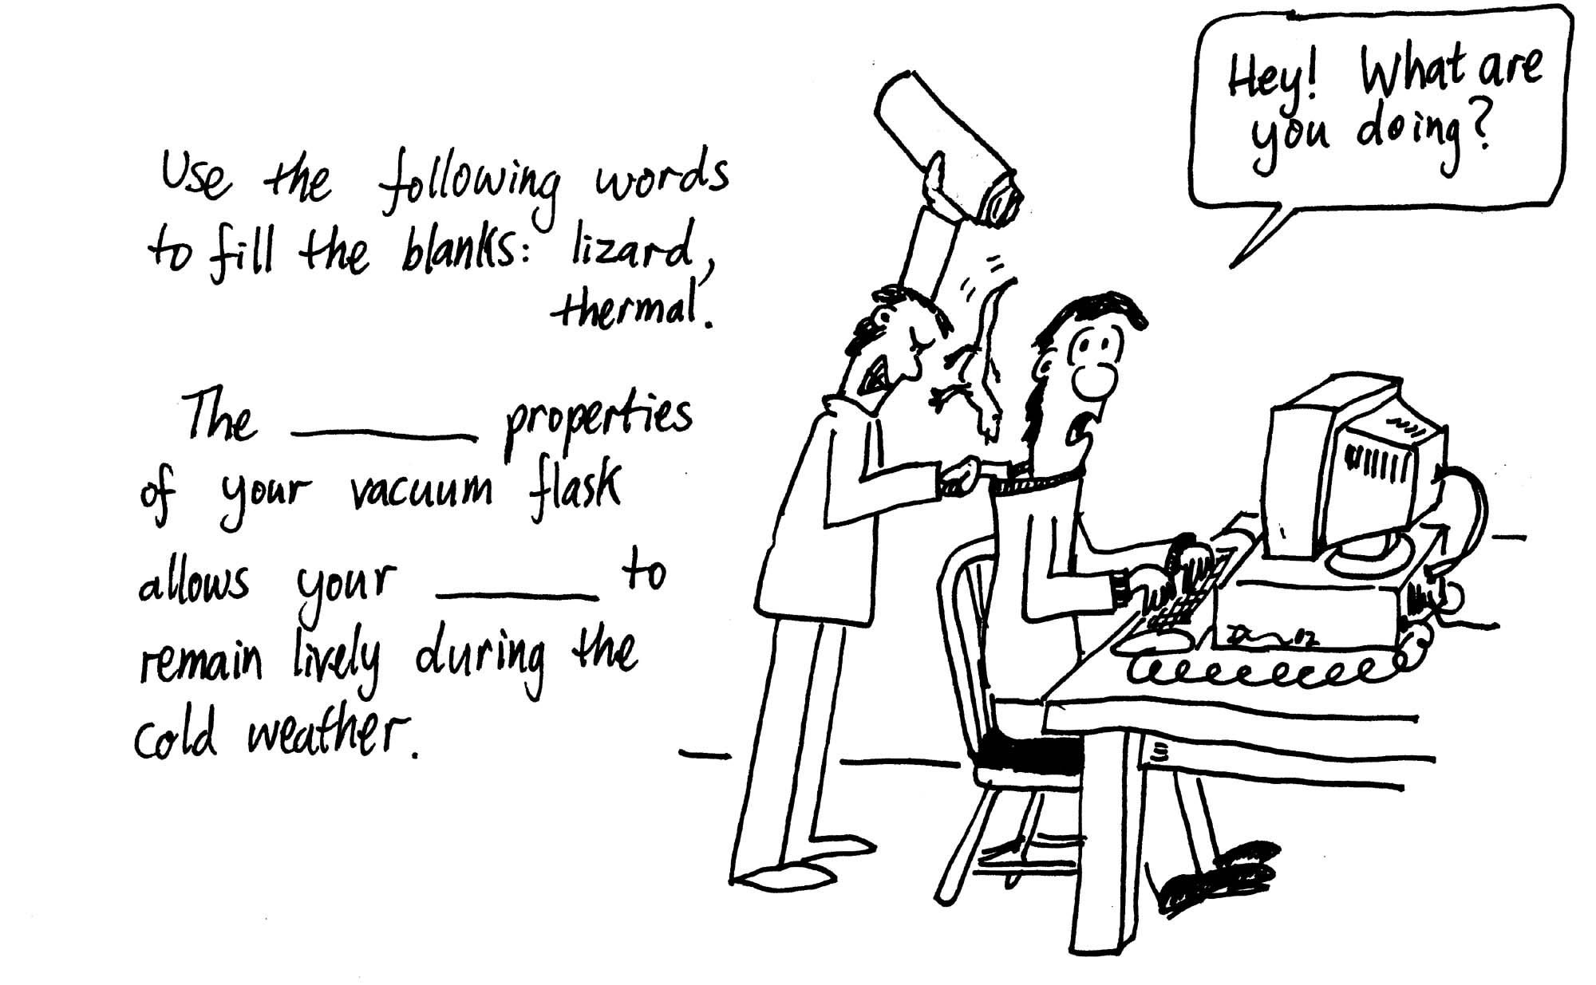
Thermos flask.
Examine the thermos flask.
It has a thick stopper, double walls which are evacuated, and the vacuum bottle is silvered on the inside. Explain how this keeps drinks either hot or cold. What processes of heat transfer are affected?

Measuring air temperatures
Check the readings on the two thermometers.
Now put one of them under the light or in the sun for a few moments.
How do the readings compare now?
What does a thermometer actually measure?

C. Qualitative Questions:

- You can make a “heat telescope” by putting the bulb of a mercury-in-glass thermometer in a paper cup lined with aluminum foil. On a cool, dry clear night you point the telescope at the sky. After a few minutes you read the thermometer. Then you point the thermometer at the earth for a few minutes and read the thermometer again.
- Do you expect any difference in the two readings? Explain your reasoning.
- Why is the cup lined with aluminum foil?

- The greenhouse effect is an issue of increasing global concern, with average temperatures expected to rise significantly around the world over the coming years. The effects of this could be disastrous, with weather patterns changing and sea levels rising.
- What is the green house effect, and what causes it?
- Draw a schematic diagram showing the thermal processes involved. Which thermal processes are affected, and why does this lead to warming?

D. Quantitative Question:

A house has well insulated walls which are 0.32 m thick with a total area of 360 m², a roof of tiles 0.08 m thick and area 280 m², and (uncovered) glass windows, 0.85 cm thick with total area 42 m². The temperature inside the house is 22⁰C and the outside temperature is 34⁰C.
- Assuming that the heat gained by the house is by conduction only, determine the rate at which heat must be removed to maintain the temperature at 22⁰C.
- Describe two ways in which the house can be made more energy efficient, so in winter it doesn’t need to be heated as much, and in summer it doesn’t need an air conditioner running so often.

Data:
k_{wall} = 0.25 J.s⁻¹.m⁻¹ .ºC⁻¹
k_{tiles} = 0.55 J.s⁻¹.m⁻¹ .ºC⁻¹
k_{glass} = 0.84 J.s⁻¹.m⁻¹ .ºC⁻¹

