Workshop Tutorials for Introductory Physics
TI6: Entropy and the Second Law of Thermodynamics

A. Review of ideas in basic physics.

Use the following words to fill in the blanks:
increase, randomness, time, Second, entropy, small, isolated

Entropy and the Second Law of Thermodynamics
If a china mug is dropped on the floor and breaks into many pieces, we accept this as a normal process. If the mug were to put itself back together and jump back into our hand we would consider this a most abnormal process. It is the ________ Law of Thermodynamics which provides the principle that governs the ordering of events. It can be said that it determines the direction of ________.
The Second Law of Thermodynamics can be stated in terms of the ________ of a system. The concept of entropy is used to describe the degree of order in a system. The number of ways a system can be organized can be used as a measure of its disorder or _________. To illustrate this concept imagine a room full of molecules and then imagine the room divided up into many different equal volume cells. The probability of finding all the molecules in one cell is very ________. The entropy of that situation has a low value. The probability of finding molecules spread throughout the imaginary cells is much greater and hence the entropy of this situation is higher. In fact if you pushed all the air molecules into a corner of a room and then released them you would expect some time later to find the molecules spread throughout the room – i.e. you would expect the entropy to _________.
The Second Law of Thermodynamics can be stated as follows: In any naturally occurring system the entropy of an isolated system cannot decrease. The word _________ means that there is no energy flow in or out of the system.
A broken mug is less ordered than an intact one. Hence it would be abnormal for the broken pieces of the mug to reassemble themselves into a more ordered state.

B. Activity Questions:

Macroscopic states and microscopic states
Take two discs from the container.
How many microstates are possible? List the microstates.
Consider the macroscopic state (also called simply a state) of half of the discs facing up to be blue and the other half to be green. What is the probability of this state?
Now take 4 discs instead of 2. How many microstates are possible? List the microstates?
What is the probability of half of the discs facing up to be blue and the other half to be green now?

What happens to the probability of finding this state as the number of discs increases?

Muliplicity
You have 6 identical “molecules” and a box with two parts.
What are the possible states (i.e. combinations of number of molecules in each half of the box)?
What is the multiplicity of each state? How many possible microstates are there altogether?
Which of these states would be the equilibrium condition? What can say about the order of this state?

C. Qualitative Questions.

- A growing plant creates a highly complex and organised structure out of simple materials such as air, water and carbon dioxide. Do plants violate the second law of thermodynamics?

- People who wear glasses sometimes walk into a humid place like a packed train carriage or the butterfly house at the zoo and have their glasses fog up. It can even happen walking outside on a hot humid day from an air-conditioned building.
- Why does the water condense on the glasses, making them fog up?
- Is there a change in the entropy of the water as it condenses? If there is, is the change positive or negative, and why?

D. Quantitative question

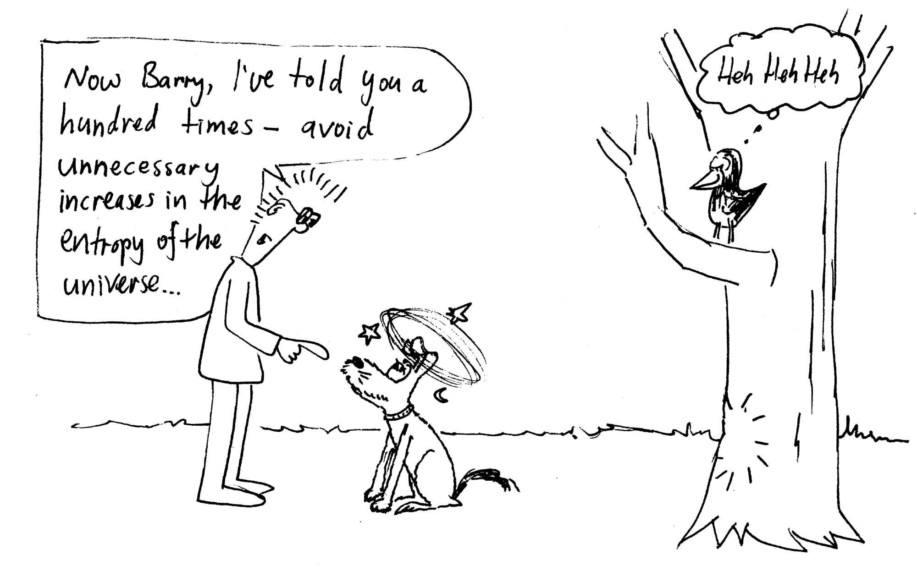
On a warm evening, 27ºC, Rebecca and Brent are sitting outside having a barbeque dinner in their back yard, and watching a magpie swooping Barry the dog. Barry, who weighs 28 kg, is running after the magpie. Unfortunately he isn’t looking where he is going and runs into a tree. Barry bounces off the tree, lands on the ground and comes to a complete stop. Barry had a speed of 8 m.s⁻¹ just before he hit the tree. What is the change in entropy of the universe due to this collision?

