Workshop Tutorials for Physics
TR6: Heat Engines

A. Qualitative Questions:

- We use heat engines all the time. A refrigerator uses a heat engine, as does an air conditioner. A car engine is also a type of heat engine.
  - Draw a schematic energy flow diagram for a heat engine. Label the hot and cold reservoirs. Use arrows to show the transfer of energy Q_{H}, Q_{C} and W.
Consider a car engine.
  - What represents the hot and cold reservoirs, and the transfer of energy Q_{H}, Q_{C} and W?
  - Where in the engine does the cyclic thermodynamic process occur?
  - What is the working substance of the engine?

- With the cost of fuel constantly increasing, it is important that engines be as efficient as possible.
  - What limits the efficiency of an engine?
  - Why are diesel engines more efficient than petrol engines?
  - How could you go about increasing the efficiency of an engine? What drawbacks might this have?

B. Activity Questions:

Stirling engine
Examine the Stirling engine and compare the up and down strokes of the engine to the four stages of the Stirling cycle on the schematic below. Draw p-V diagrams for the four stages.
T_{H}
T_{C}
Q_{H}
T_{H}
T_{C}
gas flow
T_{H}
T_{C}
Q_{C}
T_{H}
T_{C}
gas flow
1. expansion stroke
2. constant volume
3. compression stroke
4. constant volume

Bar Fridge
Inspect the back of the bar fridge.
Identify the heat reservoirs.
Draw an energy flow diagram for fridge.
Could you cool a room by leaving the fridge door open?

C. Quantitative questions.

- Air is mostly a mixture of diatomic oxygen and nitrogen which can be approximated as an ideal gas with γ = 1.40 and C_{v} = 20.8 J.mol⁻¹.K⁻¹. The compression ratio of a diesel engine is 15 to 1; this means that air in the cylinders is compressed to 1/15 of its initial volume.
If the initial pressure is 1.01 × 10⁵ Pa and the initial temperature is 27°C (300K), find
- the final temperature after compression,
- the final pressure after compression.
- How much work does the gas do during the compression if the initial volume of the cylinder is 1.00 L = 1.00 ×10⁻³ m³?

- Brent is making some ice cubes for a cocktail party. He pours 2 litres of water at 15ºC into ice cube trays and puts them in the freezer.
  - How much thermal energy must be removed from the water to freeze it into ice cubes?
Brent’s freezer has a coefficient of performance of 4.8.
  - How much energy does the freezer use to freeze the water?
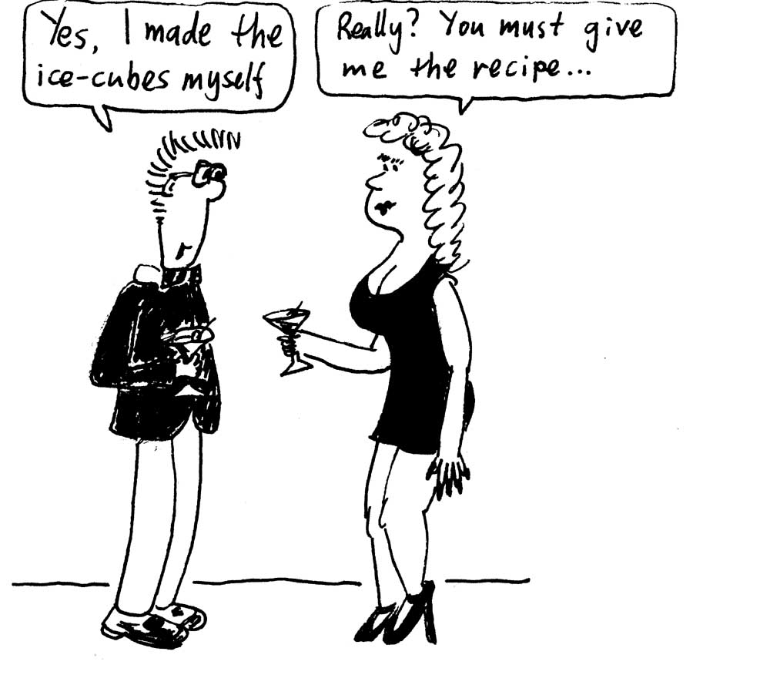
  - Would the freezer make the ice cubes more quickly if the coefficient of performance were larger, say 5.0 instead of 4.8?

data:
R= 8.315 J.mol⁻¹.K⁻¹
density of water = 1 kg.l⁻¹
heat capacity of water = 4.18 kJ.kg⁻¹.K⁻¹
latent heat of freezing = 333.5 kJ.kg⁻¹

