Workshop Tutorials for Physics
TR8: Blackbody Radiation

A. Qualitative Questions:

- Many objects such as hot metals, houses and even people behave at least partly like a black body, and this is useful when looking at the thermal properties of materials and ways to control heating and cooling.
- What is a perfect blackbody?
- What is the emissivity of a perfect black body? What does this mean physically?
- What is the coefficient of absorption of a perfect black body? What does this mean physically?
- Give an example of a good black body. Why is this a good black body?
- Give an example of a poor black body. Why is this a poor black body?

- Consider the design of solar water-heating systems. Visible light from the sun is absorbed by the solar collector.
- What kind of radiation is re-emitted into the surroundings by the solar collector? Explain your answer.
Solar collectors are specially coated to improve their performance. The amount of radiation absorbed or emitted by a collector depends on the wavelength. The properties of one recently discovered coating are shown below.
- Explain why these properties make it a particularly suitable coating.

B. Activity Questions:

1. Thermal radiation – the Leslie Cube
Use the thermopile detector to look at the radiant heat from the different surfaces of the cube.
Which surface radiates the most? Which surface radiates the least?

2. The Black Box
Look into the hole. What colour do you see?
Now open the lid. What colour is the inside of the box?
Why is it so? How can you explain your observation?

- Blackbody radiation
A pencil lead is heated by running a current through it.
Gradually turn up the power passing through the graphite.
What happens as you increase the power?
Explain your observations.

C. Quantitative questions:

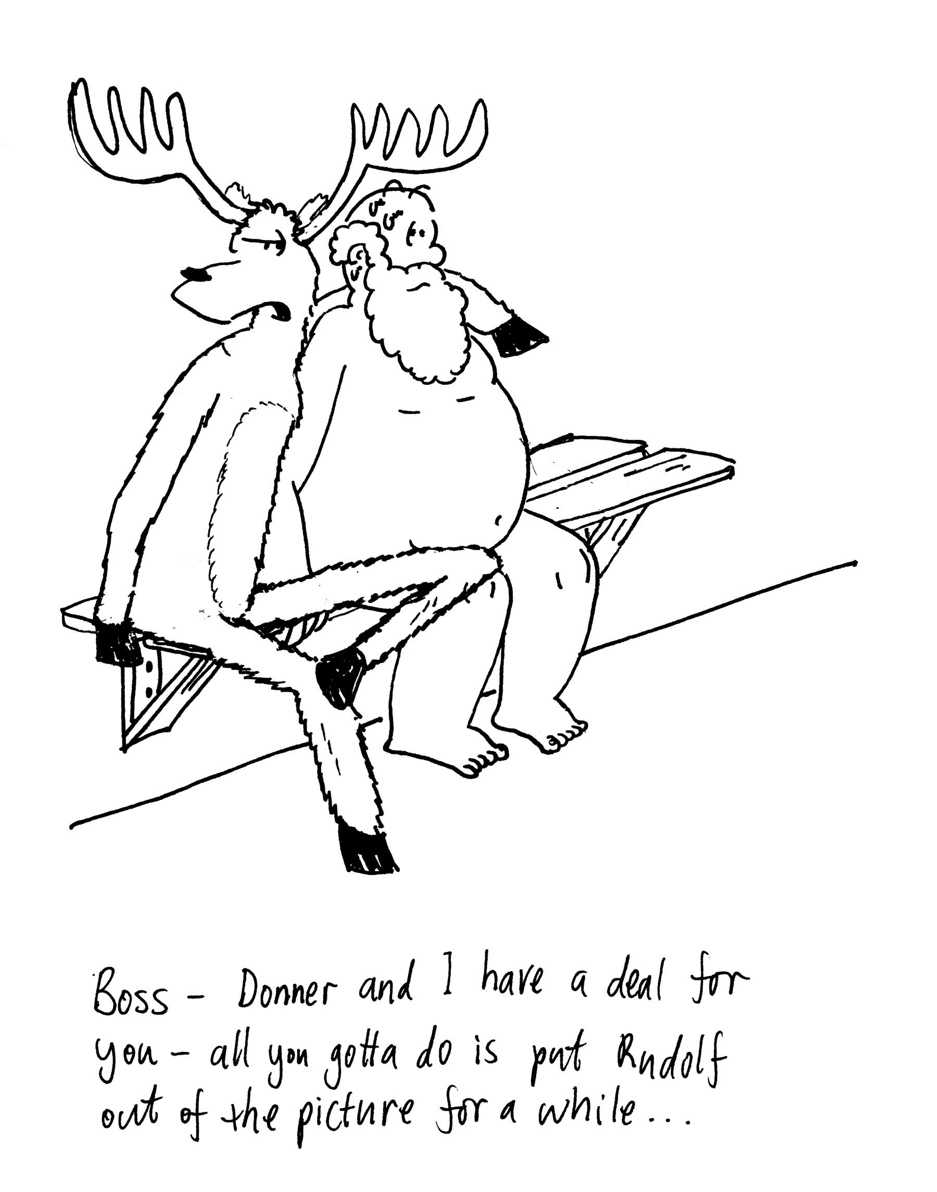
- In Finland saunas were traditionally used as a means of bathing. Now they are a popular form of relaxation. After a hard days work making toys and training reindeer, Santa Claus is sitting naked in his sauna with the temperature of the sauna at 70ºC. Assume that he has a surface area of 1.5 m² and his skin temperature is 37º C.
The emissivity of the human body in the infrared radiation range is close to one irrespective of the pigmentation of the skin, so even though Santa Claus is quite pale, he is a good approximation to a black body in the infrared region, if not in the visible region.
  - Calculate the net radiative rate of heat transfer to Santa Claus.
  - How does his body stop him from overheating and melting?

- Police and emergency workers often wear a bright yellow-green vest, especially when working around roads at night. They wear this colour because it is at or near the wavelength to which our eyes are the most sensitive. It is probably not a coincidence that our sun’s radiation output peaks at the same wavelength, around 550 nm.
- Estimate the surface temperature of the sun.
Cosmologists and astronomers often talk about cosmic background radiation, or the 2.7 K background radiation. This radiation is thought to be the result of the big bang, and it is referred to 2.7 K radiation because this is the temperature of an ideal radiator which emits radiation with the same peak in its distribution.
- What is the peak wavelength of such radiator? (Or, what is the wavelength of the cosmic background radiation?)

