Workshop Tutorials for Introductory Physics
WI1: Simple Harmonic Motion

A. Review of Basic Ideas:

Use the following words to fill in the blanks:
equilibrium, frequency, force, kinetic energy, potential, simple harmonic motion, friction, periodic, proportional, spring, driving, period, amplitude, kinetic, conserved, damped

Periodic Motion
What is periodic motion? The expansion of your lungs as you breathe, the pendulum of a grandfather clock, the back-and-forth motion of pistons in a car engine - all these are examples of motion that repeats itself over and over; ________ motion or oscillation. If the periodic motion is sinusoidal then it is called ______ _______ ________.
A body that undergoes periodic motion always has a stable ______ position. When it is moved away from this position a _____ pulls it back toward equilibrium. But by the time it gets there, it has picked up _____ _____, so it overshoots, stopping somewhere on the other side, and is again pulled back towards equilibrium. This force is ______ to the distance the body has been displaced from its equilibrium position and is written F=-kx. The minus sign tells you that the force is in the opposite direction to the displacement, and is directed towards the equilibrium position. The k is the _______ constant. Two simple examples are spring-mass systems and pendulums.
Oscillatory motion can be described by a _______, which tells you how long it takes per oscillation, and a ______, which is how many oscillations per second. The size of the oscillations is described by the _______.
When a mass on a spring oscillates it has _______ energy and elastic _______ energy and gravitational potential energy. The total energy is the sum of these and is _______. However, we know that if we start a spring oscillating, it will eventually stop, because of ______. This is known as ______ simple harmonic motion. To keep the spring oscillating we need to provide a _______force.

Discussion questions
Explain how a child on a swing fits the description of damped simple harmonic motion.
What do you need to do to keep the child swinging?

B. Activity Questions:

- Oscillations of a spring-mass system
Two identical objects are attached to identical springs
If the mass of one of the objects is increased will there be any difference in the periods of the two systems? Explain your answer.
If one of the springs is replaced with one with a larger spring constant, how will this affect the period of oscillation?
If one spring is stretched more than the other, will the periods be the same?

2. Damped oscillations
Observe the oscillation of the spring when the attached object is immersed in water.
Draw displacement-time graphs for oscillations of the object in air and in water.
Investigate the damping of your knee joint by sitting on the edge of a bench and allowing it to swing freely.

3. Charting pendulum motion
Swing the pendulum so that it draws a line on the moving paper.
How would you describe the shape of the trace that it produces?
Write an equation to describe the trace drawn. Define all the symbols that you use.

C. Qualitative Questions:

- Imagine you have a spring and you cut it into two pieces, one a third the length of the original spring and one two thirds the length of the original.
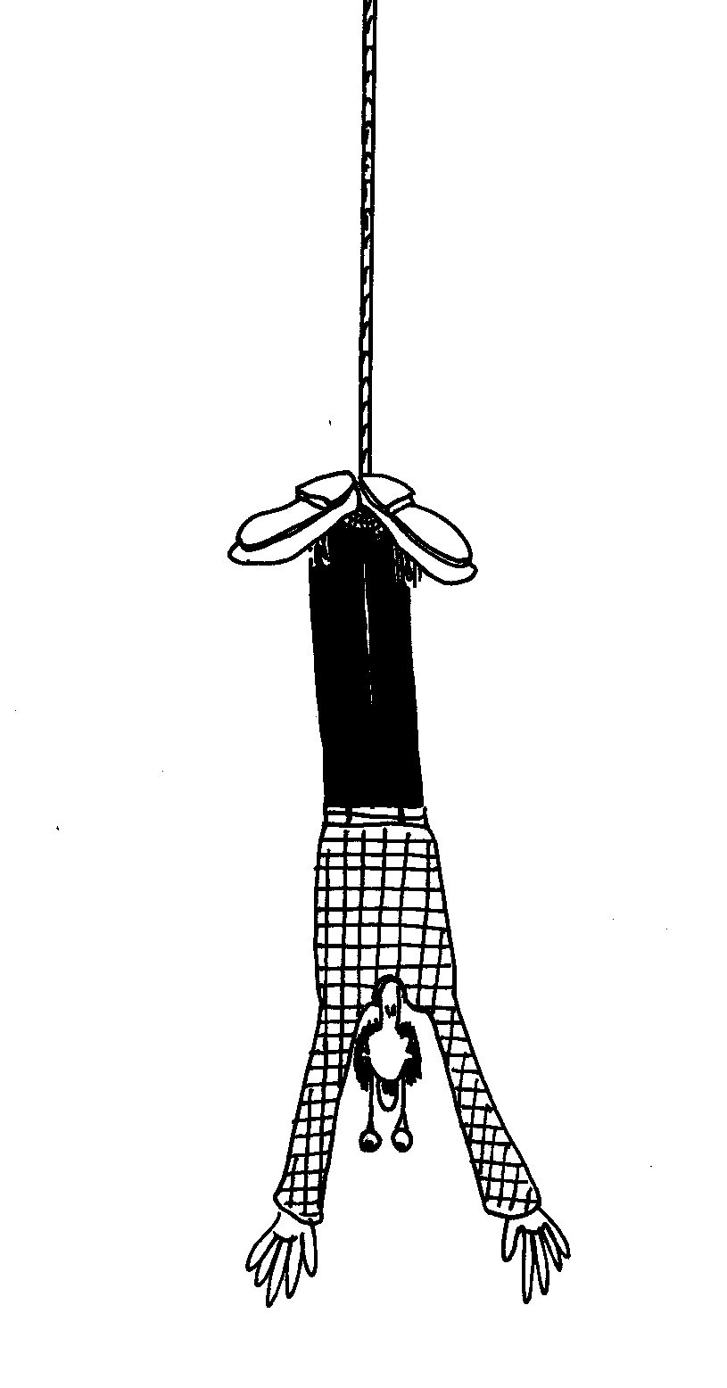
- If you attach equal masses to each new spring, will the extension be the same for each spring? If not, will it be greater for the shorter or longer spring?
- What can you say about the spring constants of the two new springs?

- Bungy jumping is an increasingly popular sport, with a growing clientele of “adrenalin junkies” and an increasing number of facilities around the world.
- Plot a graph with displacement on the vertical axis and time on the horizontal axis for a bungee jump. Zero displacement corresponds to your final equilibrium position.
- Mark on your graph the region which is approximately simple harmonic motion.
- Mark on your graph the period and positions of maximum speed, zero speed, maximum acceleration and zero acceleration.
- Do you momentarily stop at any position?
- Some people’s retinas become detached when they bungy jump. When is this most likely to happen?

D. Quantitative Question:

- A bungy fish is a toy made out of balloons. It consists of a small balloon filled with sand which is wrapped in many layers of balloons to make a fish shape, and attached to a bungy cord also made out of balloons. A 100 g blue bungy fish is bobbing up and down with amplitude 6 cm and frequency 1 Hz. At time t = 0, when you first observe the bungy fish, it has a displacement of +6 cm from its equilibrium position.
- What is the angular frequency of the bungy fish?
- Write down a formula giving the displacement of the bungy fish as a function of time.
- Where is the bungy fish at time t = 1 s?
- Where is the bungy fish at time t = 0.1 s?
- What is the force constant of the bungy cord?

