Workshop Tutorials for Introductory Physics
Solutions to WI6: Reflection and Refraction

A. Review of Basic Ideas:

Reflection and Refraction of Light
When you look into the surface of a swimming pool, often you can see both the bottom of the pool and your own reflection. When light hits any surface, in this case the surface of the water, there is usually some light reflected, some light absorbed and some which is transmitted into the underlying medium. To see your reflection, light refelcted from you must have bounced or reflected off the surface. To see the bottom of the pool some light has travelled through the air-water interface to the bottom of the pool where again some light is reflected and the rest absorbed. The reflected light then passes back up through the water – air interface and into your eyes.
You may also have noticed that swimming pools always look shallower than they really are. To understand why this is we use the laws of reflection and refraction of light and we model light as rays travelling in straight lines. Imagine a line perpendicular to the water-air interface at the point of incidence of the incoming ray. The angle between the perpendicular and the incident ray (the angle of incidence) and the angle between the perpendicular and the reflected ray (the angle of reflection) are equal. This is the law of reflection.
The law of refraction, which tells us how light bends as it moves from one medium to another, is defined in terms of a quantity known as the refractive index.
incident ray
reflected ray
transmitted ray
θ₁
θ₂
n₁
n₂
The refractive index of a material depends on the speed of light in that material. It is the ratio of the speed of light in a vacuum to the speed of light in the medium and so is always greater than 1. Once again imagine a line perpendicular to the water-air interface at the point of incidence of the incoming ray. The angle of incidence, θ₁, is the angle between the incident ray and the perpendicular. The angle of refraction, θ₂, is the angle between the perpendicular and the refracted ray in the new medium (water in this case). Call the air medium 1, with refractive index n₁ and water medium 2 with refracrive index n₂. The law of refraction states that n₁sinθ₁ = n₂sinθ₂. The greater the ratio of n₂ to n₁, the more the light will bend when it enters medium 2.

B. Activity Questions:
rainbow
white light

Prism
When light moves from air into the prism the light is refracted or bent, and it is bent again as it leaves the prism. The prism has a refractive index which varies for different wavelengths. The refractive index is greater for shorter wavelengths, and hence the blue component of the incident white light bends more than the red component.  This is how rainbows are produced, the raindrops act as prisms, but the light doesn’t just pass through the drops, it is reflected off the back surface of the drop and comes out the front separated into different wavelengths. | white  blue  red
actual position of pencil tip
apparent position of pencil tip

Bent pencil
The light from the pencil is refracted when it passes from the water into air, bending away from the normal as it moves from high to low refractive index. The light coming from the pencil tip appears to be coming from the apparent pencil tip as shown opposite.

Losing your marbles
The refractive index of the marbles and the liquid is the same, so light passing through the beaker will not be bent as it moves from water to marble to water again. If the marbles are transparent, they will be invisible in the liquid.

Total internal reflection
θ_{i}
The light ray that enters the cable is totally internally reflected provided the incident angle, θ_{i}, is greater than the critical angle. Light is trapped inside the cable and almost none gets out the sides.

C. Qualitative Questions:
actual position of fish
apparent
position of fish
- Light travelling from one medium into another is bent or refracted. When the medium it is entering has a higher refractive index than the one it is leaving, it is bent away from the normal to the surface. Water has a higher refractive index than air, so this is what happens when light reflects off a fish, passes through the water’s surface and into your eye. The apparent position of the fish is closer than its actual position, and the ratio of the apparent depth to the actual depth is equal to the ration of the refractive indices; d_{apparent} / d_{actual}.= n_{air} / n_{water.}

- The Earth is surrounded by the atmosphere, which extends a few hundred kilometres into space. When a ray of light enters the atmosphere it is refracted, or bent, by the atmosphere.
When light travels from a medium with lower refractive index to one with higher refractive index the light is bent towards the normal to the surface of the new medium. See diagram opposite. When the sun is below the physical horizon, it may still be visible because the light it emitts is refracted, so its apparent position is above the horizon. | earth  apparent position of sun  atmosphere
actual position of sun

D. Quantitative Question:

It is a calm clear day and the surface of the water is perfectly smooth. Refractive index of water is 1.33.
- The critical angle for the air water interface can be found using Snell’s law: n₁sinθ₁ = n₂sinθ₂. The critical angle is when total internal reflection occurs, ie the fish would only see a reflection from the surface of the water, and not anything outside the water. This occurs when θ₁ = 90º, so:
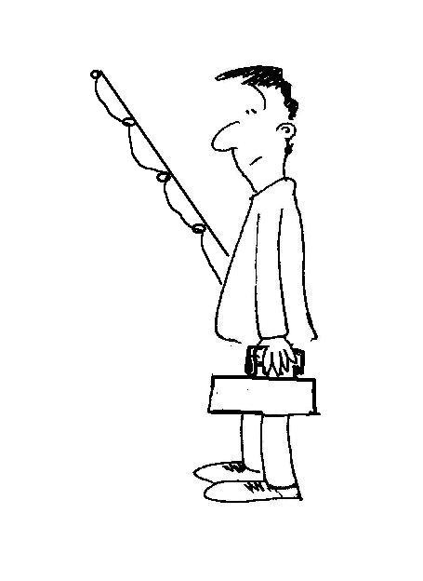
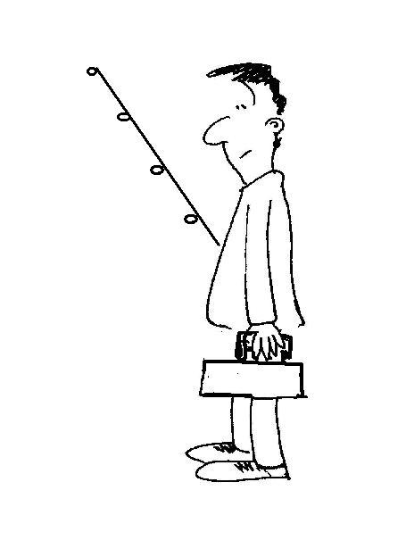
n₁sinθ₁ = n₂sinθ₂, or 1× sin(90º) = 1.33 × sinθ₂, which gives sinθ₂ = 1/1.33, and θ₂ = 49º. Any rays with incident angle greater than 49º never make it to the fish.
actual light path
fisherman
perceived position of fisherman
bird
perceived position
of bird
actual light path
perceived light paths
- See diagram. Light coming from the bird and the fisherman is diffracted, or bent, making them appear higher up and further away than they actually are. Some fish, such as angler fish, allow for this effect. Angler fish can accurately spit a stream of water at an insect a few feet above the water, allowing for diffraction.

