Workshop Tutorials for Introductory Physics
Solutions to WI7: Lenses and Mirrors

A. Review of Basic Ideas:

Seeing clearly - glasses, telescopes and microscope
Most people will need glasses at some time in their life. Why do we need glasses and what do they do?
The eye is a special optical instrument. The front of the eye acts as a lens and bends light as it passes through it. This way an image of the object we are viewing is formed on the retina. Think about one letter of the print in front of you. Light enters your eye from each part of the letter. Your eye bends the light so that all the light from one point on the letter is focused onto one point of the retina. The light from each part of the letter is thus focused on the retina and an image of the letter is formed.
Why do we need glasses? Because often the inbuilt lens in our eye cannot bend the light exactly the right amount to form a sharp image on the retina. If you are longsighted you can’t see objects that are close to you. Light rays from a close object have a larger angle cone of light and hence need to be bent more to focus on the retina. If your eye cannot bend the light enough you need a lens that converges the light rays. The power of the lens, or its ability to focus, is related to the focal length of the lens, which depends on the curvature of the sides of the lens and the material from which it is made.
Short sighted people have the opposite problem – their eyes bend the light too much and they have trouble seeing things a long way off.
So long sighted people need converging (convex) lenses, while short sighted people need diverging (concave) lenses.
Optical instruments, such as microscopes and telescopes, have a series of lenses usually with the aim of providing a magnified image of the original object. For instance a telescope gives a magnified image of distant stars, while a microscope gives a magnified image of a very small object that is quite close. The image may be real as in a slide projector, or virtual as in a magnifying glass. In a projector light actually passes through the image and it is projected on a screen. A virtual image is one where the light only appears to come from the image. A good example of a virtual image is the enlarged image you see through a magnifying glass. Light is bent as it passes through the magnifying glass to your eye so that it appears to have come from an enlarged image but the path of the light is just from the print through the lens to your eye. The image is a virtual one.

Discussion Question:
Corrective lenses for shortsightedness (myopia) are diverging or concave lenses. Diverging lenses form a virtual image behind the lens, and hence cannot be used to focus light at a point to start a fire. Piggy and his friends should not have been able to cook, or Piggy must have been long sighted.

B. Activity Questions:
convex
concave

1. Lenses – concave and convex
Convex lenses are converging lenses, and concave lenses are diverging lenses. See diagram opposite.

2. Lenses – finding the focal length of a convex lens
Hold the lens up to the window and hold a piece of paper behind it (on the other side of the lens from the window). Move the paper until you get a sharp image of the world outside the windows (or distant object such as a tree). When you have a sharp image, you measure the distance between the lens and the image (paper). This distance is the focal length of the lens.
(Using $\frac{1}{f}=\frac{1}{o}+\frac{1}{i}$, and o = ∞ so that $\frac{1}{o}$ = 0, gives f = i )

3. Half a lens
When you cover half the lens you get a fainter image. Effectively you are cutting out half the light rays, but they still produce an entire image.
object
image
object
image
complete lens – bright image
half covered lens – faint image

4. Right angled mirrors
Look at your image in the mirror.
The right angled mirror does not reverse your reflection, so when you move your hand left, you see it move to the left in your reflection. In a single mirror, left and right are reversed.

C. Qualitative Questions:
1. You want to buy a mirror but you don’t want to spend a lot of money getting a bigger mirror than you actually need.
- The angle of reflection is equal to the angle of incidence, so a ray coming from your toes to your eyes reflects off the mirror at half your height. The lower half of a full length mirror only shows the floor. A mirror only needs to be half your height, so you can see all of yourself, plus a little bit to allow for your eye height being a little less than your full height.
- The mirror should be mounted so that the top is level with the top of your head.
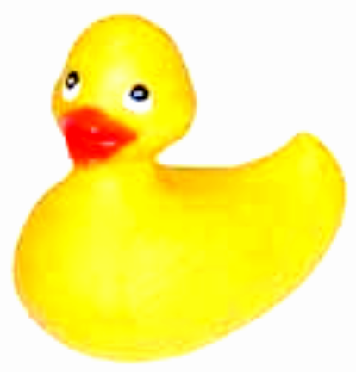

- In your reflection left and right seem to be reversed, but not up and down. This is because of the way we define left and right as relative to ourselves, not our surroundings. For example, “towards the wall” and “away from the wall” are not reversed, just as up and down are not reversed. Up and down are defined externally, usually relative to the ground. It is important to know how your coordinate systems are defined, and whether they change as you move!
f
o
i

2. See diagram opposite. The image produced is real, inverted and magnified.

D. Quantitative Question:

Optometrists write prescriptions with the lens strength measured in diopters, D. A diopter is the reciprocal of the focal length; D = 1/f. A pair of glasses has lenses with strength 1.5 D.
- The lens has a strength of 1.5 diopter, so it has a focal length of 1/1.5 = 0.66m.  - Using $\frac{1}{f}=\frac{1}{o}+\frac{1}{i}$ where f = 0.66 m and o = 1 m, we get an image distance of 2 m.  - This is a real image, if you put a screen where it appears to be, there would be light on the screen. | f  1 m  2 m

