Workshop Tutorials for Physics
WR5: Electromagnetic Waves

A. Qualitative Questions:

- Rebecca and Brent are sitting inside watching TV one evening when Brent notices a lightning flash. A few moments later they hear a peal of thunder. Brent says they’d better go bring the washing in off the line because there’s a storm coming. Rebecca’s says to wait until the next ad’ break. “hmm…” say’s Brent, as he listens to the next peal of thunder, “that storm is getting pretty close, the thunder was only a second after the lightning”.
“How can you tell?” asks Rebecca, as the first drops of rain start to fall…
How can Brent tell that the storm is getting closer? Explain your answer.

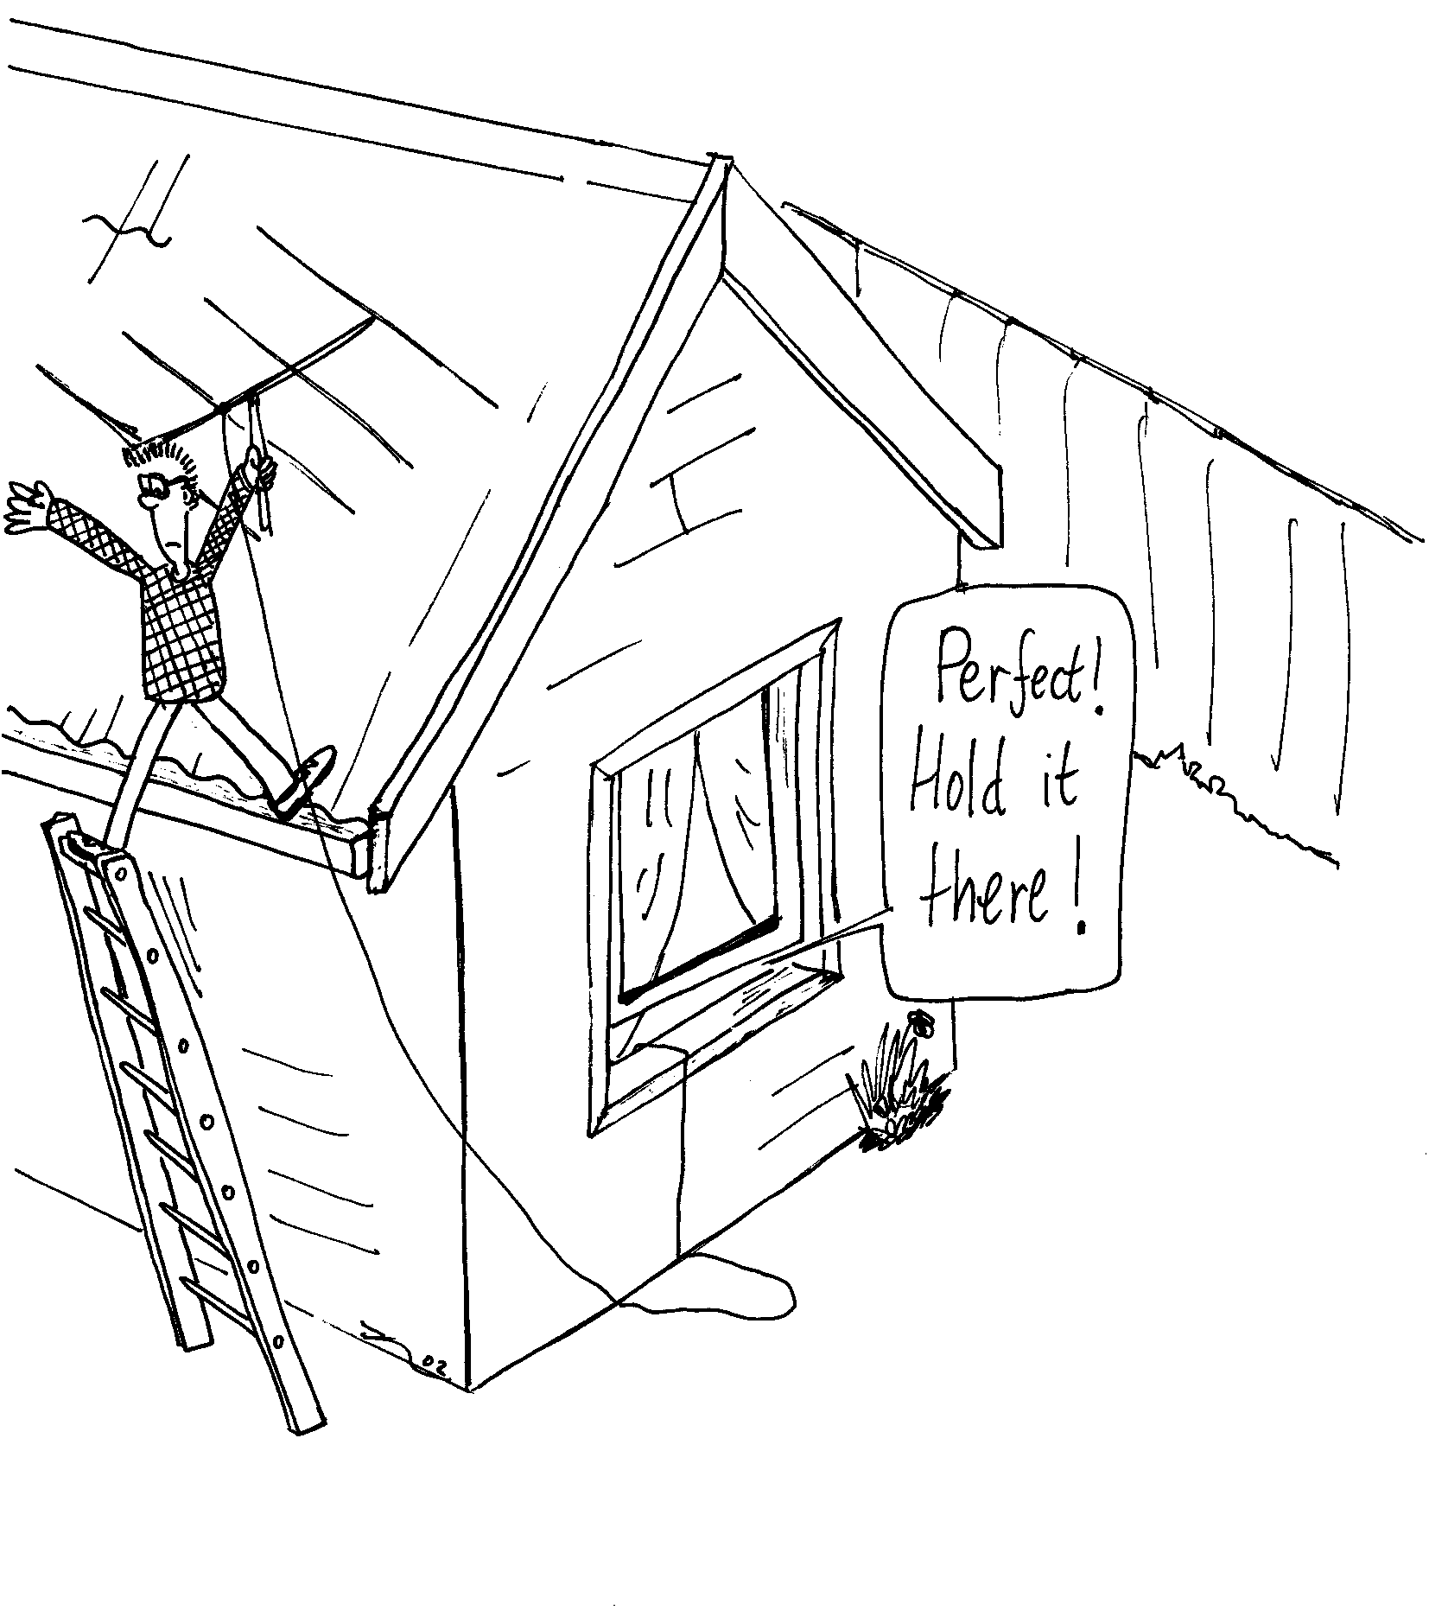
- Brent and Rebecca have bought a new TV antenna because their old one was blown off the roof in a storm. Brent is up on the roof putting up the antenna while Rebecca looks at the TV to see when the reception is the best.
It doesn’t seem to make much difference which way Brent angles it, so Rebecca goes out to see what he’s doing. She looks up and calls “Brent! You’ve set it up the wrong way! The bars should be horizontal!”
Why would it matter which way the bars of the antenna go? Draw a diagram to help explain your answer.

B. Activity Questions:

Speed of Light
Microwave the marshmallows to find the speed of light!
Read the frequency of the microwave radiation produced from the back of the microwave.
Microwave the marshmallows, watching carefully, and stopping the oven when they first begin to melt.
Measure the distance between melted bits to find the wavelength, and use this to calculate the speed of light.
Warning – very hot! Do not touch the molten marshmallows!

Prism
Shine the light through the prism.
What do you see going into the prism?
What do you see coming out?
Which is refracted (bends) more – light of long or short wavelength?

Sunset in a jar
Look at the light transmitted through the top of the beaker.
What do you notice about its colour?
What do you notice about the light coming out the sides of the beaker?
Explain the difference in these colours.
Explain why the sky on Earth is blue. What colour do you think the sky is on Mars? Why?

Polaroid glasses
Examine the glasses. How can you tell which ones are polaroid?
Which way are the lenses polarized? Why do you think they are polarised this way?

Stress lines
Examine the stressed perspex between the sheets of polaroid.
What happens when you increase the stress?
If someone in your group wears glasses, ask them to let you see them between the sheets of polaroid.
Can you see stress lines in the glasses?
Can you think of a use for this effect?

C. Quantitative Question:

- FM radio stations broadcast signals which have frequencies in MHz, for example 106.5MHz.
- Find the wavelength of the signal broadcast by this station.
AM radio stations broadcast in the “medium wave” range, which is much lower frequency than FM stations.
- Which radio station in Sydney broadcasts a signal with a wavelength of 521m?
There are two ways in which radio stations transmit signals to your car radio – one is AM or amplitude modulation, the other is FM or frequency modulation.
- Draw a diagram showing the difference between amplitude modulated and frequency modulated waves.

- The refractive indices for ordinary and extraordinary waves traveling at right angles to the optic axis in quartz are n_{o} = 1.544 and n_{e} = 1.553. A quarter wave plate is one for which the two waves get exactly one quarter of a wavelength out of step after passing through it.
- What is the thickness of the thinnest possible quarter wave plate for a wavelength of 600nm?
- Will such a quarter wave plate be thicker or thinner for light of wavelength 500nm?

