Workshop Tutorials for Physics
WR7: Mirrors

A. Qualitative Questions:

1. You want to buy a mirror to put in the inside of your closet door so you can check how you look in the morning before setting off to uni, but you don’t want to spend a lot of money getting a bigger mirror than you actually need.
- How big a mirror would you need to just be able to see yourself from top to toe?
- At what height should the mirror be mounted?
- Why are left and right reversed in a mirror but not up and down? Draw a ray diagram showing why your reflection is reversed in a mirror.

2. Dish antennas, whether for satellite TV reception, radar signals or radio-telescopes, have a particular shape.
- Describe this shape and explain why it is used. Use a ray diagram to explain your answer.
- What assumptions have you made about the object (the source of the signal) in your answer to a? Justify these assumptions.

B. Activity Questions:

Curved mirrors
Examine the reflections in the mirrors.
Which ones are concave, and which are convex?
How can you tell?

Shaving Mirror
Look at your reflection in the shaving mirror.
What do you notice about the reflection?
Examine the mirror closely.
What can you say about the shape of the mirror?

Right angled mirrors
Look at your image in the mirror.
What do you notice when you move your hands?
How is this different to a single mirror?
Draw a ray diagram showing the path of a light ray from your hand to your eye.

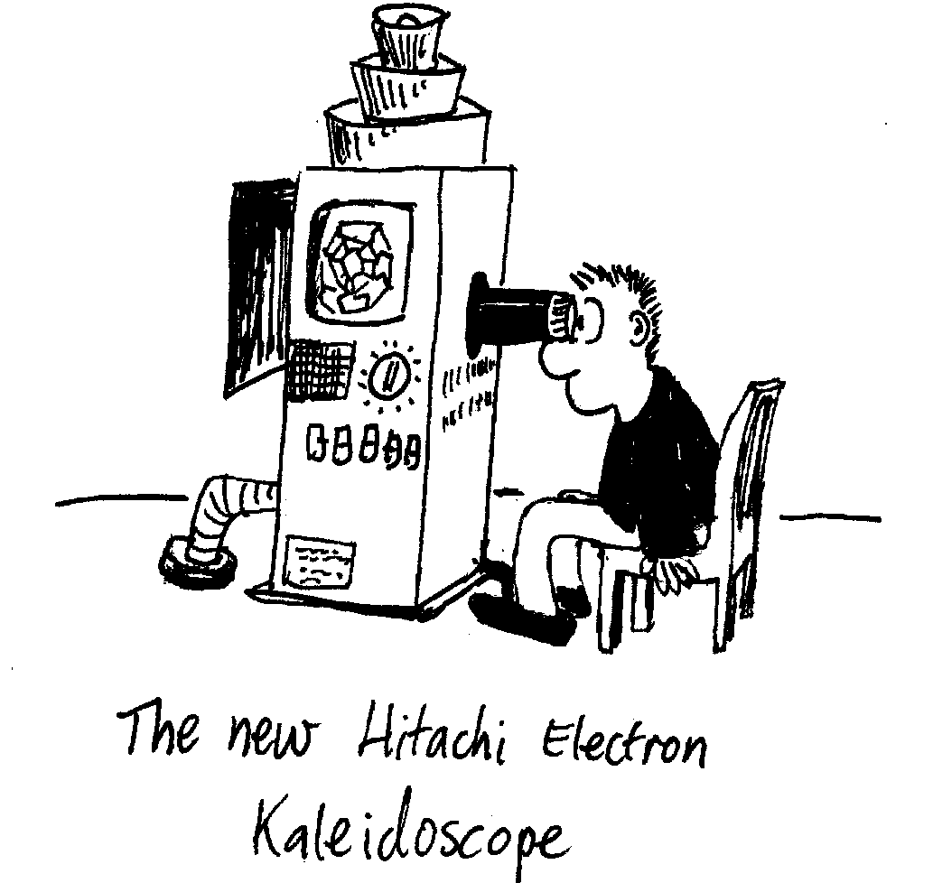
Kaleidoscope
Examine the different kaleidoscopes.
How do the images seen through them differ?

C. Quantitative Questions:

  - Some car side mirrors have a warning on them that says :”Caution: objects in mirrors may appear further away than they are”.
- Are these car mirrors concave or convex?
- Is the image from these mirrors real or virtual?
A spherical convex driving mirror in a car has a radius of curvature of 1.5 m. The driver looks in the mirror and sees the car behind. The car behind is 1.5 m high, and is 13 m away from the mirror.
- Draw a ray diagram showing the object, the mirror and the image.
- Where will the image be?
- What sort of image is this?
- How big is the image?

  - A concave shaving mirror has a focal length of 450 mm.
- How far away from your face should you hold it for the reflected image to be upright and twice the size of your actual face? Draw a ray diagram
- How far away should you hold the mirror from your face to get an image 500 mm from the mirror which is real?
- How far away should you hold the mirror from your face to get an image 500 mm from the mirror which is virtual?

