Workshop Tutorials for Physics
WR9: Optical Instruments

A. Qualitative Questions:

- Why do you think the resolving power of an instrument depends on the wavelength of radiation being used in the instrument? Would it be easier to resolve two red sources or two blue sources?

- When discussing the ability of an optical instrument to aid our ability to see we discuss the angular magnification of the instrument. Why do we talk about angular magnification rather than actual sizes of objects and images?

B. Activity Questions:

Magnifying glass
Explain how the magnifying glass works.
Draw a ray diagram showing the path of a light ray from the object to your eye.
What sort of image is produced?
What sort of lens does a magnifying glass use?

Thumb in your eye
Hold your thumb at arms length and look at it.
How can you work out the angle subtended at your eye by your thumb?
What does this tell you about the resolving power of the eye?

Microscope
Use the microscope to look at a small object.
Describe how the microscope works.
What is the difference between a simple and a compound microscope?

Telescopes
Look at the diagrams shown.
What sort of telescopes are these? Explain how they work.
Now examine the telescope on display, and use it to view a distant object out the window.
What sort of telescope is this?
objective mirror
secondary mirror
objective lens
eyepiece lens

C. Quantitative Questions:

1. A compound microscope has an objective lens of focal length 5 mm. The ocular (eyepiece) lens has a focal length of 4 cm. The lenses are separated by a distance of 24.5 cm.
- Where should an object be placed so that the final image is formed at infinity?
- What is the magnification produced by the objective lens?
- What is the magnification produced by the ocular lens?
- What is the total magnification of the microscope?

2. Brent has bought a kit to make himself a telescope so he can look at the stars and moon. Astronomical telescopes use two lenses to form an image of distant objects, such as stars.
- Explain with the aid of a diagram how Brent should arrange the two lenses to form an astronomical telescope.
- What factors determine the magnifying power of the telescope?
The moon is about 3.8 × 10⁵ km away from the earth and has a diameter of 3.16 × 10³ km.
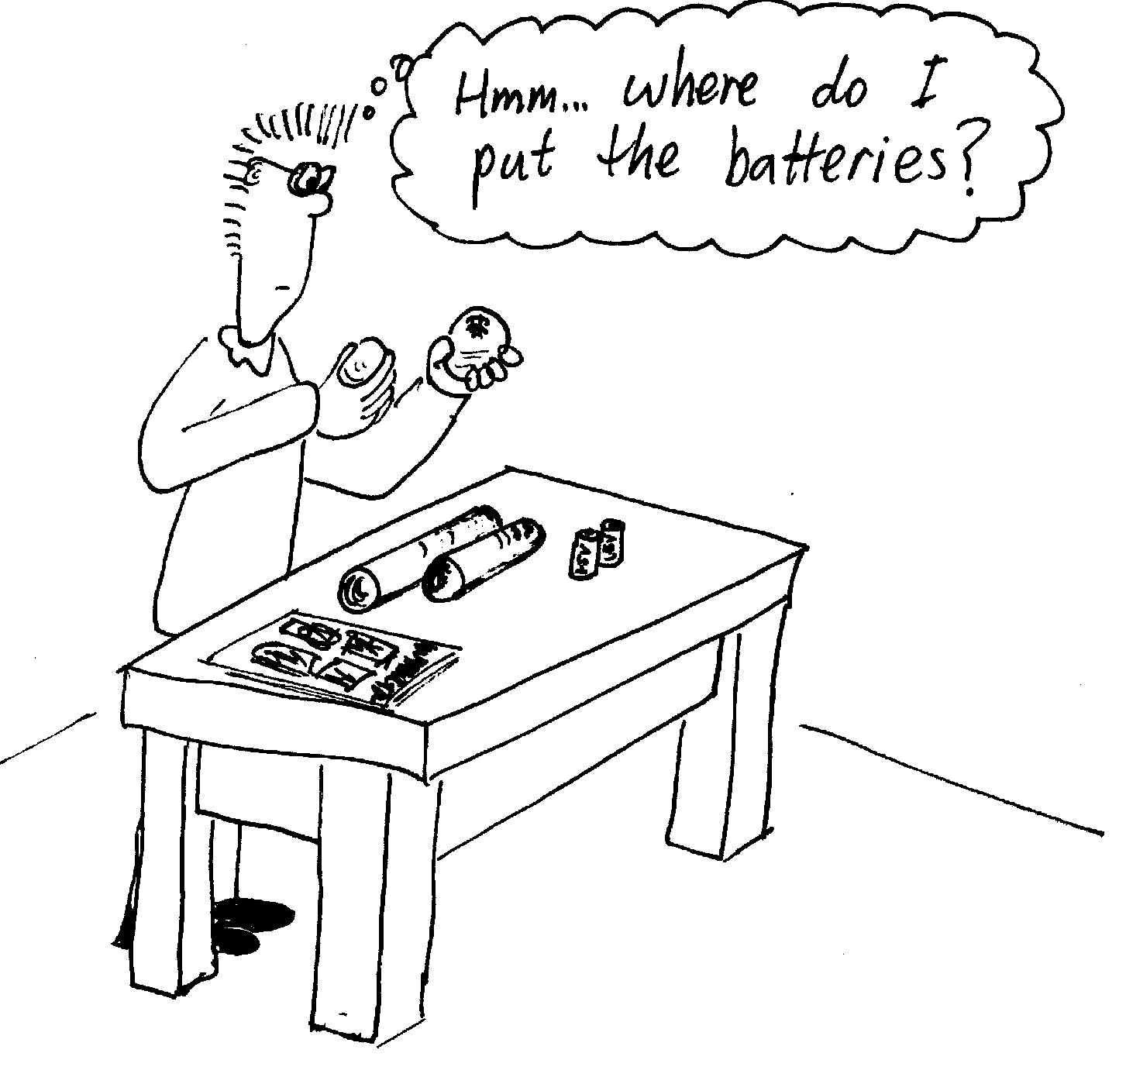
- What will be the diameter of the real image of the moon formed by an objective lens with a focal length of 16 m?

