Properties of Matter Activities

Activity | used in workshops:
Archimedes and the  King’s Crown | PI2 | 69
Ball in an Air Jet | PR3B, PR3T | 70
Bend and Stretch | PI5, PR7 | 71
Blowing and Lifting | PI3, PR3B, PR3T | 72
Breaking Chalk | PI4, PR6B, PR6T | 73
Buoyant Force I | PI2, PR2B, PR2T | 74
Buoyant Force II | PI2, PR2B, PR2T | 75
Capillarity | PR5B, PR5T | 76
Cartesian Diver | PI2, PR2B, PR2T | 77
Chimney Effect | PI3, PR3B, PR3T | 78
Crystal Structures | PI5, PR7 | 79
Elasticity – Bouncy Balls | PR6B, PR6T | 80
Hollow Tube and Disc | PI1, PR1B, PR1T | 81
Hot Honey | PI3, PR4B, PR4T | 82
Hydrometers | PI2, PR2B, PR2T | 83
Hydrostatic Paradox | PI1, PR1B, PR1T | 84
Lenard-Jones Potential | PI5, PR7 | 85
Lungs | PR1B | 86
Measuring Fluid Flow | PR4B, PR4T | 87
Pascal’s Vases | PR1T | 88
Rheological Materials | PR4B, PR4T | 89
Rolling Paper | PR6B, PR6T | 90
Rubber Bands | PI4, PR6B, PR6T | 91
Soap Films | PR5B, PR5T | 92
Shoes | PI4, PR6B, PR6T | 93
Squirting | PI1, PR1B, PR1T | 94
Suction Cups and  Magdeburg Plates | PI1, PR1B, PR1T | 95
Surface Tension I - Floating | PR5B, PR5T | 96
Surface Tension II - Detergent | PR5B, PR5T | 97
Surface Tension III - Paintbrush | PR5B, PR5T | 98
Two Sheets of Paper | PI3, PR3B, PR3T | 99

Archimedes and the King’s Crown

Apparatus
a crown, made of metal or some other material (clay, play dough) and painted with metallic paint, a large measuring cylinder, a weighing scale, a table of densities, including gold and the material the crown is made from
Paper towels etc for clean up.

Action
The students weigh the crown with the scales. They immerse the crown in the measuring cylinder, and measure the increase in volume due to the crown. They then use the mass and volume to calculate the density of the crown, and compare this to the value given for gold.

The Physics
A fully immersed object displaces its own volume of fluid. The mass divided by the volume gives the density.

Accompanying sheet

Archimedes and the King’s Crown

Use the equipment to find the density of the crown.

Do you have a gold crown in your hands?
If not, what is it made of?

Ball in an Air Jet

Apparatus
light ball, such as a ping-pong ball, or beach ball for large air jets.
air pump, to supply air jet

Action
the students position the ball in the air jet so that it stays there, and explain why this is possible.

The Physics
The air jet has a velocity profile with the air in the middle having greater velocities than the air near the edges. So if the ball is balanced in the air jet as shown, v₁ > v₂ and P₁< P₂. This pressure difference results in a 'lift' force up which is equal and opposite to the weight of the ball.

high v
low v
low v

v₂, P₂
v₁, P₁

Accompanying sheet

Ball in an Air Jet

Balance the ball so it stays in the jet.
It should balance with the air jet pointing straight up or at an angle.

Why does it stay there instead of falling down or being blown away?

Bend and Stretch

Apparatus
box of chalk, strips or rods of metal, length of rubber hose.

Action
The students attempt to bend and break the materials using bending, tension, compression, shear forces.

The Physics
Most materials are better able to withstand compressive and tension forces than shearing or torsional forces. Metal is more plastic than chalk, and hence will bend before it breaks. However the yield strength is much less than the ultimate strength, so the metal will permanently deform well before it breaks. The rubber has a high yield strength, and the ultimate strength is similar to the yield strength, so the rubber will “bounce back” as long as it isn’t ruptured.

Accompanying sheet

Bend and Stretch

Bend, twist, compress and stretch the different materials.

Which ones break by bending? Which ones break by twisting?
What about stretching and compressing?
Which ones bend and which ones stretch?

What can you say about the yield strength, Young’s modulus
and ultimate strengths of these materials?

Blowing and Lifting

Apparatus
polystyrene block or light cardboard sheet with rod (nail) through the middle, air blower, tube

Action
The students lift the block by blowing the air down the tube over the block. The nail or rod allows them to locate the tube over the block. They should explain why blowing on the block lifts it, instead of pushing it down.

The Physics
The high velocity air flowing over the upper surface of the block is at lower pressure than the air below which is at atmospheric pressure, so the block lifts. This is an application of Bernoulli’s principle.

tube
block with rod
high velocity, low pressure
block lifts

Accompanying sheet

Blowing and Lifting

Lift the foam block by blowing down into the hollow tube above it.

How is this possible?

Why isn’t the block blown away from the tube?

Breaking Chalk

Apparatus
box of chalk

Action.
The students attempt to break the chalk by compressing it, stretching it, bending it and twisting it. They should comment on the strength of the chalk to withstand different types of applied force.

The Physics
Most materials are better able to withstand compressive and tension forces than shearing or torsional forces. This is the reason bones are generally broken due to twisting or bending, and very rarely due to compression.
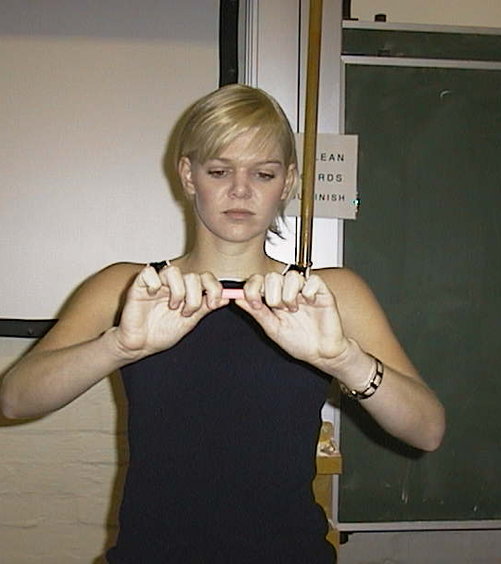
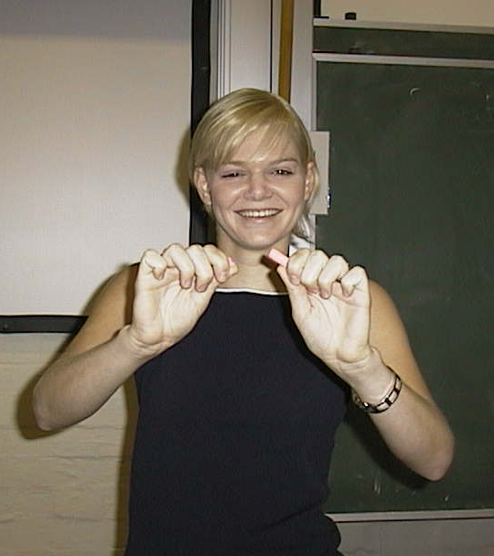

Hannah (University of Sydney) discovers that chalk is weak to bending forces.

Accompanying sheet

Breaking Chalk

Try to break the chalk by compressing it.
Can you break it by stretching it?

What about bending or twisting?

How do you think most bone fractures occur?

Buoyant Force I

Apparatus
An object (preferably dense, e.g. a metal weight) suspended from a spring balance.
A container of water.

Action
The students compare the weight of the metal weight using the spring balance when the metal weight is in air and when it is submerged in water. They should explain why the readings on the spring balance are different.

The Physics
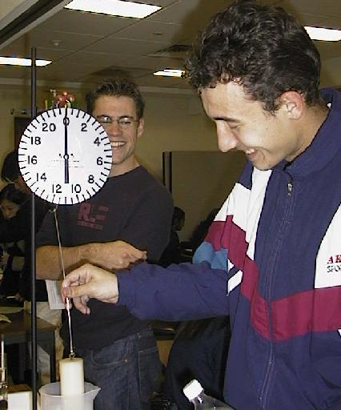
The object will weigh less in water than air because water is more dense than air and hence the buoyant force is greater. In both cases F_{B} + T = mg, and the scale measures the tension, T. F_{B} is greater in water, hence T is less.

Students at the University of Sydney measuring the buoyant force on an object.

Accompanying sheet

Buoyant Force I

An object is suspended from a spring balance.

What happens to the reading on the spring balance
when the cylinder is immersed in water? Why?

Draw a diagram showing the forces acting on the object.

Buoyant Force II

Apparatus
an object (preferably dense, e.g. a metal weight) suspended from a spring balance, a container of water, a weighing scale (for example a set of kitchen scales)

Action
A container of water is placed on a weighing scale. A metal weight, suspended from a spring balance, is immersed in the container of water. The students explain why the reading changes on both sets of scales.

The Physics
The cylinder will weigh less in water than air because water is more dense than air and hence the buoyant force is greater. In both cases F_{B} + T = mg, and the scale measures the tension, T. F_{B} is greater in water, hence T is less.
The container will weigh more with the cylinder in it because even though the block is not resting on the bottom, it has raised the level of water, hence increased the pressure at the bottom and increased the weight of the container.

Accompanying sheet

Buoyant Force II

An object is suspended from a spring balance.
What happens to the reading when the object is immersed in water? Why?

A container of water is placed on a weighing scale.
The object, suspended from the spring balance, is immersed in the water.

What happens to the reading on the scale? Why?

Capillarity

Apparatus
capillary tubes with different diameters, container of water with dye, two small glass sheets or a pair of glass petrie dishes, perspex sheets or petrie dishes

Action.
The students hold the tubes with one end in the container of coloured water and observe how high it rises in the different tubes. They should also note the shape of the meniscus. Different fluids can also be used.
The pairs of plates are held close together and dipped into the water. The petrie dishes can be held so that the bottoms of the two dishes are together and the dipped into the water. The students should observe how the water rises between the different materials. As an interesting extension a paperclip or lump of blu-tack can be used to slightly separate one side of a pair of plates. When the bottom is dipped into the water it will rise to a height depending on the separation and form a curve.

The Physics
Water molecules are attracted to glass more than to each other. When the glass tubes are dipped in water the adhesion between the glass and water causes a thin film of water to be drawn up over the glass (a). Surface tension causes this film to contract (b). The film on the inner surface continues to contract, raising water with it until the weight of the water is balanced by the adhesive force (c). The smaller the tube, the greater the height to which the water will rise.
a
c
b

Water does not adhere to perspex, hence it will not rise between perspex plates, but water will rise between glass plates. If you hold a pair of plates together at one end and slightly apart at the other then the distance, r, between them increases as you move from the closed side to the open side. If you dip this into water it will rise between the plates to a height, h, proportional to $\frac{1}{r}$, giving a neat hyperbola ($\frac{1}{r}$ curve). | closed  end  open  end  r  h

Accompanying sheet

Capillarity

Allow the liquid to rise in the different tubes.
Explain why water rises to different heights
in different diameter capillary tubes.

Water rises up between two glass plates but not between perspex plates.
Explain why.

Cartesian Diver

Apparatus
Plastic soft drink bottle filled with water.
Cartesian diver- for example upside down test tube partly filled with air, inside the bottle.

Action
The students squeeze the bottle, which makes the diver sink.

The Physics
When the bottle is squeezed the pressure is transmitted evenly and without loss to all parts of the fluid. Water is almost incompressible, but air is very compressible, hence the air bubble in the diver is compressed, changing his average density. The more you squeeze, the denser he becomes, and the faster he sinks. When you let go, he decompresses and rises again



Accompanying sheet

Cartesian Diver

Squeeze the bottle and see what happens to the diver.

Explain your observations.

Can you maintain the diver at a fixed depth?

Chimney Effect

Apparatus
clear glass or Perspex tube, with mesh at top and bottom, and gap at bottom, or held with stand, polystyrene beads in the tube (larger than gaps in mesh), air blower
The mesh prevents the polystyrene balls from flying out and being lost or making a mess.

Action
The students blow the air across the top of the chimney.

The Physics

The air blowing across the top of the chimney is at a high velocity and hence lower pressure than the air in and below the chimney. If the pressure gradient is great enough there will be a flow of air up the chimney, which will carry the polystyrene beads with it. This an application of the Bernoulli effect.

air flow

air hose

Accompanying sheet

Chimney Effect

Aim the air flow across the top of the chimney.
What happens to the little balls?
Explain your observations.

Why is this such a useful effect?

Crystal Structures

Apparatus
models showing different crystal structures.

Action
The students observe the crystal structures, and try to identify the basis cell and the coordination number of the crystal.

The Physics
The basis or unit cell is the smallest repeated cell in a crystal. The coordination number, CN, is the number of nearest neighbour atoms for each atom. Some examples of unit cells are shown below.

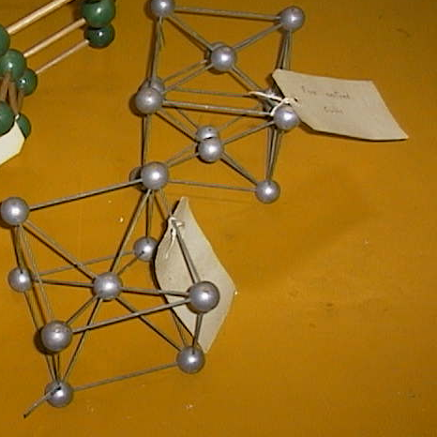

face centred
cubic, CN 12
simple cubic,
CN 6

body centred
cubic, CN8

Accompanying sheet

Crystal Structures

Can you identify the unit cell for the crystal structures shown?

What is the coordination number for each lattice?

Elasticity – Bouncy Balls

Apparatus
several balls, some bouncy, some not bouncy, steel ball and steel plate or other hard surface to bounce it off, plasticine or blu-tac rolled into a ball.

Action
The students rank the balls in order of bounciness and explain what makes a ball bouncy.

The Physics
There are several ways of explaining the bounciness.
In energy terms, the more efficient the ball is at converting kinetic energy to elastic potential energy and back to kinetic, the better it will bounce as less energy is lost. This will also depend on the energy absorbing properties of the surface it bounces off.
stress
strain
In terms of stress and strain, the more linear the relationship the less energy is lost. Most materials show hysteresis, and during the collision the stress-strain curve is different for the compressing phase and the expanding phase. The difference between the two curves (shaded region) gives the energy lost.
The less difference between the curves, the less energy is lost and the more bouncy the ball is.

selection of balls

steel plate

Accompanying sheet

Elasticity - Bouncy Balls

Bounce the various balls and rank them in order of their bounciness.

Why are some balls bouncier than others?

Why does the steel ball bounce better off the steel plate than off the carpet?

Hollow Tube and Disc

Apparatus
A tube and a disc larger than the end of the tube with a string attached to it.

Action
The students use the string to hold the disc flush against the tube and dip it into water. The disc stays against the tube when they release the string. When they release the string in air the disc falls away.

The Physics
The disc stays attached when there is a pressure difference exerting a force which holds it in place. When the pressure difference decreases such that the force falls below mg of the disc, the disc falls.

in air
in water

Accompanying sheet

Hollow Tube and Disc

Use the string to hold the disc in place as you put it into the water.
Now release the string and see what happens.
Does this happen in air?

Why does the disc fall away in air, but remain attached in the water?

Hot Honey

Apparatus
clear jar with some honey in it, and scale marked on, with well sealing lid, hot water in container larger than the jar, icy cold water in container larger than the jar

Action
The students observe the height or volume of honey in the jar. The students tilt the jar and observe how long it takes the honey to run from one end of the jar to the other.
The jar of honey is heated in the hot water and the volume is again noted. The students observe how long it takes the hot honey to run from one end of the jar to the other. The students try to determine whether there is necessarily a relationship between density and viscosity.
The jar should be placed in the cold water after this so that it cools enough for other groups to repeat the observation quickly.

The Physics
The density of the honey changes negligibly when it is heated, the volume does not change and the jar is sealed so the mass of honey has not changed. The hot honey is considerably less viscous than the cold honey, and runs very quickly from one end of the jar to the other.
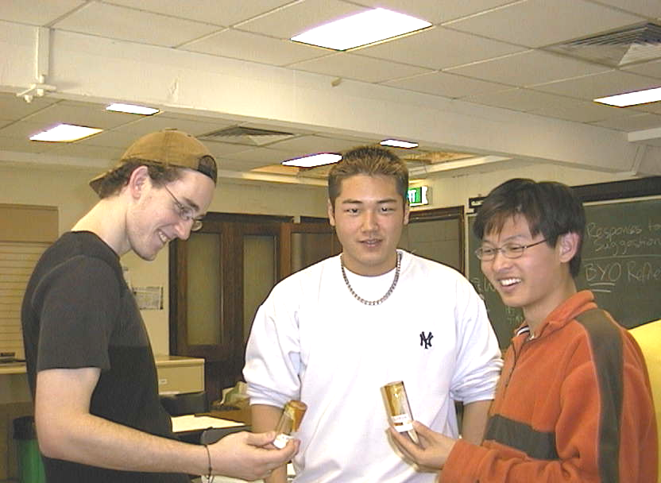

Students at the University of Sydney observing hot runny honey and cold (not-runny) honey.

Accompanying sheet

Hot Honey

Observe the volume of honey in the jar.
Tilt the jar and see how quickly the honey flows.

Heat the jar in the hot water.
Has the volume changed? Has the density changed?
What about the viscosity?

What can you conclude about the relationship between viscosity and density?
When you are done, cool the honey in the cold water for the next group.

Hydrometers

Apparatus
three or four simple hydrometers - either commercially produced or lengths of wood with a weight at the end and a calibrated scale, beakers containing liquids of different densities

Action
The students use the hydrometers to measure the densities of various fluids. They try to explain why the scale is marked from high densities at the bottom to low densities at the top.

The Physics
The buoyant force is equal to the weight of fluid displaced, which is equal to the weight of the object displacing the fluid if it is floating. Hence the buoyant force on any floating objects with the same mass, is the same regardless of the fluid they are floating in. The more dense a fluid the less of the fluid will be displaced to balance the weight of the hydrometer. Hence a hydrometer sits higher in more dense fluids, so the large numbers are at the bottom, and the small numbers at the top.
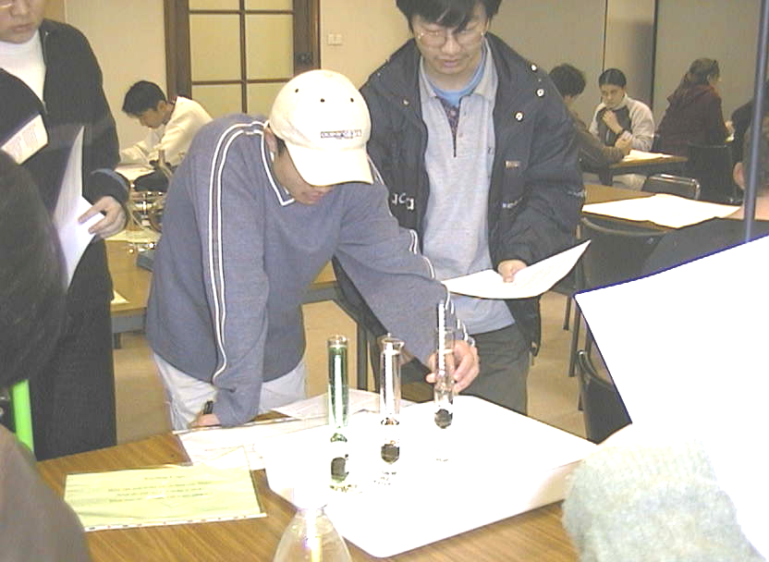

Students at the University of Sydney looking at hydrometers suspended in cylinders containing three different fluids.

Accompanying sheet

Hydrometers
Observe the heights at which the hydrometers float in the different liquids.

Is the buoyant force on the hydrometers the same or different?
Why?

Why is the scale on the hydrometer marked the way it is?

Hydrostatic Paradox

Apparatus
set of containers with different shapes but same base area, filled to same height with liquid, scales to weigh the containers on

Action
The students fill the containers to the same height, and predict which will be heaviest and lightest. The students then consider how the force can be the same on the bottom of each container, as they each have the same depth of fluid, yet the weight, which is the force of the container on the scales, is different.

The Physics
The pressure is the same at the bottom of each container (because they are filled to the same height). But they all have the same base area, so the force experienced by the base of each container is the same. Therefore, they should all give the same reading on the scale. This second argument is wrong because we have only considered the force of the water on the base of the containers. When calculating the force of the water on the container, we must include the forces on the sides, which may have a component in the vertical direction. The containers have different masses because they contain different masses of water.

Accompanying sheet

Hydrostatic Paradox

The vessels have the same base area and are filled with water to the same depth.

Which contains the greatest volume of water?

Which has the greatest weight of water in it?
Which has the greatest mass of water in it?

Which has the greatest pressure on its bottom?

Lenard-Jones Potential

Apparatus
diagram of Lenard-Jones potential, for example that shown below

Action
The students examine the diagram and identify directions of forces in different regions, positive and negative potential energies, etc.

The Physics

The equilibrium distance between the atoms occurs when the potential is a minimum. The force is the negative of the gradient of the potential, F = -dP/dr, so where the slope is positive the force is negative, ie towards r = 0. To the left of the equilibrium separation the force is repulsive, where the gradient is negative. To the right of this point the force is attractive (where the gradient is positive).

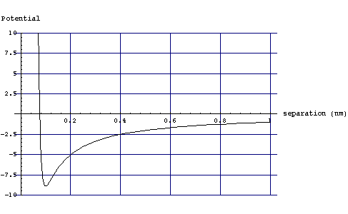

Accompanying sheet

Lenard-Jones Potential

The graph shows a plot of potential as a function of inter-atomic distance.
Where is the potential energy positive
and where is it negative for this pair of atoms?

Where the force between them repulsive?
Where is it attractive? How do you know?

What is the equilibrium distance for this pair of atoms?

The Lungs

Apparatus
lung model components: large glass (clear) bottle with bottom cut off, plug with Y-tube inserted into it, 2 balloons, flexible rubber sheet. See picture below.

Action
The students pull the diaphragm on the bottom of the bottle, causing the lungs (balloons) to inflate.

The Physics
When the students pull the diaphragm on the bottom of the bottle down the volume of the bottle increases. This lowers the pressure in the bottle. Inside the balloons it is approximately atmospheric pressure, while outside is now lower. The balloons inflate due to the pressure difference, their volume increases, lowering their internal pressure and drawing air into them. This is how we breathe - increasing the volume of our chest cavity to lower the pressure in our lungs and draw air in.
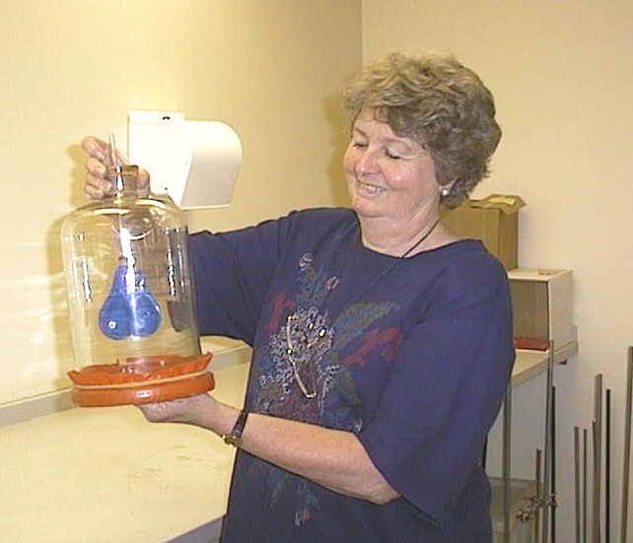
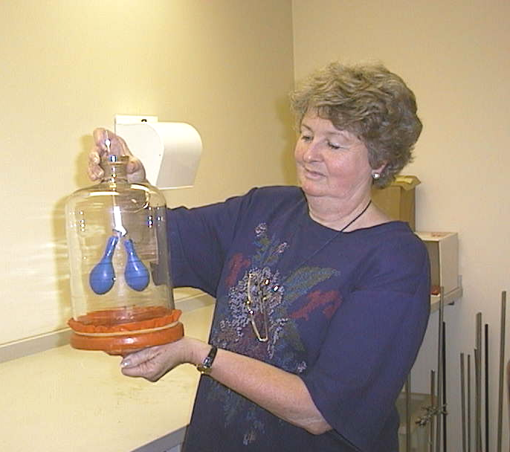

lungs at rest
pull down on the diaphragm and lungs expand

Accompanying sheet

The Lungs

Pull the diaphragm downwards
What do you observe?

What has happened to the pressure in the chest cavity?
What has happened to the pressure in the lungs?

Explain why this has happened.

Measuring Fluid Flow

Apparatus
Set of syringes or capillary tubes with different diameters and lengths, water and possibly other more viscous fluids, such as milk, stop watch, small measuring cylinders or beakers

Action
The students time how long it takes some small volume of fluid to pass through the different tubes. They should determine what factors increase and what factors decrease fluid flow.

The Physics
Fluid flow increases with radius of tube (it increases with r⁴), it decreases linearly with length of tube and viscosity of the fluid. It also increases with increased pressure drop along the path. This is important with syringes with plungers which allow you to increase the flow by increasing the pressure.
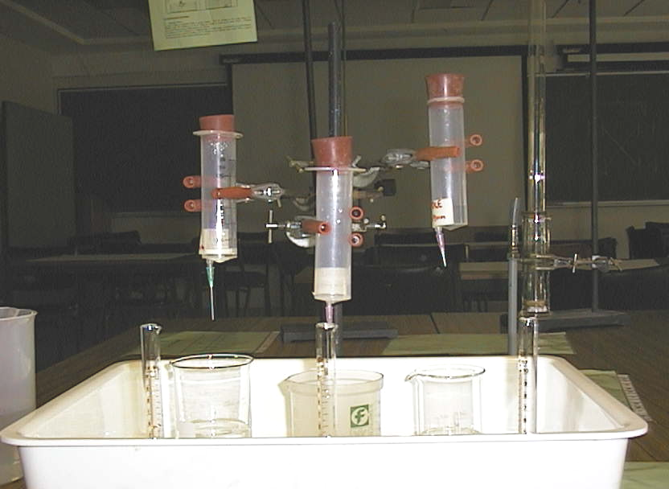

Accompanying sheet

Measuring Fluid Flow

Time how long it takes for a given amount of fluid to
flow through the different capillaries.

How does flow rate vary with diameter?

Does the length of the tube affect the flow rate?

Pascal's Vases

Apparatus
Set of Pascal’s vases: pipes or vessels of different sizes and shapes attached to a common reservoir at the base.

Action
The students explain why the fluid levels are the same in all the vases. They then apply a pressure to the fluid in one vase and see what happens to the fluid levels in the other vases.

The Physics
An increase in the pressure in one tube will be transmitted to the other tubes, and the liquid level in these tubes will rise. This is possible because the vases are all connected and hence are really a single vessel.

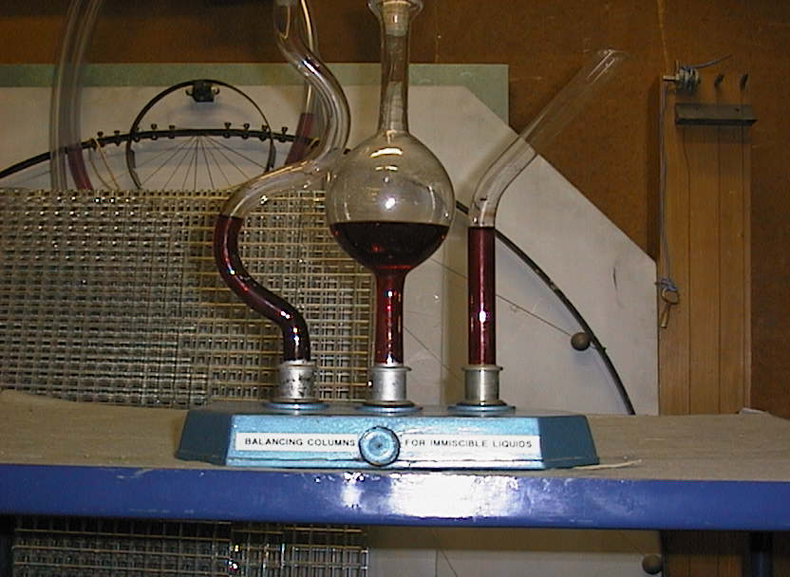

Accompanying sheet

Pascal’s Vases

The bases of the vases are linked to a common reservoir.

Why is the water level the same in each column?

What would happen if the pressure in one column was increased
and the others were still open?

Rheological Materials

Apparatus
selection of rheological materials; e.g. starch and water mix, corn-flour and water mix, glycerine and water mix, toothpaste, syringes, beakers, retort stands and stop watches

Action
The students investigate the flow rate of the various fluids supplied, and try to explain how their coefficients of viscosity are changing with time and applied shear stress. They should try to categorise the fluids as Newtonian or non-Newtonian, and then as dilatant, pseudoplastic or plastic.

The Physics
Newtonian fluids have constant viscosity with changing applied stress. Water and water-glycerine mixes are Newtonian fluids.
Many fluids are non-Newtonian, their coefficient of viscosity, η, changes with applied shearing stress.
Psuedo-plastics have a coefficient of viscosity, η, which falls with applied shear stress. A solution of starch is a good example. It will flow quickly, and then the flow rate will slow down. The force due to the fluid above drops as the fluid level drops. As the force drops η rises, so the flow rate decreases.
Dilatant fluids have a viscosity which increases with increasing stress. A corn-flour water mix is a good example of a dilatant fluid. Other examples include printing inks and wet sand. The flow rate of a dilatant fluid increase with time as the shear forces drop.
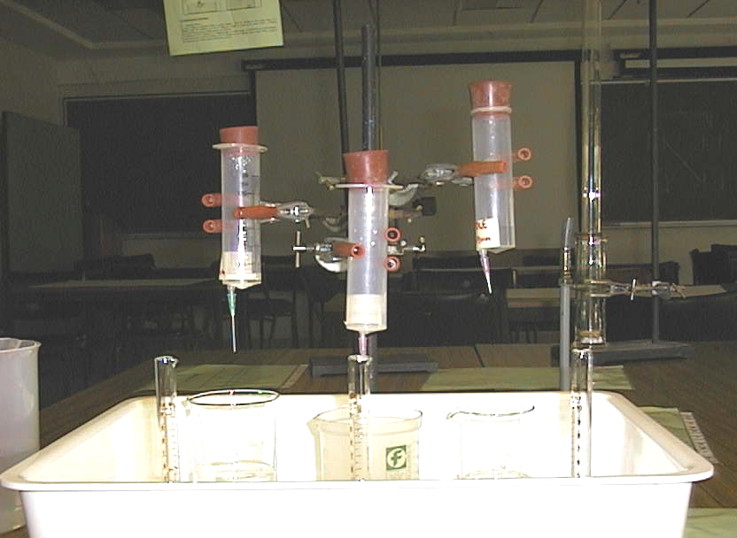
Toothpaste does not flow until a large enough stress is applied. Hence it will sit on a brush without spreading out and dropping off, but can still be squeezed out of the tube easily. Toothpaste and other materials which do not flow until a large force is applied are called plastic, other examples include paint for brushing and sewerage sludge.
η
shear rate
Newtonian
Pseudoplastic
Dilatant

Accompanying sheet

Rheological Materials

Examine the materials supplied.

Which are fluids?
Which are Newtonian fluids?

Measure the flow rates of the fluids and see how the viscosity changes.

Rolling Paper

Apparatus
pieces of scrap paper – the paper will be crumpled afterwards. (a selection of A3 and A4 is good.), weight – such as a textbook, scissors, sticky-tape

Action
The students experiment with rolling the paper to form cylinders, and seeing if they can hold the weight of the textbook without buckling. They can investigate the effects of height and radius, and cross sectional area. They can cut pieces in half, quarters etc to change the cross section. If you have large enough pieces of paper (A3), they can also investigate the ability of a cylinder to support its own weight.

The Physics
Thin walled structures tend to buckle, so there is a limit to the advantage to be gained by using hollow beams rather than solid beams. The weight of the load and the cylinder itself is not precisely over the base of the cylinder, hence a torque is exerted on the cylinder. If the walls are strong enough, the internal forces in the material will balance the torque. The paper rolls with smaller radius in which the paper forms multiple layers have thicker walls and are hence stronger. Shorter rolls are also stronger than taller ones as the torque will be less.
Any vertical column will buckle under its own weight if the ratio of its height to radius is too great. This is a limiting factor in the height of many structures, including trees.

Accompanying sheet

Rolling Paper

Roll the papers to make columns of various heights and radii.

Which columns can support the text book?
How does the strength change with height?
What about radius?

What happens when they fail? Explain why the columns collapse.

Rubber Bands

Apparatus
selection of rubber bands, including broken ones, hung from retort stand, weights with hangers, a ruler

Action
The students hang weights from the rubber bands to determine the spring constant of the rubber bands, and how linear the stress strain relationship for the bands is. They can estimate the Young’s modulus of a band, or compare the Young’s moduli of bands with similar cross sectional area. They can experiment with attaching bands in series and parallel to see how this affects the stress-strain relationship. They may also want to determine the ultimate strength of the rubber, by hanging on larger weights until a band breaks, although this can be a bit dangerous.

The Physics
The Young’s, E, modulus is given by F/A = E× ΔL/L, where L is the length, F is the applied force (mg for the weight in this case), and A is the cross sectional area of the material (rubber). Note that rubber bands obey this linear relationship for small applied forces only, however they can be subjected to large forces without being permanently deformed. The ultimate strength is measured by breaking the material.
The rubber band that stretches the least for a given weight (applied force) has the greatest spring constant. If you had rubber bands of the same cross sectional area then the one that stretches the least also has the greatest elastic modulus. If you cut a strip of rubber in half it would stretch less for a given weight, so its spring constant will have decreased. The modulus of elasticity depends on the material, and will not have changed. If you joined two rubber strips or bands together in parallel they would also stretch less, but again the modulus of elasticity has not changed. Effectively you will have doubled the spring constant by doubling the cross sectional area.

ruler
rubber bands

weights

Accompanying sheet

Rubber Bands

Use the weights to find the spring constant of the rubber bands.
How linear is the stress - strain relationship for these bands?

Cut a band into a strip, and measure its spring constant.
Now cut it in half and repeat the measurement.
What has happened?
What happens if you connect two strips in parallel?

Soap Films

Apparatus
soapy water mix to make soap films ( a little glycerine in the mix helps), wire loop with handle and piece of thread with a loop in it loosely tied across the wire loop, pen or pencil to pierce soap film, selection of wire frames to make bubbles

Action
The students dip the loop into the soapy water mix to produce a soap film across the loop, with the thread and its loop imbedded in the film. They then pierce the film within the loop of thread with a pencil, and observe what happens to the film and thread.

The Physics
When the film inside the inner loop is pierced the outer film is able to contract, pulling the inner loop into a circle, to minimize the surface area of the remaining film. The lowest energy state for a liquid – air interface is that with the smallest surface area.

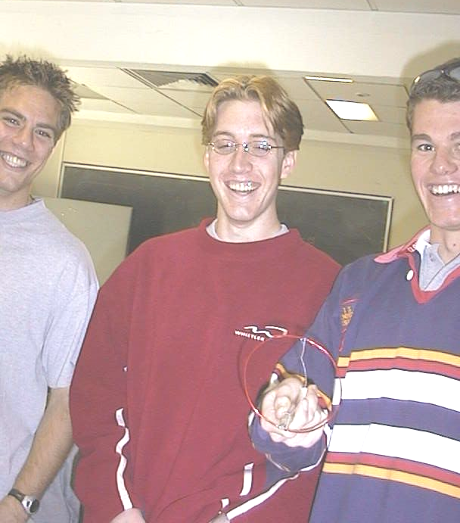

Students with a soap film at the University of Sydney.

Accompanying sheet

Soap Films

Dip the loop in the soapy water to form a film.
Now pierce the film inside the loop of thread.

What happens to the rest of the film? Why?

Experiment with making bubbles.
What do you notice about the surfaces of the bubbles?

Shoes

Apparatus
old worn shoes, or nothing, students can look at their own shoes.

Action
The students look at their own shoes and each other’s while standing still and while walking. They also examine the pair of worn shoes. The students describe the forces acting on the shoes while standing still and while walking, and try to explain why the shoes are wearing in the way they are.

The Physics
While standing still the shoes are subject to compressive force from the person wearing them. Most materials are very strong to compressive forces. While walking the shoes are also subject to shearing forces, as the foot pushes at the top of the sole (inside the shoe) and the frictional force of the ground acts on the bottom of the sole. In addition the sole is bent as you walk.

mg
N
compressive forces
and shearing forces
compressive
forces only
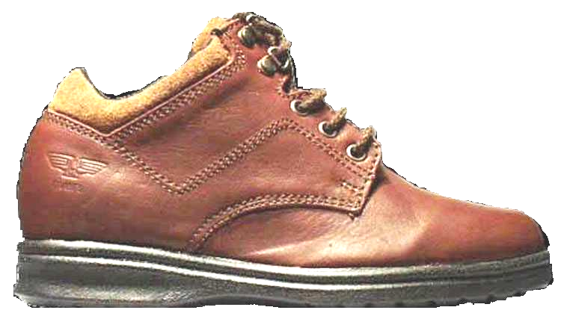

force of ground

force of foot

Accompanying sheet

Shoes

Examine your own shoes and the shoes on display.

What forces are they subject to while standing still?
What about when walking?

Can you find any patterns of wear due to these forces?

Squirting

Apparatus
various squirting devices including:
a container with holes along the side, so students can see how the water flow varies with height,
a drinking straw and cup of water,
a watering can with a closable top, for example a conical flask with holes in the bottom and a mouth small enough to be closed by covering with a thumb.
A bucket or two is also handy and paper towels or tea towels for cleaning up spillages.

Action
The students investigate how the flow of water through a leak depends on depth.
They dip the straw into the water, then close off the top with a finger and raise it, taking the water inside along with it. When they uncover the top, the water falls out.

The Physics
The water will come out perpendicular to the container wall, as this is the direction of the net force. The pressure is greater near the bottom, so the water squirts out with greatest velocity here. The horizontal distance the water squirts will be a maximum for holes at half the depth of the water. (See solutions to problem sheet PR4T -Fluid Flow I for details.)
In the straw and watering can the liquid is held in by the low pressure in the tube or bottle, when this pressure is increased to atmospheric pressure by opening the lid or removing the finger the water will come out.

Accompanying sheet

Squirting

Why does the water squirt out the holes in the bottle?
What can you say about the direction of the water as it leaves the holes?

Insert the straw into the cup, then put your finger over the top and lift it out.
Explain what happens.
What happens when you uncover the top?
Why?

Suction Cups and Magdeburg Plates

Apparatus
suction cups and / or Magdeburg plates with pump to reduce pressure, large sink plungers are also popular with students

Action

The students stick the suction cups to smooth and rough surfaces, and try to determine what makes them stick.
The Magdeburg plates are held together while the air between them is pumped out and students attempt to pull them apart.

The Physics
The force required to pull a suction cup off a surface or the Magdeburg plates apart is proportional to the difference in pressure across the plates/cup and the surface area of the plates/cup.
In order for a suction cup to stick there needs to be lower pressure between the cup and the surface to which it sticks, and it needs to seal against the surface so that the pressure difference is maintained.

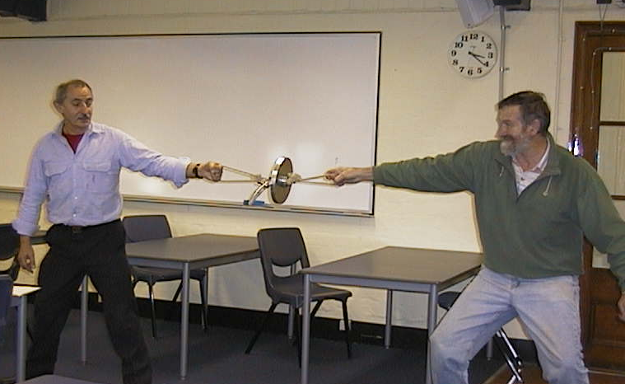

Even two grown men have difficulty separating the Magdeburg plates when the air between them is removed.

Accompanying sheet

Suction Cups and Magdeburg Plates

How can you make the suction cup stick to a surface?
Explain what happens when it sticks and when it fails to stick.

When are the Magdeburg plates hard to pull apart?
When are the Magdeburg plates easy to pull apart? Explain why.

Surface Tension I- Floating

Apparatus
container of water, selection of needles and small metal rod, box of matches and small lengths of wood

Action

The students experiment with trying to float the needles, matches and lengths of wood and metal. They should try to float both dry and wet needles and matches, and try to explain why dry needles will float, but not wet needles or larger metal objects, while all the wood floats.

The Physics
The wood floats because it is less dense than water and the buoyant force due to the displaced fluid will be greater than the weight force of the wood. Wood floats in the water.
Metal is more dense than water and hence will sink. However a needle can be made to float on the water if it does not break the surface. The surface of water acts like a stretched skin (trampoline) and the needle sits on it. If the needle is too heavy and the skin cannot support the weight of the needle, the skin ruptures. The skin can also rupture if it is pricked, so if the needle is light enough to be supported by the skin but the skin is pricked in the process of making it float the needle sinks. If the needle is initially wet the water on the needle joins the water in the container and is equivalent to a pricked skin, wet needle will not float.

Accompanying sheet

Surface tension I- Floating

Try to float a needle on the surface of the water.
How do you have to put it in to make it float? Why?

Will it float if it is wet?

Will the larger pieces of metal float?
What about the matchsticks and larger pieces of wood?

Surface Tension II- Detergent

Apparatus
glass of water, ground pepper (finely ground), detergent, container for used water and container of fresh water if no sink and tap handy.

Action
The students sprinkle pepper over the glass of water. They then add a drop of detergent and observe and explain what happens.

The Physics
When the detergent is added the pepper can be seen to move rapidly towards the edges of the glass a moment later.
The motion of the pepper is due to the lowered surface tension with the detergent film. The detergent film is like a stretched membrane which is weak in the middle. When a hole forms it expands and the pepper is moved away from the centre with the retracting film.

Accompanying sheet

Surface Tension II – Detergent

Sprinkle pepper over the water in the glass.

Now add a drop of detergent.

Explain what happens to the pepper.

Clean out the glass and refill it with fresh water for the next group.

Surface Tension III - Paintbrush

Apparatus
glass of water, paintbrushes with long bristles, paper towels to dry brushes

Action
The students hold the paintbrush in the water and observe the bristles. They pull it out and observe the bristles and explain the difference.

The Physics
When the paint brush is pulled out of the water the surface tension of the water on the bristles pulls them together. When it is in the water there is no inwards force pulling the bristles together, and small currents in the water fluff out the bristles.

Accompanying sheet

Surface Tension III – Paintbrush

Dip the paintbrush into the water
How do the bristles look while in the water?

Pull the paint brush out of the water.
How do the bristles look now?

Explain your observations.

Two Sheets of Paper

Apparatus
two pieces of paper, two retort stands with clips to hold the paper
The sheets of paper should be hung parallel, spaced a few centimeters apart.

Action
The students blow between the two pieces of paper. An extension is holding a single piece horizontally and blowing along it so that it rises.

The Physics
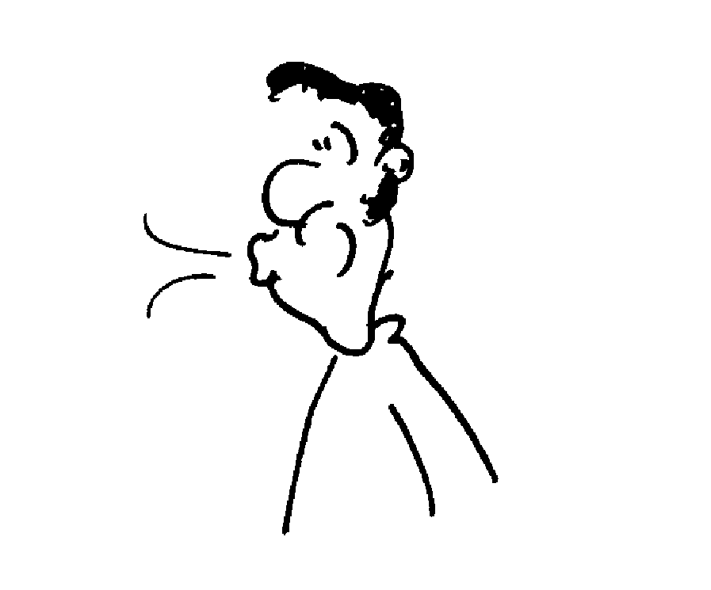
When you blow between the two pieces of paper the air between them is at a higher velocity and lower pressure than the air around them and they are pushed together. This is an application of the Bernoulli effect.
~ 2cm
blow

Accompanying sheet

Two Sheets of Paper

Blow between the sheets of paper.

Explain what you observe.

Where else have you observed this effect?

