Quantum Atomic and Nuclear Physics Activities

Activity | used in workshops:
Band Structure Models | QR7 | 231
Binding Energy | QI4, QR13 | 232
Cathode Ray Tube | QR11 | 233
Classical Particle in an Elastic Potential Energy Well | QR3 | 234
Colleen’s Cubes | QI5, QR14B, QR14T | 235
Common Sources of Radiation | QR15B | 236
Compact Discs | QR10 | 237
Coolite Balls | QI4, QR13 | 238
Diffraction Patterns | QR12B, QR12T | 239
Electron Interference | QR2 | 240
Emission Spectra | QI2, QI3, QR5 | 241
Exposure Levels | QR15B | 242
Hydrogen Spectrum | QI2, QR5 | 243
Identify the Element | QI2, QI3 | 244
Laser Light I - Focus | QR9 | 245
Laser Light II- Spectrum | QR9 | 246
Light Emitting Diode | QR8 | 247
Measuring Momentum and Position I | QR4 | 248
Measuring Momentum and Position II | QR4 | 249
Measuring Radiation | QI6, QR15T, QR15B | 250
Molecular Models | QR6 | 251
Molecular Models of Semiconductors | QR7 | 252
Nuclear Power Stations | QR15T | 253
Periodic Table | QR6 | 254
Photoelectric Effect | QR1 | 255
Potential Wells and Wave Functions | QR3 | 256
Semiconductor Diode | QR8 | 257
Smoke Detector | QI5, QR14B, QR14T | 258
Solar Panels | QR8 | 259
Thermocouples and Thermistors | QR8 | 260
Transistors | QR10 | 261
Wave and Particle Nature of Light I- Interference Pattern | QI1, QR1, QR2 | 262
Wave and Particle Nature of Light II- Spectral Lines | QI1, QR1, QR2 | 263
Waves on a String | QR3 | 264
X-ray Diffraction | QR12B, QR12T | 265
X-ray Pictures | QI6, QR12B, QR12T | 266
X-ray Tube | QR11 | 267

Band Structure Models

Apparatus
“egg carton” like containers with indentations for marbles or balls (electrons), divided into bands and spaced appropriately for metals, semiconductors etc, model electrons, “eggs”, e.g. marbles, to fill the holes in the containers

Action
The students examine the models and explore how electrons and holes can act as charge carriers.

The Physics
The “egg cartons” represent energy bands, which can be full, partly full or empty of electrons, depending on the material being represented. More or less electrons can be added to represent n and p type semiconductors.
boards with holes to represent bands.

E_{.g.}

model electrons, e.g. marbles.

Accompanying sheet:

Band Structure Models

Examine the band structure models.

How can you make n or p type semiconductors?

How can a “hole” act as a charge carrier?

Binding Energies

Apparatus
a large chart of the binding energy or mass defect per nucleon

Action
The students examine the chart and identify which nuclei are the most stable and which processes can lead to stability for different nuclei.

The Physics
The most stable nuclei are those with the greatest binding energy per nucleon. Those that are much heavier than iron tend to undergo fission to move back towards the stable region of the chart. Small nuclei like hydrogen can undergo fusion (at high enough temperatures, such as in stars) to form larger elements with greater binding energy per nucleon.

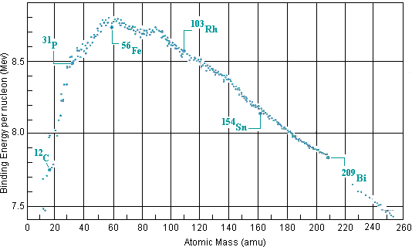

Accompanying sheet:

Binding Energies

Examine the chart of binding energies.
What does the diagram represent?

Fission and fusion are opposite processes,
when fission occurs a nucleus breaks apart
and when fusion occurs two nuclei fuse to form a larger one.
How can both these processes release energy?

Which nuclei are more likely to undergo fusion?
Which will undergo fission? Explain your answer.

Cathode Ray Tube

Apparatus
working cathode ray tube

Action
The students examine the tube and identify the important components. They should note the similarity to the x-ray tube.

The Physics
The cathode ray tube has a source of electrons (the cathode rays) which are accelerated using an electric potential difference and “steered” using coils. When the electrons collide with phosporus atoms on the screen photons in the visible region are produced. An x-ray tube works in the same way but uses a larger accelerating potential to give the electrons more energy so that x-rays rather than visible photons are released when the target is hit. The target material is usually a metal in an x-ray tube. Old TV sets and oscilloscopes use a phosphorus screen.
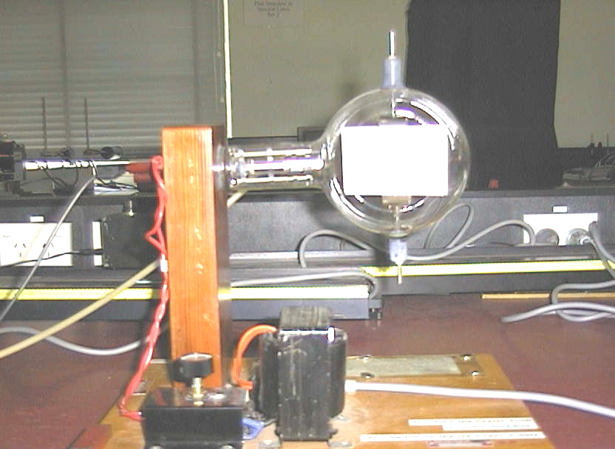

Accompanying sheet:

Cathode Ray Tube

What is a cathode ray?

The cathode ray tube is very like the x-ray tube.

Identify the main components.
How is the cathode ray tube different to the x-ray tube?

Classical Particle in an Elastic Potential Energy Well

Apparatus
air track with spring mounted at each end, short glider

Action
The students observe the way the “classical particle” (the glider) is reflected from the springs at the ends of the track, and sketch the elastic potential energy of the system as a function of glider position. They should observe that the glider is slowed by the springs and then reflected, and note the relative time spent by the glider around the middle of the track and near the ends. They can then sketch the probability of finding the glider at a given position on the track.

The Physics
The elastic potential energy, U, of a spring-mass system is proportional to (Δl)² where Δl is the compression (or extension) of the spring away from its equilibrium length. The spring is compressed by the glider, and is otherwise at equilibrium. The potential energy as a function of glider position, x, is therefore zero except where the glider compresses the springs at either end of the track, at which positions it is proportional to (Δl)². This is very much like an infinite potential well, and is approximately square except for the curvature at the edges.  For a given interval in space, the glider spends more time near the ends of the track as it must be slowed down and change direction, then be accelerated away again at the track ends. The surface is approximately frictionless so the glider travels at constant speed once it is no longer in contact with the end springs. The probability density, P, is shown opposite, the dotted lines show the ends of the air track. | P  x  U  x
The probability density for an electron in a well is the opposite to this for the electron’s ground state, and in general is a minimum (zero) at the edges of the well.

Accompanying sheet:

Classical Particle in an Elastic Potential Energy Well

Send the glider along the air track and allow it to bounce off the spring at the end.
Sketch the elastic potential energy of the system
as a function of glider position.

Allow the glider to bounce back and forth.
Where does it spend most of its time?
Sketch the probability of finding the glider at a position on the track
as a function of position.
How does this compare to the probability density
for an electron trapped in a potential well?

Colleen’s Cubes

Apparatus
100 or more wooden cubes, about 2cm to a side, each with a dot on one side, a large jar and a tray

Action
The students pour the cubes from the jar into a single layer in the tray. They remove those with dots showing, count the number remaining and repeat several times, or until no cubes are left. They then sketch the number left with each throw or the number removed. (Or both.)

The Physics
This represents the random process of nuclear decay. The sketch will be (approximately) exponentially decreasing.

jar and cubes

tray

Accompanying sheet:

Colleen’s Cubes

Shake the jar containing the nuclei (cubes) and pour them into the tray.
Write down the number of cubes with dots showing on top,
remove those cubes and replace the rest in the jar.
How many cubes are left of the original 100?
Repeat several times.

Sketch the number of cubes removed (the activity) as a function of time.
Sketch the number of cubes remaining in the jar as a function of time.

Common Sources of Radiation

Apparatus
some (slightly) radioactive samples and/or laboratory sources, see table below
Mantles for gas lanterns are also an excellent example.

Action
The students measure the radiation from the sources and compare it to the background level.

The Physics
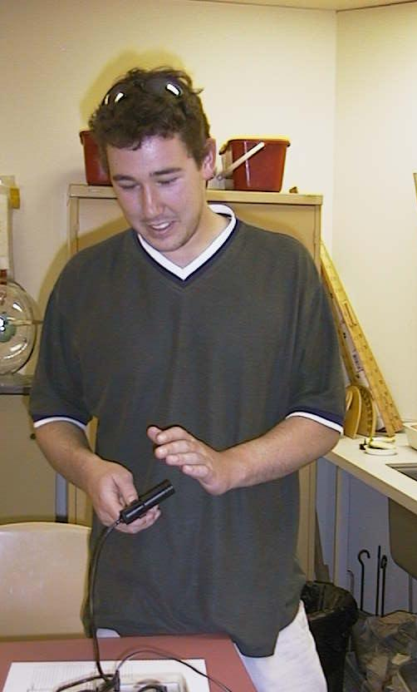
Most of the sources will have levels barely above background. It helps to have a common laboratory source such as Cs for comparison.

Radioactivity in some common substances.
Substance | Activity (Bq/kg)
garden soil | 2000
brazil nuts | 400
human bodies | 80
cows milk | 50
sea water | 12
tap water | 0.1

A student at the Australian Catholic University measuring his own radioactivity.

Dosage limits for ionizing radiation (from the ARPANSA website):
The NHMRC recommended radiation dose limit for the public is 1 mSv (1000 µSv) per year.
ANSTO's dose constraint for reactors, which has been agreed by the Nuclear Safety Bureau, is 100 µSv per year for members of the public

Accompanying sheet:

Common Sources of Radiation

Use the counter to measure the radiation coming from the various sources.

How do they compare to background radiation?
How do they compare to the recommended maximum dosages?

Compact Discs

Apparatus
CD, reasonably high powered optical microscope

Action
The students observe the CD under the microscope.

The Physics
The students will observe pits, which are spaced to be resolvable by a laser. They should identify that this is how information is encoded on the CD, and the spacing between the pits must be great enough to be resolvable by the CD player. This is digital encoding, unlike magnetic tapes and vinyl records which use analog encoding.

Accompanying sheet:

Compact Discs

Examine the CD under the microscope.

Can you see the pattern of pits which digitally stores the information?

How is this different to the way information was stored on vinyl records?

How is this different to the way information is stored on magnetic tape?

Coolite Balls

Apparatus
two or three coolite balls hanging from threads very close to each other, some way of charging the balls, e.g. fur and glass rod

Action
The students charge up the coolite balls such that they all have the same charge type, and explain their observations. They should make the analogy to putting charged particles together in the nucleus.

The Physics
Like charges will repel and the coolite balls will move away from each other. If the only force in the nucleus was the electrostatic force, nuclei would not be stable.

cloth and rod for charging balls

coolite balls

Accompanying sheet:

Coolite Balls

Charge the coolite balls so that they have opposite charges.
What happens?

Now charge them so they have like charges and observe what happens.

How do protons stay together in the nucleus?

Diffraction Patterns

Apparatus
laser, piece of pantyhose material in a single layer

Action
The students shine the laser light through the material and observe the resulting pattern. They then stretch the material and observe how the pattern changes.

The Physics
The network of fine threads in the fabric forms a grating. When you shine the laser light through the fabric you see a diffraction pattern.
The spacing between the maxima in the pattern (bright spots) is inversely proportional to the grid spacing; d sinθ = mλ, can be used to find the grid spacing, d, given the angular separation, θ, of the maxima.
pull
pull
pull
pull
The diagrams show the fabric to the left and the diffraction pattern to the right. When you stretch the fabric horizontally it also squeezes in vertically, the pattern will do the reverse of this, squeezing in horizontally and stretching vertically. When you stretch it vertically it will squeeze in vertically and stretch horizontally.

Note that this activity is also used in a waves workshop.

Accompanying sheet:

Diffraction Patterns

Shine the laser light through the fabric.

What sort of pattern do you see?

How does the pattern change when you stretch the fabric horizontally?
What about when you stretch it vertically?

Electron Interference

Apparatus
photographic plates or diagrams showing an interference pattern due to electron interference

Action
The students look for evidence of the wave and particle nature of electrons in the pictures.

The Physics
In the early pictures individual “dots” are visible, where single electrons have been incident on the plate/detector. The discrete nature of the dots shows the particle nature of electrons.
Waves passing through the slits interfere to give a pattern of fringes, with spacing depending on de Broglie wavelength and slit separation. This is visible in the later pictures and shows the wave nature of the electrons.



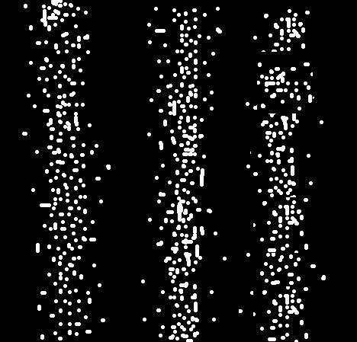
1.
2.
This diagram, or a similar one, showing electron interference can be used.

3.
4.

Accompanying sheet:

Electron Interference

A beam of electrons is directed through two narrowly spaced slits.
The emerging beam falls on a sheet of film.

These pictures contain clear evidence that the electrons are behaving
like ordinary classical particles (tiny billiard balls).

These pictures also contain clear evidence that that the
electrons are behaving like ordinary waves.

Emission Spectra

Apparatus
hand held spectrometer, light sources

Action
The students observe the spectral lines and compare them for different light sources.

The Physics
The lines correspond to electron transitions, where the emitted photon has the energy difference between the initial and final electron energy level. This energy and hence the wavelength, can be determined using the Bohr model for hydrogen, but is more complicated for larger atoms. It allows the “fingerprinting” of elements by their unique spectra, a valuable tool for finding out what something is made of.
Optometry students at the University of New South Wales observing a sodium spectrum. | 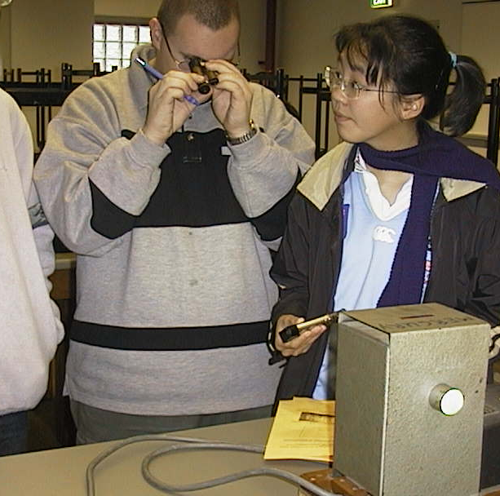

Accompanying sheet:

Emission Spectra

Use the hand held spectroscopes to "look" at light from different sources.

What are the differences in the spectra from the various sources?
Why are the spectra different?

What use can be made of the difference in spectra?

Exposure Levels

Apparatus
tables showing typical doses of radiation, for example those below, list of recommended exposure limits

Action
The students examine the tables and compare the typical dosages to the recommended limits.

The Physics
Radiation comes from many natural sources, as well as man made sources, and the typical exposures are well below recommended limits. People who work with radiation such as x-ray sources, especially radiographers and dentists, and aircraft pilots who are exposed to a lot of cosmic radiation receive much higher dosages of radiation than most other people.

Typical average annual doses due to natural radiation.
Source | Dose (μSv / yr)
local gamma radiation | 400
carbon 14 | 10
radon and decay products | 800
potassium 40 (in body) | 200
cosmic radiation | 300
uranium and thorium (in body) | 170

Typical average annual doses due to man made radiation.
Source | Dose (μSv / yr)
diagnostic radiology (eg x-rays) | 220
therapeutic radiology | 30
radioisotopes in medicine | 2
radioactive waste | 2
fallout (nuclear weapons) | 10

Dosage limits for ionizing radiation (from the ARPANSA website):
The NHMRC recommended radiation dose limit for the public is 1 mSv (1000 µSv) per year.
ANSTO's dose constraint for reactors, which has been agreed by the Nuclear Safety Bureau, is 100 µSv per year for members of the public

Accompanying sheet:

Exposure Levels

Look at the chart showing the recommended exposure limits.

How do these compare with the dosages shown in the table?

What sort of professions do you think have the highest exposure?

Hydrogen Spectrum

Apparatus
hand held spectrometer, hydrogen lamp,

Action
The students observe the spectral lines and use Bohr’s model to explain the lines.

The Physics
The lines correspond to electron transitions, where the emitted photon has the energy difference between the initial and final energy level. This energy, and hence the wavelength, can be determined using the Bohr model for hydrogen.
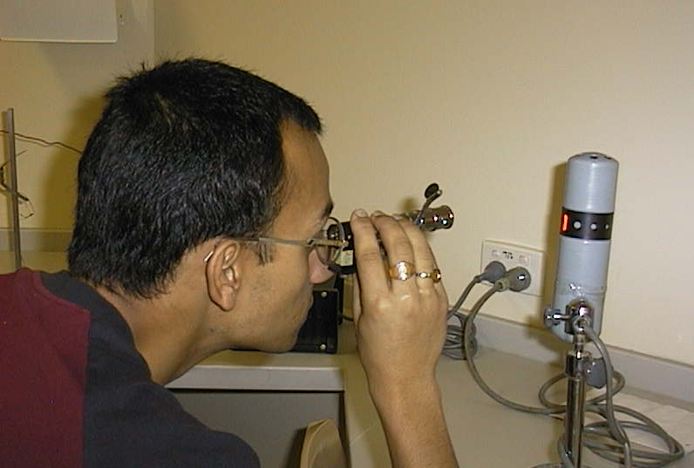

A student at the Australian Catholic University observing a hydrogen spectrum.

Accompanying sheet:

Hydrogen Spectrum

Examine the hydrogen lamp with the naked eye.

Now have a look through the spectroscope.

What do you see?

Sketch the spectra you observe.

Identify the Element

Apparatus
hand held spectrometer, discharge lamp with label covered or removed, selection of diagrams of spectra for different elements

Action
The students observe the spectral lines and compare them to the diagrams given to identify the element contained in the lamp.

The Physics
The emission spectra for each element is unique, as they all have different energy levels. This provides a way of identifying what elements are contained in an unknown sample.

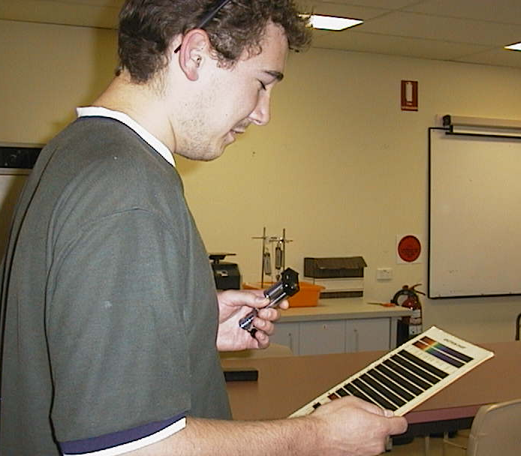
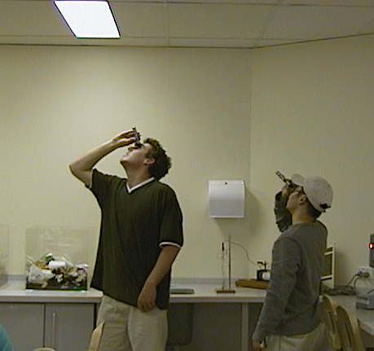

Students at the Australian Catholic University looking at the spectrum of fluorescent lights and using a chart of known spectra to identify the element (mercury) contained in the lights.

Accompanying sheet:

Identify the Element

Use the spectroscope to look at the lamp.

Now use the diagrams of spectra from known samples to
identify the element in the lamp.

What would a spectrum from a sample with several elements look like?

Laser Light I-Focus

Apparatus
laser, “white light” collimated source (or a pencil torch), used blackboard dusters

Action
The students observe the spots from the two light sources on a distant screen (or wall). They then observe the beams from the side. The dusters can be banged together to make the laser beam visible, after students have first noticed that the laser beam is invisible from the side.

The Physics
The laser produces a small spot on the wall or screen which varies very little when the distance between the laser and screen changes. The incandescent light produces a large spot, which varies in intensity from the centre out. The spot from the incandescent light varies a lot when the distance is changed, getting larger and less intense as the distance increases. A laser beam is much more highly collimated and focused than is possible with a normal incandescent light source.

laser
desk lamp

Accompanying sheet:

Laser Light I - Focus

Look at the point of light from the two sources.

Does the size of the point change much as you move the laser closer or further?
What about when you move the lamp closer?

Can you see the beams from the side?
Put some chalk dust in the air, now what can you see?

Laser light II – Spectrum

Apparatus
laser, “white light” collimated source (or a torch), prism

Action
The students observe the resulting spectrum when light from each of the sources is passed through the prism.

The Physics
The incandescent light source will produce a rainbow because it acts as a blackbody and produces a continuous spectrum. The laser produces almost monochromatic light due to electron transitions.

laser
pencil torch or collimated light source
prism
rainbow
single line

Accompanying sheet:

Laser Light II – Spectrum

Shine the white light through a prism to observe its spectrum.
What do you observe?

Now shine the laser beam through the prism.
What do you observe this time?

Why are the spectra of the two light sources so different?

Light Emitting Diodes

Apparatus
a selection of LEDs, a power supply, a switch, voltmeter, variable resistor

The switch, power supply variable resistor and an LED are wired in series, with the circuit set so that the LEDs can be swapped. The voltmeter is connected across the led.

Action
The students look at the various LEDs in the circuit, and try to explain why they produce different colours. The students adjust the variable resistor until the LED starts to glow. They then measure voltage across the LED. They should recognize that the shorter the wavelength produced, the greater the voltage needed, and relate this to the band gap of the semiconductor material of the LED.

The Physics
The colour of the LED depends on the band gap. When an electron transition occurs a photon with energy depending on the change in energy of the electron is emitted.

R
V_{in}
LED
V_{LED}

Accompanying sheet:

Light Emitting Diodes

Connect an LED to the Power Supply.
Vary the resistor until the LED just starts to glow.
What is the voltage across the LED now?
Repeat this measurement with the other coloured LEDs.
How does the voltage vary?

How does the LED produce photons?
What determines the colour of the light produced by a LED?

Measuring Momentum and Position I

Apparatus
marbles, slide, carbon paper and paper

The slide is mounted on a table such that a marble released at the top slides down and is ejected horizontally from the end of the slide. The marble falls and hits the carbon paper, which leaves a mark on the paper beneath it.

Action
The students release the marbles from the top of the slide, and using the mark on the paper from the carbon paper they calculate the horizontal momentum of the marble just prior to the collision. The students need to know the mass of the marble and the height of the desk.

The Physics
When the marble is released from the top of the slide it rolls down, gathering momentum as it falls. As it leaves the end of the slide it has horizontal velocity v. It is accelerated vertically due to gravity, and hits the floor at a time $t=(\frac{2h}{g})^{1/2}$after it leaves the end of the slide, where h is the height of the end of the slide above floor level. The collision with the floor/paper changes the momentum of the marble, hence this measurement is of the position of the marble, and we can infer from it the momentum prior to the measurement, but not during the measurement.

Accompanying sheet:

Measuring Momentum and Position I

Use the apparatus to find the horizontal momentum of the marble
during its flight.

How has your measurement affected
the position and momentum of the marble?

Do you know both position and momentum simultaneously?
If so, does this contradict the uncertainty principle?

Measuring Momentum and Position II

Apparatus
marbles, slide, web cam or light gate or other passive detector

The slide is mounted on a table such that a marble released at the top slides down and is ejected horizontally from the end of the slide. The camera is used to take a picture when the marble reaches a certain height, or a light gate or some other sort of sensor which uses light to tell when the marble reaches a particular height.

Action
The students release the marbles from the top of the slide, and using the sensor can calculate the momentum and position of the marble at a given point.

The Physics
When the marble is released from the top of the slide it rolls down, gathering momentum as it falls. As it leaves the end of the slide it has horizontal velocity v. It is accelerated vertically due to gravity, and at a time $t=(\frac{2h}{g})^{1/2}$after it leaves the end of the slide it has fallen a distance h. Knowing the horizontal distance it has traveled in this time, we can find both the marble’s momentum and position. In this case the measurement has not significantly affected the momentum, however if the object were an electron, the scattering the light used to make the measurement would have had a significant effect.

Accompanying sheet:

Measuring Momentum and Position II

Use the apparatus to measure the time
at which the marble passes a given point.

What effect has your measurement had
on the marble’s position and momentum?

Do you need to take the uncertainty principle into account in this experiment?

How would it be different if you were measuring the momentum
of an electron using this sort of apparatus?

Measuring Radiation

Apparatus
TLD badges, film badges, Geiger counter or any radiation measuring devices available, sources such as smoke detectors, old gas lamp mantles, old watches with glowing numbers

Action
The students examine the devices and try to explain how they work. They also measure the radiation from various sources.

The Physics
The GM tube in the Geiger counter is filled with low pressure gas, and around +400 Volts are applied to the thin wire in the middle. When a particle enters the tube, it ionizes a gas atom. The electron is attracted to the central wire, and as it rushes towards the wire, it ionizes more gas atoms, giving an ion cascade and creating a pulse which can be amplified and counted.
Radioactivity will darken ("fog") the photographic film in a film badge. The badges have "windows" made of different materials, which block different radiation, so that the dose of α, β and γ can be distinguished.
Scintillation detectors work by the radiation striking a suitable material such as sodium iodide and causing a tiny flash of light, which is picked up by a photo-multiplier tube.
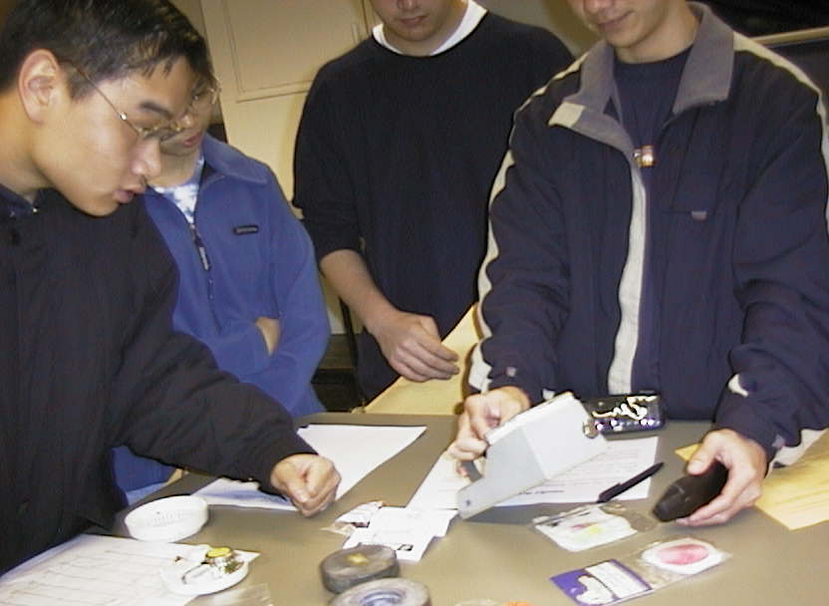

Students at the University of New South Wales using a Geiger counter to measure radioactivity from a mobile phone. Other sources including gas lantern mantles
and a smoke detector are shown.

Accompanying sheet:

Measuring Radiation

Different means of measuring radiation are shown.

Explain how they work.

Which ones would be suitable monitoring devices for
persons working in a radiation area?

Molecular Models

Apparatus
ball and stick models of atoms.

Polystyrene balls with sticks representing the outer shell electrons available for bonding. The balls could be coloured for quick identification. There should be more than one atomic species from at least a couple of periods, for example carbon and silicon or hydrogen and lithium.

Action
The students examine the models and try to match atoms from the same period. They should also try to explain what determines the chemical behaviour of the species.

The Physics
The chemical properties are determined by the number of outer shell electrons, which is determined by the quantum numbers, (n, l and m) and the Pauli exclusion principle. Hence atoms from the same period, which have the same number of outer-shell electrons, will have similar chemical properties.

H
C
Si

Accompanying sheet:

Molecular Models

Examine the ball and stick models of the atoms.

Can you group them according to period?

What determines the bonding behaviour of the atoms?

Molecular Models of Semiconductors

Apparatus
ball and stick models of Si, P and Al atoms.

Polystyrene balls with sticks representing the outer shell electrons available for bonding. The balls could be coloured for quick identification.

Action
The students examine the models and put together an n type and a p type semiconductor.

The Physics
Adding P to the Si gives an n type semiconductor, as the fifth outer shell electrons cannot be involved in bonding and hence are free to wander the lattice as charge carriers. The Al impurities give a deficit of bonding electrons, leading to holes as charge carriers.

P
Si
Al

Accompanying sheet:

Molecular Models of Semiconductors

Examine the ball and stick models of the atoms.

What happens when you put P impurities into Si?
What sort of semiconductor results?

What happens when you put Al impurities into Si?
What sort of semiconductor results?

Nuclear Power Stations

Apparatus
diagram showing nuclear power reactor and energy transformations

Action
The students examine the diagram and try to understand the chain of energy transformations, and the functions of the main components.

The Physics
See diagram below. Note that some energy is lost as heat at various stages so most of the original energy from the nuclear process is not converted to electricity. This is true of any power plant, regardless of initial energy source.
to power grid
cooling tower
generator
control rods
reactor
steam
water
condenser
cold water
turbine

Accompanying sheet:

Nuclear Power Stations

Examine the diagram showing how the reactor is used to produce electricity.

In simple terms, what is the reactor used to do?

Draw a flow chart showing the conversion of energy
from mass through to electricity.

Periodic Table

Apparatus
large chart of the periodic table of the elements

Action
The students look at the table and try to explain the relationship between position and characteristics, such as ionization energy, bonding, etc.

The Physics
The elements are arranged according to their number of outer shell electrons, which is determined by the quantum numbers, (n, l and m) and the Pauli exclusion principle.

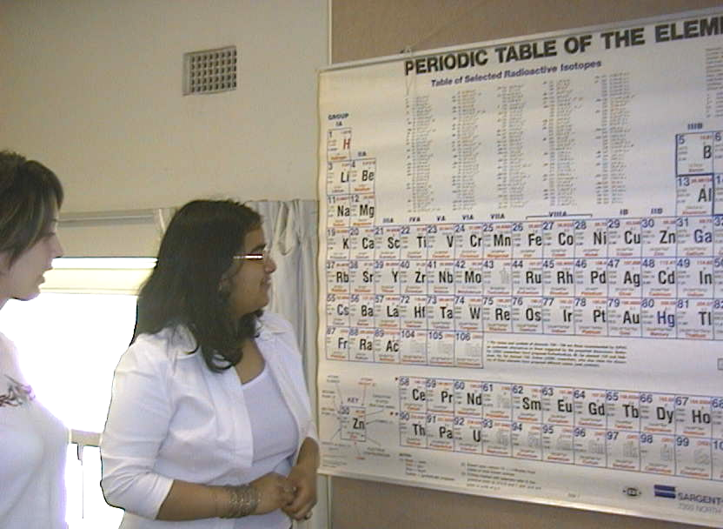

A student at the University of Sydney looking at a periodic table.

Accompanying sheet:

Periodic Table

Examine the chart of the periodic table.

Why are there only 8 elements in both the second and third period?
Shouldn’t there be more in the third?

Why do elements in a given column have similar characteristics?

Photoelectric Effect

Apparatus
ultraviolet light source, e.g. a mercury lamp, an electroscope, a metal plate
The metal plate, e.g. zinc or aluminium, is placed atop the electroscope and covered by a perspex sheet.

Action
The Students charge the electroscope so that it is negative, and the foil leaves move apart. The UV lamp is then turned on, and the perspex sheet removed. The electroscope leaves fall back together.

The physics
The UV photons collide with electrons in the metal plate, ejecting them if the energy of the photons is greater than the binding energy of the metal. The ejected electrons reduce the excess negative charge on the plate, which is connected to the electroscope. This reduces the charge on the leaves of the electroscope and they fall back together.
Note: it is almost impossible to start neutral and remove enough electrons to charge the electroscope as they recombine quickly to leave the electroscope neutral again.
UV lamp

metal plate

electroscope

Note: the perspex sheet is useful if the lamp takes a few minutes to warm up. The lamp can be turned on and the sheet used to block the UV radiation until the students are ready to use the demonstration.

Accompanying sheet:

Photoelectric Effect

The UV lamp takes several minutes to warm up.
Do Not expose yourself to UV radiation!
Do Not look up at the lamp filament!

You may need to charge the plate up initially using the electrophorus.
When the plate is charged (the leaves are separated) remove the perspex.
What do you observe?
What can you say about the work function of the metal plate?

Potential Wells and Wave Functions

Apparatus
A computer simulation, such as CUPSQM, which can generate wave functions for particles in potential wells or a set of diagrams showing wave functions for particles in potential wells

Action
The students identify the axes, and that the wave function is superimposed over the potential well, and is not measured in units of energy.

The Physics
The potential well has a vertical axis representing potential energy, which is infinite at the edges of the well. The horizontal axis represents displacement. The wave function represents the square root of the probability density, and is not measured in terms of energy. It is superimposed over the well. Many students find these diagrams particularly abstract and difficult to interpret – particularly as there are generally no units given on the axes, and they may not be aware that this is really two plots in one.

x
U
0
L
n =1
n =2
n =3

Accompanying sheet:

Potential Wells and Wave Functions

Examine the drawings of the wave functions for particles in potential wells.

What do the axes represent?

What does the wave function represent, and what are its units?

Semiconductor Diode

Apparatus
a germanium diode, a power supply, a switch, a small low voltage globe, a match or other heat source

The globe, switch, power supply and germanium diode are wired in series.

Action
The students close the switch to complete the circuit. They then heat the germanium to light the globe. They swap the polarity and repeat the process.

The Physics
When the germanium is heated more electrons move into the conduction band, allowing current to flow and the globe to light up. In reverse bias the globe takes longer to light and does not glow so brightly.

Accompanying sheet:

Semiconductor Diode

Diodes are made from semiconductor material, such as germanium.

Use a match to heat the germanium diode, to light the lamp.

Can you light the lamp with the diode connected the other way?

Explain some uses for a diode in an electrical circuit.

Smoke Detector

Apparatus
a battery operated smoke detector, opened up

The smoke detector should be opened up so circuitry is exposed and the warning stickers on the radioactive source visible.

Action
The students examine the smoke detector and identify key components including the ²⁴¹Americium α particle source.

The Physics
The α particles ionize air molecules between two charged plates. The positive ions go to the negative plate, the negative ions to the positive plate, which gives a current. When smoke enters the space between the plates the ions attach themselves to the heavy smoke particles and the flow of current is disrupted, setting off the alarm.
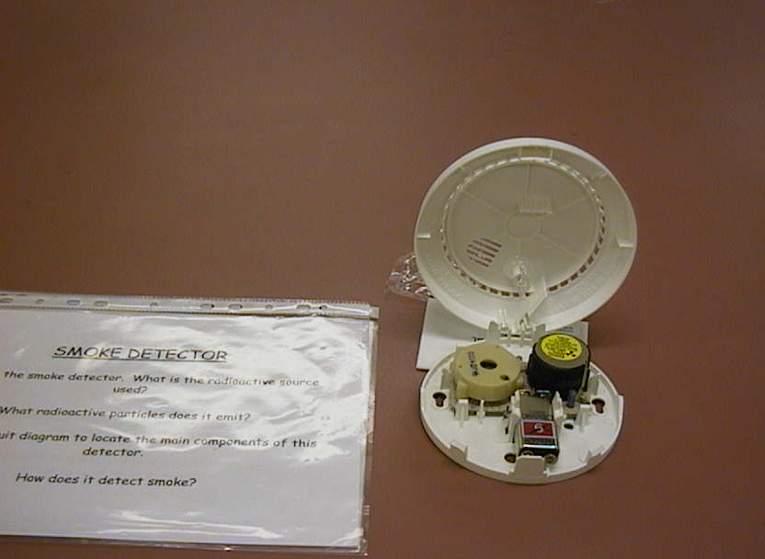

Accompanying sheet:

Smoke Detector

Examine the smoke detector.
It contains a radioactive source, ²⁴¹Americium, which emits 5.4 MeV α particles.

The α particles ionize air molecules between two charged plates.
The positive ions go to the negative plate,
and the negative ions to the positive plate, which gives a current.

How does smoke disrupt the current?
What energy is emitted by the source per second? per day?
How does this compare to acceptable exposure limits?

Solar Panels

Apparatus
solar panel, ammeter and/or voltmeter, light source

Action
The students hold the cell under the light, and vary the intensity to see what effect there is on the output from the cell.

The Physics
The electrons absorb energy (light), allowing them to jump across the band gap, and cause a current to flow. The current is proportional to the light intensity.

10 mA

Accompanying sheet:

Solar Panels

Examine the solar panel.

How does it use photons to produce an electric current?

How is this similar to a diode?

How is it different?

Thermocouples and Thermistors

Apparatus
a sample of semiconductor, a sample of metal, one or two ohm meters and a container of hot water to heat the samples in

A neat way to set this up is to have the samples each wired directly into the connectors of a multimeter with a large display, with the meter already set on an appropriate range.

Action
The students measure the resistance of each sample then heat it in the hot water and measure the resistance again.

The Physics
When a semiconductor is heated some of the electrons from the valence band are thermally excited into the conduction band, thus giving more charge carriers and a lower resistance. When a metal is heated it already has plenty of charge carriers in the conduction band, and the heat causes random oscillations of the lattice, leading to a shorter mean free path for the electrons and hence a greater resistance. So the sample with increasing resistance with heat is the metal, a thermocouple, the other is the thermistor.

00.10 Ω
500 k Ω
Ohm meters or multimeters
hot water
samples

Accompanying sheet:

Thermocouples and Thermistors

Measure the resistance of one of the samples.

Now heat it using the hot water and measure the resistance again.

Do the same for the other sample.

Which one is made of metal and which is made of a semiconductor?
Explain your answer.

Transistors

Apparatus
transistor, power supply, voltmeter, ammeter, resistors

The components are wired up in a simple circuit, for example as an amplifier.

Action
The students examine the circuit and investigate the effect of varying the supply voltage using the voltmeter and ammeter.

The Physics
The transistor amplifier works by a small change in the current in the base producing a large change in current in the collector, which gives a large signal across the load resistor.

collector
base
emitter
n
n
p
R_{b}
R _{load}
input

Accompanying sheet:

Transistors

Examine the circuit.
What does the transistor do?

Investigate the behaviour of the transistor by varying the voltage supplied.

What happens when you increase or decrease the voltage?

Wave and Particle Nature of Light I: Interference Pattern

Apparatus
a laser, slides with single and double slits

Action
The students use the laser to observe interference patterns. The students are encouraged to draw diagrams showing why the interference pattern occurs, and they should explain why this shows that light has wave properties.

The Physics
Waves passing through the two slits interfere to give a pattern of fringes, with spacing depending on wavelength and slit separation. This shows the wave nature of light. Note that there are also diffraction patterns visible.
screens so that students don’t look into the laser.

slits
screen or wall
laser

Note: This is used with both the waves workshops and the quantum workshops.

Accompanying sheet:

Wave and Particle Nature of Light I -
Interference Pattern

Observe the pattern produced by the laser light passing through the slits.

What causes this pattern?
What does this experiment tell you about the nature of light?

Wave and Particle Nature of Light II: Spectral Lines

Apparatus
spectrometer, light source, e.g. a hydrogen lamp

Action
The students observe the spectral lines and try to explain them.

The Physics
Only a single discrete quantum of light, i.e. a photon, is emitted or absorbed during electron transitions. This shows the discrete or particle nature of light.
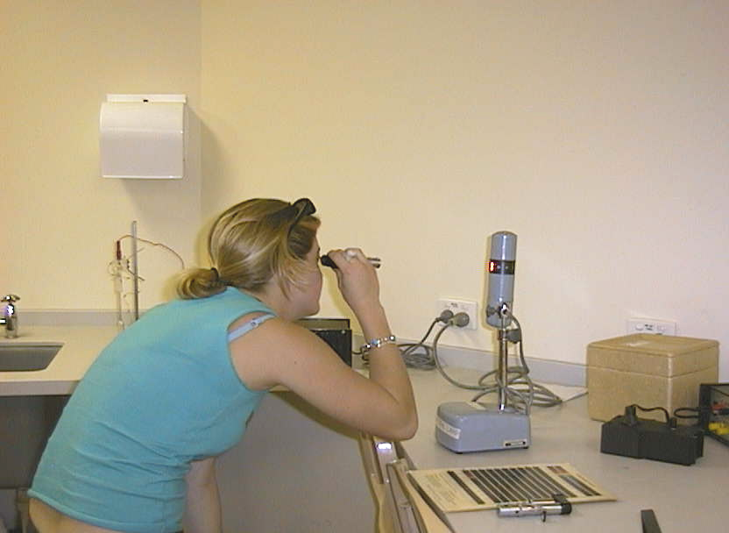

An environmental science student at the Australian Catholic University observing an emission spectrum.

Accompanying sheet:

Wave and Particle Nature of Light II –
Spectral Lines

Use the spectroscope to observe the spectra of the hydrogen lamp.

Why do you observe discrete lines?
What does this experiment tell you about the nature of light?

Waves on a String

Apparatus
taut cord or wire, oscillating driver with frequency control

The driver with amplifier is attached to one end of the cord, the other end is fixed.

Action
The students vary the frequency of the oscillator to produce standing wave patterns.

The Physics
Only certain wavelengths are possible for the standing waves; λ = 2l/n, where l is the length of the cord and n = 1, 2, 3… This gives certain discrete values of energy for each mode. This is analogous to the electron as a standing wave in the quantum model of an atom. The electron is confined to a region surrounding the nucleus, and the solutions to the Schroedinger equation are standing waves for the wave functions of the electrons, with certain discrete values of energy.

10 Hz
oscillator (driver)
frequency control
vibrating string

Accompanying sheet:

Waves on a String

Change the frequency to find harmonics and sketch the patterns on the string.
Why are only certain wavelengths of the standing wave possible?

Describe the analogy between
the waves on the string and
an electron in an orbital as described by the quantum model of the atom.

X-ray Diffraction

Apparatus
an x-ray diffraction diagram, plot of intensity vs scattering angle, for example polonium as this is a simple cubic – a simulated diffraction pattern for polonium is given below, a model of the crystal - more than a single unit cell helps for multiple plane spacings to be clear.

NaCl is also good because of its everyday familiarity, however it is a face centred cubic hence has a more complex structure and diffraction pattern.

Action
The students examine the diffraction data and try to match the peaks to planes in the crystal, and find lattice spacings.

The Physics
The atoms in the crystal form planes, with spaces between them like the lines of a diffraction grating. The larger spacings give smaller angles, because for constructive interference dsinθ = nλ, so the peaks at larger angles are for the smaller lattice spacings, such as the planes which make the sides of the unit cells. The smaller angles are for large lattice spacings.
This is reflected beam technique, in contrast to the way x-rays are used to make x-ray pictures of bones, in which the attenuated transmitted beam is used to get information about the material.

Accompanying sheet:

X-ray Diffraction

Examine the x-ray diffraction pattern.

Can you match the peaks to particular planes of atoms in the lattice?

Why are there peaks at multiples of the scattering angles?

X-ray Pictures

Apparatus
two or three x-ray pictures

Action
The students examine the pictures and identify areas of high and low x-ray absorption, and high and low tissue density.

The Physics
X-rays are more strongly absorbed by denser tissues, such as bone. This is because these tissues have a higher proportion of elements with a large number of electrons, which the x-rays interact strongly with. These areas show up white on typical x-ray images, which are negatives.
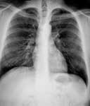

Accompanying sheet:

X-ray Pictures

Examine the x-ray films.

Why are some areas light and others dark?
In which areas are more x-rays absorbed?

Why are more x-rays absorbed in these regions?

X-ray Tube

Apparatus
Exposed x-ray tube, or opened up x-ray machine showing target and electron source.

Action
The students examine the tube and draw a diagram showing the main components.

The Physics
Electrons are emitted from the filament, and accelerated towards the target. At the target they collide with atoms of the target material and x-ray photons are emitted.

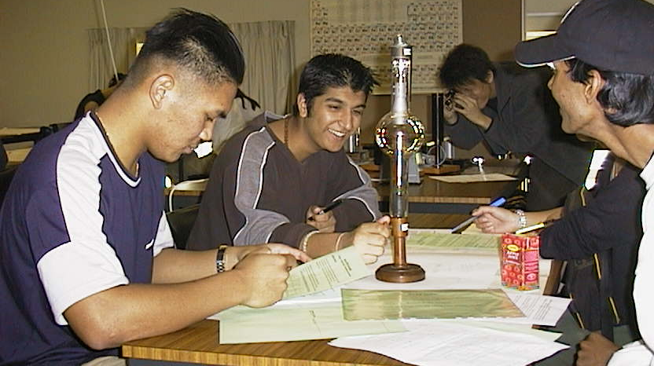

Students at the University of Sydney discussing the workings of an x-ray tube.

Accompanying sheet:

X-ray Tube

Examine the x-ray tube and draw a diagram showing the main components.

Where is the target?

Where and how are the electrons accelerated?

