Thermal Physics Activities

Activity | used in workshops:
2D Model of Gases | TI5, TR5B, TR5T | 103
Ball Bearings | TI4, TR4B, TR4T | 104
Bar Fridge | TR6 | 105
Bicycle Pump | TI4, TR4B, TR4T | 106
Blackbody Radiation | TI7, TR8 | 107
The Black Box | TI7, TR8 | 108
Blowing | TI5, TR5B, TR5T | 109
Boyle’s Law | TI5, TR5B, TR5T | 110
Cooling by Evaporation | TI2, TR2B, TR2T | 111
The Drinking Bird | TI2, TR2B, TR2T | 112
Dropper | TI5, TR5B, TR5T | 113
Heat and Work | TI4, TR4B, TR4T | 114
A Hot Bath | TI2, TR2B, TR2T | 115
Keeping Warm or Cool | TI2, TR2B, TR2T | 116
Macroscopic States and Microscopic States | TI6, TR7B, TR7T | 117
Measuring Air Temperature | TI1, TR1B, TR1T | 118
Multiplicity | TI6, TR7B, TR7T | 119
Stirling Engine | TR6 | 120
Stubby Holder | TI3, TR3B, TR3T | 122
Thermal Conductivity | TI3, TR3B, TR3T | 123
Thermal Expansion of Gases | TI1, TR1B, TR1T | 124
Thermal Expansion of Liquids | TI1, TR1B, TR1T | 125
Thermal Expansion of Solids – Bimetallic Strip | TI1, TR1B, TR1T | 126
Thermal Radiation –  the Leslie Cube | TI7, TR8 | 127
Thermometers | TI1, TR1B, TR1T | 128
Thermos Flask | TI3, TR3B, TR3T | 129
Water Boiling at less than 100º | TI5, TR5B, TR5T | 130

2D Model of Gases

Apparatus
container with sliding lid containing small balls, e.g. ball bearings or plastic balls, vibrating stand to sit the container on, either upright or on its side

Action
The students examine the equipment and identify the balls as representing gas molecules. They vary the kinetic energy (temperature) of the gas by varying the amplitude of the oscillation. They explain what happens to the pressure and volume of the gas as the temperature is varied.

The Physics
When you increase the “temperature” of the gas the molecules move faster, they have an increased velocity. This means that when they collide with the lid (and walls) of the container they exert a greater pressure, as they can transfer more momentum to the lid. If the lid is not held in place, it will be pushed up, increasing the volume of the container.
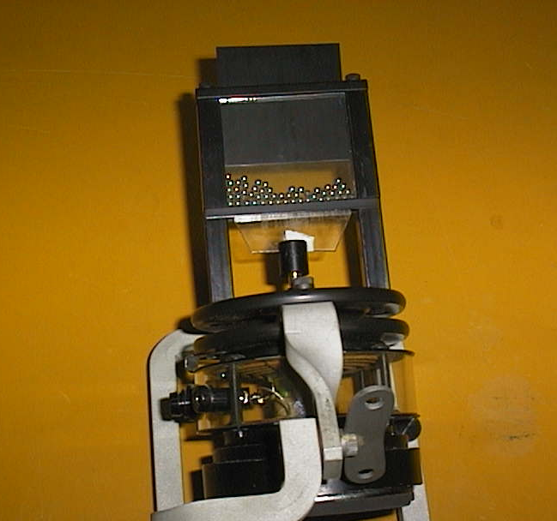

Accompanying sheet

2D Model of Gases

Increase the temperature of the “gas”.

What happens to the pressure?
What happens to the volume if the lid is not fixed?
Explain why this happens.

Ball Bearings

Apparatus
sealed perspex tube with thermocouple mounted at one end, which can be attached to a digital multimeter or thermometer, very small (~ 5 mm diameter) ball bearings or lead shot to half fill the tube

Action
The students note the temperature of the ball bearing inside the tube with the thermocouple, then disconnect it. They then shake the tube vigorously for a few minutes. (They may want to take turns.) The thermocouple is then reconnected, and they measure the temperature rise of the ball bearings.

The Physics
When you shake the tube you do work on the ball bearings and give them kinetic energy. The kinetic energy is lost as thermal energy, due to friction, as the ball bearings settle again when you stop shaking. This thermal energy increases internal energy of the “ball bearing gas” and the temperature of the ball bearings increases. This is an example of conservation of energy – the change in internal energy = the work done on the system minus the heat lost.
(You could heat up a coffee this way, but it would take years of vigorous shaking.)

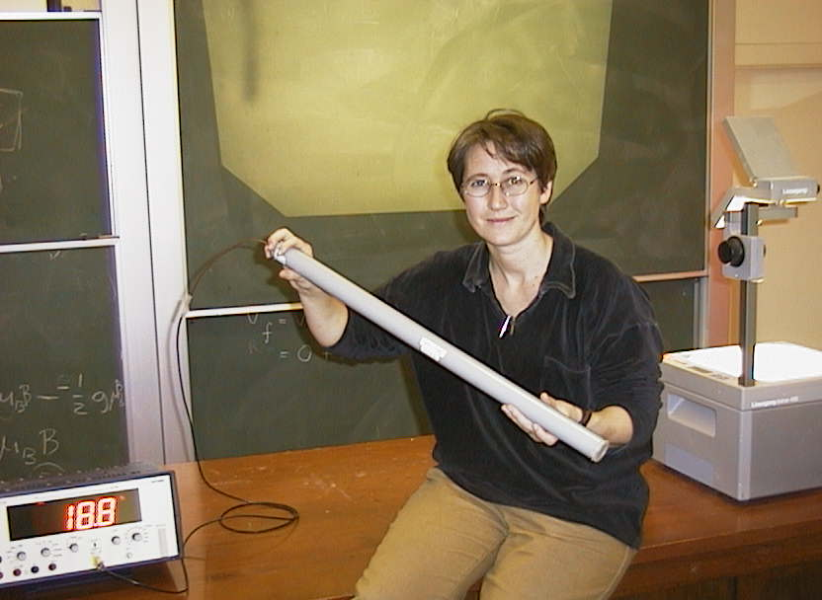

A tutor at the University of Sydney demonstrates the ball bearing tube.

Accompanying sheet

Ball Bearings

Check the temperature of the ball bearings inside of the tube.

Now shake the tube vigorously for a minute or more.

What is the temperature of the ball bearings now?
Why has it changed?

Could you use this technique to reheat a cold cup of coffee?

Bar Fridge

Apparatus
small bar fridge, or normal size fridge pulled away from a wall that groups of students can go and look at in small groups

Action
The students examine the fridge. They should identify the hot and cold reservoir and the location of the working substance. They then draw an energy flow diagram for the fridge. A small fridge brought in to the room on a trolley is excellent for large groups, small groups of students can be taken to a fridge if no small movable fridge is available.

The Physics
The cold reservoir of a fridge is the inside of the fridge. The hot reservoir is the outside air at the back of the fridge. An energy flow diagram is shown opposite.
You could not cool a room by leaving the fridge door open, even if the fridge were 100% efficient, the temperature would be unchanged. The second law of thermodynamics says that it is impossible to transfer heat from a cold reservoir to a hot reservoir with no other effect. The other effect is that work must be done, and some of this work is invariably dissipated as heat. The nett effect of leaving the fridge door open is to make the room hotter, although it may be slightly cooler directly in front of the fridge door.
Hot Reservoir
Cold Reservoir
refrigerator
Q_{H}
Q_{C}
W

Accompanying sheet

Bar Fridge

Inspect the back of the bar fridge.
Identify the heat reservoirs.

Draw an energy flow diagram for fridge.

Could you cool a room by leaving the fridge door open?

Bicycle Pump

Apparatus
bicycle pump or large syringe with thermocouple mounted inside and attached to a digital multimeter or thermometer

Action
The students cover the air nozzle with a finger so that the air cannot escape. They then pump the pump and measure the change in temperature.

The Physics
The air in the sealed off pump is compressed quickly, hence work is done on the air. There is little time for heat transfer to occur, so Q ~ 0, and the change undergone by the gas is a good approximation to an adiabatic process. The increase in internal energy is indicated by the rise in temperature, which is detected by the thermocouple inside the pump. Hence energy is conserved (first law) – the work done is converted to thermal (internal) energy of the air in the pump.

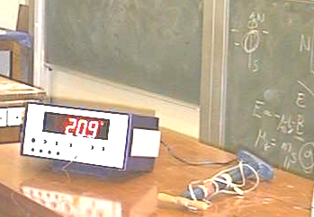

Accompanying sheet

Bicycle Pump

Note the temperature of the air inside the pump.
Put your finger on the end of the nozzle so that the air in the pump is trapped.

Pump the bicycle pump and feel what happens to the cylinder.

Measure the change in temperature.
Explain your observations using the first law of thermodynamics.

Blackbody Radiation

Apparatus
graphite rods from refillable pencils, variable power supply, stand with clips to hold the rods
A rod is held by insulated clamps on the stand and the terminals of the power supply connected to each end.

Action
The students vary the voltage across the rod and see what happens. They should do this slowly. The rod will begin to glow and may eventually burn out. The power supply should be turned off and reset to minimum power before another rod is connected (if you have many groups or multiple tutorials).
If you have small hand held spectroscopes the students can observe the rod through the spectroscope and try to estimate the wavelength of maximum intensity (although this is difficult).

The Physics
As you turn up the power supply the voltage across the graphite gets greater. This gives a bigger current through the graphite, and more power dissipated in it, hence it gets hotter. As it gets hot it begins to glow. Initially it glows red, and as it heats up more it glows orange and yellowish. If you could get it hot enough without melting it, it would glow white hot and eventually blue and ultraviolet. The rod is behaving like a black body and obeying Wein’s law, which says that the intensity of radiation increases and the wavelength of peak intensity decreases as the object gets hotter.

Accompanying sheet

Blackbody Radiation

Gradually turn up the power passing through the graphite.

What happens as you increase the power?

Explain your observations.

The Black Box

Apparatus
sturdy box, painted white inside, with a well-sealing lid and a small hole drilled in the side (a few mm diameter)

Action
The students look into the box and try to say what colour it is inside. They then open the box and see. They should explain why the box appears to be black inside, and relate this to the definition of a blackbody as a perfect absorber.

The Physics
When you look into the hole you see blackness, even though the inside of the box is white. This is because the hole is very small, and no light can get out of it to your eye. Black is an absence of light, and as there is no light in the box it appears black, just as a window to an unlit room is black regardless of the colours of the room. When the box is open light is reflected and you can see that it is white inside. A cavity or box with a small hole is a good approximation to a black-body because all light entering the hole is trapped, so the absorption is very high.

Accompanying sheet

The Black Box

Look into the hole. What colour do you see?
Now open the lid. What colour is the inside of the box?

Why is it so? How can you explain your observation?

How good an approximation to a perfect black body is the hole in this box?

Blowing

Apparatus
nothing – students use their own hands and mouths, although a cup of warm water for them to blow across may help

Action
The students blow across the cup (real or imaginary) as if they were trying to cool it in preparation for drinking it. They should observe each other doing this, and note how hard they blow, and the shape of the mouth. They then blow on their hands to warm them. They should note what they do differently when they blow to cool something to when they blow to warm something, and explain how each works.

The Physics
When you blow on your hands to warm them you do so with your mouth fairly open, and you puff on your hands, held close to your mouth. The air coming out of our mouth is at, or close to, body temperature, so it feels warm against your hands which are at a lower temperature.
When you blow on food or drink to cool it you purse your lips and blow a stream of air over it. As the air comes out of your mouth its volumes can expand as the pressure around it drops. As the volume increases the air cools, so it is cooler than body temperature, and quite a lot cooler than hot drink temperature. The flow of air helps increase cooling by convection.

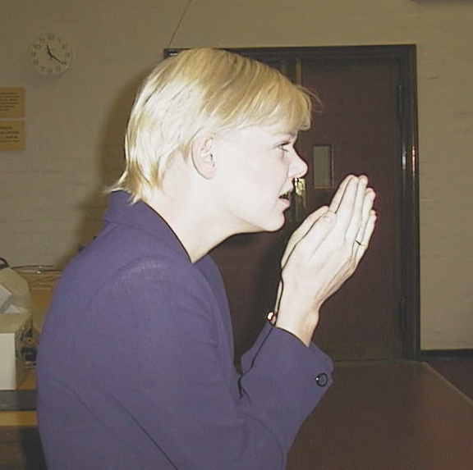
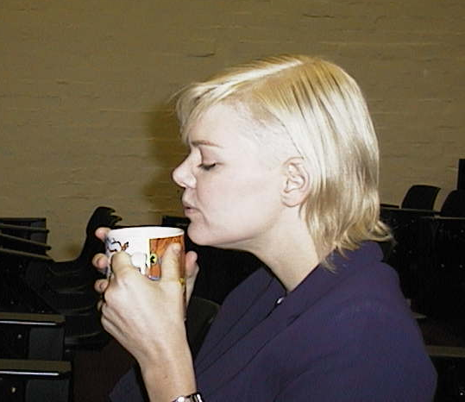

Blowing to heat (left) and blowing to cool (right)

Accompanying sheet

Blowing

Blow on your hands as if it was a cold day and you were trying to warm them.
Now blow as if you were blowing a hot drink to cool it.

How can you both heat and cool by blowing?

What do you do differently in each case, and why does it work?

Boyle’s Law

Apparatus
Boyle’s law apparatus: a hand or foot pump connected to a column of oil and a pressure gauge. It helps to have a valve fitted between the pump and column/gauge so that the students can pump to a given pressure, then close the valve to keep the pressure constant while they take a reading.

Action
The students pump with the valve open, increasing the pressure and pushing the oil column upwards. This compresses the air above. They pause a few times, close the valve, and take a pressure and volume reading of the air above the oil.

The Physics
The pressure is transmitted evenly through the oil, compressing the air above. The volume of the air decreases as pressure increases.
Boyle’s law states that volume varies inversely with pressure, (P ∝ $\frac{1}{V}$) however there may be small differences due to experimental error. This is a special case of PV = nRT, when T, and n are held constant.

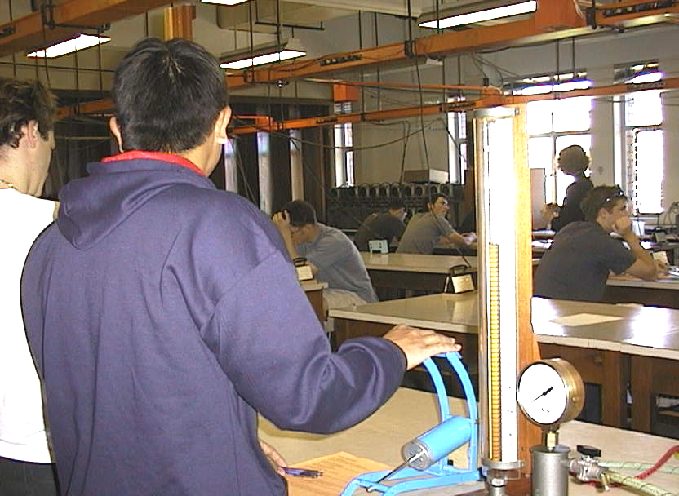

Students at the University of New South Wales using the Boyle’s law apparatus.

Accompanying sheet

Boyles Law

Use the pump to apply pressure to the oil column.
What happens as you increase the pressure?
What is happening to the volume of air above the oil?

Take a four or five readings of pressure and volume.
How does volume vary with pressure?
Sketch a graph of volume as a function of pressure.

Cooling by Evaporation

Apparatus
face washer, water (at room temperature), thermometer

Action
The students dip the face washer into water and squeeze out the excess. They then measure the temperature of the face washer. The students then wave or flap the face washer around for 30 seconds to a minute, and measure the temperature again.

The Physics
Evaporative cooling is a very effect means of cooling, and the temperature of the wet face washer will be measurably lower. Temperature is a measure of the average kinetic energy of the molecules of the face washer and water. The actual kinetic energies have a distribution of values, and those molecules with a high kinetic energy may break the bonds linking them to the rest of the water, and leave the surface – this is evaporation. The remaining water molecules have a lower average kinetic energy, and hence a lower temperature. Another way to look at it is to say that it takes energy (latent heat) to evaporate the water, and some of this must come from the face washer, hence cooling it down.

Accompanying sheet

Cooling by Evaporation

Dip the face washer in water and then squeeze most of the water out.
Measure the temperature of the moist washer.

Now wave the washer in the air.

Measure the temperature again. Has it changed? Explain why.

The Drinking Bird

Apparatus
toy drinking bird, also called the “dippy bird”
These come in several varieties – the glass ones are best so the students can see the fluid inside. They are available from some toy shops and places that sell “executive” toys.

Action
The drinking bird is set drinking from a glass of water. The students examine the bird, and explain why it continues to dip and drink and bob up again.

The Physics
The drinking bird works by evaporation of ether inside its body and evaporation of water outside its head. The liquid ether in its body evaporates at room temperature. As it vaporizes it creates an increased pressure inside the body, which pushes liquid ether up the tube to the head. Ether in the upper bulb (the head) is cooled by the evaporation of water on the outside of the head, and becomes a liquid, thus there is a transfer of ether from the lower (body) to the upper (head) bulb. When enough ether has collected in the head it overbalances the bird which pivots forwards. When the bird pivots forwards the ether runs back to the body, which pulls it upright again. The pivot tips the head into a glass of water, which wets the head, allowing it to cool again, and condense the evaporating ether again - repeating the cycle over and over.
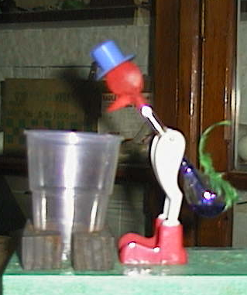
evaporation
from body
pressure pushes ether up tube
ether runs back down
bird rights itself, start cycle again!
1.
2.
3.
4.

Accompanying sheet

The Drinking Bird

The toy drinking bird has ether inside its body
and a head-of-felt which soaks up water.

Liquid ether evaporates rapidly at room temperature.

Use diagrams to explain why the drinking bird behaves in the way it does.

Dropper

Apparatus
eye-dropper or Pasteur pipette with rubber teat, cup of water

Action
The students use the dropper to pick up some water. They should do so, and then consider what they did in order to pick the water up, and why the water stays in the dropper or pipette when lifted out of the glass.

The Physics
When you squeeze the rubber top on the dropper you squeeze the air out. Then when you put the tip into the liquid and stop squeezing the top, the low pressure inside sucks up the liquid. In fact it is the higher pressure outside the dropper, in the liquid, that pushes the liquid up into the dropper. The liquid is held in by the lower pressure in the tube than the external atmospheric pressure.
squeeze and the liquid comes out
liquid is held in by the pressure difference
P_{atmospheric}
P < P_{atmospheric}
P > P_{atmospheric}

Accompanying sheet

Dropper

Use the dropper to pick up some liquid.

What holds the liquid in the dropper?

Explain why it doesn’t fall out.

Heat and Work

Apparatus
There are three sets of apparatus for this activity:
1 – an insulated container, for example a cheap thermos, with a piston that can be slid up and down in it keeping the air inside sealed in. This can be cut from cork or polystyrene with a handle attached.
2 – a thin, non-insulated tin, for example a milo tin with the lid firmly on, placed on a stand so it can be heated. Some matches or a Bunsen burner to heat the tin.
3 – a thin, non-insulated tin with a sliding lid, for example a tall narrow 1 litre fruit juice tin with a cork piston (not polystyrene or something that melts at low temperature), which fits snugly into the tin but can slide. Greasing the inside of the tin may help. A load such as a rock or large bunch of keys placed on top. This is all placed atop a stand so it can be heated from beneath with a Bunsen burner or matches.

Action
1 - The students push the piston down into the container.
2 – the students heat the container with the lid on.
3 – the students heat the container with the load in place.
The students determine which process is adiabatic, which is isochoric and which is isobaric.
They should determine the sign of the heat, work and change in internal energy for each process.

The Physics
1 - the piston is pushed into the insulated cylinder. This is adiabatic, the insulation prevents heat transfer.
2 - the gas inside the tin is heated with the lid on. This is isochoric – the volume is kept constant.
3 - the gas is heated with the sliding lid on, and a load on top – this is isobaric as the weight on top of the lid keeps the pressure constant.
 | process 1 | process 2 | process 3
Heat (+ is in) | 0 | + | +
Work (+ is out) | - | 0 | +
ΔU | + | + | +
work
gas
gas
heat
heat
gas
load
1.
2.
3.

Accompanying sheet

Heat and Work

There are three processes to perform.
In each case, consider what happens to the gas inside.

1. Push the piston down into the insulated cylinder.
2. Heat the gas inside the tin with the lid on.
3. Heat the gas with the sliding lid on, and a load on top.

Which, if any, of these processes is adiabatic, isochoric or isobaric?
Draw a table showing heat, work and change in internal energy for each process.

A Hot Bath

Apparatus
test tube, small measuring cylinder, water, thermometer, matches

Action
The students put 5 ml of water into the test tube, and measure the temperature of the water. They then light a match and hold it under the tube until it burns down to almost the end. They measure the temperature of the water again and calculate, using the heat capacity, the energy gained by the water. They can then calculate how many matches would be needed to heat a bath tub full of water to a comfortable temperature.
Note – the thermometer should have a small thermal capacity, for example a thermocouple with small probe.

The Physics
The energy gained by the water is the E_{match} = 4180 J.kg⁻¹.K⁻¹ × m × ΔT. This is the energy supplied by the match. A bath tub contains around 300 l or 0.3 m³ which is around 300 kg of water. A nice hot bath is around 50ºC, and tap water is typically at around 20ºC, so you need a temperature change of 30ºC. This requires an energy of E = 4180 J.kg⁻¹.K⁻¹ × 300 kg × 30 K = 38 MJ of energy.
If one match gives you E_{match}, then you need around (38 × 10⁶ J / E_{match} ) matches to heat up water for a bath.

Accompanying sheet

A Hot Bath

Pour about 5 ml of water into a test tube.
Measure the temperature of the water.

Hold a match under the test tube
and note the change in temperature of the water.

How much energy is gained by the water.

Estimate how many matches you need to take a hot bath

Keeping Warm or Cool

Apparatus
hot water bottle, ice pack, wheat heat pack, other hot and cold packs, preheated or cooled

Action
The students examine the hot and cold packs and measure their temperature. They then wait a while and measure the temperatures again. They should comment on the rate of cooling and explain why these materials are used.

The Physics
Hot water bottles and ice-packs rely on the high heat capacity of water to keep other items hot or cold. The water can lose or gain a lot of energy while changing temperature very little compared to most other substances. Other materials, such as wheat, are also used to fill heat packs.

Accompanying sheet

Keeping Warm or Cool

Examine the collection of items which are used to keep other objects hot or cold.

What do these objects have in common?

Measure their temperatures now and a little while later.

Have their temperatures changed significantly?

Macroscopic States and Microscopic States

Apparatus
10 or 20 plastic discs with a different colour on each side, for example the game pieces from an Othello set or even coins
(Note that in the workshop sheets we refer to green and blue.)

Action
The students examine the discs and experiment with the number of possible microstates they can produce with 2 or more discs. They should relate the number of microstates to the entropy of the system. Beginning with two discs, they count the number of microstates possible, and how many ways they can produce a given macrostate – half blue, half green facing up. They then repeat this with four discs, and consider the general case of increasing the number of discs.

The Physics
With two discs there are four possible microstates. B is blue side up, G is green side up. The possible states are BB, BG, GB, GG.
The macroscopic state of half of the discs facing up to be blue and the other half to be green has a probability of ½, as two of the four possible microstates give this macrostate.
With four discs there are 2×2×2×2 = 16 possible microstates. These are BBBB, BBBG, BBGB, BBGG, BGBB, BGBG, BGGB, BGGG, GBBB, GBBG, GBGB, GBGG, GGBB, GGBG, GGGB, GGGG. The probability of half the discs green add half blue is now 6/16 = 3/8. The probability has decreased.
In general, the more possible microstates there are, the less probable a given macrostate becomes. As the number of components increases, so does the possible number of microstates, and so does the entropy of the system.

Accompanying sheet

Macroscopic States and Microscopic States

Take two discs from the container.
How many microstates are possible? List the microstates.
Consider the macroscopic state (also called simply a state)
of half of the discs facing up to be blue and the other half to be green.
What is the probability of this state?

Now take 4 discs instead of 2. How many microstates are possible now?
What is the probability of half of the discs facing up
to be blue and the other half to be green now?

Measuring Air Temperature

Apparatus
thermometers, lamp or sunny area

Action
The students use the thermometers to measure air temperature in the sun and in the shade. They should compare the two readings and explain why they are so different even though the air temperature is not much different. They should try to explain what (literally) a thermometer is measuring the temperature of.

The Physics
A thermometer always measures its own temperature. If it is in the shade, it reaches thermal equilibrium with the surrounding air molecules and measures that temperature. When heated by the sun's radiation it measures its own raised temperature. The equilibrium temperature is greater than the air temperature because the thermometer is being heated by absorbing more heat from radiation. Hence the thermometer under the light is not measuring air temperature, only its own temperature.
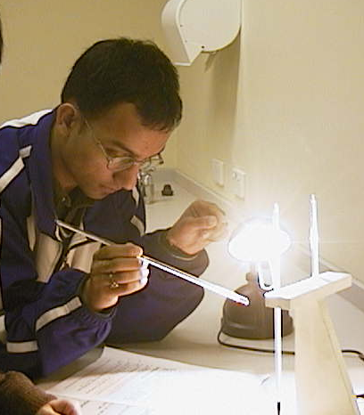

A student at the Australian Catholic University using a thermometer to measure temperature in front of a light.

Accompanying sheet

Measuring Air Temperature

Check the readings on the two thermometers.

Now put one of them under the light or in the sun for a few moments.

How do the readings compare now?
What does a thermometer actually measure?

Multiplicity

Apparatus
six or more balls or molecular models, box with two or more compartments

Action
The students experiment with the different possible microstates of this system. They should try to find how many ways each macrostate is possible, defining as they go what a microstate is and what a macrostate is. They should recognise that the greater the possible number of microstates, the higher the probability of that macrostate, and the greater the entropy of the system.

The Physics
There are 6 identical “molecules” and a box with two parts.
The possible states, written (X,Y) where X is the number in one side and Y is the number in the other are: (6,0) (5,1) (4,2) (3,3) (2,4) (1,5)(0,6). The multiplicity, W, of a state is the number of different ways in which that state can be achieved. It is equal to W=N!/n₁!n₂!. So in this case the multiplicities are: 1, 6, 15, 20, 15, 6, 1. There are 1 + 6 + 15 + 20 + 15 + 6 + 1 = 64 possible states in total.
The equilibrium condition is the most probable state – in this case the state with 3 molecules in each half of the box. This is also the most disordered state, and hence it has the greatest entropy.

Accompanying sheet

Multiplicity

You have 6 identical “molecules” and a box with two parts.
What are the possible states
(i.e. combinations of number of molecules in each half of the box)?

What is the multiplicity of each state?
How many possible microstates are there altogether?

Which of these states would be the equilibrium condition?
What can say about the order and entropy of this state?

Stirling Engine

Apparatus
small working Stirling engine

Action
The students set the engine going and observe the cycle. The students are provided with a schematic drawing of the Stirling cycle. They should try to follow the cycle on the real engine, and identify the heat reservoirs. They then draw p-V diagrams for the four stages. Note – specific instructions for individual engines may be necessary. (An addition schematic diagram is included on the next page.)

The Physics
There are four processes in the Stirling cycle:
1. Isothermal expansion at T_{H}. Left piston moves down and heat Q_{H} is transferred to the gas from the left cylinder wall, which is kept hot by the heat reservoir at T_{H}.
2. Constant volume process – temperature decreases from T_{H} to T_{C} as hot gas passes through the wire mesh. The gas heats the mesh. The volumes change by equal amounts.
3. Isothermal compression at T_{C} back to original volume. Heat Q_{C} is lost from the gas on the right hand side to the cold reservoir.
P
V
P
V
P
V
3
P
V
4
1
2
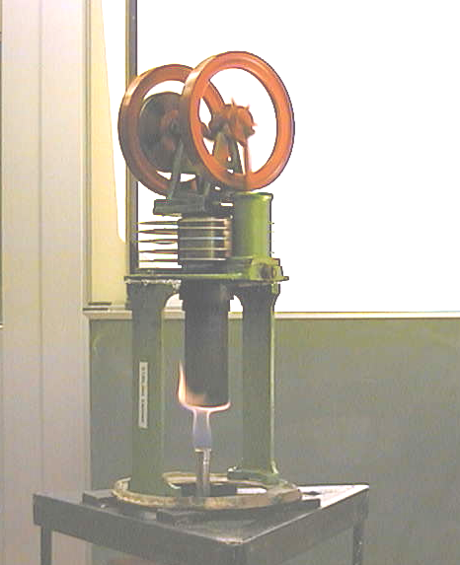
4. Constant volume process – temperature increases from T_{C} to T_{H}, cold gas is pushed across the hot wire mesh and the changes in volume of the two cylinders are equal.

Accompanying sheet

Stirling Engine

Set the Stirling engine running.

Examine the Stirling engine and compare the up and down strokes of the engine
to the four stages of the Stirling cycle on the schematic diagram.

Draw p-V diagrams for the four stages.

Diagram of Stirling cycle - can be enlarged and included with instruction sheet for students to refer to.

T_{H}
T_{C}
Q_{H}
T_{H}
T_{C}
gas flow
T_{H}
T_{C}
Q_{C}
T_{H}
T_{C}
gas flow
1. expansion stroke
2. constant volume
3. compression stroke
4. constant volume

Stubby Holder

Apparatus
one or more stubby holders, two or more cans of soft drink which have been in the fridge for some hours before hand, one of which has since been in a stubby holder, the other not
extras- piece of wetsuit material, small container of water

Action
The students measure the temperature or simply feel the temperature difference between the two cans. They should describe which processes of heat transfer are affected by the stubby holder.
If wetsuit material is available then they can also wet their hand and compare how cool or warm it feels when uncovered and when covered by the wetsuit material.

The Physics
A stubby holder works the same way as a wetsuit, and is often made of similar material. The stubby holder prevents heat loss by convection and conduction. A wetsuit works by decreasing conduction, and by trapping a layer of water against the skin it prevents convection, hence a wet hand covered by wetsuit material will feel warm, while an uncovered wet hand cools quickly. The stubby cooler and wetsuit prevent evaporative cooling. If the temperature difference is great enough the students will observe droplets of condensation on the cold uncovered cans, but not on the stubby holders containing cans.


water
wetsuit material
stubby holder
D
brown
elephant
cans of soft drink
Physics
keeping it cool
www.aip.org.au

Accompanying sheet

Stubby holder

Measure the temperature of the can which has been sitting out of the fridge.
How does it compare the one which has been out but in the stubby holder?

How does the stubby holder keep the can cool?
Which process of heat transfer is affected?

Thermal Conductivity

Apparatus
blocks of wood or plastic, polystyrene, metal or glass, multimeter with thermocouple or digital thermometer with probe, masking tape

Action
The students feel each block and rank the blocks in term of warmest to coldest. They then measure the temperature of each block by taping the probe to each block in turn.
Note that the blocks shouldn’t be handled too much or they can warm up from the students hands.

The Physics
Many students are surprised to find that the blocks are all at the same temperature (within a small range). The blocks are all at room temperature, as they are in thermal equilibrium with the air in the room. Your skin is usually a little warmer than room temperature, and when you touch something like metal it feels cold because heat is quickly conducted away from the skin by the metal. Wood and polystyrene are good insulators, and do not conduct heat away from your skin, hence they feel warm. What are you are really feeling when you feel for “temperature” is the rate at which heat is transferred to or from your skin. Hot water feels hotter than air of the same temperature and will burn when air will not.
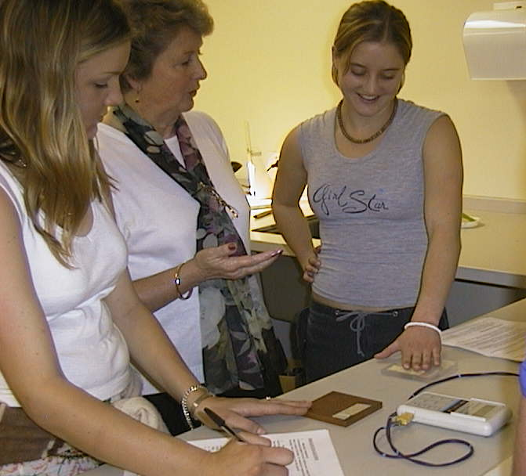

Students at the Australian Catholic University comparing the thermal conductivity of different materials.

Accompanying sheet

Thermal Conductivity

Feel the different blocks.
Which feels the coldest? Which feels the warmest?

Now measure their temperatures.
Which is the warmest? Which is the coldest?
Explain your observations.

Thermal Expansion of Gases

Apparatus
a small flask with an open top slightly smaller than a 20 cent coin, 20 cent coin, some water and ice for cooling

Action
The flask is cooled and the coin placed over the top and sealed with a little water. The students then place their hands around the flask. This causes the coin to jump up slightly as gas escapes.

The Physics
The heat from the student’s hands causes the gas inside the bottle to expand, increasing the pressure inside the bottle. When the force due to the pressure of the gas is greater than the weight of the coin it pops up, allowing some gas to escape and equalizing the pressure.

Accompanying sheet

Thermal Expansion of Gases

Cool the bottle using the ice, then take it out.
Wet the coin and place it on top of the bottle.

Now cup your hands around the bottle and observe what happens.

Explain your observations.

Thermal Expansion of Liquids

Apparatus
flask containing liquid with high coefficient of thermal expansion – such as ethanol with a bit of food colouring- with cork stopper fitted with a glass tube

Action
The students cup their hands around the flask and observe the rise of the liquid in the tube.

The Physics
The liquid expands as it is heated. The heat from the hands increases the kinetic energy of the molecules in the liquid, so they move faster on average and tend to move further apart as the collide and bump around. This results in an expansion of the liquid. The expansion is easy to see in the tube, but very difficult to see without one. Note that there is a small rise in the tube due to capillary motion before the flask is heated.

Accompanying sheet

Thermal Expansion of Liquids

Hold the beaker in your hands.

What happens to the liquid in the tube?
Explain what you observe.

Thermal Expansion of Solids – Bimetallic Strip

Apparatus
bimetallic strip clamped on a retort stand, hair dryer or hot glue gun or some other (safe) means of heating the strip

Action
The students heat the strip and observe what happens to it. They should try to explain their observations and give an example of how such a strip could be used.

The Physics
The bimetallic strip is made of two metal strips, stuck together. One of the metals expands much more than the other when they are heated. This causes the strip to bend. A bi-metallic strip can be used as a sensor in a thermostat. When the strip starts to get hot, it will bend, and can be used as a switch which either closes or opens a circuit as it bends to or away from a contact.

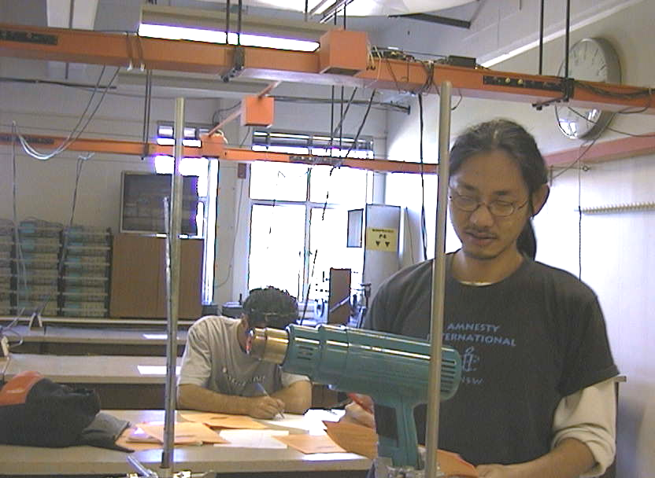
bimetallic strip bent due to heating

Accompanying sheet

Thermal Expansion of Solids – Bimetallic Strip

Heat the strip using the hot air gun.

What happens to the strip, and why?

Can you think of a use for such a strip?

Thermal Radiation – the Leslie Cube

Apparatus
thermopile (infrared detector), a Leslie cube on a stand, thermometer with thermocouple or probe
A Leslie cube is a hollow metal cube with claddings of different types – for example a painted shiny black side, a painted matt black side, a shiny metal side and a dull metal side. The cube should have a lid on top and be filled with very hot water (boiling water if possible).

Action
The students aim the thermopile at the different sides of the cube and see which side radiated the most. They can measure the temperature of each side to confirm that they are all at the same temperature.

The Physics
The greater the emissivity, ε, of the surface the more it will radiate for a given temperature. The quantity ε takes values between 0 and 1 depending on the nature of the surface radiating heat, a perfect radiator of heat has ε = 1 and is called a blackbody radiator. To a good approximation, all the sides (surfaces) of the cube are at the same temperature - the cube contains hot water and the cube’s sides are made of thin sheet metal, a good conductor of heat. The surfaces with the greater emissivity – matt black, shiny black (in that order) will radiate the most and have $e»1$ whereas shiny, polished metal (like a new stainless steel kettle) may have $e»0$.

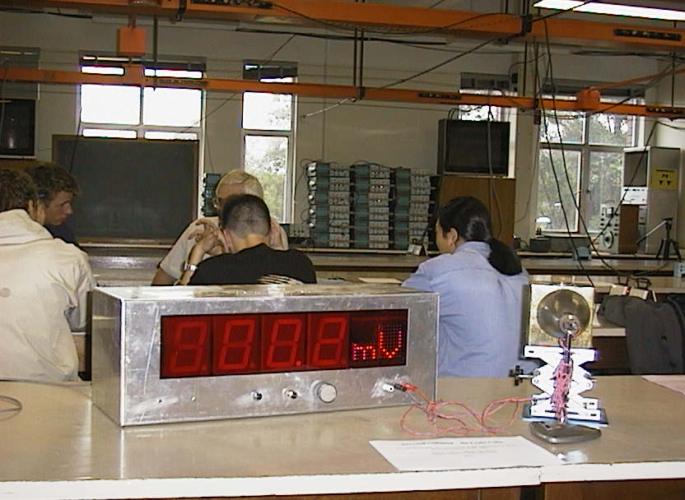
Thermopile detector in front of the Leslie cube in a workshop tutorial at the University of New South Wales

Accompanying sheet

Thermal Radiation – the Leslie Cube

Check the temperatures of the different sides to see that they are the same.

Now use the thermopile detector to measure
the radiant heat from the different surfaces of the cube.

Which surface radiates the most?
Which surface radiates the least?
Why?

Thermometers

Apparatus
a selection of thermometers including digital thermometer, liquid in glass for people or fish tank, liquid in glass for confectionary or baking, and whatever else is available, for example constant volume gas thermometer, colour changing strips.

Action
The students examine the various thermometers and take some temperature readings. They should identify (if possible) what physical property, which changes with increasing temperature, is used by the various thermometers. They should also try to identify when such a thermometer might be used.

The Physics
A liquid in glass thermometer uses the thermal expansion of a liquid to measure temperature. The scale is calibrated to read the temperature as a function of the volume of the liquid. The coefficient of expansion of the liquid and the room available for expansion determine the temperature range that the thermometer is used for. A “people” thermometer is very accurate, but reads over a small range of temperatures. A confectioners thermometer reads to very high temperatures, but is not very accurate.
Constant volume gas thermometers use the thermal expansion of a gas, which results in increasing pressure as the volume of the gas is fixed. The pressure then tells you the temperature.
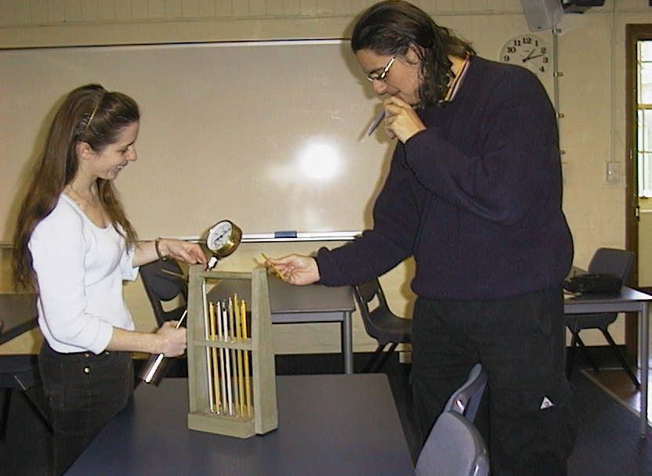
Digital thermometers use a change in electrical resistance with temperature. There are two types – those that have an increasing resistance with increasing temperature, and those that have a decreasing resistance with increasing temperature. The change in resistance is determined by the material the sensor is made out of. (This is covered in more detail in the thermocouples and thermistors activity in the Quantum, Atomic and Nuclear section.)

Students at the University of Sydney examining a range of thermometers.

Accompanying sheet

Thermometers

Examine the different thermometers on display.

What physical property do they use to measure temperature?

What would you use these thermometers for?

Thermos Flask

Apparatus
good quality thermos flask with silvered lining filled with hot water

Action
The students examine the flask and explain how the three processes of heat transfer are affected by the flask. They should note that while the liquid inside is hot, and hence the inner wall is also hot, the outer wall is at approximately room temperature.

The Physics
A thermos flask has double walls, which are evacuated and the vacuum bottle is silvered on the inside. The vacuum between the two walls prevents heat being transferred from the inside to the outside by conduction and convection. With very little air between the walls, there is almost no transfer of heat from the inner wall to the outer wall by convection. Conduction can only occur at the points where the two walls meet, at the top of the bottle and through an insulated support at the bottom. The silvered walls reflect radiated heat back to the inside, the same way a space blanket does. The diagram below shows a cross section through a thermos.

insulated cap
silvered inner wall
vacuum between glass walls
outer casing of plastic or metal
insulated support
hot
coffee

Accompanying sheet

Thermos Flask

Examine the thermos flask.
It has a thick stopper, double walls which are evacuated,
and the vacuum bottle is silvered on the inside.

Explain how this keeps drinks either hot or cold.
What processes of heat transfer are affected?

Water Boiling at less than 100º C

Apparatus
large syringe containing warm water (hot tap water)

Action
The students close the end of the syringe and pull back on the plunger rapidly. This will cause the water inside to boil and bubbles will be visible.

The Physics
Boiling happens when evaporation occurs beneath the surface of a liquid, forming bubbles of vapour which rise to the surface and escape. The pressure inside a bubble has to be equal to the pressure outside for the bubble to exist. The pressure outside the bubble depends on the temperature of the water and the pressure above the liquid. If you decrease the atmospheric pressure then the pressure required inside the bubble lowers and the molecules in the liquid don’t need to move as fast to exert this pressure on the bubble. So the boiling point decreases.
When the syringe is pulled suddenly, the volume increases, so pressure decreases and boiling point decreases.
At high altitudes where the atmospheric pressure is lower the boiling point of water is lower.
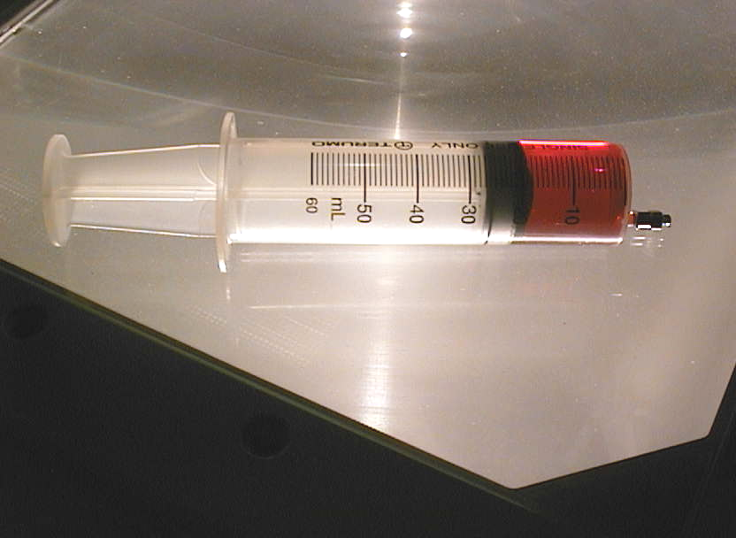
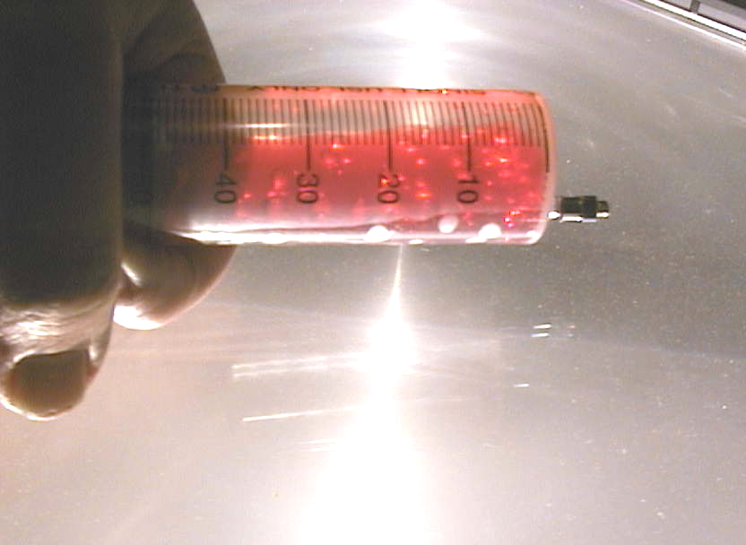

The syringe contains water and food colouring so that the bubbles are easier to see. The water boils, forming bubbles when the plunger is pulled causing a drop in pressure.

Accompanying sheet

Water boiling at less than 100º C

Close the end on the syringe by holding your thumb or a bit of cloth over it.

Now pull the plunger back rapidly.

What do you observe?
Why does this happen?
What happens to the boiling point of water at high altitudes?

