Electricity and Magnetism

Introductory Electricity and Magnetism Worksheets and Solutions

EI1: | Charge and Coulomb’s Law | 3
EI2: | Electric Fields | 7
EI3: | Electric Potential | 11
EI4: | Voltage and Current | 15
EI5: | Circuits | 19
EI6: | Electrical Safety | 23
EI7: | Magnetism | 27
EI8: | Electromagnetism | 31

Workshop Tutorials for Introductory Physics
EI1: Charge and Coulomb’s Law

A. Review of Basic Ideas:

Use the following words to fill in the blanks:
Coulomb’s, 1.6 × 10⁻¹⁹ C, electric, removing, neutral, negative, conserved, positive

Charge and electrostatic force
Electrical interactions play a key role in the chemical bonding of matter and in most biological processes such as seeing, feeling, moving and thinking. Electrical interactions occur between bodies and particles which have ________ charge which, like mass, is a fundamental property of matter.
Charge comes in discrete amounts and, like energy, it is always _________. The SI unit of charge is the coulomb (symbol C). The smallest possible discrete amount of charge, the elementary charge e, has a magnitude of _________. There are two types of electric charge, which have been arbitrarily labelled _______ and negative. Every electron has a __________ charge, of –1e ( -1.6 × 10⁻¹⁹ C), and every proton has a charge of +1e. An atom or molecule which has acquired a net electric charge by the addition or removal of a whole number of electrons always has a charge which is some positive or negative integer multiple of e.
__________ law describes the interaction between two charged particles which are not chemically bound to each other and which are at rest. The interaction involves a pair of forces as described by Newton’s third law of motion. Particle 1 exerts a force on particle 2 at the same time as particle 2 exerts a force on particle 1. These two forces have exactly the same magnitude but they act in opposite directions along the line joining the particles. If both charges have the same sign the two forces are repulsive but opposites attract each other. The common magnitude of the two forces is given by the formula: $F=k\frac{q_{1}q_{2}}{r^{2}}$.
where q₁ and q₂ are the magnitudes of the two charges and r is the distance between them; k is a universal constant; k = 9.0 × 10⁹ N.m².C⁻². Even if the charges are different the two forces still have the same magnitude.
The total amounts of negative and positive charge in the universe seem to be exactly balanced. Most objects normally have the same amount of positive charge as they do negative charge, and so are overall electrically _________. However it is possible to “charge up” an object by adding or _________ some charged particles such as electrons or ions. When you make an object negative by adding extra electrons, you must be getting those electrons from something which is becoming positive. The total amount of charge is conserved, it is just moved around.

Discussion Question
Why do you think it is easier to charge something up by the transfer of electrons rather than protons?

B. Activity Questions:

1. Tape Charge
Stick two strips of tape on to the desk, then peel them off.
Hang them close to each other and see what happens. Explain your observations.

2. van de Graaff generator
Stand on the insulating block and place your hand on the generator.
What do you feel?
What can you see when someone else is touching the generator?
Explain your observations.

3. Charged rods
Charge up the various rods using different materials.
How do the items become charged?
Balance a charged rod on a watch glass. How can you accelerate it without touching or blowing on it?

C. Qualitative Questions:

- Newton’s law of gravitation says that the force between any two objects with masses m₁ and m₂ is proportional to the product of the masses and decreases with the square of the distance between them:
F_{G} = $\frac{{\text{Gm}}_{1}m_{2}}{r^{2}}$.
How is Newton’s law of gravitation similar to Coulomb’s law? How is it different? What about the force between charges and masses?

2. In a simple (but not very accurate) model of the helium atom, two electrons (each of charge = -e) orbit a nucleus consisting of two protons (charge = +2e) and two neutrons (charge = 0). Is the magnitude of the force exerted on the nucleus by one of the two electrons less than the force exerted on the electron by the nucleus? Explain your answer.

D. Quantitative Question:

You are at the college ball and are about to impress all the girls with your levitating cat trick. You take a pair of identical, 2.0 kg, unconscious Persian cats from your bag and rub them vigorously against a glass table top. You then carefully place one cat on the (non-conducting) floor and hold the other a metre above it. There is an expectant hush as you let go of the raised cat.
- How much charge will you need to have accumulated on each cat’s fur (assuming the same on each) for the cat to levitate at 1 m above the other?
- How many excess (or deficit) electrons is this required charge equivalent to?
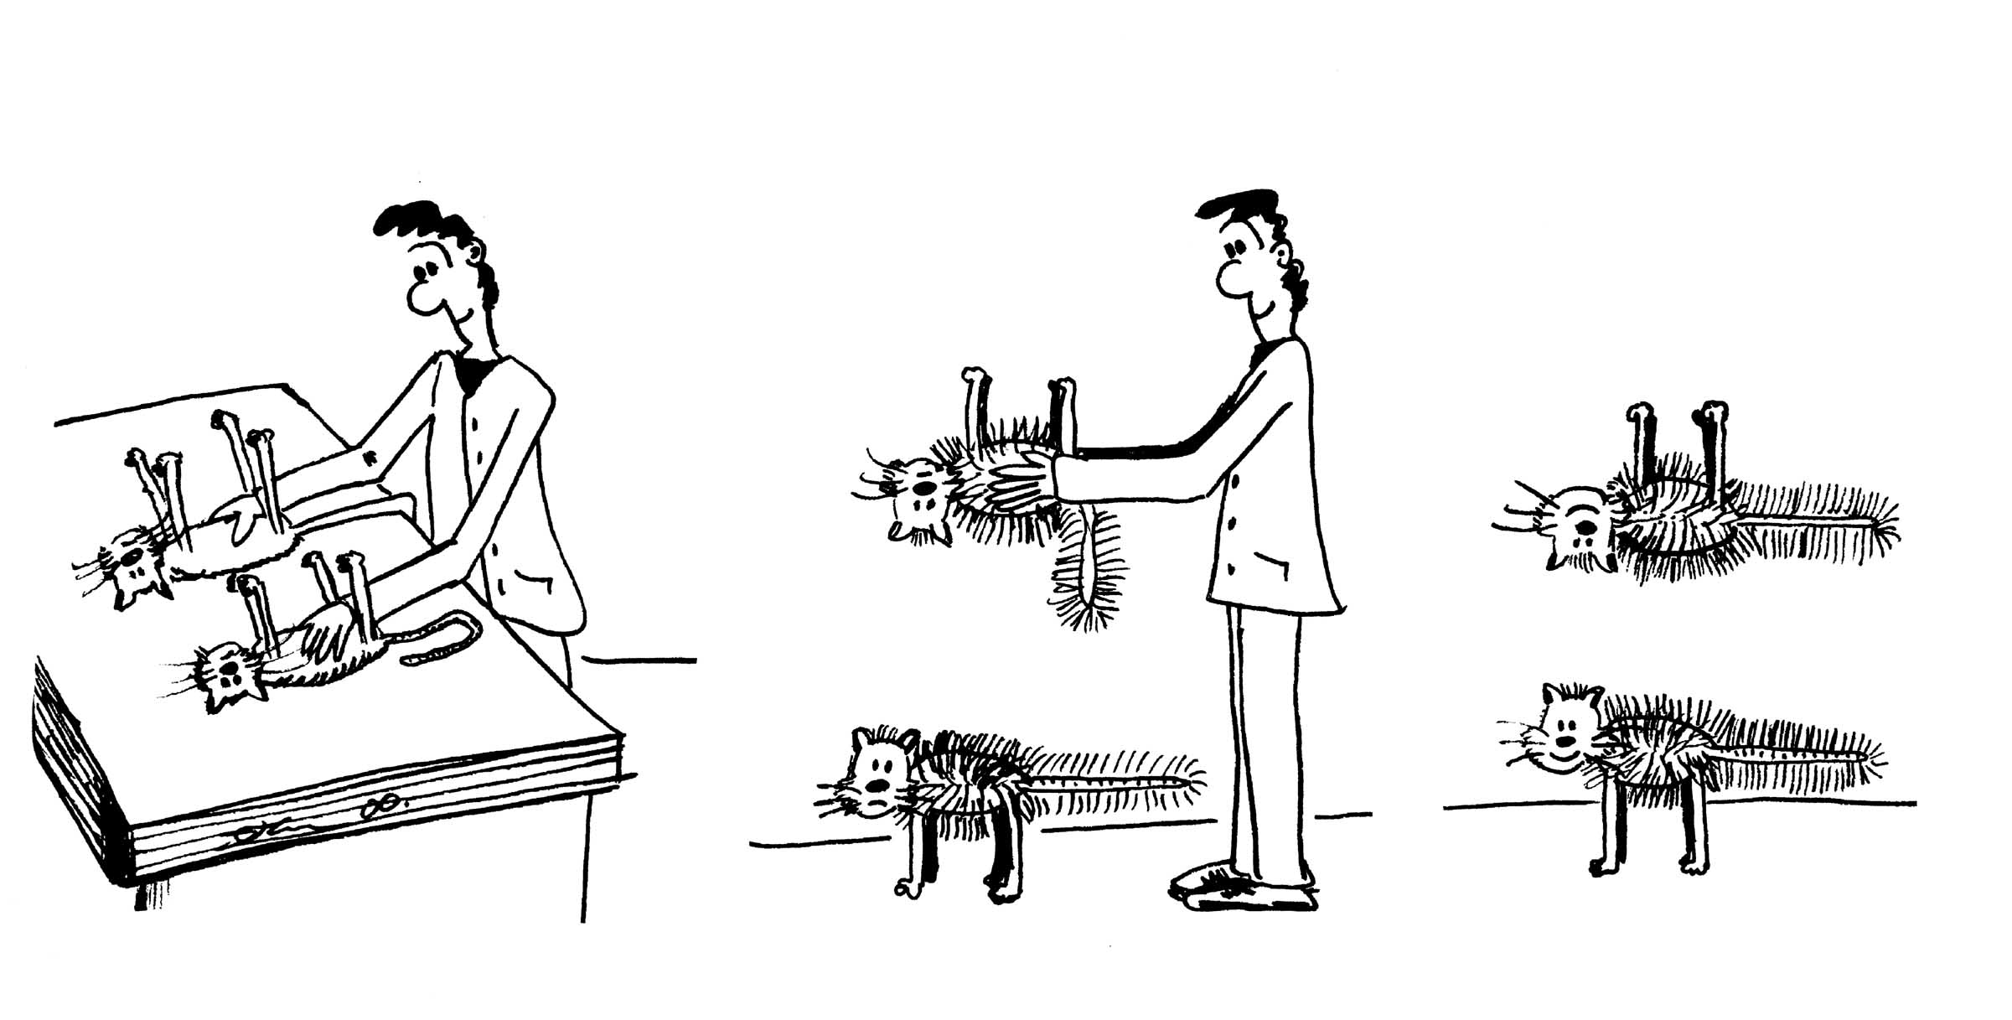
Workshop Tutorials for Introductory Physics
Solutions to EI1: Charge and Coulomb’s Law

A. Review of Basic Ideas:

Charge and Electrostatic Force
Electrical interactions play a key role in the chemical bonding of matter and in most biological processes such as seeing, feeling, moving and thinking. Electrical interactions occur between bodies and particles which have electric charge which, like mass, is a fundamental property of matter.
Charge comes in discrete amounts and, like energy, it is always conserved. The SI unit of charge is the coulomb (symbol C). The smallest possible discrete amount of charge, the elementary charge e, has a magnitude of 1.6 × 10⁻¹⁹ C. There are two types of electric charge, which have been arbitrarily labelled positive and negative. Every electron has a negative charge, of –1e ( -1.6 × 10⁻¹⁹ C), and every proton has a charge of +1e. An atom or molecule which has acquired a net electric charge by the addition or removal of a whole number of electrons always has a charge which is some positive or negative integer multiple of e.
Coulomb’s law describes the interaction between two charged particles which are not chemically bound to each other and which are at rest. The interaction involves a pair of forces as described by Newton’s third law of motion. Particle 1 exerts a force on particle 2 at the same time as particle 2 exerts a force on particle 1. These two forces have exactly the same magnitude but they act in opposite directions along the line joining the particles. If both charges have the same sign the two forces are repulsive but opposites attract each other. The common magnitude of the two forces is given by the formula: $F=k\frac{q_{1}q_{2}}{r^{2}}$
where q₁ and q₂ are the magnitudes of the two charges and r is the distance between them; k is a universal constant; k = 9.0 × 10⁹ N.m².C⁻². Even if the charges are different the two forces still have the same magnitude.
The total amounts of negative and positive charge in the universe seem to be exactly balanced. Most objects normally have the same amount of positive charge as they do negative charge, and so are overall electrically neutral. However it is possible to “charge up” an object by adding or removing some charged particles such as electrons or ions. When you make an object negative by adding extra electrons, you must be getting those electrons from something which is becoming positive. The total amount of charge is conserved, it is just moved around.

Discussion Question


Protons are in the nucleus of an atom, surrounded by electrons. It takes much less energy to move electrons from one atom to another than to break up the nucleus (nuclear fission) to allow protons to be moved. (An exception is the hydrogen nucleus which is a single proton.) Charging can also occur by moving whole atoms or molecules.
stick tape
on desk
pull off,
tape repels
B. Activity Questions:

1. Tape Charge
Large organic molecules, such as are found in sticky tape or combs and hair or glass/plastic and cloth/fur, break easily and leave these items charged. The tape pieces repel each other because they have picked up a net charge, so there is an electric field between them due to the charges. Hence they can interact without touching.

2. van de Graaff generator
van de Graaff
generator
flow of charges
You may feel tingly when you touch the generator, or you may feel nothing at all. The generator charges you up to a very high voltage, which means a lot of extra charges. Usually the dome becomes positive, so negative charges move from you to the dome, leaving you positively charged. People’s hair tends to stand up because the charges exert a repulsive force on each other, the hairs try to get as far away from each other as possible and are light enough to stand up and move apart.

3. Charged rods
The glass rods are charged by electrons moving between the rods and the fur or silk. The plastic rods are charged by organic molecules being broken and positively charged segments stripped from the rod.
You can accelerate the rod without touching or blowing on it by holding another charged rod close by. The charges on the rods interact via a field. They attract or repel each other, accelerating the rod balanced on the watch-glass.

C. Qualitative Questions:

- Comparing gravitational and electrostatic forces.
Newton’s law of gravitation says that the gravitational force between any two objects is proportional to the mass of the objects and decreases with the square of the distance between them: F_{G} = $\frac{{\text{Gm}}_{1}m_{2}}{r^{2}}$.
Coulomb’s law for electrostatics says that the force between any two charged objects is proportional to the size of the charges and decreases with the square of the distance between them: F_{E} = $\frac{{\text{kq}}_{1}q_{2}}{r^{2}}$.
Both have the same basic form in that the force varies inversely with r² and directly with either the mass or charge of the objects. However the Coulomb force is repulsive for like charges and attractive for unlike charges. The force of gravity is always attractive. Note also that there is only one sort of mass, positive mass, while in the case of electric charge there is both positive and negative charge.

- Coulomb’s law for electrostatics: F_{E} = $\frac{{\text{kq}}_{1}q_{2}}{r^{2}}$.
The force on one electron in the helium atom due to the nucleus is F = $\frac{{\text{kq}}_{1}q_{2}}{r^{2}}$=$\frac{k(−e)(2e)}{r^{2}}$,
where r is the distance from the nucleus to the electron, -e is the charge on the electron and +2e is the charge of the nucleus due to the two protons it contains.
The force on that one electron due to the nucleus is F = $\frac{k(−e)(2e)}{r^{2}}$, which has exactly the same magnitude as the force on the nucleus due to that electron, not less. Note that this is also the case for the gravitational force, the force on the Earth due to the gravitational attraction of a thrown tennis ball is the same as the force on the ball due to the earth. These are action reaction pairs, and Newton’s third law tells us that they must experience equal and opposite forces.

D. Quantitative Question:

The levitating cat trick.
- You require the electrostatic force up to equal the gravitational force down.
F_{elect} = $\frac{{\text{kq}}_{{\text{cat}}^{2}}}{r^{2}}$ =F_{grav} = mg
$\frac{9 × {\text{10}}^{9} N\text{.}m^{2}\text{.}C^{−2} × q_{{\text{cat}}^{2}}}{(1\text{.}0 m)^{2}}$= 2 kg × 9.8 m.s⁻².
q_{cat} ² = $\frac{2 \text{kg} × 9\text{.}8 m\text{.}s^{−2}× (1\text{.}0 m)^{2} }{9 × {\text{10}}^{9} N\text{.}m^{2}\text{.}C^{−2}}$ = 2.0 ×10⁻⁹ C²
so q_{cat} = 5.0 ×10⁻⁵ C.
- One electron has 1.6×10⁻¹⁹ C. The total number of electrons is the total charge / charge per electron: number of electrons = 5 ×10⁻⁵ C / 1.6×10⁻¹⁹ C per e⁻ = 3×10¹⁴ electrons.

Workshop Tutorials for Introductory Physics
EI2: Electric Fields

A. Review of Basic Ideas:

Use the following words to fill in the blanks:
electric, tangent, Newton’s, tractor, force, small, accelerates, positive, force fields, gravitational, lines, arrow

Electric Fields
In science fiction movies there are often _______ _______ protecting planets and spaceships from enemy attack, or being used in “_________ beams” to abduct people. In physics, fields are used to explain action, or force, at a distance. We constantly experience a force due to Earth’s gravitational field, even when we are not in contact with the Earth. Hence we are always trapped by the Earth’s ___________ force field. This is due to the interaction of masses at a distance. Electric charges also interact at a distance, attracting or repelling each other, and they do this via an ________ field.
The way we can tell if there is an electric field somewhere is to put a very ______ test charge at rest at that position and see if it experiences a force. The electric field, E, at a point in space is defined as the electric _______, F, acting on a ________ test charge divided by the magnitude of the test charge, E = F/q₀, where q₀ is the magnitude of the charge. So if our test charge ________, it must be experiencing a force, and hence there must be a field there. If we know the mass of the particle and we can measure its acceleration then we can find the force acting on it using _______ second law (F = ma). The field is then the force per unit charge at that point.
A convenient way of representing fields is by drawing field _______. We can draw a field line by imagining a test charge at a point and drawing an ________ showing the direction of any force acting on the test charge. At any point in space the ________ to the field line tells you the direction of the force acting on a test charge at that point.

Discussion Question
Explain why field lines lead away from positive charges and towards negative charges.

B. Activity Questions:

- van de Graaff generator and wig
Place the “wig” on the generator. What do you observe?
Explain your observations. Draw field lines for the dome of the generator.
What happens when a person, insulated from the ground, touches the generator?

- Confused bubbles
Bubbles blown towards a van de Graaff generator behave in different ways.
Identify some patterns of behaviour.
Are the bubbles initially neutral?
Why would bubbles be attracted or repelled by the generator?

- Ball in a capacitor
Explain what is happening to the ping pong ball.
Why is it behaving in this manner?
How would it behave if you removed the aluminium foil?
Draw the field lines for the capacitor plates.
C. Qualitative Questions:

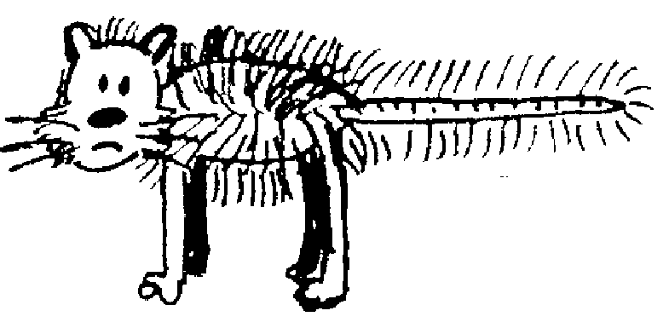
1. You charge up a cat by brushing it with a plastic comb so that the cat now has charge +q and the comb has charge –q. You charge up a test mouse to +1nC with a second comb, take that comb a long way away, then place the test mouse at different points in the room with the cat and the comb as shown below. (The room has a non-conducting floor.) Treat the cat and comb as point charges.
+q
-q
A
B
C
D
E
F

- Draw vectors showing the electric force on the test mouse at positions A, B, C, D, E and F. Draw the forces due to each charge and the net force.
- Rank the magnitudes of the electric force on the test mouse at points A, C, E and F.
- Rank the magnitudes of the electric field at points A, C E and F.
- Explain how and why your answers to part b are related to your answer for part c.
- Draw vectors showing the electric field at positions A, B, C, D, E and F. Use these vectors to help you draw field lines for the cat-comb combination.
- Are field lines “real”? Explain your answer.
V

2. Many factories use dust precipitators in their chimneys to remove airborne pollutants. The large electric field causes molecules to be ionized, and free electrons can attach to dust particles making them charged. The smoke or dust particles are attracted to the plates, and stick to them rather than being released into the atmosphere. The use of these precipitators has led to a major reduction in the levels of air pollution from factories.
In one such precipitator a pair of plates are placed in the square chimney with a large potential difference across them. A dust particle rising up the chimney has a charge of -1e.
- Draw field lines for the arrangement shown.
- Sketch the path of this particle as it ascends the chimney.
- Sketch the path of a dust particle with a charge -2e which is rising up the chimney. How will its path be different to that of the particle with charge 1e if they both have the same mass?

D. Quantitative Question:

When atoms form ionic bonds one electron is transferred from one atom to the other. This is how sodium and chlorine bind to form sodium chloride (salt). In a salt crystal the sodium is Na⁺ and the chlorine is Cl⁻, each with a charge of ±1e. They are separated in a salt crystal by 0.28 nm.
Consider only a single pair of ions, Na⁺Cl⁻, bound together.
- What is the field at a point halfway between the two ions?
- Draw a diagram showing the two ions. Draw a straight line between the two ions and extend it out to either side. Will there be any point on the line where the force on another Na⁺ ion will be zero? If so, show on your diagram approximately where this point would be.
- If you had a salt molecule with a calcium ion, Ca⁺⁺, in place of the Na⁺ would there be any point on this line where the second Na⁺ would experience no force? If so, show on your diagram approximately where this point would be.
- If there is such a point, what will the field at that point be?
Workshop Tutorials for Introductory Physics
Solutions to EI2: Electric Fields

A. Review of Basic Ideas:

Electric Fields
In science fiction movies there are often force fields protecting planets and spaceships from enemy attack, or being used in “tractor beams” to abduct people. In physics, fields are used to explain action, or force, at a distance. We constantly experience a force due to Earth’s gravitational field, even when we are not in contact with the Earth. Hence we are always trapped by the Earth’s gravitational force field. This is due to the interaction of masses at a distance. Electric charges also interact at a distance, attracting or repelling each other, and they do this via an electric field.
The way we can tell if there is an electric field somewhere is to put a very small test charge at rest at that position and see if it experiences a force. The electric field, E, at a point in space is defined as the electric force, F, acting on a positive test charge divided by the magnitude of the test charge, E = F/q₀, where q₀ is the magnitude of the charge. So if our test charge accelerates, it must be experiencing a force, and hence there must be a field there. If we know the mass of the particle and we can measure its acceleration then we can find the force acting on it using Newton’s second law (F = ma). The field is then the force per unit charge at that point.
A convenient way of representing fields is by drawing field lines. We can draw a field line by imagining a test charge at a point and drawing an arrow showing the direction of any force acting on the test charge. At any point in space the tangent to the field line tells you the direction of the force acting on a test charge at that point.

Discussion Question
Field lines show the direction of force on a positive test charge, the definition of the electric field is the force per unit charge on a small positive test charge. The force on a positive test charge due to another positive charge is always repulsive, the force is away from the positive charge, hence field lines point away from positive charges. A positive test charge will be attracted to a negative charge, and will experience a force towards the negative charge, hence field lines lead towards negative charges.

B. Activity Questions:
off
on
field lines
- van de Graaff generator and wig
The hairs of the wig stand up because they become charged by the generator. The hair stands up because the charges exert a repulsive force on each other, the hairs try to get as far away from each other as possible and are light enough to stand up and move apart. The hairs also try to line up along the field lines, but are pulled down a bit by gravity. The finer the hair the more it will stand up. When a person touches the dome their hair will also stand up if enough charge is transferred.

- Confused bubbles
The bubbles are initially neutral. The positively charged dome of the van de Graaf generator attracts negative charges which move around to the side of the bubble facing the dome. This bubble will now be attracted to the dome. The other side of the bubble will be positively charged and if the bubble bursts, those behind it may be splashed with this excess positive charge and become positively charged and be repelled by the dome.

- Ball in a capacitor
+
-
A ping-pong ball bounces continuously in between the two charged plates of a capacitor. When it contacts with one plate it picks up sufficient charge to accelerate towards the oppositely charged plate. When the foil is removed the ball still bounces, but much more slowly because it takes a longer time to charge.
The field lines are shown opposite. The lines point from the positive plate to the negative plate, they are parallel near the middle of the plates and curve outwards near the edges of the plates
C. Qualitative Questions:
+q
-q
A
B
C
D
E
F
F_{comb}
F_{cat}
F_{net}
key:
1.

- Points C and E are both 2 grid squares away from one charge and 6.5 squares from the other, and the forces are in the same direction (towards the comb). F is two grid squares away from the comb, and 10.5 from the cat, a test charge here experiences a strong force towards the comb, but also a weak force in the opposite direction due to the cat, so the total force is weaker here than at C or E. The force at A is the weakest as it is 4 grid squares away from the cat, so it feels a relatively weak force from the cat, and is also very weakly attracted towards the comb.
Electric force at C = Electric force at E > Electric force at F > Electric force at A.
- Electric field at C = Electric field at E > Electric field at F > Electric field at A.
- The electric field at any point is defined in terms of the electrostatic force that would be exerted on a positive test charge at that point. E = F/q_{o}. The vector representing the force is a tangent to the field line.
+q
-q
A
B
C
D
E
F

- Field lines are not real, they are a convenient way of representing the field, which is a way of representing forces acting at a distance.
E
-e
-2e

2. Dust precipitators to remove airborne pollutants.
a, b. See diagram opposite. The particles follow a parabolic path, much like projectiles in a gravitational field.
c. The force on the particle with charge -2e will be greater, hence it will be more strongly attracted to the positive plate.
Note that we are ignoring other forces here such as buoyancy and drag.

D. Quantitative Question:
- The field will be equal to the field due to the Na⁺ plus that due to the Cl⁻. These will be in the same direction as the Cl⁻ will attract a positive point charge, and the Na⁺ will repel it. The total field is in the direction from the sodium ion to the chlorine ion.
^{Etotal=ENa+ECl = -}$\frac{\text{ke}}{r^{2}}$ ⁻ $\frac{−\text{ke}}{r^{2}}$^{=1.4×1011 N.C}-1
Na⁺
Cl⁻
in this region the new Na⁺ moves this way
in this region the new Na⁺ moves this way
in this region the new Na⁺ moves this way
- There is no such point in this case. If the new Na⁺ is to the left of the original Na⁺ it will move away from it. If it is anywhere to the right of the original Na⁺ it will move towards the Cl⁻.
- With a Ca⁺⁺ there will be a point to the right where the attraction of the Cl⁻ is balanced by the repulsion of the Ca⁺⁺. You can calculate where this point is by setting the force due to the Cl⁻ equal to that due to the Ca⁺⁺ and solving for r.
- If there is no force, there is no field, hence the field at this point will be zero.
Workshop Tutorials for Introductory Physics
EI3: Electric Potential

A. Review of Basic Ideas:

Use the following words to fill in the blanks:
towards, ground, electric, difference, conservation, changes, kinetic, kq/r, gravitational, volt, charge

Electric potential and potential energy
When a negative charge is placed near a positive charge and released it will be accelerated _______ the positive charge. As it accelerates its kinetic energy increases as it moves faster and faster. Where does this energy come from? We know from _________ of energy that when an object gains kinetic energy it must lose some other sort of energy. In this case the charge has _______ potential energy which is converted to ________ energy. In the same way a ball held above the ground and released accelerates towards the ground as its _________ potential energy is converted to kinetic energy.
In the case of gravitational potential energy we define the zero of gravitational energy to be when an object is on the _______. This is an arbitrary but convenient convention. For charges, we usually define the zero of electric potential energy to be when the charges are infinitely far apart. As with gravitational potential it is really only the ________ in potential energy that are important, hence we usually talk about potential energy difference. The change in electric potential energy, ΔU, as a charge is moved in a uniform electric field is the electric force, F_{e}, acting on the _______, q, times the distance, d, over which it acts, ΔU = F_{E}.d. We know that the electric force is the charge times the electric field, F_{E} = qE, so the change in potential energy is ΔU = qE.d. The change in potential energy is proportional to the charge, q. The change in potential energy per unit charge is called the potential __________, ΔV = ΔU/q = E.d. The unit for energy is the joule, J, so the unit for potential difference is the joule divided by the coulomb, J/C which is also called the ________, V, in honour of Alessandro Volta who constructed the first battery in 1800. Potential differences are often referred to as voltages.
Using the convention that electric potential energy is zero at a point infinitely far away from other charges, we can define the potential due to a point charge at a distance r from that charge as V = _______ where k is the Coulomb constant, 8.99 × 10⁹ N.m².C⁻².

B. Activity Questions:

- Equipotentials
Use the probes to find lines which have the same potentials all the way along them.
These are called equipotential lines.
How can you use these equipotential lines to draw field lines?

- Batteries I
Examine the different batteries.
What does a battery do? Explain how energy is stored in a battery.

- Measuring voltages
Use the voltmeter to measure the potential differences across the terminals of the various batteries.
Use the voltmeter to measure the potential difference between two points on the wire.
Now measure the potential difference between one end of the resistor and the other.
Explain why they are different.
Voltmeters are always connected in parallel with the device you are measuring the voltage across.
Why is this the case?

C. Qualitative Questions:

- When we talk about gravity we usually talk about gravitational potential energy, and not gravitational potential. In electrostatics we do the opposite – we usually talk about electric potential rather than electric potential energy.
- What is the difference between electric potential and electric potential energy?
- Why is the electric potential energy of a pair of like charges positive and the electric potential energy of a pair of unlike charges negative?
- Is the gravitational potential energy of a pair of massive bodies such as the Earth and the moon positive or negative?

- Many factories use dust precipitators in their chimneys to remove airborne pollutants. In one such precipitator a pair of plates is placed in the square chimney with a potential difference of 2 kV between them. The large electric field causes molecules to be ionized. Free electrons and ions can then attach to dust particles making them charged. Suppose that a dust particle in the chimney has a charge of +1e.
- Draw field lines and lines of equipotential for the arrangement shown.  - If the dust particle starts from rest at point O, half way between the plates, will it move towards point A or B?  - Will the system gain or lose electric potential energy? Where does this change in energy come from?  - Repeat parts b and c for a particle with a charge of –2e. Will the change in electric potential energy be greater, less than or the same for this particle for a given distance traveled?  - Rank the electric potential at points A, B and O. | 2 kV  O  B  A

D. Quantitative Question:

Brent and his brother Bert are playing golf on a Sunday afternoon.
It gradually clouds over until there is a thick layer of cloud above him, and they hear the threatening rumble of a thunder storm. Brent tells Bert that the potential difference between the cloud layer 500 m overhead and the ground (at 0 V) is probably around a gigavolt (10⁹ V), and that he’s going back to the club house for a drink. Bert decides to finish the hole that he’s on first.
- Estimate the magnitude of the electric field that Bert is standing in. (Treat the ground and clouds as parallel charged sheets.)
- Draw a diagram showing field lines and equipotential lines for Bert.
- Bert is 180 cm tall. If Bert were not there what would be the potential difference between the ground and a point 180 cm above ground?
- When Bert is standing there what is the potential difference between the hair on his head and his feet?
- What is the electric potential of his head? Explain your answer.
- Why is it a bad idea to play golf in a storm? Refer to your diagram to help explain your answer.
Workshop Tutorials for Introductory Physics
Solutions to EI3: Electric Potential

A. Review of Basic Ideas

Electric potential and potential energy
When a negative charge is placed near a positive charge and released it will be accelerated towards the positive charge. As it accelerates its kinetic energy increases as it moves faster and faster. Where does this energy come from? We know from conservation of energy that when an object gains kinetic energy it must lose some other sort of energy. In this case the charge has electric potential energy which is converted to kinetic energy. In the same way a ball held above the ground and released accelerates towards the ground as its gravitational potential energy is converted to kinetic energy.
In the case of gravitational potential energy we define the zero of gravitational energy to be when an object is on the ground. This is an arbitrary but convenient convention. For charges, we usually define the zero of electric potential energy to be when the charges are infinitely far apart. As with gravitational potential it is really only the changes in potential energy that are important, hence we usually talk about potential energy difference. The change in electric potential energy, ΔU, as a charge is moved in a uniform electric field is the electric force, F_{e}, acting on the charge, q, times the distance, d, over which it acts, ΔU = F_{E}.d. We know that the electric force is the charge times the electric field, F_{E} = qE, so the change in potential energy is ΔU = qE.d. The change in potential energy is proportional to the charge, q. The change in potential energy per unit charge is called the potential difference, ΔV = ΔU/q = E.d. The unit for energy is the joule, J, so the unit for potential difference is the joule divided by the coulomb, J/C which is also called the volt, V, in honour of Alessandro Volta who constructed the first battery in 1800. Potential differences are often referred to as voltages.
Using the convention that electric potential energy is zero at a point infinitely far away from other charges, we can define the potential due to a point charge at a distance r from that charge as V = kq/r where k is the Coulomb constant, 8.99 × 10⁹ N.m².C⁻².

B. Activity Questions:

- Equipotentials
Equipotentials are surfaces on which the electric potential is constant. Field lines represent the magnitude and direction of forces. Field lines are always perpendicular to equipotentials, so you can use equipotentials to draw field lines (or vice versa). Note that there is no work done moving a charge along an equipotential because the force is perpendicular to the displacement, and there is no change in potential energy.

- Batteries I
A typical electrochemical cell ("battery" in ordinary language) consists of two electrodes, which are often metals, immersed in an electrolyte solution. The materials are chosen so that ions from one of the electrodes are readily soluble in the electrolyte, but when the cell is not connected to anything that process of solution is balanced by a separation of electric charge across the electrode-electrolyte boundary, which pulls ions from solution back onto the electrode. At the other electrode there is a similar equilibrium with the opposite charge separation giving a balance between ions being deposited on the electrode and dissolved. This gives oppositely charged electrodes with a potential difference between them. When an external conducting path between the two electrodes is connected, it can supply electrons to one electrode and extract them from the other, destroying the previous equilibria at the electrodes and providing a current in the external circuit. The chemical processes of solution and deposition at the electrodes can proceed and will continue to maintain a potential difference between the electrodes until the chemicals are exhausted.
Energy supplied to the external circuit comes at the expense of the energy of the system of electrodes and electrolytes. In those kinds of batteries which are "rechargeable" (actually they are not recharged, they are re-energised), the processes can be reversed and energy is put back into the chemical system.

- Measuring voltages
The resistance of the wire is much less than that of the resistor. Since the value of the current in both wire and resistor must be the same, using V = IR we can see that the potential difference across the whole wire must be much smaller than the potential difference across the resistor. The potential difference between any two points on the wire is probably so small that you could not measure it.
To say that a voltmeter is connected "in parallel" is just a fancy way of saying that you connect its terminals to the two points for which you want to know the potential difference. Since there is usually something else like a resistor already connected between those two points people say that the voltmeter and the resistor are "in parallel".

C. Qualitative Questions:

- Electric potential and potential energy.
- The electric potential energy, U, of a charge, q, at some point is the energy required or the work that must be done to move a charge from infinity to that point. For convenience we take the zero of electric potential energy to be when the charge is at infinity. The potential, V, at that point is then the potential energy per unit charge, i.e., V = U/q. We define the potential energy of a system of charges as the work done in assembling them, bringing them from infinite separation to their final configuration.
- The electric potential energy of a pair of like charges is positive because work has to be done on them to move them from infinitely far apart in towards each other. The change in potential energy is equal to the work done on the charges, hence the potential energy is positive. The opposite is true of a negative and positive charge, they do work in coming together, hence they have negative potential energy.
- The gravitational potential energy of a pair of masses is negative, as in the case of opposite charges, they are attractive, so they do work as they approach, rather than work having to be done on them to bring them together.
O
B
A
equipotentials
field lines
2. Dust precipitators.
- See diagram opposite.
- The dust particle in the chimney has a charge of +1e, hence it will be attracted to the negative plate and repelled by the positive plate, and will move towards point B.
- It will lose electric potential energy in doing this, just as a ball falling to earth loses gravitational potential energy. The dust particle will accelerate, gaining kinetic energy as it moves from O to B.
d. A particle with charge –2e will move towards A. It will also lose potential energy and gain kinetic energy, but as it’s charge is twice as great it will have twice the electric potential energy as the +1e particle, and twice as much potential energy will be converted to kinetic energy for a given distance.
e. The electric potential is highest at point A and lowest at point B; it decreases as you move from positive to negative.
equipotentials
field lines

D. Quantitative Question:

- The electric field is the potential difference per unit distance,
E = V/d = 10⁹ V / 500 m = 2.0 × 10⁶ V.m⁻¹.
- See diagram opposite.
- Assuming a uniform field, the potential difference between the ground and the air at 180 cm above the ground is V = Ed = 2.0 × 10⁶ V.m⁻¹ × 1.80 m = 3.6 MV.
- Bert, like all humans, is a good conductor, hence he will be the same potential all over, from his head to his feet, and the electric field will be distorted around him
- Bert is standing on the ground, hence he is earthed. The earth is at zero volts, so Bert will also be at zero volts, including his head.
- Walking around and swinging a golf club in a thunderstorm is dangerous. The club could act as a lightning rod, as it is long and metallic. If there is a very large electric field then lightning could strike, and Bert’s golf club, and his body, will form a path of low resistance for the current.

Workshop Tutorials for Introductory Physics
EI4: Voltage and Current
A. Review of Basic Ideas:

Use the following words to fıll in the blanks:
downwards, tap, parallel, less, current, amps, volts, bottom, towers, decreasing, gravitational, greater

Voltage, Current and Resistance
Taps are always placed at the of water tanks rather than at the top or halfway down. This is so that when the tap is turned on water will flow out. Unless some other force is provided, like
pressure from a pump, water will always flow , from a region of high gravitational potential to
one of lower gravitational potential. This is why water tanks are often placed up on stands or ,
so the water can run down to the houses. The difference in potential is what makes the water flow and gives you a current. In a similar way a battery provides an electrical potential difference, (PD or
voltage, measured in ), to produce a current in a circuit. In a plumbing system there is a current of water, in a circuit it is a current of charge (electrons) which flows through the circuit. The current, I, at some place in a circuit is equal to the rate at which charge flows past that place. If the flow is
steady then I= q/ t. The SI unit of current is the ampere, A(often called the ).
When you open a , so that water can flow out, you are the resistance to flow. The more you open the tap, the less the resistance and the greater the current of water. For an electrical
current flow, the the resistance, the smaller the current. Almost any path, for either water or charge, will have some resistance which will depend on the width of the channel, its length and the nature of any stuff inside which may impede the flow. For example, narrow pipes have greater resistance than
wide pipes and allow water to flow. Less conductive materials, which have greater resistance, allow less charge to flow.
In electric circuits the current, I, through a component, depends on its resistance, defıned as R= V/ I, where V is the potential difference between the ends of the component. Any device whose resistance stays the same when the potential difference across it is changed is said to obey Ohm's law, which says V = IR. If you have only a single path, then the more resistance you put in, the greater the total resistance and the less current will flow for a given potential difference.
If you want to get a lot of water quickly from a tank you open more than one tap, and put a bucket under each one, so that there are multiple paths for the current to flow along. Similarly, when you connect resistors in in a circuit the current is larger than if you use only a single resistor, because just
as with plumbing there are many paths for the to take.

Discussion question
If electrical potential energy is "lost" in resistors, where does it go?

B. Activity Questions:

1. Ohm's law
Use the variable voltage supply and the current meter to fınd the resistance of the mystery resistor. Check your result with the resistor colour code provided.

2. Measuring current and voltage
Examine the simple circuit set up to measure current and voltage.
Why is the voltmeter connected in parallel with the resistor? Why is the current meter connected up in series with the resistor.
Current meters have very low internal resistance. Why do you think this is important? Would you expect the voltmeter to have a high or low resistance? Why?
3. Batteries II
Examine the circuits containing the batteries.
In which direction is the current flowing in each circuit? In which direction are the electrons moving? What is the role of the battery?

4. Current, potential and resistance - a fluid model
How can you measure the current here?
How does changing the gravitational potential change the current?
How can you change the resistance? What effect does increasing the resistance have?

C. Qualitative Questions:

1. Many devices use a power supply or charger, such as mobile phones and electronic toys. The power supply uses gives the voltage and current that it supplies to the device. a. What is the difference between voltage and current? b. Can you have a voltage without a current? If yes, give an example. c. Can you have a current without a voltage? If yes, give an example. d. What are the conditions required for a current to flow?

2. Rebecca has gotten home from university after dark and accidentally left her headlights on, so that the next morning her car battery is flat. Brent kindly offers to recharge her battery using his car’s battery. He first gets out a multimeter to check that the problem is with the battery. He measures the potential across Rebecca’s battery terminals to be 10 V, and that across his own battery to be 12.5 V. a. To which terminal of Rebecca’s car battery should Brent connect the positive terminal of his car’s battery? Why?
b. Draw a circuit diagram showing how the batteries should be connected. Show how the current will flow in this circuit.

D. Quantitative Question:

Cell membranes are made up of a double layer of fats, about 6.0 nm thick, as shown below.
Inside the cell there is an excess of negative ions, mostly Cl⁻, and outside there is an excess of positive ions, mostly Na⁺. A nerve cell maintains an electric field of around 1.0×10⁷ V.m⁻¹across its cell membrane.
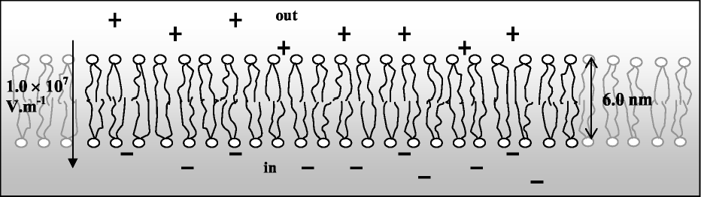
a. What is the potential difference across the cell membrane?
Cells can adjust their membrane resistance by opening and closing channels in the membrane which allow ions to flow through them.
b. If a current of 0.10 mA is flowing through the membrane, what is the resistance of the membrane? c. If the membrane had a resistance of 100 ~ , what current would flow?

Workshop Tutorials for Introductory Physics
Solutions to EI4: Voltage and Current

A. Review of Basic Ideas;

Voltage, Current and Resistance
Taps are always placed at the bottom of water tanks rather than at the top or halfway down. This is so that when the tap is turned on water will flow out. Unless some other force is provided, like pressure from a pump, water will always flow downwards, from a region of high gravitational potential to one of lower gravitational potential. This is why water tanks are often placed up on stands or towers, so the water can run down to the houses. The difference in gravitational potential is what makes the water flow and gives you a current. In a similar way a battery provides an electrical potential difference, (PD or voltage, measured in volts), to produce a current in a circuit. In a plumbing system there is a current of water, in a circuit it is a current of charge (electrons) which flows through the circuit. The current, I, at some place in a circuit is equal to the rate at which charge flows past that place. If the flow is steady then I = q / t. The SI unit of current is the ampere, A (often called the amp).
When you open a tap, so that water can flow out, you are decreasing the resistance to flow. The more you open the tap, the less the resistance and the greater the current of water. For an electrical current flow, the greater the resistance, the smaller the current. Almost any path, for either water or charge, will have some resistance which will depend on the width of the channel, its length and the nature of any stuff inside which may impede the flow. For example, narrow pipes have greater resistance than wide pipes and allow less water to flow. Less conductive materials, which have greater resistance, allow less charge to flow.
In electric circuits the current, I, through a component, depends on its resistance, defined as R = V / I, where V is the potential difference between the ends of the component. Any device whose resistance stays the same when the potential difference across it is changed is said to obey Ohm’s law, which says V = IR. If you have only a single path, then the more resistance you put in, the greater the total resistance and the less current will flow for a given potential difference.
If you want to get a lot of water quickly from a tank you open more than one tap, and put a bucket under each one, so that there are multiple paths for the current to flow along. Similarly, when you connect resistors in parallel in a circuit the current is larger than if you use only a single resistor, because just as with plumbing there are many paths for the current to take.

Discussion question
A battery or power supply provides electrical potential energy, which drives a current around the circuit. The greater the resistance, the less current will flow, because electrical potential energy is dissipated as heat or thermal energy when there is a current flow through any object which has resistance. (Note that the electrons do not “bank up” in the resistor, the current is constant around a single loop circuit, resistor just reduce the flow, not accumulate electrons.)

B. Activity Questions:

- Ohm’s law
Resistors are designed to obey Ohm’s law, which says that the resistance is R = V/I. Using your measurements of the voltage and current you can calculate the resistance of the mystery resistor.

- Measuring current and voltage
The ammeter measures the current, which is the number of charges per unit time passing through a given point on the circuit. To be able to count the charges, the ammeter must be part of the circuit and have a very low internal resistance so that it does not affect the current through the circuit.
The voltmeter is connected in parallel, because it measures the difference in potential between two points. It has a very high internal resistance so that very little current will flow through it, thus having little effect on the circuit.

- Batteries II
The person responsible for naming positive and negative charge was Benjamin Franklin who did not know that the charge carriers in a metal are really negatively charged electrons. So we are stuck with the notion of conventional current which we imagine to be a flow of positive charge, out of a battery’s positive terminal, through a conducting path, and into its negative terminal. Some people like to be more realistic and imagine the actual flow of electrons in the opposite direction. Provided either convention is kept constant in calculating variables in a circuit, you will obtain the correct answer.
The battery provides an electrical potential difference which causes a current to flow.

- Current, potential and resistance - a fluid model
You can measure the average current by timing how long it takes some amount of water to flow out of the tube. Increasing the gravitational potential difference is like increasing an electrical potential difference and will increase the current flow. (Note that this is not the same as giving each fluid molecule, or electron in a circuit, more kinetic energy.)
Squeezing the rubber pipe increases the resistance to flow and hence decreases the current.

C. Qualitative Questions:

- Voltage and current.
- Voltage is like gravitational potential difference, or a difference in height. If you have two containers linked by a pipe, water will flow until the water is at the same height in both containers. If it is already at the same height there will be no flow. A voltage is a difference in electrical potential. A voltage or electrical potential difference is necessary to make an electric current flow.
- You can have a voltage without a current. Any time that charges are separated there is a voltage, for example in a battery or across a cell membrane. Current only flows if there is a path for it to flow along.
- You cannot cause a current to flow without a voltage. In normal materials there must be an accompanying voltage to allow current flow to continue. In a superconductor the voltage can be removed once the current is established, and the current will continue to flow.
- Whenever there is a voltage across a conductor there is an electric field inside the conductor, and that field pushes the charges, e.g. electrons, and makes them flow, which is a current. A current can flow in a superconductor if there was a voltage applied to establish the current, which will continue to flow once the voltage is turned off. In normal materials there is resistance, so a voltage needs to be applied to maintain the current. This is true of most movement or flow - a force must be applied to begin the flow, which will then continue even if the force is removed. However in most circumstances there is some sort of resistance, such as friction, which will stop the movement unless a force continues to be applied. Superconduction is analogous to frictionless flow.
R_{leads}
V₁
V₂
Brent’s battery
Rebecca’s battery
i
- Brent is recharging Rebecca’s car battery using his car’s battery.
- Brent should connect the positive terminals of the two batteries together, and connect the two negative terminals together. This will allow the good battery to push charges through the weak battery from the positive to the negative, and recharge it.
- See diagram opposite. The current will flow to push positive charge to the positive terminal of Rebecca’s battery, recharging it.

D. Quantitative Question:

A cell membrane is about 6.0 nm thick, and has an electric field of around 1.0×10⁷ V.m⁻¹across it.
- Assuming a uniform field, E = V/d. Rearranging for V gives
V = Ed = 1.0×10⁷ V.m⁻¹ × 6.0 × 10⁻⁹ m = 0.060 V = 60 mV.
- Given the potential difference across the membrane and the current flowing through the membrane we can use Ohm’s law to calculate the membrane resistance: R = V/I = 0.060 V/ 0.1 × 10⁻³ A = 600Ω.
- If the membrane resistance was 100 Ω, the current would be
I = V/ R = 0.060 V /100 Ω = 6 × 10⁻⁴ A Ω = 0.60 mA.
Workshop Tutorials for Introductory Physics
EI5: Circuits

A. Review of Basic Ideas:

Use the following words to fill in the blanks:
blood, energy, voltage, current, sound, current, thermal, power, less, electrons, watts

Power, energy and electrical circuits
When you switch on a battery-powered radio, you’re using electrical ______. You can often find the rate of energy consumption written on the back of the radio as so many ______. This rate at which the radio uses energy is called ______ (P) and it depends on both the ______ (V) supplied by the battery and the total ______ (I) from the battery, through the relation: P = VI. If the power consumption is constant then the energy (E) used in a time interval (Δt) is given by E = PΔt.
Similar relations hold for appliances which run on mains electricity, which supplies an alternating current, AC. Although the AC voltage and current vary very rapidly, the average voltage, average current and average power consumption are still connected via the relation P = VI.
A radio uses electrical energy to produce ______ and quite a lot of ______ energy which leaves the radio as heat. As far as energy consumption goes, we can treat most appliances, like radios and toasters, as pure resistors. You can work out the effective resistance of an appliance by using the relation that voltage equals current × resistance, V=IR.
From this relation you can see that for a given voltage, the more resistance you have, the ______ the current will be, which seems very sensible. A resistor is like a fatty deposit in an artery, slowing down the flow of ______, or speed humps slowing down the flow of traffic. When you have resistors in parallel, their total resistance is less, because it’s like having two lanes instead of one, so more traffic can flow. When you have two parallel electrical paths the ______can flow down two paths, so you get more ______, even though there are more resistors!

Discussion questions
Can you have a voltage without a current? If yes, give an example.
Can you have a current without a voltage? If yes, give an example.

B. Activity Questions:

- Torch – a simple circuit
Dismantle the torch and examine its components.
Draw a circuit diagram for the torch, labelling each component and showing its function.

- Toaster man – resistors in series
The ammeter (which measures current) is connected where the heart would be.
What do you notice when you change the position of the connection from the “boot” to the “skin”?

- Measuring current and voltage
Examine the simple circuit set up to measure current and voltage.
Why is the voltmeter connected in parallel with the resistor?
Why is the current meter connected up in series with the resistor.
Current meters have very low resistance. Why do you think this is important?
Would you expect the voltmeter to have a high or low resistance? Why?

- Simple membrane model – resistors in parallel
Cell membranes have channels through them which can open and close allowing current (ions) to flow into or out of the cell. This can be modeled as switches and resistors in parallel.
Close one of the switches, leaving the rest open. Measure the resistance of the membrane.
Close each of the switches, and measure the resistance each time you add another resistor in parallel.
What is happening to the total resistance? Why?
What effect does this have on the total current flow through the membrane?

C. Qualitative Questions:

Consider the circuit containing 5 identical globes shown below. (Treat the globes as if they obey Ohm’s law, even though real light globes are not Ohmic.)
V
A

B
C
D E

Rank the globes, A to E, in order of increasing brightness. (Note that some may have equal brightness.)
You may want to redraw the circuit.

2. Rebecca is helping Brent study for a test on circuit theory. Brent is having trouble remembering Kirchhoff’s rules. Kirchhoff’s rule for junctions states that the total currents going into a junction must be equal to the total currents coming out of a junction. Kirchhoff’s rule for loops says that the sum of all the potential changes around a loop must be zero. Rebecca tells him that these things are pretty obvious, and are really just statements of conservation of charge and conservation of energy. How can Rebecca justify this claim? (Hint: the potential difference (or voltage) between two points is the difference in potential energy per unit charge at those points.)

D. Quantitative Question:

Two simple circuits containing a power supply and appliances which act as resistors
are shown below. In Australia the power supplied to households is an alternating (oscillating) voltage which we will treat as a 240 V battery.
1.
2.
R_{jug}
Jug
R_{jug}
R_{toaster}
R_{toaster}
power point
power point
Jug
Toaster
Toaster
240 V
240 V

The toaster has an operating resistance of 30 Ω and the electric jug has a resistance of 40 Ω.
- Calculate the total resistance of each circuit.
- What is the current flowing through the toaster in each circuit?
- What is the current flowing through the jug in each circuit?
- Circuit 1 is wired in series with the power source. What would happen if the toaster burnt out? Why are houses usually wired in parallel with the power source, as in circuit 2?
Workshop Tutorials for Introductory Physics
Solutions to EI5: Circuits

A. Review of Basic Ideas:

Power, energy and electrical circuits.
When you switch on a battery-powered radio, you’re using electrical energy. You can often find the rate of energy consumption written on the back of the radio as so many watts. This rate at which the radio uses energy is called power (P) and it depends on both the voltage (V) supplied by the battery and the total current (I) from the battery, through the relation: P = VI. If the power consumption is constant then the energy (E) used in a time interval (∆t) is given by E = P∆t.
Similar relations hold for appliances which run on mains electricity which supplies an alternating current, AC. Although the AC voltage and current vary very rapidly, the average voltage, average current and average power consumption are still connected via the relation P = VI.
A radio uses electrical energy to produce sound and quite a lot of thermal energy which leaves the radio as heat. As far as energy consumption goes, we can treat most appliances, like radios and toasters, as pure resistors. You can work out the effective resistance of an appliance by using the relation that voltage equals current × resistance, V=IR.
From this relation you can see that for a given voltage, the more resistance you have, the less the current will be, which seems very sensible. A resistor is like a fatty deposit in an artery, slowing down the flow of blood, or speed humps slowing down the flow of traffic. When you have resistors in parallel, their total resistance is less, because it’s like having two lanes instead of one, so more traffic can flow. When you have two parallel electrical paths the electrons can flow down two paths, so you get more current, even though there are more resistors!

Discussion questions:
You can have a voltage without a current. Any time charges are separated there is a voltage, for example in a battery or a cell membrane. Current only flows if there is a conducting path for it to flow along.
You cannot cause a current to flow without a voltage. The voltage supplies the force which pushes the charges, and makes them flow, which is a current. In normal materials there must be an accompanying voltage to allow current flow to continue. In a superconductor the voltage can be removed once the current is established, and the current will continue to flow, but the voltage is necessary to start the flow.

B. Activity Questions:
B
G
S
- Torch – a simple circuit
The torch has a battery, B, which supplies the voltage, a globe, G, which converts electrical potential energy into light, and a switch, S, which completes the circuit allowing current to flow when the torch is turned on. | .
Toaster
knife
flow of current
- Toaster Man – resistors in series
The current is inversely proportional to the resistance, the greater the resistance the less current can flow, and the less likely toaster man is to be electrocuted. Electricians wear rubber soled shoes to increase the resistance between themselves and the Earth.

- Measuring current and voltage
The ammeter measures the current, which is the rate at which charge passes a given place in the circuit. To do that, the ammeter must be part of the circuit. If you want the measured current to be the same as the current that would have been there without the meter then its resistance must be very small.
The voltmeter is connected in parallel, because it measures the difference in potential between two points. Connecting the voltmeter to those two points creates a parallel path. If you want the measured voltage to be the same as the voltage without the meter, you need a meter with very high resistance, so that it takes practically no current.

- Simple membrane model – resistors in parallel
When resistors are connected in parallel the total resistance is less than any individual resistance. There are more paths for the current to flow along, and so the total current is greater. Resistance is the voltage divided by the current, R = V/I, so a larger current means a smaller resistance for a given voltage supply.
A

B
V
C
D E
V

C. Qualitative Questions:
1. You can redraw the circuit as shown.
The voltage is the same across each arm of the circuit. The potential difference across each of A and B will be ½V. In the second arm we have globes, which we can treat as resistors in a combination of series and parallel. The total resistance of D and E will be half that of each of them individually, which is also half that of globe C.
Hence the resistance of this arm is 3/2 times that of a single globe. Globe C will have a potential difference of 2/3 of the voltage V, and D and E will each have 1/3 V. Brightness increases with power which goes like the V², so we can rank the brightness by ranking the voltages. Hence the order of brightness will be C → A & B → D & E (brightest to dimmest).

2. Kirchhoff’s rule for junctions states that the total currents going into a junction must be equal to the total currents coming out of a junction. This is a statement of conservation of charge, as current is just a flow of charge. Charge must be conserved, so whatever flows into a junction must flow out again. If it didn’t come out again, or if more came out than went in, then charge is either being created or destroyed.
Each point in space has only one value of electrical potential at any time. Work your way mentally around any closed path, noting and adding up all the changes in potential as you go, making sure to count decreases as negative changes and increases as positive. When you get back to the starting point the sum must be the potential that you started with. In a circuit with just one battery, any loop which includes the battery will include a rise in potential across the battery and drops (or no change) everywhere else. The connection with energy conservation is that if you imagine that you were to take a little test charge around the loop, then the potential energy of the system at the end would be the same as it was when you started. Remember that potential is defined as potential energy per unit charge.

D. Quantitative Question:

Two simple circuits containing a power supply and appliances which act as resistors are shown.
power point
power point
240 V
240 V
R_{jug}
R_{jug}
R_{toaster}
R_{toaster}
Jug
Jug
Toaster
Toaster
1.
2.

a. The total resistance of circuit 1 is simply R_{toaster} + R_{jug} = 30Ω + 40Ω = 70Ω
In circuit 2 the resistors are in parallel, so we need to use
(1/ R_{total} ) = (1/ R_{toaster} ) + (1/ R_{jug}) = 1/30 + 1/40 = 0.0583 so R_{total} = 1/0.0583 = 14.1Ω
b. In circuit 1 the same current is flowing through both appliances.
Using V=IR, we get I = V/R = 240/70 = 3.4 A.
In circuit 2 the current is different in each “arm” of the circuit. I_{toaster} = V/R = 240/30 = 8 A.
c. In circuit 1: I_{jug} = I_{toaster} = 3.4A, and in circuit 2: I = V/R = 240/40 = 6 A.
d. If the toaster burnt out in circuit 1, the circuit would be incomplete, or open, and no current could flow, so you could not operate the jug either. This would be very inconvenient, so houses are wired in parallel. Another reason is that appliances are usually designed to operate at a specific voltage, wiring everything in parallel means that everything has the same voltage across it.
Workshop Tutorials for Introductory Physics
EI6: Electrical Safety

A. Review of Basic Ideas:

Use the following words to fill in the blanks:
disconnected, heating, contract, surges, current, static, heating, lethal, fibrillation, earthed, breathing, off, hair dryers.

Electrical Safety and First Aid
Everyone gets an occasional minor electric shock, often from ______ electricity buildup. For example you might get a little shock when you touch a car door, or a metal door handle after walking across carpet. The shock is the result of ________ passing through the body. The current has two effects, it stimulates nerves and muscles, and it causes ________ of the tissues due to dissipation of electrical energy. These effects are used by doctors to treat pain and promote healing. However both these effects, if intense enough, can be ________.
Currents of around 5 mA are generally painful, and currents larger than 10 mA can cause muscles to _________. This is very dangerous, because if you touch a live wire it may cause your hand to contract, grabbing the wire, and leaving you unable to let go. Larger currents can cause the heart muscles to desynchronize, and the heart becomes ineffective and can stop. This is called _________, and even after the current is stopped fibrillation can continue. Current can also effect the respiratory muscles, disrupting _________.
You can protect yourself from electric shock by making sure that you use appliances which are properly _________. An earth connection provides a low resistance path to the earth for any unwanted current due to surges or short circuits. This means that the current passes through the Earth connection rather than through you. Safety switches detect sudden ________ in current and cut off the electricity supply. This minimizes the time that a current can pass though a person.
A lot of electric shocks can be avoided by being careful and sensible, for example keeping appliances like _______ ________ away from sinks, and keeping trees pruned clear of power lines.
If you come across someone who has received an electric shock you need to be very careful, and not touch them or even get too close before you make sure that the current has been stopped. Always turn the power _______ if possible, and if not use a large insulator like a wooden broom handle to separate the person and the current source. Once you are sure they are ________, normal first aid procedures should be followed.

B. Activity Questions:

1. Toaster man
The ammeter (measures current) is connected at the heart position. What do you notice when you change the position of the connection from the “boot” to the “skin”?
After the power supply has been on for a while, feel the resistors. What do you notice?
First aiders always look for burns on victims of electrocution. Why?

2. Safety Switch and fuses
Examine the safety switch and fuses.
Explain how they work and the role they play in preventing power surges.

3. Earth connections
Examine the appliances.
Which ones are properly Earthed? How can you tell?

C. Qualitative Questions:
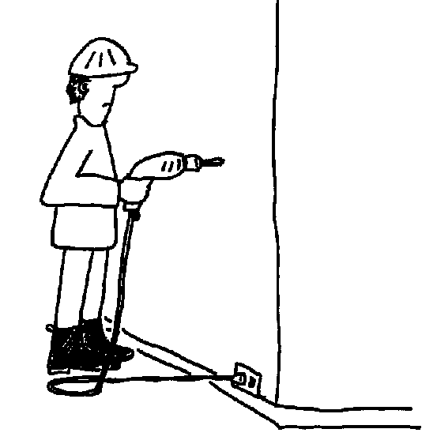

- Brian the builder is using an electric drill to put a hole in a wall so he can put a shelf up. Unfortunately Brian hasn’t checked where the power cables are inside the walls, and he’s about to drill right into one of them!
a. Draw a diagram showing the current path when Brian hits the cable if the drill is properly Earthed.
b. Draw a diagram showing the current path if the drill is not earthed.
c. What are the consequences for Brian in each case? Why is it important that appliances are correctly Earthed?

- You and your lab partner are working with electrical equipment. You see him touching two different pieces of electrical equipment at the same time.
- Why would you explain to him that this is a dangerous procedure?
Unfortunately he takes no notice of your warnings and he receives an electric shock!
- Explain what procedures you would follow to save his life, without endangering yourself.

D. Quantitative Question:

Brian the builder has drilled into a power cable in a wall, using a drill which is not Earthed. The voltage across the two live cables is 240 V, and the voltage between the drill and the Earth is also 240 V. Brian is wearing his good rubber soled boots which have a resistance of 10 MΩ, and his skin resistance is 10 kΩ. The internal body resistance is only around 100 Ω altogether.
- Draw a circuit diagram showing the resistances the current can pass through to get from the drill, through Brian, to the ground.
- Calculate the total resistance of this current path.
It takes only as little as 10 mA through the heart to cause a human heart to fibrillate and stop beating.
- What current will pass through Brian? Is he going to survive?
- What current would pass through Brian if he was working barefoot?

Workshop Tutorials for Introductory Physics
Solutions to EI6: Electrical Safety

A. Review of Basic Ideas:

Electrical Safety and First Aid
Everyone gets an occasional minor electric shock, often from static electricity buildup. For example you might get a little shock when you touch a car door, or a metal door handle after walking across carpet. The shock is the result of current passing through the body. The current has two effects, it stimulates nerves and muscles, and it causes heating of the tissues due to dissipation of electrical energy. These effects are used by doctors to treat pain and promote healing. However both these effects, if intense enough, can be lethal.
Currents of around 5 mA are generally painful, and currents larger than 10 mA can cause muscles to contract. This is very dangerous, because if you touch a live wire it may cause your hand to contract, grabbing the wire, and leaving you unable to let go. Larger currents can cause the heart muscles to desynchronize, and the heart becomes ineffective and can stop. This is called fibrillation, and even after the current is stopped fibrillation can continue. Current can also effect the respiratory muscles, disrupting breathing.
You can protect yourself from electric shock by making sure that you use appliances which are properly Earthed. An Earth connection provides a low resistance path to the Earth for any unwanted current due to surges or short circuits. This means that the current passes through the Earth connection rather than through you. Safety switches detect sudden surges in current and cut off the electricity supply. This minimizes the time that a current can pass though a person.
A lot of electric shocks can be avoided by being careful and sensible, for example keeping appliances like hair dryers away from sinks, and keeping trees pruned clear of power lines.
If you come across someone who has received an electric shock you need to be very careful, and not touch them or even get too close before you make sure that the current has been stopped. Always turn the power off if possible, and if not use a large insulator like a wooden broom handle to separate the person and the current source. Once you are sure they are disconnected, normal first aid procedures should be followed.

B. Activity Questions:
Toaster
knife
flow of current
1. Toaster Man
For a given voltage, the greater the resistance the less current can flow, and the less likely toaster man is to be electrocuted. Electricians wear rubber soled shoes to increase the resistance between themselves and the Earth, decreasing any possible current flow through themselves. First aiders look for burns on people who have had an electric shock as the skin and internal organs act as resistors, dissipating electrical potential energy as thermal energy.

2. Safety Switch and fuses
Fuses often have a thin wire through which all the current passes. When the current flows through the wire it gets hot, due to its low but non-zero resistance. If the current gets too great the wire gets too hot and melts, opening the circuit and stopping the current from flowing. The current can get too high when there is a short circuit somewhere else in the circuit, such as a knife connecting a toaster element to Earth, so current can flow through a low resistance human rather than back through the rest of the toaster circuit.
Safety switches do the same job, but have a sensor which detects current surges and trips a switch, opening the circuit. Safety switches are very fast, and can be reset, whereas fuses have to be replaced or fitted with fresh fuse wire.
Earth
active
neutral

3. Earth connections
The appliances with a third pin in their plug are Earthed. The third wire is the Earth connection, the other two pins are the live connections – the active and the neutral. If the Earth is disconnected the appliance will usually still work, but will be unsafe to use.

C. Qualitative Questions:
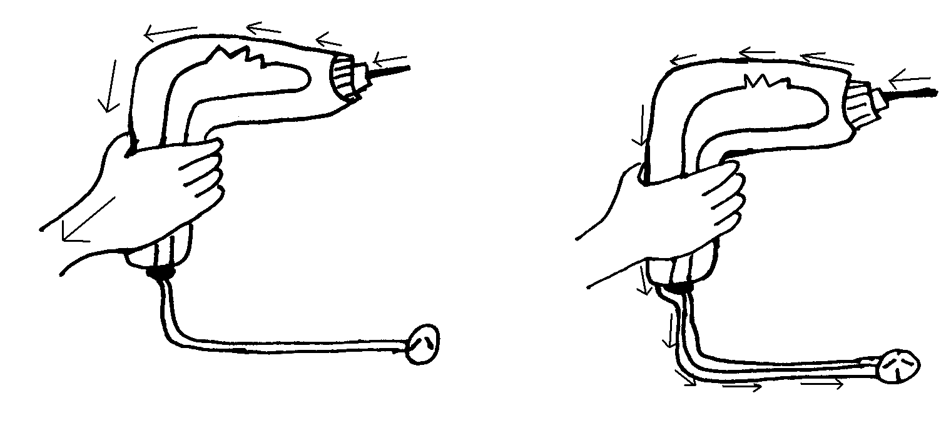
a. not Earthed.
b. Earthed.
current flow
current flow
1.

c. If the drill is Earthed only a small amount of current will flow through Brian, especially if he is wearing rubber soled boots. The Earth connection provides a path of very low resistance for the current. If the drill is not Earthed the path of least resistance from the power cable through the drill and to Earth is via Brian. Brian will probably be burnt, receive a shock, and may even be electrocuted. | 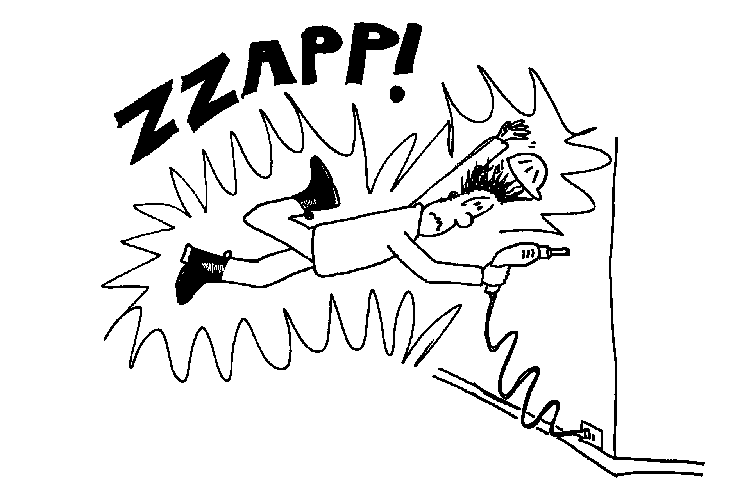

2. Your lab partner is touching two pieces of equipment at once.
- If the two pieces of equipment are at different potentials, then there is a potential difference or voltage between them. If he touches both at once he will provide a conducting path between them, and a current may flow through his body. This would be very dangerous if the current were large. Even if the equipment is properly Earthed, the potential difference may be greater between the two pieces of equipment than between either piece and the ground, and a current may flow from one to the other, or to the ground, via your lab partner.
- If your lab partner is electrocuted, DO NOT touch him! Make sure that the power is turned off or he is disconnected before you go near him. If necessary you should use something non-conductive, like a wooden broom handle, to disconnect him. Then you would follow usual first aid procedure, check for consciousness, etc, and resuscitate if not breathing. Resistors dissipate energy as heat, the greater the resistance, the hotter it will get. Skin has a high resistance, and victims of electrocution usually have burns where the current entered and exited the body. If he is conscious you should check for burns at the entry and exit points of the current, and finally you would tell him that you told him so, and explain to him the benefits of listening to your lab partner.

D. Quantitative Question:

Brian the builder has drilled into a power cable in a wall, using a drill which is not Earthed.
R_{skin}
R_{skin}
R_{skin}
R_{skin}
R_{boot}
R_{boot}
R_{skin} ~ 10 kΩ
R_{internal} ~ 100 Ω
R_{boot} ~ 10 MΩ
240 V
R_{internal}
- See opposite.
- R_{total} = R_{skin}.+ R_{internal} + R_{skin} + R_{boot}
= 10 × 10³ Ω + 100 Ω + 10 × 10³ Ω + 10 × 10⁶ Ω
~ 10 × 10⁶ Ω
- Using Ohm’s law,
i = V/R = 240V / 10 × 10⁶ Ω = 2.4 × 10⁻⁵ A
- If Brian was working barefoot his total resistance would be
R_{total} = R_{skin}.+ R_{internal} + R_{skin}
= 10 × 10³ Ω + 100 Ω + 10 × 10³ Ω = 20 × 10³ Ω
so the current would be
i = V/R = 240V / (20 × 10³ Ω) = 1.2 × 10⁻² A = 12 mA.
There is a chance that Brian’s heart would stop.

Workshop Tutorials for Introductory Physics
EI7: Magnetism

A. Review of Basic Ideas:

Use the following words to fill in the blanks:
repel, mono-poles, magnetic, electric, two, decreases, positive, attract, currents, electricity, force, velocity, tesla, direction

Magnets and magnetism
In the same way that electrically charged objects produce an _______field, magnets produce a _______ field. The force between two magnetic poles is similar to the force between electrically charged particles, the force ________ with the square of the distance between them, and like poles _______ while opposite poles ________. However there is a difference - we can isolate negative charge, for example an electron, away from positive charges, but an isolated magnetic pole has never been observed. If you start with a bar magnet and cut it in half you will have _______ magnets, each with a north pole and a south pole. Each time you cut it in half you will still have pieces with a north and a south pole.
There is a relationship between ________ and magnetism, which was discovered by Hans Oersted in 1819. During a lecture demonstration he noticed that a wire carrying an electric current deflected the needle in a nearby compass. Not only are magnetic fields produced by permanent magnets, but they are also produced by moving charges, or ________.
We define an electric field at a point as the electric _______ per unit charge on an appropriate test object at that point. The appropriate object is a small ________ charge. We can define a magnetic field in the same way. The only difficulty is that magnetic _______ (a north pole without a south pole, or a south pole without a north pole) don't exist. So what we use as our test object is a current, in particular a moving positive test charge. Experiments have shown that the force on a moving charged particle in a magnetic field depends on the size of the charge and also on the _______ of the charge. Note that we use velocity and not speed, as _______ is important. If the particle is moving parallel to the field it experiences no force, and it experiences the biggest force when it moves at right angles to the field. We can write this as F = qvBsinθ, where F is the force on the particle with charge, q, moving with velocity v through a magnetic field of strength B, and θ is the angle between the vectors v and B. This is the equation that defines magnetic field strength. The SI unit for i is the _______, T, which is equivalent to N.A⁻¹.m⁻¹.

B. Activity Questions:

- Magnets and magnetic fields
Use the iron filings to investigate the field lines of the magnets.
How do these compare with the field lines of the Earth?
Many animals such as pigeons and some fish have a magnetic sense which allows them to use the Earth’s magnetic field to navigate.

- Magnetic field around a current carrying wire – Oersted’s experiment
What happens when you turn the current on?
What happens when you change the direction of the current?
Draw a diagram showing the field produced by the current.

- Torque on a current carrying coil in a magnetic field
N
S
N
S
Draw the magnetic force at the points marked by dots on the diagrams below.
If held stationary prior to release, in which of the above cases is the loop more likely to start turning on its own.

C. Qualitative Questions:

1. The Earth’s magnetic field is important because it protects us from charged particles radiated by the sun. It also provides a means of navigating for humans and for many animals as well.
a. Sketch the magnetic field lines for the Earth’s magnetic field.
b. Sketch the path of a charged particle which has become trapped in the Earth’s magnetic field.
c. Would the aurora australis (southern lights) or the aurora borealis (northern lights) be possible if the earth had no magnetic field? Explain your answer,
The aurora australis is occasionally visible from southern Victoria and Tasmania in winter, and from further north when there is a lot of sunspot activity. However, due to light pollution, the aurora is impossible to see from large cities such as Sydney and Melbourne.
d. Why are these light shows normally seen only near the poles?

2. Electric blankets work by passing currents along wires embedded in the blankets. The resistance of the wires and the current flowing through them causes them to heat up, thus keeping you cosy and warm. However apart from heat, the current carrying wires also produce a magnetic field. The figures below show two possible ways of wiring an electric blanket.
6i
i

- Sketch the magnetic fields for a pair of neighbouring wires for the two blankets.
- Which wiring pattern would give you a lower magnetic field above the wires in the blanket?

D. Quantitative Question:

An electron is accelerated by a potential difference of 20 kV in the evacuated tube of a television set.
- How much kinetic energy has the electron gained in the tube?
- What is the speed of the electron?
It then passes through a uniform magnetic field of 300 mT.
- If the electron is travelling from left to right in the tube, and the field is directed down, which way will the electron be deflected?
- What is the magnetic force experienced by the electron?
v
m_{electron} = 9.11 × 10⁻³¹ kg

Workshop Tutorials for Introductory Physics
Solutions to EI7: Magnetism

A. Review of Basic Ideas:

Magnets and magnetism.
In the same way that electrically charged objects produce an electric field, magnets produce a magnetic field. The force between two magnetic poles is similar to the force between electrically charged particles, the force decreases with the square of the distance between them, and like poles repel while opposite poles attract. However there is a difference - we can isolate negative charge, for example an electron, away from positive charges, but an isolated magnetic pole has never been observed. If you start with a bar magnet and cut it in half you will have two magnets, each with a north pole and a south pole. Each time you cut it in half you will still have pieces with a north and a south pole.
There is a relationship between electricity and magnetism, which was discovered by Hans Oersted in 1819. During a lecture demonstration he noticed that a wire carrying an electric current deflected the needle in a nearby compass. Not only are magnetic fields produced by permanent magnets, but they are also produced by moving charges, or currents.
We define an electric field at a point as the electric force per unit charge on an appropriate test object at that point. The appropriate object is a small positive charge. We can define a magnetic field in the same way. The only difficulty is that magnetic mono-poles (a north pole without a south pole, or a south pole without a north pole) don't exist. So what we use as our test object is a current, in particular a moving positive test charge. Experiments have shown that the force on a moving charged particle in a magnetic field depends on the size of the charge and also on the velocity of the charge. Note that we use velocity and not speed, as direction is important. If the particle is moving parallel to the field it experiences no force, and it experiences the biggest force when it moves at right angles to the field. We can write this as F = qvBsinθ, where F is the force on the particle with charge, q, moving with velocity v through a magnetic field of strength B, and θ is the angle between the vectors v and B. This is the equation that defines magnetic field strength. The SI unit for B is the tesla, T, which is equivalent to N.A⁻¹.m⁻¹.

B. Activity Questions:
N
S

- Magnets and magnetic fields
Magnetic field lines start at north poles and end at south poles.
The Earth’s magnetic field is like that of a bar magnet, but the Earth’s North Pole is in fact a magnetic south pole.

- Magnetic field around a current carrying wire - Oersted’s experiment
When you turn the current on the needles move and point along the magnetic field lines. When you change the direction of the currents the needles swing around to face the opposite way. The field lines form circles around the wire as shown. The direction of the field can be determined by pointing your right thumb in the direction of the current, then your fingers curl in the direction of the field lines. | i

3. Torque on a current carrying coil in a magnetic field
both forces non-zero and perpendicular to plane of coil.
N
S
N
S
all forces
in plane of coil.

If held stationary prior to release, the loop on the left is more likely to start turning on its own.

C. Qualitative Questions:
B
Paths of charged particles

1. The Earth’s magnetic field.
- and b See diagram.
c. The auroras are caused by charged particles entering the earths magnetic field where they follow a helical path along the field lines either north or south. The light observed as auroras is due to ionization of atoms in the atmosphere when they collide with high speed charged particles. The fee electrons resulting from the collisions recombine with other atoms, losing energy in the process which is emitted as light.
d. Near the poles the field lines are denser, hence the field is stronger. Charged particles tend to become trapped in these regions, hence are more likely to interact with air here and produce the auroras.
See anything strange about this picture? The Earth’s North Pole, at the top, is actually the south pole of Earth’s magnetic dipole! The north pole of a compass needle is attracted to the North Pole.

2. Field due to parallel and anti-parallel currents.
i
a. parallel currents  i  Fields reinforce each other above and below the blanket, and cancel between the wires. | opposite currents.  i  i  Fields tend to cancel each other above and below the blanket, and reinforce between the wires.
b. The wiring on the right gives a lower magnetic field above (and below) the blanket.

D. Quantitative Question:

- The electron has gained 20 keV in kinetic energy, which is 20 × 10³ × 1.6 × 10¹⁹ J = 3.2 × 10⁻¹⁵ J.
- Assuming it started from rest, we can find the velocity from KE = ½ mv², rearranged for v:
v = $\sqrt{\frac{2\text{KE}}{m}}$= $\sqrt{\frac{2×3\text{.}2×{\text{10}}^{−\text{15}}J}{9\text{.}\text{11}×{\text{10}}^{−\text{31}}\text{kg}}}$= 8.4 × 10⁷ m.s⁻¹.
(Note that we have not taken into account relativistic effects here which become important at this speed!)
- The electron will be deflected out of the page.  - The magnitude of the force on the electron is  F = qv×B = 1.6 × 10⁻¹⁹ C × 8.4 × 10⁷ m.s⁻¹ × 300 × 10⁻³ T  = 4 × 10⁻¹² N. | v  deflection out of the page

Workshop Tutorials for Introductory Physics
EI8: Electromagnetism

A. Review of Basic Ideas:

Use the following words to fill in the blanks:
right, electricity, Faraday’s, currents, changing, thumb, induction, circles

Currents and fields
There is a relationship between ________ and magnetism, which was discovered by Hans Christian Oersted in 1819. During a lecture demonstration he noticed that a wire carrying an electric current deflected the needle in a nearby compass. Not only are magnetic fields produced by permanent magnets, but they are also produced by moving charges, or ________.
For example, the magnetic field lines produced by a current I in a long straight wire form _______ around the wire and the magnitude of the field at a distance r from the axis of the wire is given by $B=\frac{μ_{0}I}{2πr}$. The constant μ₀ is the permeability of free space, and is equal to 4π × 10⁷ N.A⁻². You can use your _______ hand to find the direction of the field. Point your _______ in the direction of the current and your fingers curl in the direction of the field. The field is _________ to the current that produced it.
It turns out that not only do currents produce a magnetic field, but a _________ magnetic field produces a current. This effect is called electromagnetic _________, because the changing magnetic field induces an electric field which can cause a current in a conductor. Such an induced current also produces a magnetic field whose net effect is to oppose the change that produced the current in the first place. This is Lenz’s law.
The induced electric field exists even if there is no conductor and no induced current. Such induced electric fields are often described in terms of an associated quantity called emf. In a closed conducting loop such as a coil of wire with resistance R the induced emf and the induced current are related by emf = IR. We can find the emf induced in a closed loop of area A, using ________ law : emf = $−\frac{dΦ}{\text{dt}}$, where Φ is the magnetic flux through the loop. In the simple case of a uniform field perpendicular to the plane of the loop, the flux is given by Φ = BA.

Discussion Question:
You can induce an emf by changing the size of the magnetic field though a loop. How else could you induce an emf?

B. Activity Questions:

The magnetic force - pinch effect
Turn on the power supply and observe what happens to the wires.
Draw a diagram showing the fields, currents and forces on the wires.
How can you make the wires repel instead of attracting?

- Electromagnetic Induction – two coils of wire and a magnet
If a magnet is moved into and out of a closed loop of wire, a current is induced in the loop of wire.
How do the direction and magnitude of the current depend on the motion of the magnet?
What happens if the magnet is reversed?
What happens if the loop is moved and the magnet is stationary?
Will a similar phenomenon be observed if a current carrying coil of wire moves relative to a loop of wire?

- Magnetic braking I – pendulums
Allow the pendulums to swing between the magnets.
Which pendulums swing and which stop? Why?

- Magnetic braking II – magnets in pipes
Drop the magnet down the pipes.
Why do magnets take longer falling down a copper pipe than free falling?
What is happening in the copper pipe with the slit?

C. Qualitative Questions:

1. Almost all electricity production uses a generator. Coal and nuclear power stations use steam and hydroelectric stations use liquid water to drive a turbine which runs the generator. Even cars use a generator to charge the battery while the engine is running.
- Draw a diagram showing the main components of a generator.
- Referring to your diagram, explain how a generator works.
- Why do generators produce an alternating current (AC) rather than a direct current (DC)?
2. Two circular loops lie adjacent to each other. One is connected to a source that supplies a current; the other is a simple closed ring. The current in the first loop travels clockwise. The loops can be arranged so that they stand parallel to each other (arrangement I) or next to each other (arrangement II).
a. Would you expect a difference in the induced current when the power supply is turned on in the two arrangements? Explain why or why not.
b. Sketch a graph of the current as a function of time when the power supply is turned on and then off again.

D. Quantitative Question:

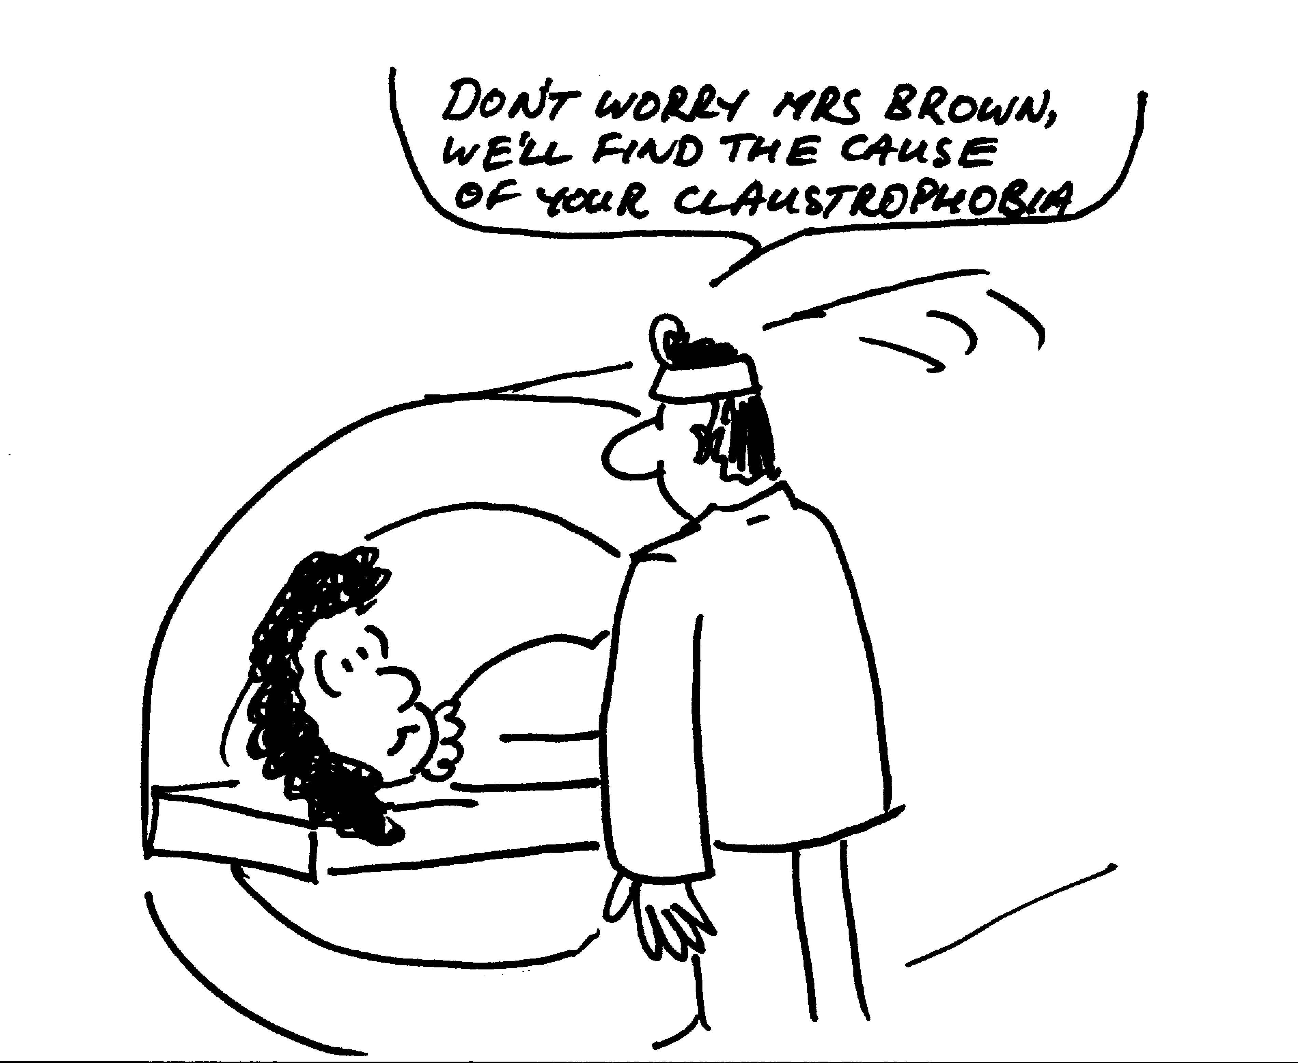
Magnetic resonance imaging (MRI) is used to produce images of the interior of the body, especially the brain. The patient is strapped down tightly to a flat stretcher which then slides into the scanner. The scanner produces a strong variable magnetic field.
- Why are patients asked to remove all jewelry and any clothing with zips or metal buttons or clips?
The human body can be described as a bag of salt water, because it contains a great deal of fluid with dissolved ions. A woman is in an MRI scanner which can produce a field of 1.5 T. The largest surface area through which magnetic flux passes is 0.04 m² with a normal parallel to the direction of the field.
- If the maximum average induced emf is to be kept less than 0.01 V, how long must it take for the machine be powered down from maximum field to zero?

Workshop Tutorials for Introductory Physics
Solutions to EI8: Electromagnetism

A. Review of Basic Ideas:

Currents and fields
There is a relationship between electricity and magnetism, which was discovered by Hans Christian Oersted in 1819. During a lecture demonstration he noticed that a wire carrying an electric current deflected the needle in a nearby compass. Not only are magnetic fields produced by permanent magnets, but they are also produced by moving charges, or currents.
For example, the magnetic field lines produced by a current I in a long straight wire form circles around the wire and the magnitude of the field at a distance r from the axis of the wire is given by $B=\frac{μ_{0}I}{2πr}$. The constant μ₀ is the permeability of free space, and is equal to 4π × 10⁷ N.A⁻². You can use your right hand to find the direction of the field. Point your thumb in the direction of the current and your fingers curl in the direction of the field. The field is perpendicular to the current that produced it.
It turns out that not only do currents produce a magnetic field, but a changing magnetic field produces a current. This effect is called electromagnetic induction, because the changing magnetic field induces an electric field which can cause a current in a conductor. Such an induced current also produces a magnetic field whose net effect is to oppose the change that produced the current in the first place. This is Lenz’s law.
The induced electric field exists even if there is no conductor and no induced current. Such induced electric fields are often described in terms of an associated quantity called emf. In a closed conducting loop such as a coil of wire with resistance R the induced emf and the induced current are related by emf = IR. We can find the emf induced in a closed loop of area A, using Faraday’s law : emf = $−\frac{dΦ}{\text{dt}}$, where Φ is the magnetic flux through the loop. In the simple case of a uniform field perpendicular to the plane of the loop, the flux is given by Φ = BA.

Discussion Question:
The induced emf is equal to the rate of change of the flux through the loop. You can change the flux to induce an emf either by changing the field, or by changing the size or orientation of the loop.

B. Activity Questions:
F_{ba} = force on i_{b} due to B field from i_{a}
F_{ab} = force on i_{a} due to B field from i_{b}
i_{b}
B due to i_{a}
F_{ba}
i_{a}
B due to i_{b}
F_{ba}
- The magnetic force – pinch effect
Both currents produce a magnetic field. A current carrying wire in a magnetic field experiences a force proportional to the current and the external field, F ∝ i×B. This force will be towards the other wire when the currents are parallel, and away from it when the currents are anti-parallel.

- Electromagnetic Induction – two coils of wire and a magnet
The direction of the current depends on the motion of the magnet relative to the loop and changes when the magnet is reversed. The magnitude of the current depends on the speed of the motion, number of turns of wire and the 'angle' between the loop and the magnet. It doesn’t matter whether the coil or the magnet is moved, only the relative motion of the two is important.
A current carrying coil of wire has a magnetic field so there will be an induced current in a closed loop of wire which is moving relative to a current carrying coil.

- Magnetic braking I – damped pendulums
In all cases currents are induced in sheets and loops without slits and not in sheets or loops with slits. The induced currents experience a force due to the magnetic field from the magnets, which produces a force on the pendulum opposing the motion that causes them, braking the pendulums without slits.
- Magnetic braking II – magnets in pipes
The movement of the magnet creates currents in the copper pipe, which produce magnetic fields, which act to oppose the motion which causes them, slowing the fall of the magnet. The plastic pipe is an insulator, no current is created and hence the magnet is not braked. In the pipe with the slit there are still currents produced in vertical loops, but not around the pipe as the slit prevents this. So the fall is slowed, but not as much as in the complete pipe.
coil
N
S
i
i
i
i
brushes
rotating shaft to spin coil

C. Qualitative Questions:

1. Almost all electricity production uses a generator.
- See diagram opposite.
- The shaft at the bottom of the generator is mechanically driven. This can be done by a turbine which has water falling over it (hydro-electric) to make it spin or by steam pushing it (coal, nuclear, geothermal). Wind vanes in wind farms can also be used to drive the shaft. The shaft is attached to the coil and rotates it in the magnetic field produced by the magnets. The magnetic flux through the coil changes as the coil rotates, it is a maximum when the coil is perpendicular to the field and zero when the coil is parallel to the field. The changing magnetic flux through the coil induces an emf causing a current to flow.
- According to Lenz’s law the current flows to counteract the change in magnetic flux. As the coil turns from parallel to the field to perpendicular the magnetic flux increases. As it continues to turn the magnetic flux decreases again. While the flux is increasing the current flows in one direction and while the flux decreases the current flows the opposite way. Hence an alternating current is produced.

2. Induced currents in loops.
I
II
a. The induced currents in the two arrangements are different because the magnetic field, B, through the area of the loop in arrangement II is smaller than that in arrangement I. Thus changes in the magnetic field dB and the rate of change of flux dΦ/dt will also be smaller. So any induced emfs and currents will be smaller. | i  t  power on  power off
b. When the power supply is switched on the current will begin to flow producing an increasing magnetic field which causes a current in the other wire. When the magnetic field is constant there will be no current induced in the other coil. When the magnetic field decreases after the power supply is turned off a current will briefly flow in the other direction.

D. Quantitative Question:

- The changing magnetic field will induce a current. Metal jewellery or zips etc have low resistance so large currents could be induced in them.
- According to Faraday’s law the induced emf = -dΦ_{B}/dt, which is the rate of change of magnetic flux.
Φ_{B} = BAcosθ for a uniform field. So now we have
emf = -dΦ_{B}/dt = d(BAcosθ)/dt = d(BA)/dt = A (dB/dt) = A(B_{max}/T) for a steadily changing field with B perpendicular to A, which reaches its maximum value at time T. We want the maximum value of the emf to be 0.01 V, and we are finding T: T = B.A/emf = 1.5 T × 0.04 m² / 0.01 V = 6 s.
It must take at least 6 s for the machine to reduce the field to zero.

