Thermal Physics

Introductory Thermal Physics Worksheets and Solutions

TI1: | Temperature | 3
TI2: | Heat and Energy | 7
TI3: | Heat Transfer | 11
TI4: | First Law of Thermodynamics | 15
TI5: | Kinetic Theory | 19
TI6: | Entropy and the Second Law of Thermodynamics | 23
TI7: | Blackbody Radiation | 27

Workshop Tutorials for Introductory Physics
TI1: Temperature

A. Review of ideas in basic physics.

Use the following words to fill in the blanks:
freezing, warmer, digital, temperature, thermometer, equilibrium, water, boiling, 298 K, nett

Temperature
We often talk about objects being hot or cold. But hotness or coldness are relative and are not very accurate descriptors. A more accurate way of defining the hotness or coldness of an object is to measure its __________. To illustrate this point, consider what you feel when you step barefooted from a tiled area onto a carpeted area of a floor. The carpet will feel ________, especially on a cold day. Yet common sense should tell you that they are both at the same temperature.
To measure temperature we use a _________. Thermometers contain some material with a property that is dependent on temperature. For example, the thermometer may contain a liquid such as mercury which expands with increasing temperature and moves up a scale. Many _______ thermometers have a sensor made of a material whose electrical resistance varies with temperature.
Most importantly, if the thermometer is to read exactly the temperature of an object it must be in thermal ________ with that object. If two objects are in thermal equilibrium then there is no ________ flow of thermal energy between them. It is important to leave the thermometer in contact with the object whose temperature is to be measured for a long enough period of time until thermal equilibrium is reached.
We encounter temperature in everyday usage measured on a range of temperature scales. For example the Celsius scale is established by taking two fixed points; zero degrees, the _________ point of _______ and 100 degrees, the _______ point of water, and dividing the interval between into 100 equal divisions. In physics we use the Kelvin scale. On this scale 0 K equals minus 273.15 ºC; room temperature is ________ (often rounded to 300K) on the Kelvin scale.

B. Activity Questions:

- Thermometers
Examine the different thermometers on display.
What physical property do they use to measure temperature?
What would you use these thermometers for?

- Thermal Expansion of gases
Place the coin on top of the bottle.
Now cup your hands around the bottle and observe what happens.
Explain your observations.

- Thermal Expansion of liquids
Hold the beaker in your hands.
Explain what you observe.

- Thermal Expansion of solids - bimetallic strip
Heat the strip using the hairdryer or hot air gun.
What happens to the strip, and why?
Can you think of a use for such a strip?

C. Qualitative Questions:

1. There are different ways of measuring temperature depending on what you’re measuring the temperature of, and what temperature range you need to measure.
- Describe two different ways of measuring temperature. What physical properties do they rely on?
- Give examples of when you might use these methods.
- Why do you always have to hold the thermometer under your tongue for what seems like hours (but is usually about 30 seconds) when you have your temperature measured?

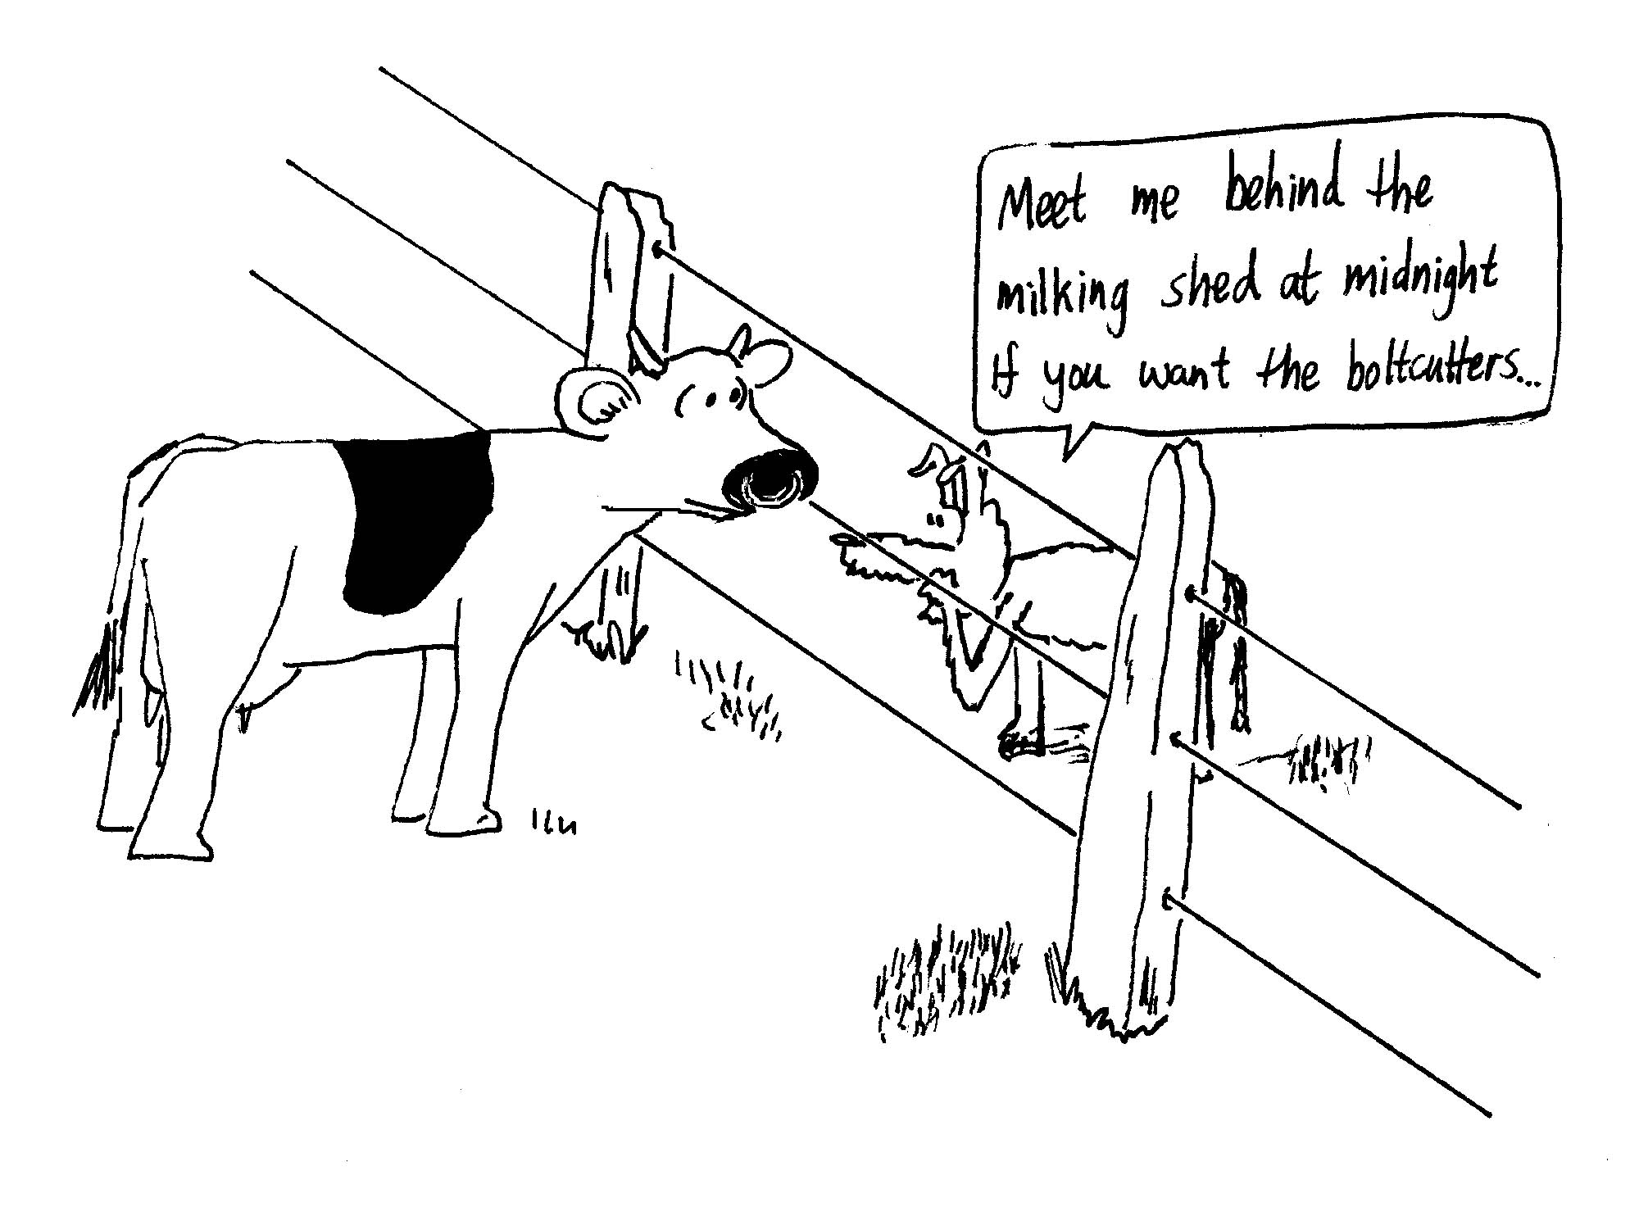

2. A farmer is stringing a wire fence in the middle of the day. He makes it nice and tight so that his cows can’t push through it.
- That night all the wires break. Why?
- How does running hot water over a jar make the lid easier to get off when both the jar and the lid are being heated?

C. Quantitative question.

You fill your petrol tank with 50 l of petrol [full] in the morning when the temperature is 20ºC. The car is left in the sun and the temperature in the car rises to 55ºC. The coefficient of volume expansion for petrol is β = 0.95 × 10⁻³ C⁻¹.
- How much petrol will overflow?
- If petrol is 98 ¢/litre, how much money have you wasted?
Workshop Tutorials for Introductory Physics
Solutions to TI1: Temperature

A. Review of ideas in basic physics.

Temperature
We often talk about objects being hot or cold. But hotness or coldness are relative and are not very accurate descriptors. A more accurate way of defining the hotness or coldness of an object is to measure its temperature. To illustrate this point, consider what you feel when you step barefooted from a tiled area onto a carpeted area of a floor. The carpet will feel warmer, especially on a cold day. Yet common sense should tell you that they are both at the same temperature.
To measure temperature we use a thermometer. Thermometers contain some material with a property that is dependent on temperature. For example, the thermometer may contain a liquid such as mercury which expands with increasing temperature and moves up a scale. Many digital thermometers have a sensor made of a material whose electrical resistance varies with temperature.
Most importantly, if the thermometer is to read exactly the temperature of an object it must be in thermal equilibrium with that object. If two objects are in thermal equilibrium then there is no nett flow of thermal energy between them. It is important to leave the thermometer in contact with the object whose temperature is to be measured for a long enough period of time until thermal equilibrium is reached.
We encounter temperature in everyday usage measured on a range of temperature scales. For example the Celsius scale is established by taking two fixed points; zero degrees, the freezing point of water and 100 degrees, the boiling point of water, and dividing the interval between into 100 equal divisions. In physics we use the Kelvin scale. On this scale 0 K equals minus 273.15 ºC; room temperature is 298 K (often rounded to 300K) on the Kelvin scale.

B. Activity Questions:

- Thermometers
A liquid in glass thermometer uses the thermal expansion of a liquid to measure temperature. The scale is calibrated to read the temperature as a function of the volume of the liquid. There are also thermometers which use the thermal expansion of a gas, which results in increasing the pressure of the gas if the volume of the gas is fixed. The pressure then tells you the temperature. These are called constant volume gas thermometers.
Digital thermometers use a change in electrical resistance with temperature. There are two types – those that have an increasing resistance with increasing temperature, and those that have a decreasing resistance with increasing temperature. The change in resistance is determined by the material the sensor is made out of.

- Thermal Expansion of gases
The heat from your hands causes the gas inside the bottle to expand, increasing the pressure inside the bottle. When the force due to the pressure of the gas is greater than the weight of the coin it pops off.

- Thermal Expansion of liquids
The heat from your hands causes the liquid to expand. As it cools it contracts again. This is how a typical liquid in glass thermometer works.

- Thermal Expansion of solids - bimetallic strip
The bimetallic strip is made of two metals, one of which expands much more than the other when they are heated. A bi-metallic strip can be used as a sensor because the two metals which make up the strip expand at different rates. When they start to get hot, the strip will bend, and can be used as a switch which either closes or opens a circuit as it bends to or away from a contact. A single strip would expand, but not bend in this way. | metal one, small expansion  metal two,  large expansion  heat  strip bends as metal two expands, but cannot stretch freely because it is attached to metal one.

C. Qualitative Questions:

- Measuring temperature.
  - A medical mercury-in-glass thermometer relies on the expansion of mercury up a fine (bore) tube as temperature increases. Digital thermometers, like those found in a car, are more robust and are part of an electrical circuit. The physical property that varies with temperature in most types of digital thermometer is electrical resistance.
  - The mercury in glass thermometer is extremely accurate and so can be used to measure body temperature accurately. Digital thermometers are often used where remote sensing is needed. The electrical signal can be fed into a computer from a remote terminal
  - A thermometer has to be held in the mouth long enough to allow the thermometer to come to thermal equilibrium with your body. When it is inserted it will be at room temperature.

2. A farmer is stringing a wire fence in the middle of the day. He makes it nice and tight so that his cows can’t push through it. That night all the wires break.
- The wires break because they contract and get shorter when they cool off. If the force pulling them is great enough and the change in temperature is large, they will break.
- Pouring hot water over a jar can make the lid easier to take off. Both the jar and the lid are being heated, but metal expands more than glass for a given temperature increase, so the lid expands more than the jar and loosens. Plastic also has a higher coefficient of expansion than glass, so running hot water over jars with plastic lids works as well as over metal lids.

C. Quantitative question:

You fill your petrol tank with 50 L of petrol [full] in the morning when the temperature is 20ºC. The car is left in the Sun and the temperature, in the car, rises to 55ºC.
- We can use β = (ΔV)/(VΔT).
We know ΔT = 55ºC – 20ºC = 35 ºC, and β = 0.95x10⁻³ C⁻¹. Rearranging for ΔV gives:
ΔV = β V ΔT = = 0.95 × 10⁻³ C⁻¹ × 50 l × 35ºC = 1.7 l
- At 98 ¢/litre, you’ve wasted 1.7 l × 98 ¢/litre = $1.63. You’ve also spilt petrol down the side of the car, which is bad for the paint, and left a flammable, toxic puddle on the ground!
Note that the tank will also expand, but the coefficient of expansion for steel is α ~ 1 × 10⁻⁵ C⁻¹, so the expansion of the tank would be smaller than that of the fuel, and give an overestimate of only around 6 ¢ in the answer to part b.
Workshop Tutorials for Introductory Physics
TI2: Heat and Energy

A. Review of ideas in basic physics.

Use the following words to fill in the blanks:
333 kJ, 0ºC, thermal, ice, constant, latent, less, specific, heat

Heat and Energy
Brent and Rebecca have decided to go to the beach. It is a really hot day and they want to take plenty of cold drinks, which they wish to keep cold. They fill their cool box with _______ and put in their drinks. The temperature outside the cool box is much greater than the temperature inside.
As the day progresses _______ energy is transferred through the cool box walls. The flow of thermal energy will be from the outside to inside the cool box. Brent and Rebecca discuss whether the temperature changes as the cool box is heated. They discover that as long as there is some ice the temperature is ________. The heat, i.e. transfer of thermal energy, from the air outside is melting the ice. The thermal energy added is breaking the bonds between the ice molecules and water is forming. While this is happening the inside of the box stays at a constant _________.
Rebecca tells Brent that the energy needed to change the phase of 1 kilogram of a substance is called the _________ heat. For example 333 kJ of energy is needed to melt 1 kilogram of ice. When ice is forming, _________ per kilogram must flow from the freezing water. Not all substances have the same latent heat. Ethyl alcohol needs only 104 kJ per kilogram to freeze. But why then is a form of alcohol, glycol alcohol, used in antifreeze if alcohol needs _________ energy than water to freeze? The answer is that the melting (and freezing point) of alcohol is at least –100ºC.
By the end of the day at the beach, all the ice is melted in the cool box. ______ continues to be transferred into the box but now the temperature of the drinks and melted ice starts to increase. The ________ heat of the water and drinks will determine how quickly the contents heat up and the subsequent temperature change. Either it is time to go home or quickly finish off the drinks.

B. Activity Questions:

The drinking bird
The toy drinking bird has ether inside its body and a head-of-felt which soaks up water. Liquid ether evaporates rapidly at room temperature.
Use diagrams to explain why the drinking bird behaves in the way it does.

A hot bath
Pour about 5 ml of water into a test tube.
Hold a match under the test tube and note the change in temperature of the water.
Use this to determine the energy gained by the water.
Estimate how many matches you need to take a hot bath.

Keeping warm or cool
Examine the collection of items which are used to keep other objects hot or cold.
What do these objects have in common?
Measure their temperatures now and a little while later.
Have their temperatures changed significantly?

Cooling by evaporation
Dip the face washer in water and then squeeze most of the water out.
Measure the temperature of the moist washer.
Now wave the washer in the air.
Measure the temperature again. Has it changed? Explain why.

C. Qualitative Questions.

- Rebecca has left the margarine out on the kitchen bench after making toast in the morning. Later in the day Brent finds it all liquid and puts it back in the fridge. Being curious about how long it will take to cool, and how much energy this will take, he puts a thermometer in it and checks it every few minutes. After it has cooled down and solidified he plots the temperature and obtains the cooling curve shown. Explain what is happening in each of regions A, B, and C.
A
B
C

- Heat can be added to a substance without causing the temperature of the substance to rise.
- Does this contradict the concept of heat as energy in the process of transfer because of a temperature difference?
- Why must heat be supplied to melt ice when, after all, the temperature does not change?
Suppose you have an ice-box with food, drinks, ice and some melt-water from the ice. You want to keep the food cold for as long as possible.
- Should you retain the cold melt-water, or should you drain it through a convenient one-way valve?

D. Quantitative question

The energy released when water condenses during a thunderstorm can be very large.
Calculate the energy released into the atmosphere for a small storm of 1 km radius and assuming that 2 cm of water is precipitated.

Data:
Density of water = 1000 kg.m⁻³
latent heat of vapourisation = 2257 kJ.kg⁻¹.

Workshop Tutorials for Introductory Physics
Solutions to TI2: Heat and Energy

A. Review of ideas in basic physics.

Heat and Energy
Brent and Rebecca have decided to go to the beach. It is a really hot day and they want to take plenty of cold drinks, which they wish to keep cold. They fill their cool box with ice and put in their drinks. The temperature outside the cool box is much greater than the temperature inside.
As the day progresses thermal energy is transferred through the cool box walls. The flow of thermal energy will be from the outside to inside the cool box. Brent and Rebecca discuss whether the temperature changes as the cool box is heated. They discover that as long as there is some ice the temperature is constant. The heat, i.e. transfer of thermal energy, from the air outside is melting the ice. The thermal energy added is breaking the bonds between the ice molecules and water is forming. While this is happening the inside of the box stays at a constant 0ºC.
Rebecca tells Brent that the energy needed to change the phase of 1 kilogram of a substance is called the latent heat. For example 333 kJ of energy is needed to melt 1 kilogram of ice. When ice is forming, 333 kJ per kilogram must flow from the freezing water. Not all substances have the same latent heat. Ethyl alcohol needs only 104 kJ per kilogram to freeze. But why then is a form of alcohol, glycol alcohol, used in antifreeze if alcohol needs less energy than water to freeze? The answer is that the melting (and freezing point) of alcohol is at least –100ºC.
By the end of the day at the beach, all the ice is melted in the cool box. Heat continues to be transferred into the box but now the temperature of the drinks and melted ice starts to increase. The specific heat of the water and drinks will determine how quickly the contents heat up and the subsequent temperature change. Either it is time to go home or quickly finish off the drinks.

B. Activity Questions:

The drinking bird
The drinking bird works by evaporation of ether inside its body and evaporation of water outside its head. The liquid ether in its body evaporates at room temperature. As it vaporizes it creates an increased pressure inside the body, which pushes ether up the tube to the head. Ether in the upper bulb (the head) is cooled by the evaporation of water on the outside of the head, and becomes a liquid, thus there is a transfer of ether from the lower (body) to the upper (head) bulb. When enough ether has collected in the head it overbalances the bird which pivots forwards. When the bird pivots forwards the ether runs back to the body, which pulls it upright again. The pivot tips the head into a glass of water, which wets the head, allowing it to cool again, and condense the evaporating ether again - repeating the cycle over and over.
evaporation
from body
pressure pushes ether up tube
ether runs back down
bird rights itself, start cycle again!

A hot bath
The energy gained by the water is the E_{match} = 4180 J.kg⁻¹.K⁻¹ × m × ΔT. This is the energy supplied by the match. A bath tub contains around 300 l or 0.3 m³ which is around 300 kg of water. A nice hot bath is around 50ºC, and tap water is typically at around 20ºC, so you need a temperature change of 30ºC. This requires an energy of E = 4180 J.kg⁻¹.K⁻¹ × 300 kg × 30 K = 38 MJ of energy.

If one match gives you E_{match}, then you need around (38 × 10⁶ J / E_{match} ) matches to heat up water for a bath.

Keeping warm or cool
Hot water bottles and ice-packs rely on the high heat capacity of water to keep other items hot or cold. The water can lose or gain a lot of energy while changing temperature very little compared to most other substances. Other materials, such as wheat, are also used to fill heat packs.

Cooling by evaporation
Evaporative cooling is a very effect means of cooling, and the temperature of the wet face washer will be measurably lower. Temperature is a measure of the average kinetic energy of the molecules of the face washer and water. The actual kinetic energies have a distribution of values, and those molecules with a high kinetic energy may break the bonds linking them to the rest of the water, and leave the surface – this is evaporation. The remaining water molecules have a lower average kinetic energy, and hence a lower temperature. Another way to look at it is to say that it takes energy (latent heat) to evaporate the water, and some of this must come from the face washer, hence cooling it down.

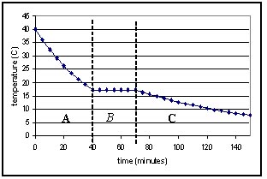
C. Qualitative Questions.

- Rebecca has left the margarine out on the kitchen bench, Brent finds it all liquid and puts it back in the fridge. In region A the liquid margarine is cooling, and loses heat in proportion to the temperature difference between itself and the air. As the margarine cools the temperature difference decreases, and it loses heat more slowly. Hence the graph is curved, and like many other physical processes (such as radioactive decay and capacitor discharge), it follows an exponential decay.
The rate of cooling also depends on the heat capacity of the material.
In region B the temperature is constant over time. In this region the margarine is solidifying so it continues to lose thermal energy (‘heat’) without changing temperature, this is the ‘latent heat’ associated with a change of state – from liquid to solid margarine. In region C the margarine has solidified and is again cooling. It is now cooling more slowly than it did as a liquid as the margarine approaches the temperature of its surroundings – we say that the margarine is coming into thermal equilibrium with its environment.

- Heat can be added to a substance without causing the temperature of the substance to rise.
- If there is an increase in temperature of a system then energy is transferred from the environment into the system: Heat is added to the system. This energy transfer, heat, increases the kinetic and potential energies of the molecules in the system thus increasing the temperature of the system. There can be energy transfer (heat exchange) with no change in temperature if there is a phase change. The energy is transferred into or released from energies associated with changing the bonds among molecules.
- In ice the molecules are held tightly together. Supplying heat gives the extra energy required to break the bonds so the solid turns into liquid. This is the latent heat of transformation.
- The water from the melted ice should be retained at least until all the ice is melted. The water allows heat to be conducted effectively from the food to the ice, and will also absorb heat from the food after the ice is melted until the food and water reach equilibrium.

D. Quantitative question:

If a small storm of 1 km radius precipitates 2 cm of water, the total volume of water precipitated is:
V = πr² × d = π × (1000 m)² × 0.02 m = 63 × 10³ m³. This is equivalent to 63 × 10⁶ kg of water. The energy released is the latent heat of transformation, which for water is 2257 J.kg.⁻¹, so the total energy released by the condensation during this storm is E = 63 × 10⁶ kg × 2257 J.kg.⁻¹ = 1.4 × 10¹¹ J.
Workshop Tutorials for Introductory Physics
TI3: Heat Transfer

A. Review of Basic Ideas:

Use the following words to fill in the blanks:
wetsuit, conduction, hot, sun, cold, radiation, flow, conducted, energy

Convection, conduction and radiation
Imagine a day at the beach, on a mild day with a maximum temperature of 25ºC. You find a nice sheltered spot in the dunes and lie on the sand for a while enjoying the sunshine. Even though it’s not a particularly hot day after a while you get quite warm. This seems odd, because heat flows from ________ regions to ________ regions, and as your skin temperature is warmer than the air, it seems odd that you are getting hotter. To understand why you are getting hotter you need to consider the heat transfer processes that are occurring. You get hot because you are absorbing radiation from the _______. This is one way in which heat can be transferred. All hot bodies radiate heat, in proportion to their temperature. You can absorb a lot of __________ from the sun when the weather is cold, and lose heat to the air by ____________, convection and radiation quite quickly. When this happens you don’t get hot even though you are absorbing a lot of radiation.
You decide to take a swim to cool off. When you get into the water it feels very cold, because your body quickly loses heat by conduction to the water. The water molecules in contact with your skin can absorb heat from your skin which is ___________ away by the water.
The movement of the water also helps you cool off quickly. The water molecules can absorb heat as they get close to your skin, increasing their own kinetic energy, and then move away taking that energy with them. Convection involves a _________ of material, while conduction and radiation involve a flow of _______ (heat), but not matter.
If you lie very still in a rock pool so that the water hardly moves you feel a little warmer after a while, because the water around you has warmed up a bit, and is not being moved away by convection. A __________ keeps you warm this way, by trapping a layer of water against your skin, and not letting it flow around. A wetsuit also works by decreasing conduction of heat.

B. Activity Questions:

Thermal conductivity.
Feel the different blocks. Which feels the coldest? Which feels the warmest?
Now measure their temperatures. Which is the warmest? Which is the coldest? Explain your observations.

“Stubby holder”
How does the stubby holder keep the can cool? Which process of heat transfer is affected?
Wetsuits worn when swimming in cold waters are effective in reducing heat loss from the body. A wetsuit is named so because it traps a layer of water. Explain why wearing a wetsuit keeps a swimmer warmer.

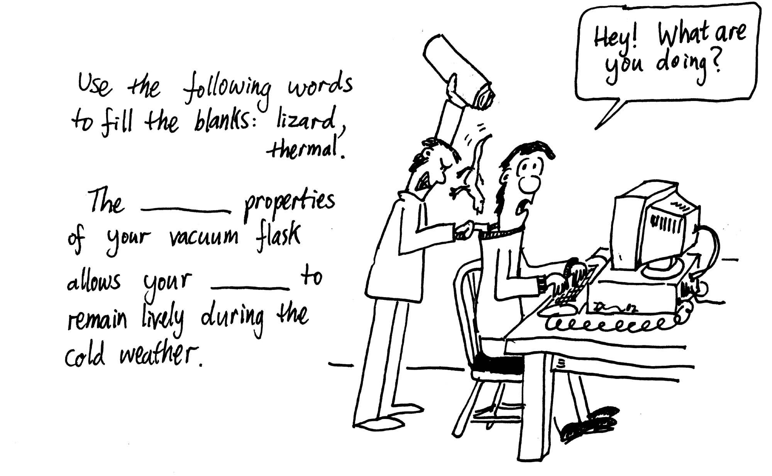
Thermos flask.
Examine the thermos flask.
It has a thick stopper, double walls which are evacuated, and the vacuum bottle is silvered on the inside. Explain how this keeps drinks either hot or cold. What processes of heat transfer are affected?

Measuring air temperatures
Check the readings on the two thermometers.
Now put one of them under the light or in the sun for a few moments.
How do the readings compare now?
What does a thermometer actually measure?

C. Qualitative Questions:

- You can make a “heat telescope” by putting the bulb of a mercury-in-glass thermometer in a paper cup lined with aluminum foil. On a cool, dry clear night you point the telescope at the sky. After a few minutes you read the thermometer. Then you point the thermometer at the earth for a few minutes and read the thermometer again.
- Do you expect any difference in the two readings? Explain your reasoning.
- Why is the cup lined with aluminum foil?

- The greenhouse effect is an issue of increasing global concern, with average temperatures expected to rise significantly around the world over the coming years. The effects of this could be disastrous, with weather patterns changing and sea levels rising.
- What is the green house effect, and what causes it?
- Draw a schematic diagram showing the thermal processes involved. Which thermal processes are affected, and why does this lead to warming?

D. Quantitative Question:

A house has well insulated walls which are 0.32 m thick with a total area of 360 m², a roof of tiles 0.08 m thick and area 280 m², and (uncovered) glass windows, 0.85 cm thick with total area 42 m². The temperature inside the house is 22⁰C and the outside temperature is 34⁰C.
- Assuming that the heat gained by the house is by conduction only, determine the rate at which heat must be removed to maintain the temperature at 22⁰C.
- Describe two ways in which the house can be made more energy efficient, so in winter it doesn’t need to be heated as much, and in summer it doesn’t need an air conditioner running so often.

Data:
k_{wall} = 0.25 J.s⁻¹.m⁻¹ .ºC⁻¹
k_{tiles} = 0.55 J.s⁻¹.m⁻¹ .ºC⁻¹
k_{glass} = 0.84 J.s⁻¹.m⁻¹ .ºC⁻¹

Workshop Tutorials for Introductory Physics
Solutions to TI3: Heat Transfer

A. Review of Basic Ideas:

Convection, conduction and radiation
Imagine a day at the beach, on a mild day with a maximum temperature of 25ºC. You find a nice sheltered spot in the dunes and lie on the sand for a while enjoying the sunshine. Even though it’s not a particularly hot day after a while you get quite warm. This seems odd, because heat flows from hot regions to cold regions, and as your skin temperature is warmer than the air, it seems odd that you are getting hotter. To understand why you are getting hotter you need to consider the heat transfer processes that are occurring. You get hot because you are absorbing radiation from the sun. This is one way in which heat can be transferred. All hot bodies radiate heat, in proportion to their temperature. You can absorb a lot of radiation from the sun when the weather is cold, and lose heat to the air by conduction, convection and radiation quite quickly. When this happens you don’t get hot even though you are absorbing a lot of radiation.
You decide to take a swim to cool off. When you get into the water it feels very cold, because your body quickly loses heat by conduction to the water. The water molecules in contact with your skin can absorb heat from your skin which is conducted away by the water.
The movement of the water also helps you cool off quickly. The water molecules can absorb heat as they get close to your skin, increasing their own kinetic energy, and then move away taking that energy with them. Convection involves a flow of material, while conduction and radiation involve a flow of energy (heat), but not matter.
If you lie very still in a rock pool so that the water hardly moves you feel a little warmer after a while, because the water around you has warmed up a bit, and is not being moved away by convection. A wetsuit also keeps you warm this way, by trapping a layer of water against your skin, and not letting it flow around. A wetsuit also works by decreasing conduction of heat.

B. Activity Questions:

Thermal conductivity
The blocks are all at room temperature. Your skin is usually a little warmer than room temperature, and when you touch something like metal it feels cold because heat is quickly conducted away from our skin by the metal. Wood and polystyrene are good insulators, and do not conduct heat away from your skin, hence they feel warm. What are you are really feeling when you feel for “temperature” is the rate at which heat is transferred to or from your skin.

“Stubby holder”
The stubby holder prevents heat loss by convection and conduction. When a wetsuit traps a layer of water it also prevents convection, as there is no longer a flow of water over the skin.

Thermos Flask
A thermos flask has double walls, which are evacuated and the vacuum bottle is silvered on the inside. The vacuum between the two walls prevents heat being transferred from the inside to the outside by conduction and convection. The silvered walls reflect radiated heat back to the inside, the same way a space blanket does.

Measuring air temperatures
A thermometer always measures its own temperature. If it is in the shade, it reaches thermal equilibrium with the surrounding air molecules and measures that temperature. When heated by the sun's radiation it measures its own raised temperature. The equilibrium temperature is greater than the air temperature.

C. Qualitative Questions:

- You can make a “heat telescope” by putting the bulb of a mercury-in-glass thermometer in a paper cup lined with aluminum foil. On a cool, dry clear night you point the telescope at the sky. After a few minutes you read the thermometer. Then you point the thermometer at the earth for a few minutes and read the thermometer again.
- The thermometer will have a higher reading when pointed at the ground. This is because the Earth is hotter than the sky and hence radiates energy as infrared radiation. This radiation heats up the liquid in the thermometer and it expands, giving a greater temperature reading than when pointed at the sky.
- The cup is lined with aluminum foil to reflect the incident radiation onto the thermometer. The cup acts as a radiation collector.

2. The greenhouse effect.
- Greenhouse gases like carbon dioxide and methane in the atmosphere absorb energy which is radiated by the Earth’s surface. These gases then radiate in all directions, so some radiation is absorbed back at the Earth’s surface rather than being lost to space. In a glass greenhouse there is this effect of preventing radiation escaping, and also prevention of heat loss by convection, much as in a closed car. Note that this is quite different to the effect of ozone depleting gases (chloro-fluoro-carbons or CFCs), which break up ozone molecules which shield us from UV radiation.
b.
1. radiation comes in from sun.
2. radiation interacts with plants, Earth etc.
3. radiation remitted with lower energy, especially infrared
4. radiation absorbed or reflected by green houses gases: heat trapped

D. Quantitative Question:

A house has well insulated walls which are 0.32 m thick with a total area of 360 m², a roof of tiles 0.08 m thick and area 280 m², and (uncovered) glass windows, 0.85 cm thick with total area 42 m². The temperature inside the house is 22⁰C and the outside temperature is 34⁰C.
k_{wall} = 0.25 J.s⁻¹.m¹ .ºC⁻¹, k_{tiles} = 0.55 J.s⁻¹.m¹ .ºC⁻¹, k_{glass} = 0.84 J.s⁻¹.m¹ .ºC⁻¹
The rate of flow of heat, Q, in J.s⁻¹(= watts) across an area A of material with thermal conductivity k is given by $Q=\text{kA}\left(ΔT/l\right)$ where ΔT is the temperature difference and l is the thickness of the material. The total heat flow into the room will be $Q_{\text{total}}=$$Q_{\text{wall}}+Q_{\text{wood}}+Q_{\text{glass}}$
$=(0\text{.}\text{25})(\text{360})\left(\frac{\text{34}−\text{22}}{0\text{.}\text{32}}\right)+(0\text{.}\text{55})(\text{280})\left(\frac{\text{34}−\text{22}}{0\text{.}\text{08}}\right)+(0\text{.}\text{84})(\text{42})\left(\frac{\text{34}−\text{22}}{0\text{.}\text{0085}}\right)$
= 3375 J.s⁻¹ + 23100 J.s⁻¹ + 49800 J.s⁻¹ = 76 kJ.s⁻¹ = 76 kW.
which is the heat to be removed to maintain the temperature at 22ºC. Note that most of this is due to heat loss from the uncovered windows, simply closing curtains or blinds can make a big difference to your heating or air conditioning bill!

Workshop Tutorials for Introductory Physics
TI4: First Law of Thermodynamics

A. Review of Basic Ideas:

Use the following words to fill in the blanks:
into, sun, thermal, internal, physics, friction, isolated, ΔU = W, ΔU = Q, small, work, Rebecca, positive

Conservation of Energy and the First Law of Thermodynamics
Conservation of Energy is one of the most useful and widely used concepts in _________. You may have seen the concept of conservation of energy in the study of motion (mechanics), but often with a qualifying statement - providing the effects of ________ can be ignored. The first law of thermodynamics is a statement of conservation of energy that includes any flow of _______ energy in or out of a system. It establishes Conservation of Energy as a central principle in physics.
To discuss the flow of energy in or out of a system we first have to define the system we are talking about. A system may or may not be an isolated system. An ________ system is one where no energy flows in or out of the system. Consider the situation where Brent and ________ are sitting on the beach with the cool box of drinks. The cool box is not an isolated system as thermal energy flows in. Consider the system of the earth plus cool box. Since energy flows to the earth from the _______ this system is not isolated either. One of the essential skills of a physicist is to be able to judge which features of a situation are essential to solving a problem and which features are not really significant. It may be that a system can be treated as an isolated system when the flow of energy is very ________.
The First Law of Thermodynamics states that any change in ________ energy, ΔU, of a system is equal to the sum of the work done on the system and the heat flow into the system. Mathematically it can be written ΔU = Q + W, where the work, W, is ________ when work is done on the system and the heat, Q, is positive when heat flows ________the system.
In the example of the cool box the increase in internal energy is due to the flow of thermal energy into the cool box. No ________ is being done on the cool box. So ________ . Pumping bicycle tyres is another example. Here we are compressing the gas as we pump and so work is being done on the gas. If we do it quickly the thermal energy has no time to flow out and the internal energy of the gas increases. This is an example of an adiabatic process, where ___________.

B. Activity Questions:

Bicycle pump
Put your finger on the end of the nozzle so that the air in the pump is trapped.
Pump the bicycle pump and feel what happens to the cylinder.
Explain your observations using the first law of thermodynamics.

Ball bearings in a tube
Check the temperature of the ball bearings inside of the tube.
Now shake the tube vigorously for a minute or more.
What is the temperature of the ball bearings now?
Why has it changed?
Could you use this technique to reheat a cold cup of coffee?

Heat and Work
There are three processes to perform.
In the first system, the piston is pushed down into the insulated cylinder.
In the second system, the gas inside the tin is heated with the lid on.
In the third system the gas is heated with the sliding lid on, and a load on top.
force
gas
gas
heat
heat
gas
load
1.
2.
3.

Which, if any, of these processes is adiabatic?
Are any of them isochoric? What about isobaric?
Draw a table showing the heat, work and change in internal energy for each process.

C. Qualitative Questions.

- Consider the human body as a system and apply the first law of thermodynamics to it. We know that over any given period of sufficient length (say one day), there will be a net heat flow from the body (i.e. Q is negative) and the body will do some external work on its surroundings (i.e. W is positive). The first law then tells us that ΔU is negative. So, each day there would be a decrease in internal energy.
  - Does the internal energy of the human body decrease as described above?
  - Explain how (and in what form) internal energy is added to the body to balance the continual decrease due to heat flow from the body and work being done by the body.
  - In the context of the human body, explain the following statement, “the first law of thermodynamics is a restatement of the law of conservation of energy”.

- On a very hot day Brent comes home and finds Rebecca sitting in front of the fridge with the door open. She explains that the air conditioner stopped working, so she’s using the fridge to cool the room instead
  - Will this cool the kitchen? What will happen to the temperature of the kitchen?
  - What would happen if Rebecca tried to cool the kitchen with an ice box full of ice instead?
  - How does an air conditioner keep a room cool without violating the first law of thermodynamics?

D. Quantitative questions.

A series of thermodynamic processes is shown in the pV-diagram below. In process ab, 150 J of heat are added to the system, and in process bd, 600 J of heat are added. Find:
- the internal energy change in process ab;
2 × 10⁻³ m³
5 × 10⁻³ m³
V
a
b
c
d
P
8.0 × 10⁴ Pa
3.0 × 10⁴ Pa
- the internal energy change in process abd;
- the total heat added in process acd.

Workshop Tutorials for Introductory Physics
Solutions to TI4: First Law of Thermodynamics

A. Review of Basic Ideas:

Conservation of Energy and the First Law of Thermodynamics
Conservation of Energy is one of the most useful and widely used concepts in physics. You may have seen the concept of conservation of energy in the study of motion (mechanics), but often with a qualifying statement - providing the effects of friction can be ignored. The first law of thermodynamics is a statement of conservation of energy that includes any flow of thermal energy in or out of a system. It establishes Conservation of Energy as a central principle in physics.
To discuss the flow of energy in or out of a system we first have to define the system we are talking about. A system may or may not be an isolated system. An isolated system is one where no energy flows in or out of the system. Consider the situation where Brent and Rebecca are sitting on the beach with the cool box of drinks. The cool box is not an isolated system as thermal energy flows in. Consider the system of the earth plus cool box. Since energy flows to the earth from the sun this system is not isolated either. One of the essential skills of a physicist is to be able to judge which features of a situation are essential to solving a problem and which features are not really significant. It may be that a system can be treated as an isolated system when the flow of energy is very small.
The First Law of Thermodynamics states that any change in internal energy, ΔU, of a system is equal to the sum of the work done on the system and the heat flow into the system. Mathematically it can be written ΔU = Q + W, where the work, W, is positive when work is done on the system and the heat, Q, is positive when heat flows into the system.
In the example of the cool box the increase in internal energy is due to the flow of thermal energy into the cool box. No work is being done on the cool box. So ΔU = Q. Pumping bicycle tyres is another example. Here we are compressing the gas as we pump and so work is being done on the gas. If we do it quickly the thermal energy has no time to flow out and the internal energy of the gas increases. This is an example of an adiabatic process, where ΔU = W .

B. Activity Questions:

Bicycle pump
The air in the sealed off pump is compressed quickly, hence work is done on the air. There is little time for heat transfer to occur, so Q ~ 0, and the change undergone by the gas is a good approximation to an adiabatic process. The increase in internal energy is indicated by the rise in temperature, which is detected by a thermocouple inside the pump.

Ball bearings in a tube
When you shake the tube you do work on the ball bearings and give them kinetic energy.
The kinetic energy is lost as thermal energy as the ball bearings settle again, and this thermal energy increases the temperature of the ball bearings.
You could heat up a coffee this way, but it would take years of vigorous shaking!

Heat and Work
There are three processes: in the first system, the piston is pushed down into the insulated cylinder. This is adiabatic, as the insulation prevents heat exchange. In the second system, the gas inside the tin is heated with the lid on. This is isochoric – the volume is kept constant. In the third system the gas is heated with the sliding lid on, and a load on top – this is isobaric as the weight on top of the lid keeps the pressure constant.
 | process 1 | process 2 | process 3
Heat (+ is in) | 0 | + | +
Work (+ is out) | - | 0 | +
ΔU | + | + | +

C. Qualitative Questions.

- Consider the human body as a system and apply the first law of thermodynamics to it..
  - Internal energy is related to temperature. The human body has fairly constant temperature, hence the internal energy does not decrease as described above.
  - Internal energy is added to the body to balance the continual decrease due to heat flow from the body and work being done by the body. The added internal energy comes from food. The food is broken down into simple components like sugars which are stored, then when the body needs energy the sugar is broken down and oxidized (has oxygen added), and there is energy released.
  - We gain energy from the food, air and water that we take in. This energy is converted to heat and into work, and stored as potential energy, for example in fats. The total energy is always conserved, and the change in internal energy is the difference between the energy gained and the energy lost as heat and work.

- Brent comes home and finds Rebecca sitting in front of the fridge with the door open.
- The temperature of the room will increase if Rebecca leaves the fridge door open. Energy is required to “move” the heat from the inside of the fridge to the coils at the back of the fridge. The energy comes from the electricity used to run the fridge, and the process is not perfectly efficient, some of the energy is lost as heat (for example due to resistance in the wiring). Even if the process was 100% efficient, the temperature would not drop because the total energy would be conserved, although directly in front of the door might be a little cooler than near the back of the fridge.
- An icebox full of ice would help to cool the flat. Thermal energy from the air is used to melt the ice, the amount of energy required is called the latent heat of transformation. So the air will lose energy to melt the ice, thus cooling the air.
  - An air conditioner keeps a room cool without violating the first law of thermodynamics. It moves heat from the inside of a house to the outside. To do this uses energy. An air conditioner always has one side poking out of the house where hot air is pumped out, or a duct going to the outside.

D. Quantitative questions.

A series of thermodynamic processes is shown in the pV-diagram below. In process ab, 150 J of heat are added to the system, and in process bd, 600 J of heat are added.
- The internal energy change in process ab must be 150 J because the work done is zero (no volume change) so ΔU_{ab} = Q_{ab}.
2 × 10⁻³ m³
5 × 10⁻³ m³
V
a
b
c
d
P
8.0 × 10⁴ Pa
3.0 × 10⁴ Pa
- In process bd the pressure is constant so the work done is
W_{bd} = p(V_{d} –V_{b})
=(8.0×10⁴ Pa) (5.0 ×10⁻³ m³ – 2.0 ×10⁻³ m³) = 240 J
We know from a that the work done in process ab is zero, so the total work in process abd is
W_{abd} = W_{bd} + W_{ab} = 240 J + 0 J = 240J
The total heat added is
Q_{abd} = Q_{ab} + Q_{bd} = 150 J + 600 J = 750 J.
The change in internal energy is the heat added minus the work done, which is
ΔU_{abd} = Q_{abd} - W_{abd} = 750 J – 240 J = 510 J.
- The change in internal energy, ΔU is independent of path, so ΔU_{acd} = ΔU_{abd} = 510 J.
The total work for path acd is
W_{acd} = W_{ac} + W_{cd}= p(V_{c} –V_{a}) + 0 = (3.0×10⁴ Pa) (5.0 ×10⁻³ m³ – 2.0 ×10⁻³ m³) = 90 J.
The heat added is
Q_{acd}= ΔU_{acd} + W_{acd} = 510 J + 90 J = 600 J. This is quite different to process abd.
Workshop Tutorials for Introductory Physics
TI5: Kinetic Theory

A. Review of Basic Ideas:

Use the following words to fill in the blanks:
kinetic energy, pressure, number, momentum, molecules, mole, macroscopic, kinetic, force, PV = nRT, increase

Kinetic Theory
Properties of materials can be described at the _________ level, which we can see and measure easily or at the microscopic level where special equipment is needed to observe what is happening to atoms and _________. For example, the pressure of a gas can be described as the ________ per unit area exerted by the gas on a surface or can be thought of as the _________ imparted to the surface by the molecules of the gas. Similarly we can talk of the temperature of a gas and measure it with a thermometer or we can say the temperature of a gas is determined by the average _________ energy of the gas molecules.
Kinetic theory describes the properties of gases at the molecular level. In particular it describes the temperature, T, pressure, P, and volume, V, of a gas and how they are related. For an ideal gas - one where there is no attraction between the molecules - it can be shown that ___________ where n represents the number of moles of gas and R is the universal gas constant. One _________ contains 6.023 × 10²⁴ molecules of gas. It is interesting to note that this equation does not depend on the type of molecule, but rather on the _________ of molecules present.
Real gases can be considered as ideal when the density of the gas is low enough so that attraction between the molecules is negligible. The equation above shows us that if we keep the volume constant and _________ the temperature then the pressure will increase. We can think about this at the molecular level. Increasing the temperature increases the average kinetic of the molecules, so when they collide with the surfaces of the container we would expect to see a greater change in momentum as they reverse direction. Hence the _________ is greater.
Kinetic theory can also explain why evaporation from your skin (perspiration) helps you stay cool. Those molecules with the greatest ________ ________ are more likely to escape from your body thus reducing the average kinetic energy of those left behind, thus reducing your temperature.

B. Activity Questions:

2D model of gases
What happens when you increase the “temperature” of the gas?
How do the pressure and volume change?

Water boiling at less than 100°C
Can you make the warm water in the syringe boil?
Why does it boil at this lower temperature?

Blowing
Blow on your hands as if it was a cold day and you were trying to warm them.
Now blow on them as if you were blowing a hot drink to cool it.
How can you both heat and cool by blowing?
What do you do differently in each case, and why does it work?

Dropper
Use the dropper to pick up some liquid.
What holds the liquid in the dropper?
Explain why it doesn’t fall out.

Boyle’s law.
Take four or five measurements of pressure and volume using the apparatus provide.
Plot these points. Do they agree with the gas laws?

C. Qualitative Questions.

- Two equal-sized rooms communicate through an open doorway. However, the average temperatures in the two rooms are maintained at different values.
- In which room are there more air molecules? Explain your answer.
- In which room will the average speed of the molecules be lower? Why?

- Brent has bought Rebecca a new pressure cooker for her birthday. Rebecca is a bit skeptical about the device, but decided to cook a casserole in it to test it out. The pressure cooker is a fancy one, and comes with a cookbook. One recipe lists the cooking time for a chicken casserole as only 20 minutes. “Wow!” says Rebecca “that usually takes at least 45 minutes to cook!”
  - Why does food cook so much faster in a pressure cooker than in a saucepan?
After cooking the casserole, Rebecca insists they let it cool a few minutes. She explains that its much hotter than if she’d cooked it in a saucepan, so they’d better let it cool a little before tucking in.
  - Is the casserole much hotter than one from a saucepan? What limits the temperature of a normal saucepan and a pressure cooker?

D. Quantitative questions.

Valuable documents and artifacts are sometimes kept in an inert atmosphere to stop them from decomposing, for example the declaration of independence in the US is kept in a sealed vault under nitrogen. A local museum is setting up a display of early Australian flags, including the original flag from the Eureka Stockade in Ballarat. They have a glass case specially made in which to display the flag. The case has a volume of 8 litres. The flag is laid out and nitrogen (N₂ gas) is pumped into the case to displace the air, so that it contains only nitrogen gas at atmospheric pressure. This is done at night when the temperature is 8ºC, so that the display can be launched at a ceremony the next morning. The next day is very hot, and it gets up to 35ºC. During the ceremony someone notices a hissing sound coming from the case, and a leak is discovered. The leak is fixed, but not before enough nitrogen has escaped so that the pressure has reached equilibrium. That evening, when the temperature has dropped back to 8ºC again, the pressure inside the case is measured.
- How much nitrogen (in grams) remains in the case?
- How much nitrogen has been lost from the case? How much will need to be added to refill the case to atmospheric pressure?
- What is the pressure inside the case now, before it is refilled?

Data:
Gas constant R = 8.31 J.mol⁻¹.K⁻¹
Molar mass of nitrogen gas = 28 g.mole⁻¹.
Workshop Tutorials for Introductory Physics
Solutions to TI5: Kinetic Theory

A. Review of Basic Ideas:

Kinetic Theory
Properties of materials can be described at the macroscopic level, which we can see and measure easily or at the microscopic level where special equipment is needed to observe what is happening to atoms and molecules. For example, the pressure of a gas can be described as the force per unit area exerted by the gas on a surface or can be thought of as the momentum imparted to the surface by the molecules of the gas. Similarly we can talk of the temperature of a gas and measure it with a thermometer or we can say the temperature of a gas is determined by the average kinetic energy of the gas molecules.
Kinetic theory describes the properties of gases at the molecular level. In particular it describes the temperature, T, pressure, P, and volume, V, of a gas and how they are related. For an ideal gas - one where there is no attraction between the molecules - it can be shown that PV = nRT where n represents the number of moles of gas and R is the universal gas constant. One mole contains 6.023 × 10²⁴ molecules of gas. It is interesting to note that this equation does not depend on the type of molecule, but rather on the number of molecules present.
Real gases can be considered as ideal when the density of the gas is low enough so that attraction between the molecules is negligible. The equation above shows us that if we keep the volume constant and increase the temperature then the pressure will increase. We can think about this at the molecular level. Increasing the temperature increases the average kinetic of the molecules, so when they collide with the surfaces of the container we would expect to see a greater change in momentum as they reverse direction. Hence the pressure is greater.
Kinetic theory can also explain why evaporation from your skin (perspiration) helps you stay cool. Those molecules with the greatest kinetic energy are more likely to escape from your body thus reducing the average kinetic energy of those left behind, thus reducing your temperature.

B. Activity Questions:

2D model of gases
When you increase the “temperature” of the gas the molecules move faster, they have an increased velocity. This means that when they collide with the lid (and walls) of the container they exert a greater pressure, as they can transfer more momentum to the lid. If the lid is not held in place, it will be pushed up, increasing the volume of the container.

Water boiling at less than 100°C
Boiling happens when evaporation occurs beneath the surface of a liquid, forming bubbles of gas which rise to the surface and escape. The pressure inside a bubble has to be equal to the pressure outside for the bubble to exist. The pressure outside the bubble depends on the temperature of the water. So boiling depends not only on temperature, but pressure as well. If you decrease the atmospheric pressure then the pressure required inside the bubble lowers and the molecules in the liquid don’t need to move as fast to exert this pressure on the bubble. So the boiling point decreases.
When the syringe is pulled suddenly, the volume increases, so pressure decreases and boiling point decreases.

Blowing
When you blow on your hands to warm them you do so wit your mouth fairly open, and you puff on your hands, held close to your mouth. The air coming out of our mouth is at, or close to, body temperature, so it feels warm against your hands which are at a lower temperature.
When you blow on food or drink to cool it you purse your lips and blow a stream of air over it. As the air comes out of your mouth its volumes can expand as the pressure around it drops. As the volume increases the air cools, so it is cooler than body temperature, and quite a lot cooler than hot drink temperature. The flow of air helps increase cooling by convection.

Dropper
When you squeeze the rubber top on the dropper you squeeze the air out. Then when you put the tip into the liquid and stop squeezing the top, the low pressure inside sucks up the liquid. In fact it is the higher pressure outside the dropper, in the liquid, that pushes the liquid up into the dropper. The liquid is held in by the lower pressure in the tube than the external atmospheric pressure.

Boyle’s law.
Hopefully your results agree with Boyle’s law, which states that volume varies inversely with pressure, (P ∝ $\frac{1}{V}$) however there may be small differences due to experimental error.

C. Qualitative Questions.

- Two equal-sized rooms communicate through an open doorway. However, the average temperatures in the two rooms are maintained at different values.
- The rooms are of equal volume and must have equal pressures, otherwise air would rush from one room to the other. One room is being maintained at a higher temperature, so using PV = nRT, this room must have a smaller number of air molecules, n, if T is greater but PV is the same.
- Temperature is a measure of average kinetic energy, hence the molecules in the room with lower temperature will have lower average kinetic energy and lower average speeds.

- Brent has bought Rebecca a new pressure cooker for her birthday.
  - Food cooks faster in a pressure cooker than in a saucepan because the pressure is much higher, hence the temperature can be higher. In a saucepan, even with the lid on, the pressure cannot exceed atmospheric pressure by very much. When a liquid boils, bubbles are formed beneath the surface of the liquid. The pressure within a bubble has to be equal to that of the atmosphere plus the water above for the bubble to exist. The pressure outside the bubble depends on the temperature of the water. So boiling depends on temperature, and pressure. If you increase the pressure then the pressure required inside the bubble increases and the temperature needed to make the liquid boil increases. So the boiling point increases, and the food is cooked at a higher temperature, hence it cooks faster.
  - The casserole will be hotter than one from a saucepan. A normal saucepan with water (or a water based food in it), can only get to 100ºC. At this temperature, any extra heat (thermal energy) that goes from the hotplate into the pan goes to changing the state of the water into steam. In a pressure cooker the temperature can get much hotter, as the water inside boils at a higher temperature, so much more heat can be added, increasing temperature rather than breaking bonds to change state. Pressure cookers typically cook at around 120 ºC, which is also hot enough to kill many nasty bacteria such as botulism.

D. Quantitative questions.

The case has a volume of 8 litres ( = 8 × 10⁻³ m³) of N₂ gas at atmospheric pressure, at T = 8ºC = 291 K. The next day T = 35ºC = 308 K and enough nitrogen escapes so that P = 1 atm = 100 kPa again. That evening, when the temperature has dropped back to 8ºC again, the pressure inside the case is measured.
- Using PV = nRT, we get:
n_{next day} = PV/RT = (1.0 × 10⁵ Pa × 8 × 10⁻³ m³ ) / (8.31 J.mol⁻¹.K⁻¹ × 308 K) = 0.31 mol
0.31 mole = 0.31 × 28 g.mole⁻¹ = 8.8 g of N₂ gas.
- We need to know how much was originally there to know how much was lost:
n_{initial} = PV/RT = (1.0 × 10⁵ Pa × 8 × 10⁻³ m³ ) / (8.31 J.mol⁻¹.K⁻¹ × 281 K) = 0.34 mol,
hence 0.34 mole – 0.31 mole = 0.03 moles was lost. This is equivalent to 0.84 g. This is how much will need to be put back in to refill the case.
- We know that n_{final} = n_{next day} because the leak was fixed, so we can now find P_{final} :
P = nRT/V = (0.31 mole × 8.31 J.mol⁻¹.K⁻¹ × 281 K) / (8 × 10⁻³ m³) = 9.0 × 10⁴ Pa = 90 kPa = 0.9 atm.

Workshop Tutorials for Introductory Physics
TI6: Entropy and the Second Law of Thermodynamics

A. Review of ideas in basic physics.

Use the following words to fill in the blanks:
increase, randomness, time, Second, entropy, small, isolated

Entropy and the Second Law of Thermodynamics
If a china mug is dropped on the floor and breaks into many pieces, we accept this as a normal process. If the mug were to put itself back together and jump back into our hand we would consider this a most abnormal process. It is the ________ Law of Thermodynamics which provides the principle that governs the ordering of events. It can be said that it determines the direction of ________.
The Second Law of Thermodynamics can be stated in terms of the ________ of a system. The concept of entropy is used to describe the degree of order in a system. The number of ways a system can be organized can be used as a measure of its disorder or _________. To illustrate this concept imagine a room full of molecules and then imagine the room divided up into many different equal volume cells. The probability of finding all the molecules in one cell is very ________. The entropy of that situation has a low value. The probability of finding molecules spread throughout the imaginary cells is much greater and hence the entropy of this situation is higher. In fact if you pushed all the air molecules into a corner of a room and then released them you would expect some time later to find the molecules spread throughout the room – i.e. you would expect the entropy to _________.
The Second Law of Thermodynamics can be stated as follows: In any naturally occurring system the entropy of an isolated system cannot decrease. The word _________ means that there is no energy flow in or out of the system.
A broken mug is less ordered than an intact one. Hence it would be abnormal for the broken pieces of the mug to reassemble themselves into a more ordered state.

B. Activity Questions:

Macroscopic states and microscopic states
Take two discs from the container.
How many microstates are possible? List the microstates.
Consider the macroscopic state (also called simply a state) of half of the discs facing up to be blue and the other half to be green. What is the probability of this state?
Now take 4 discs instead of 2. How many microstates are possible? List the microstates?
What is the probability of half of the discs facing up to be blue and the other half to be green now?

What happens to the probability of finding this state as the number of discs increases?

Muliplicity
You have 6 identical “molecules” and a box with two parts.
What are the possible states (i.e. combinations of number of molecules in each half of the box)?
What is the multiplicity of each state? How many possible microstates are there altogether?
Which of these states would be the equilibrium condition? What can say about the order of this state?

C. Qualitative Questions.

- A growing plant creates a highly complex and organised structure out of simple materials such as air, water and carbon dioxide. Do plants violate the second law of thermodynamics?

- People who wear glasses sometimes walk into a humid place like a packed train carriage or the butterfly house at the zoo and have their glasses fog up. It can even happen walking outside on a hot humid day from an air-conditioned building.
- Why does the water condense on the glasses, making them fog up?
- Is there a change in the entropy of the water as it condenses? If there is, is the change positive or negative, and why?

D. Quantitative question

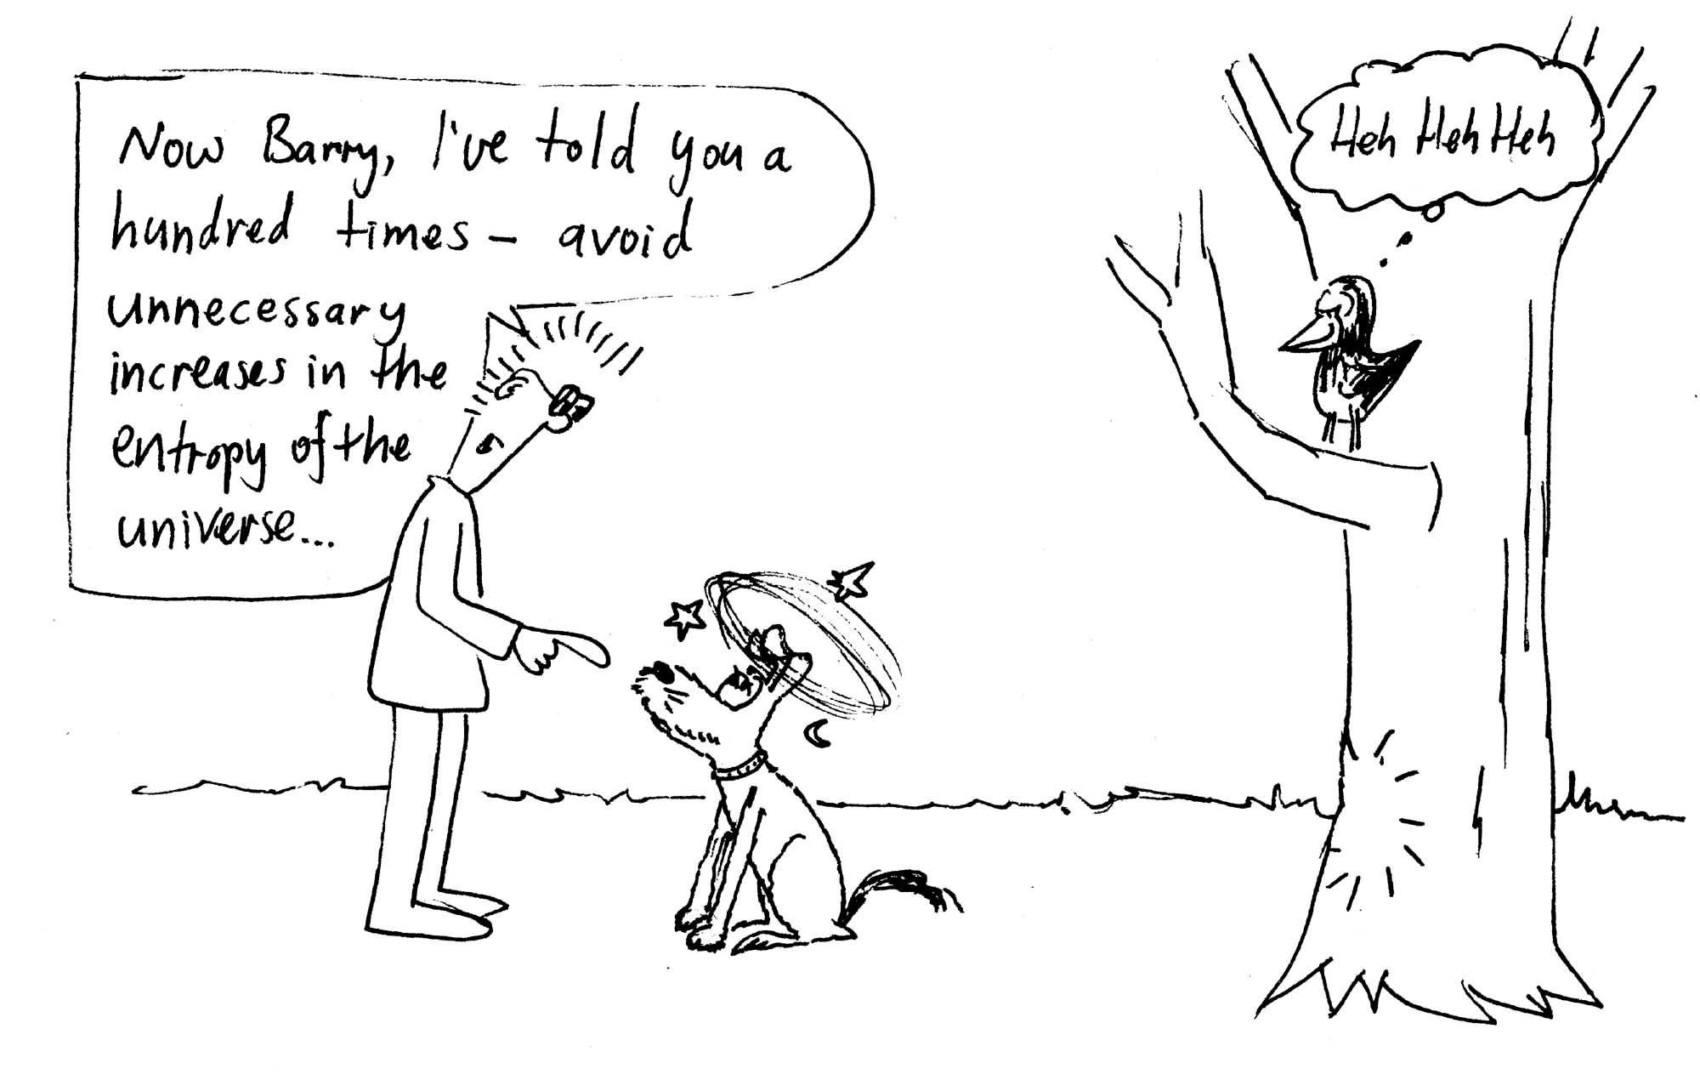
On a warm evening, 27ºC, Rebecca and Brent are sitting outside having a barbeque dinner in their back yard, and watching a magpie swooping Barry the dog. Barry, who weighs 28 kg, is running after the magpie. Unfortunately he isn’t looking where he is going and runs into a tree. Barry bounces off the tree, lands on the ground and comes to a complete stop. Barry had a speed of 8 m.s⁻¹ just before he hit the tree. What is the change in entropy of the universe due to this collision?
Workshop Tutorials for Introductory Physics
Solutions to TI6: Entropy and the Second Law of Thermodynamics

A. Review of ideas in basic physics:

Entropy and the Second Law of Thermodynamics
If a china mug is dropped on the floor and breaks into many pieces, we accept this as a normal process. If the mug were to put itself back together and jump back into our hand we would consider this a most abnormal process. It is the Second Law of Thermodynamics which provides the principle that governs the ordering of events. It can be said that it determines the direction of time.
The Second Law of Thermodynamics can be stated in terms of the entropy of a system. The concept of entropy is used to describe the degree of order in a system. The number of ways a system can be organized can be used as a measure of its disorder or randomness. To illustrate this concept imagine a room full of molecules and then imagine the room divided up into many different equal volume cells. The probability of finding all the molecules in one cell is very small. The entropy of that situation has a low value. The probability of finding molecules spread throughout the imaginary cells is much greater and hence the entropy of this situation is higher. In fact if you pushed all the air molecules into a corner of a room and then released them you would expect some time later to find the molecules spread throughout the room – i.e. you would expect the entropy to increase.
The Second Law of Thermodynamics can be stated as follows: In any naturally occurring system the entropy of an isolated system cannot decrease. The word isolated means that there is no energy flow in or out of the system.
A broken mug is less ordered than an intact one. Hence it would be abnormal for the broken pieces of the mug to reassemble themselves into a more ordered state.

B. Activity Questions:

Macroscopic states and microscopic states
With two discs there are four possible microstates. B is blue side up, G is green side up. The possible states are BB, BG, GB, GG.
The macroscopic state of half of the discs facing up to be blue and the other half to be green has a probability of ½, as two of the four possible microstates give this macrostate.
With four discs there are 2×2×2×2 = 16 possible microstates. These are BBBB, BBBG, BBGB, BBGG, BGBB, BGBG, BGGB, BGGG, GBBB, GBBG, GBGB, GBGG, GGBB, GGBG, GGGB, GGGG. The probability of half the discs green add half blue is now 6/16 = 3/8. The probability has decreased.
In general, the more possible microstates there are, the less probable a given macrostate becomes. As the number of components increases, so does the possible number of microstates, and so does the entropy of the system.

Muliplicity
You have 6 identical “molecules” and a box with two parts.
The possible states, written (X,Y) where X is the number in one side and Y is the number in the other are: (6,0) (5,1) (4,2) (3,3) (2,4) (1,5)(0,6). The multiplicity, W, of a state is the number of different ways in which that state can be achieved. It is equal to W=N!/n₁!n₂!. So in this case the multiplicities are: 1, 6, 15, 20, 15, 6, 1. There are 1 + 6 + 15 + 20 + 15 + 6 + 1 = 64 possible states in total.
The equilibrium condition is the most probable state – in this case the state with 3 molecules in each half of the box. This is also the most disordered state.

C. Qualitative Questions.

- Plants do not violate the second law of thermodynamics. The plant uses energy from the sun to break down nutrients from the soil, and carbon dioxide from the air. These nutrients are then used to build complex molecules. Even though locally (inside themselves) they increase order by making complex molecules, the overall entropy of the plant and its surroundings increases, as they use the light and produce oxygen.

- People who wear glasses sometimes walk into a humid place and have their glasses fog up.
  - The glasses fog up because water condenses out from the surrounding air onto the colder surface of the glasses. The water molecules lose energy as they change phase from vapour to liquid. You may also have seen this happen on the side of a cold can or bottle when you take it out of the fridge.
  - As the liquid is a more ordered state than vapour then the condensed water has lost entropy. The change is negative. The change in entropy depends on temperature – while the change in both temperature and entropy is negative for the water, it is positive for the glasses, which absorb heat from the water. The total change in entropy of the universe when the water condenses is still positive or zero.

D. Quantitative question

On a warm evening, 27ºC = 300 K, Barry, who weighs 28 kg, runs into a tree. Barry bounces off the tree, lands on the ground and comes to a complete stop. Barry had a speed of 8 m.s⁻¹ just before he hit the tree. The change in entropy of the universe due to this collision is given by ΔS = W_{lost} /T where T is the temperature and W_{lost} is the work lost due an irreversible process – Barry’s collision is an irreversible process – his mechanical energy (kinetic energy) is completely lost as thermal energy, and cannot be changed back into mechanical energy. The work lost due to the collision is the kinetic energy previously had by Barry – KE = ½ mv² = ½ × 28 kg × (8 m.s⁻¹) = 896 J.
The change in entropy of the universe is ΔS = W_{lost} /T = 896 J / 300 K = 3.0 J.K⁻¹.
Workshop Tutorials for Introductory Physics
TI7: Blackbody Radiation

A. Review of ideas in basic physics.

Use the following words to fill in the blanks:
temperature, P = σ AT⁴, electromagnetic, warmth, stars, spectrum, absorbed, emissivity,

Blackbody Radiation
Try holding your hands close to but not touching a mug of hot coffee – you can feel the _______. This warmth is actually _________ radiation emitted from the mug. The amount and wavelength of radiation will depend on certain characteristics of the mug including its temperature. As you already know a hot body will radiate more than a cold one. The surface of the body will also affect the amount of radiation leaving the body. In fact each object has a characteristic ________ of emitted radiation.
To provide a standard for the amount of radiation emitted from a body we define an ideal object called a blackbody. A blackbody is one where all the radiation hitting the body is _______, a perfect absorber. It is also a perfect emitter, emitting the maximum amount of radiation possible for a body at a given temperature.
The Stefan-Boltzmann law tells us that the rate at which energy is radiated from a body is ________ for a perfect blackbody, where σ = Stefan-Boltzmann constant and A = surface area. For any other body, the power is P = εσΑT⁴, where ε is the _________ of the body – a characteristic of the surface.
Wien’s Law relates the wavelength λ_{m} at which emitted radiation is a maximum to the temperature of the body. It states that λ_{m}×T = constant. A body with a lower temperature will emit more radiation of longer wavelength. This provides a useful way of measuring the ________ of things without having to get close enough to them to reach thermal equilibrium with them. This is particularly useful for astronomers as it gives them a means of measuring the surface temperatures of distant _______. It can also provide a warning not to touch something – if it is hot enough to be glowing, like an electric hot plate, then it is much too hot to touch.

Discussion Question
All bodies emit and absorb radiation but, as we have seen, rates will vary. Can you explain why a white car parked in the sun does not get as hot as a dark coloured one? Is it because dark colours attract more heat?

B. Activity Questions:

Thermal radiation – the Leslie Cube.
Use the thermopile detector to look at the radiant heat from the different surfaces of the cube.
Which surface radiates the most? Which surface radiates the least?

The Black Box
Look into the hole. What colour do you see?
Now open the lid. What colour is the inside of the box?
Why is it so? How can you explain your observation?

Blackbody radiation.
Gradually turn up the power passing through the graphite.
What happens as you increase the power?
Explain your observations.

C. Qualitative Questions.

- It took a long time for someone to come up with an explanation of black body radiation. Eventually Max Planck came up with an explanation, and it led to the development of quantum physics, which changed not only how we understand the universe, but also led to the development of all modern electronics, including TVs, mobile phones and computers.
  - Explain the meaning of the term black body radiation.
Consider two black bodies at different temperatures.
  - Sketch, on a single set of axes, graphs showing the relation between the power emitted per unit area, per unit wavelength interval and the wavelength. Indicate which graph represents the higher temperature.
If the temperature of the sun were suddenly to increase (but its size were to stay the same) how would the following quantities change at the surface of the earth?
  - The total radiant power received.
  - The wavelength for maximum spectral intensity of received radiation.
  - The radiant power received in the visible range.

- A thermos bottle consists of an inner bottle and an outer bottle, usually with the space between them evacuated. This prevents heat loss by conduction. What sort of material should be used to coat the walls of the thermos? Should the material behave like a blackbody radiator?

D. Quantitative question:

In the movie “2001: a space odyssey” an astronaut walks briefly in space with no space suit. If you did this you would radiate thermal energy, but absorb almost none from your environment.  - At what rate would you lose energy? Assume that your emissivity is 0.90 and estimate the other data that you need.  - How much energy would you lose in 30 s? | 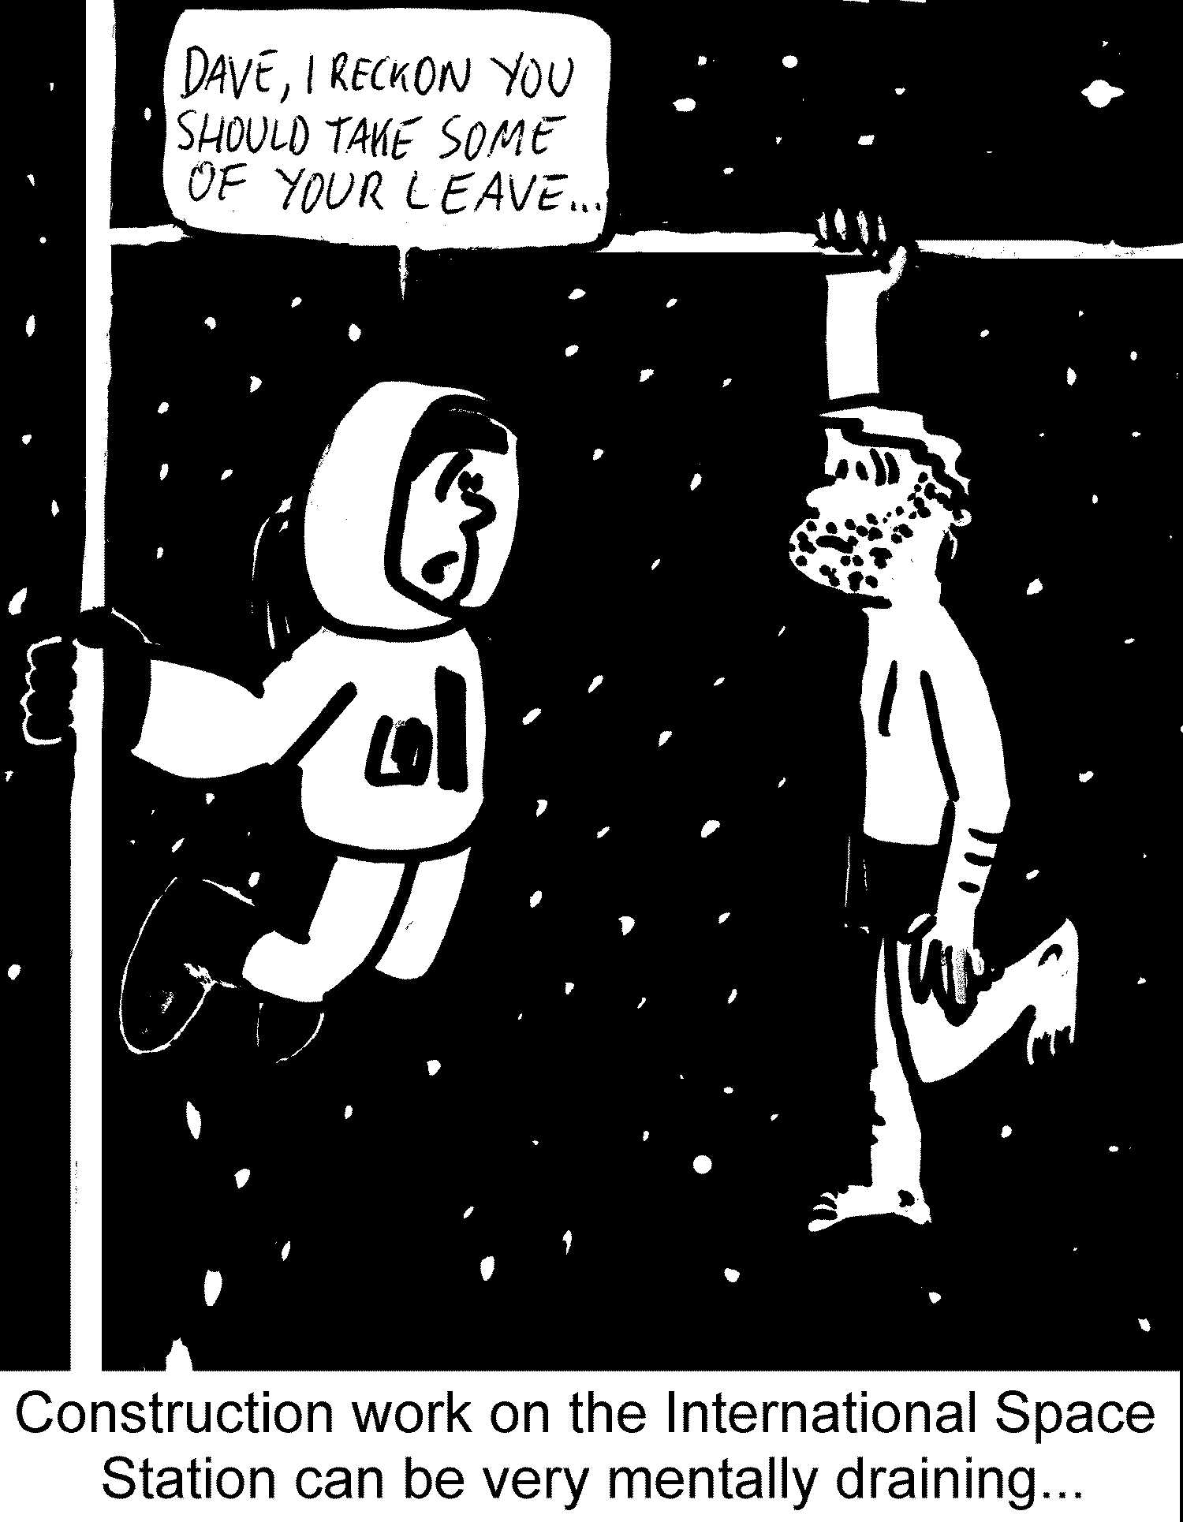

Workshop Tutorials for Introductory Physics
Solutions to TI7: Blackbody Radiation

A. Review of ideas in basic physics.

Blackbody Radiation
Try holding your hands close to but not touching a mug of hot coffee – you can feel the warmth. This warmth is actually electromagnetic radiation emitted from the mug. The amount and wavelength of radiation will depend on certain characteristics of the mug including its temperature. As you already know a hot body will radiate more than a cold one. The surface of the body will also affect the amount of radiation leaving the body. In fact each object has a characteristic spectrum of emitted radiation.
To provide a standard for the amount of radiation emitted from a body we define an ideal object called a blackbody. A blackbody is one where all the radiation hitting the body is absorbed, a perfect absorber. It is also a perfect emitter, emitting the maximum amount of radiation possible for a body at a given temperature.
The Stefan-Boltzmann law tells us that the rate at which energy is radiated from a body is P = σ AT⁴ for a perfect blackbody, where σ = Stefan-Boltzmann constant and A = surface area. For any other body, the power is P = εσΑT⁴, where ε is the emissivity of the body – a characteristic of the surface.
Wien’s Law relates the wavelength λ_{m} at which emitted radiation is a maximum to the temperature of the body. It states that λ_{m}×T = constant. A body with a lower temperature will emit more radiation of longer wavelength. This provides a useful way of measuring the temperature of things without having to get close enough to them to reach thermal equilibrium with them. This is particularly useful for astronomers as it gives them a means of measuring the surface temperatures of distant stars. It can also provide a warning not to touch something – if it is hot enough to be glowing, like an electric hot plate, then it is much too hot to touch.

Discussion Question
All bodies emit and absorb radiation but, as we have seen, rates will vary. A white car parked in the sun does not get as hot as a dark coloured one because it will absorb less radiation than a dark coloured car, and reflect more. Sometimes people say that dark colours attract heat – this is not true, you cannot attract heat. The amount of incident heat depends on the surface area of the object and the intensity of radiation only.

B. Activity Questions:

Thermal radiation – the Leslie Cube.
The greater the emissivity, ε, of the surface the more it will radiate for a given temperature. The quantity ε takes values between 0 and 1 depending on the nature of the surface radiating heat, a perfect radiator of heat has ε = 1 and is called a blackbody radiator. To a good approximation, all the sides (surfaces) of the cube are at the same temperature - the cube contains hot water and the cube’s sides are made of thin sheet metal, a good conductor of heat. The surfaces with the greater emissivity – matt black, shiny black (in that order) will radiate the most and have $e»1$ whereas shiny, polished metal (like a new stainless steel kettle) may have $e»0$.

The Black Box
When you look into the hole you see blackness, even though the inside of the box is white. This is because the hole is very small, and no light can get out of it to your eye. Black is an absence of light, and as there is no light in the box it appears black, just as a window to an unlit room is black regardless of the colours of the room. When the box is open light is reflected and you can see that it is white inside. A cavity or box with a small hole is a good approximation to a black-body because all light entering the hole is trapped, so the absorption is very high.

Blackbody radiation.
As you turn up the power supply the voltage across the graphite gets greater. This gives a bigger current through the graphite, and more power dissipated in it, hence it gets hotter. As it gets hot it begins to glow. Initially it glows red, and as it heats up more it glows orange and yellowish. If you could get it hot enough without melting it, it would glow white hot and eventually blue and ultraviolet.

C. Qualitative Questions.

- Max Planck came up with an explanation of Black body radiation.
- A black body is a perfect absorber, one which absorbs all incident radiation. A black body is also a perfect emitter, emitting the maximum amount of radiation for a body at that temperature. Such radiation is called black body radiation.  - See diagram opposite. The higher the temperature, the lower the wavelength of peak intensity, and the greater the peak intensity.  If the temperature of the sun were suddenly to increase (but its size were to stay the same) :  - The total radiant power received by the Earth would increase.  - The wavelength for maximum spectral intensity of received radiation would decrease.  - The radiant power received in the visible range would increase. | intensity  high temperature  low temperature  wavelength

- A thermos bottle consists of an inner bottle and an outer bottle, usually with the space between them evacuated. This prevents heat loss by conduction. There is a vacuum between the walls and this limits transfer of thermal energy by both conduction and convection. The inner wall is often made of glass, and is very shiny so that it reflects heat back into a hot drink. To reduce loss of thermal energy by radiation we want the walls of the container to not be a good absorber of radiation nor to be a good emitter, they should have both a low coefficient of absorption, and a low emissivity. So the walls should not behave like a black body radiator.

D. Quantitative question:

In the movie “2001: a space odyssey” an astronaut walks briefly in space with no space suit. Would he have felt the cold of space? If you did this you would radiate thermal energy, but absorb almost none from your environment.
- Estimating the average human body to have a surface area of 1.5 m², and a skin temperature of around 30ºC = 303 K (a bit less than core temperature of 37ºC).
The heat radiated is then P = σεAT⁴ = 5.67 × 10⁻⁸ W.m⁻².K⁻⁴ × 0.90 × 1.5 m²× (303 K)⁴ = 0.7 kW.
This is about the same as a small fan heater.
- The energy you would lose in 30 s is E = t× P = 30 s × 0.7 kW = 21 kJ.

