Electricity and Magnetism

Regular Electricity and Magnetism Worksheets and Solutions

ER1: | Charge and Coulomb’s Law | 3
ER2B: | Electric Fields | 7
ER2T: | Electric Fields | 11
ER3: | Flux and Gauss’ Law | 15
ER4B: | Electric Potential | 19
ER4T: | Electric Potential | 23
ER5B: | Capacitance | 27
ER5T: | Capacitance | 31
ER6: | Circuits | 35
ER7B: | Magnetic Fields | 39
ER7T: | Magnetic Fields | 43
ER8: | Electromagnetic Induction | 47
ER9: | Applications of Electromagnetism | 51
ER10: | Circuits II | 55
ER11: | AC Circuits | 59

Workshop Tutorials for Physics
ER1: Charge and Coulomb’s Law

A. Qualitative Questions:

- Which of the following effects are fundamentally electrical in nature? Briefly discuss the origin of each effect.
  - tension in a spring,
  - “crackles” when you take clothes off,
  - “crackles” from walking on dry leaves,
  - the spiral structure of galaxies,
  - nerve conduction,
  - nuclear fission,
  - the auroras,
  - pressure in a gas.

- In a simple (but not very accurate) model of the helium atom, two electrons (each of charge = -e) orbit a nucleus consisting of two protons (charge = +2e) and two neutrons (charge = 0). Is the magnitude of the force exerted on the nucleus by one of the electrons less than the force exerted on the electron by the nucleus? Explain your answer.

B. Activity Questions:

- Tape Charge
Stick two strips of tape on the desk, then peel them off.
Hang them close to each other and see what happens. Explain your observations.

- Electroscope and electrophorus
Charge up the plate using the electrophorus, by first rubbing the lower plate with the rubber glove, then placing the metal plate on the lower plate. Before the upper plate is removed, touch the top of the metal plate with your finger.
Explain how the metal plate becomes charged.
One can separate the electroscope leaves by both touching and not touching the electroscope with the metal plate.
Explain how.

- Charged rods
Charge up the rods using different materials. How do the items get charged?
Balance a charged rod on a watch glass. How can you accelerate it without touching or blowing on it?

C. Quantitative Questions:

- Newton’s law of gravitation says that the magnitude of the force between any two objects with mass is proportional to the masses of the objects and decreases with the square of the distance between them:
F_{G} = $\frac{{\text{Gm}}_{1}m_{2}}{r^{2}}$.
  - How is Newton’s law of gravitation similar to Coulombs law? How is it different?
In a simple (but not very accurate) model of the hydrogen atom, an electron orbits the nucleus at a mean distance of 5.29 × 10⁻¹¹ m. The nucleus (a proton) has a mass of 1.67 × 10⁻²⁷ kg and the electron has a mass of 9.11 × 10⁻³¹ kg.
  - What is the ratio of the gravitational force to the electrostatic force acting on the electron due to the nucleus?

Data:
G = 6.67 × 10⁻¹¹ N.m².kg⁻²
ε₀ = 8.85 × 10⁻¹² N.m².C⁻²
e = 1.6 × 10⁻¹⁹ C

2. Rebecca and Brent are putting up their Christmas decorations ready for Christmas Eve. Brent hangs a pair of glass-ball Christmas tree decorations from a single 40 cm long thread looped over a pin as shown. Rebecca wants the balls to hang 20 cm apart (centre to centre), and she suggests to Brent that he put in another pin so the balls hang apart.
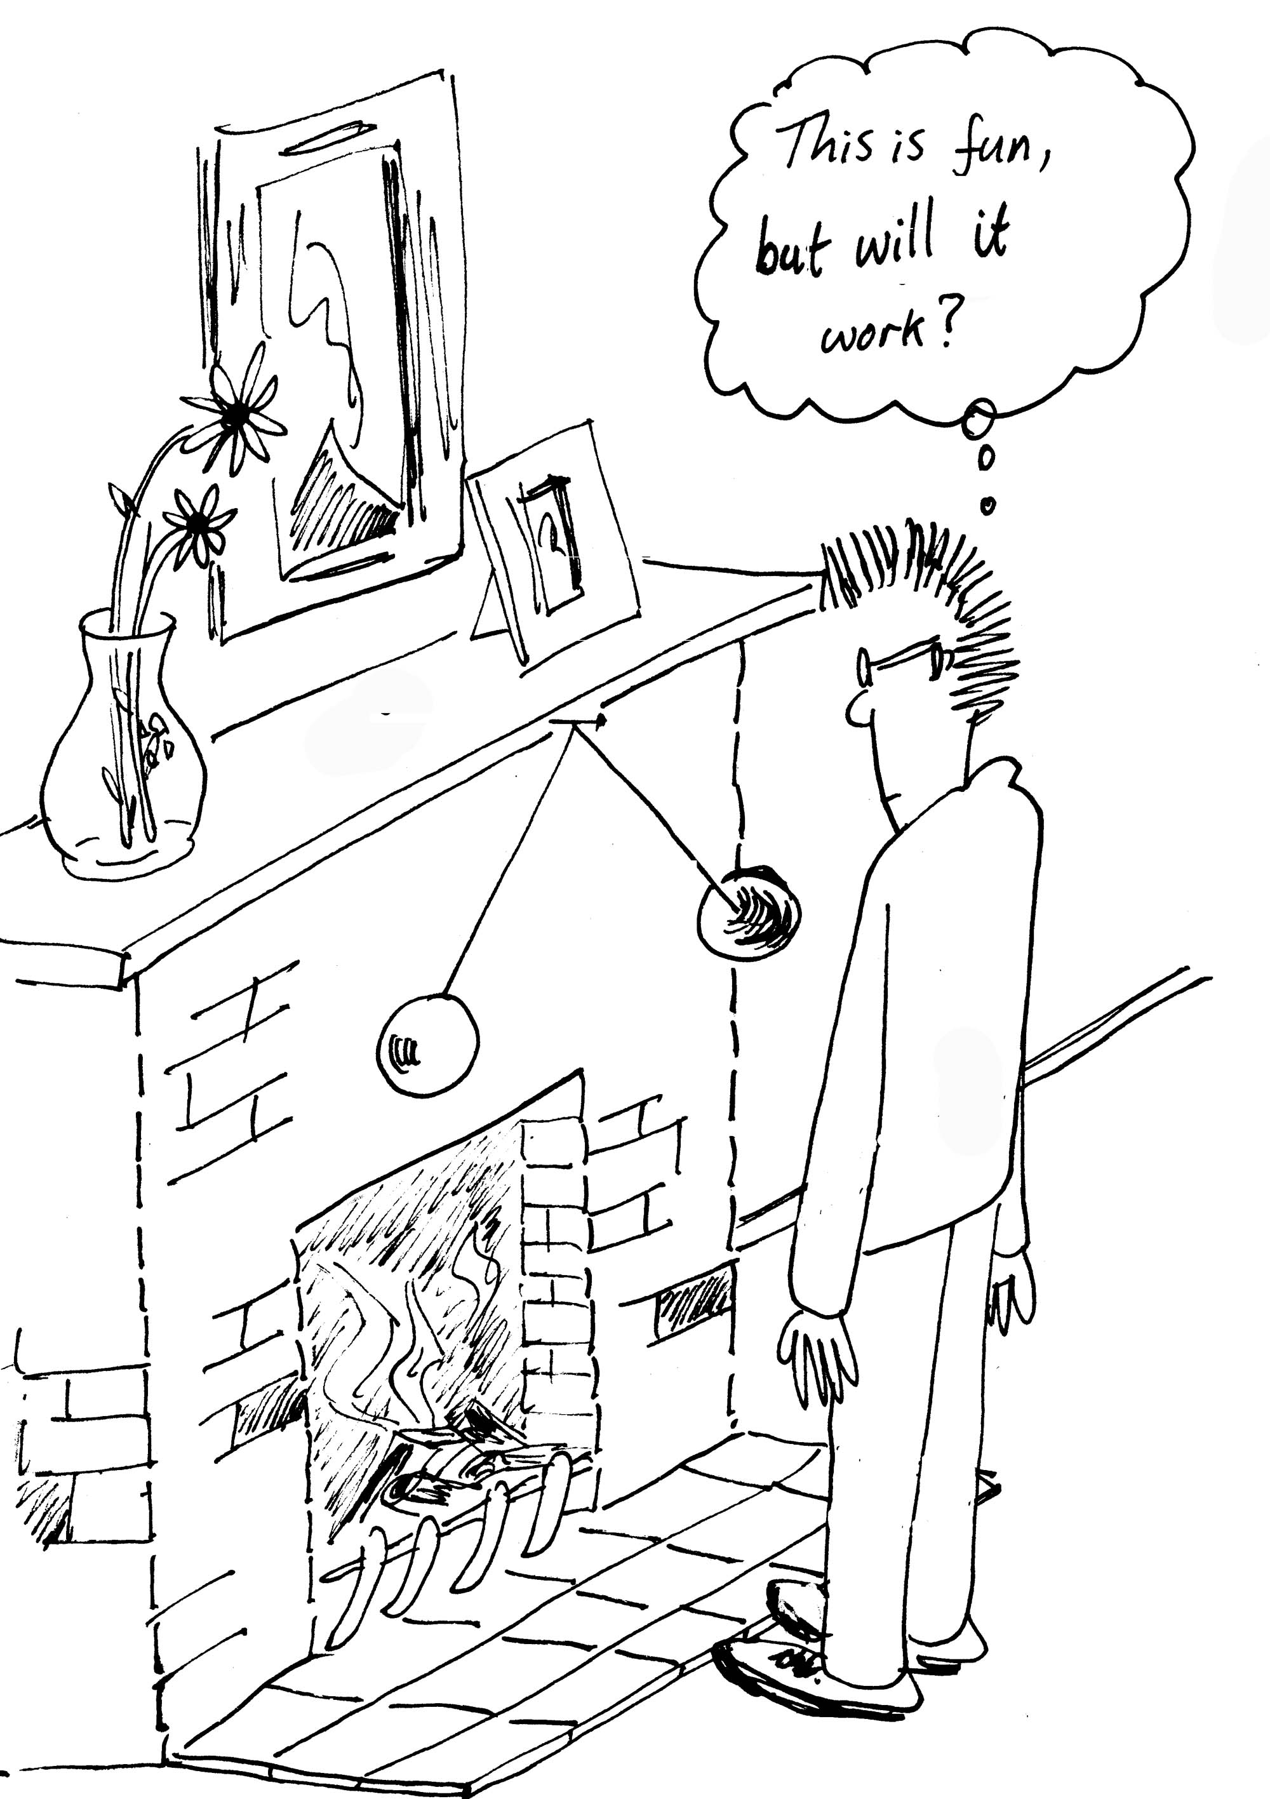
Not wanting to make lots of pin holes in the wall, Brent suggests that they charge the balls up instead so that they repel each other, thus removing the need for another pin, and simultaneously creating an interesting talking point. The thread is non-conducting, and the balls are coated in a shiny and conductive metal paint. The balls each have a mass of 10 g and a radius of 5 cm. The thread is very fine so its mass can be ignored. Brent uses Barbara the cat to charge up a Perspex rod, by rubbing it on her fur until it starts crackling and she runs away. He then uses the rod to charge the balls while holding them in contact by the threads
- Draw a diagram showing all the forces acting on the balls.
- How much charge must be placed on each ball so that they hang 20 cm apart (centre to centre) as Rebecca wants them to?
- This may be fun, but will it work?

Workshop Tutorials for Physics
Solutions to ER1: Charge and Coulomb’s Law

A. Qualitative Questions:
1. The following effects are fundamentally electrical in nature:
a. tension in a spring – this is due to the distortion of bonds in the spring, which are electrical in nature.
b. “crackles” when you take clothes off – this is due to buildup of charge on the garment
c. “crackles” from walking on dry leaves – as in a, this is due to breaking and distortion of bonds in the leaves, so this is also electrical in nature.
e. nerve conduction – relies on the movement of ions across cell membranes
g. the auroras – are due to charged particles becoming trapped in the Earth’s magnetic field.
h. pressure in a gas is due to the electrical repulsion of the molecules.
The following are not electrical in nature:
d. the spiral structure of galaxies – is due to gravitational forces
f. nuclear fission – the strong nuclear force holds nuclei together, although the energy released in nuclear fission comes from the electric force which drives the pieces apart.
- Coulomb’s law for electrostatics: F_{E} = $\frac{{\text{kq}}_{1}q_{2}}{r^{2}}$.
The force on one electron in the helium atom due to the nucleus is F = $\frac{{\text{kq}}_{1}q_{2}}{r^{2}}$=$\frac{k(−e)(2e)}{r^{2}}$,
where r is the distance from the nucleus to the electron, -e is the charge on the electron and +2e is the charge of the nucleus due to the two protons it contains.
The force on that one electron due to the nucleus is F = $\frac{k(−e)(2e)}{r^{2}}$, which has exactly the same magnitude as the force on the nucleus due to that electron, not less. Note that this is also the case for the gravitational force, the force on the Earth due to the gravitational attraction of a thrown tennis ball is the same as the force on the ball due to the earth. These are action reaction pairs, and Newton’s third law tells us that they must experience equal and opposite forces.


stick tape
on desk
pull off,
tape repels

B. Activity Questions:
1. Tape Charge
Large organic molecules, such as are involved in sticky tape or combs and hair or glass/plastic and cloth/fur, break easily and leave these items charged. The tape pieces repel each other because they have picked up a net charge, hence there is an electric field between them due to the charges. Hence they can interact without touching.
2. Electroscope and electrophorus
Rubbing with the rubber gloves charges the lower plate of the electrophorus. The neutral metal conducting plate (with insulated handle) is placed on the lower plate and charges in the metal separate with the lower surface having a charge opposite in sign to the charged lower plate. The upper surface of the metal plate is then earthed (by touching with a finger), leaving a net charge on the metal plate. It can then be removed. When the upper plate of the electrophorus touches the electroscope, charge flows onto the cap, stem and leaves of the electroscope. Since the leaves have excess like charge they will repel each other. When the upper plate of the electrophorus is held near the uncharged electroscope, charge in the electroscope will separate and the cap will have the opposite charge to the electrophorus and the leaves the same charge as the electrophorus. Once again the leaves themselves will have like charge and so will repel each other.

3. Charged rods
The glass rods are charged by electrons moving to or from them from the fur or silk. The plastic rods are charged by organic molecules being broken and positively charged segments stripped from the rod.
You can accelerate the rod without touching or blowing on it by holding another charged rod close by: the charges on the rods interact via a field, and attract or repel, accelerating the rod balanced on the watch-glass.

C. Quantitative Questions:
- Comparison of gravitation and electrostatic force.
- Newton’s law of gravitation says that the force between any two masses is proportional to the size of the masses and decreases with the square of the distance between them: F_{G} = $\frac{{\text{Gm}}_{1}m_{2}}{r^{2}}$.
Coulomb’s law for electrostatics says that the force between any two charges is proportional to the size of the charges and decreases with the square of the distance between them: F_{E} = $−\frac{{\text{kq}}_{1}q_{2}}{r^{2}}$.
Both have the same basic form in that the force varies inversely with r² and directly with either the product of the masses or the product of the charges of the objects. Note also that there is only one sort of mass, positive mass and that the gravitational interaction is always attractive, whereas in the case of electric charge there are both positive and negative charges and the interaction can be either attractive or repulsive.
- An electron in a hydrogen atom orbits the nucleus at a mean distance of 5.29 × 10⁻¹¹ m. The nucleus (a proton) has a mass of 1.67 × 10⁻²⁷ kg and the electron has a mass of 9.11 × 10⁻³¹ kg.
The ratio of the forces is:
F_{E} / F_{G} =$−\frac{{\text{kq}}_{1}q_{2}}{r^{2}}$ / $\frac{{\text{Gm}}_{1}m_{2}}{r^{2}}$ = $−\frac{{\text{kq}}_{1}q_{2}}{{\text{Gm}}_{1}m_{2}}$= $\frac{8\text{.}\text{99 }×{\text{10}}^{9}N\text{.}m^{2}\text{.}C^{\text{-2}}×1\text{.}6×{\text{10}}^{−\text{19}}C×1\text{.}6×{\text{10}}^{−\text{19}}C}{6\text{.}\text{67 }×{\text{10}}^{−\text{11}}N\text{.}m^{2}\text{.}{\text{kg}}^{\text{-2}}×1\text{.}\text{67}×{\text{10}}^{−\text{27}}\text{kg}×9\text{.}\text{11}×{\text{10}}^{−\text{31}}\text{kg}}$ = 2 × 10³⁹
Hence the electrostatic force is 39 orders of magnitude stronger than the gravitational force between the electron and proton in a hydrogen atom!
W
T
F_{E}
10 cm
25 cm
θ
- The string that holds the balls is 40 cm long, and the balls have a radius of 5 cm, so the center of the ball is 25 cm from the pin, and 10 cm from the mid point between the balls (directly beneath the pin).
- The following forces act on each of the balls: The force exerted by the string, T, the electrostatic force, F_{E,} and the weight W = mg. See diagram opposite.
- Since the balls are stationary, the sum of forces acting on each one must be zero.
In the x direction: F_{E} + T sinθ = 0 (1)
In the y direction: mg + T cosθ = 0 (2)
From the dimensions given, sin θ =10/25, so θ =23.58º.
Combining (1) and (2) gives tanθ = F_{E} /mg,
So kq₁q₂/r² = mg tanθ or q₁q₂ = mgtanθ r²/k
But q₁ = q₂ = q as charge will distribute evenly over the identical balls,
q =$\sqrt{\frac{\text{mg}\text{tan}θ r^{2}}{k}}=\sqrt{\frac{\text{.}\text{01}\text{kg}×9\text{.}\text{888}m\text{.}s^{−2}×0\text{.}\text{436}×(0\text{.}2m)^{2}}{8\text{.}\text{99}×{\text{10}}^{9}N\text{.}m^{2}\text{.}C^{−2}}}$= 0.44μC.
- In time the ions in the air will neutralize the charge on the balls and they would not stay apart. On a humid day this would happen fairly quickly.

Workshop Tutorials for Biological and Environmental Physics
ER2B: Electric Fields

A. Qualitative Questions:

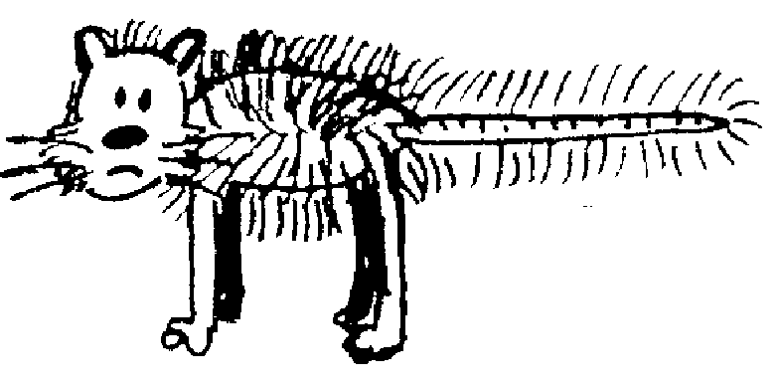
1. You charge up a cat by brushing it with a plastic comb so that the cat now has charge +q and the comb has charge –q. You charge up a test mouse to +1nC with a second comb, take that comb a long way away, then place the test mouse at different points in the room with the cat and the comb as shown below. (The room has a non-conducting floor.) Treat the cat and comb as point charges.
+q
-q
A
B
C
D
E
F

- Draw vectors showing the electric force on the test mouse at positions A, B, C, D, E and F. Draw the forces due to each charge and the net force.
- Rank the magnitudes of the electric force on the test mouse at points A, C, E and F.
- Rank the magnitudes of the electric field at points A, C E and F.
- Explain how and why your answers to part b are related to your answer for part c.
- Draw vectors showing the electric field at positions A, B, C, D, E and F. Use these vectors to help you draw field lines for the cat-comb combination.
- Are field lines “real”? Explain your answer.

- In the figure below the + signs represent a very wide and very long sheet of charge.
C D

A
B

- Draw vectors to show the direction of the electric field at the points A, B, C and D.
Two students are trying to decide where the field is strongest. Brent says that because C and D are further from the charges, the field must be weaker at these points than at A and B. Rebecca says that the field will be the same at C and D as it is at A and B because of the way the field lines are drawn.
- Draw the field lines and decide who you agree with. Explain why the other student is wrong.

B. Activity Questions:

- van de Graaff generator and wig
Place the “wig” on the generator. What do you observe?
Explain your observations. Draw field lines for the dome of the generator.
What happens when a person, insulated from the ground, touches the generator?

- Ball in a capacitor
Explain what is happening to the ping pong ball.
Why is it behaving in this manner?
How would it behave of you removed the aluminium foil?
Draw the field lines for the capacitor plates.

- Confused bubbles
Bubbles blown towards a van de Graaff generator behave in different ways.
Identify some patterns of behaviour.
Are the bubbles initially neutral?
Why would bubbles be attracted or repelled by the generator?

C. Quantitative Questions:

1. When atoms bind ionically at least one electron is transferred from one atom to the other. This is how sodium and chlorine bind to form sodium chloride (salt). In a salt crystal the sodium is Na⁺ and the chlorine is Cl⁻, each with a charge of ±1e. They are separated in a salt crystal by 0.28 nm.
- Considering only a single pair of ions, Na⁺Cl⁻, what will the force between the two ions be?
- What is the field at point halfway between the two ions?
- Draw a diagram showing the two ions. Draw a straight line between the two atoms and extend it out to either side. Will there be any point on the line where the force on another Na⁺ ion will be zero? If so, show on your diagram approximately where this point would be.
- If you had a salt molecule with a calcium ion, Ca⁺⁺, in place of the Na⁺ would there be any point on this line where the second Na⁺ would experience no force? If so, show on your diagram approximately where this point would be.
- If there is such a point, what will the field at that point be?
- What is the ratio of the force on the Cl⁻ to that on the Ca⁺⁺ ?

2. Cell membranes are made up of a double layer of fats, about 8.0 nm thick, as shown below.
Inside the cell there is an excess of negative ions, mostly Cl⁻, and outside there is an excess of positive ions, mostly Na⁺. The cell maintains an electric field across the membrane of 10⁷ N.C⁻¹.
8.0 nm
out

in

- Draw field lines for the section of membrane shown.
- What must be the charge per unit area on either side of the membrane?

Workshop Tutorials for Biological and Environmental Physics
Solutions to ER2B: Electric Fields

A. Qualitative Questions:
+q
-q
A
B
C
D
E
F
F_{comb}
F_{cat}
F_{net}
key:
1.

- Points C and E are both 2 grid squares away from one charge and 6.5 squares from the other, and the forces are in the same direction (towards the comb). F is two grid squares away from the comb, and 10.5 from the cat, a test charge here experiences a strong force towards the comb, but also a weak force in the opposite direction due to the cat, so the total force is weaker here than at C or E. The force at A is the weakest as it is 4 grid squares away from the cat, so it feels a relatively weak force from the cat, and is also very weakly attracted towards the comb.
Electric force at C = Electric force at E > Electric force at F > Electric force at A.
- Electric field at C = Electric field at E > Electric field at F > Electric field at A.
- The electric field at any point is defined in terms of the electrostatic force that would be exerted on a positive test charge at that point. E = F/q_{o}. The vector representing the force is a tangent to the field line.
+q
-q
A
B
C
D
E
F

- Field lines are not real, they are a convenient way of representing the field, which is a way of representing forces acting at a distance.
A B
C D
2. Electric field due to a sheet of charge.
- The field lines all point away from the sheet of positive charge. See opposite.
- Brent is wrong. The net force is perpendicular and away from the sheet. Components of the forces acting in any other direction cancel each other out. As long as the sheet is infinite, there is always a pair of charges at the same distance away in either direction from the points shown. All the field vectors have the same magnitude, and are parallel. Hence the density of field lines is not changing as we move away from the sheet, so the magnitude of the field is constant.

B. Activity Questions:
off
on
field lines
- van de Graaff generator and wig
The hairs of the wig stand up because they are charged by the generator. Usually the dome becomes positive, so negative charges move from the wig to the dome, leaving it positively charged. The hair stands up because the charges exert a repulsive force on each other, the hairs try to get as far away from each other as possible and are light enough to stand up and move apart.
The hairs also line up along the field lines. When a person touches the dome their hair will also stand up if enough charge is transferred.
+
-
- Ball in a capacitor
A ping-pong ball bounces continuously in between the two charged plates of a capacitor. When it touches one plate it picks up charge and accelerates towards the oppositely charged plate. If the foil is removed the ball still bounces, but much more slowly because it takes longer to charge. The field lines are shown opposite. The lines point from the positive plate to the negative plate, they are parallel near the middle of the plates and curve outwards near the edges of the plates
- Confused bubbles
The bubbles are initially neutral. The positively charged dome of the van de Graaff generator attracts negative charges which move around to the side of the bubble facing the dome. This bubble will now be attracted to the dome. The other side of the bubble will be positively charged and if the bubble bursts, those behind it may be splashed with this excess positive charge and become positively charged and be repelled by the dome.

C. Quantitative Questions:
1. Electrostatic forces and fields between ions in a salt crystal.
- F = $\frac{{\text{kq}}_{1}q_{2}}{r^{2}}$ = 8.9×10⁹ Nm²C⁻² ×(1.6 × 10⁻¹⁹C)²/ (0.28×10⁻⁹m)² = 2.9×10⁻⁹ N.
- The field will be equal to the sum of the field due to the Na⁺ and that due to the Cl⁻. These will be in the same direction as the Cl⁻ will attract a positive point charge, and an Na⁺ will repel it.
E_{total}=E_{Na}+E_{Cl}=$\frac{\text{ke}}{r^{2}}$+$\frac{\text{ke}}{r^{2}}$ = 2×8.9×10⁹ Nm²C⁻²×1.6×10⁻¹⁹C/(0.14×10⁻⁹m)²=1.4×10¹¹ N.C⁻¹
- There is no such point for this case, another Na⁺ will move away from the existing Na⁺ and towards the Cl⁻ if it is to the right of the Na⁺, and away further to the left if it is to the left of the Na⁺. See diagram below.
Ca⁺⁺ or Na⁺
Cl⁻
0.28 nm
0.68nm
F =E = 0 with Ca⁺⁺

- With a Ca⁺⁺ there will be a point to the right where the attraction of the Cl⁻ is balanced by the repulsion of the Ca⁺⁺. We require that F_{Cl} = F_{Ca}.
F_{Cl} = $\frac{{\text{kq}}_{1}q_{2}}{R^{2}}$= $\frac{−2\text{ke}\text{.}e}{(R+0\text{.}\text{28} \text{nm})^{2}}$ = F_{Na}. Now we can solve for R.
Cancel the k’s and e’s : 1/ R² = 2 / (R+0.28 nm)² or R² = (R + 0.28 × 10⁻⁹ m )²/2
take the square root of both sides: R = (R +0.28 nm)/√2.
- R(√2-1) = 0.28 × 10⁻⁹ m so R = 0.28 × 10⁻⁹ m/(√2-1) = 0.68 nm. If there is no force, the field is zero.
- The force will be the same on both ions, according to Newton’s 3rd law.
2. a. The field, if uniform, is E = V/d = 90 × 10⁻³V/ 8.0×10⁻⁹ m = 1.125×10⁷V.m⁻¹ ~ 1.1×10⁷V.m⁻¹.
b. The energy required to move 3 Na⁺ ions across this voltage gradient is W = qΔV = 3×1.6×10⁻¹⁹C × 90 × 10⁻³V = 4.3×10⁻²⁰ J.
But 2 K⁺ ions move into the cell, doing work, W = qΔV = 2×1.6×10⁻¹⁹C × 90 × 10⁻³V = 2.9×10⁻²⁰ J.
The pump must supply the difference of 1.4×10⁻²⁰J.
Workshop Tutorials for Technological and Applied Physics
ER2T: Electric Fields

A. Qualitative Questions:
1. A useful way of representing fields is by drawing field lines.
a. Draw electric field lines for the charges shown below. Note that the charges have equal magnitude.

b. Draw gravitational field lines for the earth and moon, shown below.
Hint: what do we use to define the field at a given point in space?
c. Gravitational and electric fields have some similarities and some differences. Use your diagram above to help explain these similarities and differences.

2. In the figure below the + signs represent a very wide and long sheet of charge (an infinite sheet).
C D

A
B

- Draw vectors to show the direction of the electric field at the points A, B, C and D.
Two students are trying to decide where the field is strongest. Brent says that because C and D are further from the charges, the field must be weaker at these points than at A and B. Rebecca says that the field will be the same at C and D as it is at A and B because of the way the field lines are drawn.
- Draw the field lines and decide who you agree with. Explain why the other student is wrong.

B. Activity Questions:
1. van de Graaff generator and wig
Place the “wig” on the generator. What do you observe?
Explain your observations. Draw field lines for the dome of the generator.
What happens when a person, insulated from the ground, touches the generator?

2. Ball in a capacitor
Explain what is happening to the ping pong ball.
Why is it behaving in this manner?
How would it behave of you removed the aluminium foil?
Draw the field lines for the capacitor plates.
3. Confused bubbles
Bubbles blown towards a van de Graaff generator behave in different ways.
Are the bubbles initially neutral?
Identify some patterns of behaviour. Why would bubbles be attracted or repelled by the generator?

C. Quantitative Questions:
- A photocopier works by putting positive charge onto the paper at the places where the image will appear. The toner particles are given a negative charge so that they will be attracted to these points. A wire, called the corona wire, is used to put the positive charge onto the paper. This wire typically has a radius of around 50 μm and charged to a potential of around +7kV, giving the wire a linear charge density of 40 nC.m⁻¹.
  - Assuming the corona wire is uniformly charged, draw a diagram showing the wire and the field it produces.
  - How does the field strength vary with the distance from the wire? How does this compare to the way field varies with distance from a point charge? What about a sheet of charge?
  - Write down an expression for the field at some distance r from the wire.
  - What is the electric field at a distance of 0.1 mm from the wire, approximately the distance from the wire to the paper?
2. Electric fields are used in many devices, such as photocopiers, printers and radiation detectors. Neutron detectors also use electric fields to count incident neutron radiation.
A neutron detector consists of a positively charged plate and a neutral plate (earthed) with a space in between filled with ³He. The plates are actually made by wrapping wire around a square plate, and the plates are typically 10 cm × 10 cm and spaced 5 mm apart. Neutrons don’t have a charge, so the electric field doesn’t affect them. However when a neutron collides with a ³He atom, it breaks apart into a tritium (³H) a proton and a photon. This photon can then ionize another atom, causing an electron to be ejected. This electron is then accelerated by the electric field to a plate, where it causes a small current. You can even tell where on the wire the electron hit by looking at the time gap between the current pulse reaching the two ends of the wire. This process is shown below. The proton is also accelerated towards the earthed plate, but being much heavier it takes a lot longer to get there. | counter  ³He gas  positively charged coil
³He + n → p + ³H + photon
photon ionizes atom
³He atoms
electron attracted to positive plate

incident neutron

Consider an electron which has been emitted from an atom midway between the plates, 8 cm above the bottom of the detector. The electron is initially at rest. Assuming it does not interact with any other atoms as it falls, how big an electric field is necessary to ensure that it reaches the positive plate before “falling out” of the detector?
(Hint: you will need to use Δx = v_{o}t + ½ at² .) data: m_{e} = 9.11 × 10⁻³¹ kg, e = 1.6 × 10⁻¹⁹ C.
Workshop Tutorials for Technological and Applied Physics
Solutions to ER2T: Electric Fields

A. Qualitative Questions:
1.
a.

b. | Use the force on a point charge, or in the case of a gravitational field, a point mass to define the field lines. In b, the force, and hence the field, is zero where the test mass is equally attracted to both Earth and moon.
c. Both gravitational and electric fields are defined in terms of force on a point object (charge or mass), and both obey a 1/r² law. In gravity there is only one type of “charge”, which is mass. In electrostatics there are two types, positive and negative. Like gravitational “charges” attract each other, but like electric charges repel each other and opposite charges attract. However the field lines are similar for a pair of positives for both gravitational and electric fields. Note that the direction of the field lines is different, they go into a mass, and out from a positive charge.
A B
C D
2. A sheet of charge.
- The field lines all point away from the sheet of positive charge. See opposite.
- Brent is wrong. The net force is perpendicular and away from the sheet. Components of the forces acting in any other direction cancel each other out. As long as the sheet in infinite, there is always a pair of charges at the same distance away in either direction from the points shown. All the field vectors have the same magnitude, and are parallel. Hence the density of field lines is not changing as we move away from the sheet, so the magnitude of the field is constant.
B. Activity Questions:

- 1. van der Graaf Generator:  - The hairs of the wig stand up because they are charged by the generator. Usually the dome becomes positive, so negative charges move from the wig to the dome, leaving it positively charged. The hair stands up because the charges exert a repulsive force on each other, the hairs try to get as far away from each other as possible and are light enough to stand up and move apart. The hairs also line up along the field lines. When a person touches the dome their hair will also stand up if enough charge is transferred. | off  on  field lines

2. Ball in a capacitor
+
-
A ping-pong ball bounces continuously in between the two charged plates of a capacitor. When it contacts with one plate it picks up sufficient charge to accelerate towards the oppositely charged plate. If the foil is removed the ball still bounces, but much more slowly because it takes longer to charge. The field lines are shown opposite. The lines point from the positive plate to the negative plate, they are parallel near the middle of the plates and curve outwards near the edges of the plates

3. Confused bubbles
The bubbles are initially neutral. The positively charged dome of the van de Graaf generator attracts negative charges which move around to the side of the bubble facing the dome. This bubble will now be attracted to the dome. The other side of the bubble will be positively charged and if the bubble bursts, those behind it may be splashed with this excess positive charge and become positively charged and be repelled by the dome.
side-on view:
C. Quantitative Questions:

1. A photocopier corona wire typically has a radius of around 50 μm and charged to a potential of around +7kV, giving the wire a linear charge density of 40 nC.m⁻¹.  - See diagram opposite. The field spreads radially outwards from the wire.  - The field of a point charge varies as 1/r², whereas the field from a line charge falls off as 1/r. Hence the field of the point charge falls away to zero more quickly. The field produced by a sheet of charge is uniform and does not vary with r. (Note, this is assuming an infinite sheet! – a situation we can use as an approximation when the dimensions of the sheet are many times the distance r from the sheet.  - The field at some distance r from the wire is given by the expression  E = λ/2πε_{o}r, where λ is the linear charge density.  - E = λ/2πε_{o}r = $\frac{\text{40}×{\text{10}}^{−9}C\text{.}m^{−1}}{2×3\text{.}\text{142}×8\text{.}5×{\text{10}}^{−\text{12}}N\text{.}m^{−2}\text{.}C^{−2}×1\text{.}0×{\text{10}}^{−3}m}$  = 750 kV.m⁻¹. | from above:
counter
³He gas
positively charged coil
2. The electron accelerates vertically because of the gravitational field and horizontally because of the electric field. If the electron is to hit the plate the time taken to fall 8cm must be no less than the time taken to move 2.5cm to the positive plate under the action of the electric field. In the limiting case we take the time to fall 8 cm equal to the time to move 2.5 cm horizontally.
Using Δy = v_{o}t + ½ a_{y}t² where a_{y} = g and v_{o} = 0 gives
t² =2Δy/g.
In the horizontal direction , Δx = v_{o}t + 1/2 a_{x}t²,
where a_{x} = eE/m and v_{o} = 0 ,
so eE/m = a_{x} = 2Δx/t² =2Δx g/2Δy.
Thus E =Δx gm/Δy e = 2.5 × 10^{-2.}m × 9.11 × 10⁻³¹ kg × 9.8m.s⁻²/1.6 × 10⁻¹⁹ C × 8.0× 10^{-2.}m
E =1.7 × 10⁻¹¹N.C⁻¹.
Workshop Tutorials for Physics
ER3: Flux and Gauss’ Law

A. Qualitative Questions:

1. Consider a Gaussian surface that encloses part of the distribution of positive charges shown below.
P
q₁
q₂
q₃
q₄
Gaussian surface

- Write an expression for the flux through the Gaussian surface shown.
- Which of the charges contribute to the electric field at point P?
Suppose you have a Gaussian surface which contains no net charge.
- Does Gauss’ law require that there is no electric field at all points on the surface? Draw a diagram to help explain your answer.
- Is the converse necessarily true, i.e. that if the electric field is zero everywhere then the charge contained must be zero?
2. A “Faraday cage” is a metal cage used to shield devices from electromagnetic fields. These are often used in precision experiments when a very small voltage needs to be measured. For example, a Faraday cage is usually used when measuring potential changes across nerve membranes, otherwise these changes cannot be detected due to “noise” from nearby electrical wiring.
- Using gauss’ law, explain how a conducting wire cage can shield its contents from external electric fields.
It is regularly proposed that Faraday cages be placed around sources of electric fields, such as mobile phones and large transformers, to protect people from possible effects of exposure to electric fields.
- Would this shield nearby people? Explain why or why not.

B. Activity Questions:

Faraday’s Icepail
Explain how the initially neutral pail became charged.
Why is the charge transferred totally to the pail and not shared between the pail and the ball?
How does this experiment confirm Gauss’ law?
- Gauss’ law
Fill the metal can with polystyrene balls and place it on the generator.
Now turn the generator on. Explain what happens.
Remove the metal can and replace it with the plastic one.
Explain what happens this time when you turn the generator on.

Flux
Hold the solar panel in front of the light.
What is the direction of the vector representing the area upper surface of the panel?
Give an expression for the flux of light onto the panel.
How can you orient the panel to maximise the flux?
If the orientation were kept constant, how would the flux change if you doubled the area of the panel?

C. Quantitative Questions:

1. Doctor Frankenstein’s great grandson, Wayne Frankenstein, has discovered the original notebooks explaining the process of reanimation. Being a scientist himself, he sets out to continue his great grandfather’s experiment. Wayne finds a vacant block where he measures the electric field at a height of 300m to have a magnitude of 60 N.C⁻¹, and at 200m the field has a magnitude of 100 N.C⁻¹. The field is directed vertically down.
Wayne builds a machine which will capture all the charge in a cube of size 100 m×100 m×100 m.
a. If the cube has horizontal faces at altitudes 200 m and 300 m, what will be the flux through the surface of this cube?
b. How much charge will Wayne’s machine collect?
c. Wayne directs the charge through a dead cat to reanimate it. If all the charge flows through the cat in 1.0 ms, what current will flow through the cat?
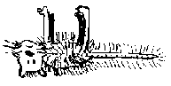
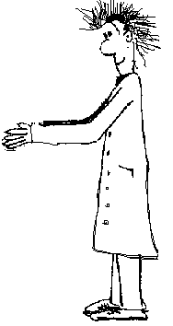
200m
E

100m

2. A neutral, spherical, thin metal shell has a point charge +q at its centre.
- Draw a diagram showing the field lines and distribution of charges.  - Use Gauss’ law to derive expressions for the electric field between the charge and the shell, and the field outside the shell.  - Has the shell any effect on the field due to q?  - Has the presence of q any effect on the charge distribution of the shell?  - If a second point charge is held outside the shell, does this outside charge experience a force? | +q  neutral
- Does the inside charge experience a force?
- Is there a contradiction with Newton's third law here? Why or why not?

Workshop Tutorials for Physics
Solutions to ER3: Flux and Gauss’ Law

A. Qualitative Questions:
P
q₁
q₂
q₃
q₄
Gaussian surface

- A Gaussian surface.
- The flux through the surface shown is Φ =$\frac{q_{\text{inside}}}{ε_{0}}$=$\frac{q_{2}+q_{3}}{ε_{0}}$.
- All of the charges contribute to the electric field at point P, a field at any point is the sum of the fields due to all charges present.
Suppose you have a Gaussian surface which contains no net charge.
- Gauss’s law does not require that there is no electric field at all points on the surface, it requires that the integral of E over the entire surface is zero. Consider for example a dipole consisting of two charges of equal magnitude and opposite sign, enclosed in a Gaussian surface. The points on the surface which are closer to one charge than the other will have a non-zero field, however the integral of the field over the entire surface will still be zero.  If the electric field is zero everywhere then the total charge contained must be zero. If there was a net charge contained there would be points at which there was a field. | E = 0 along this line.  Gaussian surface, ∫E.dA = 0.  E field lines out of surface in this region  E field lines into surface in this region

2. A “Faraday cage” is a metal cage used to shield devices from electromagnetic fields.
- A conducting wire cage can shield its contents from external electric fields. Consider a metal shell in an electric field. According to Gauss’s law if there is no contained charge then the flux through the surface must be zero and the electric field anywhere within the conductor must also be zero. Physically, if there is an electric field outside the conductor then there will be charge separation on the outside of the conductor. The charges will move until there is no longer a force acting on them, and hence the field must be zero. As long as the wires of the cage are close together compared to the size of the cage the field inside the cage will be approximately zero. This is why when you pass over a bridge which has metal scaffolding on it you lose radio reception, particularly on the AM band. Radio waves are electromagnetic waves, and the scaffolding shields you against them. FM has shorter wavelengths so needs a finer mesh to shield against it.
- You cannot shield against electric fields by putting the devices that generate the fields into metal cages. The field induces charge separation on the cage, such that the field outside the cage is the same as if the cage were not there.
B. Activity Questions:
- Faraday’s Icepail
The ball is lowered into the container, and charges are induced on the container walls. When the ball is touched to the inner surface all its excess charge is transferred to the container and appears on the outer wall of the container. All the charge is transferred because when the ball is in contact with the container they act as a single conductor.
The electric field within a conductor is zero, and if you draw a Gaussian surface inside the conductor it will contain zero charge because E = 0 everywhere on the surface. Hence the ball can contain no charge.
When the ball is removed, we can see that it has no charge, thus confirming Gauss’s law.
- Gauss’ law
When the generator is turned on the metal becomes charged. On a conductor all the charge goes to the outside of the conductor, so the balls inside do not become charged. When the plastic cup is placed on the generator the balls fly out. The plastic is an insulator, so the charge does not flow easily to the outer surface. The balls inside become charged and repel each other and are light enough to fly out of the cup.
- Flux
The flux onto the panel is Φ = -AIcosθ where I is the intensity of the light, A is the area of the panel and θ is the angle between the normal vector to the surface and the direction of the incident radiation. Note the minus sign because the flow lines and the vector representing the area are in opposite directions.
max
A
min
A
(out of page)
To maximise the flux you need to maximise the area that the light “sees”, so the surface should be perpendicular to the light. To minimise the flux you turn the area parallel to the light. Doubling the A would double the flux.
C. Quantitative Questions:
1. Wayne Frankenstein’s cat re-animator.
a. The flux through the top surface will be:
Φ = $\oint{E\text{.}\text{dA}}$ = E.A = 60 N.C⁻¹ × 100 m × 100 m = 6.0×10⁵ N.C⁻¹.m².
The flux through the bottom surface is Φ = $\oint{E\text{.}\text{dA}}$ = E.A = 100 NC⁻¹ × (100m)² = 1.00 × 10⁶ N.C⁻¹.m².
The sides are parallel with the field so there will be no flux through the sides, so the net flux through the cube is 1.00 × 10⁶ N.C⁻¹.m² - 6.0 × 10⁵ N.C⁻¹.m² = 4.0×10⁵ N.C⁻¹.m².
- For any closed surface (Gauss’ law), Φ = $\oint{E\text{.}\text{dA}}$ = q/ε₀ where q is the charge enclosed by the surface.
Φ = $\oint{E\text{.}\text{dA}}$ = 4.0×10⁵ NC⁻¹m² = q/ε₀ and q = 4.0 × 10⁵ N.C⁻¹.m² × 8.85×10⁻¹² C².N⁻¹.m⁻² = 3.5×10⁻⁶ C
- If 3.5×10⁻⁶ C flows through the cat in 1 ms, the current will be:
I = Δq/Δt = 3.5×10⁻⁶ C/1×10⁻³s = 3.5 mA. (Not very much, the cat will definitely stay dead.)
+q
neutral
Gaussian surface
r
2. Charge inside a shell.  - See diagram opposite.  - Inside the shell we choose an imaginary spherical Gaussian surface of radius r centred on the charge q. According to Gauss’ law Φ = $\oint{E\text{.}\text{dA}}$ = q/ε₀.  E.dA = EdA in this case because E is perpendicular to the A at all points. So:  $E\oint{\text{dA}}$ = E 4πr² = q/ε₀. And E(r) = $\frac{q}{4{\text{πε}}_{0}r^{2}}$ If we choose a Gaussian surface outside the sphere the charge contained will be the same, so the expression for E will be the same. | .
- The thin shell has no effect on the field due to q, as the field inside and outside the shell are described by the same equation. If the shell had finite thickness the field would be zero inside the metal.
- Since the shell is a conductor the charges on the shell will distribute themselves such that there will be a charge +q on the outer surface of the shell and –q on the inner surface.
- A test charge outside the sphere will experience a force because it is in an electric field.
- The inner charge will not experience a force because it is shielded by the shell. The charges on the outside of the shell will redistribute themselves, but those on the inside will not, so the field inside the shell does not change.
- There is no conflict with Newton’s third law. The forces on the point charge in the shell and the test charge are not an action-reaction pair. The force on the test charge is due to the charges on the outside of the shell.
Workshop Tutorials for Biological and Environmental Physics
ER4B: Electric Potential

A. Qualitative Questions:

- Brent and his brother Bert are playing golf on a Sunday afternoon.
It gradually clouds over until there is a thick layer of cloud above them, and they hear the threatening rumble of a thunder storm. Brent tells Bert that the potential difference between the cloud layer overhead and the ground is probably around a gigavolt (10⁹ V), and that he’s going back to the club house for a drink. Bert decides to finish the hole that he’s on first.
- Draw field lines and equipotential lines for Bert and his surroundings.
- What is the potential difference between Bert’s feet and his head?
- Is this different from the potential difference between the ground at his feet and the air at the level of his head, if he wasn’t standing there?
- What is the electric potential of Bert’s head? Explain your answer.
- Why is it a bad idea to play golf in a storm?
- Even when it is fine weather there is an electric field of around 100 V.m⁻¹, yet we don’t get electrocuted just walking around or playing golf in the sunshine. Why not?

- Many factories use dust precipitators in their chimneys to remove airborne pollutants. In one such precipitator a pair of plates is placed in the square chimney with a potential difference of 2 kV between them. The large electric field causes molecules to be ionized. Free electrons and ions can then attach to dust particles making them charged. Suppose that a dust particle in the chimney has a charge of +1e.
- Draw field lines and lines of equipotential for the arrangement shown.  - If the dust particle starts from rest at point O, half way between the plates, will it move towards point A or B?  - Will the system gain or lose electric potential energy? Where does this change in energy come from?  - Repeat parts b and c for a particle with a charge of –2e. Will the change in electric potential energy be greater, less than or the same for this particle for a given distance traveled?  - Rank the electric potential at points A, B and O.  - What do you think the difference between electric potential and electric potential energy is? | 2 kV  O  B  A

B. Activity Questions:
- Equipotentials
Use the probe to mark out equipotential lines for the arrangements of charge as shown.
What does the density of equipotential lines tell you?

- Measuring voltages
Use the voltmeter to measure the potential differences across the terminals of the various batteries.
Use the voltmeter to measure the potential difference between two points on the wire.
Now measure the potential difference between one end of the resistor and the other.
Explain why they are different.
Voltmeters are always connected in parallel with the device you are measuring the voltage across.
Why is this the case?

C. Quantitative Questions:

- Cell membranes are made up of a double layer of fats, about 8.0 nm thick, as shown below.
Inside the cell there is an excess of negative ions, mostly Cl⁻, and outside there is an excess of positive ions, mostly Na⁺. The cell maintains a potential difference of around –90 mV across the cell membrane.
8.0 nm
-90 mV
out

in

a. Assuming the electric field is uniform, what is the magnitude of the electric field across the membrane?
The membrane potential is maintained by biochemical pumps which move ions into and out of the cell. Moving positive ions against an electrical potential gradient requires energy, and up to 20% of the body’s resting energy usage may be used in maintaining this movement.
b. A particular pump transports 3 Na⁺ ions out of the cell at the same time as it transports 2 K⁺ ions into the cell. What minimum energy must this process use?

2. Electrocardiograms (ECGs) record electric potential differences between points on the chest due to the electrical activity of the heart. The heart behaves at some moments like a dipole as shown.
The charges are 6 cm apart, point P is at an electrode 6.0 cm from charge A and point Q is at an electrode 9.0 cm from a point half way between the charges as shown. The charge at point A is + 2.0 × 10⁻¹⁴ C, and that at point B is – 1.5 × 10⁻¹⁴ C  - Draw lines of equipotential for this arrangement.  - What is the potential at point P due to charge A?  - What is the potential at point P due to charge B?  - What is the potential at point P?  - What is the potential difference between points P and Q? | 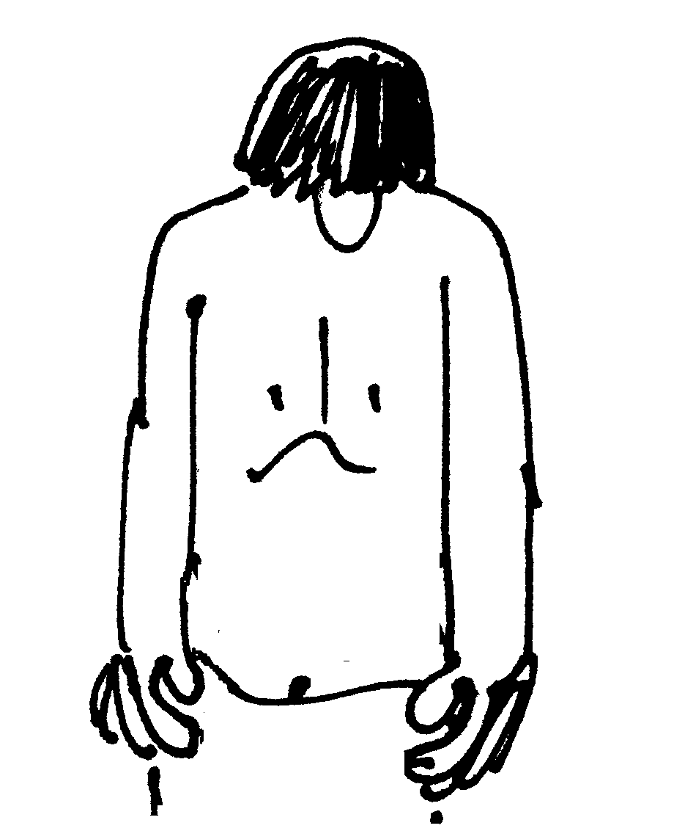  B  P  A  Q

Workshop Tutorials for Biological and Environmental Physics
Solutions to ER4B: Electric Potential

A. Qualitative Questions:
equipotentials
field lines

1. Playing golf in a storm.
- The clouds are negative with respect to the Earth, which is at zero, so the field lines go from the Earth to the clouds.
See diagram opposite.
- Bert, like all humans, is a good conductor, hence he will be at the same potential all over, from his head to his feet, and the electric field will be distorted around him.
- There will be a very high potential difference between the air above his head and the ground at his feet, given by ΔV = Ed.
d. Bert is standing on the ground, hence he is earthed. The earth is at zero volts, so Bert will also be at zero volts, including his head.
e. Walking around and swinging a golf club in a thunderstorm is dangerous. The club could act as a lightning rod, as it is long and metallic. If there is a very large electric field then lightning could strike, and Bert’s golf club, and his body, will a form path of low resistance for the current.
f. There are very few free charges in the air usually, so no current is established. Breakdown of dry air to give free charges occurs at fields around 3×10⁶ V.m⁻¹, which is much more than the fine weather field of 100 V.m⁻¹.
2. Dust precipitators.
O
B
A
equipotentials
field lines
- See diagram opposite.
- The dust particle in the chimney has a charge of +1e, hence it will be attracted to the negative plate and repelled by the positive plate, and will move towards point B.
- The system will lose electric potential energy in doing this, just as when a ball falls, the ball-earth system loses gravitational potential energy. The dust particle will accelerate, gaining kinetic energy as it moves from O to B.
- A particle with charge –2e will move the opposite way, towards A. It will also lose potential energy and gain kinetic energy, but as its charge is twice as great it will have twice the electric potential energy as the +1e particle, and twice as much electric potential energy will be converted to kinetic energy for a given distance traveled.
- The electric potential is highest at point A and lowest at point B; it decreases as you move from positive from to negative.
- The electric potential energy of a charge at some point is the energy required or the work that must be done to move a charge from infinity to that point. The potential energy is the potential energy of the whole system of charges. For convenience we take the zero of electric potential energy to be when the charge is at infinity so we can talk about the potential energy of that particular charge due to the field produced by other charges. The potential is then the potential energy per unit charge.
B. Activity Questions:

- Equipotentials
Equipotentials are surfaces on which the electric potential is constant. Field lines represent the magnitude and direction of forces. Field lines are always perpendicular to equipotentials, so you can use equipotentials to draw field lines (or vice versa). Note that there is no work done moving a charge along an equipotential because the force is perpendicular to the displacement, and there is no change in potential energy.

- Measuring voltages
The resistance of the wire is much less than that of the resistor. Since the value of the current in both wire and resistor must be the same, using V = IR we can see that the potential difference across the whole wire must be much smaller than the potential difference across the resistor. The potential difference between any two points on the wire is probably so small that you could not measure it.
To say that a voltmeter is connected "in parallel" is just a fancy way of saying that you connect its terminals to the two points for which you want to know the potential difference. Since there is usually something else like a resistor already connected between those two points people say that the voltmeter and the resistor are "in parallel".

C. Quantitative Questions:
1. Membrane potential and electric field.
a. The field, if uniform, is
E = V/d = 90 × 10⁻³V/ 8.0×10⁻⁹ m = 1.1×10⁷ V.m⁻¹.
b. To move 3 Na+ ions to a location at higher potential requires 3e∆V of energy input. But when 2 K+ions go the other way to a lower energy state they release energy 2e∆V. That requires a net energy input of e∆V by the pump, W = eΔV = 1.6×10⁻¹⁹C × 90 × 10⁻³ V = 1.4 ×10⁻²⁰ J gained.
B
P
A
Q
6 cm
6 cm
9 cm
9.5 cm
9.5 cm

2. The charges are 6 cm apart, point P is 6 cm from charge A and point Q is 9 cm from a point half way between the charges as shown. Hence electrode P is 6 cm away from charge A and 12 cm away from charge B. Electrode Q is 9.5 cm away from both charges A and B. The charge at point A is shown is + 1.5 × 10⁻¹⁴ C, and that at point B is – 1.0 × 10⁻¹⁴ C
B
P
A
Q
- See diagram opposite.
- The potential at point P due to charge A will be
V =$\frac{\text{kq}}{r}$ = $\frac{8\text{.}\text{99}×{\text{10}}^{9}N\text{.}m^{2}\text{.}C^{−2}×1\text{.}5×{\text{10}}^{−\text{14}}C}{0\text{.}\text{06}m}$ = + 2.2 mV.
- The potential at point P due to charge B will be
V = $\frac{\text{kq}}{r}$= $\frac{8\text{.}\text{99}×{\text{10}}^{9}N\text{.}m^{2}\text{.}C^{−2}×−1\text{.}0×{\text{10}}^{−\text{14}}C}{0\text{.}\text{06}m}$ = - 1.5 mV.
- The potential at point P will be the sum of the potentials due to the two charges, which is
V_{P} = 2.2 mV + -1.5 mV = 0.7 mV
- To find the potential difference between points P and Q we first need to find the potential at Q:
V_{Q} = $\frac{{\text{kq}}_{A}}{r_{A}}$+ $\frac{{\text{kq}}_{B}}{r_{B}}$ = $\frac{8\text{.}\text{99}×{\text{10}}^{9}N\text{.}m^{2}\text{.}C^{−2}×1\text{.}5×{\text{10}}^{−\text{14}}C}{0\text{.}\text{095}m}$+$\frac{8\text{.}\text{99}×{\text{10}}^{9}N\text{.}m^{2}\text{.}C^{−2}×−1\text{.}0×{\text{10}}^{−\text{14}}C}{0\text{.}\text{095}m}$ = 0.5 mV
The potential difference between P and Q is therefore V_{P} - V_{Q} = 0.7 mV – 0.5 mV = 0.2 mV.
Workshop Tutorials for Technological and Applied Physics
ER4T: Electric Potential

A. Qualitative Questions:

1. When we talk about gravity we usually talk about gravitational potential energy, and not gravitational potential. In electrostatics we do the opposite – we usually talk about electric potential rather than electric potential energy.
a. What is the difference between electric potential and electric potential energy?
b. Why is the electric potential energy of a pair of like charges positive and the electric potential energy of a pair of unlike charges negative?
c. Is the gravitational potential energy of a pair of masses positive or negative?
d. The electric field inside a uniformly charged hollow sphere is zero. Does this necessarily mean that the potential inside the sphere is zero?

- Many factories use dust precipitators in their chimneys to remove airborne pollutants. In one such precipitator a pair of plates is placed in the square chimney with a potential difference of 2 kV between them. The large electric field causes molecules to be ionized. Free electrons and ions can then attach to dust particles making them charged. Suppose that a dust particle in the chimney has a charge of +1e.
- Draw field lines and lines of equipotential for the arrangement shown.  - If the dust particle starts from rest at point O, half way between the plates, will it move towards point A or B?  - Will the system gain or lose electric potential energy? Where does this change in energy come from?  - Repeat parts b and c for a particle with a charge of –2e. Will the change in electric potential energy be greater, less than or the same for this particle for a given distance traveled?  - Rank the electric potential at points A, B and O. | 2 kV  O  B  A

B. Activity Questions:

- Measuring voltages
Use the voltmeter to measure the potential differences across the terminals of the various batteries.
Use the voltmeter to measure the potential difference between two points on the wire.
Now measure the potential difference between one end of the resistor and the other.
Explain why they are different.
Voltmeters are always connected in parallel with the device you are measuring the voltage across.
Why is this the case?

- Equipotentials
Use the probe to mark out equipotential lines for the arrangements of charges as shown.
What does the density of equipotential lines tell you?

C. Quantitative Questions:

1. Brent and his brother Bert are playing golf on a Sunday afternoon.
It gradually clouds over until there is a thick layer of cloud above them, and they hear the threatening rumble of a thunder storm. Brent tells Bert that the potential difference between the cloud layer 500 m overhead and the ground is probably around a gigavolt (10⁹ V), and that he’s going back to the club house for a drink. Bert decides to finish the hole that he’s on first.

- Estimate the magnitude of the electric field that Bert is standing in. (Treat the ground and clouds as parallel charged sheets.)
- Draw a diagram showing field lines and equipotential lines for Bert.
- Bert is 180 cm tall. If Bert were not there what would be the potential difference between the ground and a point 180 cm above ground?
- When Bert is standing there what is the potential difference between the hair on his head and his feet?
- What is the electric potential of his head? Explain your answer.
- What is the change in electric potential energy of an electron that moves between the cloud and the ground?

1.4 cm

2. Geiger counters are used to detect ionizing radiation. The detector part consists of positively charged wire which is mounted inside a negatively charged conducting cylinder, as shown. The charges on the wire and the cylinder are equal, and are opposite, so a strong radial electric field is set up inside the cylinder. The cylinder contains an inert gas at low pressure.
When radiation enters the tube it ionizes some of the gas atoms, and the resulting free electrons are attracted to the positive wire which runs down the middle. On their way to the wire these free electrons ionize more atoms, giving rise to more free electrons, which ionize more atoms, and so on. This is called a cascade effect.
- The radius of the central wire is 25 μm, the radius of the cylinder is 1.4 cm and the length of the tube is 16 cm. If the electric field at the cylinder’s inner wall is 2.9 × 10⁴ N.C⁻¹, what is the total positive charge on the inner wire?
- Find an expression for the potential difference between the inner wire and the outer cylinder in terms of the linear charge density, λ.
- Calculate the potential difference between the wire and the cylinder.
Hint: the electric field due to a line of charge with charge density λ is given by E = $\frac{λ}{2{\text{πε}}_{0}r}$ where r is the radial distance from the line of charge.

Workshop Tutorials for Technological and Applied Physics
Solutions to ER4T: Electric Potential

A. Qualitative Questions:

1. Electric potential and potential energy.
a. The electric potential energy of a charge at some point is the energy required or the work that must be done to move a charge from infinity to that point. The potential energy is the potential energy of the whole system of charges. For convenience we take the zero of electric potential energy to be when the charge is at infinity so we can talk about the potential energy of that particular charge due to the field produced by other charges. The potential is then the potential energy per unit charge.
b. The electric potential energy of a pair of like charges is positive because work has to be done on them to move them from infinitely far apart in towards each other. The change in potential energy is equal to the work done on the charges, hence the potential energy is positive. The opposite is true of a negative and positive charge, they do work in coming together, hence they have negative potential energy.
c. The gravitational potential energy of a pair of masses is negative, as in the case of opposite charges, they are attractive, so they do work as they approach, rather than work having to be done on them to bring them together.
d. Electric field is defined as the change in potential with distance. If the electric field is zero, then the potential is not changing with distance, i.e. it is constant, but this does not necessarily mean that it is zero.
O
B
A
equi-potentials
field
lines

2. Dust precipitators.
- See diagram opposite.
- The dust particle has a charge of +1e, hence it will be attracted to the negative plate and repelled by the positive plate, and will move towards point B.
- The system will lose electric potential energy, just as when a ball falls, the ball-earth system loses gravitational potential energy. The dust particle will accelerate, gaining kinetic energy as it moves from O to B.
- A particle with charge –2e will move the opposite way, towards A. It will also lose potential energy and gain kinetic energy, but as its charge is twice as great it will have twice the electric potential energy as the +1e particle, and twice as much electric potential energy will be converted to kinetic energy for a given distance traveled.
- The electric potential is highest at point A and lowest at point B; it decreases as you move from positive from to negative.

B. Activity Questions:
  - Measuring voltages
The resistance of the wire is much less than that of the resistor. Since the value of the current in both wire and resistor must be the same, using V = IR we can see that the potential difference across the whole wire must be much smaller than the potential difference across the resistor. The potential difference between any two points on the wire is probably so small that you could not measure it.
To say that a voltmeter is connected "in parallel" is just a fancy way of saying that you connect its terminals to the two points for which you want to know the potential difference. Since there is usually something else like a resistor already connected between those two points people say that the voltmeter and the resistor are "in parallel".

2. Equipotentials
Equipotentials are surfaces which have the same value of electric potential and field lines represent the magnitude and direction of forces. Field lines are perpendicular to equipotentials, so you can use equipotentials to draw field lines.

C. Quantitative Questions:
equipotentials
field lines

1. The potential difference between the cloud layer 500 m overhead and the ground is probably around 10⁹ V.
- The electric field is the potential difference per unit distance,
E = V/d = 10⁹ V / 500 m = 2.0 × 10⁶ V.m⁻¹.
- See diagram opposite.
- Assuming a uniform field, the potential difference between the ground and the air at 180 cm above the ground is
V = Ed = 2.0 × 10⁶ V.m⁻¹ × 1.80 m
= 3.6 × 10⁶ V = 3.6 MV.
- Bert, like all humans, is a good conductor, hence he will be the same potential all over, from his head to his feet, and the electric field will be distorted around him
- Bert is standing on the ground, hence he is earthed. The earth is at zero volts, so Bert will also be at zero volts, including his head.
- The change in electric potential energy of an electron moving from the clouds to the ground will be the change in potential × the charge of the electron, ΔU = Ve = 10⁹ V × 1.6 × 10⁻¹⁹ C = 1.6 × 10⁻¹⁰J.
1.4 cm
2. Geiger counters are used to detect ionizing radiation. The detector part consists of positively charged wire which is mounted inside a negatively charged conducting cylinder, as shown. The radius of the central wire is 25 μm, the radius of the cylinder is 1.4 cm and the length of the tube is 16 cm. If the electric field at the cylinder’s inner wall is 2.9 × 10⁴ N.C⁻¹.
- The field at the inner wall of the cylinder will be entirely due to the enclosed charge (Gauss’ law), so we can use the expression given in the hint, E = $\frac{λ}{2{\text{πε}}_{0}r}$, to find the linear charge density:
λ=2πε_{o}rE = 2 × π × 8.85 × 10⁻¹² F.m⁻¹ × 0.014 m × 2.9 × 10⁴ N.C⁻¹
= 2.3 × 10⁻⁸ C.m⁻¹.
The length, l, of the tube and wire is 16 cm, so the total excess charge on the wire is q = λ × l = 0.16 m × 2.3 × 10⁻⁸ C.m⁻¹ = 3.6 nC.
- The potential difference between the inner wire and the outer cylinder is
ΔV = V_{w} - V_{c}. = $−\int_{r_{c}}^{r_{w}}{E\text{.}\text{dr}}$= $\int_{r_{w}}^{r_{c}}{\frac{λ}{2{\text{πε}}_{0}r}}$.dr = ${\left[\frac{λ}{2{\text{πε}}_{0}}\text{ln}r\right]}_{r_{w}}^{r_{c}}$ = $\frac{λ}{2{\text{πε}}_{0}}$(lnr_{w} – lnr_{c}) = $\frac{λ}{2{\text{πε}}_{0}}$ln$(\frac{r_{c}}{r_{w}})$.
- The potential difference between the wire and the cylinder is
ΔV = $\frac{λ}{2{\text{πε}}_{0}}$ln$(\frac{r_{c}}{r_{w}})$ = $\frac{2\text{.}\text{3 }×{\text{ 10}}^{8}\text{ C}\text{.}m^{\text{-1}}}{2×π×8\text{.}\text{85}×{\text{10}}^{\text{-12}}F\text{.}m^{−1}}$ln$(\frac{0\text{.}\text{14}m}{\text{25}×{\text{10}}^{−6}m})$ = 3.6 × 10³V = 3.6 kV.

Workshop Tutorials for Biological and Environmental Physics
ER5B: Capacitance

A. Qualitative Questions:
d
A
- A capacitor consists of two parallel plates with area A which are separated by a distance d.
What will be the effect on the capacitance of :
- Pushing the plates toward each other so d is halved?
- Doubling the area, A, of both plates?
- Doubling the area of one plate only?
- Sliding one of the plates relative to the other so the overlap is halved?
- Doubling the potential difference between the plates?

- The cell membranes of axons and dendrites can be modelled as a circuit of resistors and capacitors, as shown below. R_{m} is the resistance of the membrane, R_{i} is the internal resistance of the cell and C_{m} is the capacitance of the membrane. When an impulse is received at a synapse there is a sharp “pulse” at that point, either a positive change in the membrane potential (an excitatory post synaptic potential) or a negative change (an inhibitory post synaptic potential). This pulse is transmitted along the dendrite to the cell body. Note that this is a passive process, the impulse is not reinforced as it travels, unlike the transmission of action potentials in the axon. Explain what effect the combination of resistance and capacitance has on the pulse as it moves along the dendrite.

R_{i}
R_{i}
R_{i}
R_{i}
R_{i}
R_{m}
R_{m}
R_{m}
R_{m}
C_{m}
C_{m}
C_{m}
C_{m}

B. Activity Questions:

- Variable capacitor I – giant capacitor
Examine the variable capacitor.
How can the capacitance be varied?
What happens to the paper strips when the capacitor is turned on? Why?
Sketch the electric field between the plates.

- Variable capacitor II – tuning capacitor
Examine the variable capacitor.
How can the capacitance be varied?
Can you think of where these devices might be used?

- Energy stored by a capacitor
Examine the circuit set up to show how energy (½ CV²) is stored by a capacitor.
Does changing the voltage supplied increase the capacity of the capacitor?
Does changing the supply voltage change the amount of energy that can be stored?
This is similar to the circuit found in the electronic flash in a camera.

C. Quantitative Questions:

- Nerve cells, such as that shown in the diagram below, transmit electrical signals between sensory receptors and the brain, and then to the muscles. A nerve cell has a cell body with dendrites where the signals come in, and a long axon at the other end where signals are sent out.
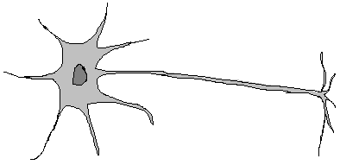
Cell body
dendrite
axon

A particular nerve cell connects a pressure sensitive cell in your big toe to another nerve in your spinal cord. The axon has a membrane with a 90mV potential difference across an 8.0 nm thick membrane . The axon is like a long tube, with a radius of 5μm and a length of 1m. The dielectric constant of the membrane is 7.
- Given the radius of the axon and the thickness of the membrane, what sort of capacitor can you treat the axon membrane as being equivalent to?
- What is the capacitance per unit area of the axon?
- What is the capacitance of the axon?
- What is the magnitude of charge separated by the axon membrane?
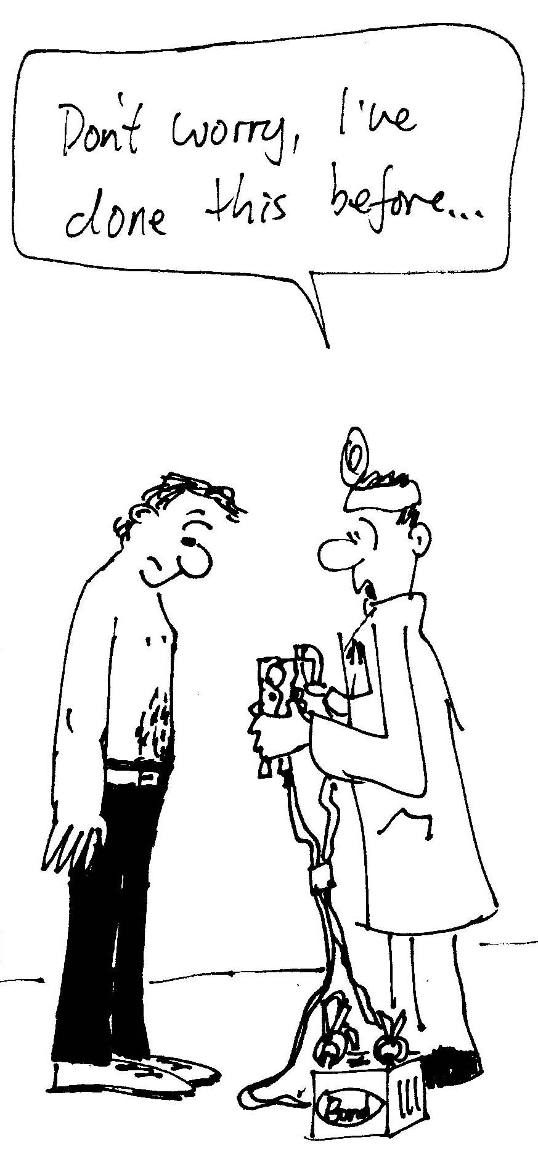
2. Electric shock can injure and harm. But it can also be used (by experts, and judiciously!) to revive people using a cardiac defibrillator which sends an electrical impulse to the heart to re-start it, for example after a heart attack. You see these being used all the time on television shows like ER, General Hospital, All Saints etc. when people are rushed into the emergency room after suffering a heart attack or bad electric shock.
A certain cardiac defibrillator consists of a capacitor charged up to 1.0 × 10⁴ V (10,000 volts) with a total stored energy of 450 J.
- Calculate the charge on the capacitor in this defibrillator.
- If the internal resistance of the defibrillator is small, and the resistance across the skin of the patients chest is 1.0 kΩ, how long will it take the defibrillator to discharge 90% of its stored charged into the patients chest?

Workshop Tutorials for Biological and Environmental Physics
Solutions to ER5B: Capacitance

A. Qualitative Questions:

- Capacitance of a parallel plate capacitor.
- Since , reducing d to half its value will double the capacitance.
- Doubling the area of both plates will again double the capacitance (assuming an ideal capacitor).
- Doubling the area of one plate only will not change the capacitance since A is the area of overlap.
- If the area of overlap is 50% of its original value, then the capacitance also halves.  - Doubling the potential difference between the plates results in no change in the capacitance. The capacitance is determined by geometrical quantities. | slide  A

- As an excitation, a voltage spike, moves along the membrane the resistances dissipate energy as heat, so the pulse gets smaller. The capacitors in combination with the resistors also act to smooth the peak, so that it gets smaller and spreads out, as shown in the diagram below. This is because it takes some time (determined by the time constant), to both charge and discharge the capacitor as the pulse passes along. The circuit shown below is also a good model of a lossy transmission line, such as any cable used to carry electrical signals, for example a TV antenna cable.
V
x and t
R_{i}
R_{i}
R_{i}
R_{i}
R_{i}
R_{m}
R_{m}
R_{m}
R_{m}
C_{m}
C_{m}
C_{m}
C_{m}

B. Activity Questions:
+
-
1. Variable capacitor I – giant capacitor
The capacitance is inversely proportional to the separation of the plates, moving the plates closer together increases the capacitance. The paper strips lift and align with the field lines when the field is strong enough. The strips become charged by the plate to which they are attached, and are both repelled by this plate and attracted towards the opposite plate.

2. Variable capacitor II – tuning capacitor
Notice that the capacitor is a series of leaves. Rotating the “stem” rotates one set of leaves so that the area of overlap changes. This changes the value of the capacitor.
Variable capacitors can be used in tuning devices such as radios where dialing up the radio station is just twisting the “stem”. The variable capacitor is part of the resonant circuit where maximum response to the transmitted signal depends on matching the resonant frequency of the circuit with the frequency of the signals carrier waves.
3. Energy stored by a capacitor
We can use the battery to charge up the capacitor and store energy U= ½ CV² (in the form of stored charge or an electric field). If we then disconnect the capacitor from the battery and connect the leads across the small electric motor fitted with a ‘propeller’ – the stored electrical energy is converted into mechanical energy – in the form of rotational motion.
Changing the supply voltage does not change the capacitance, but it does change the amount of energy stored, in the same way that pouring water into a bucket does not change the capacity of the bucket, but it does change the amount of water actually in it.

C. Quantitative Questions:

- Capacitance of an axon.
a. The radius, 5 μm, is huge compared to the thickness, 8 nm, so if you look at any small piece of membrane it will be approximately flat, and we can treat it as a parallel plate capacitor.
b. The capacitance of a parallel plate capacitor is given by C = εA/d where ε = ε_{o}× κ where κ is the dielectric constant of the material between the plates. So the capacitance per unit area is:
C/A = ε/d = 8.85 × 10⁻¹² F.m⁻¹ × 7 / 8.0 × 10⁻⁹ m = 8 ×10⁻³ F.m⁻².
- The surface area of the axon is 2πRl where R is the radius and l is the axon length. So:
C = εA/d = 2πRl × 7.7 ×10⁻³ F.m⁻² = 2π × 5 × 10⁻⁶ m × 1.0 m × 8 ×10⁻³ F.m⁻² = 2 × 10⁻⁷ F.
- We know the potential difference across the membrane and its capacitance, so we can use
q = CV = 2 × 10⁻⁷ F × 90 × 10⁻³ V = 2 × 10⁻⁸ C.
axon
in
out
membrane
cross section through axon

- A certain cardiac defibrillator consists of a capacitor charged up to 10⁴ V (10,000 volts) with a total stored energy of 450 J.
- The Electrical Potential Energy stored in a capacitor is PE = ½ QV, so
450 J = ½ × 10,000 V × Q, gives Q = 0.090 C.
- We need to know the time constant, τ, of the circuit to find how long it takes to discharge. We know the resistance, R = 1.0kΩ. The capacitance is C=Q/V = 0.090C/10,000V = 9.0 μF, so
τ = RC = 1.0× 10³ Ω× 9.0 μF = 9.0 ms.
As the capacitor discharges the Voltage, V, at any time, t, is given by V = V_{o}(1-e^{-t/RC}), and Q = Q_{o}(1-e^{-t/RC}). Thus Q/ Q_{o} = 1-e^{-t/RC}, i.e. 0.9 = 1-e^{-t/9.0ms}. So t = -ln(0.1) × 9.0 ms = 21 ms.
Workshop Tutorials for Technological and Applied Physics
ER5T: Capacitance

A. Qualitative Questions:

- A capacitor consists of two parallel plates with area A which are separated by a distance d.
What will be the effect on the capacitance of :  - Pushing the plates toward each other so d is halved?  - Doubling the area, A, of both plates?  - Doubling the area of one plate only?  - Sliding one of the plates relative to the other so the overlap is halved?  - Doubling the potential difference between the plates? | d  A

- Many processes in nature follow a similar pattern of increasing and decreasing – exponentially. Examples include capacitor charging and discharging, nuclear decay and cooling of hot sunstances.
- Sketch a graph of the magnitude of electric charge on either plate of a capacitor versus the magnitude of the potential difference between the plates.
- What does the slope of this graph indicate? What are alternative units for the slope beside CV⁻¹ (coulombs per volt)?
- Suppose a capacitor has charges Q_{o} on its plates and a potential difference of magnitude |V₀| between them. Indicate such a point on your graph. What is the physical significance of the area under the curve between the origin and the point (Q_{o}, V₀)?

B. Activity Questions:

1. Variable capacitor I – giant capacitor
Examine the variable capacitor.
How can the capacitance be varied?
What happens to the paper strips when the capacitor is turned on? Why?
Sketch the electric field between the plates.

2. Variable capacitor II – tuning capacitor
Examine the variable capacitor.
How can the capacitance be varied?
Can you think of where these devices might be used?

3. Energy stored by a capacitor
Examine the circuit set up to show how energy (½ CV²) is stored by a capacitor.
Does changing the voltage supplied increase the capacity of the capacitor?
Does changing the supply voltage change the amount of energy that can be stored?
This is similar to the circuit found in the electronic flash in a camera.

C. Quantitative Questions:

- A parallel plate capacitor has circular plates of 8.2 cm radius separated by 1.3mm of air. They are connected to a 240V power supply and allowed to charge up before being disconnected.
- Calculate the capacitance of this capacitor.
- What charge will appear on the plates?
- What is the electrical energy stored between the plates?
- If the plates (from above) are pulled apart to a separation of 2.6 mm without affecting the charge distribution, what happens to the electric field between the plates?
- What is the potential difference between the plates with the new separation?
- What is the electrical energy stored between the plates with the new separation?
- Comment on your answers to parts c and f. What has happened to the energy?

0.5 mm
3mm

- A coaxial cable connecting a TV to an antenna socket is 3 m long. The inner conductor has an outer radius of 0.5 mm, the outer conductor has an inner radius of 3 mm. The space between the conductors is filled with plastic with κ = 2.6. What is the capacitance of this cable?

Workshop Tutorials for Technological and Applied Physics
Solutions to ER5T: Capacitance

A. Qualitative Questions:

- Capacitance of a parallel plate capacitor.
  - Since ,reducing d to half its value will double the capacitance.
  - Doubling the area of both plates will again double the capacitance (assuming an ideal capacitor).
  - Doubling the area of one plate only will not change the capacitance since A is the area of overlap.
- If the area of overlap is 50% of its original value, then the capacitance also halves.  - Doubling the potential difference between the plates results in no change in the capacitance. The capacitance is determined by geometrical quantities. | slide  A

- Charge, capacitance and potential difference.
V
Q
V₀
Q₀
- See diagram opposite.
- The slope of the graph is the capacitance, C = Q/V. The unit CV⁻¹ is also called the farad, in honour of Michael Faraday who did a lot of the early work in electromagnetism.
- See diagram opposite. The area under the curve, shaded grey, is a triangle and has area ½ base × height
= ½ V₀ ×Q_{oi} = ½ V₀ (V₀ × C) = ½ V₀ ² C
which is the energy stored in the capacitor.

B. Activity Questions:
+
-
1. Variable capacitor I – giant capacitor
The capacitance is inversely proportional to the separation of the plates, moving the plates closer together increases the capacitance. The paper strips lift and align with the field lines when the field is strong enough. The strips become charged by the plate to which they are attached, and are both repelled by this plate and attracted towards the opposite plate.

2. Variable capacitor II – tuning capacitor
Notice that the capacitor is a series of leaves. Rotating the “stem” rotates one set of leaves so that the area of overlap changes. This changes the value of the capacitor.
Variable capacitors can be used in tuning devices such as radios where dialing up the radio station is just twisting the “stem”. The variable capacitor is part of the resonant circuit where maximum response to the transmitted signal depends on matching the resonant frequency of the circuit with the frequency of the signals carrier waves.

3. Energy stored by a capacitor
We can use the battery to charge up the capacitor and store energy U= ½ CV² (in the form of stored charge or an electric field). If we then disconnect the capacitor from the battery and connect the leads across the small electric motor fitted with a ‘propeller’ – the stored electrical energy is converted into mechanical energy – in the form of rotational motion.
Changing the supply voltage does not change the capacitance, but it does change the amount of energy stored, in the same way that pouring water into a bucket does not change the capacity of the bucket, but it does change the amount of water actually in it.

C. Quantitative Questions:

1. A parallel plate capacitor has circular plates of 8.2 cm radius separated by 1.3mm of air. They are connected to a 240V power supply and allowed to charge up before being disconnected.
a. The capacitance is given by;
and
$C=\frac{(8\text{.}\text{85}×{\text{10}}^{−\text{12}}C^{2}N^{−1}m^{−2})π(8\text{.}2×{\text{10}}^{−2}m)^{2}}{1\text{.}3×{\text{10}}^{−3}m}$= 1.4 × 10-10F = 140 pF.

b. The charge on the plates is given by q = CV,
thus q=(1.4 × 10⁻¹⁰ F) (240 V) = 3.4 × 10⁻⁸ C = 34 nC.
c. The electrical energy stored between the plates is;
U= ½ CV² = 0.5 (1.4 × 10-10F)(240 V)2 = 4.0 × 10-6 J
d. If the plates are pulled apart without affecting the charge distribution, the electric field between the plates remains unchanged. The field line pattern and density does not change thus the electric field does not change.
e. The potential difference doubles to 480 V, using E = V/d .
f. The electrical energy stored between the plates is 8.0 × 10⁻⁶ J. It has also doubled.
g. The electrical energy stored in part f is greater than that in part c. In going from c to f we have added energy by doing work on the system when pulling the plates further apart. This has increased the energy of the system.

2. The coaxial cable acts as a cylindrical capacitor.  The capacitance of a cylindrical capacitor is given by  C = 2Lπε₀/ln(b/a)  where b and a are the inner radius of the outer conductor and the outer radius of the inner conductor respectively, and L is the length of the capacitor. In this case we have a dielectric separating the conductors, so we must replace ε₀ with κε₀ which gives  C = 2Lπκε₀/ln(b/a)  = 2×3 m × 2.6 × 8.85×10⁻¹² F.m⁻¹/ln (3mm/0.5mm)  C = 8 × 10⁻¹¹ F = 80 pF. | 0.5 mm  3mm

Workshop Tutorials for Physics
ER6: Circuits

A. Qualitative Questions:

- Consider the circuit containing 5 identical globes shown below. (Treat the globes as if they obey Ohm’s law, even though real light globes are not Ohmic.)
V
A

B
C
D E

Rank the globes, A to E, in order of increasing brightness. (Note that some may have equal brightness.)
You may want to redraw the circuit.

2. A capacitor in an RC circuit has a charge qo when the switch is open. The capacitor will discharge when the switch is closed.
- Does the time taken for the charge to fall to qo/2 depend on qo?
- Does the time required for the voltage to drop by a certain amount (say 1 volt) depend on the initial voltage?
- Does it depend on C or R?

B. Activity Questions:

- Torch – a simple circuit
Dismantle the torch and examine its components.
Draw a circuit diagram for the torch, labelling each component and showing its function.

- Resistivity and resistance
Measure the resistance of the objects displayed.
How does the length of the object affect its resistance?
Does the shape or size of its cross section have an affect?

- Current - Voltage characteristics
Sketch a graph of I vs V for a resistor and a globe.
Now do some measurements with a resistor and globe.
Do they agree with your predictions?

- Toaster man – resistors in series
The ammeter (measures current) is connected in the heart position.
What do you notice when you change the position of the connection from the “boot” to the “skin”?
- Simple membrane model – resistors in parallel
Cell membranes have channels across them which can open and close allowing current (ions) to flow in or out of the cell. This can be modeled as switches and resistors in parallel.
Close one of the switches, leaving the rest open. Measure the resistance of the membrane.
Close each of the switches, and measure the resistance each time you add another resistor in parallel.
What is happening to the total resistance? Why?
What effect does this have on current flow across the membrane?

C. Quantitative Questions:

- Any power supply, such as a mobile phone charger or a solar cell, can be treated as a source of emf, ε, (a battery) in series with a resistor, r, which is the internal resistance of the power supply.
R
power supply
r
ε

A solar cell generates a potential difference of 0.10 V across a 500 Ω resistor. The same solar panel generates a potential difference of 0.15 V across a 1000 Ω resistor.
- Write an equation relating the voltage drops around the circuit.
- What is the emf, ε, of the solar cell?
- What is the internal resistance of the solar cell?
The area of the cell is 5 cm². The rate per unit area at which it receives light energy is 2.0 mW cm⁻².
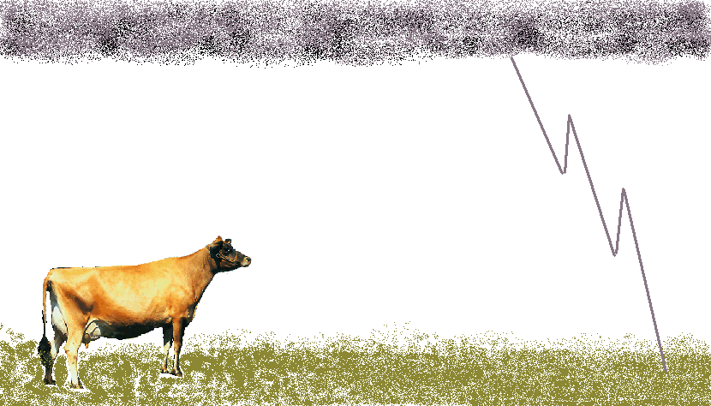
- What is the efficiency of the cell for converting light energy to thermal energy in the 1000 Ω external resistor?

2.
When lightning hits the ground it usually spreads out radially as it penetrates the ground.
Cows are often injured or killed by lightning. Consider a cow which is standing in a field when lightning strikes near by. The cow is facing towards the strike which is 10 m away.

- Draw a circuit diagram showing the cow as a path of resistors between the ground at the front end of the cow near the strike and the ground at the far end of the cow. Consider the front feet to be connected to a single source of emf. Include the resistances across the feet, legs and body.
- If the resistance to enter each hoof is approximately 600 Ω, that through each leg is 500 Ω and the body resistance is around 1000 Ω, what is the total resistance of the cow?
- It takes around 100 mA or more across the body to stop a human heart, and a similar amount to stop a cows heart. If the potential difference between the front legs and the back legs is 150V, is the cow going to be killed?
- Even if the cow isn’t killed, what injuries due to the current might it suffer and why?
Workshop Tutorials for Physics
Solutions to ER6: Circuits

A. Qualitative Questions:
A

B
V
C
D E
V

1. You can redraw the circuit as shown.
The voltage is the same across each arm of the circuit. The potential difference across each of A and B will be ½V. In the second arm we have globes, which we can treat as resistors in a combination of series and parallel. The total resistance of D and E will be half that of each of them individually, which is also half that of globe C.
Hence the resistance of this arm is 3/2 times that of a single globe. Globe C will have a potential difference of 2/3 of the voltage V, and D and E will each have 1/3 V. Brightness increases with power which goes like the V², so we can rank the brightness by ranking the voltages. Hence the order of brightness will be C → A & B → D & E (brightest to dimmest).

2. Charging and discharging capacitors.
- The capacitor discharges as $q(t)=q_{0}e^{\frac{−t}{\text{RC}}}$. This can be rearranged to $t\text{=-}\text{RC}\text{ln}\frac{q}{q_{0}}$ =$\text{RC}\text{ln}\frac{q_{0}}{q}$
When q= ½ q_{o}, the time taken to discharge is simply t=RCln2, which is independent of initial charge.
- The voltage drop across the capacitor is given by $V(t)=V_{0}e^{\frac{−t}{\text{RC}}}$ and this can be rearranged to $t=\text{RC}\text{ln}\frac{V_{0}}{V}$. If the voltage drop decreases by 1V then $t=\text{RC}\text{ln}\frac{V_{0}}{V_{0}−1}$, which is dependent on initial voltage and RC.
- The decay (of both charge and voltage) is exponential. A property of exponential relations is that if the “change” can be expressed as a ratio as in a then the time taken for the change is independent of initial value. On the other hand if the “change” is expressed as a “measured value” as in b then the time taken for the change is dependent on initial value.

B. Activity Questions:
B
G
S
- Torch – a simple circuit
The torch has a battery, B, which supplies the voltage, a globe, G, which converts electrical energy into light, and a switch, S, which completes the circuit allowing current to flow when the torch is turned on. | .
- Resistivity and resistance
Resistance increases with length, and decreases with cross section for a given material.
Resistivity is a property of the material, and does not depend on shape or size.
- Current - Voltage characteristics
resistor  V  I | globe  V  I
The temperature of the filament in the globe increases very quickly as the current increases. The resistance increases with temperature, hence the I-V plot for the globe is curved.
- Toaster Man.
The current is inversely proportional to the resistance, the greater the resistance the less current can flow, and the less likely toaster man is to be electrocuted. The total resistance of resistors in series is the sum of the individual resistances.
- Simple membrane model – resistors in parallel
When resistors are connected in parallel the total resistance is less than any individual resistance. There are more paths for the current to flow along, and so the total current is greater. Resistance is the voltage divided by the current, R = V/I, so a larger current means a smaller resistance for a given voltage supply.
R
power supply
r
ε

C. Quantitative Questions:
- Internal resistance of power supplies.
a. ε = V_{R} + V_{r} = iR + ir.
We know from Ohm’s law that V = IR, so we can write for the current i = V_{R}/R. We can rewrite the expression for ε as
ε = iR + ir = (V_{R}/R)R + (V_{R}/R)r = V_{R}+ (V_{R}/R)r

b. Using the two values for V_{R} and R given, we get two equations with two unknowns:
ε = V_{R}+ (V_{R}/R)r = 1.0 V + (1.0 V / 500 Ω)r
ε = V_{R}+ (V_{R}/R)r = 1.5 V + (1.5 V / 1000 Ω)r
setting these equal to each other gives
1.0 V + (1.0 V / 500 Ω)r = 1.5 V + (1.5 V / 1000 Ω)r and rearranging: (1.0/500 – 1.5/1000) r = 0.5 Ω
(0.5/1000)r = 0.5 Ω so r = 1000 Ω.
c. Substituting the value for r into either of the equations in b gives ε = V_{R}+ (V_{R}/R)r = 3.0 V.
- The efficiency is equal to P_{out} / P_{in} .The power in, P_{in} = 20 W.m⁻² × 5 × 10⁴ m² = 0.01 W = 10 mW.
The power out is P_{out} = V²/R = (1.5 V)² / 1000 Ω = 2.25×10⁻³W = 2.3 mW.
The efficiency is P_{out} / P_{in} = 2.3mW / 10 mW = 0.23 or 23%
R_{h}
R_{h}
R_{h}
R_{h}
R_{l}
R_{l}
R_{l}
R_{l}
R_{b}
2. Resistance of a cow.
- See diagram opposite.  R_{l} – resistance of leg = 500 Ω  R_{b} – resistance of body = 1000 Ω  R_{h} – resistance of hoof = 600 Ω  - See diagram opposite, The total resistance of  each leg + hoof = 600 Ω + 500 Ω = 1100 Ω.  There are two of these in parallel, so the total is  R_{legs+hoofs} = (1/1100Ω +1/1100Ω)⁻¹ = 550 Ω.  There are two of these, one at each end of the cow, in series with the body, so the total cow resistance is 550 Ω + 550 Ω + 1000 Ω = 2100 Ω.  - Using Ohm’s law, i = V/R = 150 V / 2100 Ω = 71 mA. This is the current flowing across the entire body of the cow, the current along any given path, including that through the heart will be less than this, hence the cow is unlikely to be killed. Note that as little as 10 mA through the heart is enough to cause a human heart to fibrillate and stop beating | 600  600  600  600  500  500  500  500  1000  1100  1100  1100  1100  1000  550  550  1000  =  =
d. Resistors dissipate electrical energy as heat. The cow is acting as a resistor, hence she is going to produce heat and probably be burned. Electrocution victims usually suffer burns. The cow may also panic and run away and run through a fence, this is quite common and many animals including dogs injure themselves when frightened by storms.

Workshop Tutorials for Biological and Environmental Physics
ER7B: Magnetic Fields

A. Qualitative Questions:
1. The Earth’s magnetic field is important because it protects us from charged particles radiated by the sun. It also provides a means of navigating for humans and for many animals as well.
a. Sketch the magnetic field lines for the Earth’s magnetic field.
b. Sketch the path of a charged particle which has become trapped in the Earth’s magnetic field.
c. Would the aurora australis (southern lights) or the aurora borealis (northern lights) be possible if the earth had no magnetic field? Explain your answer,
The aurora australis is occasionally visible from southern Victoria and Tasmania in winter, and from further north when there is a lot of sunspot activity. However, due to light pollution, the aurora is impossible to see from large cities such as Sydney and Melbourne.
d. Why are these light shows normally seen only near the poles?

2. Electric blankets work by passing currents along wires embedded in the blankets. The resistance of the wires and the current flowing through them causes them to heat up, thus keeping you cosy and warm. However apart from heat, the current carrying wires also produce a magnetic field. The figures below show two possible ways of wiring an electric blanket.
6i
i

- Sketch the magnetic fields for a pair of neighbouring wires for the two blankets.
- Which wiring pattern would give you a smaller average magnetic field above the wires in the blanket?

B. Activity Questions:

- Magnets and magnetic fields
Use the iron filings to investigate the field lines of the magnets.
How do these field lines compare to the magnetic field lines of the Earth?
Many animals such as pigeons and some fsish have a magnetic sense which allows them to use the Earth’s magnetic field to navigate.

- Magnetic field around a current carrying wire – Oersted’s experiment
Use the compasses to find the direction of the magnetic field at different points around the wire.
Draw a diagram showing the field around the wire.
What happens when you swap the connections and change the direction of the current?

- Solenoid
Draw a diagram showing the magnetic field in and around the solenoid.
Are there any points where the magnetic field is zero?
How does the magnetic field vary inside the solenoid?

The magnetic force - pinch effect
Turn on the power supply and observe what happens to the wires.
How can you make them repel instead of attracting?
Draw a diagram showing the field, current and forces on the wires.

D. Quantitative Questions:

The heart produces an electric field due to the movement of charges required to trigger the heart muscles to contract. Measuring the changes in potential is a common way of investigating heart function and is called an electrocardiogram or ECG measurement. The heart also produces a magnetic field of around 5.5 × 10⁻¹¹ T, and measuring changes in this magnetic field, called a magnetocardiogram (MCG), can also give valuable information about the condition of the heart.
Consider a carbonate ion, HCO₃⁻, moving in the blood at 0.52 m.s⁻¹.
  - What will be the maximum possible acceleration of this ion as it moves past the heart?
  - What will be the minimum acceleration of this ion as it moves past the heart?

Data HCO₃ has a mass of 61 amu, and 1 amu = 1.67 × 10⁻²⁷ kg.

- Magnetic field therapy is used to treat all sorts of ailments in humans and in horses and even dogs and cats, in particular soft tissue and bone damage.
A magnetic field generator which consists of a coil of wire is placed around the person to be treated as shown below. The generator can produce a field inside the coil of 100 G = 0.015 T when a current of 1.5 A runs through the coil. The coil has a diameter of 510mm and has a total length of 230 mm.
If the coil is a simple solenoid, what length of wire is used to make the coil?
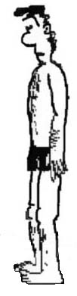

Workshop Tutorials for Biological and Environmental Physics
Solutions to ER7B: Magnetic Fields

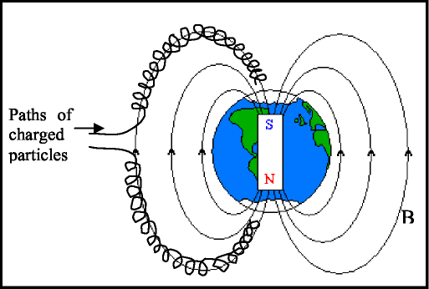
A. Qualitative Questions:

1. The Earth’s magnetic field.
a. and b See diagram.
c. The auroras are caused by charged particles
entering the Earth’s magnetic field where they follow helical paths along the field lines either north or south. The light observed as auroras is due to ionization of atoms in the atmosphere when they collide with high speed charged particles. The free electrons resulting from the collisions recombine with ionised atoms, losing energy in the process which is emitted as light of the auroras.
d. Near the poles the field lines are denser, hence the field is stronger. Charged particles tend to become trapped in these regions, hence they are more likely to interact with air here and produce the auroras. See anything strange about this picture? The Earth’s North Pole, at the top, is actually the south pole of Earth’s magnetic dipole! The north pole of a compass needle is attracted to the geographical North Pole.

2. Magnetic fields from electric blankets.

b. The wiring on the right gives a lower magnetic field above (and below) the blanket. B. Activity Questions:
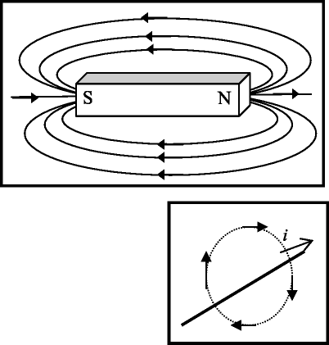
1. Magnets and magnetic fields
Magnetic field lines start at north poles and end at south poles.
The Earth’s magnetic field is like that of a bar magnet, but the Earth’s North Pole is in fact a magnetic south pole.
2. Magnetic field around a current carrying wire
The magnetic field lines are circles around the wire. If you point your right thumb in the direction of the current your fingers will curl in the direction of the magnetic field. When the direction of the current is reversed the direction of the magnetic field is also reversed.

3. Solenoid
The field inside the solenoid is approximately uniform, while that outside the solenoid is approximately zero. If the solenoid was infinitely long the field outside would be exactly zero.

4. The magnetic force - pinch effect When the currents are in the same direction the wires attract each other. The wires can be made to repel by reversing the direction of the current in one wire.

D. Quantitative Question:
1. Acceleration of ions in the blood due to the heart’s magnetic field.
a. The maximum possible acceleration will occur when the ion is moving at right angles to the magnetic field as this is when the maximum force occurs.
1.6 ×10⁻¹⁹C × 0.52m.s⁻¹ × 5.5T ×sin90º
The acceleration a = F/m = qvB sin~/m = 61×1.67 ×10⁻²⁷kg
This is 0.045 mm.s⁻², which is small, but enough to accelerate the ions from one side of a blood vessel to the other in a short time.
b. The minimum acceleration will be zero which occurs when the ion moves parallel to the magnetic field. From part a, a = qvB sin ^{0o} /m =0
2. The magnitude of the magnetic field, B, inside a solenoid is given by B = µ0ni, where n is the number of turns (N) divided by the length (a) of the solenoid (n = N/a). The length (L) of wire needed is the number of turns (N) multiplied by the circumference of one turn: ~d where d is the diameter of the solenoid. Putting these together we find that N drops out and we get:

L= $\frac{πd\text{.}\text{Ba}}{μ_{o}I}$ = π ×0.51 m × 0.015 T × 0.23 = 3km 4π ×10⁻⁷ T.m.A⁻¹ × 1.5 A

Workshop Tutorials for Technological and Applied Physics
ER7T: Magnetic Fields

A. Qualitative Questions:

i
i
1
2
3
4
1. Two fixed wires cross each other perpendicularly so that they do not actually touch but are close to each other as shown in the figure. Equal currents i exist in the wires, in the directions indicated.
- In what region(s) will there be points of zero net magnetic field?
- If the wires are free to move, describe what happens when the currents are sent through both of them.

2. Oscillator circuits are used to produce electronic tones, for example in battery powered doorbells, they are used in timing devices and have many other useful applications. They are often made using capacitors and inductors.
- How is energy stored in a capacitor?
- How is energy stored in an inductor?
- Draw a diagram showing the magnetic field due to an inductor. Show how the fields from all the individual loops of wire add to give the resultant field.
- Why does a circuit containing an inductor and capacitor act as an oscillator?

B. Activity Questions:

- Magnets and magnetic fields
Use the iron filings to investigate the field lines of the magnets.
How do these field lines compare to the magnetic field lines of the Earth?
Many animals such as pigeons and some fish have a magnetic sense which allows them to use the Earth’s magnetic field to navigate.

- Magnetic field around a current carrying wire – Oersted’s experiment
Use the compasses to find the direction of the magnetic field at different points around the wire.
Draw a diagram showing the field around the wire.
What happens when you swap the connections and change the direction of the current?

- Solenoid
Draw a diagram showing the magnetic field in and around the solenoid.
Are there any points where the magnetic field is zero?
How does the magnetic field vary inside the solenoid?

The magnetic force - pinch effect
Turn on the power supply and observe what happens to the wires.
How can you make them repel instead of attracting?
Draw a diagram showing the field, current and forces on the wires.

C. Quantitative Questions:

- In the inside of a TV set an electron is accelerated by a potential difference of 20 kV in an evacuated tube. It is then passed through a uniform magnetic field of 100 mT which deflects it to the desired position on the screen.
- Draw a diagram showing the path of the electron as it passes from the electron source to the screen.
The energy of subatomic particles is often measured in electron volts, because these are a convenient size. For every volt it is accelerated by, an electron gains 1 electron volt (eV) in kinetic energy, where 1eV = 1.6 × 10⁻¹⁹ J
- After passing through the accelerating potential, what is the kinetic energy of the electron in eV? (Assume it started with negligible kinetic energy.) What will be its kinetic energy in joules?
- What is the speed of the electron just before it enters the magnetic deflecting field?
- What will be the radius of curvature of its path in the field?
- If the electron is travelling from left to right in the tube, and the field is directed down, which way will the electron be deflected? (Draw a diagram.)

v

2. As part of Sydney’s preparations for the Olympic games, Redfern station was upgraded. Consider a builder standing in the station area above the platforms. One of the high voltage lines which power the trains is 2 m directly beneath him, carrying a current of 100 A. The power lines run approximately north-south and the current is southwards. The builder is using a magnetic compass to find north to make sure that the new entrance to platform 10 faces the right way.
- What is the magnetic field due to the power cable where the builder is standing?
- If the horizontal component of the Earth’s magnetic field is 20 μT in Redfern, which way will the compass needle point? (Is there going to be a problem with his compass reading and hence the positioning of the platform entrance?)

Workshop Tutorials for Technological and Applied Physics
Solutions to ER7T: Magnetic Fields
A. Qualitative Questions:

1. Current carrying wires and magnetic fields.
a. See diagram opposite. Dots show field out of the page, × is field
into the page. Along the thick dotted line the fields will cancel and
there will be no net field.
b. If the wires were free to move they would both rotate and settle
along the diagonal with parallel currents. Any small movement which
moves the wires away from being completely perpendicular will
result in the wires being either attracted to each other or repelled.

2. Oscillator circuits often made using capacitors and inductors
a. The energy is stored in the capacitor by virtue of the electric field between the plates which arises from the separated charges stored on them. The energy can be thought of as being stored in the electric field.
b. The energy is stored in the inductor by virtue of the magnetic field caused by the current flowing through the inductor. The energy can be thought of as being stored in the magnetic field.
c. See diagram opposite.
d. Consider a simple ideal circuit containing a capacitor and an inductor, a switch and no resistance. Assume that initially the capacitor is charged and the switch is open. When the switch is closed, current is set up in the inductor as the capacitor
discharges. This current produces a magnetic field in and around the inductor.

Since the current is changing the magnetic flux is changing in the inductor and an emf which opposes the change is produced. This back emf causes a current in the opposite direction, recharging the capacitor. The process then repeats itself, giving an oscillating current. A capacitor and inductor, together with an energy source such as a battery can be connected to drive a small speaker to give a sound at a particular frequency. The frequency will depend on the values of capacitance and inductance in the circuit.

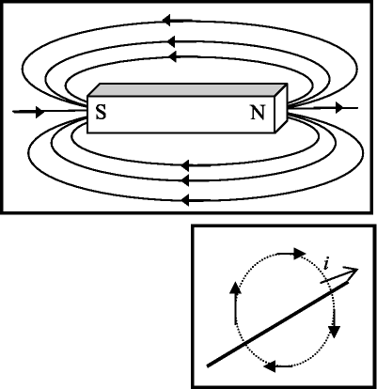
B. Activity Questions:

1. Magnets and magnetic fields
Magnetic field lines start at north poles and end at south
poles. The Earth’s magnetic field is like that of a bar magnet, but
the Earth’s North Pole is in fact a magnetic south pole.

2. Magnetic field around a current carrying wire
The magnetic field lines are circles around the wire. If you point
your right thumb in the direction of the current your fingers will curl
in the direction of the magnetic field. When the direction of the
current is reversed the direction of the magnetic field is also reversed.
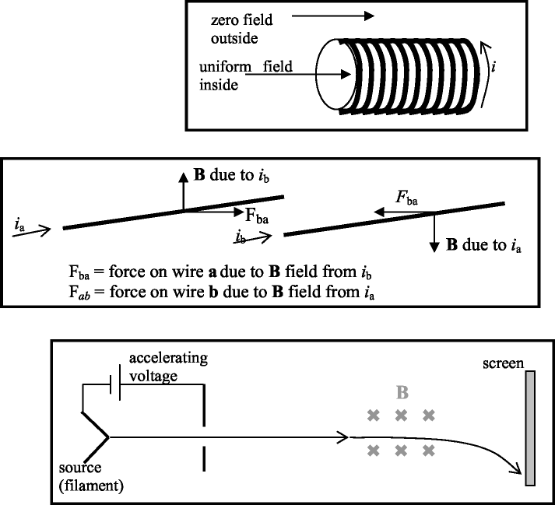
3. Solenoid
The field inside the solenoid is approximately
uniform, while that outside the solenoid is
approximately zero. If the solenoid was infinitely long
the field outside would be exactly zero.

4. The magnetic force - pinch effect
When the currents are in the same
direction the wires attract each
other. The wires can be made to
repel by reversing the direction of
the current in one wire.

D. Quantitative Question:

1. An electron in a television set.
a. See diagram opposite.
Note that the magnetic field is produced
by coils (not shown). The deflection in
one direction and sometimes both may
be achieved with an electric field rather
than a magnetic field.
b. The electron gains 1 eV for each volt that it is accelerated through, hence it gains 20 keV as it passes
through the accelerating voltage, which is 20×10³ eV × 1.6 × 10⁻¹⁹ J.eV⁻¹ = 3.2 × 10⁻¹⁵ J
c. KE = ½ mv². Rearrange to get v = √2(K.E/m) = √2(3.2 × 10⁻¹⁵ J / 9.1 × 10⁻³¹ kg) = 8.4×10⁷ m.s⁻¹.
Note that at this speed, ~0.3×c, relativistic effects should be allowed for. Hence this is an over estimate of
the electron’s speed.
d. The radius of curvature of the path is
r = mv/qB = 9.1 × 10⁻³¹ kg × 8.4×10⁷ m.s⁻¹/1.6 × 10⁻¹⁹C × 100 mT
= 4.8 × 10⁻³ m = 4.8 mm
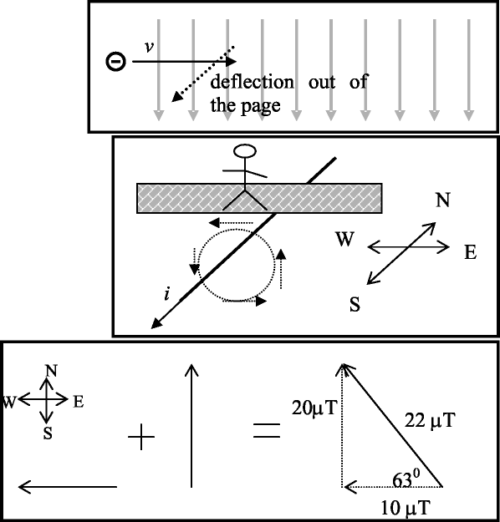
e. See diagram opposite. Note that because the
electron is negatively charged the deflection is the
opposite way to a positive (conventional) current.

2.
a. The direction of the magnetic field is
to the west. It has a magnitude of
B = µ_{o} i/2πr
= 4π×10⁻⁷ T.m.A⁻¹ × 100A / 2π × 2.0 m
= 1.0 × 10⁻⁵ T = 10 µT.
b. See diagram opposite. Using vector addition the field at the point where the man is standing is 22 µT, pointed 63º
west of north. Hence the needle is
pointing 27º away from (magnetic) north,
and the platform entrance is likely to be
built at an odd angle.

Workshop Tutorials for Physics
ER8: Electromagnetic Induction

A. Qualitative Questions:

- Two circular loops lie adjacent to each other. One is connected to a source that supplies a current; the other is a simple closed ring. The current in the first loop is clockwise. The loops can be arranged so that they stand parallel to each other (arrangement I) or next to each other (arrangement II).
arrangement I arrangement II

- Would you expect a difference in the induced current when the power supply is turned on in the two arrangements? Explain why or why not.
- In which directions will the induced currents be in these two arrangements when the power supplies are turned on?
- Sketch a graph of the current as a function of time when the power supply is turned on and then off again for the first arrangement of coils.

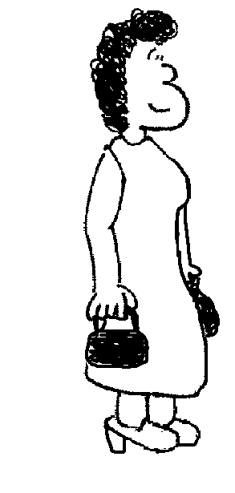
- A metal detector at an airport security checkpoint contains two coils, one in either side. One coil acts as a transmitter and the other as a receiver. The transmitting coil is connected to a power supply which provides an alternating current. The receiving coil is connected to a sensor which detects changes in current and an alarm.
i
transmitting coil
receiving coil
  - How can a coil act as a transmitter? What is actually transmitted?
  - How does the second coil act as a receiver?
When a person walks between the two coils carrying something made of metal an alarm is sounded.
  - Why do metal objects set off the alarm? Explain what is happening here.

B. Activity Questions:

- Electromagnetic Induction – two coils of wire and a magnet
If a magnet is moved into and out of a closed loop of wire, a current is induced in the loop of wire.
Does the direction of the current depend on the motion of the magnet relative to the loop? What happens if the magnet is reversed?
Does the magnitude of the current depend on the speed of the motion, the number of turns of wire, angle between the loop and the magnet? What happens if the loop is moved and the magnet is stationary?
Will a similar phenomenon be observed if a current carrying coil of wire moves relative to a loop of wire?

2. Torque on a current carrying coil in a magnetic field
N
S
N
S

Draw the magnetic force at the points marked by dots on the diagrams opposite.
In which of the above cases is the loop more likely to start turning on its own if held stationary prior to release?

3. Magnetic braking and damping – magnets in pipes
Why do magnets take longer falling down a copper pipe than a plastic pipe?
What happens when the pipe has a slit in it? Why?

- Jumping Rings.
What makes the ring jump?
Try to make the different sorts of rings jump.
What sort of ring won’t jump? Why?
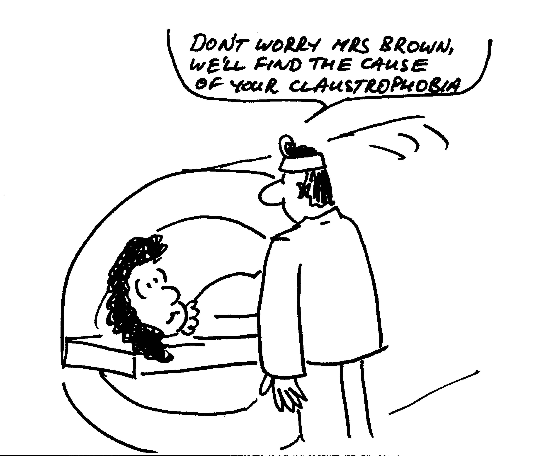

C. Quantitative Questions:

1. Magnetic resonance imaging (MRI) is used to produce images of the interior of the body, especially the brain. The patient is strapped down tightly to a flat stretcher which is then slid into the MRI scanner. The scanner produces a strong magnetic field which is varied in time.
a. Why are patients asked to remove all jewelry and any clothing with zips or metal buttons or clips?
The human body has been described as a bag of salt water, because it contains a great deal of fluid with dissolved ions. A woman is in an MRI scanner which can produce a field of 1.5 T. The largest surface area through which magnetic flux passes is 0.04 m² and has a normal which is parallel to the direction of the field.
b. If the maximum average induced emf is to be kept less than 0.01 V, how long must it take for the machine to be powered down from maximum field to zero?

- A helicopter is hovering with its 5.0 m long blades rotating at 200 rpm. The local magnetic field is directed upwards at approximately 60º to the horizontal and has a magnitude of 50 mT. What is the induced emf between the hub (where the blades join to the helicopter) and the tips of the blades?
(Hint – the emf induced across a short length, Δl, of conductor is the rate at which it cuts through magnetic flux.)
Workshop Tutorials for Physics
Solutions to ER8: Electromagnetic Induction

A. Qualitative Questions:

  - Two coils.
- The induced currents in the two arrangements are different because the magnetic field, B, through the area of the loop in arrangement II is smaller than that in arrangement I. Thus changes in the magnetic field and the rate of change of flux will be smaller, and any induced emfs and currents will also be smaller.
- When the power supply is switched on the current will begin to flow producing an increasing magnetic field which causes a current in the other wire. In both cases this current will produce a magnetic field which acts to decrease the total magnetic field. Hence it is in the opposite direction to the field caused by the current in the loop with the power supply. For arrangement I the current will be clockwise in the second loop, and for arrangement II it will be anti-clockwise. You can use the right-hand rule to check that this gives fields that oppose each other.
I
II

i
t
power on
power off
- When the magnetic field is constant there will be no current induced in the other coil. When the magnetic field decreases after the power supply is turned off a current will briefly flow in the other direction.

  - A metal detector at an airport security checkpoint contains two coils, one in either side. One coil acts as a transmitter and the other as a receiver. The transmitting coil is connected to a power supply which provides an alternating current. The receiving coil is connected to a sensor which detects changes in current and an alarm.
- The alternating current in the coil produces an alternating magnetic field. The magnetic field exists outside the coil.
- The changing magnetic flux through the receiving coil, due to the transmitting coil, induces an emf in the receiving coil (Faraday’s law). If the loop is complete there is also an induced current.
When a person walks between the two coils carrying something made of metal an alarm is sounded.
- The changing magnetic field due to the transmitting coil produces eddy currents in any metal object within the field. These eddy currents in turn produce a magnetic field. The magnetic field at the receiving coil is a sum of these two fields, and is different from the field produced by the transmitting coil alone. This changes the induced emf in the receiving coil. The resulting change in current is detected by the sensor which triggers the alarm.

B. Activity Questions:

- Electromagnetic Induction – two coils of wire and a magnet
The direction of the current depends on the motion of the magnet relative to the loop and changes when the magnet is reversed. The magnitude of the current depends on the speed of the motion, number of turns of wire and the angle between the loop and the magnet. It doesn’t matter whether the coil or the magnet is moved, only the relative motion of the two is important (it was this observation that led Einstein to his theory of relativity).
A current-carrying coil of wire has a magnetic field so there will be an induced current in a closed loop of wire which is moving relative to a current-carrying coil.

- Torque on a current-carrying coil in a magnetic field
both forces non-zero and perpendicular to plane of coil.
N
S
N
S
all forces
in plane of coil.

If it is held stationary prior to release, the loop on the left is more likely to start turning on its own.

3. Magnetic braking and damping – magnets in pipes
The movement of the magnet creates currents in the copper pipe, which produce magnetic fields, which act to oppose the motion which causes them, slowing the fall of the magnet. The plastic pipe is an insulator, no current is created and hence the magnet is not braked. In the pipe with the slit there are still currents produced in vertical loops, but not around the pipe as the slit prevents this. So the fall is slowed, but not as much as in the complete pipe.

- Jumping Rings
An AC coil with a long iron core produces an alternating magnetic flux, mostly in the region in and near the core. An emf is induced in a small conducting ring when it is slipped over the core and the power is turned on to the coil. If the ring is complete, a current is also induced and the resulting magnetic force is sufficient to launch the ring several feet into the air. A split ring or a non-conductive ring will not jump because no current is induced.

C. Quantitative Questions:

  - MRI scans and induced currents.
- The changing magnetic field will induce a current. Metal jewelry or zips etc have low resistance so large currents could be induced in them.
- According to Faraday’s law the induced emf = -dΦ_{B}/dt, which is the rate of change of magnetic flux.
Φ_{B} = ∫B.dA = B.A for a uniform field. So now we have
emf = -dΦ_{B}/dt = d(B.A)/dt = B.A/t for a steadily changing field, or for the average value.
We want the maximum value of the emf to be 0.01 V, and we are finding t:
t = B.A/emf = 1.5 T × 0.04 m² / 0.01 V = 6 s.
It must take at least 6 s for the machine to reduce the field to zero.

  - The component B perpendicular to the area swept out by the blades is B_{perp} = Bsin 60º = 43 mT.
  - The blades sweep out an area of πr² = π×(5.0 m)² = 25π m² per revolution. They revolve 200 times per minute, which is 200/60 times per second, so they sweep out an area of 200/60 × 25π m² per second. Hence the induced emf = B × d(A)/dt = 200/60 × 25π m² s⁻¹ × 43 mT = 11 V.
Workshop Tutorials for Physics
ER9: Applications of Electromagnetism

A. Qualitative Questions:

1. A transformer uses a current in a primary coil to induce a current in a secondary coil, as shown in the diagram below.
secondary
primary
i
iron toroid
V

- Explain how a current is produced in the secondary coil which is wound around the toroid when there is no external magnetic field around the toroid.
The ratio of the voltage across the primary coil to the voltage across the secondary coil is equal to the ratio of the number of turns on the primary coil to the number of turns on the secondary coil, i.e. $\frac{V_{P}}{V_{S}}=\frac{N_{P}}{N_{S}}$.
- Explain why this is the case.
(Hint: think about the magnetic field in the toroid.)

2. Electric motors are used in thousands of applications, from electric toothbrushes to electric cars, drills, pumps, fans and vacuum cleaners. A simple electric toothbrush comes with rechargeable batteries and a charger which the toothbrush sits on when not in use. The toothbrush circuitry is completely enclosed in a plastic cylinder so that moisture can’t get in.
- Describe the basic circuit components that the toothbrush must have to function.
The cylindrical handle of the toothbrush has an indent in the base which fits over a peg on the charger, allowing it to sit upright on the charger. There is no direct electrical connection between the charger and the toothbrush.
- Explain how the batteries are charged without a direct electrical connection.
Some cordless electric jugs also work this way.

B. Activity Questions:

- Torque on a current carrying coil in a magnetic field
N
S
N
S
Draw the magnetic force at the points marked by dots on the diagrams opposite.
If held stationary prior to release, in which of the above cases is the loop more likely to start turning on its own?

- Simple electric motor
Connect the battery to the motor. You may need to give it a nudge to start it spinning.
Draw a diagram showing the current traveling through the loop and the force due to the magnets.
Using your diagram, explain why the loop spins.

- Electricity generator
Turn the handle so that the LED lights up.
Explain what is happening to produce a current.
How is this similar and different to the electric motor?

- Power plants
Examine the diagrams showing how electricity is produced using geothermal power, nuclear power and hydroelectric power. How are these methods different?
How are they similar?
Can you think of a way of commercially producing electricity which does not use a generator?

C. Quantitative Question:

- A backup power generator for a hospital needs to produce an emf of 240 V RMS so that the medical equipment will run even in a power failure. The coil rotates at 50 Hz. The coil consists of 500 m of wire wrapped into a rectangular coil of side lengths 20 cm and 15 cm.
  - What magnetic field is necessary to produce an RMS emf of 240V?
This generator is to be modified to power a 120 V (RMS) piece of equipment from a US manufacturer. The cheapest way to do this is by unwinding some of the wire that makes up the coil and reconnecting it.
  - How much wire should be removed?

- Rebecca has left her car head lights on again and the battery has gone flat. Brent suggests that rather than using his car to recharge the battery they build a battery charger so she can recharge it herself. He suggests that she modify an old transformer that they don’t need anymore to do the job. The old transformer has a primary coil of 300 turns. It will need to be connected to mains voltage, 240 V, and put out a voltage of 12 V to charge the battery.
  - How many turns should Rebecca wind to make the secondary coil?
Rebecca finishes winding the coil, and checks the output just to be sure. She measures the input current and voltage, and also the output current and voltage.
  - If the primary current is 2.5A and the secondary current is 4.0 A, what is the efficiency of the transformer?
When the transformer is finished Rebecca suggests that they give it a go. Brent points out that the mains power supply from the wall socket is an alternating current supply, and hence the transformer can’t be connected straight onto the battery.
  - Why is this a problem?
Brent quickly puts together a rectifier circuit which converts AC to DC at the cost of 3 V. This will allow the transformer to be connected to the battery, but unfortunately it now doesn’t supply enough voltage to charge the battery enough to start the car.
  - How many turns need to be added to the secondary coil to get 12 V out of the finished battery charger now?
Workshop Tutorials for Physics
Solutions to ER9: Applications of Electromagnetism

A. Qualitative Questions:

1. A transformer uses a current in a primary coil to induce a current in a secondary coil, as shown in the diagram below.
secondary
primary
i
iron toroid
V

- The alternating current in the primary coil produces a fluctuating magnetic field in the toroid. Although the magnetic field does not extend beyond the toroid, this changing magnetic field produces an electric field which does extend outside the toroid. The electric field provides a force on the charges in the secondary coil, which makes them move, hence producing a current in the secondary coil.
- The ratio of the voltage across the primary coil to the voltage across the secondary coil is equal to the ratio of the number of turns on the primary coil to the number of turns on the secondary coil, i.e. $\frac{V_{P}}{V_{S}}=\frac{N_{P}}{N_{S}}$.
The magnetic field, B, throughout the toroid must be the same all throughout the toroid, hence the flux, Φ, through any loop of wire around the toroid is the same. (Assuming that the area of the loops is the same.) The change in flux, dΦ/dt must also be the same through any loop. The emf or voltage, V, across a coil wrapped about the toroid is V = N × dΦ/dt where N is the number of turns. Hence V_{p} = N_{p} × dΦ_{p}/dt and
V_{s} = N_{s} × dΦ_{s}/dt, or V_{s} / N_{s} = dΦ_{s}/dt Using the fact that Φ_{s} = Φ_{p}, we can now write
V_{p} = N_{p} × dΦ_{p}/dt = N_{p} × dΦ_{s}/dt = N_{p} × V_{s} / N_{s} which is the same as $\frac{V_{P}}{V_{S}}=\frac{N_{P}}{N_{S}}$.

2. An electric toothbrush with charger.
- Inside the toothbrush there would have to be a battery and a motor to give the mechanical movement of the brush. A switch is also necessary to disconnect the battery when not in use.
- There is a coil sealed in the base of the hand-piece and the peg that it sits on when being charged has an iron core. There is a second coil which is sealed in the charger. When the charger is plugged into the mains the current in the charger coil induces a current in the hand-piece coil. The peg with the iron core improves the magnetic flux linkage. This current would be alternating and would have to be rectified before charging the battery. Hence in our solution to part a we should add a coil and rectifier circuit to convert the AC induced emf into a DC emf to charge the battery.

B. Activity Questions:

  - Torque on a current carrying coil in a magnetic field
both forces non-zero and perpendicular to plane of coil.
N
S
N
S
all forces
in plane of coil.

If held stationary prior to release, the loop on the left is more likely to start turning on its own.
  - Simple electric motor
The current experiences a force due to the external magnetic field from the magnets. On one side of the coil the force is upwards, on the other it is downwards, resulting in a torque on the coil (figure a). If the current continues to flow, as the coil begins to rotate the forces will change direction and point in the opposite direction and oppose the motion of the coil (figure b). Hence it is important that the current be stopped so that the force becomes zero. The coil will then continue to rotate, with no force other than friction opposing it, until it returns to its original position. It will then get another push to continue it spinning and, as long as the force due to the field on the current is greater than friction, it will continue to spin.
i
N
S
F
F
B
Figure a
i
N
S
F
F
B
Figure b

  - Electric generator
The generator is really just a motor in reverse. Rather than using a current in a magnetic field to produce a torque on a coil, it uses the motion of a coil in a magnetic field to induce a current in the coil. The induced emf in the coil is proportional to the rate of change of magnetic flux through the coil. As the coil rotates the magnetic flux oscillates, increasing and decreasing as the angle between the plane of the coil and the field changes. This induces an alternating current in the coil, which lights up the LED as the current flows in one direction only.

  - Power plants
Virtually all commercial electricity production uses a generator. Usually water, either as liquid or as steam, is used to drive a turbine which spins a coil in a generator to produce an emf. Examples include wind power, coal and other fossil fuel power plants, geothermal power and nuclear power plants. Solar cells do not use a generator, they use the photoelectric effect to produce a current.

C. Quantitative Question:
- A generator.
  - The length of a turn is 0.70m and the area, A, is 0.03 m². So N = 500 m / 0.7 m = 714.
240V RMS is obtained when the maximum value of the emf generated is 240√2 V.
The emf generated at ant time t is ε = dΦ/dt = d[NABcos(ωt)] / dt = NABω sinωt.
The max emf is when sin(ωt) = 1, which gives ε_{max} = NABω.Setting the two maximum emf values equal:
emf_{max}= NABω = 240√2, and rearranging for B:
B =$\frac{ε_{\text{max}}}{\text{NA}ω}$= $\frac{\text{240}\sqrt{2} V}{\text{714}×0\text{.}\text{03} m^{2}×2π\text{50} \text{Hz}}$ = 0.05 T.
  - To reduce the emf by half we reduce the number of turns by half - 357 turns, should be removed.

- Building a battery charger.
    - The relationship between the number of turns and the voltage output in a transformer is given by $\frac{N_{p}}{N_{s}}=\frac{V_{p}}{V_{s}}$. Therefore N_{s} = N_{p}.V_{s} / V_{p} = 300 × 12 V / 240 V = 15 turns.
    - Efficiency = $\frac{P_{\text{out}}}{P_{\text{in}}}=\frac{V_{s}I_{s}}{V_{p}I_{p}}=\frac{\text{12} V×4\text{.}0 A}{\text{240} V×2\text{.}5 A}$ = 0.08 or 8%.
    - If charge is to build up on the terminals over time then the battery needs to have DC current flowing through it in a direction opposite to that when it is supplying power.
    - They need 12 V + 3 V =15V from the secondary.
N_{s} = N_{p}.V_{s} / V_{p}= 300 × 15 V / 240V = 75/4 ~ 19 turns.
Workshop Tutorials for Physics
ER10: Circuits II

A. Qualitative Questions:

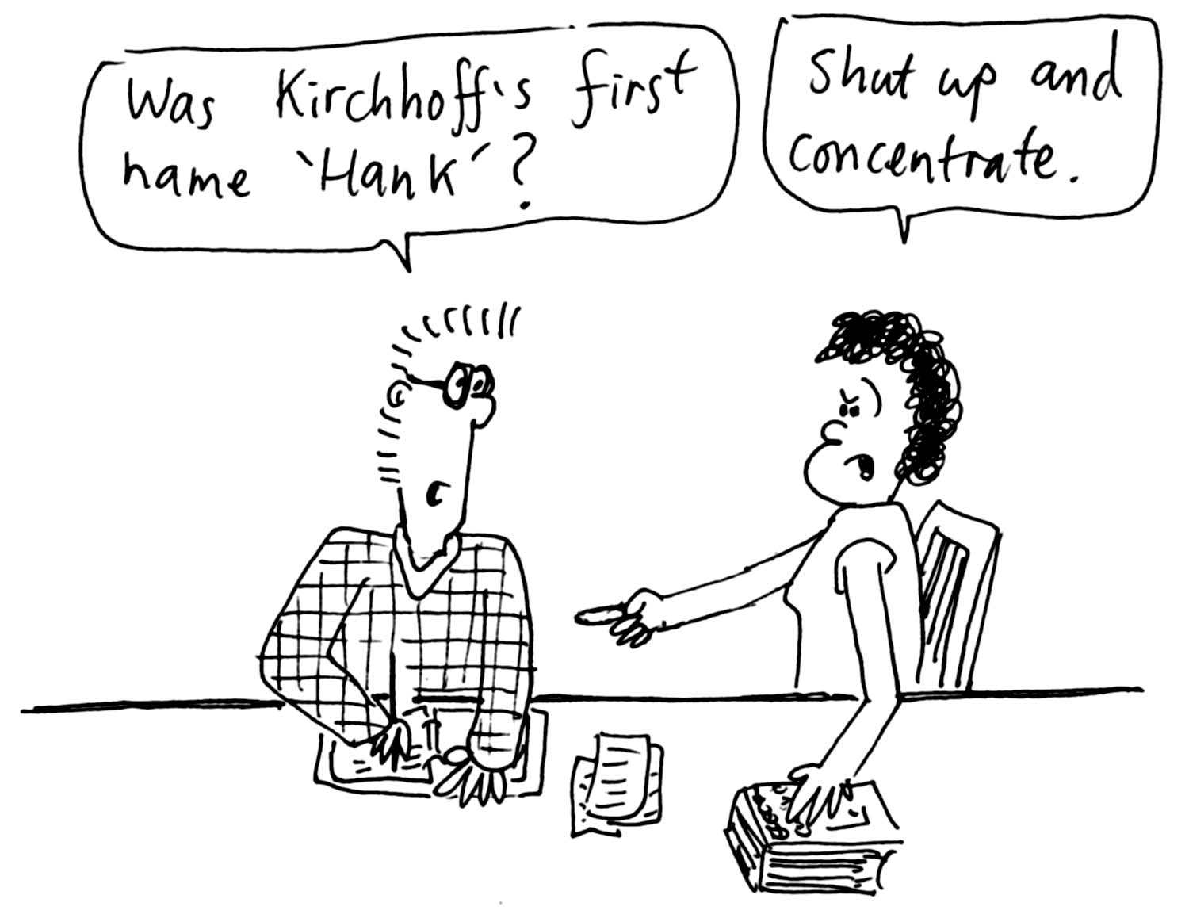
1. Rebecca is helping Brent study for a test on circuit theory. Brent is having trouble remembering Kirchhoff’s rules. Kirchhoff’s rule for junctions states that the total currents going into a junction must be equal to the total currents coming out of a junction. Kirchhoff’s rule for loops says that the sum of all the potential changes around a loop must be zero.
Rebecca tells him that these things are pretty obvious, and are really just statements of conservation of charge and conservation of energy. How can Rebecca justify this claim? (Hint: the potential difference (or voltage) between two points is the difference in potential energy per unit charge at those points.)

2. Two of the most common circuit components are resistors and capacitors.
- Why is it that resistors connected in series give a large total resistance, but resistors connected in parallel give a low total resistance?
- Why do capacitors in series and parallel add to give a total capacitance the opposite way to resistors?

B. Activity Questions:

- Measuring Current and Voltage
Examine the circuit.
Why is the ammeter connected in series in the circuit?
Why is the voltmeter connected in parallel?
Should the internal resistance of voltmeters be large or small? Why?
What about the internal resistance of ammeters?

- Wheatstone Bridge
Explain how this circuit works.
Find an expression for R_{x}, the unknown resistor, when the bridge is “balanced”.
Balance the bridge to find the value of the unknown resistor.

- Charging capacitors
Connect up different resistors and observe the effect on the capacitor voltage, V_{c}, during charging. What do you notice about the rate of charging with different resistors in the circuit?
Suppose instead that we kept the resistor value fixed and changed the value of the capacitor in the circuit – would this produce a similar result?

C. Quantitative Questions:

  - Rebecca has gotten home from university after dark and accidentally left her headlights on, so that the next morning her car battery is flat. Brent kindly offers to recharge her battery using his car’s battery. He first gets out a multimeter to check that the problem is with the battery. He measures the potential across Rebecca’s battery terminals to be 10 V, and that across his own battery to be 12.5 V. The jumper leads have a resistance of 0.1 Ω, and each battery has an internal resistance of 0.02 Ω.
- To which terminal of Rebecca’s car battery should Brent connect the positive terminal of his car’s battery? Why?
- Draw a circuit diagram showing how the batteries should be connected. Include all resistances.
- What will be the charging current if Brent has connected the batteries together correctly?
- What will be the current if he has gotten them the wrong way around?
- How much charge does Brent’s battery add to Rebecca’s battery?

2. The diagram below shows a simple circuit equivalent for a cell membrane, for example the membrane of a nerve cell. The resistances R_{m} represent the resistance across the membrane, R_{i} represents the internal resistance of the cell and R_{o} represents the resistance along the outside of the membrane.
R_{i}
R_{i}
R_{i}
R_{i}
R_{i}
R_{m}
R_{m}
R_{m}
R_{m}
R_{o}
R_{o}
R_{o}
R_{o}
R_{o}

If R_{o}= R_{i} = R, show that the total resistance of the membrane is R_{T} = R + [R² + 2RR_{m}]^{1/2}.
(Hint: start by separating the circuit into one unit plus the rest of the chain. As the chain is infinite subtracting one unit does not change the total resistance.)
Workshop Tutorials for Physics
Solutions to ER10: Circuits II

A. Qualitative Questions:

1. Kirchhoff’s rule for junctions states that the total currents going into a junction must be equal to the total currents coming out of a junction. This is a statement of conservation of charge, as current is just a flow of charge. Charge must be conserved, so whatever flows into a junction must flow out again. If it didn’t come out again, or if more came out than went in, then charge is either being created or destroyed.
Each point in space has only one value of electrical potential at any time. Work your way mentally around any closed path, noting and adding up all the changes in potential as you go, making sure to count decreases as negative changes and increases as positive. When you get back to the starting point the sum must be the potential that you started with. In a circuit with just one battery, any loop which includes the battery will include a rise in potential across the battery and drops (or no change) everywhere else. The connection with energy conservation is that if you imagine that you were to take a little test charge around the loop, then the potential energy of the system at the end would be the same as it was when you started. Remember that potential is defined as potential energy per unit charge.

2. Two of the most common circuit components are resistors and capacitors.
- When the charge moves around the circuit there is a loss in electrical potential energy due to the resistance of the resistors in the circuit. The more resistors an electron has to pass through, the more energy is lost (as thermal energy), and the less current flows. Hence the more resistors there are in series, the greater the total resistance. Resistors in parallel provide multiple paths for the current to flow along, hence more current can flow and the total resistance is less, like a multi-lane freeway.
- Capacitors are devices to store charge. The charge, Q, stored for a given voltage, V, depends on the capacitance of the capacitors. Imagine three identical capacitors in parallel. This in effect gives us one capacitor with three times the plate area, i.e. the overall capacitance is increased and three times as much charge (3Q) is stored for a given voltage. Now imagine the three capacitors in series. When the same voltage as above is placed across them, each capacitor has 1/3 V across it, so it stores only one third the charge. The net charge is effectively +Q/3 on the left most plate and –Q/3 on the right most plate (or vice versa), hence the capacitance of the three in series is 1/3 of a single capacitor, and much less than the capacitance of the three in parallel.

B. Activity Questions:

- Measuring Current and Voltage
The ammeter measures the current, which is the number of charges per unit time passing through a given point on the circuit. To be able to count the charges, the ammeter must be part of the circuit and have a very low internal resistance so that it does not affect the current through the circuit.
The voltmeter is connected in parallel, because it measures the difference in potential between two points. The voltage across any arm is the same, so it is connected in parallel, forming another arm with the component we wish to measure the voltage across. It has a very high internal resistance so that very little current will flow through it, thus having little effect on the circuit.

- Wheatstone Bridge
When there is no potential difference between points a and b there is no current flow between these points. Hence all of current I₁ flows through R₁ into R₃, and all of current I₂ flows through R₂ into R_{x}. We also know that the potential difference across R₁, must be equal to the potential difference across R₂., i.e. that V₁ = I₁ R₁ = I₂ R₂. The potential differences across R₃ and into R_{x} must also be equal, giving I₁ R₃ = I₂ R_{x}. We can now divide the second equation by the first to give R₃ / R₁= R_{x}/R₂, and rearrange to obtain an expression for R_{x}. : R_{x}. = (R₂ R₃)/ R₁.

- Charging capacitors
The potential difference is initially all across the resistor; as the capacitor charges the potential difference across the capacitor builds up from zero to a maximum (the supply voltage). The greater the resistance, the greater the time constant and the longer it takes for the capacitor to charge up.

C. Quantitative Questions:

  - Brent measures the potential across Rebecca’s battery terminals to be 10 V, and that across his own battery to be 12.5 V. The jumper leads have a resistance of R_{j} = 0.1 Ω, and each battery has an internal resistance of R_{b} = 0.02 Ω.
R_{j}
R_{b}
V₁
R_{b}
V₂
  - Brent should connect the positive terminal of his car’s battery to the positive terminal of Rebecca’s battery, and connect the two negative terminals together. This will allow the good battery to push charges through the weak battery from the positive to the negative, and recharge it.
  - See diagram opposite. Note that the resistance of the jumper leads is only included once.
- If Brent has connected the batteries together correctly the current which flows will be the total emf divided by the total resistance (Ohm’s law) :
I = $\frac{V_{1}−V_{2}}{2R_{b}+R_{j}}$= $\frac{\text{12}\text{.}5V−\text{10}V}{2×0\text{.}\text{02}Ω+0\text{.}1Ω}$ = 18 A.
This current will decrease as the weaker battery (Rebecca’s) becomes charged.
- If Brent has connected the batteries the wrong way around, so that the emfs add, the current will be
I = $\frac{V_{1}+V_{2}}{2R_{b}+R_{j}}$= $\frac{\text{12}\text{.}5V+\text{10}V}{2×0\text{.}\text{02}Ω+0\text{.}1Ω}$ = 160 A.
This is a very big current and will probably damage both the batteries and the jumper cables.
- Brent’s battery does not add charges (electrons) to Rebecca’s battery – it adds electrical potential energy.
2. The resistances R_{m} represent the resistance across the membrane, R_{i} represents the internal resistance of the cell and R_{o} represents the resistance along the outside of the membrane.
R_{i}
R_{i}
R_{i}
R_{i}
R_{i}
R_{m}
R_{m}
R_{m}
R_{m}
R_{o}
R_{o}
R_{o}
R_{o}
R_{o}

If R_{o}= R_{i} = R, then the resistance of the single section of membrane shown shaded in the diagram is 2R + R_{m}. As the circuit is of effectively infinite length, the rest of the membrane to the right has a resistance effectively the same as the total resistance, R_{T}. This R_{T} is in parallel with the membrane resistance, R_{m}, so we can write the total resistance of the entire circuit shown above as R_{T} = 2R + $(\frac{1}{R_{m}}+\frac{1}{R_{T}})^{−1}$.
We now wish to rearrange this to get R_{T}. We start by multiplying everything by $(\frac{1}{R_{m}}+\frac{1}{R_{T}})$which gives:
R_{T} $(\frac{1}{R_{m}}+\frac{1}{R_{T}})$ = 2R $(\frac{1}{R_{m}}+\frac{1}{R_{T}})$+1 or $(\frac{R_{T}}{R_{m}})$+1 = $(\frac{2R}{R_{m}}+\frac{2R}{R_{T}})$+1, and getting rid of the ones and multiplying by R_{T} and R_{m} gives:
R_{T}² = 2RR_{T} + 2RR_{m} or R_{T}² - 2RR_{T} - 2RR_{m} = 0 which is a quadratic of form ax² +bx +c = 0, and can be solved by inspection or using the quadratic formula to give:
R_{T} = R ± [R² + 2RR_{m}]^{1/2} we take the positive solution, R_{T} = R + [R² + 2RR_{m}]^{1/2} because R (= R_{i} = R₀) is in series with the rest of the circuit, hence the total resistance must be greater than R.
Workshop Tutorials for Physics
ER11: AC Circuits

A. Qualitative Questions:
L
ε

- An inductor is connected to an AC power supply. If the frequency of the power supply is doubled:  - What will happen to the inductance of the inductor?  - What will happen to the inductive reactance of the inductor?  - If it was a capacitor that was connected to this power supply what would happen to the capacitive reactance when the frequency was doubled? | C  ε

- When a resistor is connected to any power supply the voltage across the resistor and the current through the resistor are always in phase. This is not the case for capacitors and inductors. Consider an LC series circuit that is connected to an AC power supply, for example the mains power from a typical wall socket.
- Do you think the current and the voltage across the capacitor are in or out of phase? Why? If there is a phase difference, what would it be?
- Do you think the current and the voltage across the inductor are in or out of phase? Why? If there is a phase difference, what would it be?

B. Activity Questions:

- Series RLC circuit
Connect the AC power supply to the RLC circuit.
Use the oscilloscope to view the potential difference across the inductor and the capacitor.
Sketch a graph of what you see. What do you notice about the two curves?
As you vary the frequency of the input voltage what happens to the globe? Explain this effect.
As you vary the inductance of the inductor what happens to the globe? Explain this effect.
R
V_{in}
C
V_{out}
R
V_{in}
C
V_{out}
- High pass and low pass filters
Vary the frequency of the input voltage while observing the output on the oscilloscope.
What sort of filter is this?
How does it work?
Repeat your observations with the second filter.
What sort of filter is this one and how does it work?

- Tuning circuit
Examine the circuit and identify the main components.
How is this circuit tuned?

C. Quantitative Question:
L
C
- A variable capacitor, C, with a range from 10 pF to 365 pF is used in the tuning circuit of a car radio. The capacitor is part of a variable frequency LC circuit as shown opposite.
  - What is the ratio of maximum to minimum frequencies that can be tuned with this capacitor?
A second capacitor, C₁, is in parallel with the variable capacitor.  - What value capacitor, C₁, must be added in parallel to this circuit to reduce this ratio by a factor of 2?  - With this value of C₁, what inductance should the inductor, L, be for be the circuit to tune in to the AM radio band, with frequency range 540 kHz to 1600 kHz? | L  C  C₁

L
C
R
ε

- RLC circuits have many uses, for example they are used as the tuning circuit in radios, and as frequency generators to produce musical tones for doorbells. A mains powered RLC circuit is shown below. The power supply, ε, is 240 V (RMS) with a frequency of 50 Hz. The resistor has a resistance of 50 Ω, the capacitor has a capacitance of 50 μF and the inductor has an inductance of 0.05H.
  - Calculate the total impedance, Z, of the circuit.
  - Sketch and label a phase amplitude diagram showing the potential difference across each component, and use this to find the phase angle between the current and the applied emf, ε.
  - Calculate the resonant frequency, ω_{o}, for this circuit. How does this compare to the frequency of the emf source?
  - Calculate the quality factor, Q, for this circuit. What does this tell you about the circuit?

Workshop Tutorials for Physics
Solutions to ER11: AC Circuits

A. Qualitative Questions:
- An inductor is connected to an AC power supply. If the frequency of the power supply is doubled:
  - The inductance, L, will not change. The inductance depends on the physical characteristics of the inductor, characteristics such as the number of turns of wire and the cross sectional area.
  - The inductive reactance, X_{L}, does change. The voltage drop developed across the inductor depends on the rate of change of flux and that depends on the frequency of the input voltage. Since X_{L} = 2πfL, when the frequency doubles so does the inductive reactance.
  - The capacitive reactance also depends on frequency and hence changes. The capacitive reactance is:
X_{C} =$\frac{1}{2π\text{fC}}$. When the frequency is doubled the capacitive reactance is halved.

- Current and voltage in capacitors and inductors.
  - The current through and voltage across a capacitor are out of phase. The voltage across the capacitor depends on the charge stored on the capacitor. As the voltage (and charge stored) increases through the first part of any cycle, the current will decrease from its initial maximum value. Then as the current reverses the capacitor begins to discharge and the voltage across it starts to decrease. The instantaneous current in the circuit leads the instantaneous voltage across the capacitor by one-quarter of a cycle.
  - The current through and voltage across an inductor are also out of phase.. The voltage across the inductor is the back emf developed because of the changing magnetic flux linking the coils of the inductor. The magnetic flux is changing because the current is an alternating current. Once again as the current decreases from its initial maximum, a voltage develops across the inductor, but in this case the direction is opposite. Once again the phase difference is one quarter of a cycle, but now as the voltage developed is in the opposite direction, i.e. the voltage is maximum negative as the current goes to zero, the instantaneous current in the circuit lags the instantaneous voltage across the inductor by one-quarter of a cycle.

B. Activity Questions:
V_{C}
V_{L}
t
- Series RLC circuit
See diagram opposite. The voltages across the inductor and the capacitor depend on the reactance of the two components. The reactance, X, depends on the frequency, f: X_{C} = 1/ 2πfC and X_{L} = 2πfL. When X_{c} = X_{L}, the voltage drop across L and C is zero, since V_{C} and V_{L} are 180º out of phase and equal in magnitude, cancelling each other out.
So the impedance of the circuit = R, the resistance of the globe. The current will be a maximum and the bulb will glow most brightly. Varying the inductance, L, of the inductor until X_{c} = X_{L} will lead to a similar effect.
R
V_{in}
C
V_{out}
R
V_{in}
C
V_{out}

- High pass and low pass filters
The top circuit is a low pass filter. As the frequency changes, X_{C} changes, hence V_{C} changes. When the frequency is low the reactance is high and most of the voltage is dropped across the capacitance rather than the resistance. Thus V_{out} will be high. We call this a low pass filter as low frequencies provide a significant output, but high frequencies do not.
The bottom circuit is a high pass filter. The output is taken across the resistor now. At high frequencies the reactance of the capacitor is low, so the voltage dropped across the capacitor is low while that across the resistor is high. Hence for a high pass filter we take V_{out} across the resistor.

- Tuning circuit
A tuning circuit consists of a inductor and a capacitor, usually in parallel.
Either the inductance of the inductor or the capacitance of the capacitor must be able to be varied. By varying either the capacitance or inductance the resonant frequency of the circuit is varied. When the resonant frequency matches an incoming signal, for example the carrier wave of your favourite radio station, then the circuit is tuned to that frequency and the radio program can be heard.

C. Quantitative Question
L
C
- A variable capacitor (10 pF to 365 pF) is used in a tuning circuit.
  - The frequency decreases with increasing C or L.
f_{max} = $\frac{ω_{\text{max}}}{2π}=\frac{1}{2π}\sqrt{\frac{1}{{\text{LC}}_{\text{min}}}}$, and f_{min} = $\frac{ω_{\text{min}}}{2π}=\frac{1}{2π}\sqrt{\frac{1}{{\text{LC}}_{\text{max}}}}$.
The ratio of maximum to minimum is therefore f_{max /} f_{min} =$\sqrt{\frac{C_{\text{max}}}{C_{\text{min}}}}$= $\sqrt{\frac{\text{365}\text{pF}}{\text{10}\text{pF}}}$= 6.0
A second capacitor, C₁ is in parallel with the variable capacitor. So the total capacitance is now C_{total} = C +C₁.  b. We want to reduce the frequency ratio by a factor a 2, i.e. f_{max /} f_{min} = 3.  We can write this ratio for the new circuit as f_{max /} f_{min} =$\sqrt{\frac{C_{\text{max}}+C_{1}}{C_{\text{min}}+C_{1}}}$=3. | L  C  C₁
Rearranging for C₁ gives: C₁ = (C_{max} - 9C_{min})./8 = (365 pF – 9 × 10 pF)/8 = 34 pF
- We want to tune in to the AM radio band, 540 kHz to 1600 kHz. To find the appropriate value of L we can use our expression for f_{max} from part a and remembering to include the extra capacitor, C₁:
f_{max} = $\frac{1}{2π}\sqrt{\frac{1}{L(C_{\text{min}}+C_{1})}}$ and rearranging this for L: (2πf_{max} )² = $\frac{1}{L(C_{\text{min}}+C_{1})}$
and finally L = $\frac{1}{(2{πf}_{\text{max}})^{2}(C_{\text{min}}+C_{1})}$ = $\frac{1}{(2π×1\text{.}6×{\text{10}}^{6}\text{Hz})^{2}(\text{10}×{\text{10}}^{\text{-12}}F+\text{34}×{\text{10}}^{−\text{12}}F)}$ = 2.2 × 10⁻⁴ H = 0.22 mH.
Note that we get the same answer of we use the expression for minimum frequency instead.

- Series LCR circuit with ε = 240 V (RMS) f = 50 Hz. R = 50 Ω, C = 50 μF and I = 0.05H.
- The total impedance, Z, of the circuit depends upon the angular frequency, ω, of the power supply, which is ω = 2πf = 2π × 50 Hz = 314 rad.s⁻¹. The total impedence, Z, is given by
Z = $\sqrt{R^{2}+(ωL−\frac{1}{ωC})^{2}}=\sqrt{{\text{50}}^{2}+(\text{314}×0\text{.}\text{05}−\frac{1}{\text{314}×\text{50}×{\text{10}}^{−6}})^{2}}$ = 69 Ω
φ
V_{L}
V_{C}
V_{R}
ε
V_{L} - V_{c}
  - See diagram opposite.
Using Ohm’s law; V_{L} = iX_{L}, V_{C} = iX_{C}, and V_{R} = iR.
The impedances of the components are:
X_{L} = ωL = 16 Ω, X_{C} = $\frac{1}{ωC}$ = 64 Ω, R = 50Ω.
We wish to find the angle, φ, between V_{R} and ε:
tan φ = (V_{L} - V_{C}) / V_{R} = (iX_{L} - iX_{C}) / iR = (X_{L} -X_{C})/R
=(16 Ω – 64 Ω)/50 Ω = -0.95.
and finally, φ = -44º. (So current leads ε.)
  - The resonant frequency, ω_{o}, is : ω_{o} = $\frac{1}{\sqrt{\text{LC}}}$= 630 rad.s⁻¹. This is twice the source frequency, so the circuit is a long way from resonance.
  - Q = $\frac{1}{R}\sqrt{\frac{L}{C}}$ = 2. The quality factor is an indication of the bandwidth, the distance between the half power points, Q = $\frac{ω_{o}}{Δω}$, where Δω is the bandwidth. So Δω = ω_{o}/Q = 630 rad.s⁻¹/2 = 315 rad.s⁻¹. This means that the emf frequency, 314 rad.s⁻¹, is just at the lower end of the bandwidth.

