Regular Mechanics Worksheets and Solutions

MR1: | Motion | 3
MR2: | Using Vectors | 7
MR3B: | Newton’s Laws | 11
MR3T: | Newton’s Laws | 15
MR4B: | Newton’s Laws II – Frictional Forces | 19
MR4T: | Newton’s laws II – Frictional Forces | 23
MR5B: | Work, Power and Energy | 27
MR5T: | Work, Power and Energy | 31
MR6B: | Conservation of Energy | 35
MR6T: | Conservation of Energy | 39
MR7B: | Conservation of Momentum | 43
MR7T: | Conservation of Momentum | 47
MR8B: | Equilibrium | 51
MR8T: | Equilibrium | 55
MR9B: | Rotational Dynamics I | 59
MR9T: | Rotational Dynamics I | 63
MR10B: | Rotational Dynamics II | 67
MR10T: | Rotational Dynamics II | 71
MR11: | Rolling | 75
MR12: | Gravity and Kepler’s Laws | 79
MR13: | Relativity | 83

Workshop Tutorials for Physics
MR1: Motion

A. Qualitative Questions:

- A person standing on the edge of a cliff, at some height above the ground below, throws one ball straight up with initial speed u and then throws another ball straight down with the same initial speed. Which ball, if either, has the larger speed when it hits the ground? Neglect air resistance.

- When a skydiver jumps out of a plane there are two forces acting on him – a constant force due to gravity and varying force due to air resistance. His acceleration is given by a = g – bv² where g is the acceleration due to gravity, v is his velocity and b is a constant (the co-efficient of drag). When he jumps from the plane he falls some thousands of feet before opening his parachute.
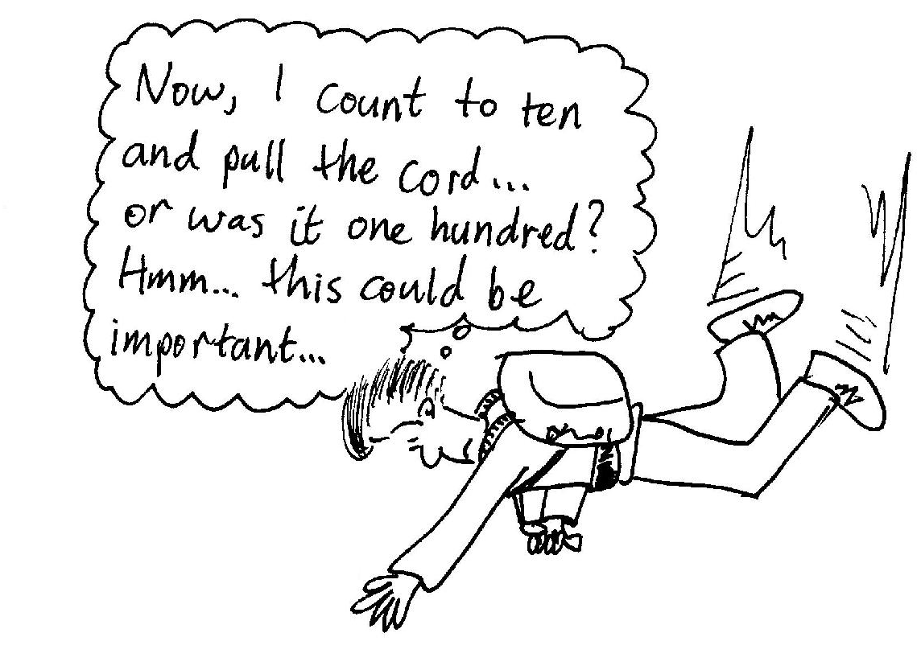
- What factors affect the value of b, the coefficient of drag?
- What happens to the value of b when he opens his parachute?
- Draw a sketch of the skydiver’s velocity as a function of time.
- Draw a sketch of the skydiver’s acceleration as a function of time.

B. Activity Questions:

- Accelerometer
Pull the accelerometer at a constant speed. What does it show? Why?
Now accelerate it forwards. What do you observe?
Allow the accelerometer to roll freely on a rough surface, for example the carpet. What does it show as it slows down?

- Pendulum
Watch the pendulum swinging back and forth.
Sketch plots of the bob’s position, velocity and acceleration with time.
Can you have a zero velocity but a non-zero acceleration?

- Acceleration due to gravity
Throw the ball straight up into the air, and catch it when it comes back down again.
Sketch the acceleration as a function of time.
Sketch the ball’s velocity and displacement with time.
Describe what happens in terms of the velocity and acceleration of the ball.

C. Quantitative Questions:

- Over the 2000 Christmas holiday period the NSW road toll was greater than that for all other states and territories combined, and was for 2001 more than double the toll for any other state. This has prompted calls from the community for the government to “do something about it”. One recent initiative has been to lower the speed limit in residential streets from 60 km.h⁻¹ to 50 km.h⁻¹, however getting motorists to obey the limits is an ongoing problem.
Your car will accelerate from 0 to 100 km.h⁻¹ in 12 seconds.
- Assuming a uniform acceleration, how long does it take you to reach 50 km.h⁻¹?
- How long does it take you to reach 60 km.h⁻¹?
- What distance do you travel in these times for accelerating to each speed limit?
- How much longer does it take to travel a distance of 5 km at the reduced speed limit compared to the previous limit, starting from rest and using maximum acceleration, without exceeding the speed limit?

- A student throws a ball with a speed of 15.0 m.s⁻¹ at an angle of 40.0° above the horizontal directly toward a wall as shown below. The wall is 10.0 m from the release point of the ball.
- How long is the ball in the air before it hits the wall?
- How far above the release point does the ball hit the wall?
- What are the horizontal and vertical components of its velocity as it hits the wall?
- When it hits, has it passed the highest point on its trajectory?

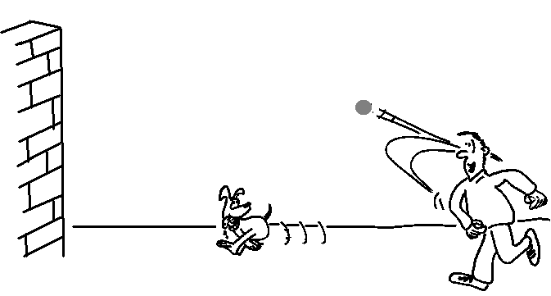
40º
10 m

Workshop Tutorials for Physics
Solutions to MR1: Motion

A. Qualitative Questions:

- If you throw a ball up with vertical velocity v, it will rise until all its kinetic energy, ½ mv² is converted to gravitational potential energy, it will then fall, and that gravitational potential energy will be converted back into kinetic energy. Ignoring any work done on the ball by air resistance, it will have a velocity v when it reaches the same height from which it was thrown. From here it will continue to descend and accelerate at g, the same as if it was thrown down with a velocity v. Hence both balls will have the same velocity when they reach the ground. (Although the one thrown down will reach the ground first.)

- A skydiver’s acceleration is given by a = g – bv² where g is the acceleration due to gravity, v is his velocity
v
v_{term. c}
v_{term. o}
t
open chute
and b is a constant (the co-efficient of drag). When he has reached terminal velocity the acceleration is zero,
a = g – bv² = 0.
- Factors which affect the value of b include the cross sectional area of the skydiver and parachute and the material on the surface pushing against the air.  - When he opens his parachute he greatly increases the value of b by increasing the cross sectional area.  - See opposite. The diver’s velocity increases with his parachute closed until he reaches terminal velocity, v_{term c}, when g – bv² = 0 and bv² = g. When he opens the parachute he slows down until he reaches a new lower terminal velocity, v_{term c}.  - The skydiver’s acceleration is the derivative of the velocity, dv/dt. It decreases to zero as the air resistance increases. When the parachute is opened the air resistance increases to greater than the gravitational force, and the acceleration is upwards, decreasing to zero again as the new terminal velocity is reached. | a  t  open chute  g

B. Activity Questions:
velocity
(slowing down)
acceleration
constant v
accelerating
- Accelerometer
The surface of the fluid in the accelerometer should be fairly flat and horizontal if you pull it smoothly at constant speed, as shown opposite. This shows that, when it is moving at constant speed, there is no net force on the fluid; it looks just as it would if it were standing still (if you ignore any bumps and vibrations).
When you accelerate the accelerometer forwards the fluid’s surface will make an angle to the horizontal. The direction of the slope of the fluid shows you the direction of the acceleration. The fluid surface is at an angle because the net force on the fluid is no longer zero. The fluid collects at the back of the accelerometer when it accelerates.

If you push the accelerometer and let go, it will slow down and eventually stop. The slope of the fluid ‘points’ towards the back, showing that the acceleration is in the opposite direction to the velocity of the accelerometer when it is slowing down.
t
x
t
t
v
a
- Pendulum
See diagrams opposite. The displacement is sinusoidal, x = Asin(ωt). The velocity is zero when x is a maximum. The acceleration goes like –x.
You can have a zero velocity but a non-zero acceleration. At the top of the pendulum’s swing, just as it reverses direction, the bob’s acceleration is greatest (which means the velocity is changing at the greatest rate), yet at that instant the velocity itself is zero.

- Acceleration due to gravity
t
x
t
v
t
a
g
The ball slows as it climbs until it reaches its peak, then speeds up as it falls. The acceleration of the ball is constant once it leaves your hand, and is due to gravity only. See diagrams opposite.

C. Quantitative Questions:
- Your car will accelerate from 0 to 100 km.h⁻¹ in 12 seconds, which is 0 m.s⁻¹ to 28 m.s⁻¹ in 12s.
- Assuming a uniform acceleration, the acceleration is a = dv/dt = (28 m.s⁻¹ – 0 m.s⁻¹) / 12 s = 2.3 m.s⁻². 50 km.h⁻¹ = 14 m.s⁻¹, to find the time taken to reach this speed we use v = v₀ + at, rearranged to give
t = (v - v₀)/a = (14 m.s⁻¹ - 0 m.s⁻¹)/2.3 m.s⁻² = 6.1 s.
- To reach 60 km.h⁻¹ (= 17 m.s⁻¹) takes t = (v - v₀)/a = (17 m.s⁻¹ - 0 m.s⁻¹)/2.3 m.s⁻² = 7.2 s
- The distance traveled in the time taken to reach the new speed limit is
x = v_{o}t + ½ at² = 0 + ½ × 2.3 m.s⁻² × (6.1 s)² = 43 m.
The distance traveled in the time taken to reach the old speed limit is
x = v_{o}t + ½ at² = 0 + ½ × 2.3 m.s⁻² × (7.2 s)² = 60 m.
- At the new speed limit it takes 6.1 s to travel the first 43 m, leaving 5000 m – 43 m = 4957 m to go.
This will take t = x / v = 4957 m / 14 m.s⁻¹ = 354 s, add the initial 6.1 s, giving 360 s or 6 minutes.
At the old speed limit it takes 7.2 s to travel the first 60 m, leaving 5000 m – 60 m = 4940 m to go.
This will take t = x / v = 4940 m / 17 m.s⁻¹ = 291 s, add the initial 7.2 s, giving 298 s or 5 minutes.
It takes only one extra minute for this short trip, at a speed with a much shorter stopping distance.
θ
v_{y}
v_{x}
v₀
x
- The ball’s velocity has horizontal and vertical components which can be treated independently.
The horizontal component of the initial velocity is v_{x} = v_{o} cosθ. There is no acceleration in the horizontal direction, so this is the horizontal velocity of the ball for its entire flight. The vertical component of the initial velocity is v_{y} = v_{o} sinθ, and in the vertical direction the ball has a constant acceleration due to gravity. Hence at any time v_{y} = v_{o} sinθ - gt.
- The ball is x = 10 m away from the wall to begin with. The time taken for the ball to reach the wall is
t = x/v = x/ (v_{o} cosθ) = 10 m / (15 m.s⁻¹ cos 40º) = 0.87 s.
- The vertical position of the ball at any time is y = (v_{o} sinθ)t – ½ gt².
The ball reaches the wall at time t = 0.87 s, hence it hits at a height
y = (v_{o} sinθ)t – ½ gt² = (15 m.s⁻¹ sin 40º) × 0.87 s – ½ × 9.8 m.s⁻² × (0.87 s)² = 4.7 m.
This is the height above the height at which the ball was released.
- As the ball hits the wall the horizontal component of its velocity is still (v_{o} cosθ) = 11.5 m.s⁻¹.
The vertical component is v_{y} = v_{o} sinθ - gt = (15 m.s⁻¹ sin 40º)– (9.8 m.s⁻² × 0.87 s) = 1.1 m.s⁻¹.
Note that this is positive so the ball is going upwards. The total velocity is v = (v_{y}² + v_{x}²)^{1/2} = 12 m.s⁻¹.
- The ball cannot have passed the highest point of its trajectory as it is still going upwards.
Workshop Tutorials for Physics
MR2: Using Vectors

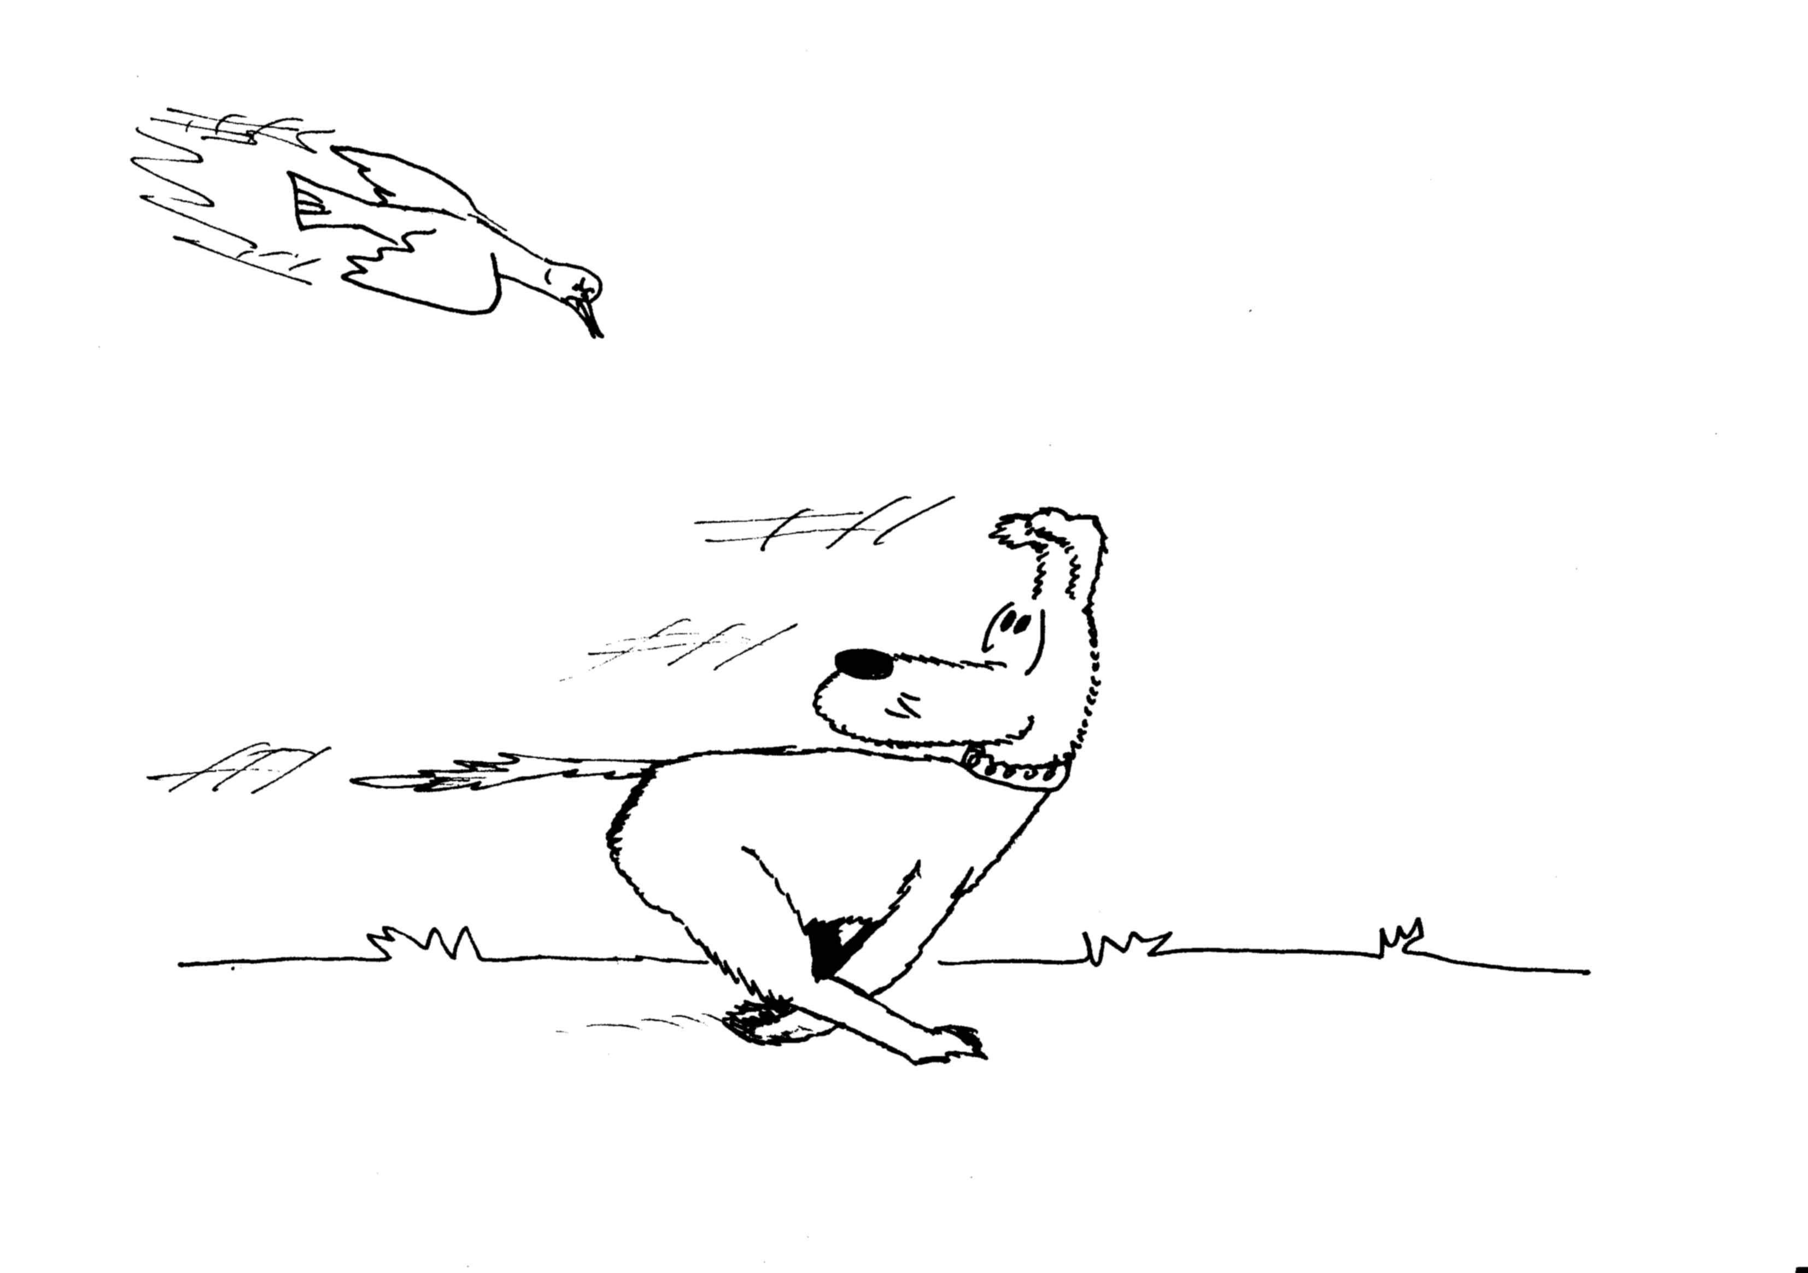
A. Qualitative Questions:

1. Barry the dog is running around the yard chasing birds, which he never catches.
- Can the magnitude of Barry’s displacement be less than the distance he has traveled?
- Can the displacement be more than the distance traveled?
Barry comes to rest in the yard, some distance from where he started.
- Can any component of his displacement vector be greater than the magnitude of the vector itself?
- How could a component have the same magnitude as the magnitude of his displacement vector?

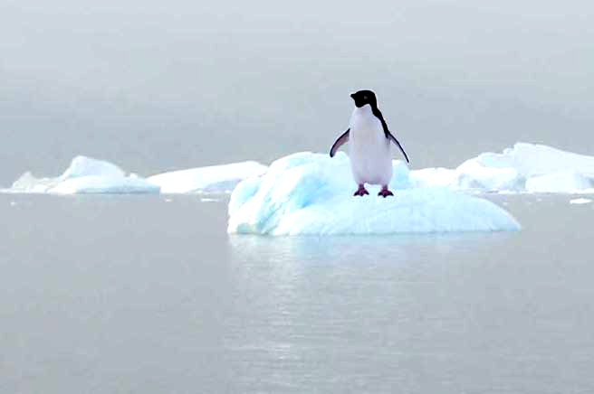
2. A penguin is floating on an iceberg. The iceberg drifts slowly towards the shore and bounces off at a gentle angle.
- Draw the path of the penguin.
- Draw the velocity vector of the penguin before the collision with the shore.
- Draw the velocity vector of the penguin after the collision with the shore.
- Draw the acceleration vector of the penguin during the collision.
- How would this acceleration vector look if the collision had been a head on one, with the iceberg (and penguin) bouncing back at 180º?

B. Activity Questions:

- Battleship
Describe how vectors are used to give positions in this game.
How else could you describe the position of a ship?

- Map
How are vectors used on the maps?
You should be able to find at least two examples.

- Vector Game
Appoint one group member to be a caller. Everyone else chooses a starting position and walks the vectors as called. When you get it wrong, you’re out!

- Mirrors and reflections
Look at your reflection in the mirror.
Move your right hand to the right. What does your reflection do?
Why is it that left and right are reversed in the mirror, but not up and down?

C. Quantitative Questions:

- A magpie has a position vector given by $\vec{R}$= 5t$\hat{i}$+(14 -7t+ t²)$\hat{j}$ where the unit vector $\hat{j}$ is in the vertical direction, upwards positive.
- Find the magpie’s instantaneous velocity as a function of time. Draw a sketch of the velocity vector at several times.
- Find the instantaneous acceleration as a function of time. Sketch the acceleration at several times.
- Describe the path of the bird, using a diagram. What do you think it might be doing?

- Brent is taking Rebecca for a ride in his new boat. They’re planing to go across from Cairns to one of the small islands of the Great Barrier Reef. Brent is very proud of his new boat, especially the autonavigation feature. He shows Rebecca how he can program in the coordinates. “I just punch in 6 km east and 2 km north, and we’ll be there in no time!”
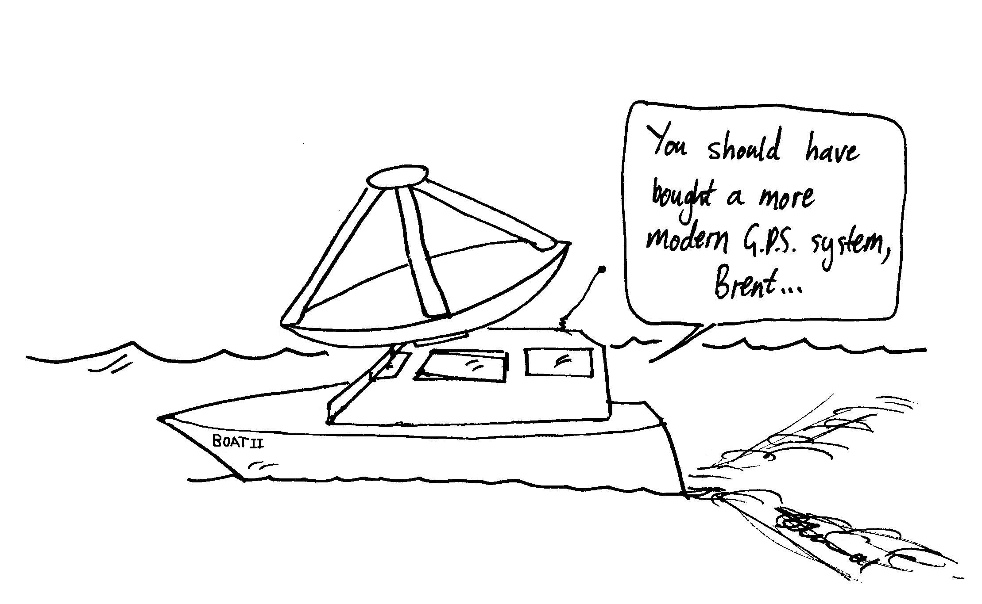
An hour and a half later the navigator beeps to say they are about to arrive. Rebecca looks around and sees the island due south of them.
“Okay, I’ll just reverse the instructions and we’ll go back to Cairns and start again” says Brent.
Another hour and a half later they end up 12km north of where they started.
“Did you allow for the current?” asks Rebecca.
- Draw a diagram showing their path.
- What is the velocity of the current?
- What is the magnitude and direction of the velocity of the boat relative to the water for the first hour and a half?
- What is the magnitude and direction of the velocity of the boat relative to the island for the first hour and a half?

Workshop Tutorials for Physics
Solutions to MR2: Using Vectors

A. Qualitative Questions:

1. Barry is running around the yard chasing birds.
- Barry’s displacement can be less than the distance he has traveled. Imagine if Barry ran backwards and forwards across the yard twice and finished back in the same place. His displacement (the vector quantity representing the difference between the initial and final position) would be zero but he would have run a fair distance.
- The displacement can never be more than the distance traveled. To travel from one point in space to another, the minimum distance Barry can travel is the straight line joining the two points. He can never travel less distance than that.
Barry comes to rest in the yard, some distance from where he started.
- No component of his displacement vector can be greater than the magnitude of the vector itself. Components are defined in two directions at right angles to each other. Hence the displacement is the hypotenuse of a right angle triangle. The hypotenuse will be greater than either of the two sides.
- If the directions of the components were taken such that one was in the same direction as the displacement then one component would have the same magnitude as the displacement vector and the other would be zero.

2. A penguin floating on an iceberg drifts slowly towards the shore and bounces off at a gentle angle.
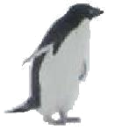
Shore
a.
b, c, d.
v_{i}
v_{f}
a = v_{f} - v_{i}
-v_{i}
v
a
e.
v_{i}
v_{f}
v_{f}
v_{i}
a

B. Activity Questions:

- Battleship
Battleship and similar games use vectors to determine the position of a ship. The vectors are usually written in terms of letter and number axes, rather than x, y axes, but are otherwise identical to vectors used in physics and mathematics. One way of describing the position of a pin is to give the lengths of perpendicular components, for example horizontal (numbers) and vertical (letters). Another way is to give the length of the vector and its angle to the horizontal. For example a pin at position C4 is also 5 units from the origin on a line 49º above the horizontal.

- Maps
Vectors are used to define positions on the maps via a letter/number grid. Most maps will also show a vector pointing north to define compass directions on the map.

- Vector Game
The axes are chosen in advance and marked, so you know which direction is +x and which direction is +y. For example, forward may be +x and right may be +y. If the caller says “5x + 3y” you take 5 steps forwards and three steps to the right. If the caller says “-5x - 3y” you take five steps back and three steps left.

- Mirrors and reflections
In your reflection left and right seem to be reversed, but not up and down. This is because of the way we define left and right as relative to ourselves, not our surroundings. For example, “towards the wall” and “away from the wall” are not reversed, just as up and down are not reversed. Up and down are defined externally, usually relative to the ground. It is important to know how your coordinate systems are defined, and whether they change as you move!
v_{t<3.5 s}
v _{t =3.5 s}
v _{t >3.5 s}
a ₁
v_{f}
a ₂
v_{f}
a ₃
v_{f}
C. Quantitative Questions:
- A magpie has a position vector given by $\vec{R}$ = 5t. $\hat{i}$+(14 -7t+ t²)$\hat{j}$.
- The instantaneous velocity is found by taking the derivative of $\vec{R}$, $\vec{v}$ = d$\vec{R}$/dt =5.$\hat{i}$+( -7+ 2t)$\hat{j}$.

This is a constant velocity in the horizontal or $\hat{i}$direction, and a steadily increasing vertical velocity. The vertical component is initially negative and increases over time, becoming positive for times t > 3.5 s. See diagram opposite.
- The instantaneous acceleration is found by taking the derivative of $\vec{v}$, $\vec{a}$= d$\vec{v}$/dt =2t$\hat{j}$. This is always upwards and increasing.
- The bird has constant velocity horizontally, and is coming down and then going up again. The bird may be swooping after prey. See plot opposite.

- Brent is taking Rebecca for a ride in his new boat. He shows Rebecca how he can program in the coordinates. “I just punch in 6 km east and 2 km north, and we’ll be there in no time!”
An hour and a half later the navigator beeps to say they are about to arrive. Rebecca looks around and sees the island due south of them.
N
E
Island
12km
6 km
8 km
53º
10 km
6 km
2 km
18º
6.3 km
relative to the water:
relative to the island:
- The current takes them north of the island on the way out and takes them further north on the way back. See diagram opposite.
- They are a total of 12 km north over the whole trip which takes 3 hours. The velocity of the current is thus 4 km.h⁻¹ due north.
- The velocity of the boat relative to the water (ie ignoring the current) is
v = x/ t =${\sqrt{(2 \text{km})^{2}+(6 \text{km})^{2}}}/1\text{.}5 h$ =${\sqrt{\text{40} {\text{km}}^{2}}}/1\text{.}5 h$
v = 4.2 km.h⁻¹.
It is in a direction θ = tan⁻¹(2 km /6 km) = 18.4º north of east.
- The boat travels 6 km east and (2 km +6 km) north relative to the island. Remember Brent punches in 6 km east and 2 km north and an extra 6 km north is provided by the current. This journey takes 1.5 h.
Total displacement = $\sqrt{(6 \text{km})^{2}+(8 \text{km})^{2}}$ = 10 km.
v = 10 km /1.5 h = 6.7 km.h⁻¹.
The direction of v is θ  = tan⁻¹(8 km /6 km) = 53.1º north of east

Workshop Tutorials for Biological and Environmental Physics
MR3B: Newton’s Laws I

A. Qualitative Questions:

- When high jumpers or pole vaulters land they have a mattress or other soft surface to land on, so that they are not injured.
- How does the mattress prevent injury? Explain your answer in terms of acceleration and forces.
- Draw a sketch of a high jumper just before he lands, as he starts to sink in to the mattress and when he has come to rest. Show the direction of motion at each position.
- Draw arrows representing the direction and magnitudes of all the forces acting on the high jumper at each position.
- Sketch a graph of the high jumper’s acceleration over time as he lands.
- Sketch a graph of the magnitude of the normal (contact) force acting on the high jumper over time.

- Which of the following pairs are action-reaction pairs, and which are not? Explain your answers.
- The Earth attracts a brick, the brick attracts the Earth.
- A donkey pulls forward on a cart, accelerating it; the cart pulls backwards on the donkey.  - A donkey pulls forward on a cart without moving it, the cart pulls back on the donkey.  - A donkey pulls forward on a cart without moving it, the Earth exerts and equal and opposite force on the cart.  - The Earth pulls down on the cart; the ground pushes up on the cart with an equal and opposite force. | 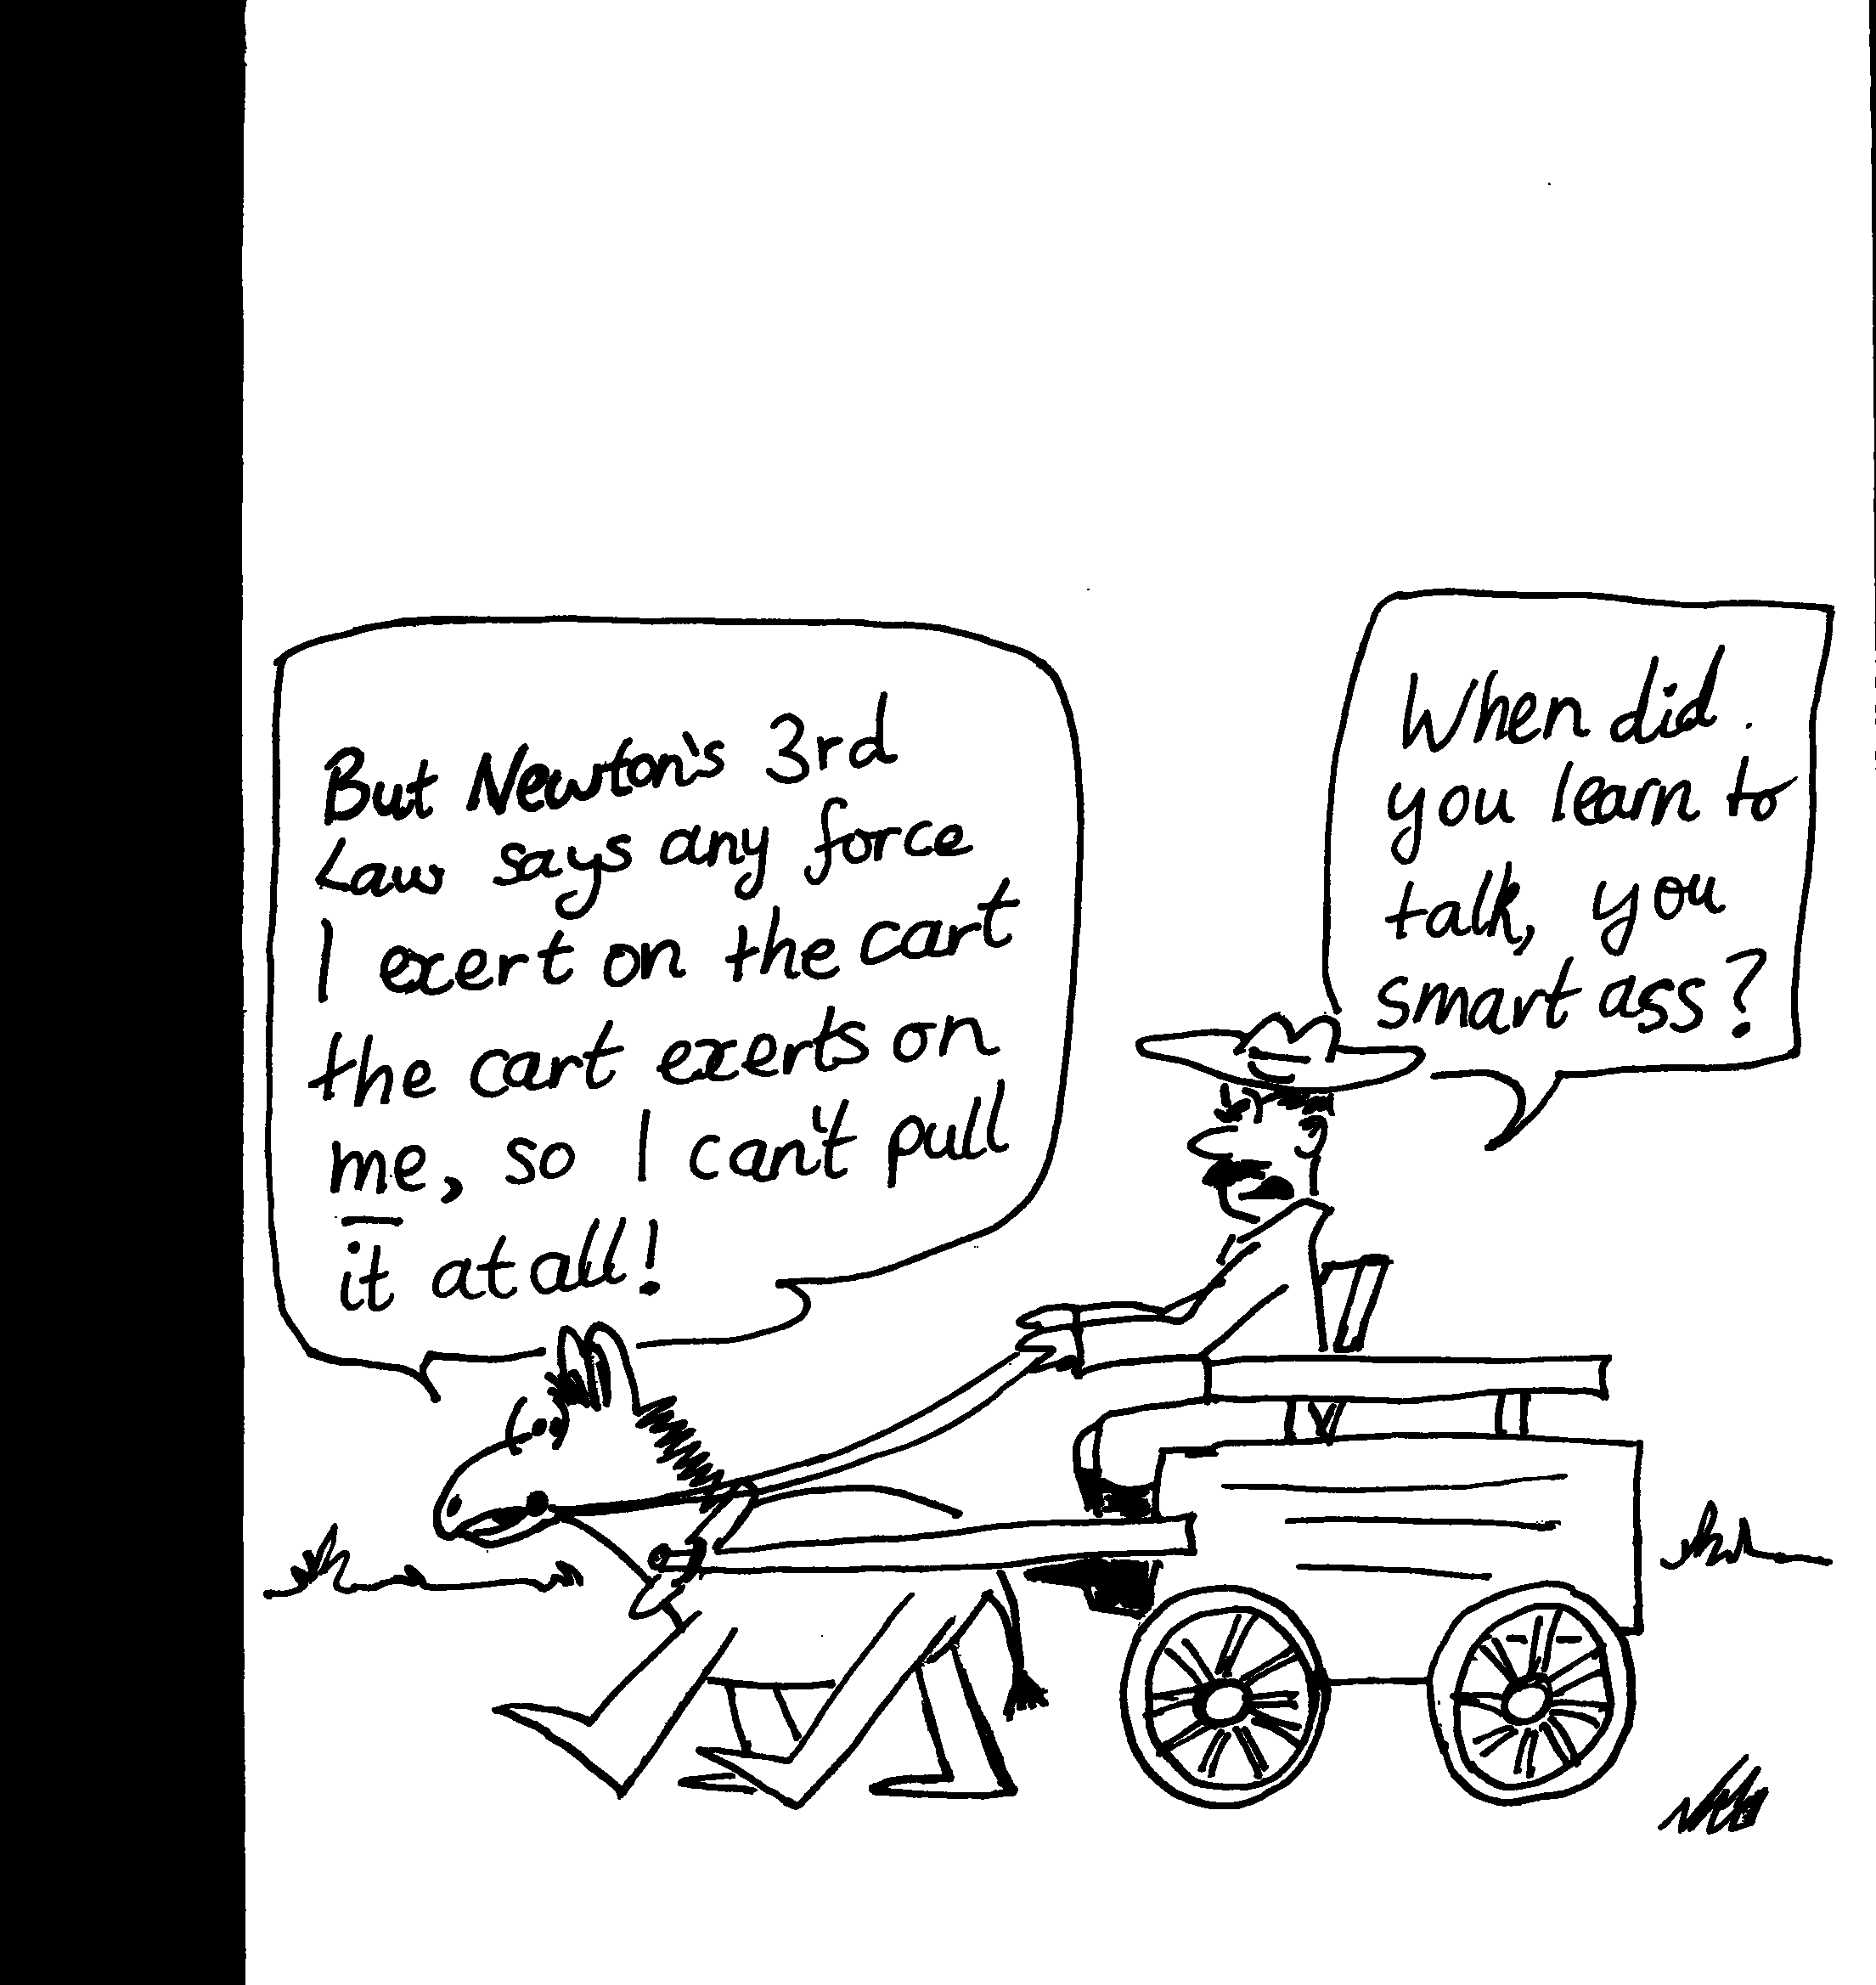

B. Activity Questions:

- Smooth variable ramp
Draw a free body diagram for the trolley.
What are the components of the forces acting parallel and perpendicular to the ramp?
Is the force on the trolley from the spring balance equal to mgsinθ? Comment on your answer.
What happens to the force needed to keep the trolley stationary as the inclination of the ramp is increased?

- Constant velocity
Pull the trolley along a flat surface with the spring balance.
What does the spring balance indicate?
Set the ramp so that the trolley rolls down freely.
Pull the trolley up the ramp with constant velocity. This is not easy and may take several attempts.
What is the reading on the spring balance now? Is it what you expect it to be?
Is this reading different to that when pulling the trolley on a flat surface with constant velocity?

- Constant acceleration
Set the ramp so that the trolley rolls down freely.
When the trolley is released at the top it accelerates down the ramp. What net force is acting to accelerate the trolley?
Is the trolley in equilibrium?

- Newton’s Cradle (2 balls)
Swing one ball out and release it.
Draw a diagram showing the forces acting on the balls when they collide.
Is there an action-reaction pair here? If so, what is it?

C. Quantitative Question:

- The Earth has a mass of 6.0 × 10²⁴ kg and orbits the sun, which has a mass of 2.0 × 10³⁰ kg at a mean distance of 150 × 10⁶ km. The gravitational force acting on any mass m due to another mass M is given by
F = $\frac{\text{GmM}}{r^{2}}$ where r is the distance between the two masses and G is a constant, G = 6.67 × 10⁻¹¹ N/m².kg⁻².
- Which, if either, is greater: the gravitational force of the sun on the Earth, or the Earth on the sun? Explain your answer.
- Calculate the gravitational force exerted on the Earth by the sun.
- Calculate the gravitational force exerted on the sun by the Earth.
- What is the acceleration of the Earth due to this force? In what direction is this acceleration?
- What is the acceleration of the Sun due to this force? In what direction is this acceleration?
The electrostatic force (also called a Coulomb force) acting between two charged objects has a very similar mathematical form to the gravitational force. The force is proportional to the product of the two charges and is inversely proportional to the square of the distance separating them.
- A helium atom has a positively charged nucleus (q_{nucleus} = +2e) with two negatively charged electrons (q = -e) orbiting it. What is the ratio of the electric force acting on one of the electrons due to the nucleus to the force acting on the nucleus due to one of the electrons?

- Orthopaedic surgeons use traction, as shown, to ensure appropriate forces on bones and muscles during the healing process. A block, W, of weight 100 N is held on a light flexible cord which passes around low friction pulleys P1, P2, P3. P1 is movable and is attached to the foot.
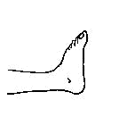
P2 and P3 are fixed and are attached to a rigid frame (not shown). The magnitude of the force exerted by the contraption on the foot is 50 N.
θ
θ
- What is the tension in the cord? Does it vary through the length of the cord?  - Calculate the angle θ when the force of 50 N is applied.  - What other force (not shown) would be required to prevent the patient being pulled out of bed?  - How would the tension in the cord change if real-life pulleys with friction are considered? What effect would this have on the forces on the foot? | P1  P2  P3  W

Workshop Tutorials for Biological and Environmental Physics
Solutions to MR3B: Newton’s Laws I

A. Qualitative Questions:

- When high jumpers or pole-vaulters land they have a mattress or other soft surface to land on, so that they are not injured.
- The forces acting on the high jumpers or pole-vaulters from contact with the ground can cause injury. Using a mattress increases the time of contact and so for a given change in velocity the deceleration is less. The magnitude of the contact force, F_{C}, will be reduced thus reducing the chance of injury.
- and c, see diagrams below. Initially the only force is gravity, acting down. Once the jumper touches the mattress it accelerates her upwards, providing a force, greater than gravity to slow her down. As he slows, this force decreases until there is no net force acting and she is stationary, having come to a rest on the mattress.
F_{g}
F_{c}
F_{c} >F_{g}
F_{c}
F_{g}
F_{c} =F_{g}
F_{g}
F_{g} only

t
a
free fall
slowed by mattress
stopped
F_{g}
F_{c}
d. and e, see graph opposite.
Note that the acceleration is proportional to the net force, F_{g} + F_{c.}

- An action - reaction force pair is of the form F_{AB} and F_{BA} where F_{AB} is the force due to B acting on A, and F_{AB} = - F_{BA}.
- Brick-Earth pair: This is an action-reaction pair, the forces are equal and opposite and act on different objects.
- Donkey and cart - this is an action reaction pair.
- Donkey and cart - this is an action reaction pair.
- Donkey, cart, the Earth- there are three objects so this is not an action reaction force pair.
- Earth, cart; the ground – again there are three objects, and both forces are acting on the cart, so this cannot be an action-reaction pair.
mg sin θ
mg sin θ
θ
N
mg cos θ
mg
θ
N
pull of spring

B. Activity Questions:

Smooth variable ramp
With no friction the force needed to keep the trolley on the ramp is a component of the weight: mgsinθ. The spring balance may read a little less than this as friction is also acting to prevent the trolley rolling down due to gravity.
As the angle of inclination, θ, is increased the force needed to hold the trolley increases, reaching a maximum of mg when θ = 90º.

Constant velocity
To pull a trolley up a ramp at constant speed we need to apply a constant force of mgsinθ so that the net force is zero (ignoring friction). N balances the component of mg perpendicular to N, which is mgcosθ, so the pull must be equal to the component of gravity mgsinθ. On a flat surface the net force acting to give a constant velocity is zero. Hence at constant velocity the spring balance will read close to zero. On a flat surface we need just enough force to oppose frictional forces. There is always some friction, the force required to pull the trolley at constant velocity will be equal to the frictional force acting it.

Constant acceleration
When the trolley accelerates down the ramp it is not in equilibrium. The unbalanced force is the component of gravity parallel to the ramp
F_{AB}
F_{BA}
T
T
mg
mg

Newton’s Cradle (2 balls.)
When one ball is held out and released it swings back, hitting the second ball and causing it to swing out. The action-reaction pair is the force of ball A on ball B and the force of ball B on ball A, F_{AB} and F_{BA}.

C. Quantitative Question:
- The gravitational force acting on any mass m due to another mass M is given by F = $\frac{\text{GmM}}{r^{2}}$.
- The gravitational force of the sun on the Earth is equal to the Earth on the sun, as both are equal to $\frac{\text{GmM}}{r^{2}}$, where m is the mass of the Earth and M is the mass of the sun. This is what we would expect from Newton’s third law.
- The gravitational force exerted on the Earth by the sun is
F = $\frac{\text{GmM}}{r^{2}}$ = $\frac{6\text{.}\text{67}×{\text{10}}^{−\text{11}}N\text{.}m^{−2}{\text{kg}}^{−2}×6\text{.}0×{\text{10}}^{\text{24}}\text{kg}×2\text{.}0×{\text{10}}^{\text{30}}\text{kg}}{(\text{150}×{\text{10}}^{9}m)^{2}}$ = 3.6 × 10²² N.
- The gravitational force exerted on the sun by the Earth is exactly the same, 3.6 × 10²² N.
- Using Newton’s second law, the acceleration of the Earth is
a = F/m = 3.6 × 10²² N / 6.0 × 10²⁴ kg = 5.9 × 10⁻³ m.s⁻², towards the sun as this is an attractive force.
- The acceleration of the Sun is a = F/m =3.6 × 10²² N/2.0 × 10³⁰ kg =1.8 × 10⁻⁸ m.s⁻², towards Earth.
- A helium atom has a positively charged nucleus (q_{nucleus} = +2e) with two negatively charged electrons (q = -e) orbiting it. The ratio of the magnitude of electric force acting on one of the electrons due to the nucleus to the force acting on the nucleus due to one of the electrons is one, the force on the electron is exactly equal but opposite in sign to the force on the nucleus.
50 N
100 N
θ
θ
P1
P2
P3
W
50 N

2. Traction.
- T, the tension in the light flexible cord, is the same everywhere. If a weight of 100 N is hanging off the pulley P3 then the tension in this part of the cord is 100 N. And the tension of 100 N is maintained throughout the cord.
- The force exerted by the contraption on the foot is 5O N. The foot exerts 50 N on the contraption via P1. This has to be balanced by the horizontal component shown by the arrows. To maintain equilibrium: 50 N = T cos θ + Tcos θ
50 N = 100 N cosθ + 100 N cosθ and θ = 76°

- 50N to the left on pulley P1 as shown in diagram. This is provided by the friction between the patient and the bed.
- In equilibrium (static) friction is irrelevant. If the system is not in equilibrium the tension will increase or decrease depending on the direction of motion.
Workshop Tutorials for Technological and Applied Physics
MR3T: Newton’s Laws I

A. Qualitative Questions:

1. Which of the following pairs are action-reaction pairs, and which are not? Explain your answers.
- The Earth attracts a brick, the brick attracts the Earth.
- A donkey pulls forward on a cart, accelerating it; the cart pulls backwards on the donkey.
- A donkey pulls forward on a cart without moving it, the cart pulls back on the donkey.
- A donkey pulls forward on a cart without moving it, the Earth exerts an equal and opposite force on the cart.
- The Earth pulls down on the cart; the ground pushes up on the cart with an equal and opposite force.
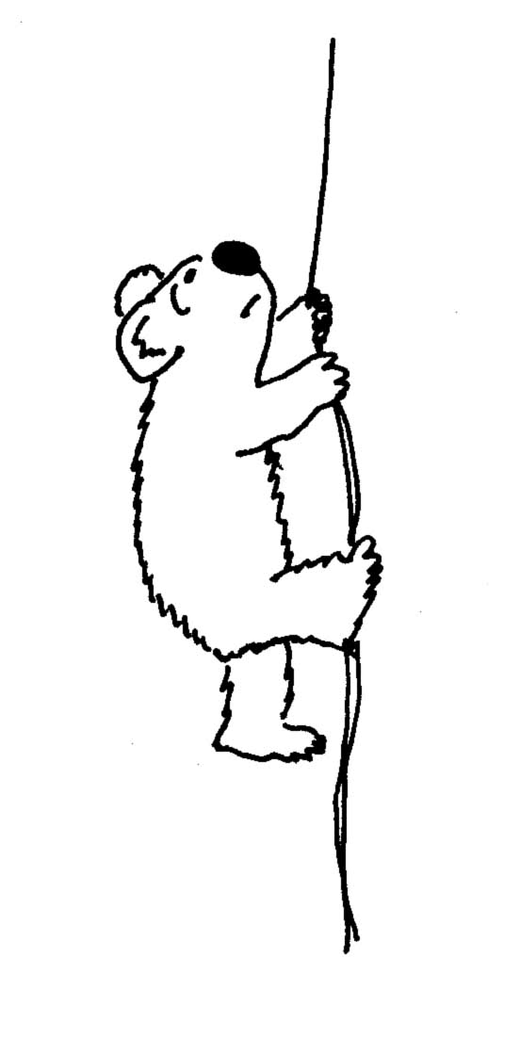

- A 10 kg koala has a firm hold on a light rope that passes over a frictionless pulley and is attached to a 10 kg bunch of gum leaves. The koala looks upwards, sees the gum leaves, and starts to climb the rope to get them.
- Draw a free-body diagram for the situation when the koala is stationary and one for when the koala is starting to climb the rope.
- As the koala climbs, do the gum leaves move up, move down or remain at rest?
- As the koala climbs, does the distance between the koala and the gum leaves decrease, increase or remain constant?
- The koala releases her hold on the rope. What happens to the distance between the koala and the gum leaves as she is falling.
- Before reaching the ground, the koala grabs the rope to stop her fall. Discuss what happens to the koala and gum leaves

B. Activity Questions:

- Smooth variable ramp
Draw a free body diagram for the trolley.
What are the components of the forces acting parallel and perpendicular to the ramp?
Is the force on the trolley from the spring balance equal to mgsinθ? Comment on your answer.
What happens to the force needed to keep the trolley stationary as the inclination of the ramp is increased?

- Constant velocity
Pull the trolley along a flat surface with the spring balance.
What does the spring balance indicate?
Set the ramp so that the trolley rolls down freely.
Pull the trolley up the ramp with constant velocity. This is not easy and may take several attempts.
What is the reading on the spring balance now? Is it what you expect it to be?
Is this reading different to that when pulling the trolley on a flat surface with constant velocity?

- Constant acceleration
Set the ramp so that the trolley rolls down freely.
When the trolley is released at the top it accelerates down the ramp. What net force is acting to accelerate the trolley?
Is the trolley in equilibrium?

- Newton’s Cradle (2 balls)
Swing one ball out and release it.
Draw a diagram showing the forces acting on the balls as they collide.
Is there an action-reaction pair here? If so, what is it?

C. Quantitative Questions:

- The Earth has a mass of 6.0 × 10²⁴ kg and orbits the sun, which has a mass of 2.0 × 10³⁰ kg at a mean distance of 150 × 10⁶ km. The gravitational force acting on any mass m due to another mass M is given by
F = $\frac{\text{GmM}}{r^{2}}$ where r is the distance between the masses and G is a constant, G = 6.67 × 10⁻¹¹ N.m⁻².kg⁻².
- Which, if either, is greater: the gravitational force of the sun on the Earth, or the Earth on the sun? Explain your answer.
- Calculate the gravitational force exerted on the Earth by the sun.
- Calculate the gravitational force exerted on the sun by the Earth.
- What is the acceleration of the Earth due to this force? In what direction is this acceleration?
- What is the acceleration of the Sun due to this force? In what direction is this acceleration?
The electrostatic force (also called a Coulomb force) acting between two charged objects has a very similar mathematical form to the gravitational force. The force is proportional to the product of the two charges and is inversely proportional to the square of the distance separating them.
- A helium atom has a positively charged nucleus (q_{nucleus} = +2e) with two negatively charged electrons (q = -e) orbiting it. What is the ratio of the electric force acting on one of the electrons due to the nucleus to the force acting on the nucleus due to one of the electrons?

- Brent and Rebecca are trying to push their piano across a room with polished floor boards. They are standing at adjacent corners and both pushing as hard as they can.
Rebecca pushes with a force F_{R}= (200$\hat{i}$ + 150$\hat{j}$) N and Brent pushes with force F_{B}= (300$\hat{i}$ - 300$\hat{j}$) N.
- What is the total force on the piano?
- If the piano has a mass of 200 kg what is its acceleration?
- What is the magnitude of the force on the piano?
Unbeknownst to Brent and Rebecca there is a box of books sitting against the opposite side of the piano. If the piano and books combined only accelerate at 2.1 m.s⁻²
- What is the mass of the box of books?
- What is the force of the piano on the box of books?
- What is the force of the box of books on the piano?
Workshop Tutorials for Technological and Applied Physics
Solutions to MR3T: Newton’s Laws I

A. Qualitative Questions:

1. An action reaction force pair is of the form F_{AB} and F_{BA} where F_{AB} is the force due to B acting on A, and F_{AB} = - F_{BA}.
- Brick-Earth pair: This is an action-reaction pair, the forces are equal and opposite and act on different objects.
- Donkey and cart - this is an action-reaction pair.
- Donkey and cart - this is an action-reaction pair.
- Donkey, cart, the Earth- there are three objects so this is not an action-reaction force pair.
- Earth, cart; the ground – again there are three objects, and both forces are acting on the cart, so this cannot be an action-reaction pair.
T
T
W_{leaves}
W_{koala}
T
T
W_{leaves}
W_{koala}

- Koala climbing for gum leaves.
- See diagrams opposite.
- If the koala is not climbing then the system is in equilibrium. As the koala climbs, the gum leaves move upwards. The koala exerts a downward force on the rope, increasing the tension. This provides an unbalanced upward force on the gum leaves, causing them to move up.
- The tension in the rope is the same all along the rope (between the koala and gum leaves). As the koala accelerates up the rope, the tension in the rope increases (available length decreases) providing the same unbalanced upward forces on both the koala and gum leaves. Thus both move up the same distance. Distance between koala and gum leaves remains unchanged.
- Assuming a frictionless pulley and rope of negligible mass, then both the koalas and gum leaves are "free-falling". Assuming that drag forces are negligible, free fall is independent of mass and is described by the 3 equations for uniformly accelerated motion. Thus both the koala and gum leaves will cover the same distances in the same times. The distance between the koala and gum leaves has not changed.
- When the koala grabs the rope to stop her fall the gum leaves stop falling too. When the koala grabs the rope one of several things can happen. For example, if we assume an un-stretchable rope, the tension in the rope momentarily becomes extremely large and decelerates the koala and gum leaves. It appears as if the gum leaves and koala stop instantaneously. If the rope is stretchable the koala and gum leaves may oscillate. In either case the koala is still the same distance away from the gum leaves.

mg sin θ
mg sin θ
θ
N
mg cos θ
mg
θ
N
pull of spring
B. Activity Questions:

A variable ramp
With no friction the force needed to keep the trolley on the ramp is a component of the weight: mgsinθ. The spring balance may read a little less than this as friction is also acting to prevent the trolley rolling down due to gravity.
As the angle of inclination, θ, is increased the force needed to hold the trolley increases, reaching a maximum of mg when θ = 90º.

Constant velocity
To pull a trolley up a ramp at constant speed we need to apply a constant force of mgsinθ so that the net force is zero (ignoring friction). N balances the component of mg perpendicular to N, which is mgcosθ, so the pull must be equal to the component of gravity mgsinθ. On a flat surface the net force acting to give a constant velocity is zero. Hence at constant velocity the spring balance will read close to zero. On a flat surface we need just enough force to oppose frictional forces. There is always some friction, the force required to pull the trolley at constant velocity will be equal to the frictional force acting it.

Constant acceleration
When the trolley accelerates down the ramp it is not in equilibrium. The unbalanced force is the component of gravity parallel to the ramp.
F_{AB}
F_{BA}
T
T
mg
mg

Newton’s Cradle (2 balls.)
When one ball is held out and released it swings back, hitting the second ball and causing it to swing out. The action reaction pair is the force of all A on ball B and the force of ball B on ball A, F_{AB} and F_{BA}.

C. Quantitative Questions:
- The gravitational force acting on any mass m due to another mass M is given by F = $\frac{\text{GmM}}{r^{2}}$.
- The gravitational force of the sun on the Earth is equal to the Earth on the sun, as both are equal to $\frac{\text{GmM}}{r^{2}}$, where m is the mass of the Earth and M is the mass of the sun. This is what we would expect from Newton’s third law.
- The gravitational force exerted on the Earth by the sun is
F = $\frac{\text{GmM}}{r^{2}}$ = $\frac{6\text{.}\text{67}×{\text{10}}^{−\text{11}}N\text{.}m^{−2}{\text{kg}}^{−2}×6\text{.}0×{\text{10}}^{\text{24}}\text{kg}×2\text{.}0×{\text{10}}^{\text{30}}\text{kg}}{(\text{150}×{\text{10}}^{9}m)^{2}}$ = 3.6 × 10²² N.
- The gravitational force exerted on the sun by the Earth is exactly the same, 3.6 × 10²² N.
- Using Newton’s second law, the acceleration of the Earth is
a = F/m = 3.6 × 10²² N / 6.0 × 10²⁴ kg = 5.9 × 10⁻³ m.s⁻², towards the sun as this is an attractive force.
- The acceleration of the Sun is a = F/m =3.6 × 10²² N/2.0 × 10³⁰ kg =1.8 × 10⁻⁸ m.s⁻², towards Earth.
- A helium atom has a positively charged nucleus (q_{nucleus} = +2e) with two negatively charged electrons (q = -e) orbiting it. The ratio of the magnitude of electric force acting on one of the electrons due to the nucleus to the force acting on the nucleus due to one of the electrons is one, the force on the electron is exactly equal but opposite in sign to the force on the nucleus.

- Rebecca pushes with a force F_{R}= (200$\hat{i}$ + 150$\hat{j}$) N and Brent pushes with force F_{B}= (300$\hat{i}$ - 300$\hat{j}$) N.
- The total force on the piano is:
F_{T} = F_{R} + F_{R} = (200$\hat{i}$ + 150$\hat{j}$) N + (300$\hat{i}$ - 300$\hat{j}$) N = (500$\hat{i}$ – 150$\hat{j}$)N
- The acceleration can be found using F_{T} = ma, rearrange to:
a = F_{T}/m = (500i – 150j) N /150 kg = (3.3$\hat{i}$ – 1.0$\hat{j}$) m.s⁻²
- The magnitude of the force on the piano is |F_{T}| = (500² + 150²)^{1/2} N = 520 N.
The magnitude of the acceleration will therefore be |a| = 522 N / 200 kg = 2.6 m.s⁻².
- If the force applied is 520 N and the acceleration is 2.1 m.s⁻² then the total mass is
m = F/a =520 N/ 2.1 m.s⁻² = 247 kg.
The piano has a mass of 200 kg, so the books must have a mass of 47 kg.
- The force of the piano on the box of books is the force that accelerates the books, hence
F = ma = 2.1 m.s⁻² × 47 kg = 99 N.
- The force of the box of books on the piano must also be 99 N as this is the reaction pair to the force of the piano on the books.

Workshop Tutorials for Biological and Environmental Physics
MR4B: Newton’s Laws II – Frictional Forces

A. Qualitative Questions:

- We often think of the frictional force as an annoyance - something that wastes energy and needs to be overcome to get things moving. In fact without friction, we wouldn’t even be able to walk around!
- Explain why this is the case.
- Draw a diagram showing the forces acting on a foot as it steps off the ground and steps back down again. Show the direction of the frictional force in both cases.
- What would happen if there was no friction between your feet and the ground? Use your diagrams to help explain your answer.
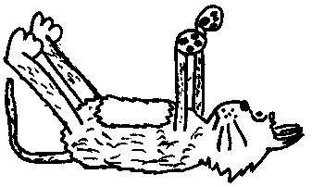
- In New York city cat’s fall out of apartment windows at a rate of around one per day. Many of these cat’s fall from windows several floors up. A New York vet did a study on the injuries the cat’s suffered and how they depended on the height from which the cat fell. It turned out that cats falling from more than seven floors up had fewer and less severe injuries than cats falling from lower down. There are two important things that happen here. One is that cats need a second or so to turn around so that they can land on their feet. The other is that they reach terminal velocity within a few floors.
- What is terminal velocity, and what happens when a cat reaches it?
- Describe what happens to the gravitational potential energy of the cat/Earth system as the cat falls. Sketch a graph showing the different forms of energy as a function of time as the cat falls. Mark on your graph the time at which the cat reaches terminal velocity.
- If air resistance didn’t increase with increasing speed, would cats ever reach a terminal velocity? Draw a diagram showing the forces acting on the cat before and after it reaches terminal velocity. The relative sizes of the arrows representing the forces should indicate the relative magnitude of the forces.

B. Activity Questions:

- Shoes
Examine the shoes on display.
When would you use these types of shoe?
Why do they have different soles?

- Boxes on a Trolley
Several boxes of the same size, shape and material are packed so that they have different weights. These are placed on a stationary trolley.
If the trolley is accelerated, which, if any, box will you expect to slip off the trolley first? Why?
Do the masses of the boxes affect the falling and slipping in the situations described above?

- Block on a rough variable ramp
For a particular angle, is the force needed to keep a block stationary on the ramp larger, smaller or the same for a rough surfaced ramp in comparison to a smooth surfaced ramp. Why?
Draw a free body diagram for the block.
Adjust the angle of inclination and note when the box begins to slide.
How will this angle be different for a smooth ramp?

- Falling objects and terminal velocity
Hold a piece of paper horizontally and drop it. What happens?
What happens if you hold it vertically and then drop it?
Now crumple a piece of paper up into a ball and drop it.
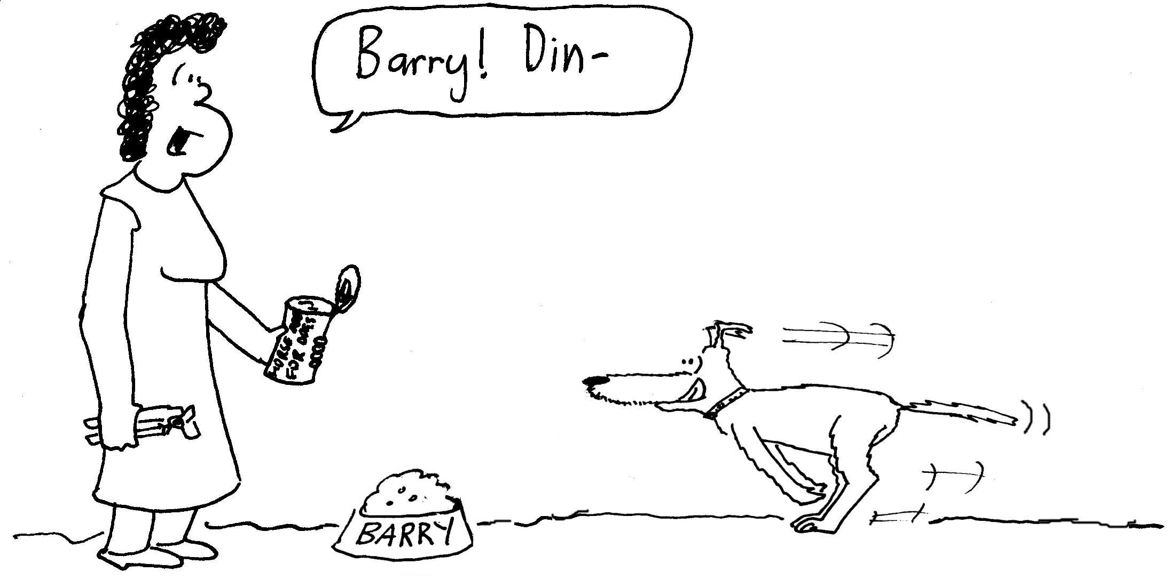
Explain your observations.

C. Quantitative Question:

- Rebecca calls Barry the dog to have his dinner. If the coefficient of friction between Barry’s feet and the floor is 0.76, what is the maximum acceleration he can achieve?

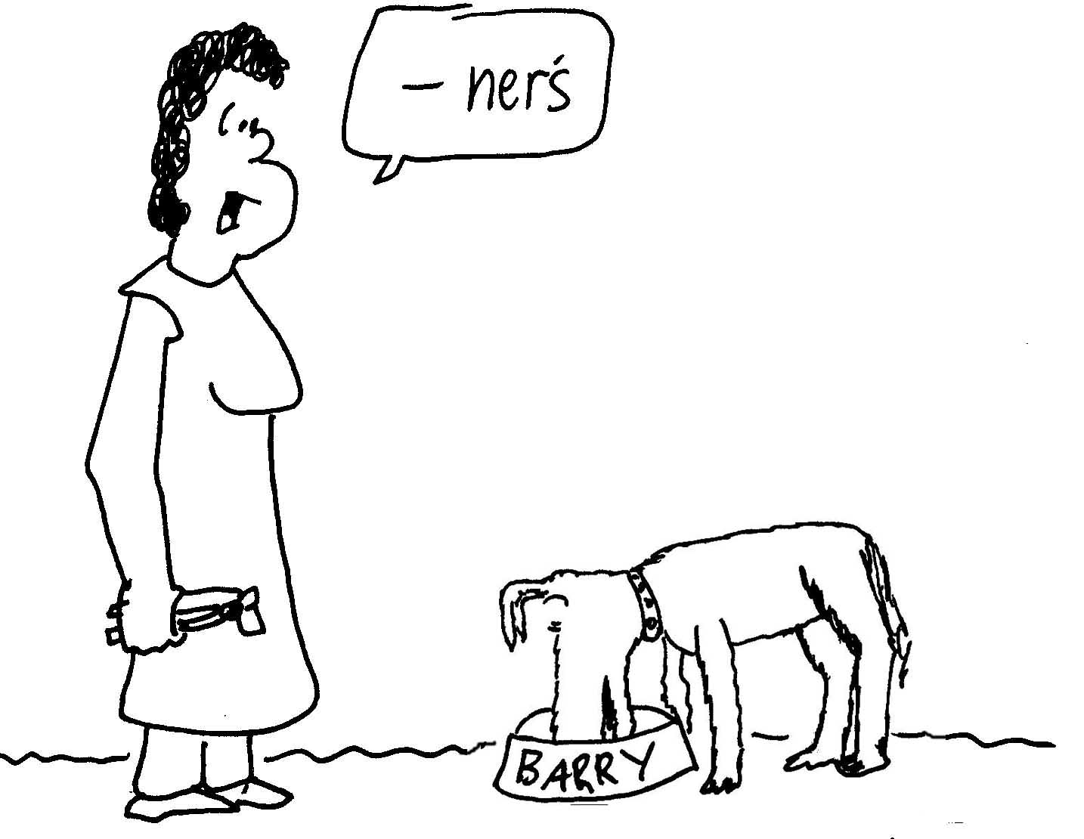
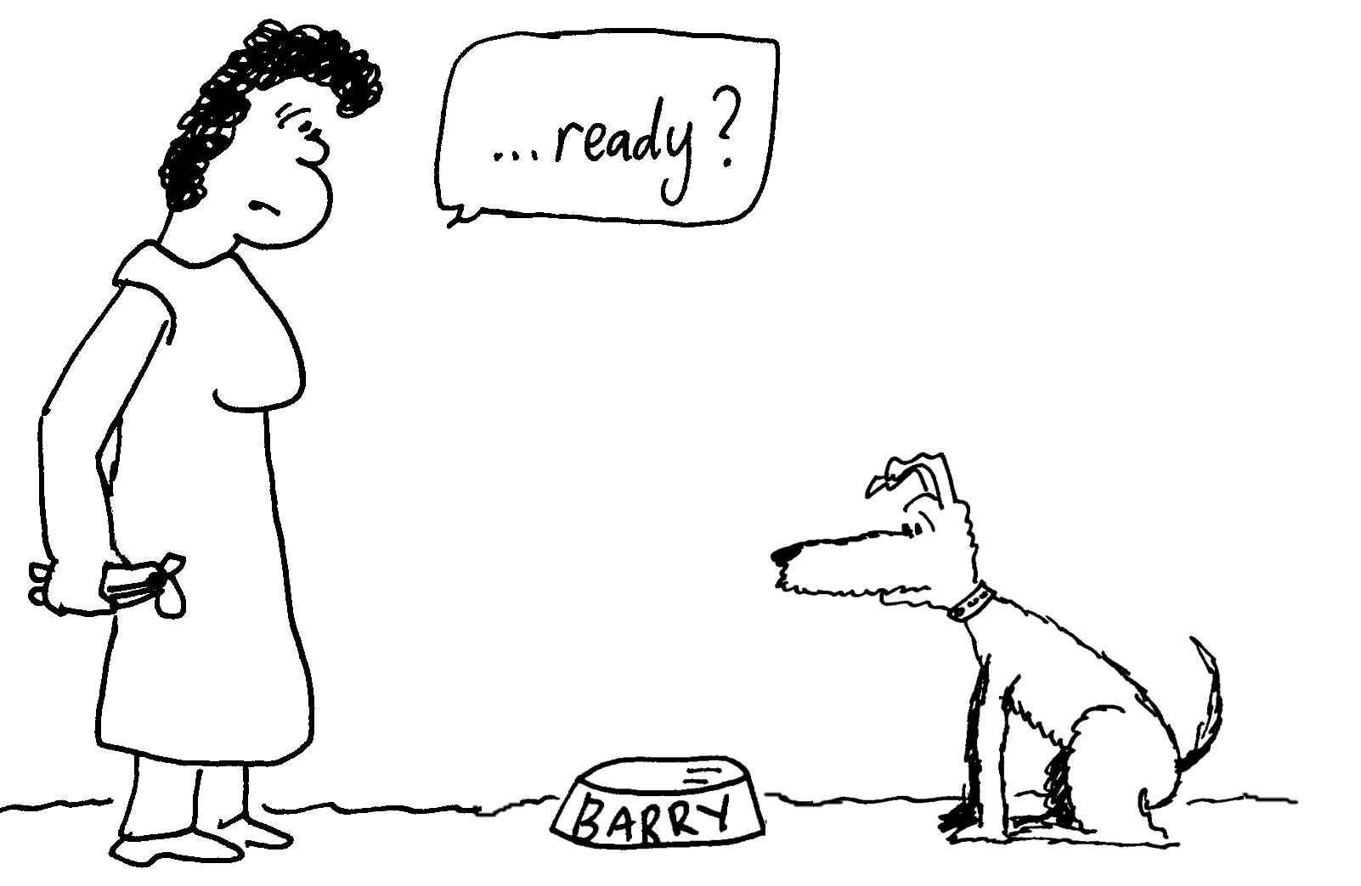

- Landslides can occur when the frictional force between rocks or dirt on a hill side and the ground beneath is no longer enough to hold them in place. Consider the diagram opposite. Weathering can cause cracks in rocks. The section of rock shown is held place by the frictional force between it and the hillside beneath. Water fills the crack and when it freezes overnight it expands and exerts a force on the rock, pushing it down along the slope. The angle between the hillside and the horizontal is 25º, and the coefficient of static friction between the rock and hill is 0.65. The coefficient of kinetic friction between the rock and hill is 0.45, and the rock has a mass of 2000 kg. | rock  25º  ice
- Draw a diagram showing all the forces acting on the rock.
- What force parallel to the hillside must the expanding water exert to move the rock?
- If it exerts this force, such that the rock begins to slide, at what rate will it accelerate down the hill?
- If there is a road 10 m down hill from the rock, what will be the velocity of the rock when it reaches the road?

Workshop Tutorials for Biological and Environmental Physics
Solutions to MR4B: Newton’s Laws II – Frictional Forces

A. Qualitative Questions:

- Without friction, we wouldn’t even be able to walk around!
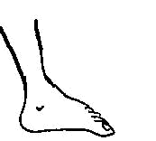
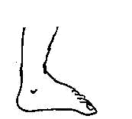
- When we walk on the ground we use our muscles to push down and back on the ground. The ground then pushes back on us (Newton’s third law – for every force there is a reaction force) and this propels us forward.
F_{GF}
F_{FG}
friction
F_{GF}
F_{FG}
friction
- See diagram opposite. When stepping off the ground we exert a force, F_{FG}, on the ground with our foot, directed down and back. There is a reaction force from the ground, F_{GF}, which has a component due to friction which prevents the foot sliding backwards on the surface. This force is mostly exerted around the front of the foot. When the foot comes down again it exerts a downwards and forwards force on the ground, the ground exerts an upwards and backwards force on the foot. | foot comes up  foot goes down
- If there was no friction (as on ice or an oily patch on concrete pavement), then we could not apply a backward-directed push to the ground – our foot would just slide over it. Hence the ground would not be able to push us forward.

- Falling cats reach terminal velocity within a few floors.
- Terminal velocity is the name given to the constant velocity which occurs when a falling body has no nett force acting on it. This is the situation when the drag force upwards equals the gravitational force downwards. Thus the falling cat will be falling vertically at constant speed and zero acceleration.
- The gravitational potential energy (PE) decreases as the cat falls closer to earth. The cat accelerates gaining kinetic energy (KE). If the cat is moving at terminal speed then the decrease in gravitational potential energy will appear as an increase in thermal energy (TE) in the atmosphere due to the drag (frictional ) forces. See graph opposite.  Energy  time  v_{terminal}  impact  PE  KE  TE  - See diagrams opposite. Initially the gravitational or weight force on the cat, mg, is greater than the frictional force, F_{f}, due to air resistance. The net force is downwards so the cat accelerates downwards. When the cat reaches terminal velocity the air resistance is equal to the gravitational force and the cat no longer accelerates but falls at a constant (terminal) velocity. This would not happen if air resistance did not increase with velocity. | 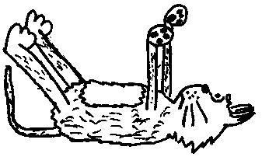  mg  F_{f}  mg  F_{f}

B. Activity Questions:

- Shoes
Shoes with spiked soles, such as football boots are designed to help grip soft slippery surfaces, for example a muddy playing field. Sneakers and running shoes are also designed to grip, but do not have spikes as they are generally used on hard surfaces which are not as slippery as mud. Dancing shoes usually have smooth soles that the wear can slide a bit, but not too much. Dancers often put talc on their shoes (as weight lifters do on their hands) to give themselves a bit more grip.

- Boxes on a trolley  All boxes slip off together. If the trolley is accelerated forwards the boxes slip backwards, and if it is decelerated the boxes slip forwards. The rougher the surfaces, the harder it is for slipping to occur, i.e. slipping occurs at a greater acceleration. The acceleration of the truck and μ, the coefficient of friction between the trolley and the box, determine if the box slips or not. The mass of the boxes don't affect their slipping. | mg  N  F_{fric}  a  slides off this way if not enough friction
N = mgcosθ
mgsinθ
F_{fric}
θ
mgcosθ
- Block on a rough variable ramp
Consider forces up and down the inclined plane. Just before slipping the forces up the ramp (frictional forces ) must be equal to the forces down the ramp (component of weight ), so
F_{fric} = μmgcosθ = mgsinθ and μ=tanθ
If the F_{f} is greater (a rough surface), the angle for slipping is larger. A smoother ramp gives a smaller angle for slipping.

- Falling objects and terminal velocity
Air resistance varies with the surface area pushing against the air. A flat sheet of paper held out flat and dropped has a large area in the direction of movement and hence falls slowly and tends to glide around on the way. Sheet of paper dropped vertically falls much faster as it experiences less air resistance. A crumpled sheet falls at an intermediate rate. Note that in the absence of air they would all fall and accelerate at the same rate.

C. Quantitative Questions:

- Rebecca calls Barry the dog to have dinner. The coefficient of friction between Barry’s feet and the floor is 0.76, so the frictional force, F_{fric} = μN.
If Barry does not push down on the ground then the normal force will just equal his weight, W = mg.
By Newton’s Second Law:
ΣF_{x} = ma_{x}, so a_{x} = ΣF_{x} / m = μmg / m = μg = 0.76 × 9.8m.s⁻² = 7.5 m.s⁻².
N
F_{ice}
F_{friction}
mg

- Landslides can occur when the frictional force between rocks or dirt on a hill side and the ground beneath is no longer enough to hold them in place. Water fills the crack and when it freezes overnight it expands and exerts a force on the rock, pushing it away down the slope.
- See diagram opposite.
- Consider the forces parallel to the hillside, these are the static frictional force, F_{friction} = μ_{s}mgcosθ, the force of the ice, F_{ice} and the component of the gravitational force along the slop, mg_{parallel} = mgsinθ.

The net parallel force at equilibrium is F_{net} = mg_{parallel} - F_{friction} - F_{ice} = 0
thus μ_{s}mgcosθ = mgsinθ + F_{ice}. If μ_{s}mgcosθ < mgsinθ + F_{ice} the rock will begin to slide. For this to occur
F_{ice} > μ_{s}mgcosθ - mgsinθ = 0.65 × 2000 kg × 9.8 m.s⁻² × cos 25º - 2000 kg × 9.8 m.s⁻² × sin 25º =3.3 kN
- Once the rock starts to slide the frictional force will be a kinetic frictional force. Assume the ice is no longer in contact with the rock. For forces parallel to the slope ΣF_{parallel} = ma_{parallel}.
so a_{parallel}. = (-μmgcosθ + mgsinθ)/m = -0.45 × 9.8 m.s⁻² cos 25º + 9.8 m.s⁻² × sin 25º = 0.15 m.s⁻².
- We can use the kinematics equation v²=v_{o}² +2as to find the velocity at the road:
v²=v_{o}² +2as = (0 m.s⁻¹)² + 2 × 0.15 m.s⁻² × 10 m = 3.0 m².s⁻².
Thus v = (3.0 m².s⁻² )^{1/2} = 1.7ms⁻¹, parallel to the slope and downwards.
This is a bit faster than walking pace, 1.7 m.s⁻¹ ~ 6 km.h⁻¹.
Workshop Tutorials for Technological and Applied Physics
MR4T: Newton’s Laws II – Frictional Forces

A. Qualitative Questions:

- When you’re driving a car at constant speed all the petrol or gas you’re burning is being used just to overcome frictional forces, such as air resistance and friction in the drive train of the car. However friction is also necessary to drive the car at all.
- Explain why you need friction to start the car moving.
- Why do tyres grip the road better on level ground than they do when going uphill or downhill? Use diagrams to explain your answer.
ABS (anti-skid braking) is an important safety feature on modern cars which stops the tyres from skidding when braking. A car can roll to a halt sooner than it will skid to halt.
- What does this tell you about the relative sizes of the coefficients of static and kinetic friction between a road and tyres?

- A passenger sitting in the rear of a bus claims that he was injured when the driver slammed on the brakes causing a suitcase to come flying toward the passenger from the front of the bus.

Is this possible? Explain your answer.

B. Activity Questions:

- Shoes
Examine the shoes on display.
When would you use these types of shoe?
Why do they have different soles?

- Boxes on a Trolley
Several boxes of the same size, shape and material are packed so that they have different weights. These are placed on a stationary trolley.
If the trolley is accelerated, which, if any, box will you expect to slip off the trolley first? Why?
Do the masses of the boxes affect the falling and slipping in the situations described above?

- Block on a rough variable ramp
For a particular angle, is the force needed to keep a block stationary on the ramp larger, smaller or the same for a rough surfaced ramp in comparison to a smooth surfaced ramp. Why?
Draw a free body diagram for the block.
Adjust the angle of inclination and note when the box begins to slide.
How will this angle be different for a smooth ramp?

- Falling objects and terminal velocity
Hold a piece of paper horizontally and drop it. What happens?
What happens if you hold it vertically and then drop it?
Now crumple a piece of paper up into a ball and drop it.
Explain your observations.

C. Quantitative Questions:

- A box is placed on the back of a truck and the truck accelerates away (in first gear). The coefficient of friction between the surface of the truck and the box is μ.
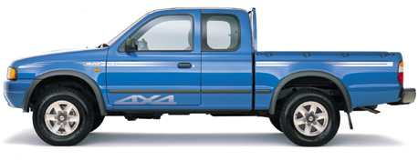

- Identify each force, including frictional force, acting on the box as the truck accelerates.
- Draw a free body diagram showing the forces acting on the box.
- What is the direction of acceleration of the box?
- What is the direction of the net force acting on the box?
- Under what conditions would the box not move with the truck?
- What is the maximum acceleration of the truck before the box starts to slide?
The truck is moving at 10 m.s⁻¹ when it hits a tree and suddenly comes to halt. The box slides 1.2 m before stopping.
- What is the coefficient of kinetic friction between the box and the tray of the truck?

- Around areas where road works are being done you may see piles of gravel. Very large piles of gravel can often be seen along the Princes Highway between Sydney and Melbourne where new lanes are being constructed or the road is being resurfaced. If the piles are made too tall the gravel tends to slide down. Consider a conical pile which has a base with radius r, where the coefficient of friction between the bits of gravel is μ = 0.4. If the width of the area available for this pile is 20 m, so that the radius cannot exceed 10 m, to what maximum height can the gravel be piled?

Workshop Tutorials for Technological and Applied Physics
Solutions to MR4T: Newton’s Laws II – Frictional Forces

A. Qualitative Questions:

- When you’re driving a car at constant speed all the petrol or gas you’re burning is being used just to overcome frictional forces, such as air resistance and friction in the drive train of the car. However friction is also necessary to drive the car at all.
- For the car to move an external unbalanced force needs to be present. This external force comes from the road acting on the tyres as they are driven to rotate by the engine. If there was no friction between the road and the tyres then the tyres would slip round and there would be no forward force on the car from the road - think about a car on ice or bogged in mud.
- The frictional force is given by the coefficient of friction times the normal force. The normal force is always less when the car is on a slope and so therefore the frictional force is less.
- If the car takes longer to come to a halt then the acceleration will be less. The acceleration will depend on the coefficient of friction. If friction is the only force acting in the horizontal direction then a_{x} = μN/m = μg. Thus the coefficient of kinetic friction will be less since the time to come to a halt is longer when the car is sliding.
constant velocity
braking
constant velocity
braking
2. The case will only go backwards if the bus is accelerating forwards. A suitcase cannot fly backwards if the bus is moving forwards at constant speed or braking. If there is not enough friction to slow the case along with the bus then as the bus slows the case will continue to move forwards. At constant speed there is no net force on the bus or case, and the case will not move relative to the bus. Hence the passengers claim cannot be true if the bus was going forwards and braking.
A suitcase may fly towards the rear if a reversing bus decelerates. When the driver slams on the brakes the suitcase will continue to move backward, unless the force of friction between the case and the bus is enough to accelerate it along with the bus.

B. Activity Questions:

- Shoes
Shoes with spiked soles, such as football boots are designed to help grip soft slippery surfaces, for example a muddy playing field. Sneakers and running shoes are also designed to grip, but do not have spikes as they are generally used on hard surfaces which are not as slippery as mud. Dancing shoes usually have smooth soles that the wear can slide a bit, but not too much. Dancers often put talc on their shoes (as weight lifters do on their hands) to give themselves a bit more grip.

- Boxes on a trolley  All boxes slip off together. If the trolley is accelerated forwards the boxes slip backwards, and if it is decelerated the boxes slip forwards. The rougher the surfaces, the harder it is for slipping to occur, i.e. slipping occurs at a greater acceleration. The acceleration of the truck and μ, the coefficient of friction between the trolley and the box, determine if the box slips or not. The mass of the boxes don't affect their slipping. | mg  N  F_{fric}  a  slides off this way if not enough friction

- Block on a rough variable ramp
N = mgcosθ
mgsinθ
F_{fric}
θ
mgcosθ
Consider forces up and down the inclined plane. Just before slipping the forces up the ramp (frictional forces ) must be equal to the forces down the ramp (component of weight ), so
F_{fric} = μmgcosθ = mgsinθ and μ=tanθ
If the F_{f} is greater (a rough surface), the angle for slipping is larger. A smoother ramp gives a smaller angle for slipping.

- Falling objects and terminal velocity
Air resistance varies with the surface area pushing against the air. A flat sheet of paper held out flat and dropped has a large area in the direction of movement and hence falls slowly and tends to glide around on the way. Sheet of paper dropped vertically falls much faster as it experiences less air resistance. A crumpled sheet falls at an intermediate rate. Note that in the absence of air they would all fall and accelerate at the same rate.

C. Quantitative Questions:
direction of
motion
mg
N
F_{fric}
F_{fric}
v= 10 m.s⁻¹
v= 0
x= 2 m
1. Box on a truck.
- The forces acting on the system (the box) are the weight force, mg, the normal force, N, and the frictional force of the truck’s tray on the box.
- See diagram opposite.
- The acceleration is in the direction of the net force, to the left.
- The net force must be in the direction of acceleration, which is to the left, if the box is to move off with the truck.
- Friction is the force which causes the box to accelerate with the truck. If there was not enough friction between the box and the tray of the truck, the box would not accelerate as much as the truck and the truck would move out from beneath it and the box would fall off the back of the truck.
- In the vertical direction: mg = -N or mg + N = 0.
In the horizontal direction: F_{fric} = net force = ma.
Using F_{fric} = μN = ma, the maximum acceleration is
a_{max} = μN / m = μmg / m = μg.
- The box moves 2 m, while accelerating from 10 m.s⁻¹ to 0 m.s⁻¹. The acceleration can be found using v² = v_{o}² + 2ax.
Rearranging: a = ½ (v² - v_{o}²)/x = ½ (0-(10 m.s⁻¹)²)/ 1.2 m = 42 m.s⁻²
The net force is F = ma = μ_{k}mg. Rearranging for μ gives μ_{k} = a/g = 42 m.s⁻² / 9.8 m.s⁻² = 4.3

Consider a conical pile of gravel which has a base with radius r, where the coefficient of friction between the bits of gravel is μ = 0.4. The width of the area available for this pile is 20 m, so that the radius cannot exceed 10 m. For the pile of gravel to be stable then the sum of forces acting on each stone must be zero.
Model the forces acting on a stone on the edge of the pile as shown opposite.  To find the maximum height we need to find the angle the side forms with the base, since tanθ = height / radius = h/r, so h = r tanθ  Resolving perpendicular to the plane ΣF_{perp} = mg cos θ - N = 0, i.e. N = mg cos θ.  Resolving along the plane, ΣF_{para} = mgsinθ - μN = 0.  mgsinθ - μ mg cosθ = 0, i.e. μ = tanθ, so then h = rμ = 10 m × 0.4 = 4 m. | mg  F_{fric}  N  θ
This is the condition for a piece of gravel which is just on the point of sliding. At greater angles the gravel will slide and at smaller angles the static frictional force will match the component of gravity along the slope.
Workshop Tutorials for Biological and Environmental Physics
MR5B: Work, Power and Energy

A. Qualitative Questions:
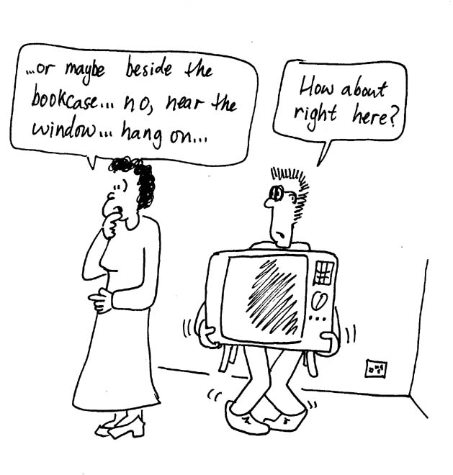
- Rebecca has asked Brent to move the television from one side of the room to the other. Brent grumbles that he’s been working all day and wants to relax a bit, to which Rebecca replies that as the TV will start at rest, end at rest and not change height, she’s not actually asking him to do any work! Is the total work done on the TV to move it really zero? Does Brent have to do any work to move it?

- The force of gravity holds the Earth in its orbit around the sun and the moon in its orbit around the Earth, giving them an acceleration at all times as they orbit.
What work is done by these forces? Explain your answer.

B. Activity Questions:

1. Pendulum
Draw a diagram showing the forces acting on the pendulum as it swings.
What forces are doing work?

2. Falling
What energy changes occur when you drop an object?
What work is being done, and on what?
What force or forces are doing the work?

3. Power
Look at the labels on the back of the appliances.
What power do they use? At what rate do they turn electrical energy into other forms of energy?
What energy conversions are taking place when these appliances are working?

C. Quantitative Questions:

- Ant nests often have a circular pile of dirt or sand around their entrances where the dirt from the tunnels has been placed. In the process of digging a tunnel a worker ant is carrying a grain of sand weighing 1.0 μg out of the nest to add to the pile. When he reaches the nest entrance the ant drops the sand and pushes it, at constant velocity, up the slope surrounding the nest entrance. This slope makes an angle of 40º to the horizontal and is 5 cm long. The coefficient of friction between the slope and the sand is 0.97.

What force is exerted by the ant as he pushes the sand?
How much work is done on the sand by the ant as he pushes it to the top of the pile?
How much work is done by the weight of the sand?
How much work is done by friction?
What is the total work done on the sand? Can you explain your answer?

- Many insects and even some small birds are capable of hovering apparently motionless in the air. In fact if you took a film of a hovering insect and slowed it down enough you’d be able to see that the insect actually is constantly moving up and down slightly. To stay hovering they have to beat their wings up and down, with the wings angled differently on the up and down stroke. On the down stroke the wing is angled so it pushes down flat on the air, and on the up stroke it angles the wing.
  - Explain how this allows the insect to push itself up with the down stroke but not pull itself down on the upstroke. What are the action-reaction forces?
A bee has a mass of around 0.1 g and is hovering in front of a flower, so that it drops no more than 1 mm in each upstroke. It beats its wings with a frequency of 200 Hz, or 200 times every second.
  - How much work must the bee wings do during the down stroke to maintain its average position?
  - What is the work done by the bee’s wings on the bee during the upstroke??
  - What power must the bee generate to continue hovering?
Wings push down, bee goes up.
Lowest position, start down-stroke.
Highest position, start up-stroke.
Wings go up, bee falls down.
Workshop Tutorials for Biological and Environmental Physics
Solutions to MR5B: Work, Power and Energy

A. Qualitative Questions:

- The total work done on the TV really is zero. It starts with no kinetic energy and ends with no kinetic energy. However this does not mean that Brent does no work on the TV. He must accelerate it to move it, and increase its potential energy, doing work against gravity, if he lifts it. This energy comes from chemical potential energy stored in Brent. When he decelerates the TV and puts it down he must absorb the energy he has put in. However this energy is not converted back to chemical potential energy, but is lost as heat. In addition, if Brent slides the TV then the energy he has put in to accelerate it and give it kinetic energy will be dissipated as heat due to friction by the floor and TV. So while the energy of the TV has not changed, and no work has been done on it, Brent must do work to move it.

- No net work is done on a body in uniform circular motion. The net force (or centripetal force) is always directed in towards the centre of the circle, and is at right angles to the direction of travel. Hence the work W = F.d = Fdcosθ = 0, because the force, F, is perpendicular to the direction of the displacement, d. Using energy considerations we come to the same conclusion – neither potential energy nor the kinetic energy of the body is changing, hence no work can be being done on the body.
The Earth does not follow a circular path, however over a complete orbit there is still no net work done. The Earth travels in an elliptical path, so the gravitational force between the sun and Earth is not quite perpendicular to the Earth’s path. The Earth speeds up as it moves closer to the sun, and gravity does work. It slows down again as it moves further away. There is a variation in the gravitational potential energy and kinetic energy of the Earth, however the total energy is always constant. Over a complete orbit the gravitational force does no net work.

B. Activity Questions:
mg
T
1. Pendulum
The forces acting on the pendulum are its weight (gravity), and the tension in the string. The tension is always at right angles to the path, hence it does no work. Ignoring friction, only the weight of the pendulum does work as it swings, converting gravitational potential energy into kinetic energy and back again.

2. Falling
When you drop an object it falls due to gravity, losing gravitational potential energy. As it falls this gravitational potential energy is converted to kinetic energy, and the object gains speed. The change in kinetic energy is equal to the work being done on the falling object, and is done by gravity. Air resistance may also do some negative work on the object, acting to reduce its kinetic energy and slow it down.

3. Power
The power used by the appliances is written on the back, and is measured in watts, W, or sometimes volts × current or VI. If an appliance is rated at X watts it converts X joules per second of energy.
A hairdryer converts electrical energy into thermal energy (heat) and kinetic energy, a lamp produces heat and light. All appliances convert at least some electrical energy into thermal energy.

C. Quantitative Questions:
F_{push}
F_{gravity}
F_{friction}
40º
- A worker ant is carrying a grain of sand weighing 1.0 μg out of the nest to add to the pile. When he reaches the nest entrance the ant drops the sand and pushes it, at constant velocity, up the slope surrounding the nest entrance. This slope makes an angle of 40º to the horizontal and is 5 cm long. The coefficient of friction between the slope and the sand is 0.97.
a. If the ant pushes at constant velocity, then the force, F_{push}, he exerts up the slope equals the net force down the slope. The forces down the slope are the component of the gravitational force, mgsinθ, and the frictional force F_{friction} =μN = μmgcosθ. Therefore
F_{push} = mgsinθ + μmgcosθ = mg(sinθ + μcosθ)
    - = 1.0 × 10⁻⁹ kg × 9.8 m.s⁻² (sin 40º + 0.97 × cos40 º) = 13.58 x 10⁻⁹ N.
Work of the ant on the sand is W_{ant} = F_{push}dcos θ =13.58 × 10⁻⁹ N × 0.05 m cos(0 º) = 6.79 x10⁻⁸ J.
c. Work done by the weight of the sand,
W_{gravity} = F_{gravity} d cosθ = mgdcosθ = 1.0 × 10⁻⁹ kg × 9.8 m.s⁻² × 0.05 m × cos(130º) = -3.15 × 10⁻⁸ J.
d. Work done by friction,
W_{friction} = F_{friction} dcosθ = μNdcosθ = μ(mgcos40^{ο}) dcos(180º)
= 0.97 × (1.0 × 10⁻⁹ kg × 9.8 m.s⁻² × cos(40º) )× 0.05 m × cos (180º) = -3.64 × 10⁻⁸ J.
e. The total work is sum of b, c and d above.
Total work = W_{ant} + W_{gravity} +W_{friction} = 6.79 x10⁻⁸ J + -3.15 × 10⁻⁸ J + -3.64 × 10⁻⁸ J = 0 J.
We expect this zero value as the kinetic energy is unchanged (Work-Energy theorem).

- To stay hovering a bee beats its wings up and down, with the wings angled differently on the up and down stroke.
- On the down stroke the air resistance (drag) will be large as the maximum cross section moves through the air. As the insect pushes down (action) the air pushes back (reaction). If the push up by the air on the insect is greater than the gravitational force the acceleration will be upwards. On the upstroke the wing is angled so the air resistance is much much less and therefore the acceleration will be approximately gravitational. The bee is in free fall during the upstroke and gains kinetic energy as it falls.
- During the down stroke the bee gains gravitational potential energy. If we ignore any frictional losses then work done = KE lost = GPE gained.
Work done = mgh = 0.1 x10⁻³ kg × 9.8 m.s⁻² × 1.0 × 10⁻³ m = 9.8 x10⁻⁷ J
- We assume that the work done by the bee’s wings on the upstroke is zero as the wings provide no air resistance and the bee is in free fall.
- The power generated is the rate of work done. In $\frac{1}{\text{200}}$s, 9.8 × 10⁻⁷ J of work is done.
- The power is 9.8 x10⁻⁷ J / $\frac{1}{\text{200}}$= 9.8 x10⁻⁷ J × 200 s⁻¹=1.96 × 10⁻⁴ J.s⁻¹ = 0.20 mW.

Workshop Tutorials for Technological and Applied Physics
MR5T: Work, Power and Energy

A. Qualitative Questions:

- Rebecca has asked Brent to move the television from one side of the room to the other. Brent grumbles that he’s been working all day and wants to relax a bit, to which Rebecca replies that as the TV will start at rest, end at rest and not change height, she’s not actually asking him to do any work! Is the total work done on the TV to move it really zero? Does Brent have to do any work to move it?

- Rebecca and Brent are on holiday driving around Australia when their car overheats. They stop outside a small petrol station to let it cool down before continuing on. They agree that they must go easy on the engine, but they disagree about when the engine does the most work. Brent says that the work done in accelerating from 0 to 40km.h⁻¹ is less than the work done in accelerating from 40 km.h⁻¹ to 60 km.h⁻¹ and that hence they should drive slowly. Rebecca says that the work done in accelerating from 40 km.h⁻¹ to 60 km.h⁻¹ is less than the work done in going from 0 to 40km.h⁻¹. At this point the petrol station attendant says that the work done depends on the mass of the car. Then his buddy pokes his head out and tells them that it depends on how long they take to accelerate, and if they don’t want the engine to overheat they should accelerate slowly, and not tear around like racing drivers.
Who is right? What should they do?

B. Activity Questions:

1. Pendulum
Draw a diagram showing the forces acting on the pendulum as it swings.
What forces are doing work?

2. Falling
What energy changes occur when you drop an object?
What work is being done, and on what?
What force or forces are doing the work?

3. Power
Look at the labels on the back of the appliances.
What power do they use? At what rate do they turn electrical energy into other forms of energy?
What energy conversions are taking place when these appliances are working?

C. Quantitative Questions:

- The force exerted by a stretched or compressed spring is F = -kx where k is the spring constant and x is the distance the free end of the spring is from its relaxed or equilibrium position. The suspension system of most cars consists of springs which help decrease the impact of bumps and make the car more stable. A ford laser has a body weighing 9900N, which when fitted onto the suspension system lowers it by 9 cm.
- What is the spring constant of the car’s suspension system?
Four Sumo wrestlers have hired a Ford Laser to tour around Sydney and surrounds for a weekend. When they get into the car it sinks on its suspension by a further 10 cm.
- What is the combined mass of the Sumos?
- How much work did the weight of the Sumos do on the suspension system?
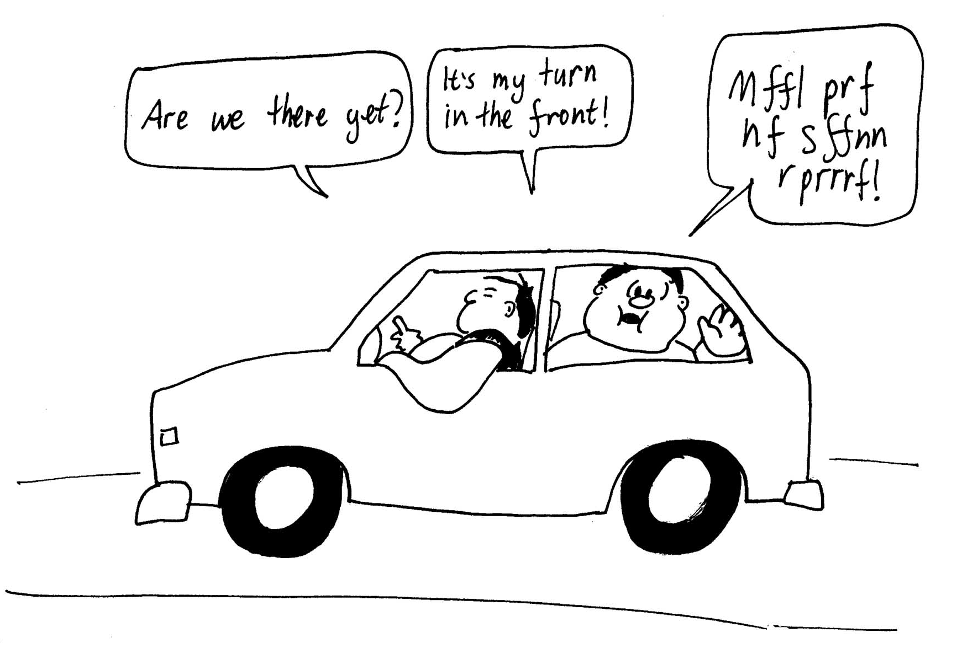

- Brent is pushing a piano up a ramp to get it into a moving van. The ramp makes an angle of 15º with the horizontal and has a smooth, but not frictionless surface. The coefficient of kinetic friction between the ramp and the piano is 0.20, and the piano has a mass of 200 kg. The ramp is 5.0 m long and Brent pushes the piano along the ramp with a constant velocity.
- What force is exerted by Brent as he pushes the piano?
- How much work is done on the piano by Brent?
- How much work is done by the weight of the piano?
- How much work is done by friction?
- What is the total work done on the piano?
Workshop Tutorials for Technological and Applied Physics
Solutions to MR5T: Work, Power and Energy

A. Qualitative Questions:

- The total work done on the TV really is zero. It starts with no kinetic energy, ends with no kinetic energy, and assuming the floor is flat it will not change the gravitational potential energy of the TV. However this does not mean that Brent does no work on the TV. He must accelerate it to move it, and increase its potential energy if he lifts it. This energy comes from chemical potential energy stored in Brent and the oxygen in the air he breathes. When he decelerates the TV and puts it down he must absorb the energy he has put in. However this energy is not converted back to chemical potential energy, but is lost as heat. In addition, if Brent slides the TV then the energy he has put in to accelerate it and give it kinetic energy will be dissipated as heat due to friction by the floor and TV. So while the energy of the TV has not changed, and no work has been done on it, Brent must do work to move it.

- The work done by the car can be measured by the change in kinetic energy. This change will be given by the difference in the squares of the speed. The change from 0 to 40 km.h⁻¹ provides a smaller change in KE than that from 40 km.h⁻¹ to 60 km.h⁻¹. So Brent is correct.
Since KE and hence change in KE also depends on mass the petrol station attendant is correct, however as they are unlikely to be able to change the mass of the car significantly, this is not very helpful.
The buddy of the petrol station attendant brings time into the discussion. A shorter time means that the same change in KE occurs at a faster rate. Thus the power needed will be different – more power needed for a shorter time but the actual amount of work done will be the same. So he is wrong about the amount of work done, but the rate at which the work is done is still important. They should accelerate slowly to whichever speed they choose, and try to sit steadily at that speed. (Note that at constant speed all the car’s engine does is match the frictional forces acting on the car. Air resistance increases with increasing speed, so the engine does less work to maintain a constant speed at lower speeds.)

B. Activity Questions:
mg
T
1. Pendulum
The forces acting on the pendulum are its weight (gravity), and the tension in the string. The tension is always at right angles to the path, hence it does no work. Ignoring friction, only the weight of the pendulum does work as it swings, converting gravitational potential energy into kinetic energy and back again.

2. Falling
When you drop an object it falls due to gravity, losing gravitational potential energy. As it falls this gravitational potential energy is converted to kinetic energy, and the object gains speed. The change in kinetic energy is equal to the work being done on the falling object, and is done by gravity. Air resistance may also do some negative work on the object, acting to reduce its kinetic energy and slow it down.

3. Power
The power used by the appliances is written on the back, and is measured in watts, W, or sometimes volts × current or VI. If an appliance is rated at X watts it converts X joules per second of energy.
A hairdryer converts electrical energy into thermal energy (heat) and kinetic energy, a lamp produces heat and light. All appliances convert at least some electrical energy into thermal energy.

C. Quantitative Questions:

- The force exerted by a stretched or compressed spring is F = -kx where k is the spring constant and x is the distance the free end of the spring is from its relaxed or equilibrium position. The suspension system of most cars consists of springs which help decrease the impact of bumps and make the car more stable. A ford laser has a body weighing 9900 N, which when fitted onto the suspension system lowers it by 9 cm.
- The spring constant of the car’s suspension system is k = F/x = 9900 N / 0.09 m = 1.1 × 10⁵ N.m⁻¹.
Four Sumo wrestlers have hired a Ford Laser to tour around Sydney and surrounds for a weekend. When they get into the car it sinks on its suspension by a further 10 cm.
- The springs of the suspension have sunk an extra Δx = 10 cm, so the force exerted by the weight of the Sumos is W = kΔx = 1.1 × 10⁵ N.m⁻¹ × 0.1 m = 11000 N.
The combined mass of the Sumos is m = W/g = 11000 N / 9.8 m.s⁻² = 1100 kg. (An average mass of around 280 kg.)
- The work done by the Sumos’ weight is converted into kinetic energy as the car sinks which is converted into elastic potential energy as the car reaches its new equilibrium position and stops. So, ignoring any change in kinetic energy – the car sinks but does not oscillate:
the work done = energy gained = ½ k (x₂² - x₁²) = 0.5 × 1.1 × 10⁵ N.m⁻¹× [(0.19 m)² - (0.09 m)²]= 1.5 kJ.

- Brent is pushing a piano up a ramp which makes an angle of 15º with the horizontal. The coefficient of friction between the ramp and the piano is 0.2, and the piano has a mass of 200 kg. The ramp is 5 m long and Brent pushes the piano along the ramp with a constant velocity.  - Since the piano is moving at constant velocity, the vector sum of the forces acting must be zero.  Along the plane of the ramp: F_{Brent} - mgsinθ – F_{friction} = 0.  Perpendicular to the plane: N – mgcos θ = 0. | F_{friction}  F_{gravity}  F_{Brent}  N  15º  105º
Using the first equation:
F_{Brent} = mgsinθ + F_{friction} = mgsinθ + μ mgcos θ = 200 kg × 9.8 ms⁻² (sin 15º + 0.2 cos 15 º) = 886 N.
- Work done by Brent on the piano is W_{Brent} = F_{Brent}. d = F_{Brent}dcos 0^{ο} = 886 N × 5 m × cos 0 º = 4.4 kJ.
- The work done by the weight of the piano is:
W_{weight} = mgdcos θ = 200 kg × 9.8 ms⁻² × 5 m × cos 105 º = - 2.5 kJ.
- The work done by friction is:
W_{friction} = F_{friction} dcos180º = μNdcos180º = μ(mgcos15^{ο}) dcos(180º)
= 0.2 × (200 kg × 9.8 ms⁻² × cos 15º) × 5 m × (cos 180º) = - 1.9 kJ.
- The total work done on the piano = W_{Brent} + W_{weight} + W_{friction} = 4.4 kJ + - 2.5 kJ + - 1.9 kJ = 0 J.
This is to be expected as the change in KE is zero, hence by the work energy theorem the total work done is zero. The gravitational PE gained is defined as the negative of the work done by the gravitational force and is 2.5 kJ.
Workshop Tutorials for Biological and Environmental Physics
MR6B: Conservation of Energy

A. Qualitative Questions:

1. Gravitational potential energy is often defined as PE = mgh where m is the mass of the object, g is the acceleration due to gravity and h is the height.
- Where is h measured from?
- Is it possible to have a negative gravitational potential energy? If so, how?
- Is it possible to have a negative kinetic energy?
- Is it possible to define an absolute value for gravitational potential energy and kinetic energy anyway?

2. Rebecca gets up in the morning and discovers that Brent has left the fan going all night. She turns it off and yells at him for wasting energy. “But you can’t waste energy” Brent replies “energy is conserved!”
“What about friction? That’s a non-conservative force!”
- What is the difference between a conservative force and a non-conservative force? Give an example of each.
- Where does the energy go when a non-conservative force is acting?
- Can Brent get the energy back?

B. Activity Questions:

1. Pendulum
At what position is the kinetic energy maximum, minimum? At what position is the potential energy maximum, minimum? Draw energy bar graphs for the pendulum at different points in its swing.

2. Bouncing balls I
Drop the balls from the same height.
Why do some balls bounce higher than others?
Can you make any of the balls bounce higher than the original height? Does this contradict conservation laws? Explain your answer.

3. Solar panel and electric circuit
Trace the energy conversions using a flow chart and identify which ones are "useful" and which are not.
Think of a case where this "not useful" energy may be useful.
Trace energy transformations from water stored in a dam, which supplies a hydro-electric power station, to turning on an appliance at home.

4. Tennis racquet
The strings on a tennis racquet are designed so that the energy transferred to the strings is minimal. Explain the following observation:
A ball dropped on a tennis racquet, whose handle you clasp firmly with your hands, does not bounce as high as when the ball is dropped on a racquet that is held firm by stepping on the handle.

C. Quantitative Questions:

- A typical aerobics activity is stepping up onto a block and then down again.
- Using your own weight, and a block height of 25 cm, how much energy does it take to step up onto the block?
- Where does this energy come from? (More specifically than just food.)
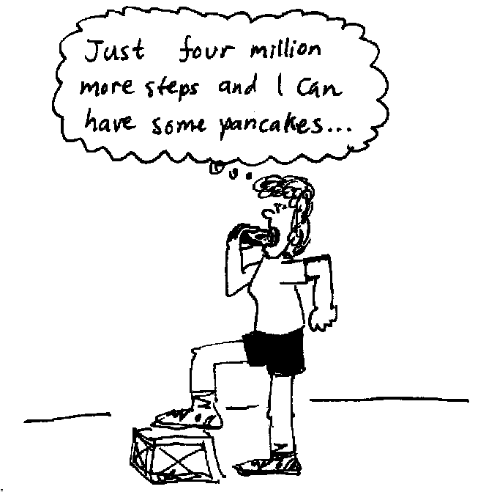
- Draw a flow chart showing the changes in forms of the energy used to step onto the block and down again.
- Your muscles are at best around 20% efficient at turning stored energy into work. Given that a doughnut contains about 600 kJ, how many times do you have to step up and down to use up two doughnuts?

2. Archer fish are famous for their ability to bring down insects and other small prey from overhanging vegetation by spitting jets of water at them. Their aim is accurate for up to five feet, and they possess excellent binocular vision to enable them to judge distance. In addition to this, they have the ability to make corrections for refraction between the water and air, and to make allowance for the curvature in the trajectory of the water jet.
An archer fish spits 10 ml (10 cm³ or 10⁻⁵ m³) of water at an insect hovering directly above him. The water has an initial velocity of 8.0 m.s⁻¹ as it leaves the archer’s mouth and reaches a height of 3.0 m.
- What was the initial kinetic energy of the water?
- What was the increase in thermal energy due to air friction during ascent?
- Where does this thermal energy go?
The water strikes the 0.2 g insect at the top of its trajectory, and it falls with the water to the waiting fish.
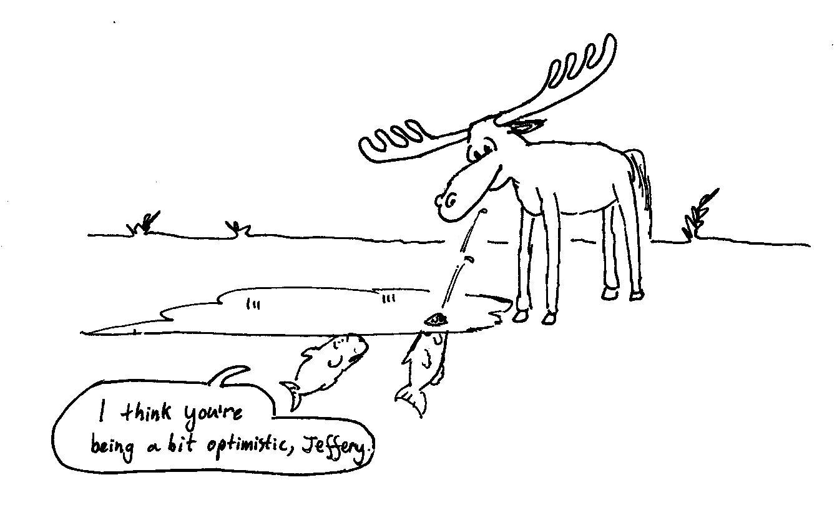
d. Ignoring air resistance, what is the kinetic energy of the insect when it reaches the fish? Where did this energy come from?
Workshop Tutorials for Biological and Environmental Physics
Solutions to MR6B: Conservation of Energy

A. Qualitative Questions:

1. Gravitational potential energy and kinetic energy.
- The height h in gravitational potential energy, mgh, depends on the situation being analysed. It is often measured from the surface of the Earth. This is an arbitrary but convenient zero point, as all we can really measure is changes in energy.
- If you define the surface of the Earth as the zero gravitational potential energy, then anywhere below the surface is negative, for example down a mine or well.
- It is not possible to have a negative kinetic energy as this would imply a negative mass. (Even if the velocity is negative the KE is ½ mv², so is still positive.)
- We can’t define an absolute value for either gravitational or kinetic energy. For gravitational potential energy we define it relative to some height, and for kinetic energy we define the movement as being relative to something. Your velocity relative to the Earth’s surface is different to your velocity relative to a moving train, so depending on your frame of reference you may have different kinetic energies.

2. Conservative and non-conservative forces.
- A conservative force conserves mechanical energy, kinetic and potential energy, converting one into the other, for example gravity which converts potential energy to kinetic energy. A conservative force also reverses the energy transfer, for example throwing something upwards in a gravitational field- the kinetic energy is transferred to potential energy, and back to kinetic energy when it falls again. Friction is a non-conservative force, as it converts kinetic energy into heat, thus taking away some mechanical energy from the system, although the total energy is still conserved.
- When a non-conservative force is acting some energy is lost as heat, which gradually dissipates throughout the system, increasing the kinetic energy of many individual atoms.
- Brent can’t get the energy back it is dissipated to many atoms. However there are systems which get back some of the heat generated by friction, although these are always much less than 100% efficient.
max P.E.
max K.E.
max P.E.
PE KE
PE KE
PE KE
B. Activity Questions:

Pendulum
a. At the lowest point of its motion, kinetic energy is maximum and potential energy is minimum.
b. At the highest point of its motion, kinetic energy is minimum (i.e. zero) and potential energy is maximum.
lamp- electrical energy to light energy and heat
solar cell- light energy to electrical energy and heat
motor- electrical energy to kinetic energy and heat
2. Solar panels and electric circuit
a. Energy as light is converted to electrical energy by the solar cell which is then converted to kinetic energy by the motor. Some energy is also converted to heat, which is usually not considered useful.
b. Heat is useful energy when you want to heat or cook something.
c. Dammed water has gravitational potential energy, which is converted to kinetic energy when the dam is open. This is converted to kinetic energy of a turbine placed in the flow, which is attached to a generator. The generator turns the kinetic energy into electrical energy which is converted into light, heat sound or mechanical energy by a home appliance.

3. Bouncing balls I
a. Balls that lose less energy to non-mechanical forms rise higher than balls that lose more energy.
lots of energy lost
no energy lost
b. A ball can bounce higher than the original height if we throw the balls instead of just dropping them. These balls start off with kinetic energy and gravitational potential energy instead of just gravitational potential energy.
little energy
lost
fixed
lots of energy lost
vibrates
4. Tennis racquet
A tennis racquet that is held in your hands vibrates. Some of the kinetic energy of the ball on impact is transferred to the racquet and some is transferred to your wrist, hands and arms thus the ball has a smaller kinetic energy when it bounces up and rises to a lower height.
A racquet that you step on cannot vibrate and thus energy is not transferred to your ankles and foot. Thus the kinetic energy of the ball just before impact is approximately equal to the kinetic energy of the ball just after impact and it rises to almost the height it was dropped from.

C. Quantitative Question:

- When you step up onto the block you must increase your gravitational potential energy by
ΔPE = mgh where h = 25 cm = 0.25 m. If you weigh 60 kg, for example, then
ΔPE = mgh = 60 kg × 9.8 m.s⁻² × 0.25 m = 147 kg.m².s⁻² = 147 J.
- The energy comes from the breaking and reforming of bonds when food is broken down. This involves adding oxygen to food. The final state of the atoms in the food and the oxygen must be lower energy than the initial state, the difference in energy is what you get from breaking it down.
bonding energy
kinetic energy
potential energy energy
kinetic energy
heat
heat
heat
heat

- Your muscles are at best around 20% efficient at turning stored energy into work, so to change your potential energy by 147 J you actually need 147 J × 100% / 20 % = 147 J × 5 = 735 J. Note that you need this much for every step, as mechanical energy is entirely dissipated as heat in the process of stepping down, so you cannot recycle energy from kinetic to potential and back to kinetic. Given that a doughnut contains about 600 kJ, to use two doughnuts you need to step up
1200 kJ / 735 kJ.step⁻¹ = 1,633 steps. This is a lot!

2. An archer fish spits 10⁻⁵ m³ of water (= 10⁻⁵ m³ × 10³ kg.m⁻³ = 0.01kg) at an insect directly above him. The water has an initial velocity of 8 m.s⁻¹ as it leaves the archer’s mouth and reaches a height of 3 m.
- The initial kinetic energy of the water is KE = ½ mv² = ½ × 0.01 kg × (8 m.s¹)² = 0.32 J.
- At the top of the water’s trajectory it has a gravitational potential energy of
PE = mgh = 0.01 kg × 9.8 m.s⁻² × 3 m = 0.29 J The energy lost as thermal energy is the difference between initial (maximum) kinetic energy and the maximum gravitational potential energy, which is Thermal E = 0.32 J – 0.29 J = 0.03 J
- This thermal energy causes heating of the water and the air which the water comes into contact with.
- Ignoring air resistance, the kinetic energy of the insect when it reaches the fish comes entirely from the potential energy the insect had before the water hit it, causing it to stop flapping its wings. Its kinetic energy as it reaches the fish is KE = ½ mv² = mgh_{top} = 0.2 × 10⁻³ g × 9.8 m.s⁻² × 3 m = 3.9 × 10⁻³ J.
Workshop Tutorials for Technological and Applied Physics
MR6T: Conservation of Energy

A. Qualitative Questions:

- You throw a ball vertically into the air and catch it when it returns. Answer parts a and b ignoring air resistance, and then taking it into account.
- What happens to the ball's kinetic energy during the flight?
- What happens to the total energy?
- What happens to the energy of the ball as you catch it and it comes to rest?
- Why is it easier to catch a ball while moving your hands backwards?

- Gravitational potential energy is often defined as PE = mgh where m is the mass of the object, g is the acceleration due to gravity and h is the height.
- Where is h measured from?
- Is it possible to have a negative gravitational potential energy? If so, how?
- Is it possible to have a negative kinetic energy?
- Is it possible to define an absolute value for gravitational potential energy and kinetic potential energy anyway?

B. Activity Questions:

- Bouncing balls I
Drop the balls from the same height.
Why do some balls bounce higher than others?
Can you make any of the balls bounce higher than the original height? Does this contradict conservation laws? Explain your answer.

- Solar panel and electric circuit
Trace the energy conversions using a flow chart and identify which ones are "useful" and which are not.
Think of a case where this "not useful" energy may be useful.
Trace energy transformations from water stored in a dam, which supplies a hydro-electric power station, to turning on an appliance at home.

- Tennis racquet
The strings on a tennis racquet are designed so that the energy transferred to the strings is minimal. Explain the following observation:
A ball dropped on a tennis racquet, whose handle you clasp firmly with your hands, does not bounce as high as when the ball is dropped on a racquet that is held firm by stepping on the handle.
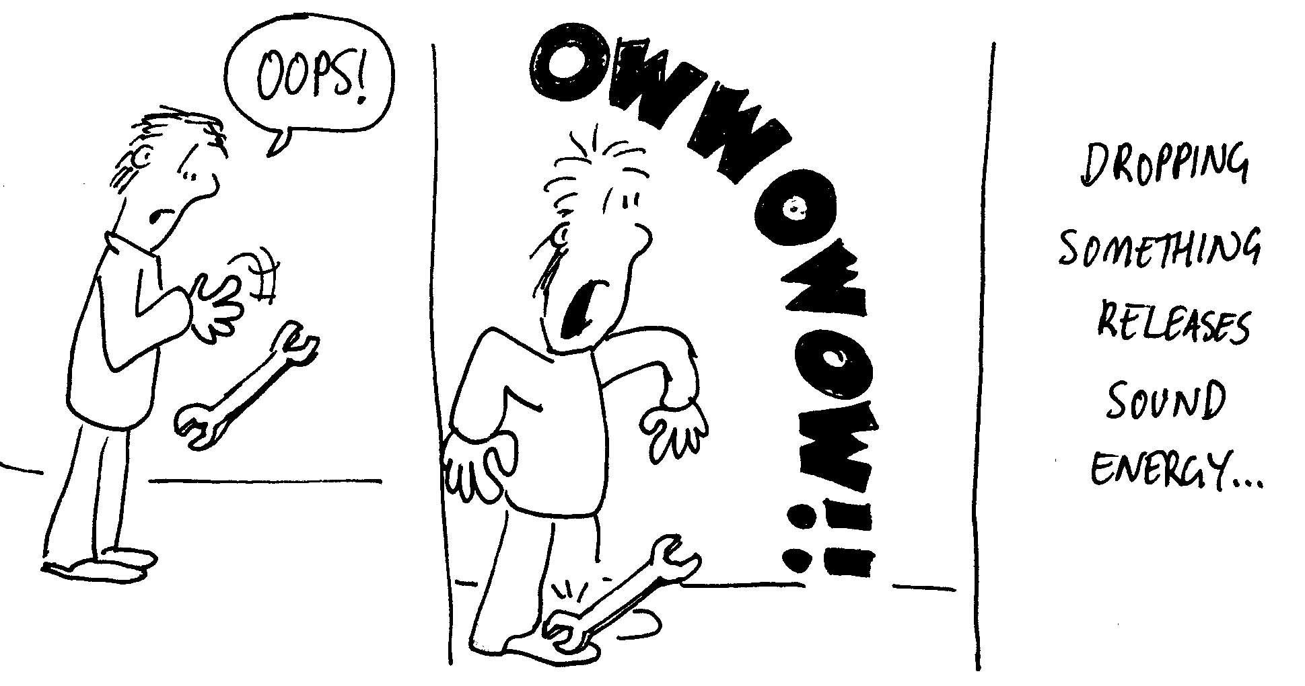

C. Quantitative Questions:

1. Brent, who has a mass of 70 kg, slides from rest down a banister (hand rail) of a flight of stairs. The banister is 3.0 m long and at an angle of 30º to the horizontal and the coefficient of friction between Brent’s clothes and the banister is 0.50.
- Draw a diagram showing the forces acting on Brent as he slides down the banister.
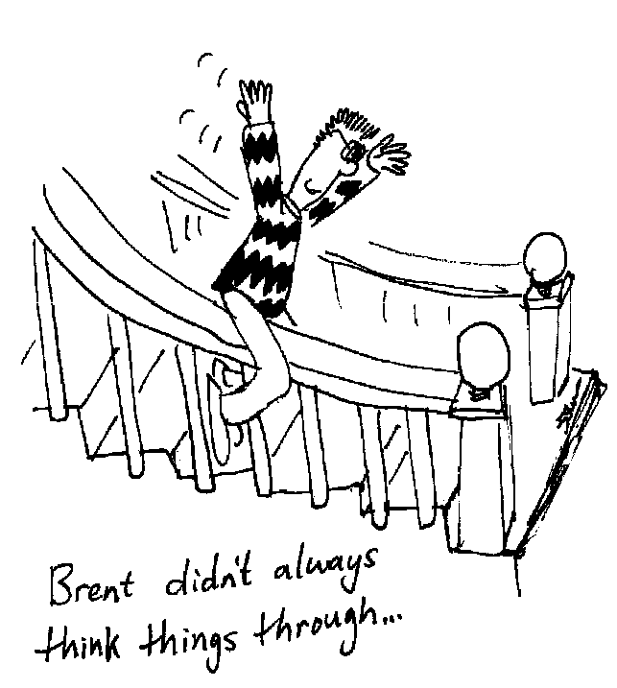
- Which of these forces does work on Brent?
- Describe the energy transfers (noting the forces causing them) that take place as Brent slides down the banister.
- Write down a relation between Brent’s total energy at the top of the rail and his total energy at the bottom of the rail. Include all energies mentioned in part c.
- Estimate the Brent’s speed as he reaches the end of the banister.
- What is the average rate at which energy is dissipated as Brent slides down the banister?

2. A coyote, a 16 kg canine, rests on a giant spring at the bottom of a 10 m high cliff waiting for a roadrunner (small brown bird) to pass by overhead. The spring is compressed 10.0 cm by the coyote.
- What is the spring constant?
The coyote pushes the spring down an additional 50.0 cm using a lever cleverly set up for this purpose. As the roadrunner appears overhead and looks down at him he releases the spring.
- What is the elastic potential energy of the compressed spring just before that release?
- What is the change in the gravitational potential energy of the coyote-Earth system when the coyote moves from the release point to its maximum height? (Treat the spring as massless.)
- Is the coyote going to make it to the top of the cliff to grab the roadrunner?
- A real spring (one with a mass) would keep oscillating after the coyote has flown off. Where does this energy come from?
- What happens to the total energy of the spring-coyote system in this process assuming negligible frictional forces?

Workshop Tutorials for Technological and Applied Physics
Solutions to MR6T: Conservation of Energy

A. Qualitative Questions:
v = 0
v = v_{i}
v = v_{i}
PE = 0
KE = ½ mv_{i}²
PE = mgh
KE = 0
PE = 0
KE = ½ mv_{i}²
h

1. a. and b. With no air resistance:
The ball has an initial velocity, v_{i}, and kinetic energy KE_{i} =½ mv_{i}². It also has an initial height h_{i} =0 and potential energy PE_{i} = mgh_{i} = 0. As the ball goes up, its kinetic energy decreases and is zero at a height of h, its gravitational potential energy increases and is maximum at h. The reverse happens on the way down, such that the total energy of the ball is constant, i.e. at every instant PE + KE = total energy.
Or, in terms of work rather than potential energy, there is no change in kinetic energy of the ball between the initial and final positions thus the total work is zero. During the flight the work done by weight on the way up is W=-mgh and on the way down is W = mgh.
a. and b. With air resistance:  As the ball goes up, there is work done by air resistance, so the ball’s its kinetic energy decreases and is zero at a height h' which is less than h. On the way down again there is work done by air resistance. Hence the final kinetic energy is less than the initial kinetic energy, so final speed is less than initial speed. The total energy of the ball-earth system is PE + KE + W_{air resistance}.  Total energy is constant but the ball has less mechanical energy when caught. Some of its energy has been converted into heat due to work done by air resistance. | v = 0  PE = mgh’ < ½ mv_{i}²  KE = 0  h’  v = v_{i}  v < v_{i}  PE = 0  KE = ½ mv_{i}²  PE = 0  KE < ½ mv_{i}²
c. The energy is converted into heat, sound and motion of the muscles in your hand.
d. Your hand must do work on the ball to change its kinetic energy from ½ mv² to 0. The work done is given by the force times the distance, so if you increase the distance over which your hand applies the force to stop the ball, the force required is less. If the force on the ball by your hand is less then the force by the ball on your hand will also be less.

2. Gravitational potential energy.
- The height h in gravitational potential energy, mgh, depends on the situation being analysed. It is often measured from the surface of the Earth. This is an arbitrary but convenient zero point, as all we can really measure is changes in energy anyway.
- If you define the surface of the Earth as the zero gravitational potential energy, then anywhere below the surface is negative, for example down a mine or well.
- It is not possible to have a negative kinetic energy as this would imply a negative mass. (Even if the velocity is negative the KE is ½ mv², so is still positive.)
- We can’t define an absolute value for either gravitational or kinetic energy. For gravitational potential energy we define it relative to some height, and for kinetic energy we define the movement as being relative to something. Your velocity relative to the Earth’s surface is different to your velocity relative to a moving train, so depending on your frame of reference you may have different kinetic energies.

B. Activity Questions:

- Bouncing balls I
Balls that lose less energy to non-mechanical forms rise higher than balls that lose more energy. A ball can bounce higher than the original height if we throw the balls instead of just dropping them. These balls start with kinetic and potential energy instead of just potential energy.
2. Solar panels and electric circuit  a. Energy as light is converted to electrical energy by the solar cell which is then converted to kinetic energy by the motor. Some energy is also converted to heat, which is usually not considered useful.  b. Heat is useful energy when you want heating or cooking.  c. Dammed water has gravitational potential energy, which is converted to kinetic energy when the dam is open. This is converted to kinetic energy of a turbine placed in the flow, which is attached to a generator. The generator turns the kinetic energy into electrical energy which is converted into light, heat sound or mechanical energy by a home appliance. | lamp- electrical energy to light energy and heat  solar cell- light energy to electrical energy and heat  motor- electrical energy to kinetic energy and heat
little energy
lost
fixed
lots of energy lost
vibrates
3. Tennis racquet
A tennis racquet that is held in your hands vibrates. Some of the kinetic energy of the ball on impact is transferred to the racquet and some is transferred to your wrist, hands and arms thus the ball has a smaller kinetic energy when it bounces up and rises to a lower height.
A racquet that you step on cannot vibrate and thus energy is not transferred to your ankles and foot. Thus the kinetic energy of the ball just before impact is approximately equal to the kinetic energy of the ball just after impact and it rises to almost the height it was dropped from.
v_{o} =0
3m
30º
N=mgcos30º
mgsin30º
mgcos30º
friction
f= μN
= μmgcos30º
C. Quantitative Question:

1. Brent on the banister.
- See diagrams opposite
- Frictional force and the gravitational force do work on Brent.
- Initially Brent is at rest and has potential energy but no kinetic energy. As he slides the potential energy is converted to kinetic energy and thermal energy.
- Initial PE = final KE + thermal energy.
- Initial PE = mgh = mgLsin30º; final KE = ½ mv²,
thermal energy produced = fL = μmgcos30ºL
and using d : mgLsin30º = ½ mv² + μmgcos30º
we get v ² = 2gL (sin30º - μcos30º) = 3.9. Therefore v = 2.0 m.s⁻¹.
- The average rate at which mechanical energy is dissipated is the average power which is <P> = F<v> and F = f = μmgcos30º, where <v> = ½ (v_{o}+v) = 0.99 m.s⁻¹, so <P> = μmgcos30º<v> = 0.29 kW.

2. Coyote on a spring.
  - The spring constant is: k = ΔF/Δx = mg/Δx = (16 kg × 9.8 m.s⁻² )/ 0.1 m = 1.6 kN.m⁻¹.
  - When the spring is compressed by a further 50 cm, the total compression is through 60 cm or 0.60 m.
The elastic potential energy is U = ½ kx² = ½ × 1600 N.m⁻¹ × (0.60 m)² = 0.28 kJ
  - When the spring is released the elastic PE is converted to gravitational PE,    ΔU = 0.28 kJ
  - The coyote rises by a distance y. So ½ kx² = mgy which we rearrange to give
y = $\frac{{\text{kx}}^{2}}{2\text{mg}}$=$\frac{\text{282}J}{\text{16}\text{kg}×9\text{.}8m\text{.}s^{−2}}$=1.8 m. This is not even close to the 10 m height he needs.
  - The energy of the oscillating spring comes from the kinetic energy of the spring just as the coyote loses contact.
  - The total energy remains constant; energy is being converted from one form to another; kinetic energy of both coyote and spring, gravitational potential energy of the coyote and the spring potential energy.
Workshop Tutorials for Biological and Environmental Physics
MR7B: Conservation of Momentum

A. Qualitative Questions:

- A great many of the interesting things that happen during sports are collisions; between people, (boxing, football) between people and objects such as in (soccer, skydiving) or between two objects (cricket, car racing). When there is a collision between two objects there is a change in momentum of each object although the total momentum before and after the collision remains constant when there are no external forces acting.
- What factors contribute to the amount of damage which is done during a collision?
- How can you minimise the effects of a collision?
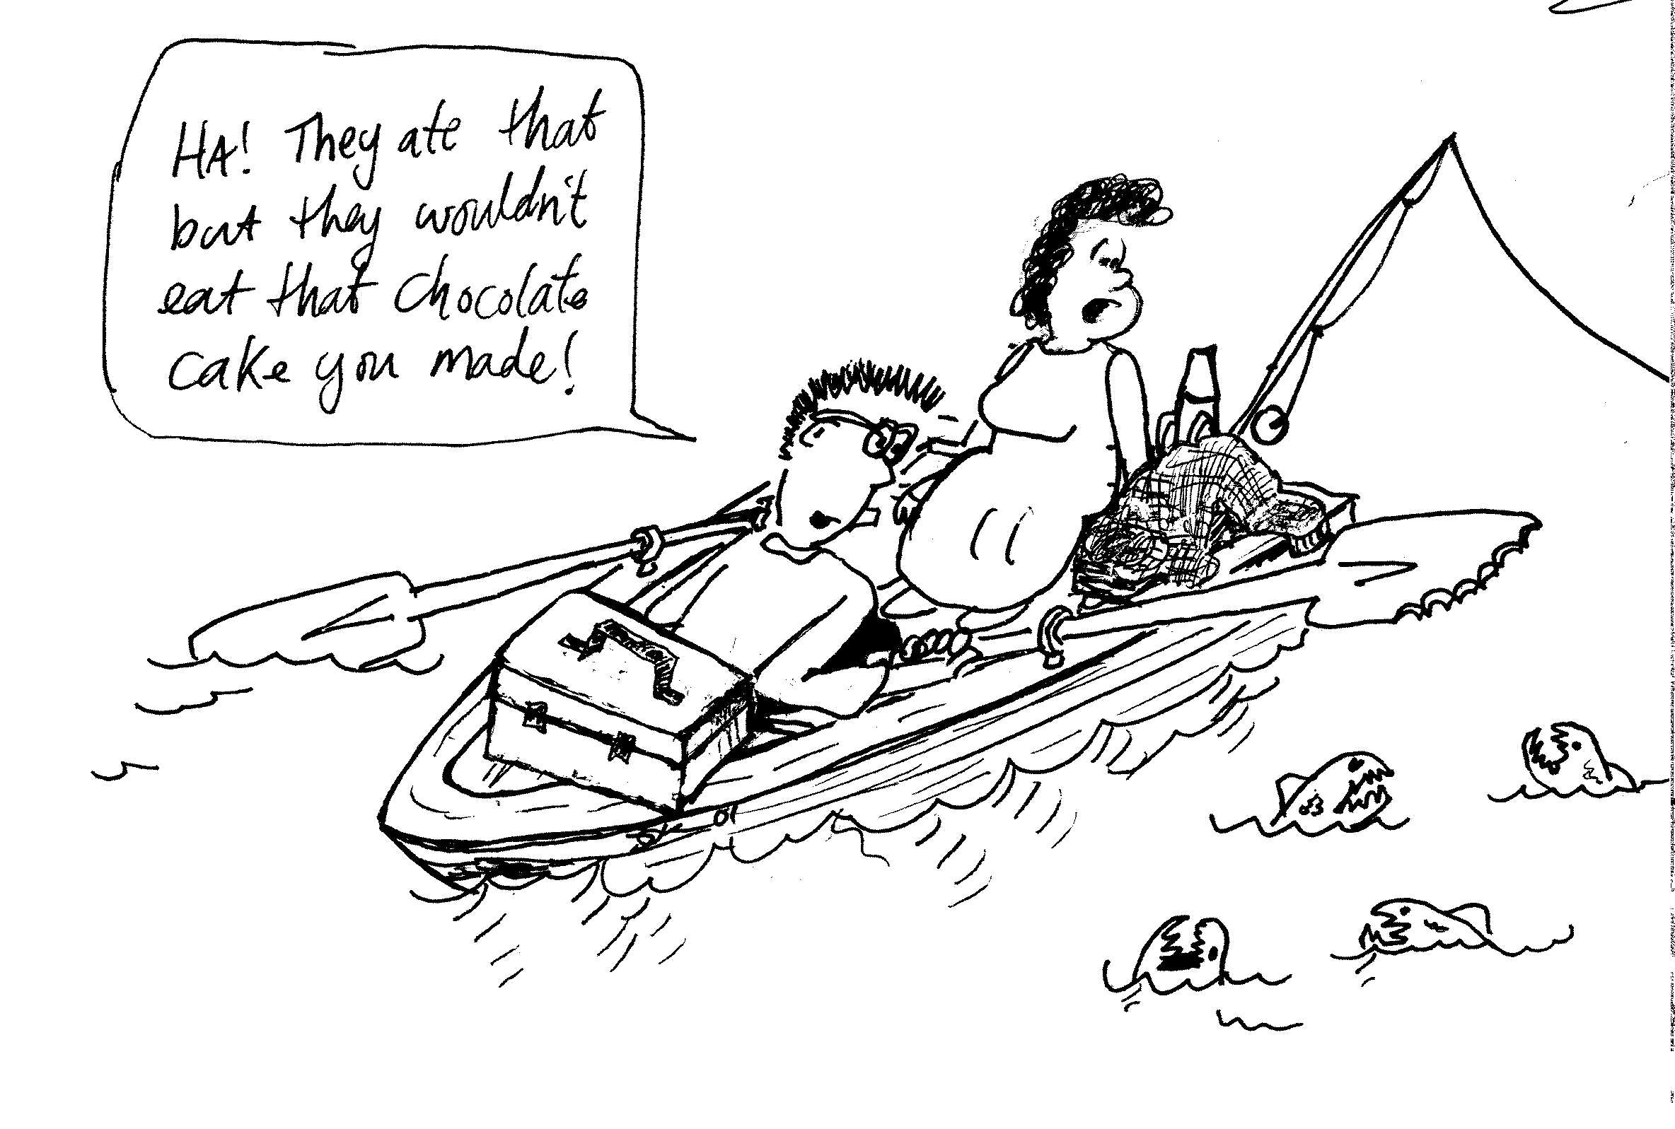
2. Rebecca and Brent are on safari, and have taken a boat out on a lake to do some fishing. They’re well prepared, with plenty of fishing gear, lunch, raincoats and warm jumpers, but no mobile phone. They throw in a line and see a host of little fish descend upon the bait and guzzle it and the line. Brent pokes the paddle at them to see what they do, and they eat that too. At this point Rebecca recognises the fish as piranhas, and also the problem that they are now in the middle of the lake, miles from civilization, with no paddle, no mobile phone, and surrounded by piranhas. She suggests that Brent walk on the boat away from the shore, and because of conservation of momentum this will make the boat go towards the shore.
- Will this get them to shore?
- What should they do to get themselves back to shore?

B. Activity Questions:

- Pendulum on Trolley
Swing the pendulum bob.
What happens to the trolley? Why does it behave like this?

- Air track
- What happens when a moving object collides with an identical stationary one? What if they have different masses?
- Send two identical objects, spaced a few centimetres apart, with the same velocity towards a third. What happens when they collide? This is like a row of moving traffic hitting a stationary vehicle.
Experiment with other combinations of moving and stationary objects.
- What purpose do the metal loops serve?
- Note the difference in collisions when the air track is switched on and when it is off. When is the coefficient of kinetic friction greater?

- Newton's cradle
Explain the difference between the two types of apparatus on display.
Can you explain the behaviour of the balls with only energy conservation or do you need conservation of momentum as well. Discuss your answer.

- Bouncing balls II
Hold a little ball in contact with and directly above a big ball. Drop the balls together.
Describe what happens. Why does this happen?
Do you get the same behavior if the big ball is above the little ball?

C. Quantitative Questions:

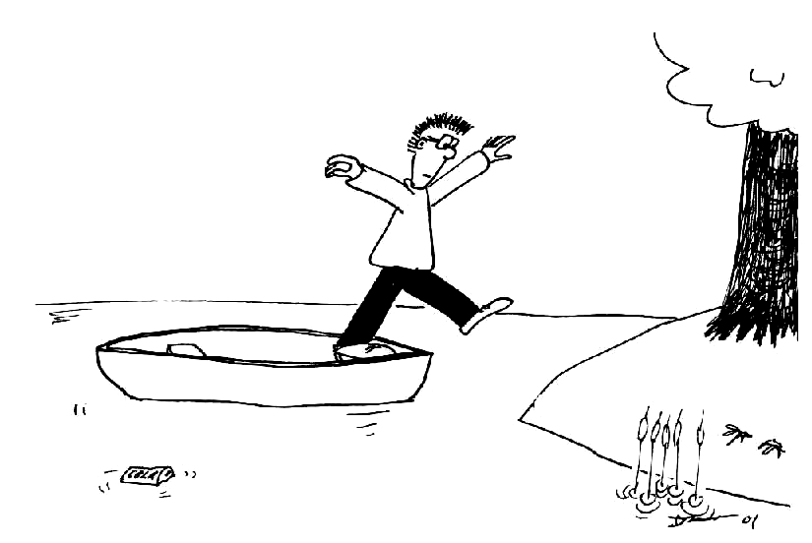
- Brent is standing in a canoe and wishes to jump ashore without getting wet. The canoe has a mass of 60 kg and Brent has a mass of 70 kg. The canoe is 1 m from the shore. Brent jumps with a velocity of 2.5 m.s⁻¹ towards the shore.
- Draw a diagram showing the movement of Brent and the canoe.
- At what initial velocity does the canoe move away from Brent?

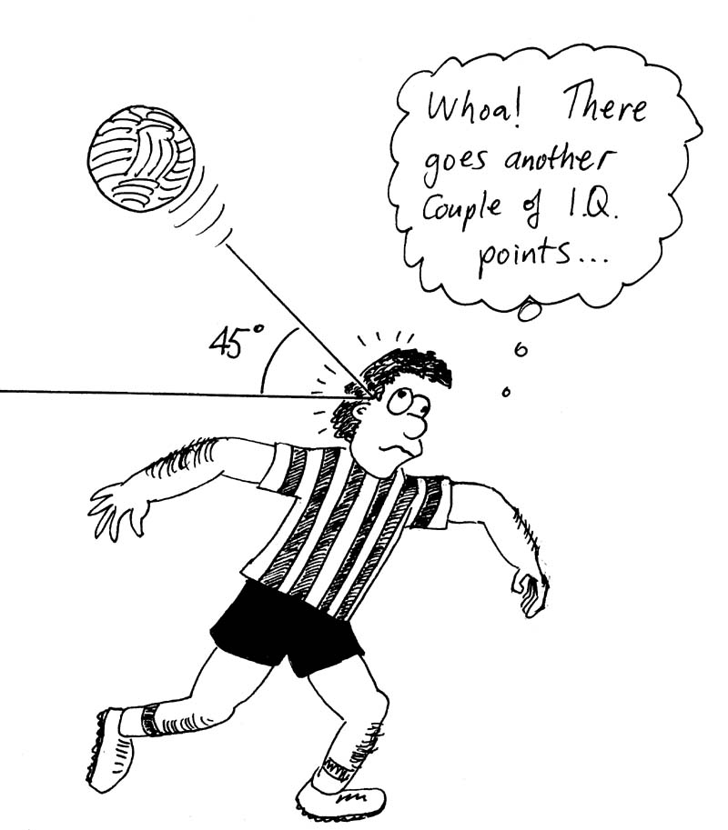
- Around 30% of professional soccer players, as well as many amateur players, suffer permanent headaches, memory loss and other ill effects due to “heading” the ball. On the field, at least 22% of injuries are to the head or neck from heading the ball. A soccer ball weighing 450 g is headed by an 80 kg player. The ball is traveling horizontally with a velocity of 20 m.s⁻¹ when it hits him, and bounces off at an angle of 45º with a velocity of 8 m.s⁻¹.
- What is the change in momentum of the ball? Draw a diagram showing the initial and final momentum to help explain your answer.
- If only the head of the player moves, pivoting on the neck, what velocity does the head have immediately after the collision? The head is around 7% of the total body mass.
- How much kinetic energy must the neck absorb as the head comes to a stop?

Workshop Tutorials for Biological and Environmental Physics
Solutions to MR7B: Conservation of Momentum

A. Qualitative Questions:

- Collisions.
a. The amount of damage caused during a collision will be determined by the magnitude of the forces acting during that collision. This will depend on the change in momentum on impact and the time for which the colliding bodies are in contact.
b. To miminise damage for a given momentum change of an object, it is better to maximize the time of collision. Change in momentum equals average force × time of collision. For example, a “soft” landing onto a mattress causes less damage than a “hard” landing onto concrete as the time of impact is longer and hence the average force exerted by the surface on the body is less.
mv < 0
mv > 0
mv = 0
mv = 0
mv = 0
mv = 0

2. Rebecca and Brent are on the lake without a paddle.  a. Brent will not get the boat to shore by walking in the opposite direction. In the absence of external forces the centre of mass will not move, and when he gets to the end of the boat and stops it will be less than one boat lengths closer to shore. See diagram opposite.  b. They could throw things overboard as hard as they could in a horizontal direction away from shore. By conservation of momentum, whatever momentum they give the thrown objects must also be given to them and the boat, but in the opposite direction. This maintains conservation of momentum, so that the total momentum of the system is still zero. | mv < 0  mv > 0

B. Activity Questions:

- Pendulum on Trolley
When you raise the bob and hold the base still the total momentum of the pendulum-trolley system is zero. When you release the bob it swings down, gaining momentum. In order for momentum to be conserved the trolley must move the opposite way, which it does. As the pendulum swings back and forth the trolley will roll back and forth in the opposite direction, until friction eventually stops it.
v
v
v
v
v
v
a.
b.
before
before
after
after
- Air track
a, b. See opposite.
c. The metal loops help make the collisions elastic and prevent the gliders sticking to each other.
d. The frictional forces are much greater with the air flow turned off and the gliders can no longer be considered an isolated system as the external forces due to friction become significant.

- Newton's cradle  Steel balls have (almost) elastic collisions, in which both kinetic energy and momentum are conserved. The lead balls have inelastic collisions in which only momentum is conserved.  Both energy and momentum conservation are needed to explain the behaviour of the balls. Energy conservation is needed to account for the kinetic energy of the balls before and after the collision, and any thermal energy produced in an inelastic or partially inelastic collision - KE_{initial} = KE_{final} + E_{thermal}. The collisions obey conservation of momentum. | mgh₁  mgh₂  h₂ < h₁  ½ mv₁²  collisions  between  the balls  ½ mv₂²

- Bouncing balls II  a. The small ball held over the big ball bounces off higher as some momentum is transferred from the big ball to the small ball, increasing its velocity. Momentum has been conserved during the collision and the change in momentum of the small ball is large.  b. If the balls are switched around the momentum is still conserved, but the transfer of momentum from the small to the big ball makes little difference to the big ball’s velocity due to its large mass. | v  v  v

C. Qualitative Questions:
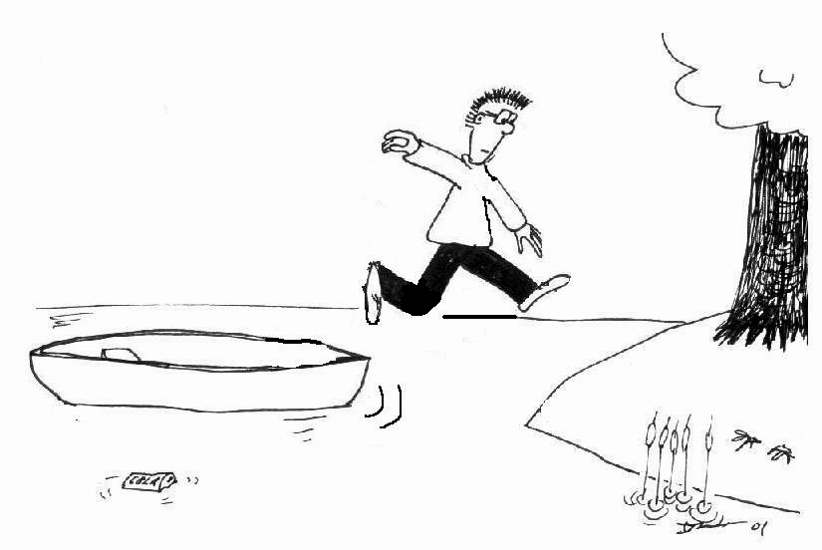
- The canoe has a mass of 60 kg and Brent has a mass of 70 kg.
v_{B}
v_{C}
The canoe is 1 m from the shore. Brent jumps with a
horizontal velocity of 2.5 m.s⁻¹ towards the shore.
a. See diagram opposite.
b. We can use conservation of momentum to find the velocity of the canoe.
p_{i} = p_{f.}
p_{i} = p_{B} + p_{C} = m_{B}v_{B} + m_{C}v_{C}
= 70 kg × 0 m.s⁻¹ + 60 kg × 0 m.s⁻¹ = 0 kg.m.s¹.
p_{f} = m_{B}v_{B} + m_{C}v_{C} = p_{i} = 0 kg.m.s¹.
so v_{C} = - m_{B}v_{B} / m_{C} = -70 kg × 2.5 m.s⁻¹ / 60 kg
v_{C} = -2.9 m.s⁻¹

p_{i}
p_{f}
- p_{i}
p_{f}
Δ p
p_{f head}
- Heading a soccer ball.
The change in momentum is Δp = p_{f} - p_{i}. See diagram opposite.
Looking at the components:
In the y direction:
Δp_{y} = p_{fy} –p_{iy} = 0.450 kg × 8 m.s⁻¹ sin45º - 0 = 2.54 kg.m.s⁻¹
In the x direction:
Δp_{x} = p_{fx} – p_{ix} = - 0.450 kg × 8 ms⁻¹ × cos45º – ( 0.450 kg × 20 m.s⁻¹)
= - 2.54 kg.m.s⁻¹ – 9.0 kg.m.s⁻¹ = - 11.54 kg.m.s⁻¹.
Δp² = Δp_{x}² + Δp_{y}² = (2.54² + 11.54²) kg².m².s⁻²
and Δp = 11.8 kg.m.s⁻¹ at angle θ = tan⁻¹(2.54/11.54) = 12º above the horizontal.
The change in momentum of the head will be equal and opposite, i.e. 11.8 kg.m.s⁻¹ at 11º below the horizontal. The mass of the head = 0.07 × 80 kg = 5.6 kg.
Hence the velocity of the head will be 11.8 kg.m.s⁻¹ / 5.6 kg = 2.1 m.s⁻¹ in a direction 23º below the horizontal.
The kinetic energy to be absorbed = ½mv² = ½ × 5.6 kg × (2.1 m.s⁻¹)² = 12 J.
Workshop Tutorials for Technological and Applied Physics
MR7T: Conservation of Momentum

A. Qualitative Questions:

- A physicist observes an unstable particle at rest. Suddenly the particle decays into at least two fragments, perhaps more. Consider the three cases shown below. The paths and velocity vectors of two of the resulting fragments are shown, but the masses of the fragments are unknown.
A
B
C

- In which cases (if any) can the physicist be certain of the existence of at least one other additional, unobserved particle associated with the decay? Explain your reasoning.
- For each case, what can be said (if anything) about the relative masses of the fragments?

- A group of students are designing a roller coaster. They want to be able to make it go faster along a straight, frictionless length of track. Brent suggests putting some water in the bottom half of the carriage and a plug in the bottom, which can be removed. His theory is that when the plug is removed the carriage will speed up. Rebecca tells him not to be silly, the carriage will slow down. Julia doesn’t think it will make any difference, but lets them go ahead and try it just to prove her point. Who is right and why?

B. Activity Questions:

- Air track
- What happens when a moving object collides with an identical stationary one? What if they have different masses?
- Send two identical objects, spaced a few centimetres apart, with the same velocity towards a third. What happens when they collide? This is like a row of moving traffic hitting a stationary vehicle.
Experiment with other combinations of moving and stationary objects.
- What purpose do the metal loops serve?
- Note the difference in collisions when the air track is switched on and when it is off. When is the coefficient of kinetic friction greater?

- Newton's cradle
Explain the difference between the two types of apparatus on display.
Can you explain the behaviour of the balls with only energy conservation or do you need conservation of momentum as well. Discuss your answer.

- Bouncing balls II
Hold a little ball in contact with and directly above a big ball. Drop the balls together.
Describe what happens. Why does this happen?
Do you get the same behavior if the big ball is above the little ball?

C. Quantitative Question:

- A steel wrecking ball of mass 200 kg is fastened to a 10 m long chain which is fixed at the far end to a crane. The ball is released when the chain is horizontal as shown. At the bottom of its path, the ball strikes a 1000 kg car initially at rest on a frictionless surface. The collision is completely inelastic so that the ball and car move together just after the collision. What is the speed of the ball and car just after the collision?

- Voyager 2 was one of a pair of spacecraft launched to explore the planets of the outer solar system and the interplanetary environment. Voyager 2 lifted off in August 1977, and flew by Jupiter (closest approach July 1979) and Saturn (Aug. 1981). It then continued on to successful flybys of Uranus (Jan. 1986) and Neptune (Aug.1989). Voyager is still speeding away from the sun and sending back data, taking measurements of the interplanetary magnetic field, plasma, and charged particle environment.
To allow Voyager 2 to continue on from Jupiter to Saturn it used a slingshot maneuver to approach and then move off in the opposite direction. A sling shot maneuver can be modeled approximately as a collision to analyse the motion of the space craft. Voyager 2 approached Jupiter as shown below with a velocity of 12 km.s⁻¹ (relative to the sun) The orbital speed of Jupiter is 13 km.s⁻¹.
- What was Voyager 2’s speed after the sling shot encounter?
- What assumption did you need to make to calculate this speed?
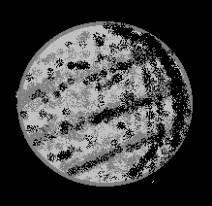

Workshop Tutorials for Technological and Applied Physics
Solutions to MR7T: Conservation of Momentum

A. Qualitative Questions:
B
C
A
or
small mass
big mass
equal masses
third, unobserved particle
equal masses

- A particle, initially at rest decays into at least two fragments, perhaps more.
In all cases the initial momentum is zero, p_{i} = 0, so the final momentum must also be zero.
In diagram A the velocities are in opposite directions but are different in magnitude. This means that either the masses of the particles are different and the lower one is heavier, or that there is another particle involved. See diagram opposite.
There must be another particle in B. The total momentum as shown in this diagram is not zero, as the two velocity vectors are in different directions. Regardless of the masses of the two particles their momenta cannot add to zero. Hence there must be at least one other particle present.
In diagram C if the masses are equal then momentum is conserved. If the masses are not equal then a third particle is needed to satisfy conservation of momentum.

2. Julia is correct. Pulling the plug will not change the speed of the roller-coaster. The water flows out with the same horizontal velocity as the roller coaster. Since no external horizontal forces are acting, the horizontal component of the momentum of both water and roller coaster are conserved, and the horizontal component of the roller coaster’s velocity does not change. | v  v  v  v  v  v
v
v
v
v
v
v
a.
b.
before
before
after
after
B. Activity Questions:

1. Air track  a, b. See opposite.  c. The metal loops help to ensure elastic collisions and prevent gliders sticking together.  d. The frictional forces are much greater with the air flow turned off and the gliders can no longer be considered an isolated system as the external forces due to friction become significant. | mgh₁  mgh₂  h₂ < h₁  ½ mv₁²  collisions  between  the balls  ½ mv₂²

2. Newton's cradle
Steel balls have almost elastic collisions, in which both kinetic energy and momentum are conserved. The lead balls have inelastic collisions in which only momentum is conserved.
Both energy and momentum conservation are needed to explain the behaviour of the balls. Energy conservation is needed to account for the KE of the ball at the time of impact. The collisions obey conservation of momentum.

3. Bouncing balls II  a. The small ball held over the big ball bounces off higher as some momentum is transferred from the big ball to the small ball, increasing its velocity. Momentum has been conserved during the collision and the change in momentum of the small ball is large.  b. If the balls are switched around the momentum is still conserved, but the transfer of momentum from the small to the big ball makes little difference to the big ball’s velocity due to its large mass. | v  v  v
v_{f}
m₁ + m₂
v_{1i}
v_{2i} = 0
m₁
m₂
A
B
h
Just before collision:
Just after collision:
C. Quantitative Question:

1. At position A, the ball has no kinetic energy and potential energy = m₁gh
At position B, just before the collision, the ball's gravitational potential energy is zero and the kinetic energy is ½ m₁v_{1i} ².
Using conservation of energy, m₁gh = ½ m₁v_{1i} ²
and $v_{1i}=\sqrt{2\text{gh}}$
$=\sqrt{2×9\text{.}8 m\text{.}s^{−2}×\text{10} m}$ = 14 m.s⁻¹.
The collision is inelastic so we cannot use conservation of mechanical energy, but momentum is still conserved.
We know that the ball and car move off together, so from conservation of momentum : $m_{1}v_{1i}=(m_{1}+m_{2})v_{f}$
Rearranging we obtain
$v_{f}=\frac{m_{1}v_{1i}}{m_{1}+m_{2}}=\frac{\text{200}\text{kg}\text{.}\text{14}m\text{.}s^{−1}}{\text{200}\text{kg}+\text{1000}\text{kg}}=2\text{.}\text{33} m\text{.}s^{\text{-1}}$

- Voyager approaches Jupiter with a speed of 12 m.s⁻¹ relative to the sun. Relative to Jupiter it approaches with a speed of 12 m.s⁻¹ + 13 m.s⁻¹ = 25 m.s⁻¹.  We use the equations for elastic collisions with a stationary target, and to do this we need to take our frame of reference as Jupiter. (Jupiter is the stationary target.)  so: $v_{\text{voy}\text{.}f}=\frac{m_{\text{voy}\text{.}}−m_{\text{Jup}}}{m_{\text{voy}}+m_{\text{Jup}}}v_{\text{voy}\text{.}i}−v_{\text{voy}\text{.}i}$  and $v_{\text{Jup}\text{.}f}=\frac{2m_{\text{voy}\text{.}}}{m_{\text{voy}}+m_{\text{Jup}}}v_{\text{voy}\text{.}i}$ ~ 0.  If we assume there are no energy losses, and that the mass of Jupiter is much greater than that of Voyager, then it will rebound with the same relative speed, i.e. 25 m.s⁻¹, in the opposite direction.  This is the speed relative to Jupiter at which it rebounds, remember that Jupiter is moving at 13 m.s⁻¹ relative to the sun. This means that relative to the sun, voyager will rebound at 25 m.s⁻¹ + 13 m.s⁻¹ = 38 m.s⁻¹!  b. The assumptions that we made were that the collision was elastic, and that the mass of Jupiter was much greater than that of Voyager, both of which are reasonable assumptions. | 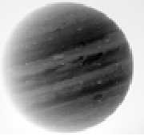  v _{(voy)}= 25 m.s⁻¹  v _{(Jup)} = 0 m.s⁻¹  v _{(Jup)} = 0 m.s⁻¹  v _{(voy)}= 25 m.s⁻¹  Relative to Jupiter:  before  after  Relative to the sun:  before  after  v _{(voy)}= 38 m.s⁻¹  v _{(Jup)} = 13 m.s⁻¹  v _{(voy)}= 12 m.s⁻¹  v _{(Jup)} = 13 m.s⁻¹

Workshop Tutorials for Biological and Environmental Physics
MR8B: Equilibrium

A. Qualitative Questions:

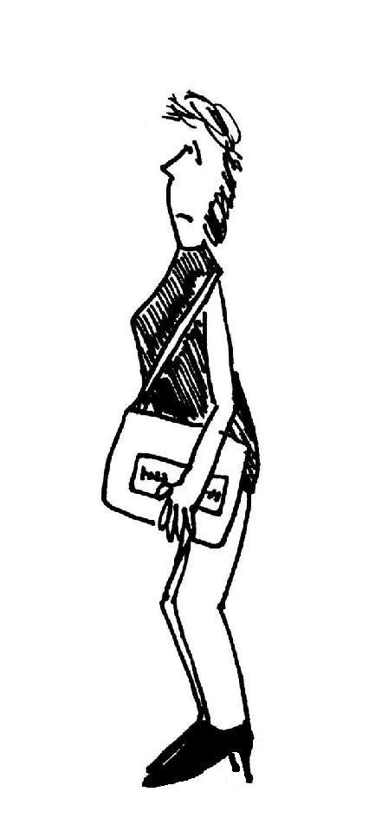
- There has been a recent fashion trend of stiletto heels, very high, sharp heels. Some women claim that wearing stilettos is empowering, while most just find it unstable. Chiropractors are definitely not in favour of this trend. "Sometimes I see a woman walking down the street with high heels and a two-ton handbag, and I want to stop her and make her aware of what she is doing to her body," Dr. Jerome McAndrews, national spokesperson for the American Chiropractic Association.
- How does wearing high heels affect the posture? Draw diagrams showing the centre of mass and forces acting on the body when standing still, both flat footed and in high heels.
- What effects might long term wearing of high heels have that so annoys Dr McAndrews (and many other chiropractors)?
- Why does carrying a heavy bag exacerbate the problem?
- Even though they don’t tip you forwards, thick flat platform soles still feel precarious and can make you unstable. Why is this?

2. You’re sitting with a friend at the Olympics and watching the pole vaulting, amazed at how high they can throw themselves. Your friend tells you that a good pole-vaulter sends their centre of gravity under the bar. How is this possible? Use a diagram to explain your answer.

B. Activity Questions:

- Centre of mass and stability
Examine the various displays to get a feel for the centre of mass and stability.
Stand with your back against the wall and try to touch your toes. What happens, and why?

- Finding your own centre of mass
Use the two bathroom scales and the long plank to find your centre of mass.
Is it where you expect it to be? Is it different for other people in your group?

- Tools
On display are tools that use 'torque' in their design and application. Identify their pivots, axes of rotation and direction of forces on the tools.
Why is it easier to loosen a tight screw with a thick handled screw driver than a skinny one?

- The human body
On display are some diagrams showing the use of torques around joints in the human body.
Identify the pivot and direction of forces on the body parts shown.
Move your own joints and see if you can feel how they pivot and where the torques are applied.

C. Quantitative Questions:

The biceps muscle is connected from the shoulder (scapula) to the radius bone at a point around 5.0 cm from the elbow, as shown below. Its contractions flex the arm. The biceps muscle acts approximately vertically to pull the arm up. The weight of the hand and forearm is around 4.0 kg for a 70 kg person, and is typically around 35 cm long, with a center of mass about halfway along.
- Show the pivot on the diagram.
- Mark where the force of the biceps is applied.
- Draw a diagram of the arm as a rod. Indicate the forces acting on it and the position of the pivot.
- Calculate the force exerted by the biceps of a 70 kg person holding their arm horizontally.
- How would this force increase if they were holding a weight, such as a heavy handbag in their hand?
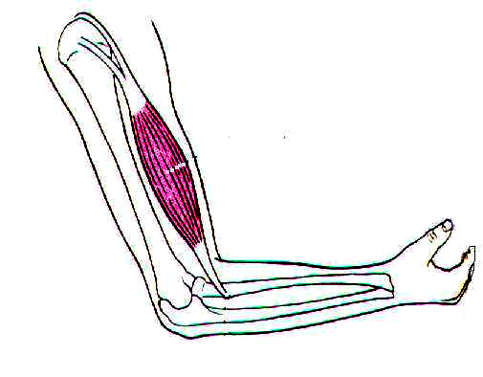
biceps muscle
humerus
radius
ulna

2. A common weight training exercise for the deltoids involves holding a weight in each hand and raising them with arms straight out to the sides of the body up to shoulder height, as shown below.
- Why is it recommended that you have your feet apart to shoulder width while doing this exercise?
- What advantages are there in doing this exercise with both arms simultaneously?
An 85 kg man is doing this exercise with 5 kg dumbbells in each hand. An arm and hand is typically 13% of the body mass. His arm is 60 cm long from shoulder to the palm of his hand, and its centre of mass is approximately half way along the arm. The deltoid muscle connects 11 cm from the shoulder joint and when the arm is horizontal can be modelled as shown below.
- How much force must the deltoid exert when the arm is horizontal?
- How much work does the deltoid do on the weight in lifting it from its lowest position to shoulder height?
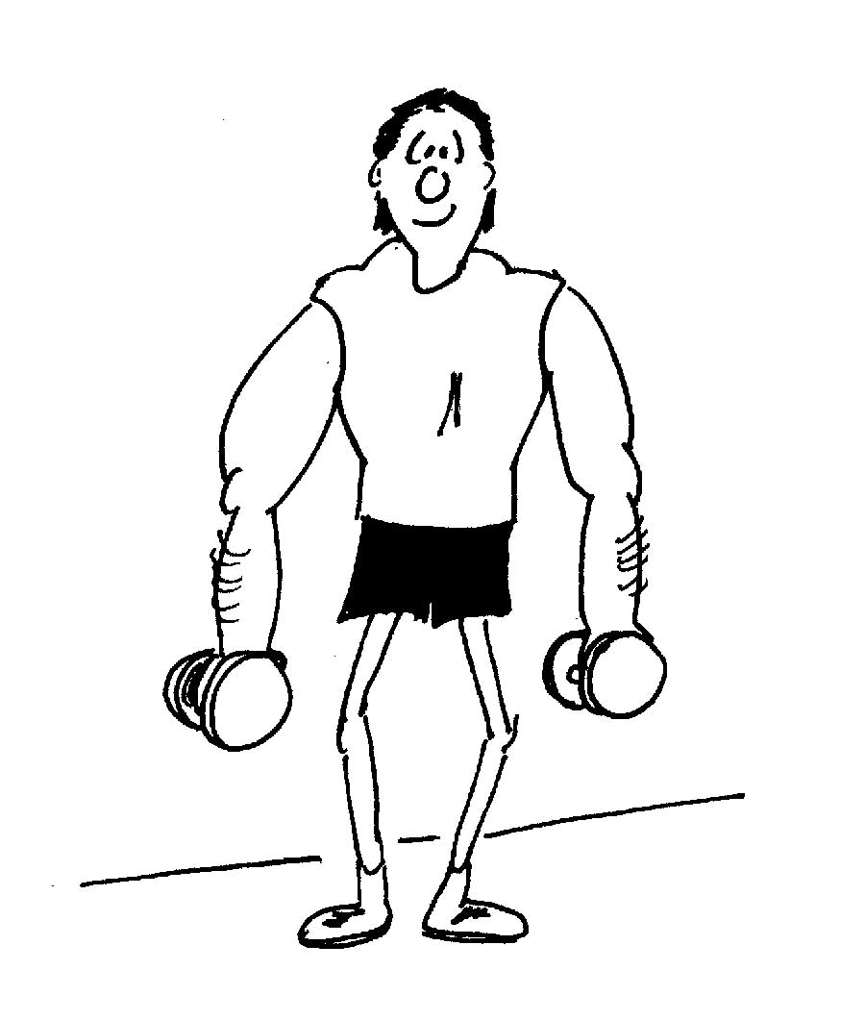
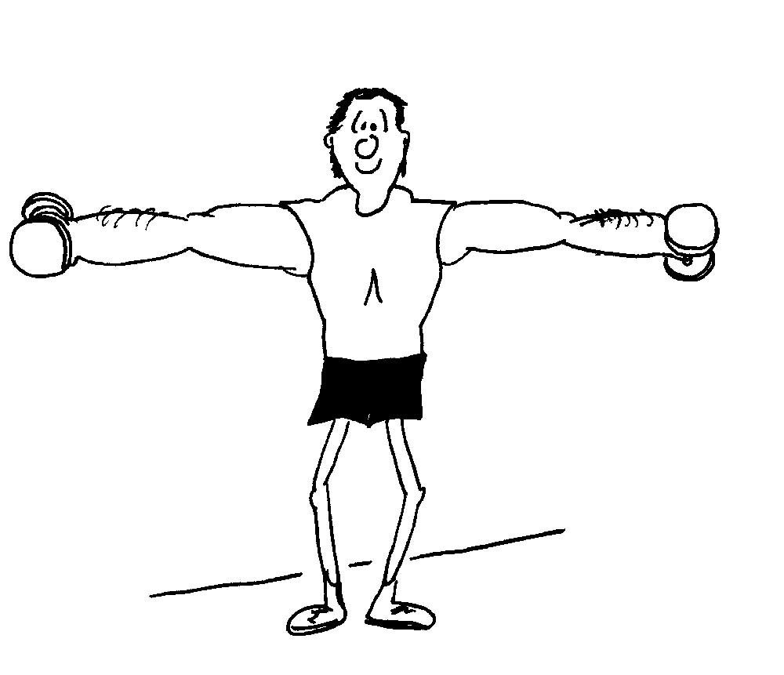
18º
11 cm

Workshop Tutorials for Biological and Environmental Physics
Solutions to MR8B: Equilibrium

A. Qualitative Questions:

- "Sometimes I see a woman walking down the street with high heels and a two-ton handbag”.
- Wearing high heels tips the body forward so that the center of mass moves forward and the body becomes less stable. A body is most stable if the center of mass lies near the center of the area of contact of the feet with the floor. To keep the body upright, muscles have to do extra work and this puts a strain on the body. See diagram opposite.  - Long term wearing of high heels means that the constant strain could cause permanent damage. High heels have been linked to arthritis in the knees.  normal posture | W  W  W  tilt due to high heels – cannot balance  adjust posture to balance
- Carrying a heavy bag changes the position of the centre of mass. Depending on the position of the bag the centre of mass could move forwards or sideways. In either case to keep the body upright, muscles have to do extra work and this puts a strain on the body.
- Platform shoes raise the center of mass and thus once again can affect the stability of the body. If the body starts to rotate (fall over) then the torque due to the mass of the body will be greater due to the longer lever arm (height above the ground). This torque needs to be counteracted by muscles in the body, if the person is not to fall over.
centre of mass
centre of mass
below bar
2. The centre of mass of the human body can be outside the body, for example if you touch your toes your centre of mass is outside your body. A pole-vaulter (and a high jumper) bends their body so that the centre of mass is outside the body. It follows a curve through the air which passes below the bar.

B. Activity Questions:

- Centre of mass and stability
As long as the center of mass is over the base, an object will be stable. When you try to touch your toes you lean back and put your bottom out. The wall behind you prevents this so you cannot touch your toes and maintain your balance.
scale
scale
center of mass
- Finding your own centre of mass
When the reading on the scales is the same, your center of mass is half way between them. Your centre of mass should be about hip height for females, and a bit higher for males.

3. Tools
The forces shown are those applied by the hands of the person applying the tool, and the object which the tool is being applied to. A thick handled screwdriver is easier to use because you can apply a greater torque for the same applied force – just like having a longer lever.
F (object)
pivot
F (hands)
F (object)
F (hands)
pivot
F (object)
F (object)
F (hands)
F (hands)
pivot
F (hands)

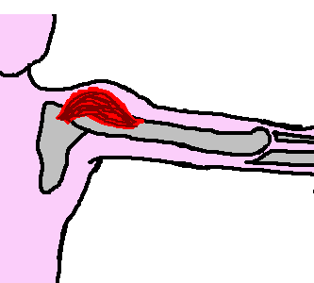
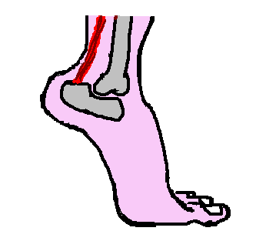
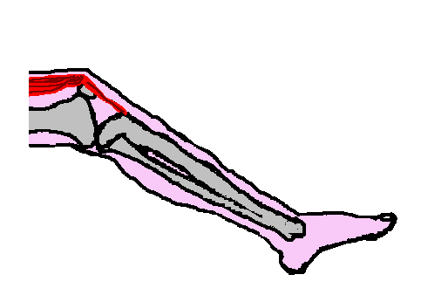
4. The human body
pivot
W_{arm}
T_{deltoid}
pivot
N_{ground}
W_{body}
T_{tendon}
pivot
W_{leg}
W_{foot}
T_{tendon}

C. Quantitative Questions:
force from biceps
m_{arm}g
pivot
arm’s centre of mass

m_{sphere}g
pivot
bicep applies force here
x
X
1.
a, b, c. see opposite.
- The biceps provide a force to counteract the weight of the arm. Considering torques about the pivot point (the elbow joint), in equilibrium τ_{biceps} = τ_{arm} so τ_{biceps} = F_{biceps}x.
τ_{arm} = m_{arm}gX = 4.0 kg × 9.8 m.s⁻² × ½(0.35 m) = 6.9 N.m.
So F_{biceps} = τ_{arm} / 0.05 m = 140 N.
- Holding a weight in the hand adds a large extra torque, as the distance from the hand to the pivot is large (35 cm). Even a small extra weight means the bicep has to apply a large extra force to keep the arm horizontal.

2. Deltoid exercises.
  - Having your feet apart gives greater stability. If your centre of mass (including the weights) lies inside the area bounded by your feet you will not fall over.
  - If you exercise both arms simultaneously then the centre of mass will more likely remain central to the body, making it easier to balance.
W_{arm}
W_{dumbbell}
F_{joint}
T_{deltoid}

  - The mass of the arm is 0.13 × 85 kg = 11 kg.
The deltoid muscle exerts a force T at an angle of 18º.
The reaction force, F_{joint}, acts at the pivot point and hence exerts no torque about that point, neither does T_{x deltoid}, the horizontal component of T_{deltoid}.
Take torques about the pivot (the shoulder joint):
0.30 m × (11 kg × 9.8 m.s⁻²) + 0.60 m × (5 kg × 9.8 m.s⁻²) = 0.11 m × T_{y deltoid}.
T_{y deltoid} = (32 + 29)N.m / 0.11 m = 560 N = T_{deltoid} sin 18º .So T_{deltoid} = 560 N / sin 18º. = 1.8 kN.
d. Defining work done as energy gained, the 5 kg mass has been lifted 0.6 m and the 11 kg arm by 0.30m. Hence total potential energy gain = (5 kg × 9.8 m.s⁻² × 0.6 m + 11 kg × 9.8 m.s² × 0.30 m) = 62 J.
Workshop Tutorials for Technological and Applied Physics
MR8T: Equilibrium

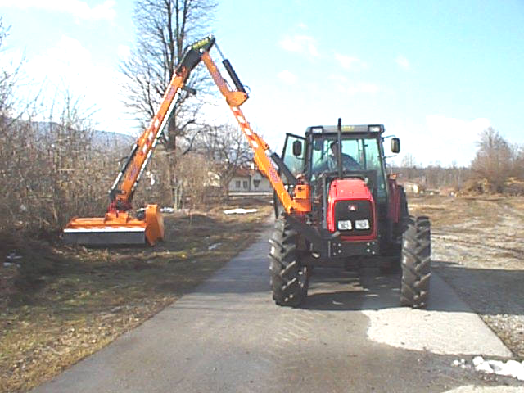
A. Qualitative Questions:

- Levers are used in many different types of machinery and in the human body. For example, hydraulic arms such as that shown opposite are used in heavy lifting machinery. There are three classes of lever, as shown in the diagram below. Class one levers have the pivot point or fulcrum between the load and the applied force. Second class levers have the load between the fulcrum and the applied force, and third class levers have the applied force between the load and the fulcrum.
- Give an example of the use of each type of lever. Use diagrams to show where the load, fulcrum and applied force are.
- What sort of lever is a wheelbarrow? What about a pair of tweezers?

applied force
load
fulcrum
Class 1
applied force
load
fulcrum
Class 2
applied force
load
fulcrum
Class 3

2. Almost any tool you can think of uses a lever to apply a torque. A wrench is an obvious example, but even a hammer acts like a part of a lever, with the elbow of the person swinging the hammer as the fulcrum. Well designed tools can make a job much easier, and safer.
- Why is it easier to undo a tight screw with a thick handled screwdriver?
- Sometimes mechanics put a bit of pipe over the handle of a wrench to give them more torque. Explain why this is very effective, but can be dangerous.
Car workshop manuals list torque settings for the bolts on the engine head, and advise that you use a torque wrench when replacing the engine head.
- Why do they list torques rather than forces?

B. Activity Questions:

- Centre of mass
Examine the various displays to get a feel for the centre of mass and stability.
Stand with your back against the wall and try to touch your toes. What happens, and why?

- Your own centre of mass
Use the two bathroom scales and the plank to find your own centre of mass.
Where is your centre of mass when the readings on the two scales are the same?
On a human the centre of mass is usually around 55% of the height, up from the feet, when the arms are at the sides of the body, a little lower on average for females than males.

3. Tools
On display are tools that use 'torque' in their design and application.
Identify their pivots, axes of rotation and direction of forces.

C. Quantitative Questions:

  - Brent is going to build a barbeque for Rebecca for her birthday. He’s borrowed his mum’s Volvo station wagon and set off down to the local brick and pavers shop. The Volvo has a mass of 1700 kg, of which 60% is supported by the front wheels and 40% by the back wheels. The car has a wheel base (the distance between the front and rear axles) of 3.5 m. The manual for the car says that it has a load capacity of 500 kg, so Brent makes sure that he only buys 500 kg of bricks.
- Brent starts loading bricks into the back of the car and notices that the front is rising. Why is this happening?
He keeps loading bricks until there are 300 kg of bricks in the back, with their centre of mass about 70 cm behind the back axle.
- How much total weight now rests on the front wheels?
- How much rests on the back wheels?
He continue loading bricks into the back and notice that the car is getting very low at the back, in fact the underside of the car is virtually touching the back wheels
- Was the manual necessarily wrong about the load carrying capacity?
- What should he do with the bricks to solve this problem?

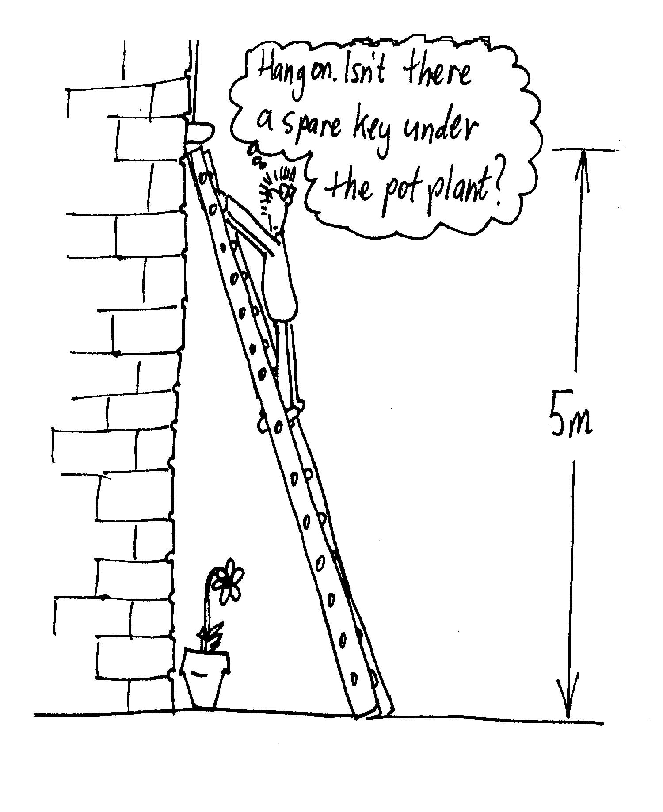
  - Brent has locked the keys in the house and is trying to get in. He walks around the house and discovers that there is an upstairs window open. The window is 5 m above ground level and the wall is made of smooth bricks and is effectively frictionless. Brent has a ladder in his shed which he sets up so the top rests on the window sill. It is 7 m long and weighs 25 kg. The coefficient of friction between the ground and the ladder is 0.45.
- Draw a diagram of Brent climbing a ladder towards the window. Label the forces acting on the ladder.
- Will he be able to climb to the top of the ladder (ie feet on the top rung) without it sliding? Assume Brent has a mass of 70kg.
- How could Rebecca help? (Apart from having a spare set of keys).

Workshop Tutorials for Technological and Applied Physics
Solutions to MR8T: Equilibrium

A. Qualitative Questions:

- There are three classes of lever, as shown in the diagram below. Class one levers have the pivot point or fulcrum between the load and the applied force. Second class levers have the load between the pivot and the applied force, and third class levers have the applied force between the load and the pivot.
- Class 1– Using a crowbar to lift a rock, where a block of wood is placed under the crowbar to provide the fulcrum. Class 2 – A nutcracker or a wrench. Class 3 – hydraulic arms (and real arms).
F (object)
pivot
F (hands)
F (object)
F (hands)
F (load)
F (lift)
pivot

pivot

- A wheel barrow is a Class 2 lever. The fulcrum is the point where the frame joins the axle, the load is in the barrow and the arms lifting the handles are the applied force. Tweezers are Class 3, since the force is applied by the fingers somewhere along the tweezers’ arms and the load lies at the end of the tweezers’ arms.

- Almost any tool you can think of uses a lever to apply a torque. A wrench is an obvious example, but even a hammer acts like a part of a lever, with the elbow of the person swinging the hammer as the fulcrum. Well designed tools can make a job much easier, and safer.
- The applied torque, $\vec{τ}$= $\vec{r}$×$\vec{F}$. The torque applied with a thick handled screw driver is greater since the lever arm is greater. The action of the hand is at a greater distance from the axis of rotation.
- Sometimes mechanics put a bit of pipe over the handle of a wrench to give them more torque. This gives a greatly extended lever arm and so greater torque for the same applied force. However if the screw or bolt suddenly loosens then the pipe can start rotating very quickly and cause an injury.
- The torque is specified since a given force could be applied in different ways to provide different torques. The torque is specified because it is important not to over-tighten the bolts which hold the engine head onto the block. Over-tightening the bolts could warp the head, damaging the engine.

B. Activity Questions:

- Centre of mass
As long as the center of mass is over the base, an object will be stable. When you try to touch your toes you lean back and put your bottom out. The wall behind you prevents this so you cannot touch your toes and maintain your balance.
scale
scale
center of mass
- Finding your own centre of mass
When the reading on the scales is the same, your center of mass is half way between them. Your centre of mass should be about hip height for females, and a bit higher for males.

3. Tools
The forces shown are those applied by the hands of the person applying the tool, and the object which the tool is acting to.
F (object)
pivot
F (hands)
F (object)
F (hands)
pivot
F (object)
F (object)
F (hands)
F (hands)
pivot
F (hands)
F (nail)

C. Quantitative Question:

1. The Volvo has a mass of 1700 kg, 60% supported by the front wheels and 40% by the back wheels. The wheel base is 3.5 m, and it has a load capacity of 500 kg.
- The load of bricks provides a torque to the back of the wagon causing it to rotate downwards (and hence the front upwards) until a new equilibrium position is found.
pivot
W_{bricks}
R_{front}
- The weight of the car and bricks on the front wheels, W_{C+B (front)}, will be equal and opposite to the reaction force R_{front} of the ground on the front wheels. We can find this by taking torques about the line of contact of the back wheels with the ground. The forces acting vertically down are weight of the car acting at the front wheels, W_{C(front)}, and the back wheels, W_{C (back),} and the weight of the bricks W_{B}.
W_{C(front)} = 0.6 × 1700 kg × 9.8 m.s⁻², W_{C(Back)} = 0.4 × 1700 kg × 9.8 m.s⁻², and W_{bricks} =300 kg × 9.8 m.s⁻².
Taking torques about the line of contact of the back wheels on the ground, forces through this line have no torque. Since the car is stationary, the clockwise torques τ_{c} have to equal the anticlockwise torques, τ_{ac}
τ_{c} = 300 kg × 9.8m.s⁻² × 0.70 m + R_{front} × 3.5 m, and τ_{ac} = 0.6 × 1700 kg × 9.8 m.s⁻² × 3.5 m.
Hence 300 kg × 9.8 m.s⁻² × 0.70 m + R_{front} × 3.5 m =0.6 × 1700 kg × 9.8m.s⁻² × 3.5 m, and R_{front} = 9400 N.
- To find the weight on the back wheels we need to find the reaction force R_{back} of the ground on the back wheels. Since the car is stationary the total sum of forces on the car equals zero.
Hence R_{back} + R_{front} = 1700 kg × 9.8 m.s⁻² + 300 kg × 9.8 m.s⁻².
R_{back} = 2000 kg × 9.8 m.s⁻² – 9408 N = 10192 N = 10 kN.
- No the manual isn’t wrong, he needs to spread the load.
- He should put some of the bricks in front of the back axle i.e. inside the car.
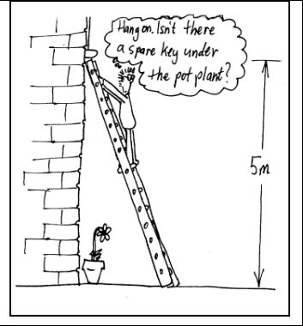
R_{wx}
R_{Gx}
R_{Gy}
W_{L}
W_{B}
2. Brent climbing the ladder.
- See diagram opposite. R_{Gx} and R_{Gy} are the reaction at the ground on the ladder. R_{wx} is the reaction of the wall on the ladder, R_{wy} = 0 as the wall is frictionless. W_{L} and W_{B} are the weight of the ladder and Brent respectively. The angle θ can be found: sin θ = 5/7, so θ = 45.6º.
- R_{Gx} =μ R_{GY} is the maximum frictional force that can be exerted by the ground. In equilibrium : Σ Fx = 0 and hence R_{Gx} = R_{wx}
The Σ Fy =0 and the net τ about any point = 0.
Take the torques about the point where the ladder touches the ground. R_{wx} × 0.5 m = W_{L} × 3.5 sin θ + W_{B} × 7 m × cos θ, gives R_{wx}= 790 N. But R_{Gy} = W_{L}+ W_{B} and the maximum value of R_{Gx} is
R_{Gx max} = 0.45 × R_{Gy} = 0.45 × (25 kg + 70 kg) × 9.8 m.s² = 419N.
Hence R_{wx} does not = R_{Gx}, and so the ladder slips.
Brent can not climb to the top of the ladder without it slipping.
- Rebecca needs to apply a horizontal force, pushing the ladder against the wall to stop it from sliding.

Workshop Tutorials for Biological and Environmental Physics
MR9B: Rotational Dynamics I

A. Qualitative Questions:

1. When you’re sitting in a car which rounds a corner at high speed you can feel yourself pushed radially outwards against the car door or the person sitting next to you. If you were orbiting the Earth in the space shuttle you would not feel this force. Why is this the case?

- Rebecca has gone to a conference in Cairns in northern Queensland, leaving Brent at home in Sydney to look after Barry the dog.
  - Which one them has the greater angular speed, ω?
  - Which of them has the greater linear speed, v?
Use a diagram showing their positions on the Earth to explain your answers.

B. Activity Questions:

- Clocks
What is the angular speed of the second hand?
What are the angular speeds of the minute and hour hands?
Does the size of the clock affect the angular speeds of the hands?
Does it affect the linear speed of the ends of the hands?

- Rotation platform
What affects the 'slipping off' of the block?
Which way does the block go as it slips off?
Where is it more likely to slip, and why?

- A Loaded Race
Will all the cylinders roll down with same speed?
Will all the spheres roll down with same speed?
Try rolling them down the incline.
Explain why some of them roll down faster than the others.

C. Quantitative Question:

- Many bacteria have flagella or cilia, tiny little waving appendages, which they use to propel them selves. These were always believed to just wave around to move the bacteria, but it turns out that some of them actually act as tiny propellers. However the smallest natural propeller is part of an ATPase molecule. An ATPase is an enzyme which either breaks down or builds up an ATP(Adenosine tri-phosphate) molecule. ATP is the energy currency of cells: energy is liberated by breaking one of the phosphate bonds, or stored by attaching a phosphate. The FI-ATPase molecule has seven sub-units, six of which form a ring around the seventh sub-unit, as shown below. This middle piece actually spins around like the rotor of an electric motor, but it was only by attaching another molecule like a propeller blade that it was possible to observe this movement.
FI-ATPase molecule
propeller
actin molecule
- If each rotation takes 100 ms, what is the angular velocity of the attached actin molecule?
- If the actin molecule is 1 μm long and has a mass of 2 × 10⁻²²kg, what is the moment of inertia of the propeller?
- Assuming constant angular acceleration, if it takes 100 ms to perform a rotation starting from rest, what is the angular acceleration of the actin?

I_{rod} = $\frac{1}{3}$ml².

- Australia’s first wind farm is located on King Island, and the Tasmanian government is considering a plan to set up a new 130 MW wind farm in north west Tasmania. If you want to set up your own wind generator, it is possible to get plans from the internet to build your own home wind generator. One design uses a steel rotor which weighs around 20 kg, and is 2 m long.
pivot
2 m

- What is the moment of inertia of the rotor if you treat it as a single rod?
The designer of this wind generator claims that it can produce 500 Watts in a 35 km.h⁻¹ wind, which is not much more than a pleasant breeze.
- If the output from the generator is 15% of the kinetic energy of the rotor, how fast (how many revolutions per minute) must the rotor be doing to give this output?
- How many of these home made windmills would you need to set up a wind farm capable of producing 130 MW in a 35 km.h⁻¹ wind?

I_{rod} = $\frac{1}{\text{12}}$Ml². where l is the total length of the rod and M is the mass of the rod.

Workshop Tutorials for Biological and Environmental Physics
Solutions to MR9B: Rotational Dynamics I

g
tyres
v
friction
car
Space shuttle

A. Qualitative Questions:

1. If you are in a car that rounds a corner, you pitch outward against the inside of the car door, not because of some outward force, but because there is no force holding you in the circular motion (which the seat belts or the friction between the seat and you would have provided). In the absence of a force, you tend to go in a straight line while the car curves, crosses your straight line path and intercepts you. In a space shuttle, you feel the same gravitational pull towards the earth as the shuttle. In the absence of the shuttle you will still go in a circular path and no force from the shuttle is required to hold you in that path. (This is free fall.)

- Rebecca is in Cairns, Brent is in Sydney.
a. Both Rebecca and Brent move 2π radians (one rotation) in 24 hours as the Earth spins, hence they have the same angular velocity.
b. Rebecca is further north than Brent, and closer to the equator (Southern hemisphere), hence her distance from the axis of rotation of the Earth is greater than Brent’s. She travels a greater distance in the same time, 24 hours, so she must have a greater linear velocity, v.

B. Activity Questions:

- Clocks
The second hand goes around the clock face, that is through 2π radians, in 1 min.
So its angular speed is 2π radian/60 seconds, that is 0.105 rad.s⁻¹.
The minute hand goes around the clock face in one hour.
So its angular speed is 2π / 3600 rad.s, that is 1.75 × 10⁻³ rad.s⁻¹.
The hour hand goes around the clock face in 12 hours. 12 hours is 12 hours × 60 min/hour × 60 s/min, that is 43200 s. So its angular speed is 2π rad / 43200s, that is 1.45 × 10⁻⁴ rad.s⁻¹.
The angular speed will be the same regardless of the clock size, however the linear speed of the pointers at the ends of the hand will be greater for larger clocks.
mg
N
F_{fric}
- Objects on a rotation platform
Speed of rotation, distance from the centre and friction affect slipping; mass doesn't affect slipping.
The box will slide off at a tangent to the curve, in the direction of its velocity vector. At the edges of the platform the linear acceleration is greatest, hence it is most likely to slip when close to the edge.

- A loaded race
m
v = 0 m.s⁻¹
v > 0 m.s⁻¹
h

Neglecting air resistance all the solid spheres will hit the bottom at the same time. From energy conservation equations we have

mgh = ½ mv² + ½ Iω² rearranging for v gives for solid spheres. Thus the velocity at the bottom of the ramp is independent of M and R ie all the balls should reach the bottom at the same time.

For a solid cylinder
Generally spheres have a higher speed than a cylinder.

C. Quantitative Question:

- Spinning ATP molecule.
- One complete rotation takes 100 ms, so the angular velocity is
ω = 2πf = 2π(1/T) = 2π(1/0.100s) = 62.8 rad.s⁻¹
(This is 6000 rpm, about the red-line on the tachometer of most 4 cylinder cars.)
- If we treat the actin molecule as a rod 1 μm long with a mass of 2 × 10⁻²²kg, pivoted at one end, the moment of inertia of the actin propeller is
I = ml²/3 = 2 × 10⁻²²kg×(1 × 10⁻⁶m)² /3 = 7 × 10⁻³⁵ kg.m².
- Assuming constant angular acceleration, if it takes 100 ms to perform a rotation starting from rest, the angular acceleration of the actin is α = Δω/Δt = (62.8 rad.s⁻¹ – 0) /0.100s =628 rad.s⁻²

2. A wind generator uses a single steel rotor which weighs around 20 kg, and is 2 m long.
  - Since the rotor is rotating about its midpoint the moment of inertia,
I = I_{rod} = $\frac{1}{\text{12}}$Ml² = $\frac{1}{\text{12}}$× 20 kg × (2 m)² = 6.7 kg.m².
  - The kinetic energy of the rotor is in the form of rotational kinetic energy KE = ½Iω². The output is 15% of this and has to equal 500 Joules each second (500 Watts).
Each second, ½ Iω² × (15/100) = 500 J, rearranging for ω² gives:
ω² = 500 J × (100/15) × 2/6.7 kg.m² = 995 rad² s⁻¹, so ω = 31 rad.s⁻¹.
In revolutions per min, ω = 31 × 60/2π revs. per minute = 300 revs.per minute.
  - To generate 130 MW, we need 130 MW / 500W = 26,000 generators.
A small home wind generator generates around 500 W, so to commercially produce electricity you would need a lot (26,000) generators. Large commercial wind generators can generate several MW.

Workshop Tutorials for Technological and Applied Physics
MR9T: Rotational Dynamics I

A. Qualitative Questions:

- A toy aeroplane at the end of a string is swung in a vertical circle as shown below.
A
E
C
B
D
- Draw a free body diagram showing the forces acting on the plane for each of the positions A, B, C, D and E.
- What is the direction of the net force at A?
- What is the direction of the net force at E?
- What can you say about the net force at the other positions? Is it radially inwards?
- What is the minimum velocity at A to keep the plane moving in a circle of radius R?

- With the growing concern about the environment, alternative energy sources such as solar and wind are becoming increasingly popular. A small wind generator can be built from parts easily available from hardware stores, and several commercial models are available in Australia.
Consider the rigid blade of a wind generator. The blade is free to rotate about a fixed axis.
- Can the blade have non zero angular acceleration even if the angular velocity of the body is (perhaps instantaneously) zero?
You don’t have enough steel to make the rotor blades, but you have some wood, so you make the blades half out of wood and half out of steel as shown.
Pivot
Pivot
steel
wood

- For a given wind velocity, which arrangement shown above will give the greater angular acceleration?

B. Activity Questions:
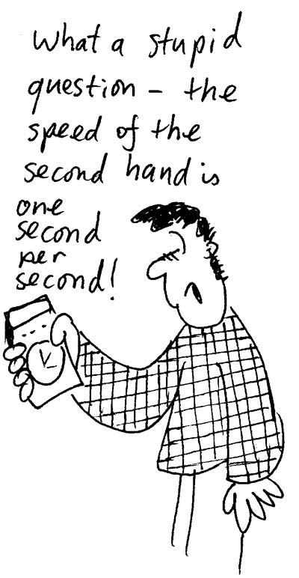
- Clocks
What is the angular speed of the second hand?
What are the angular speeds of the minute and hour hands?
Does it matter how big the clock is?
Does it make a difference to the linear velocity?

- Rotation platform
What affects the 'slipping off' of the block?
Which way does the block go as it slips off?
Where is it more likely to slip, and why?

- A loaded race
Will all the cylinders roll down with same speed?
Will all the spheres roll down with same speed?
Try rolling them down the incline.
Explain why some of them roll down faster than the others.

C. Quantitative Questions:

- In an Atwood's machine (as shown), one block has a mass of 500 g and the other block has a mass of 460 g. The pulley, which is mounted in horizontal frictionless bearings, has a radius of 5.0 cm.
The pulley has a mass and so the tension in the two parts of the rope is different. When released from rest, the heavier block is observed to fall 75.0 cm in 5.0 s (without the cord slipping on the pulley).Describe the motion of the blocks when they are released from rest.  - Describe the motion of the pulley. What causes it to accelerate?  - What is the acceleration of each block?  - What is the tension in the part of the cord that supports the heavier block?  - What is the tension in the part of the cord that supports the lighter block?  - What is the angular acceleration of the pulley?  - What is the rotational inertia of the pulley? | 460 g  500 g

- Consider a formula one racing car engine being tested. The angular position θ of the flywheel is given by θ = (2.0 rad.s⁻³)t³. The diameter of the flywheel is 0.36 m.
- Find the angle θ, in radians and in degrees, at times t₁ = 2.0 s and t₂ =5.0 s.
- Find the distance that a particle on the rim moves during that time interval.
- Find the average angular velocity, in rad.s⁻¹ and in rev.min⁻¹ (rpm), between t₁ = 2.0 s and t₂=5.0 s.
- Find the instantaneous angular velocity at t = 3.0 s.
- Find the average angular acceleration between t₁ = 2.0 s and t₂=5.0 s.
- Find the instantaneous angular acceleration at t = 2.0 s.

Workshop Tutorials for Technological and Applied Physics
Solutions to MR9T: Rotational Dynamics I
A
E
C
B
D
mg
mg
mg
mg
T
T
T
T
T
r
mg
A. Qualitative Questions:

1. A toy aeroplane is swung in a vertical circular.
- See free body diagram opposite.
- The net force at A is directly downwards, and towards the centre of the circle.
- The net force at E is directly upwards, and towards the centre of the circle.
- At other positions the net force is the sum of the tension and the weight, mg, and is not quite directed radially inwards.
- At point A the net force is T + mg, which must equal the centripetal force, mv²/R.
So we can write mv²/r.= T + mg, or v² = r.(T + mg)/m.
The minimum possible value of the tension is zero, and this will give the minimum value of v needed to maintain circular motion. Hence v_{min}² = r(mg)/m = rg and so v_{min} = $\sqrt{\text{rg}}$.

- Consider the rigid blade of a wind generator. The blade is free to rotate about a fixed axis.
- The blade can have non zero angular acceleration even if the angular velocity of the body is (perhaps instantaneously) zero. There will be a non zero value whenever the velocity is changing – even if it is passing through zero, for example as it changes direction of rotation.
Pivot
Pivot
steel
wood

The arrangement on the left has a greater moment of inertia because the denser part of the blade, the steel, is located at a greater distance from the pivot. The torque, τ, required to give an angular acceleration, α, is τ = Iα. For a given wind velocity, the greater the moment of inertia, the lower the angular acceleration, hence the arrangement on the right, with smaller I, will have a greater angular acceleration, α.

B. Activity Questions:

- Clocks
The second hand goes around the clock face, that is through 2π radians, in 1 min.
So its angular speed is 2π radian/60 seconds, that is 0.105 rad.s⁻¹.
The minute hand goes around the clock face in one hour.
So its angular speed is 2π / 3600 rad.s, that is 1.75 × 10⁻³ rad.s⁻¹.
The hour hand goes around the clock face in 12 hours. 12 hours is 12 hours × 60 min/hour × 60 s/min, that is 43200 s. So its angular speed is 2π rad / 43200s, that is 1.45 × 10⁻⁴ rad.s⁻¹.
mg
N
F_{fric}
- Objects on a rotation platform
Speed of rotation, distance from the centre and friction affect slipping; mass doesn't affect slipping. The box will slide off at a tangent to the curve, in the direction of its velocity vector. At the edges of the platform the linear acceleration is greatest, hence it is most likely to slip when close to the edge.

- A loaded race
Neglecting air resistance all the solid spheres will hit the bottom at the same time. From energy conservation equations we have mgh = ½ mv² + ½ Iω². Rearranging for v gives for solid spheres. Thus the velocity at the bottom of the ramp is independent of M and R hence all the balls should reach the bottom at the same time.
For a solid cylinder , so generally spheres have a higher speed than a cylinder.

C. Quantitative Questions:

- One block has a mass of 500 g, and the other a mass of 460 g. The pulley has a radius of 5.00 cm. When released from rest, the heavier block falls 75.0 cm in 5 s (without the cord slipping on the pulley).
- The acceleration, a, of the blocks are of constant magnitude, either up or down. If down is taken to be +ve and '+a' is the acceleration of the heavier block, its vertical displacement is given by y = ½ at². The pulley accelerates due to the torque from the rope. The torque results from the tensions in either part of the rope being different, if they were the same there would be no net torque.
m_{l}
m_{h}g
m_{h}
m_{l}g
T_{h}
T_{l}
a
a
- Both blocks have the same magnitude of acceleration given by
a = $\frac{2y}{t^{2}}$= $\frac{2×0\text{.}\text{75}m}{(5\text{.}\text{00}s)^{2}}$ = 0.06 m.s⁻².
The heavy block accelerates down, the lighter block accelerates up.

- The net force on the heavier block is m_{h}g – T_{h} = m_{h}a. So:
T_{h} = m_{h} (g –a) = 0.50 kg (9.8 m.s⁻² – 0.06 m.s⁻²) = 4.9 N.
- For the lighter block m_{l}g – T_{l} = -m_{l}a. So: T_{l} = m_{l} (g + a) = 0.46 kg (9.8 m.s⁻² + 0.06 m.s⁻²) = 4.5 N
- Since the cord does not slip on the pulley, the tangential acceleration of a point on the run of the pulley must be the same as the acceleration of the blocks, so α = a/R = 0.060 m.s⁻² / 0.050 m = 1.2 rad.s⁻².
- We know the acceleration of the pulley, so we can find the moment of inertia if we know the net torque acting on it. The net torque acting on the pulley is T = (T_{h} - T_{l})R = Iω. So now:
I = $\frac{(T_{h}−T_{l})R}{α}$ = $\frac{(4\text{.}9N−4\text{.}5N)0\text{.}\text{05}m}{1\text{.}2\text{rad}\text{.}s^{\text{-2}}}$= 1.4 × 10⁻² kg.m².

- θ = (2.0 rad.s⁻³)t³, the diameter of the flywheel is 0.36 m.
  - θ₁ = (2.0 rad.s⁻³)(2.0 s)³ = 16 rad = 920º, and θ₂ = (2.0 rad.s⁻³)(5.0 s)³ = 250 rad = 14,000º.
b. In this time the flywheel turns through an angular displacement of θ₂ - θ₁ = 250 rad – 16 rad = 234 rad.
The radius r is half the diameter, or 0.18 m. So the distance, d, is d = rθ = 0.18 m × 234 rad = 42 m.
c. The average angular velocity is ω_{av} = $\frac{θ_{2}−θ_{1}}{t_{2}−t_{1}}$= $\frac{\text{250}\text{rad - 16 rad}}{5\text{.}0\text{s-2}\text{.}\text{0s}}$= 78 rad.s⁻¹.
There are 2π radians per revolutions so ω_{av} = 2π × 78 rad.s⁻¹ = 12.4 rev.s⁻¹ = 740 rev.min⁻¹.
d. The instantaneous angular velocity is given by
ω = dθ /dt = d/dt [(2.0 rad.s⁻³) t³] = 2.0 rad.s³ (3t²) = 6.0 rad.s⁻³t².
So at time t = 3.0 s, ω = 6.0 rad.s⁻³t² = 6.0 rad.s⁻³× (3.0 s)² = 54 rad.s⁻¹.
e. The acceleration is the change in velocity. The values of ω at the two times are
ω₁ = 6.0 rad.s⁻³× (2.0 s)² = 24 rad.s⁻¹ and ω₂ = 6.0 rad.s⁻³× (5.0 s)² = 150 rad.s⁻¹,
so the average angular acceleration over this time is α_{av} = $\frac{\text{150}\text{rad}\text{.}s^{\text{-1}}\text{ - 24 rad}\text{.}s^{\text{-1}}}{5\text{.}0\text{s-2}\text{.}\text{0s}}$= 42 rad.s².
- The instantaneous angular acceleration at any time is α = dω/dt = d/dt [6.0 rad.s⁻³t²] = 12 rad.s⁻³ × t.
- So at t = 2s the angular acceleration is α = 12 rad.s⁻³ × t = 12 rad.s⁻³ × 2.0 s = 24 rad.s⁻².
Note that the acceleration is not constant but is increasing in time in this case.
Workshop Tutorials for Biological and Environmental Physics
MR10B: Rotational Dynamics II

A. Qualitative Questions:

- Global warming is an important issue. Many scientists believe that some of the ice in the arctic and antarctic will melt due to increasing temperatures over the next few decades. This will have many effects, such as decreasing sea temperature and increasing water levels. As the ice melts the water will be redistributed such that there will more water near the equator.
- What effect would this have on the moment of inertia of the Earth?
- How will this effect the length of a day?

- One of the most popular forms of entertainment in the world is sport, and millions of dollars are spent developing better tennis racquets, lower friction swimming suits, harder to detect performance enhancing drugs and more efficient bicycles. As a professional physicist you’ve been called in by the Australian Institute of Sport to help them design a better bicycle wheel. There are two designs that they’re investigating. The first is a solid wheel of uniform density, and the second is a spoked wheel with very light spokes so that virtually all the mass of the wheel is at the rim. Both wheels have the same mass and radius.
- For a given translational velocity, assuming no slipping, which will be greater for the solid wheel; its translational kinetic energy or its rotational kinetic energy?
- What about for the spoked wheel at the same translational velocity?
- Which wheel will you recommend that they use and why?

(note: I_{disc} = ½ MR², I_{hoop} = MR²)

B. Activity Questions:

- The rotating stool
Sit on the stool and start rotating with equal weights held in your hands.
Start with the hands in close to your chest and slowly stretch your hands outwards.
What do you observe?
What happens when you pull them back in again? Why?

- Bicycle wheel
Spin up the bicycle wheel. What do you feel when you try to tilt the wheel?
Carefully hand the wheel to someone sitting on the rotating stool.
What happens when they tilt the wheel? Why?
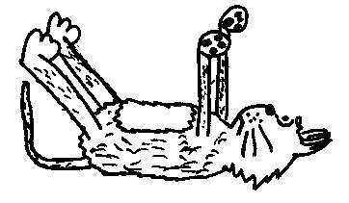
- Falling cats
The diagram on display shows how a cat can rotate itself around so that it always lands on its feet. Sit on the rotating stool and see if you can turn yourself around the way a cat does.
How is it possible to do so without violating conservation of angular momentum?

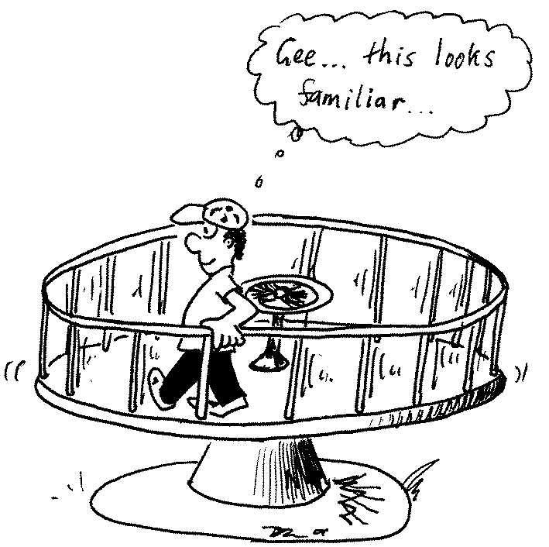
C. Quantitative Questions:

- A merry go round can be described as a horizontal platform in the shape of a disc which rotates on a frictionless bearing about a vertical axis through its centre. The platform has a mass of 150 kg, a radius of 2.0 m and a rotational inertia of 300 kg.m². A 60 kg student walks slowly from the rim of the platform toward the centre. If the angular speed of the system is 1.5 rad.s⁻¹ when the student starts at the rim, what is the angular speed when he is 0.5 m from the centre?

- There are two competing forces in stars which for most of a stars existence roughly balance. One is the gravitational force which pulls the atoms and subatomic particles in towards each other. The other is an outward pressure due to the thermal energy of the particles, which bump against each other. As the nuclear processes in a star slow down the star begins to cool, and gravity becomes stronger than thermal pressures.
- What happens to the star when it runs low on nuclear fuel?
- What happens to the star’s moment of inertia?
The surface of our sun rotates at about one revolution per month, although being made of gas it rotates more slowly at the equator than at the poles. It has a mass of 2 × 10³⁰ kg and a radius of 1.4 million kilometres.
- Assuming that the whole sun rotates at one revolution per month, what is the angular momentum of the sun?
Old collapsed stars, called neutron stars, can rotate at speeds up to 800 revolutions per second.
- By how much would our sun have to collapse to spin at this speed?

Workshop Tutorials for Biological and Environmental Physics
Solutions to MR10B: Rotational Dynamics II

A. Qualitative Questions:

- As polar ice melts the water will be redistributed such that there will more water near the equator.
- If there is more water near the equator there will be greater mass further from the axis of rotation of the earth. Hence the moment of inertia will be greater.
- Conservation of angular momentum tells us that Iω stays constant, providing no external torques are acting. If we assume this is the case then as I increases, ω will decrease. The rate of rotation slows down and the days will lengthen.

2. Bicycle wheels.  a. For a given velocity, v, the solid wheel will have a translational kinetic energy of ½ Mv² where v is the velocity of the centre of mass. Its rotational kinetic energy is ½ Iω² = ½ (½ MR²) ω² and using v = ωR we get a rotational energy of ½ (½ MR²)(v/R)² = ¼ Mv². This is only half the value of the translational kinetic energy.  b. The spoked wheel can be approximated as a hoop, and will have a translational kinetic energy of ½ Mv² where v is the velocity of the centre of mass, same as the solid wheel.  Its rotational kinetic energy is ½ Iω² = ½ (MR²) ω² and using v = ωR we get a rotational energy of ½ (MR²)(v/R)² = ½ Mv², exactly the same as the translational kinetic energy. | v_{cm}  ω  solid wheel;  I = ½ MR²  spoked wheel;  I = MR²  v_{cm}  ω
c. If you accelerate the wheel while riding, more energy goes into translational motion for the solid wheel than for the spoked wheel, for a given mass and radius, hence this design will be faster.

B. Activity Questions:

large I, small ω.
small I, large ω.
- Rotating Stool
The angular momentum of the system (person and weights) is conserved. When, sitting on a rotating stool, you stretch your hands the system has a larger rotational inertia and a smaller angular velocity. When the hands are pulled inward towards the body the rotational inertia decreases and hence the angular velocity increases.

- Bicycle wheel
If the wheel is not spinning it is easy to tilt it from side to side. When the wheel is spinning it can be very difficult to tilt it, and you feel it exerting a large force on you. Tilting the wheel changes its (vector) angular momentum, and this requires a torque to be exerted by you. When a person sitting on the rotating stool tries to tilt the wheel they also feel the force that it exerts on them, but they are not held stationary to the ground by friction, so they begin to rotate with the stool. Angular momentum is conserved - when the person changes the angular momentum of the wheel by tilting it, their angular momentum must change also. (Remember that angular momentum is a vector quantity, it changes when the direction or plane of rotation changes, not only when the angular speed changes.)

- Falling cats
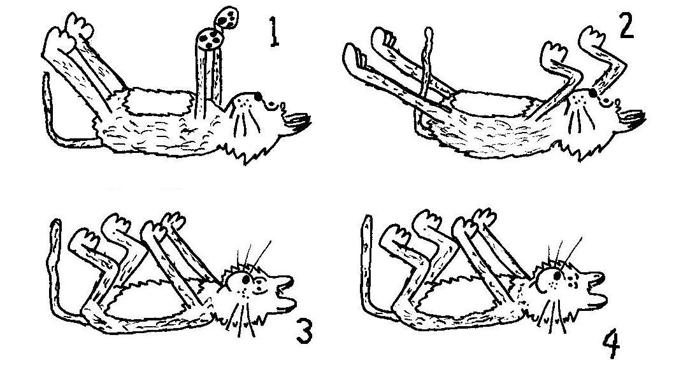
Conservation of angular momentum is not violated, at any time your total angular momentum is zero.
The procedure is as follows:
- Falling with all four limbs sticking straight out.
- Pull in front legs (arms) and rotate them 60º clockwise. Outstretched rear legs have to rotate 30⁰ anti-clockwise.
- Extend front legs (arms) and rotate them 30º anti-clockwise, and pull in back legs which have to rotate 60º clockwise.
You should now be rotated 30º clockwise. Repeat this 5 times and you’ll be facing the right way and ready to land!

C. Quantitative Questions:

- As the student moves in from the rim his moment of inertia changes and so the total moment of inertia of the system (platform + student) changes. Since the interaction occurs between the student and the platform we can regard this as a collision and angular momentum (Iω ) is conserved. The moment of inertia of the student is I_{s} = m_{s}r_{s}². Now (Iω )_{i} = (Iω )_{f} so, (I_{p} + I_{si})ω _{i} = (I_{p} + I_{sf})ω _{f ,} so:
ω_{f} = $\frac{(I_{p} +I_{\text{si}})ω_{i}}{(I_{p} +I_{\text{sf}})}$ = $\frac{(\text{300} \text{kg}\text{.}m^{2} +60 \text{kg }×(2 m)^{2})1\text{.}5 \text{rad}\text{.}s^{\text{-1}}}{(\text{300} \text{kg}\text{.}m^{2} +60 \text{kg }×(0\text{.}5 m)^{2})}$ = 2.6 rad.s⁻¹.

2. Stars and angular momentum conservation.
a. When a star runs low on nuclear fuel it starts to cool and the pressure inside it decreases, allowing it to contract due to the force of gravity.
b. The mass of the sun will not change much, but as it contracts its radius decreases and hence its moment of inertia will decrease.
c. The moment of inertia of a solid sphere is (2/5) (MR²). The angular momentum is Iω = (2/5) (MR²)ω where ω = 2π rad/month, on average there are 3600×24×365/12 seconds in a month, ~ 2.63×10⁶s,
so ω = 2π/2.63×10⁶s = 2.39×10⁻⁶ rad.s⁻¹. So the angular momentum is
(2/5) (MR2)ω = (2/5)× 2 × 1030 kg × (1.4 × 109m)2× 2.39×10-6 rad.s-1 = 3.75 × 1042 kg.m2.s-1.
d. For our sun to rotate at 800 rev.s¹ , or ω ~ 5000 rad.s⁻¹, with the same angular momentum, we need I_{i}ω_{i} = I_{f}ω_{f}. so I_{f} = I_{i}ω_{i} /ω_{f}.  so I_{f} = 3.75 × 10⁴² kg.m².s⁻¹ / 5000 s⁻¹ = 7.5 × 10³⁸ kg.m².  We can now use I = (2/5) (MR²) to find the new radius:  R² = . I / [(2/5) (M)]  = 7.5 × 10³⁸ / [(2/5) (2 × 10³⁰ kg)] = 9.38×10⁸ m²  R = 3.06×10⁴ m or only about 30km. This is a huge decrease from the original 1.4 million km! | large I,  small ω.  tiny I,  HUGE ω.

Workshop Tutorials for Technological and Applied Physics
MR10T: Rotational Dynamics II

A. Qualitative Questions:

- Imagine standing on the edge of a merry-go-round. The merry-go-round is rotating clockwise.
- Where are you more likely to slide off the merry go round; near the middle or near the edge?
- If you walk in towards the centre of the merry-go-round, what will happen to your angular momentum and angular velocity?
- If you stay at the edge and start to walk in the direction of the rotation what will happen to the angular momentum of the system (you plus the merry-go-round)?
- What will happen to the angular momentum and angular velocity of the merry-go-round?
- What will happen to your angular momentum and angular velocity?
- How would it be different if you started to walk in the opposite direction?

- One of the most popular forms of entertainment in the world is sport, and millions of dollars are spent developing better tennis racquets, lower friction swimming suits, harder to detect performance enhancing drugs and more efficient bicycles. As a professional physicist you’ve been called in by the Australian Institute of Sport to help them design a better bicycle wheel. There are two designs that they’re investigating. The first is a solid wheel of uniform density, and the second is a spoked wheel with very light spokes so that virtually all the mass of the wheel is at the rim. Both wheels have the same mass and radius.
- For a given translational velocity, assuming no slipping, which will be greater for the solid wheel; its translational kinetic energy or its rotational kinetic energy?
- What about for the spoked wheel at the same translational velocity?
- Which wheel will you recommend that they use and why?
(note: I_{disc} = ½ MR², I_{hoop} = MR²)

B. Activity Questions:

- The rotating stool
Sit on the stool and start rotating with equal weights held in your hands.
Start with the hands in close to your chest and slowly stretch your hands outwards.
What do you observe?
What happens when you pull them back in again? Why?

- Falling cats
The diagram on display shows how a cat can rotate itself around so that it always lands on its feet. Sit on the rotating stool and see if you can turn yourself around the way a cat does.
How is it possible to do so without violating conservation of angular momentum?

- Bicycle wheel
Spin up the bicycle wheel. What do you feel when you try to tilt the wheel?
Carefully hand the wheel to someone sitting on the rotating stool.
What happens when they tilt the wheel? Why?

C. Quantitative Questions:

- A merry go round can be described as a horizontal platform in the shape of a disc which rotates on a frictionless bearing about a vertical axis through its centre. The platform has a mass of 150 kg, a radius of 2.0 m and a rotational inertia of 300 kg.m². A 60 kg student walks slowly from the rim of the platform toward the centre. If the angular speed of the system is 1.5 rad.s⁻¹ when the student starts at the rim, what is the angular speed when he is 0.5 m from the centre?
I_{B}
ω_{A}
ω_{B}
I_{A}
I_{A} + I_{B}
ω
- The figure shows two disks, one an engine flywheel, the other a clutch plate attached to a transmission shaft. Their moments of inertia are I_{A} and I_{B}; initially, they are rotating with constant angular velocities ω_{A} and ω_{B}, respectively. We then push the disks together with forces acting along the axis only, so as to keep their faces parallel. The disks rub against each other and eventually reach a common final angular velocity, ω.
- Derive an expression for ω.
Suppose the flywheel A has a mass of 2.0 kg, a radius of 0.20 m, and an initial angular velocity of 50 rad.s⁻¹ and the clutch plate B has a mass of 4.0 kg, a radius of 0.10 m, and an initial angular velocity of 200 rad.s⁻¹.
- Find the common angular velocity, ω, after the disks are pushed into contact.
- Is kinetic energy conserved in this process?

Workshop Tutorials for Technological and Applied Physics
Solutions to MR10T: Rotational Dynamics II

A. Qualitative Questions:

- Imagine standing on the edge of a merry-go-round. The merry-go-round is rotating clockwise.
- You are most likely to slip off near the edge of the merry go round as this is where your linear velocity and acceleration are greatest and a larger frictional force is required to provide this acceleration.
- If you walk in towards the centre of the merry-go-round, the moment of inertia will decrease. If angular momentum is to be conserved the merry-go-round, and you, will rotate faster.
- If you stay at the edge and walk in the direction of the rotation there are no external forces acting on the system so the angular momentum must be conserved. The moment of inertia is not changing, so the angular velocity will remain the same.
force of merry go round on foot
force of foot on merry go round
ω decreases
- You apply a force to the merry go round as you push your foot backwards against it, slowing it down and decreasing its angular momentum and angular velocity.
- Angular momentum is conserved, so your angular momentum and angular velocity increase as the angular momentum and angular velocity of the merry-go-round decreases. This is due to the reaction force of the merry-go-round pushing against you.
- If you walked in the opposite direction your angular momentum and angular velocity would decrease, and that of the merry-go-round would increase.
v_{cm}
ω
solid wheel;
I = ½ MR²
spoked wheel;
I = MR²
v_{cm}
ω

2. Bicycle wheels.

a. For a given velocity, v, the solid wheel will have a translational kinetic energy of ½ Mv² where v is the velocity of the centre of mass. Its rotational kinetic energy is ½ Iω² = ½ (½ MR²) ω² and using v = ωR we get a rotational energy of ½ (½ MR²)(v/R)² = ¼ Mv². This is only half the value of the translational kinetic energy.
b. The spoked wheel can be approximated as a hoop, and will have a translational kinetic energy of ½ Mv² where v is the velocity of the centre of mass, same as the solid wheel.
Its rotational kinetic energy is ½ Iω² = ½ (MR²) ω² and using v = ωR we get a rotational energy of ½ (MR²)(v/R)² = ½ Mv², exactly the same as the translational kinetic energy.
c. If you accelerate the wheel while riding, more energy goes into translational motion for the solid wheel than for the spoked wheel, for a given mass and radius, hence this design will be faster.
large I, small ω.
small I, large ω.
B. Activity Questions:

1. Rotating Stool
The angular momentum of the system (person and weights) is conserved. When, sitting on a rotating stool, you stretch your hands the system has a larger rotational inertia and a smaller angular velocity. When the hands are pulled inward towards the body the rotational inertia decreases and hence the angular velocity increases.

2. Falling Cats
Conservation of angular momentum is not violated, at any time your total angular momentum is zero.
The procedure is as follows:
- Falling with all four limbs sticking straight out.
- Pull in front legs (arms) and rotate them 60º clockwise. Outstretched rear legs have to rotate 30⁰ anti-clockwise.
- Extend front legs (arms) and rotate them 30ºanti-clockwise, and pull in back legs which have to rotate 60º clockwise.
You should now be rotated 30º clockwise. Repeat this 5 times and you’ll be facing the right way and ready to land!

3. Bicycle wheel
If the wheel is not spinning it is easy to tilt it from side to side. When the wheel is spinning it can be very difficult to tilt it, and you feel it exerting a large force on you. When a person sitting on the rotating stool tries to tilt the wheel they also feel the force that it exerts on them, but they are not held stationary to the ground by friction, so they begin to rotate with the stool. Angular momentum is conserved - when the person changes the angular momentum of the wheel by tilting it, their angular momentum must change also. (Remember that angular momentum is a vector quantity, it changes when the direction or plane of rotation changes, not only when the angular speed changes.)

C. Quantitative Questions:
- As the student moves in from the rim his moment of inertia changes and so the total moment of inertia of the system (platform + student) changes. Since the interaction occurs between the student and the platform we can regard this as a collision and angular momentum (Iω ) is conserved. The moment of inertia of the student is I_{s} = m_{s}r_{s}². Now (Iω )_{i} = (Iω )_{f} so, (I_{p} + I_{si})ω _{i} = (I_{p} + I_{sf})ω _{f ,} so:
I_{A} + I_{B}
ω
I_{B}
ω_{A}
ω_{B}
I_{A}
ω_{f} = $\frac{(I_{p} +I_{\text{si}})ω_{i}}{(I_{p} +I_{\text{sf}})}$ = $\frac{(\text{300} \text{kg}\text{.}m^{2} +60 \text{kg }×(2 m)^{2})1\text{.}5 \text{rad}\text{.}s^{\text{-1}}}{(\text{300} \text{kg}\text{.}m^{2} +60 \text{kg }×(0\text{.}5 m)^{2})}$ = 2.6 rad.s⁻¹.
- Pushing discs together.
- When the net external torque acting on the system of the two discs is zero, the angular momentum of the system is conserved. The external forces are along the axis of rotation and thus exert no torque about this axis. The only torque acting on either disk is the torque applied by the other disk, these are internal torques so angular momentum is conserved. At the end they rotate together as one body with total rotational inertia I = I_{A} + I_{B} and angular velocity ω. Conservation of angular momentum gives
I_{A}ω_{A} + I_{B}ω_{B} = (I_{A} + I_{B})ω, rearranging for ω gives: ω = $\frac{I_{A}ω_{A}+I_{B}ω_{B}}{I_{A}+I_{B}}$
- The rotational inertia of the two disks are I_{A} = ½ m_{A}r_{A}² = ½ × 2.0 kg × (0.20 m)² = 0.040 kg.m²
and I_{B} = ½ m_{B}r_{B}² = ½ × 4.0 kg × (0.10 m)² = 0.020 kg.m². Using our answer to part a gives:
ω = $\frac{I_{A}ω_{A}+I_{B}ω_{B}}{I_{A}+I_{B}}$=$\frac{0\text{.}\text{04}\text{kg}\text{.}m^{2}×\text{50}\text{rad}\text{.}s^{−1}+0\text{.}\text{02}\text{kg}\text{.}m^{2}×\text{200}\text{rad}\text{.}s^{−1}}{0\text{.}\text{04}\text{kg}\text{.}m^{2}+0\text{.}\text{02}\text{kg}\text{.}m^{2}}$ = 100 rad.s⁻¹.
- KE_{i} = ½ I_{A}ω_{A}² + ½ I_{B}ω_{B}² = ½ × 0.040 kg.m² × (50 rad.s⁻¹)² + ½ × 0.020 kg.m² × (200 rad.s⁻¹)² = 450 J.
KE_{f} = ½ (I_{A}+ I_{B})ω² = ½ × (0.040 kg.m² + 0.020 kg.m²) × (100 rad.s⁻¹)² = 300 J.
Kinetic energy has not been conserved, even though the resultant external force and torque are zero, because non conservative (frictional) internal forces act while the two disks rub together as they gradually approach a common angular velocity.
Workshop Tutorials for Physics
MR11: Rolling

A. Qualitative Questions:

- We often think of friction as an annoying force that must be overcome to move things around. However friction is necessary for walking, driving and even rolling a ball or using a yo-yo.
  - Draw a diagram showing the forces acting on a ball which is rolling down a hill.
  - How are the forces different for a ball sliding down a hill without rolling?
  - Sometimes when you try to accelerate a car too hard on a wet or slippery road the wheels spin and the car doesn’t move. Explain why this happens.

- In a lot of manufacturing industries it is important that all the items are of a similar size. A confectionery company is looking for a way to separate spherical lollies of the correct size from those that are too big or too small. One of their engineers suggests using a ramp at the end of the lolly making machine. He says that the different sized lollies will roll down at different speeds, so all they have to do is hold a container under the end of the ramp at the right time for the good lollies, and put the rubbish bin under it for the wrong sized lollies. Will this solution work? Explain your answer.
(Hint – think about the relationship between v, ω and the height the lollies drop through, h.)

B. Activity Questions:

- Rolling down a ramp
Experiment with releasing the balls on the two surfaces.
Why does one slide and the other roll?
Will a ball get to the bottom of a ramp quicker if the ramp is frictionless or if there is some friction? Explain your answer.

- A loaded race
Spheres, cylinders of various diameters and an inclined plane are available on the activity table.
Do all the cylinders roll down with same speed?
Do all the spheres roll down with same speed?
Try rolling them down the incline and try to explain why some of them roll down faster than the others.
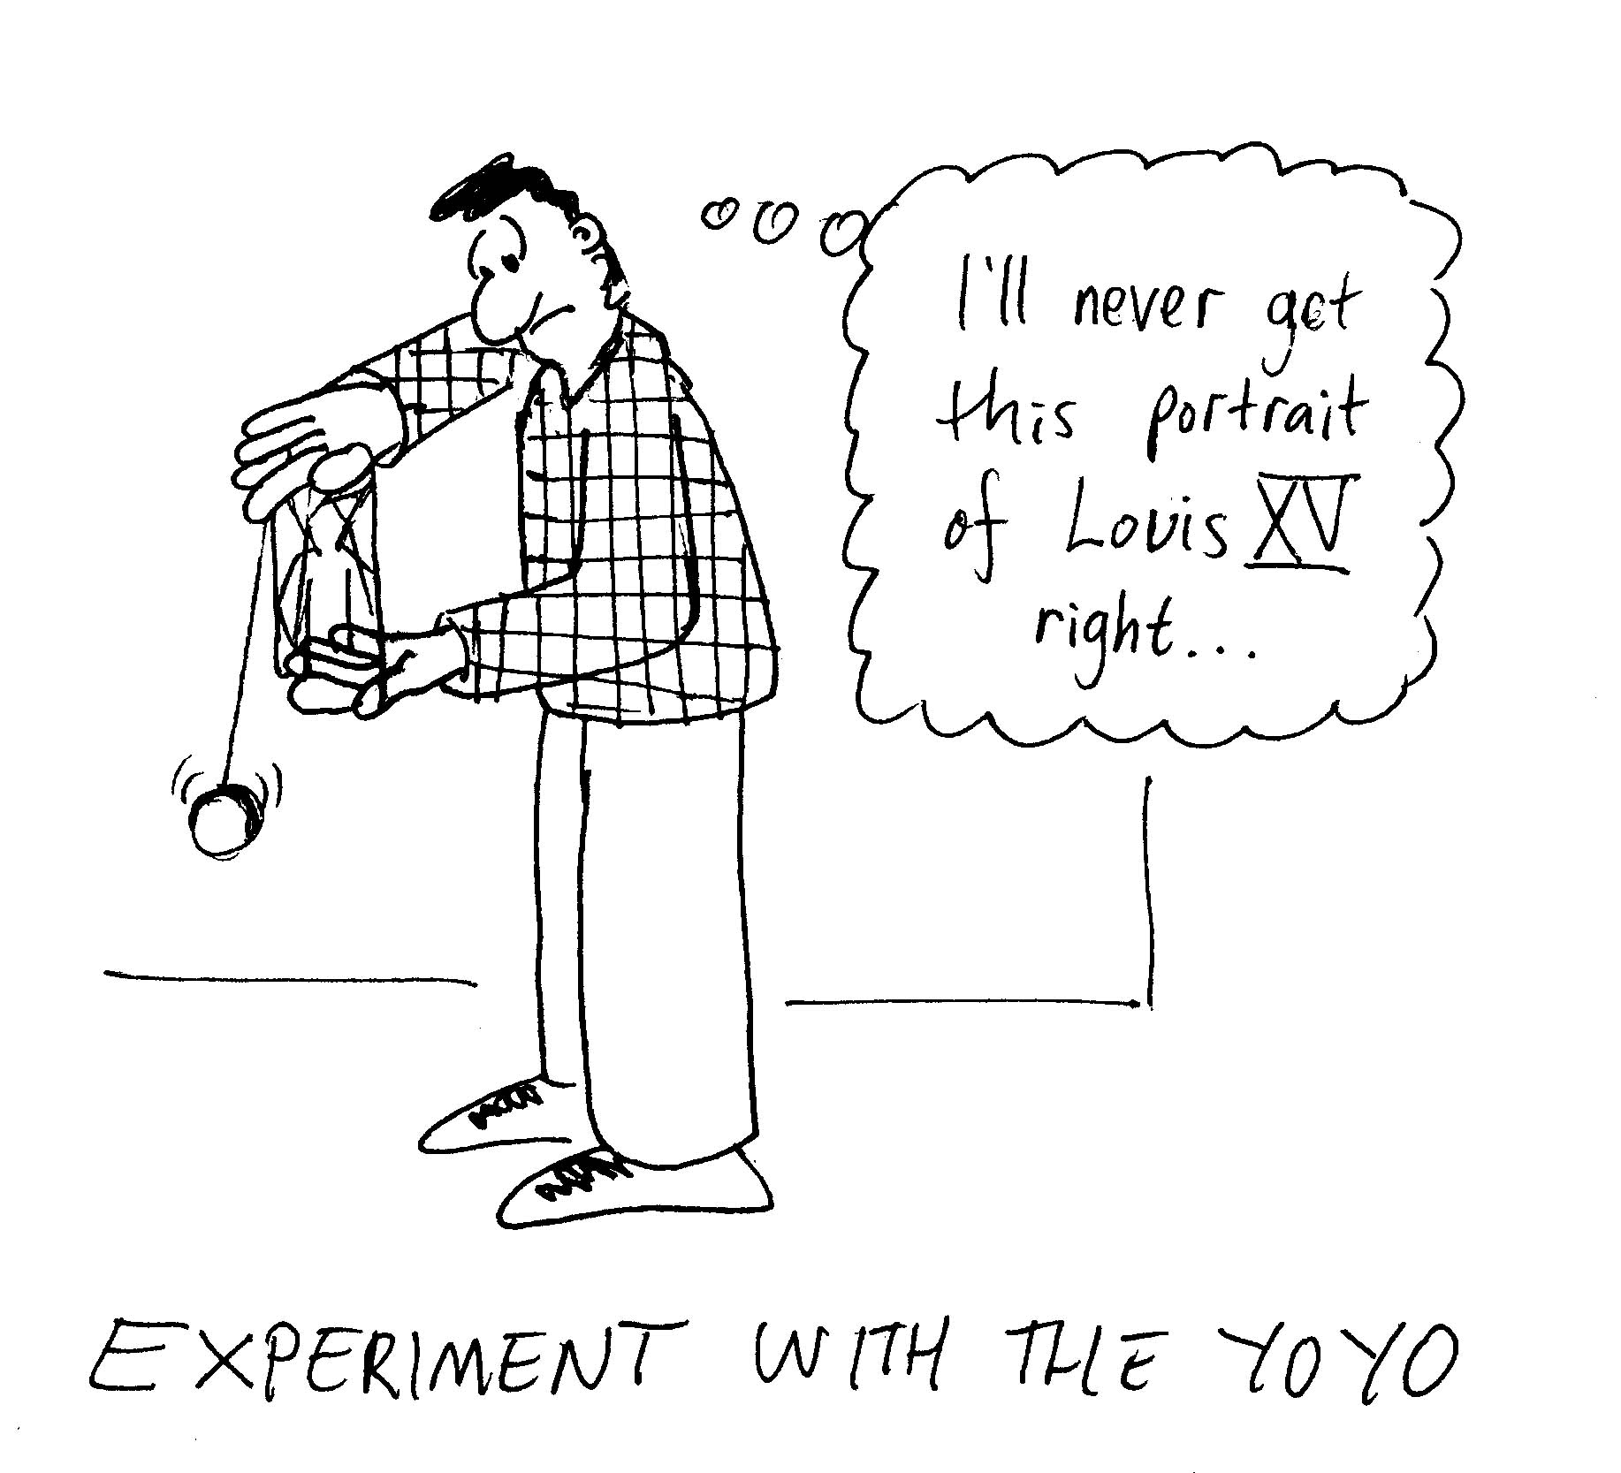
- Yo-yo
Experiment with the yo-yo.
Describe the energy conversions that occur as a yo-yo falls.
Why does a yo-yo come up again?
What provides the force to accelerate it back up?

C. Quantitative Question.

- A car is travelling at 60 km.h⁻¹ when the driver takes his foot off the accelerator and the car gradually rolls to a stop in 100 m. The wheels of the car are 75 cm in diameter.
- What is the linear acceleration of the car’s wheels?
- What is the angular acceleration of the wheels?
- If the rotational inertia of each wheel is 8 kg.m², what is the torque exerted on each wheel about its central axis? What is the source of this torque?

- The Olympic record for the one kilometre men’s cycling is one minute and 2.955 seconds, and is held by Lothar Thoms of Germany. If Lothar’s rear bicycle wheel had a diameter of 60 cm,
- What was the average linear speed of the centre of the wheel as seen by Lothar?
- What was the average linear speed of a point at the top of the wheel as seen by Lothar?
- What was the average linear acceleration of the centre of the wheel as seen by Lothar?
- What was the average linear acceleration of a point at the top of the wheel as seen by Lothar?
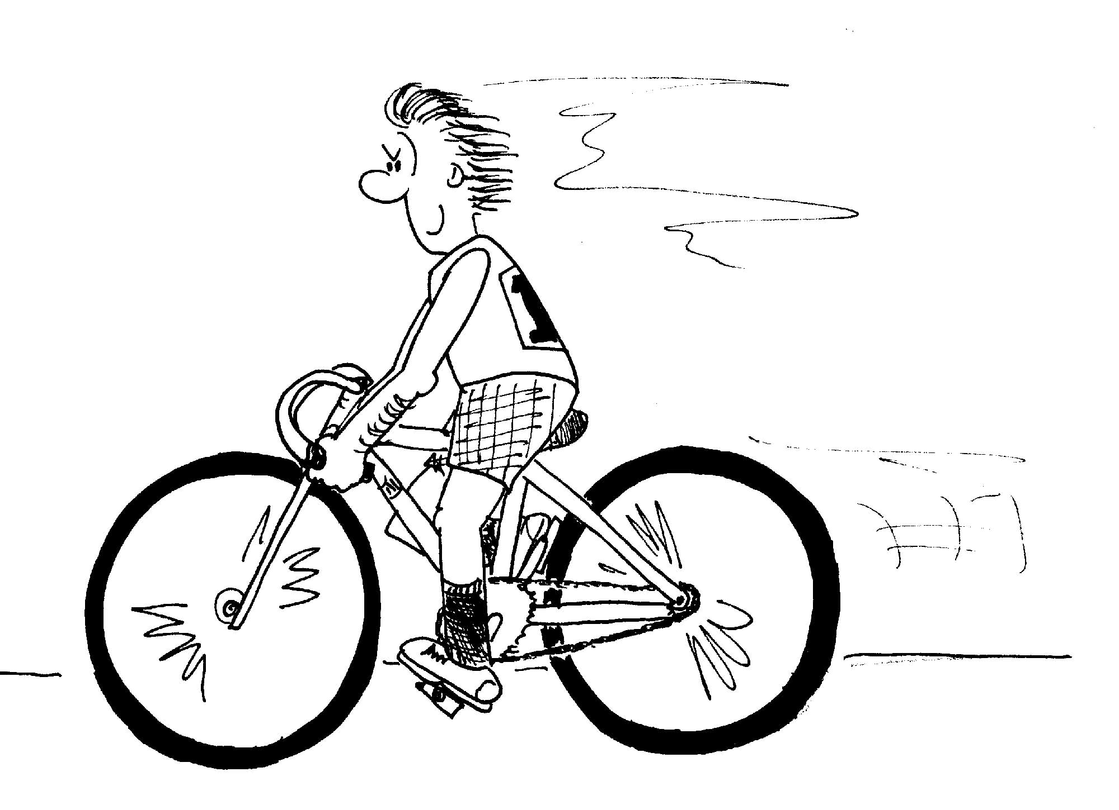
- Would a stationery spectator watching him go past see the same average linear velocity and acceleration of these points?

Workshop Tutorials for Physics
Solutions to MR11: Rolling

A. Qualitative Questions:
mg
F_{static} _{friction}
N
- Friction is necessary for walking, driving and even rolling a ball or using a yo-yo.  - See diagram opposite. Since the ball is rolling without slipping there is no sliding (kinetic) frictional force acting. However there is static frictional force acting at the point of contact with the ramp. It is this force which provides the torque about the centre of mass to cause rotation.  - When there is no rolling there will be some energy lost due to the kinetic frictional force acting. The nature of the forces acting are no different to those acting on a box sliding down a ramp. | mg  F_{sliding} _{friction}  N
Sometimes when you try to accelerate a car too hard on a wet or slippery road the wheels spin and the car doesn’t move. The wheels spin because the surfaces (the wheel and the wet road ) have a very low coefficient of friction, μ. Hence the maximum static friction = μN is low and so cannot oppose the driving force on the wheels from the engine and the wheels rotate over the surface, i.e. they spin, and the car goes nowhere.

- A confectionery company is looking for a way to separate spherical lollies of the correct size from those that are too big or too small. One of their engineers suggests using a ramp at the end of the lolly making machine and holding a container under the end of the ramp at the right time for the good lollies, and putting the rubbish bin under it for the wrong sized lollies.
The lollies all have the same gravitational potential energy, mgh, at the top of the ramp. This energy is converted into translational and rotational kinetic energy KE = ½ mv² + ½ Iω². If they roll without slipping then their translational velocity is v_{cm} = rω and KE = ½ mv² + ½ I(v_{cm} / r²). Using conservation of energy, mgh = ½ mv² + ½ I (v_{cm} / r²). For a uniform spherical lolly, I = (2/5) mr². Putting this into our equation for energy conservation gives:
mgh = ½ mv² + ½ I (v_{cm} / r²) = ½ mv² + ½ (2/5) mr² (v_{cm} / r²) or gh = ½ v² + (1/5)v.
We can see from this that as long as the lollies are spherical, neither the mass nor size of the lollies will affect their velocity and hence the time at which they reach the bottom of the ramp.

B. Activity Questions:

- Rolling down a ramp
A ball will get to the bottom of a frictionless ramp faster than one with friction. On the frictionless ramp the ball slides down without rolling, so all the balls potential energy is converted to translational kinetic energy. When the ball rolls, some of the potential energy is converted to translational kinetic energy and some to rotational kinetic energy, hence it will have a smaller translational velocity and take longer to reach the bottom. The frictional force acts to counteract the sliding that would otherwise occur. The torque means that rotational motion (rolling) occurs.

- A loaded race
m
v = 0 m.s⁻¹
v > 0 m.s⁻¹
h

Neglecting air resistance all the solid spheres will hit the bottom at the same time. From energy conservation equations we have

mgh = ½ mv² + ½ Iω² rearranging for v gives for solid spheres. Thus the velocity at the bottom of the ramp is independent of M and R, i.e. all the balls should reach the bottom at the same time. For a solid cylinder , so generally spheres have a higher speed than a cylinder.

- yo-yo
As it falls, the yo-yo loses gravitational potential energy and gains both translational kinetic and rotational kinetic energy. At the end of the fall the yo-yo continues to spin as it has angular momentum. If the string is looped loosely around the central axis then the yo-yo will stay spinning at the bottom of its fall for a reasonably long time.
The yo-yo comes up again if the yo-yoist tugs on the string. The friction between the string and the yo-yo provides an upward force on the yo-yo. Since the yo-yo is spinning, it will continue to rotate as it moves upwards again.

C. Quantitative Question
- A car is travelling at 60 km.h⁻¹ = 16.7 m.s⁻¹ when the driver takes his foot off the accelerator and the car gradually rolls to a stop in 100 m. The wheels of the car are 75 cm in diameter.
- We can find the linear acceleration of the car’s wheels using v_{f}² = v_{o}² – 2as, and rearranging for a:
a = (v_{f}² - v_{o}²) / 2s = [(16.7m.s⁻¹)² – (0 m.s⁻¹)² ] / 2 × 100m = 1.4 m.s⁻².
This is the linear acceleration of the centre of mass of the car’s wheels.
- The angular acceleration of the wheels is α = a / r = 1.4 m.s⁻² / 0.375 m = 3.7 rad.s⁻².
- The rotational inertia of each wheel is 8 kg.m², the torque exerted on each wheel about its axis is:
τ = Iα = 8 kg.m² × 3.7 rad.s⁻² = 30 N.m.
This torque is provided by the frictional forces between the road and the tyres and the frictional forces in the wheel bearings.

- Lothar’s record bicycle sprint.
  - From Lothar’s point of view, he is moving with the bicycle and so the average linear speed of the centre of the wheel is zero.
  - For Lothar the wheel is rotating uniformly about him. Thus for him all points on the rim of the bicycle have the same speed. We assume there is rolling without slipping then the instantaneous speed of the point of contact with the ground must be zero for a spectator on the ground. The total speed at any point is the magnitude of the vector sum of the velocity of the center of mass and the velocity of the wheel relative to the center of mass. From a spectators frame of reference, the average speed = distance covered / time taken = 1000 m / 62.955 s = 15.88 m.s⁻¹. For a point on the ground the velocity of the wheel relative to the center of mass must thus be –$\vec{v}$_{cm}. Since the top of the wheel is traveling in the opposite direction its velocity is +$\vec{v}$_{cm} and the speed is v_{cm}. Hence the speed is 15.88 m.s⁻¹.
  - The average linear acceleration will be zero since he sees no change in the average speed.
  - From Lothar’s frame of reference the top of the wheel is undergoing circular motion and the there will be a radial acceleration a_{r} = v²/r = (15.88 m.s⁻¹ )² / 0.60 m = 420 m.s⁻².
  - As the spectator is in a different frame of reference and the velocity of the center of mass is not zero, they will not see the same speeds and accelerations as Lothar. As explained above the velocity of a point on the ground for the spectator will be zero and the velocity of a point on the top of the wheel will be 2v_{cm}. The acceleration of the center of mass will be zero, but the acceleration of the point on the top of the wheel will be 4v_{cm}²/2r, which is double that seen by Lothar.
Workshop Tutorials for Physics
MR12: Gravity and Kepler’s laws

A. Qualitative Questions:

- The radius of the Earth is approximately 6,400 km. The International Space Station orbits at an altitude approximately 400 km above the Earth’s surface, or at a radius of around 6,800 km from the Earth’s centre. Hence the force of gravity experienced by the space station and its occupants is almost as great as that experienced by people on the surface of the Earth.
So why do astronauts and cosmonauts feel weightless when orbiting the Earth in a space station?

- If you throw a ball up in the air, it falls back to the ground.
- Briefly explain in terms of the relevant physics principles how a communications satellite can stay apparently suspended high above the earth's surface, and not fall as a ball does.
The Mir space station was in orbit from1986 until April 2001. Mir had a mass of more than 100 tons and consisted of seven modules launched separately and brought together in space over a period of 10 years.
- What effect does increasing the mass of a space station, such as Mir, have on its orbit? Does the orbital speed need to be changed to maintain a fixed orbit?

B. Activity Questions:

- Drawing orbits
Place one pin at the sun position and another at the other focus for one of the planets.
How do you know where the other focus should be?
Now cut a piece of string to a (scaled down) length equal to twice the sum of the aphelion and perihelion distances (l = 2(a+p)). Tie the string in a loop and put it around the pins. Hold the pen in the loop so that it pulls the loop taut and use the string to guide the pen to draw the orbit.
Repeat for one or two other planets.
Which planets have the most eccentric orbits? Which have the least eccentric?

- Models of the solar system
Compare the different models of the solar system.
In what ways are they different? How are they similar?

- Kepler’s Second Law
Move the “planet” around the sun.
Note the line joining the planet to the sun and observe the area that it sweeps out.
What happens to the velocity of the planet as it moves
further away from the sun (towards aphelion)?
What happens as it moves closer to the sun (towards perihelion)?

C. Quantitative Questions:

- Many science fiction stories feature men going to mars and meeting Martians. In some stories the space travelers are able to walk around quite comfortably and even breathe the Martian atmosphere.
- Given the table of information below, what is the acceleration due to gravity on Mars?
- What is the escape velocity at the surface of mars?
- What effect is this lower escape velocity likely to have on the Martian atmosphere compared to the Earth’s atmosphere?
- Would it be feasible to try to give Mars an (unenclosed) Earth-like atmosphere so that it could be colonised by humans? What would need to be done, and how habitable could Mars be made?

- In the year 2010 astronomers at the Parkes radio-astronomy facility discover what appears to be radio signals coming from Jupiter. As a senior physicist in the Australian space program your job is to get a satellite in orbit above the source of the signal to monitor it. The plan is for the space shuttle Kookaburra to head off to Jupiter and put a communications satellite at the right orbit to keep it directly above the signal.
- What height above the surface of Jupiter must the satellite be put?
- What velocity must it have to maintain this orbit?

Useful data.
 | Earth | Mars | Jupiter
Mass  (× 10²⁴ kg) | 5.97 | 0.642 | 1899
Diameter  (km) | 12,756 | 6794 | 142,984
Acceleration due to Gravity (m.s⁻²) | 9.8 |  | 23.1
Escape velocity  (km.s⁻¹) | 11.2 |  | 59.5
Period of rotation  (h) | 23.9 | 24.6 | 9.9

G = 6.67 × 10⁻¹¹ N.m².kg⁻².

Workshop Tutorials for Physics
Solutions to MR12: Gravity and Kepler’s laws

A. Qualitative Questions:

- The radius of the Earth is approximately 6,400 km. The International Space Station orbits at an altitude approximately 400 km above the Earth’s surface, or at a radius of around 6,800 km from the Earth’s centre. Hence the force of gravity experienced by the space station and its occupants is almost as great as that experienced by people on the surface of the Earth. Astronauts and cosmonauts feel weightless when orbiting the Earth because there is no contact force between them and the space station. An astronaut standing on the floor in the space station is accelerating towards the Earth at the same rate and with the same velocity as the space station, hence he or she is not “pushed” against the floor the way someone on earth is, and they feel “weightless” because they are in free fall, although the astronaut still has almost the same weight as on Earth.

- If you throw a ball up in the air it falls back to the ground.
- The communications satellite is falling and a gravitational force is acting on it. The difference between it and the ball is that the satellite has sufficient tangential speed so that it moves sideways at such a rate as to fall “past” the earth and so continue in an orbit around the earth.
- Increasing the mass of a space station, such as Mir, does not have an effect on its orbit. The gravitational force, F = Gm_{Earth}m / r² provides the force to keep Mir in orbit, and not disappear into space. The net force acting to keep an object in circular motion is the centripetal force, F = mv² / r. Equation this to the gravitational force gives Gm_{Earth}m / r² = mv² / r. or Gm_{Earth} / r = mv² , from which we can see that the velocity of the satellite depends on the mass of the Earth and the radius of its orbit, but not on the satellites mass.

B. Activity Questions:

- Drawing orbits
The planets move in elliptical orbits around the sun. The closest point to the sun is called the perihelion and the furthest point is called the aphelion. The sun is at one focus of the ellipse. The string should be a length equal to the sum of the aphelion and the perihelion, so that the pencil is at most the aphelion distance from the sun. The distance between the foci is equal to the difference between the aphelion and perihelion distances. The eccentricity of the orbit is the ratio of the distance between the foci to the length of the major axis, which is (aphelion – perihelion) / (aphelion + perihelion), which is equal to 0 for circle and is between 0 and 1 for an ellipse.
Planet | Mercury | Venus | Earth | Mars | Jupiter | Saturn | Uranus | Neptune | Pluto
Aphelion | 70 | 109 | 152 | 249 | 817 | 1515 | 3004 | 4546 | 7304
Perihelion | 46 | 108 | 147 | 206 | 741 | 1353 | 2741 | 4445 | 4435
Distances × 10⁶ km

- Models of the solar system
Our understanding of the motion of the planets has changed greatly over the last few hundred years.
You may see some of these changes by noting the differences between the models – the most obvious is that early models had the Earth at the centre of the solar system with everything else, including the sun, orbiting around it. Modern models of the solar system place the Earth at the centre.

- Kepler’s Second Law
The area swept out per unit time by the line joining the planet and the sun is constant. The distance between the sun and planet varies because the orbit is elliptical, hence the length of this line varies in time. For the area swept out per unit time to be constant the velocity must vary, decreasing as the planet moves further from the sun (towards aphelion) and increasing as it moves closer (towards perihelion).

C. Quantitative Questions:

- Many science fiction stories feature men going to mars and meeting Martians. In some stories the space travelers are able to walk around quite comfortably and even breathe the Martian atmosphere.
- The gravitational force between two bodies is given by F = Gm₁m₂ / r². Using Newton’s second law, F = ma, we can write for the acceleration due to gravity at the surface of Mars:
g_{Mars} = GM_{Mars} / r_{Mars}² = (6.67 × 10⁻¹¹ N.m².kg⁻² × 0.642 × 10²⁴ kg ) / (3397 × 10³ m)² = 3.7 m.s⁻².
- The escape velocity can be calculated using conservation of energy. Consider throwing a ball into the air with velocity v, it initially has some kinetic energy and some gravitational potential energy. When it reaches its maximum height it has only gravitational potential energy, so we can write:
E_{initial} = ½ mv² – GM_{Mars}m/R_{Mars} = E_{final} = - GM_{Mars}m/R_{max}.
If we take the case of the ball actually leaving the Earth’s gravitational field totally then R_{max} = ∞, and substituting this into the equation above gives: ½ mv² – GM_{Mars}m/R_{Mars} = - GM_{Mars}m/∞ = 0.
Rearranging for v² gives:
v² = 2GM_{Mars}/R_{Mars} = 2 × 6.67 × 10⁻¹¹ N.m².kg⁻² × 0.642 × 10²⁴ kg / 3397 × 10³ m = 2.52 × 10⁶ m².s⁻².
and v = 5.02 × 10³ m.s⁻¹ = 5.02 km.s⁻¹.
- The lower escape velocity on Mars means that high velocity gas molecules will be able to escape the atmosphere. In a gas the molecules have a range of velocities, and the average velocity depends on the temperature of the gas. On Earth, at normal atmospheric temperatures, helium molecules have enough energy to escape the atmosphere, and when a helium balloon deflates the helium is lost into outer space. On Mars, some molecules of oxygen and nitrogen would escape at normal atmospheric temperatures.
- To give Mars an (unenclosed) Earthlike atmosphere the gas which made up the atmosphere would have to be quite cold to keep it from escaping. Living on Mars with an unenclosed atmosphere would be more like living in Antarctica than in Cairns.

- Your job is to get a satellite in orbit around Jupiter above the source of the signal to monitor it. The space shuttle Kookaburra is to put a communications satellite at the right orbit, with the right velocity, to keep it directly above the signal.
- To keep a satellite above a point on the surface of a planet we require that the orbital period of the satellite matches the rotational period of the planet. We can then use Kepler’s third law for a small satellite orbiting a much larger body: T² = (r³4π²) / GM where T is the period of orbit, and r is the radius of the orbit. In this case M is the mass of Jupiter. Rearranging for r³ gives, and using T = 9.9 h = 35600 s:
r³ = (T²GM) / (4π²) = [(35600 s)² × 6.67 × 10⁻¹¹ N.m².kg⁻² × 1899 × 10²⁴ kg] / (4π²) = 4.07 × 10²⁴ m³
r = 1.60 × 10⁸ m = 160,000 km. This is the distance from the center of Jupiter, so the height above the surface of jupiter is = 160,000 – R_{Jupiter} = 160,000 – 71492 = 88,500 km.
- The total distance the satellite travels per orbit is x = 2πr = 2 × π × 1.60 × 10⁸ m = 1.01 × 10⁹ m.
It does this in a time T = 32400 s, hence it must have a (linear) velocity
v = x / T = 1.01 × 10⁹ / 35600 s = 2.82 × 10⁴ m.s⁻¹ = 28 km.s⁻¹.

 | Earth | Mars | Jupiter
Mass (× 10²⁴ kg) | 5.97 | 0.642 | 1899
Diameter (km) | 12,756 | 6794 | 142,984
g (m.s⁻²) | 9.8 | 3.7 | 23.1
Escape velocity (km.s⁻¹) | 11.2 | 5.02 | 59.5
Period of rotation (h) | 23.9 | 24.6 | 9.9

Workshop Tutorials for Physics
MR13: Relativity

A. Qualitative Questions:

- Rebecca and a group of other physics students are doing a project on relativity. They are all in a train carriage moving at a constant velocity relative to the ground. Rebecca is wearing a special hat designed by Brent. The hat has infrared photo-sensors in it, one on either side of the hat, and a small buzzer and coil inside the hat. If light reaches both sensors at once the buzzer buzzes and the coil gives Rebecca a small electric shock, and she will take the hat off. She is standing right in the middle of the carriage.
Brent is going to observe the experiment from the platform at Redfern station.
When Julia (one of the students) sees Brent on the platform she presses a button which causes infrared light to be transmitted simultaneously by devices at each end of the carriage.
- Does light reach the two sensors on Rebecca’s hat at the same time in her reference frame? Will she take the hat off?
- What do Julia and the other students observe? Do they hear the buzzer? Do they see Rebecca take the hat off?
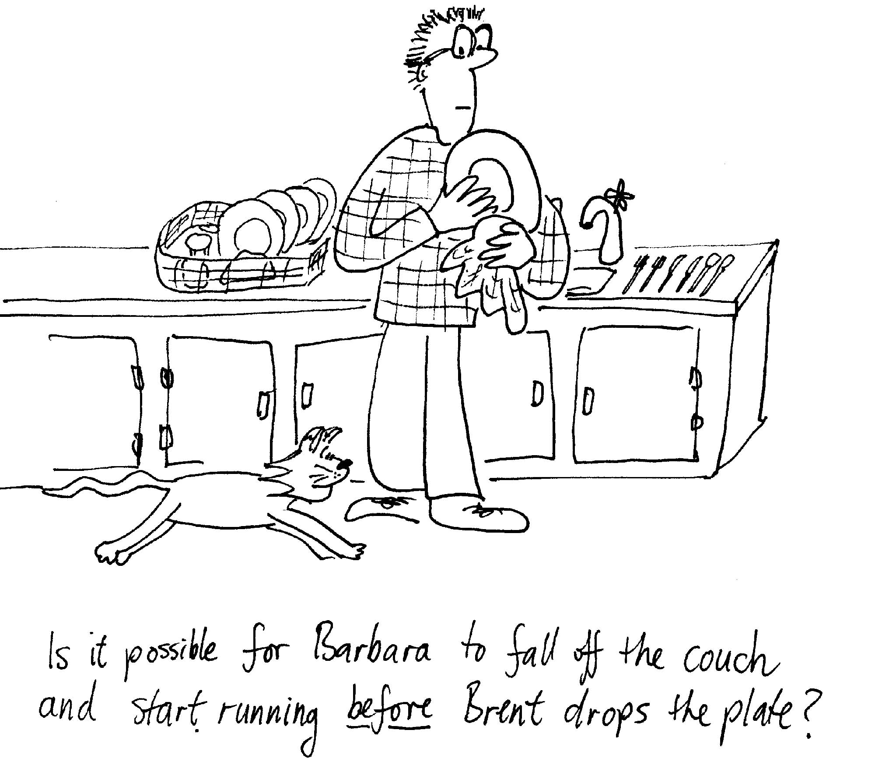
- What does Brent, standing on the platform, observe? Does the light from the two transmitters reach the sensors at the same time in his reference frame? Does he see Rebecca take her hat off? Explain why or why not.

- Brent drops a plate and it breaks, making a noise which frightens Barbara the cat, who falls off the edge of the couch and runs away. We know that events are not necessarily simultaneous in different reference frames, so is it possible for there to be a reference frame in which the cat falls off the couch before Brent drops the plate? Explain why or why not.

B. Activity Questions:

- Relativity and Electromagnetism
What happens when you move the magnet into the coil and out again?
What happens when you move the coil relative to the magnet instead?
Does it make any difference which one moves and which is stationary?

- Space-time diagram
A space-time diagram is useful for showing how things move in time.
How is this diagram different to the displacement diagrams you usually draw?
What does path A represent? What does path B represent?
Is it possible for an object to go from point P to point Q? Explain your answer.

- Minkowski diagrams
The diagram has two sets of axis, one for each of two reference frames. Frame S is stationery relative to the ground, and frame S’ is a frame moving relative to the ground along with an alien space craft at velocity v = 0.6c.
At time t = t’ = 0 the space craft passes FBI agent Fox Mulder. Fox is at the origin of the x and x’ axes.
6 ns later he turns on his mobile phone to make a call to his partner.
Mark the coordinates for each of these two events on the Minkowski diagram. Write down the x, t and x’, t’, coordinates for each event.
C. Quantitative Questions:
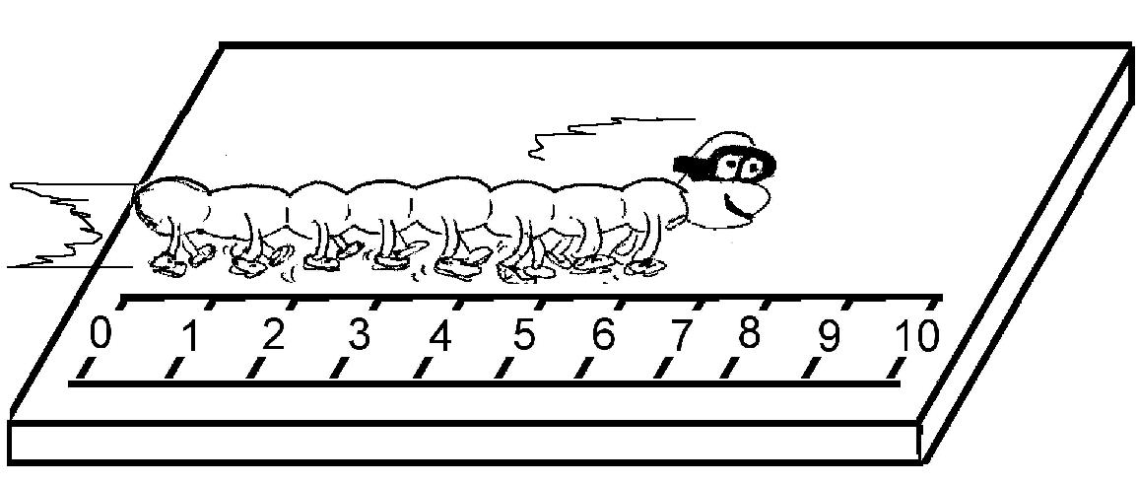
- A high speed centipede is running across a chopping block at velocity v when he is spotted by the butcher. The proper length of the centipede is 10 cm.
- What does proper length mean? How is it measured?
The butcher measures the length of the centipede to be 8cm, using a ruler inset into the chopping block.

- How fast is the centipede moving relative to the butcher?
The butcher, who wants to give the centipede a fair chance, holds two meat cleavers 9 cm apart. The instant the centipede’s tail is at point O, the butcher immediately swings both cleavers instantaneously and simultaneously down on the chopping block, one at point O the other 9 cm away, and immediately lifts them up again. (This is a butcher with very good reflexes.)
The butcher believes that as the centipede is 8cm long and the cleaver separation is 9 cm, the centipede should be safe. The centipede is not convinced, and is quite worried by the situation, as the cleavers approach at high velocity v.

- What is the separation of the cleavers from the point of view of the centipede?
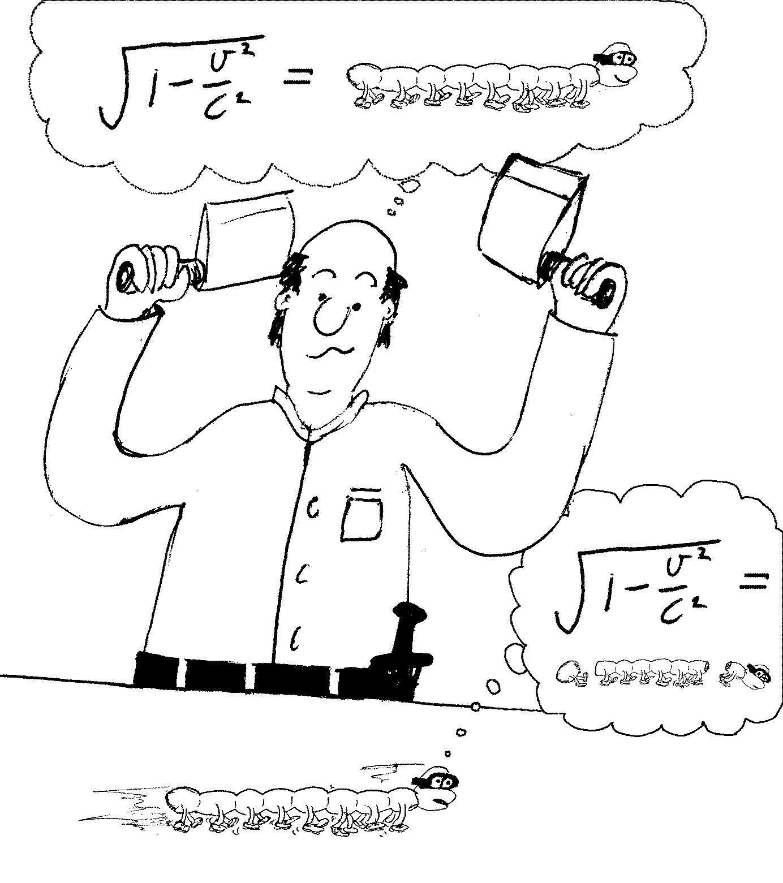
So from the butcher’s reference frame the centipede makes it, from the centipede’s reference frame, it’s going to messy. They can’t both be right.
Let the reference frame of the butcher be frame S, and that of the centipede be frame S*.
Let’s consider two events: cleaver A hitting the block and cleaver B hitting the block. These both happen at time t =0 according to the butcher.
- At what positions do these events happen in the butchers frame?
- Using the Lorentz transformations, at what time and position does event 1 (cleaver A hits the block) happen in the frame of the centipede, S*?
- At what time and position does event 2 (cleaver B hits the block) happen in the frame S*?
These two events are simultaneous from the point of view of the butcher, but they are not simultaneous from the frame of the centipede.
- Where is the centipede’s tail when cleaver A comes down in S*?
- Where is the centipede’s head when cleaver B comes
down in S*?
- Is it the end for the super speedy centipede?

- A spaceship whose rest length is 350 m has a speed of 0.82 c with respect to an observer on Earth. A micrometeorite, also with a speed of 0.82 c with respect to the observer on Earth, passes the spaceship going in the opposite direction.
- How long does the micrometeorite take to pass the space ship according to an observer on Earth?
- What is the speed of the micrometeorite according to an observer on the space ship?
- How long does the micrometeorite take to pass the space ship according to an observer on the space ship?
- According to the observer on Earth, the kinetic energy of the micrometeorite is 12 GJ. What is the rest mass of the micrometeorite?
- What is the kinetic energy of the micrometeorite according to an observer on the space ship?
Workshop Tutorials for Physics
Solutions to MR13: Relativity

A. Qualitative Questions:

- Rebecca and the hat.
- Light reach the two sensors on Rebecca’s hat at the same time in her reference frame, as the light travels equal distances to get to each side of the hat. Hence she will take the hat off.
- Julia and the other students are moving along with the same reference frame as Rebecca. They see the light reaching the two sides of the hat at the same time, they hear the buzzer buzz, and observe Rebecca taking off the hat.
- If Rebecca has taken the hat off, and the buzzer has gone off, then this is what Brent will also observe. However in Brent’s reference frame the light from the two transmitters does not reach the sensors at the same time. Different observers do not disagree on whether or not events happen, but they do disagree on whether they are simultaneous or not.

2. It is not possible for there to be a reference frame in which the cat falls off the couch before Brent drops the plate. For an observer to see the cat fall first they (and their reference frame) must be travelling faster than the speed of light, which is not possible. This would also violate causality, which is not possible when the speed of light is finite and the absolute speed limit.

B. Activity Questions:

- Relativity and electromagnetism
It makes no difference whether it is the coil or the magnet which is moving. A reference frame attached to one is not preferred to a reference frame attached to the other. It was this observation, in electromagnetism, that led Einstein to his theory of relativity.
x
t
A
B
light cone
P
Q

- Space-time diagram
Usually when we draw displacement vs time graphs we plot the time on the horizontal and the position on the vertical axis.
Line A represents an object at rest (relative to the reference frame). Its position is not changing in time. Line B represents an object whose position is changing in time, hence this is a moving object.
It is not possible for any object to move from point P in space-time to point Q, as to do so it would have to travel faster than the speed of light. No path steeper than the light cone is permitted, and it is impossible to move from the left side of the light cone to the right.
B
A
- Minkowski diagrams
The axes of frame S are the x and ct axes, the axes of frame S’ are the x’ and ct’ axes.
Event A (see diagram) is the spacecraft passing Fox Mulder, at x = 0, t = 0 in S, and x’ = 0, t’ = 0 in S’.
Event B is Fox turning his phone on. This happens at x = 0, t = 6 ns = 2 ct in the S frame. In the S’ frame this happens at x’ = -1.4, t’ = 7.5 ns. These coordinates are found by drawing lines through the point (point B in this case) parallel to the S’ axes and finding the intersections with the x’ and ct’ axes. Note that the time axis is ct not t, so to find the time we need to divide by c.

C. Quantitative Questions:

- The proper length of the centipede is 10 cm.
- Proper length is the length measured in the frame at which the object being measured is at rest. In this case it is the frame of reference of the centipede.
- If the butcher measures the length of the centipede to be 8 cm, then we can use the length transformation: $l=l_{p}\frac{1}{γ}=l_{p}\sqrt{1−v^{2}c^{2}}$ which we can rearrange to get
v = c$\sqrt{1−l^{2}l_{p^{2}}}$ = c =$\sqrt{1−0\text{.}{\text{08}}^{2}0\text{.}{\text{10}}^{2}}$= 0.6c.
The butcher believes that as the centipede is 8cm long and the cleaver separation is 9 cm, the centipede should be safe. The centipede is not convinced, and is quite worried by the situation, as the cleavers approach at high velocity v.
- To find the separation of the cleavers from the point of view of the centipede we again use the length transform: $l=l_{p}\frac{1}{γ}=l_{p}\sqrt{1−v^{2}c^{2}}$ = 0.09 $\sqrt{1−(0\text{.}6c)^{2}c^{2}}$= 0.09 × 0.8 = 7.2 cm.
This is less than the length of the centipede!
(Note also from this that 1/γ = 0.8, so γ = 1.25. This will be useful later.)
Let the reference frame of the butcher be frame S, and that of the centipede be frame S*.
Let’s consider two events: cleaver A hitting the block and cleaver B hitting the block. These both happen at time t =0 according to the butcher.
- In the butchers frame these events happen at positions x_{A} = 0 and x_{B} =9cm.
- Using the Lorentz transformations event 1 (cleaver A hits the block) happens in the frame of the centipede, S*, at time t_{A}* = [t_{A} – x_{A}(v/c² )]γ = 0× γ = 0 s. So cleaver A hits at time 0.
The position is x_{A}* = [x_{A} -vt_{A}]γ = 0× γ = 0 m. So cleaver A hits at time 0 and position 0 in both frames.
- Event 2 (cleaver B hits the block) the frame S* at
t_{B}* = [t_{B} – x_{B}(v/c² )]γ = [0 – 0.09 m ×0.6c/c²]1.25 = - 2.3 × 10⁻¹⁰ s.
and x_{B}* = [x_{B} –vt_{B}]γ = [0.09 m – 0.6c×0]1.25 = 11 cm.
So in the centipede’s frame cleaver B comes down first!
- The centipede’s tail is at 0 when cleaver A comes down in S*, which is at x = 0, t = 0 in both frames.
- The centipede’s head when cleaver B comes down in S* is at x* = 10 cm, a good 1 cm behind cleaver B in her reference frame.
- Is it the end for the super speedy centipede? No! The speedy centipede survives!!

- A spaceship with length is L_{o} = 350 m has a speed of 0.82 c with respect to an observer on Earth, which gives a Lorentz factor of γ = 1.75.
- The apparent length of the space ship according to an observer on Earth is L = L_{o}/γ , and the time it takes to pass a fixed point at speed v is L_{o}/vγ. The time taken for an object moving in the opposite direction at the same speed (the micrometeorite) to pass the space ship is half this time:
t = ½ L_{o}/vγ = 4.1 × 10⁻⁷ s = 0.41 μs.
- For an observer on the space ship the speed of the micrometeorite will be v_{meteorite =} $\frac{2v}{1+v^{2}c^{2}}$= 0.98c.
- The time taken for the micrometeorite to pass the space ship according to an observer on the space ship is therefore t = L_{o} /v = 1.2 μs.
- KE_{meteorite} = (γ-1) mc² =12 GJ so m = KE / ((γ-1) c²) = 1.8 ×10⁷ kg = 0.18 mg.
- The Lorentz factor of the micrometeorite in the frame of the space ship is 5.1.
The rest energy is mc² = 12 GJ/(1.75-1), so the kinetic energy of the micrometeorite according to an observer on the space ship is 12 GJ × (5.1 – 1)/(1.75 – 1) = 66 GJ.
Energy is also relative.

