Thermal Physics

Regular Thermal Physics Worksheets and Solutions

TR1B: | Temperature | 3
TR1T: | Temperature | 7
TR2B: | Heat and Energy | 11
TR2T: | Heat and Energy | 15
TR3B: | Heat Transfer | 19
TR3T: | Heat Transfer | 23
TR4B: | First Law of Thermodynamics | 27
TR4T: | First Law of Thermodynamics | 31
TR5B: | Kinetic theory | 35
TR5T: | Kinetic theory | 39
TR6: | Heat engines | 43
TR7B: | Entropy and the Second Law of Thermodynamics | 47
TR7T: | Entropy and the Second Law of Thermodynamics | 51
TR8: | Blackbody Radiation | 55

Workshop Tutorials for Biological and Environmental Physics
TR1B: Temperature

A. Qualitative Questions:

- Thermometers are instruments used to measure temperature. There are many different types of thermometer and the choice of which to use depends both on the object whose temperature is to be measured and the temperature range to be measured. For example, a confectionary thermometer for making lollies needs to measure up to a few hundred degrees Celsius, while a medical thermometer needs to be more accurate but only measure up to around 40º C.
- Describe two different types of thermometer. What physical properties do they rely on?
- Give examples of when you might use these methods.
- Why do you always have to hold the thermometer under your tongue for what seems like hours (but is usually about 30 seconds) when you have your temperature measured?

- When most materials are heated they expand. Water is a bit different because at low temperatures it has a negative coefficient of expansion, which means that it actually contracts and gets denser with increasing temperature. The figure below shows the density (× 10³ kg.m⁻³) of water as a function of temperature (ºC). Use this graph to help you answer the following questions.

- Explain what happens to the water at the top of a lake on a very cold day.
- How does this help to aerate the water?
This has important consequences for aquatic animals. When it gets very cold, below zero, the water starts to turn into ice.
c. Why do lakes freeze from the top down, instead of the bottom up? What might happen if water froze from the bottom up?

B. Activity Questions:

- Thermometers
Examine the different thermometers on display.
What physical quantity do they use to measure temperature?

- Thermal Expansion of gases
Place the coin on top of the bottle.
Now cup your hands around the bottle and observe what happens.
Explain your observations.

- Thermal Expansion of liquids
Hold the beaker in your hands.
Explain what you observe.

- Thermal Expansion of solids - bimetallic strip
Heat the strip using the hairdryer or hot air gun.
What happens to the strip, and why?
Can you think of a use for such a strip?

C. Quantitative Questions:

- Many people are concerned that the release of gases such as carbon dioxide into the atmosphere may trap heat in the atmosphere, leading to global warming. Global warming could have disastrous effects on the environment, and Australia is one of the developed countries most likely to suffer from climate change. Our Pacific neighbours such as Tuvalu are even more vulnerable, as small rises in ocean levels may cover islands completely and displace thousands of people.
- What change in water temperature would result in a 0.1% increase in the volume of the oceans?  (Use β = 2.07 × 10⁻⁴ K⁻¹)  Such an increase in temperature would also result in melting of some of the ice around the poles.  - Explain what effects this might have on the water volume. Would it necessarily increase the volume of water? | 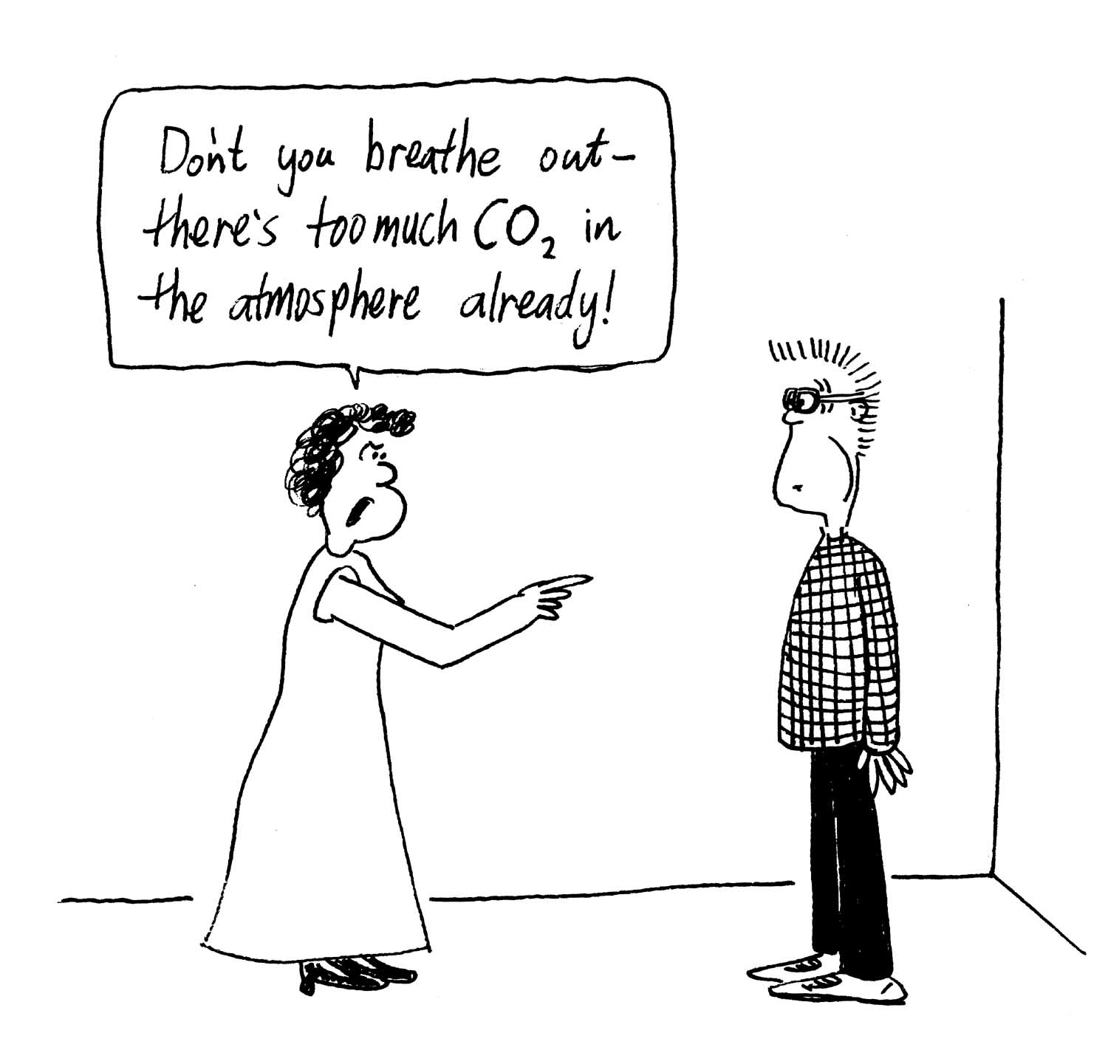

2. Most of the body stays at a fairly constant 37º C, but your mouth can experience a huge range of temperatures. If you have a hot meal followed by ice cream for dessert your teeth can experience a temperature change of almost 100º C! Amalgam fillings are made of metal, most of which have a thermal expansion coefficient around 5 × 10⁻⁵ K⁻¹. (Porcelain is slightly lower.)
A molar is around 7mm by 8mm on top and about 7mm from top to gumline. A filling can be more than half the volume of a tooth, so imagine you have a filling with a volume of 200 mm³.
- What will be its volume when you are eating ice cream at 0º C?
- What will be its volume when you drink a cup of tea which is at 65º C?
- What sort of constraints does this place on the choice of materials for dental fillings? What might be the results of a poor choice?

Workshop Tutorials for Biological and Environmental Physics
Solutions to TR1B: Temperature

A. Qualitative Questions:

- Measuring temperature.
  - A medical mercury-in-glass thermometer relies on the expansion of mercury up a fine (bore) tube as temperature increases. Digital thermometers, like those found in a car, are more robust and are part of an electrical circuit. The physical property that varies with temperature in most types of digital thermometer is electrical resistance.
  - The mercury-in-glass thermometer is extremely accurate and so can be used to measure body temperature accurately. Digital thermometers are often used where remote sensing is needed. The electrical signal can be fed into a computer from a remote terminal
  - A thermometer has to be held in the mouth long enough to allow the thermometer to come to thermal equilibrium with your body. When it is inserted it will be at room temperature.

    - The figure shows the density (× 10³ kg.m⁻³) of water as a function of temperature (ºC).
- On a very cold day when the air temperature is less than 4ºC, water at the top cools and comes to thermal equilibrium with the atmosphere. The density of water decreases as the water cools below 4ºC, shown by the graph above, and the coolest water rises to the top of the lake, while the most dense water, which is the water at 4ºC, settles to the bottom of the lake.
- This helps to aerate the water as the colder water (< 4ºC) rises and the higher temperature water (4ºC) sinks. Thus taking oxygen down to the lower depths of the lake.
- A thin skin of ice initially forms on the surface of the lake with warmer water underneath. This thin skin may get thicker over time as the colder air temperatures persist. (In Finland people drive cars over the surface of icy lakes in mid winter.) If the water froze from the bottom up i.e. if the coldest water sank then it would be possible for the lake to completely freeze and so all the aquatic life would freeze as well.

B. Activity Questions:

1. Thermometers
A liquid in glass thermometer uses the thermal expansion of a liquid to measure temperature. The scale is calibrated to read the temperature as a function of the volume of the liquid. There are also thermometers which use the thermal expansion of a gas, which results in increasing the pressure of the gas if the volume of the gas is fixed. The pressure then tells you the temperature. These are called constant volume gas thermometers.
Digital thermometers use a change in electrical resistance with temperature. There are two types – those that have an increasing resistance with increasing temperature, and those that have a decreasing resistance with increasing temperature. The change in resistance is determined by the material the sensor is made out of.

- Thermal Expansion of gases
The heat from your hands causes the gas inside the bottle to expand, increasing the pressure inside the bottle. When the force due to the pressure of the gas is greater than the weight of the coin it pops off.

- Thermal Expansion of liquids
The heat from your hands causes the liquid to expand. As it cools it contracts again. This is how a typical liquid in glass thermometer works.

- Thermal Expansion of solids - bimetallic strip
metal one, small expansion
metal two,
large expansion
heat
strip bends as metal two expands, but cannot stretch freely because it is attached to metal one.
The bimetallic strip is made of two metals, one of which expands much more than the other when they are heated. A bi-metallic strip can be used as a sensor because the two metals which make up the strip expand at different rates. When they start to get hot, the strip will bend, and can be used as a switch which either closes or opens a circuit as it bends to or away from a contact. A single strip would expand, but not bend in this way.

C. Quantitative Questions:

1. Global warming could have disastrous effects on the environment; rises in ocean levels may cover islands completely and displace thousands of people.
- A 0.1% increase in volume can be expressed mathematically as ΔV/V_{old} = 0.1/100 where ΔV equals the change in volume i.e. ΔV = V_{new}-V_{old}. The equation for volume expansion says that
V_{new} = V_{old} (1+βΔT). Rearranging this equation gives ΔV/V_{old} = βΔT so:
0.1/100 = 2.07 × 10⁻⁴ K⁻¹ × ΔT, rearranging for ΔT gives:
ΔT = 1 × 10⁻³ /2.07 × 10⁻⁴ K⁻¹ = 4.8 K.
Since the size of the units of temperature are the same in Kelvin and Celsius scales. A rise (or change) of 4.8 K is the same as a rise of 4.8ºC.
- If the remaining ice was at or below the ocean level, i.e. floating in it, the ocean level would not change as the ice melted, as the amount of water displaced by the ice is equal to the amount of water that melts to fill that volume. However the melting of the ice would cool the water around it, and keep it at 0ºC, at which point the density is greater than at temperatures much above 4ºC, giving a smaller volume, and hence temporarily decreasing the rise. Any ice above sea level would add to the total volume of sea water as it ran down into the sea, thus causing a rise in sea levels.

  - Most of the body stays at a fairly constant 37º C. Amalgam fillings are made of metal, most of which have a thermal expansion coefficient around 5 × 10⁻⁵ K⁻¹. Imagine you have a filling with a volume of 200 mm³.
- If at room temperature ( say 25ºC) the volume of your filling is 200mm³, then when eating icecream
V_{new} = V_{old} (1+βΔT),
V_{new} = 200 mm³ (1 + 5 × 10⁻⁵ K⁻¹ × −25 K) = 200 (1− 0.00125) mm³ =199.999 mm³
- When drinking hot tea:
V_{new} = 200 mm³ (1 + 5 × 10⁻⁵ K⁻¹ × 40 K) = 200 (1 + 0.002 ) mm³ =200.002 mm³
- The expansion of the filling will cause stress on the tooth, as the expanded material pushes against the tooth. It is best that the values of β for the tooth and the filling material match closely. If they don’t the tooth could crack or fracture under the stresses produced. If there is adhesion between the filling and the tooth then contraction will also cause stress, and if the adhesion is poor then contraction may allow the filling to come loose. This will depend on the type of filling material used.

Workshop Tutorials for Technological and Applied Physics
TR1T: Temperature

A. Qualitative Questions:

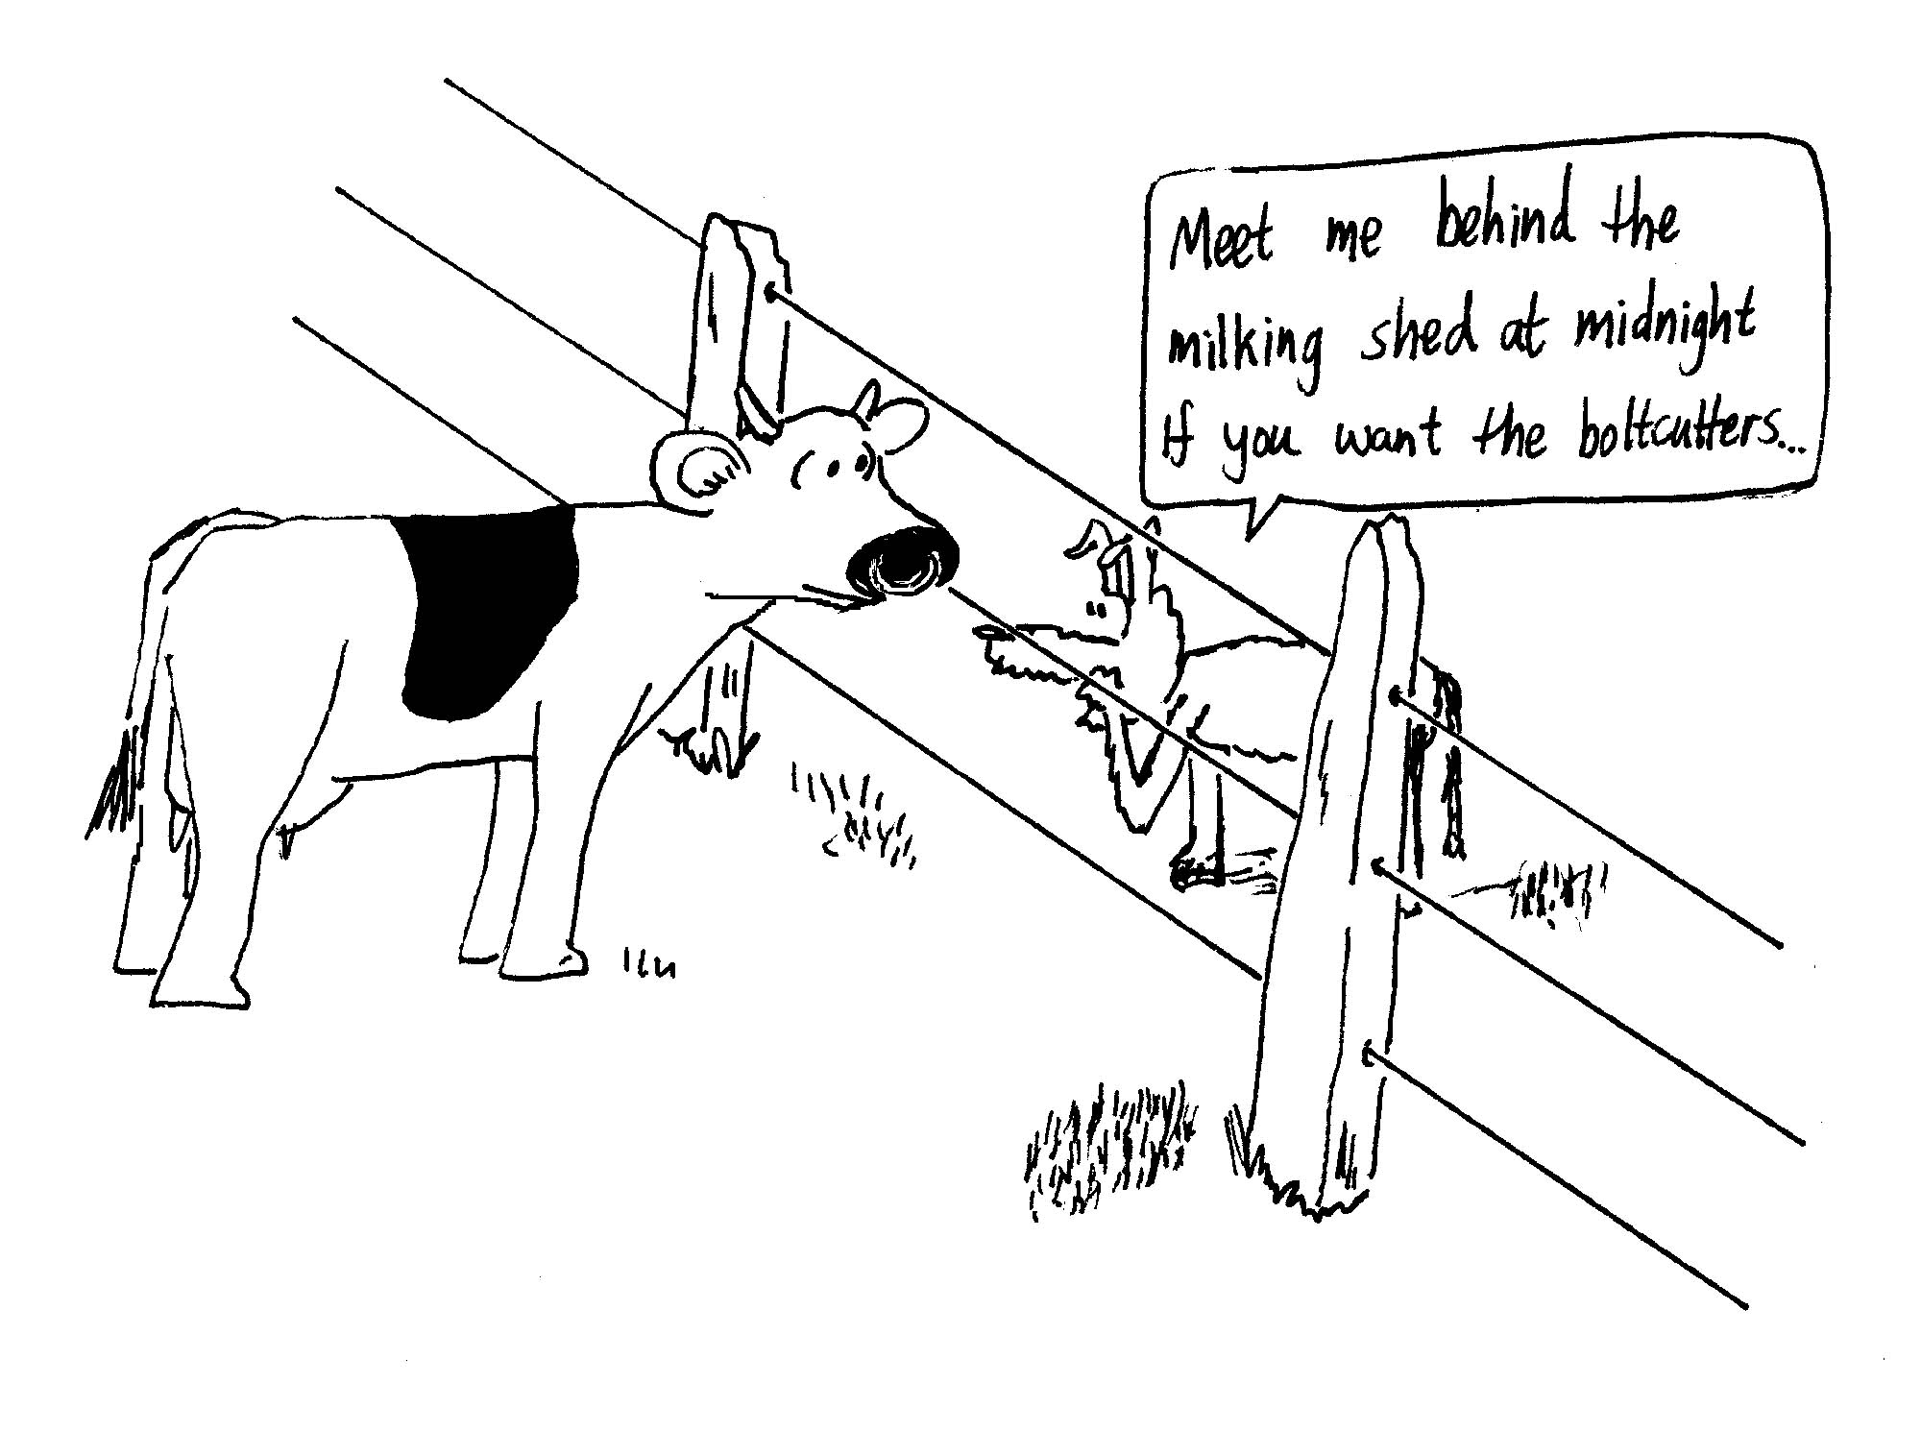
1. A farmer is stringing a wire fence in the middle of the day. He makes it nice and tight so that his cows can’t push through it.
- That night all the wires break. Why?
- How does running hot water over a jar make the lid easier to get off when both the jar and the lid are being heated?

- Thermometers are instruments used to measure temperature. There are many different types of thermometer and the choice of which to use depends both on the object whose temperature is to be measured and the temperature range to be measured. For example, a confectionary thermometer for making lollies needs to measure up to a few hundred degrees Celsius, while a medical thermometer needs to more accurate but only measure up to around 40º C.
    - Describe two different types of thermometer. What physical properties do they rely on?
b. Give examples of when you might use these methods.
- Why do you always have to hold the thermometer under your tongue for what seems like hours (but is usually about 30 seconds) when you have your temperature measured?

B. Activity Questions:

- Thermometers
Examine the different thermometers on display.
What physical quantity do they use to measure temperature?

- Thermal Expansion of gases
Place the coin on top of the bottle.
Now cup your hands around the bottle and observe what happens.
Explain your observations.

- Thermal Expansion of liquids
Hold the beaker in your hands.
Explain what you observe.

- Thermal Expansion of solids - bimetallic strip
Heat the strip using the hairdryer or hot air gun.
What happens to the strip, and why?
Can you think of a use for such a strip?

C. Quantitative Questions:

- Aluminium rivets used in aeroplane construction are made slightly larger than the rivet holes and cooled by dry ice (solid carbon dioxide) before being driven in. If the diameter of a hole is 0.3000 cm, what should be the diameter of a rivet at 20.0°C if its diameter is to equal that of the hole when the rivet is cooled to -78.0°C, the temperature of dry ice?
Assume that the expansion coefficient remains constant at 2.4 × 10-5 K-1.

2. A bridge made of steel is 500 m long. When the bridge was completed in winter (T = 0C) it was exactly 500 m long. The coefficient of linear expansion of steel is 12 × 10-6 K-1.
- Calculate the linear expansion of the bridge on a hot summer’s day with a temperature of 40C.
- If the expansions causes the bridge to rise in the middle, estimate how much the bridge would rise. (Assume that the bridge rises as an isoceles triangle.)
- If the width and depth of the metal spanning the bridge are 20 m and 30 cm respectively, what is the volume expansion of the bridge.
- What precautions do engineers take to prevent the rise in (b) from occuring.
Workshop Tutorials for Technological and Applied Physics
Solutions to TR1T: Temperature

A. Qualitative Questions:

- A farmer is stringing a wire fence in the middle of the day. He makes it nice and tight so that his cows can’t push through it. That night all the wires break.
- The wires break because they contract and get shorter when they cool off. If the force pulling them is great enough and the change in temperature is large, they will break.
- Pouring hot water over a jar can make the lid easier to take off. Both the jar and the lid are being heated, but metal expands more than glass for a given temperature increase, so the lid expands more than the jar and loosens. Running hot water over jars with plastic lids doesn’t work as well as over metal lids.

- Measuring temperature.
A medical mercury-in-glass thermometer relies on the expansion of mercury up a fine (bore) tube as temperature increases. Digital thermometers, like those found in a car, are more robust and are part of an electrical circuit. The physical property that varies with temperature in most types of digital thermometer is electrical resistance.
The mercury in glass thermometer is extremely accurate and so can be used to measure body temperature accurately. Digital thermometers are often used where remote sensing is needed. The electrical signal can be fed into a computer from a remote terminal
A thermometer has to be held in the mouth long enough to allow the thermometer to come to thermal equilibrium with your body. When it is inserted it will be at room temperature.

B. Activity Questions:

1. Thermometers
A liquid in glass thermometer uses the thermal expansion of a liquid to measure temperature. The scale is calibrated to read the temperature as a function of the volume of the liquid. There are also thermometers which use the thermal expansion of a gas, which results in increasing the pressure of the gas if the volume of the gas is fixed. The pressure then tells you the temperature. These are called constant volume gas thermometers.
Digital thermometers use a change in electrical resistance with temperature. There are two types – those that have an increasing resistance with increasing temperature, and those that have a decreasing resistance with increasing temperature. The change in resistance is determined by the material the sensor is made out of.

- Thermal Expansion of gases
The heat from your hands causes the gas inside the bottle to expand, increasing the pressure inside the bottle. When the force due to the pressure of the gas is greater than the weight of the coin it pops off.

- Thermal Expansion of liquids
The heat from your hands causes the liquid to expand. As it cools it contracts again. This is how a typical liquid in glass thermometer works.

- Thermal Expansion of solids - bimetallic strip
The bimetallic strip is made of two metals, one of which expands much more than the other when they are heated. A bi-metallic strip can be used as a sensor because the two metals which make up the strip expand at different rates. When they start to get hot, the strip will bend, and can be used as a switch which either closes or opens a circuit as it bends to or away from a contact. A single strip would expand, but not bend in this way. | metal one, small expansion  metal two,  large expansion  heat  strip bends as metal two expands, but cannot stretch freely because it is attached to metal one.

C. Quantitative Questions:
cool
fits!

1. The rivet expands when heat is added from the environment.
We use linear thermal expansion.
The rivet has a diameter of 0.3000 cm (Do) at -78.0° C (To).
Df = Do (1 + α (Tf - To) )
= 0.3000 cm (1 + (2.4 × 10⁻⁵ K⁻¹) (20.0 °C + 78.0° C)) = 0.3007 cm.
At 20.0 ° C the rivet has a diameter of 0.3007 cm.

2. A bridge made of steel is 500 m long. When the bridge was completed in winter (T = 0ºC) it was exactly 500 m long. The coefficient of linear expansion of steel is 12 × 10⁻⁶ K⁻¹.
    - When the temperature is 40C the bridge will have a length of
L = L_{o} (1 + α (Tf - To) ) = 500 m × (1 + 12 × 10⁻⁶ K⁻¹(40ºC)) = 500.24 m.
The bridge has lengthened by 24 cm.
500 m
250.12 m
7.7 m
    - The expansions causes the bridge to rise in the middle.
The original length of the bridge is 500 m, the expanded length is 500.24 m. This makes an isosceles triangle with base 500 m long and sides ½ × 500.24 m = 250.12 m long.
The height of the triangle is the rise of the expanded bridge = ((250.12 m)² – (250 m)²)^{1/2} = 7.7 m.
This is an enormous rise, for only a small linear expansion.
    - The width, W, and depth, D, of the metal spanning the bridge are 20 m and 30 cm respectively. The original volume of the bridge is V_{o} = L_{o} × W_{o} × D_{o} =500 m × 20 m × 0.3 m = 3000 m³.
The expanded volume of the bridge is:
V= L × W × D = L_{o} (1 + α (Tf - To) ) × W_{o} (1 + α (Tf - To) ) × D_{o} (1 + α (Tf - To) )
= L_{o} × W_{o} × D_{o} × (1 + α (Tf - To) )³ = 500 m × 20 m × 0.3 m × (1 + 12 × 10⁻⁶ K⁻¹(40ºC))³ = 3001.44 m³.
The expansion is therefore 1.44 m³.
- Expansion joints are used in long bridges, these look like little gaps in the bridge and allow the metal to expand, so the gaps open slightly or close slightly with changing temperature. Hinges are used at the ends of bridges rather than putting the weight directly onto the bridge supports so that the bridge can expand and contract slightly due to temperature changes without putting stress on the supports, allowing the bridge to expand without rising.
Workshop Tutorials for Biological and Environmental Physics
TR2B: Heat and Energy

A. Qualitative Questions:

- Rebecca has left the margarine out on the kitchen bench after making toast in the morning. Later in the day Brent finds it, all liquid, and puts it back in the fridge. Being curious about how long it will take to cool, and how much energy this will take, he puts a thermometer in it and checks it every few minutes. After it has cooled down and solidified he plots the temperature and obtains the cooling curve shown. Explain what is happening in each of regions A, B, and C.
A
B
C

2. It is often said that the presence of large amounts of water on the surface of the earth has a moderating effect on daily temperature conditions. Thus it can get much warmer 50 km away from the coast in comparison to coastal areas. Why is this so?

B. Activity Questions:

The drinking bird
The toy drinking bird has ether inside its body and a head-of-felt which soaks up water. Liquid ether evaporates rapidly at room temperature.
Use diagrams to explain why the drinking bird behaves in the way it does.

Keeping warm or cold.
Examine the collection of items which are used to keep other objects hot or cold.
What do these objects have in common?
Measure their temperatures now and a little while later.
Have their temperatures changed significantly?

A hot bath
Pour about 5 ml of water into a test tube.
Hold a match under the test tube and note the change in temperature of the water.
Use this to determine the energy gained by the water.
Estimate how many matches in a tree and how many trees you need to take a hot bath.

4. Cooling by evaporation
Dip the face washer in water and then squeeze most of the water out.
Measure the temperature of the moist washer.
Now wave the washer in the air.
Measure the temperature again. Has it changed? Explain why.

C. Quantitative Questions:

- The energy released when water condenses during a thunderstorm can be very large.
  - Calculate the energy released into the atmosphere for a small storm of 1 km radius and assuming that 2 cm of water is precipitated.
  - What is the average power released if the storms which causes this precipitation lasts 1 hour? How many 60 W light globes would this run?

- Brent and Rebecca are making jelly. They boil some water to dissolve the jelly crystals, then add ice to help it cool down and set faster. They use a heavy ceramic bowl for this, which allows very little heat exchange with the environment. If they have 150 mL (150 cm³) of water with jelly crystals at 80ºC, and they add 50 g of ice (at 0ºC), what will the temperature of the jelly water mix be when the ice has melted and the mix has reached equilibrium?
(Treat the jelly water mix as though it were pure water.)
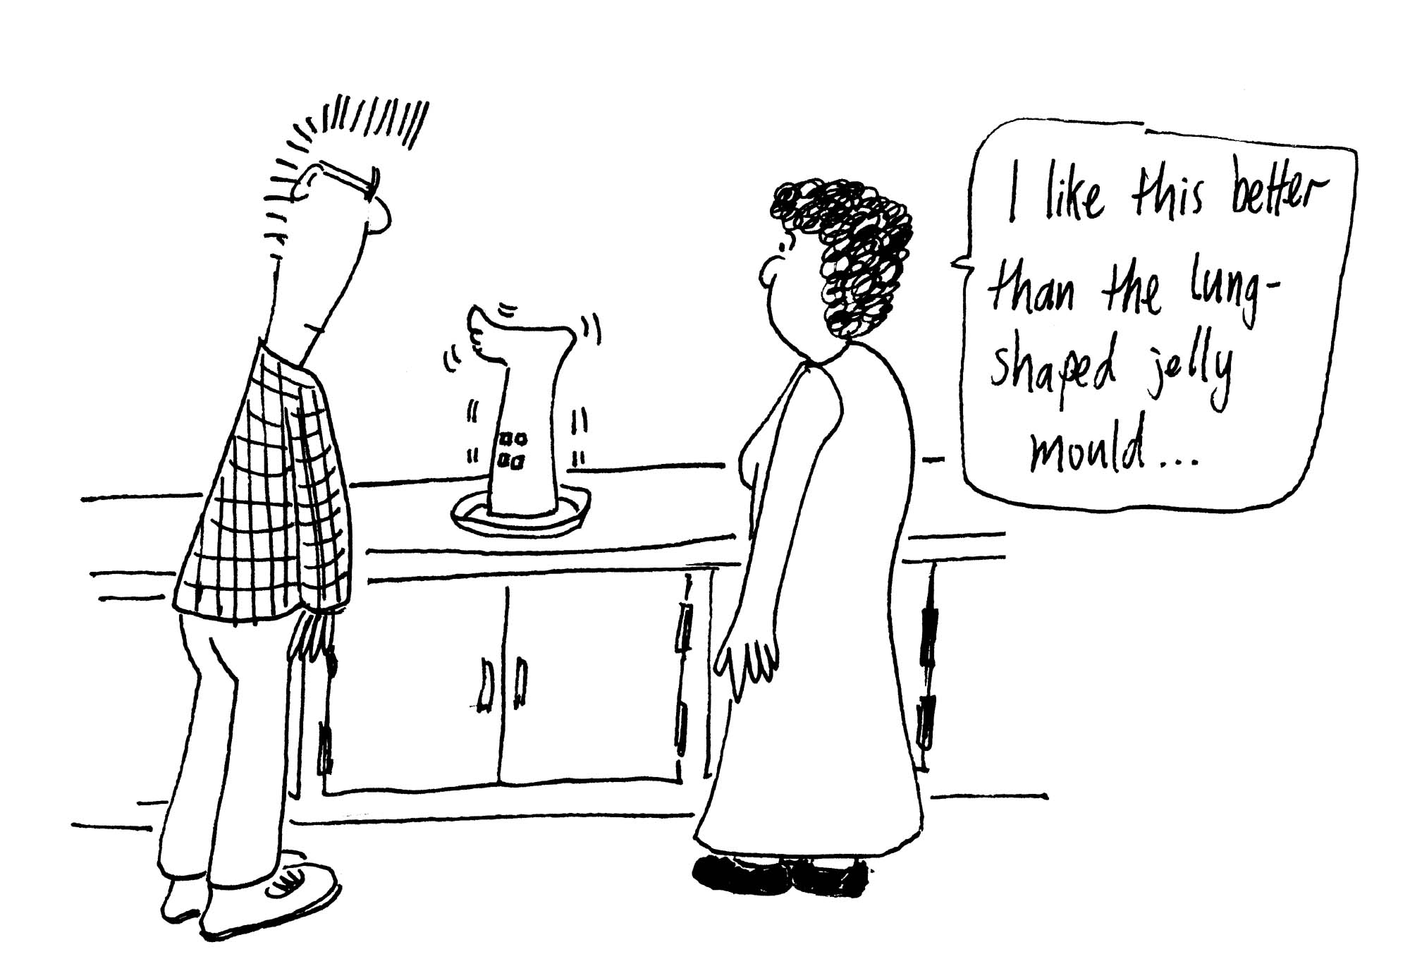
Data:
Density of water = 1000 kg.m⁻³,
specific heat capacity of water = 4190 J.kg⁻¹.K⁻¹,
latent heat of fusion of ice = 333 kJ.kg⁻¹.
latent heat of vapourisation = 2257 kJ.kg⁻¹.
Workshop Tutorials for Biological and Environmental Physics
Solutions to TR2B: Heat and Energy

A. Qualitative Questions:
A
B
C

- Rebecca has left the margarine out on the kitchen bench, Brent finds it all liquid and puts it back in the fridge. In region A the liquid margarine is cooling, and loses heat in proportion to the temperature difference between itself and the air. As the margarine cools the temperature difference decreases, and it loses heat more slowly. Hence the graph is curved, and like many other physical processes (such as radioactive decay and capacitor discharge), it follows an exponential decay.
The rate of cooling also depends on the heat capacity of the material.
In region B the temperature is constant over time. In this region the margarine is solidifying so it continues to lose thermal energy (‘heat’) without changing temperature, this is the ‘latent heat’ associated with a change of state – from liquid to solid margarine. In region C the margarine has solidified and is again cooling. It is now cooling more slowly than it did as a liquid as the margarine approaches the temperature of its surroundings – we say that the margarine is coming into thermal equilibrium with its environment.

2. The large specific heat capacity of water (4180 J.kg⁻¹.K⁻¹) means that the energy required to change the temperature of lakes, rivers and the ocean by 1 K is very large. Since a significant fraction of the thermal energy is absorbed by water, areas close to water experience smaller increases in temperature than those inland. When it is cold, heat from the water is transferred to the air and the ground near the water. This loss of heat can give a substantial increase in air and ground temperature, with only a very small change in water temperature. The specific heat capacity of soil (920 J.kg⁻¹.K⁻¹for clay) is much smaller than that of water, so that 1 kg of water can lose 920 J of heat to a kg of soil, and heat it up 1 K, while only dropping the water temperature by (920 J / 4180 J.K⁻¹)) = 0.2 K. Hence being close to the ocean can keep you warmer in winter and cooler in summer – Sydney, only about 100 km north of Canberra has less temperature variation.

B. Activity Questions:

1. The drinking bird
The drinking bird works by evaporation of ether inside its body and evaporation of water outside its head. The liquid ether in its body evaporates at room temperature. As it vaporizes it creates an increased pressure inside the body, which pushes ether up the tube to the head. Ether in the upper bulb (the head) is cooled by the evaporation of water on the outside of the head, and becomes a liquid, thus there is a transfer of ether from the lower (body) to the upper (head) bulb. When enough ether has collected in the head it overbalances the bird which pivots forwards. When the bird pivots forwards the ether runs back to the body, which pulls it upright again. The pivot tips the head into a glass of water, which wets the head, allowing it to cool again, and condense the evaporating ether again - repeating the cycle over and over.
evaporation
from body
pressure pushes ether up tube
ether runs back down
bird rights itself, start cycle again!

Keeping warm or cold.
Hot water bottles and ice-packs rely on the high heat capacity of water to keep other items hot or cold. The water can lose or gain a lot of energy while changing temperature very little compared to most other substances. Other materials, such as wheat, are also used to fill heat packs.

A hot bath
The energy gained by the water is the E_{match} = 4180 J.kg⁻¹.K⁻¹ × m × ΔT. This is the energy supplied by the match.
A bath tub contains around 300 l or 0.3 m³ which is around 300 kg of water. A nice hot bath is around 50ºC, and tap water is typically at around 20ºC, so you need a temperature change of 30ºC. This requires an energy of E = 4180 J.kg⁻¹.K⁻¹ × 300 kg × 30 K = 38 MJ of energy.

If one match gives you E_{match}, then you need around (38 × 10⁶ J / E_{match} ) matches to heat up water for a bath.

Cooling by evaporation
Evaporative cooling is a very effective means of cooling, and the temperature of the wet face washer will be measurably lower. Temperature is a measure of the average kinetic energy of the molecules of the face washer and water. The actual kinetic energies have a distribution of values, and those molecules with a high kinetic energy may break the bonds linking them to the rest of the water, and leave the surface – this is evaporation. The remaining water molecules have a lower average kinetic energy, and hence a lower temperature. Another way to look at it is to say that it takes energy (latent heat) to evaporate the water, and some of this must come from the face washer, hence cooling it down.

C. Quantitative Questions:
1. The energy released when water condenses during a thunderstorm can be very large.
  - If a small storm of 1 km radius precipitates 2 cm of water, the total volume of water precipitated is:
V = πr² × d = π × (1000 m)² × 0.02 m = 63 × 10³ m³. This is equivalent to 63 × 10⁶ kg of water. The energy released is the latent heat of transformation, which for water is 2257 J.kg.⁻¹, so the total energy released by the condensation during this storm is E = 63 × 10⁶ kg × 2257 J.kg.⁻¹ = 1.4 × 10¹¹ J.
  - The energy released is 1.4 × 10¹¹ J over 1 hour, so the average power is 1.4 × 10¹¹ J / (3600 s) = 39 MW. This would run 39 × 10⁶ W / 60 W = 650,000 light globes at 60 W each!

- Brent and Rebecca are making jelly. They dissolve the jelly crystals and then add ice too cool the mixture down.
jelly water mix at 80º
add ice
jelly water mix + ice
jelly water mix
+ melted ice
ice melts
jelly water mix + ice water in equilibrium at T_{final}
ice water warms,
jelly water cools

Heat absorbed by ice and ice water = heat lost by jelly mix.
(Heat absorbed by ice melting) + (heat absorbed by ice water going from 0ºC to T_{final})
= (heat lost by jelly water mix going from 80ºC to T_{final})
which we can write as: m_{ice}L_{f} + m_{ice}c_{water}ΔT_{ice water} = m_{jelly water}c_{water}ΔT_{jelly water}
putting in the temperatures: m_{ice}L_{f} + m_{ice}c_{water} (T_{final} –0º) = m_{jelly water}c_{water}(80º –T_{final})
and plugging in the numbers :
(50 ×10⁻³ kg × 333 kJ.kg⁻¹) + (50 × 10⁻³ kg × 4190 J.kg⁻¹. ºC⁻¹× T_{final})
= (0.15 kg × 4190 J.kg⁻¹K⁻¹× (80º –T_{final})
16650 J + 209.5 J.ºC⁻¹× T_{final} = 50280 J – 628.5 J. ºC⁻¹× T_{final}
T_{final} = 40ºC. Cool enough to put in the fridge!
Workshop Tutorials for Technological and Applied Physics
TR2T: Heat and Energy

A. Qualitative Questions:

- We use the term heat to describe the transfer of thermal energy.
- Can heat be added to a system without causing the temperature of the system to rise? Does this contradict the concept of heat as energy in the process of transfer because of a temperature difference?
- Why must heat be supplied to melt ice when, after all, the temperature does not change?
Suppose you have an icebox with food, ice and some melt-water from the ice. You want to keep the food cold for as long as possible.
- Should you retain the cold melt-water, or should you drain it through a convenient one-way valve?

- Rebecca and Brent are camping in the Grampians. Rebecca wakes up in the morning and makes a cup of tea. She starts with an ice-water mixture (at 0ºC) from their water container, which has partly frozen over night. Using an electric element plugged into the car’s cigarette lighter socket, she can deliver a constant 500 W to the water mix. Sketch a graph of the temperature of the water as a function of time, labeling any important features. Explain what is happening in the different regions of the graph you have drawn.

B. Activity Questions:

1. The drinking bird
The toy drinking bird has ether inside its body and a head-of-felt which soaks up water. Liquid ether evaporates rapidly at room temperature.
Use diagrams to explain why the drinking bird behaves in the way it does.

2 .Keeping warm or cold.
Examine the collection of items which are used to keep other objects hot or cold.
What do these objects have in common?
Measure their temperatures now and a little while later.
Have their temperatures changed significantly?

A hot bath
Pour about 5 ml of water into a test tube.
Hold a match under the test tube and note the change in temperature of the water.
Use this to determine the energy gained by the water.
Estimate how many matches you need to take a hot bath.

4. Cooling by evaporation
Dip the face washer in water and then squeeze most of the water out.
Measure the temperature of the moist washer.
Now wave the washer in the air.
Measure the temperature again. Has it changed? Explain why.

C. Quantitative Questions:

- Brent and Rebecca are looking at electric jugs in an appliance store, as Rebecca allowed the previous jug to boil dry and it shorted out and melted. They are looking at a jug with a power rating of 2400 W. The label on the jug says that it will boil water in 1 minute.
- What is the maximum amount of water that this jug can boil in 1 minute if the water is initially at room temperature (25ºC)?
- What assumptions have you made in this calculation?
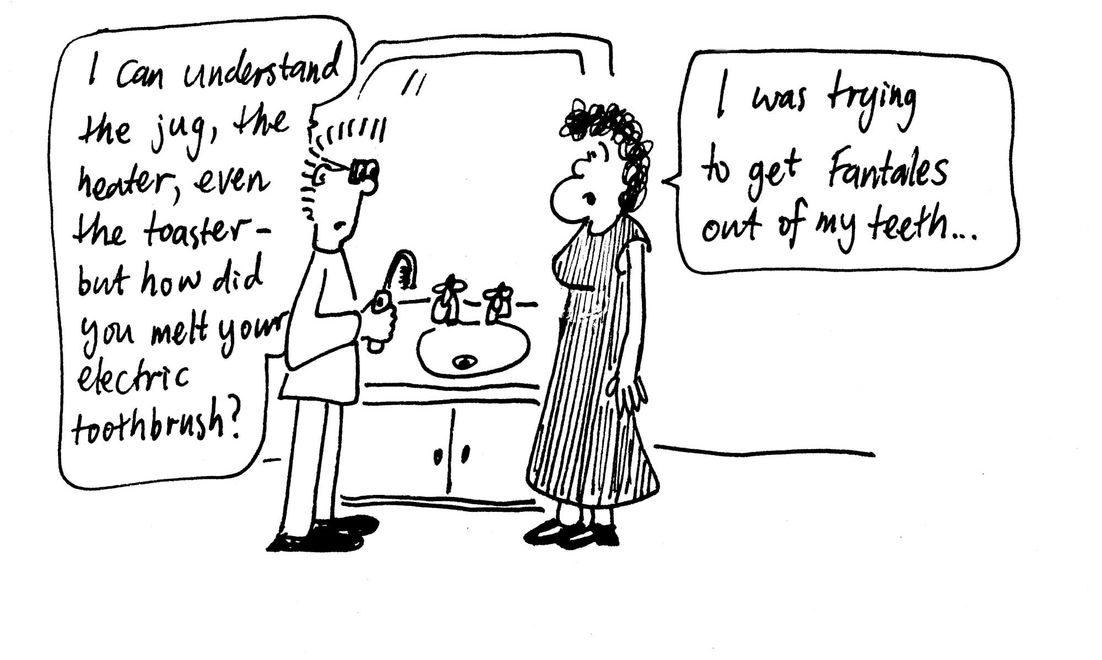
- It takes the jug 2 minutes to boil 400 ml (enough for a large cup of coffee) from room temperature to boiling. What is the efficiency of this jug?

- Brent and Rebecca are making jelly. They boil some water to dissolve the jelly crystals, then add ice to help it cool down and set faster. They use a heavy ceramic bowl for this, which allows very little heat exchange with the environment. If they have 150 mL (150 cm³) of water with jelly crystals at 80ºC, and they add 50 g of ice (at 0ºC), what will the temperature of the jelly water mix be when the ice has melted and the mix has reached equilibrium?
(Treat the jelly water mix as though it were pure water.)

Data:
Density of water = 1000 kg.m⁻³,
specific heat capacity of water = 4190 J.kg⁻¹.K⁻¹,
latent heat of fusion of ice = 333 kJ.kg⁻¹.
latent heat of vapourisation = 2257 kJ.kg⁻¹.

Workshop Tutorials for Technological and Applied Physics
Solutions to TR2T: Heat and Energy

A. Qualitative Questions:

1. We use the term heat to describe the transfer of thermal energy.
- Heat can be added to a system without causing the temperature to rise. There can be energy transfer (heat exchange) with no change in temperature if there is a phase change. The energy is transferred into or released from energies associated with changing the bonds among molecules. This does not contradict the concept of heat as energy in the process of transfer because of a temperature difference. The heat is being transferred from the environment to the substance, which is at a lower temperature.
- In ice the molecules are held tightly together. Supplying heat gives the extra energy required to break the bonds so the solid turns into liquid. This is called the latent heat of transformation. The latent heat of ice is the amount of energy required to convert 1 kg of ice into 1 kg of water with no temperature change – i.e. the amount of energy required to break the bonds only.
- You should retain the cold melt-water in an ice box as it allows better conduction of heat away from the food than air would when the food is first put into the ice box. Once all the ice has melted, the water, which has a high heat capacity, will still keep the food cooler than an ice-box with only air in it, as it will take longer to heat up the water to the outside temperature.
Temperature
time
0ºC
100ºC

2. The initial flat part of the graph shows that the temperature remains at 0ºC until all the ice is melted to water. The following sloped part of the graph shows the temperature of the water increasing to 100ºC. The final flat part of the graph shows the temperature remaining at 100ºC while the water boils and the energy supplied from the electric element is used to break the bonds between the water molecules as they become water vapour.

B. Activity Questions:

1.The drinking bird
The drinking bird works by evaporation of ether inside its body and evaporation of water outside its head. The liquid ether in its body evaporates at room temperature. As it vaporizes it creates an increased pressure inside the body, which pushes ether up the tube to the head. Ether in the upper bulb (the head) is cooled by the evaporation of water on the outside of the head, and becomes a liquid, thus there is a transfer of ether from the lower (body) to the upper (head) bulb. When enough ether has collected in the head it overbalances the bird which pivots forwards. When the bird pivots forwards the ether runs back to the body, which pulls it upright again. The pivot tips the head into a glass of water, which wets the head, allowing it to cool again, and condense the evaporating ether again - repeating the cycle over and over.
evaporation
from body
pressure pushes ether up tube
ether runs back down
bird rights itself, start cycle again!

2. Keeping warm or cold.
Hot water bottles and ice-packs rely on the high heat capacity of water to keep other items hot or cold. The water can lose or gain a lot of energy while changing temperature very little compared to most other substances. Other materials, such as wheat, are also used to fill heat packs.

A hot bath
The energy gained by the water is the E_{match} = 4180 J.kg⁻¹.K⁻¹ × m × ΔT. This is the energy supplied by the match.
A bath tub contains around 300 l or 0.3 m³ which is around 300 kg of water. A nice hot bath is around 50ºC, and tap water is typically at around 20ºC, so you need a temperature change of 30ºC. This requires an energy of E = 4180 J.kg⁻¹.K⁻¹ × 300 kg × 30 K = 38 MJ of energy.

If one match gives you E_{match}, then you need around (38 × 10⁶ J / E_{match} ) matches to heat up water for a bath.

Cooling by evaporation
Evaporative cooling is a very effective means of cooling, and the temperature of the wet face washer will be measurably lower. Temperature is a measure of the average kinetic energy of the molecules of the face washer and water. The actual kinetic energies have a distribution of values, and those molecules with a high kinetic energy may break the bonds linking them to the rest of the water, and leave the surface – this is evaporation. The remaining water molecules have a lower average kinetic energy, and hence a lower temperature. Another way to look at it is to say that it takes energy (latent heat) to evaporate the water, and some of this must come from the face washer, hence cooling it down.

C. Quantitative Questions:

1. Brent and Rebecca are looking at a jug with a power rating of 2400 W. The label on the jug says that it will boil water in 1 minute.
- In one minute the jug provides an amount of energy Q = 2400 W × 60 s = 1.44 × 10⁵ J.
The temperature has to be raised through ΔT = 75ºC = 75 K.
Using Q = m c ΔT, we have m = Q / cΔT = 1.44 × 10⁵ J / (4190 J.kg⁻¹K⁻¹×75 K) = 0.46 kg.
This is equivalent to 460 ml, a large mug-full.
- The assumption made is that the electrical energy delivered to jug element is 2400 W and this is transferred into thermal energy of the water. No energy is lost to the surroundings or in the wiring of the jug. We have assumed an energy efficiency of 100%.
- Efficiency = (energy delivered / energy supplied) ×100%.
Energy delivered = increase in energy of water = mcΔT = 0.4 kg × 4190 J.kg⁻¹K⁻¹ × 75K = 1.26 × 10⁵ J.
Energy supplied = power × time = 2500 W × 120 s = 2.88 × 10⁵ J.
Efficiency = (energy delivered / energy supplied) ×100% = 1.26 × 10⁵ J / 2.88 × 10⁵ J ×100% = 44%.

2. Brent and Rebecca are making jelly. They dissolve the jelly crystals and then add ice too cool the mixture down.
jelly water mix at 80º
add ice
jelly water mix + ice
jelly water mix
+ melted ice
ice melts
jelly water mix + ice water in equilibrium at T_{final}
ice water warms,
jelly water cools

Heat absorbed by ice and ice water = heat lost by jelly mix.
(Heat absorbed by ice melting) + (heat absorbed by ice water going from 0ºC to T_{final})
= (heat lost by jelly water mix going from 80ºC to T_{final})
which we can write as: m_{ice}L_{f} + m_{ice}c_{water}ΔT_{ice water} = m_{jelly water}c_{water}ΔT_{jelly water}
putting in the temperatures: m_{ice}L_{f} + m_{ice}c_{water} (T_{final} –0º) = m_{jelly water}c_{water}(80º –T_{final})
and plugging in the numbers : (50 ×10⁻³ kg × 333 kJ.kg⁻¹) + (50 × 10⁻³ kg × 4190 J.kg⁻¹. ºC⁻¹× T_{final})
= (0.15 kg × 4190 J.kg⁻¹K⁻¹× (80º –T_{final})
16650 J + 209.5 J.ºC⁻¹× T_{final} = 50280 J – 628.5 J. ºC⁻¹× T_{final}
T_{final} = 40ºC. Cool enough to put in the fridge!
Workshop Tutorials for Biological and Environmental Physics
TR3B: Heat Transfer

A. Qualitative Questions:

- The greenhouse effect is an issue of increasing concern, with average temperatures expected to rise around the world over the coming years. The effects of this could be disastrous, with weather patterns changing and sea levels rising.
- What is the green house effect, and what causes it?
- Draw a schematic diagram showing the thermal processes involved. Which thermal processes are affected, and why does this lead to warming?

- Every summer there is at least one report of an infant dying due to heat exhaustion or dehydration as a result of being left in a car with the windows done up. The number of incidences has increased since the legalisation of “pokies” and massive growth in the gambling industry in Australia. Dogs are also common victims of this sort of mistreatment, and it is now illegal in Australia to leave children or animals in parked cars.
It is possible for the temperature in a car to rise to more than 40º in less than 15 minutes on a 20º day. At this temperature it takes only an hour or so for an infant to suffer heat exhaustion leading to brain damage and death.
- Why do cars get so hot so quickly when the windows are wound up? What thermal processes are involved?
- Why does having the windows done up make a big difference?
- Why do dark cars get hotter than light coloured cars?
- Why is it so hard for the body to cope with this situation, as compared to being hot outside the car?
- How is this similar or different to the greenhouse effect?

B. Activity Questions:

1. Thermal conductivity.
Feel the different blocks. Which feels the coldest? Which feels the warmest?
Now measure their temperatures. Which is the warmest? Which is the coldest? Explain your observations.

2. “Stubby holder”
How does the stubby holder keep the can cool? Which process of heat transfer is affected?
Wetsuits worn when swimming in cold waters are effective in reducing heat loss from the body. A wetsuit is named so because it traps a layer of water. Explain why wearing a wetsuit keeps a swimmer warmer.

Thermos flask.
Examine the thermos flask.
It has a thick stopper, double walls which are evacuated, and the vacuum bottle is silvered on the inside. Explain how this keeps drinks either hot or cold. What processes of heat transfer are affected?

Measuring air temperatures
Check the readings on the two thermometers.
Now put them under the light or in the sun for a few moments.
How do the readings compare now?
What does a thermometer actually measure?

C. Quantitative Questions:

- Rebecca and Brent are on holiday in Europe over Christmas. One morning they go for a walk and come across an ice covered pond. Rebecca goes to walk across the surface, but Brent is worried that the ice may not be thick enough and stops her. Rebecca points out that it is -5.0ºC and has been for long enough that the water/ice will have reached thermal equilibrium.
The bottom of the pond will be at steady 4.0 ºC. If the total depth of the ice and water is 1.4 m, how thick is the ice? Do you think Brent should let Rebecca walk out across it?
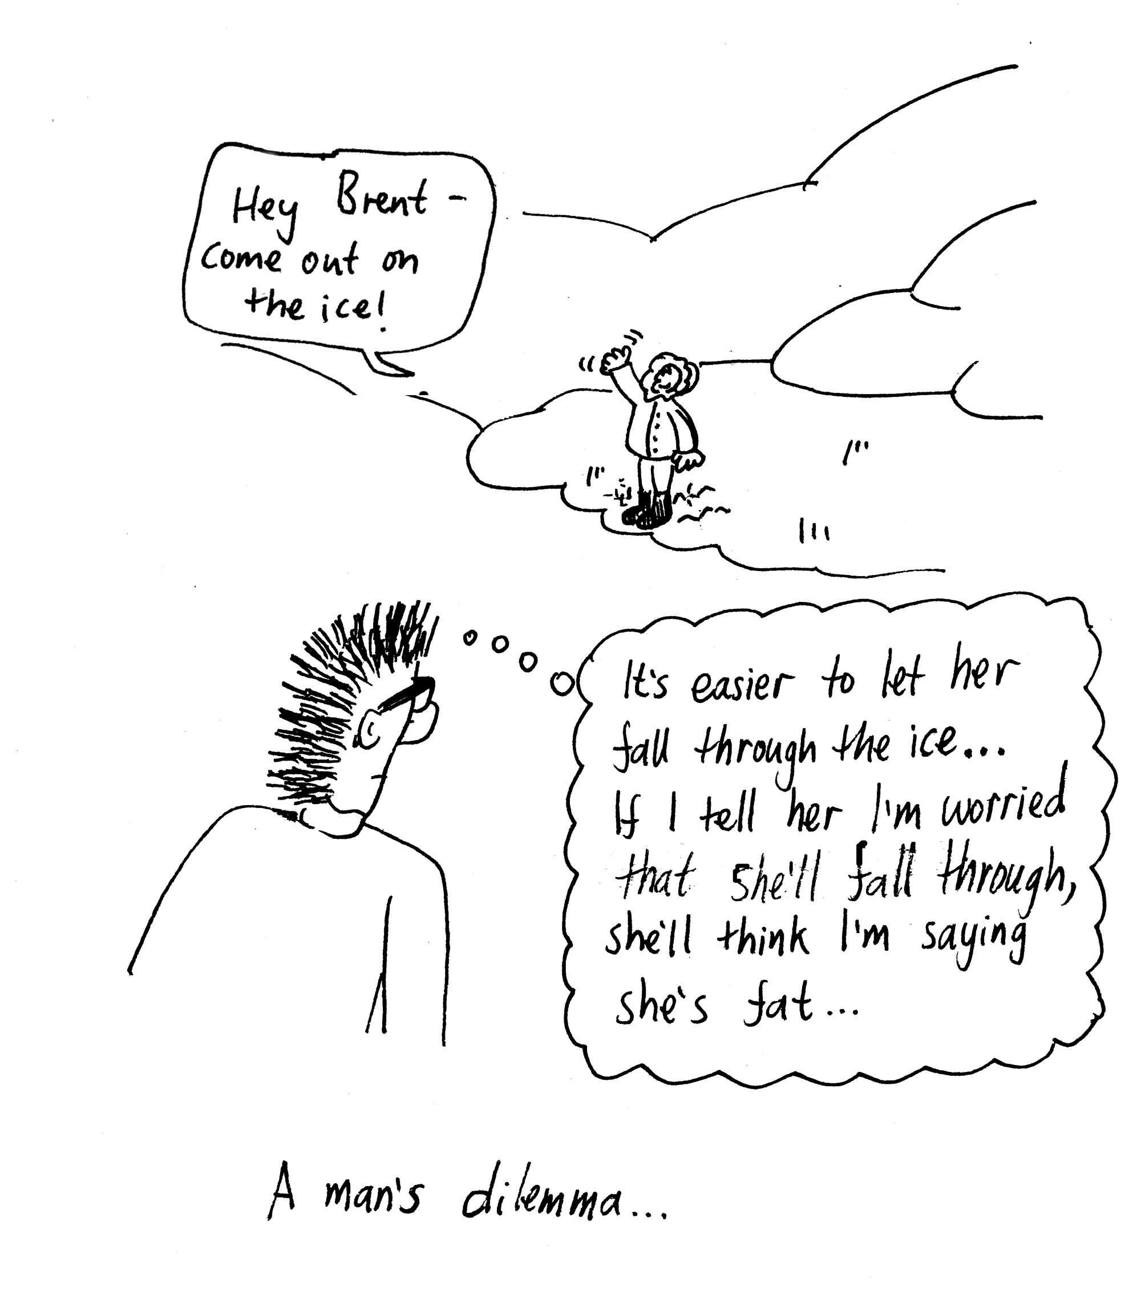

- Consider the following model of the Earth’s thermal equilibrium. The earth is in dynamic equilibrium with the radiation absorbed from the sun equal to the radiation emitted by the Earth’s surface. The Earth absorbs as a disc but radiates as a sphere and has an emissivity of 1. A square metre of the Earth’s surface receives solar energy at a rate of 1.36 kW.m⁻², and of this 70 % is absorbed and 30 % is reflected.
  - Using this simple model, estimate the average temperature of the earth.
  - The measured average temperature of the earth is more like 15º C. Explain why it is much warmer than predicted by our simple model.

Data:
Thermal conductivity of ice = 1.67 W.m⁻¹.K⁻¹,
Thermal conductivity of water = 0.50 W.m⁻¹.K⁻¹.
Radius of the Earth = 6400 km

Workshop Tutorials for Biological and Environmental Physics
Solutions to TR3B: Heat Transfer

A. Qualitative Questions:

1. The greenhouse effect is an issue of increasing concern, with average temperatures expected to rise.
- Greenhouse gases like carbon dioxide and methane in the atmosphere absorb energy which is radiated by the Earth’s surface. These gases then radiate in all directions, so some radiation is absorbed back at the Earth’s surface rather than being lost to space. In a glass greenhouse there is this effect of preventing radiation escaping, and also prevention of heat loss by convection, much as in a closed car. Note that this is quite different to the effect of ozone depleting gases (chloro-fluoro-carbons or CFCs), which break up ozone molecules which shield us from UV radiation.
b.
1. radiation comes in from sun.
2. radiation interacts with plants, Earth etc.
3. radiation remitted with lower energy, especially infrared
4. radiation absorbed or reflected by green houses gases: heat trapped

radiation comes in
some radiation
goes out
hot dog
2. The interior of a car can heat up rapidly when the car is parked in the sun with the windows wound up.
- When the windows of a car are wound up the car still absorbs heat as radiation from the sun, and radiates some of this heat at it’s characteristic temperature. However with the windows done up there is little or no air flow into or out of the car, so no heat transfer out of the car by convection can take place.
- Even on a hot day a breeze is quite cooling. This is because the moving air transfers heat away from your body surface very effectively. Air inside a closed car cannot exchange heat effectively with its environment, and as there is a net transfer of heat into the car, it gets hot very quickly.
- Dark cars get hotter than light coloured cars because they reflect less radiation, and hence absorb more radiation, thus absorbing more energy or heat.
- Air movement also helps with evaporative cooling, by reducing the moisture around the skin, allowing more moisture to evaporate, thus cooling the skin. With car windows done up, there is very little air movement in the car, so both convective and evaporative cooling are reduced. Evaporative cooling is a crucial mechanism of heat loss for humans.
- This is similar to the greenhouse effect in that more radiation is absorbed than is emitted. However the main mechanism for heat loss which is interfered with in this case is convective heat transfer.

B. Activity Questions:

1. Thermal conductivity
The blocks are all at room temperature. Your skin is usually a little warmer than room temperature, and when you touch something like metal it feels cold because heat is quickly conducted away from our skin by the metal. Wood and polystyrene are good insulators, and do not conduct heat away from your skin, hence they feel warm. What you are really feeling when you feel for “temperature” is the rate at which heat is transferred to or from your skin.

2.“Stubby holder”
The stubby holder prevents heat loss by convection and conduction. When a wetsuit traps a layer of water it also prevents convection, as there is no longer a flow of water over the skin.

Thermos Flask
A thermos flask has double walls, which are evacuated and the vacuum bottle is
silvered on the inside. The vacuum between the two walls prevents heat being transferred from the inside to the outside by conduction and convection. The silvered walls reflect radiated heat back to the inside, the same way a space blanket does.

Measuring air temperatures
A thermometer always measures its own temperature. If it is in the shade, it reaches thermal equilibrium with the surrounding air molecules and measures that temperature. When heated by the sun's radiation it measures its own raised temperature. The equilibrium temperature is greater than the air temperature.

C. Quantitative Questions:

- Rebecca wants to walk across the ice. It is -5.0ºC and has been for long enough that the water/ice will have reached thermal equilibrium. The bottom of the pond will be at steady 4.0 ºC. The total depth of the ice and water is 1.4 m. A steady state has been reached so the temperatures are not changing and the thickness of the ice is not changing.
heat flow
ice

T = 0º
water
T = 4º
air

T = -5º
x
x-L
L
However because of the temperature difference between the bottom of the pond and the air above, there is heat being conducted from the bottom of the pond to the air above. Let the thickness of the ice be x. The temperature of the bottom of the ice has to be the same as the top of the water since they are in contact and this temperature is 0.0° C.
In a steady state the rate of heat flow through water = rate of heat flow through ice:
H_{ice} = H_{water} or
$$\frac{0\text{.}\text{50}W\text{.}m^{−1}C^{−1} (4\text{.}0°C−0\text{.}0°C)}{1\text{.}4\text{ m}−x}=\frac{1\text{.}\text{67}W\text{.}m^{−1}C^{−1}(0\text{.}0°C−−5\text{.}0°C)}{x}$$
Solving for x gives x = 1.1 m. This is easily thick enough to be safe to walk on.
Note that there is no heat transfer through the water by convection because the warmer water (at ~4°C) is more dense than the colder water (at ~1°C).

- Consider the following model of the Earth’s thermal equilibrium. The earth is in dynamic equilibrium with the radiation absorbed from the sun equal to the radiation emitted by the Earth’s surface. The Earth absorbs as a disc but radiates as a sphere and has an emissivity, e, of 1. A square metre of the Earth’s surface receives solar energy at a rate of I_{o} = 1.36 kW.m⁻², 70 % is absorbed and 30 % is reflected.
a. The absorbing area is A_{abs} = πR ². The amount of energy absorbed is P_{abs}= 0.7I_{o} A = 0.7I_{o}πR ².
This must be equal to the energy radiated if the Earth is in equilibrium. If the Earth radiates as a blackbody then P_{rad} = (4πR²)eσT⁴. Setting this equal to the amount absorbed gives:
P_{rad} = (4πR²)eσT⁴= P_{abs} = 0.7I_{o} × πR ² cancelling out the πR² gives:
4eσT⁴= 0.7I_{o} so T⁴ = 0.7I_{o}/4 eσ = (0.7 × 1.36 kW.m⁻² )/( 4 × 1 × 5.67 × 10⁻⁸ W.m⁻².K⁻⁴) = 4.2 × 10⁹ K⁴.
So T = 255 K = - 18ºC.
b. The measured average temperature of the earth is more like 15º C. which is much warmer than predicted by our simple model. This is because our model assumes that all the radiation emitted by the Earth escapes. In fact there is a natural greenhouse effect due to the atmosphere which prevents this radiation being lost to space, as much of it is reflected or reemitted back to the Earth.
Workshop Tutorials for Technological and Applied Physics
TR3T: Heat Transfer

A. Qualitative Questions:

- You have spent most of the morning at university with your car parked out in the sun. At lunchtime you decide to drive to the shopping centre with some friends for lunch. When putting your seat belt on you burn yourself on the metal buckle of the seat belt but not the belt itself. One of your friend explains this by saying that the buckle is at a hotter temperature than the belt which is why the buckle burns you. “But hang on”, says another friend, “the buckle is shiny and the belt is black, surely the belt must be hotter because it absorbs more heat?”
  - Why does the buckle burn, but not the belt, and is the belt actually hotter?
When you get to the shopping center you can park either at the top of a multistory carpark, under a metal roof, or in an outside car park under a tree. Your friend advises you to park under a tree rather than under the metal roof.
  - Why is it cooler under the tree than under the metal roof?

- Car engines can be damaged by overheating and require costly repairs. Overheating the engine can cause the cylinder head to warp and damage the head gasket which seals the gap between the head and the engine block. If this happens you not only need to replace the head gasket, but the cylinder head will need to be ground to make it flat again. This can cost thousands of dollars. The cooling system of a car usually includes a radiator at the front, filled with water which circulates around the engine, and a fan between the radiator and the engine itself. Describe how this system acts to keep the engine cool. What heat transfer processes are involved, and what design features are there in a typical cooling system, and the radiator itself, to control engine temperature?

B. Activity Questions:

Thermal conductivity.
Feel the different blocks. Which feels the coldest? Which feels the warmest?
Now measure their temperatures. Which is the warmest? Which is the coldest? Explain your observations.

2. “Stubby holder”
How does the stubby holder keep the can cool? Which process of heat transfer is affected?
Wetsuits worn when swimming in cold waters are effective in reducing heat loss from the body. A wetsuit is named so because it traps a layer of water. Explain why wearing a wetsuit keeps a swimmer warmer.

Thermos flask.
Examine the thermos flask.
It has a thick stopper, double walls which are evacuated, and the vacuum bottle is silvered on the inside. Explain how this keeps drinks either hot or cold. What processes of heat transfer are affected?

Measuring air temperatures
Check the readings on the two thermometers.
Now put them under the light or in the sun for a few moments.
How do the readings compare now?
What does a thermometer actually measure?
C. Quantitative Questions:

1. Rebecca and Brent are on holiday in Europe over Christmas. One morning they go for a walk and come across an ice covered pond. Rebecca goes to walk across the surface, but Brent is worried that the ice may not be thick enough and stops her. Rebecca points out that it is -5.0ºC and has been for long enough that the water/ice will have reached thermal equilibrium.
The bottom of the pond will be at steady 4.0 ºC. If the total depth of the ice and water is 1.4 m, how thick is the ice? Do you think Brent should let Rebecca walk out across it?

2. Slow combustion wood heaters are used in many houses. They typically have a chamber where the wood is burnt, with a glass door. The glass door allows heat to be radiated to the room. They usually have a wide copper or steel flue (pipe) leading out to a chimney at the roof. This flue is important in heating the room, as it radiates a substantial amount of heat due to the hot air flowing through it. A copper flue 2 m long and 0.008m thick has a surface area of 0.12 m². The hot air flowing through the flue is at 80.0ºC and the temperature of the room is 16ºC. The outside surface of the pipe is at 79.8ºC, and the pipe is in thermal equilibrium with its surroundings.
- At what rate is heat conducted through the pipe?
- What is the net rate of energy radiated from the pipe? Assume that the outer surface of the pipe has an emissivity of 1.
- What is the rate of convective heat loss from the pipe? Explain any assumptions you have made.

Data:
Thermal conductivity of ice = 1.67 W.m⁻¹.K⁻¹,
Thermal conductivity of water = 0.50 W.m⁻¹.K⁻¹.
Thermal conductivity of copper = 390 W.m⁻¹.K⁻¹
Workshop Tutorials for Technological and Applied Physics
Solutions to TR3T: Heat Transfer

A. Qualitative Questions:

    - When putting your seat belt on you burn yourself on the metal buckle of the seat belt but not the belt itself. One of your friends says, “the buckle is shiny and the belt is black, surely the belt must be hotter because it absorbs more heat?”
a. The belt may be slightly hotter if it is absorbing more radiated heat. It is more likely that the belt and buckle are in thermal equilibrium, in which case they are at the same temperature. The buckle has a much higher heat conductivity than the belt, so even if it is slightly cooler, it can still transfer heat to you much faster, burning you when the belt does not.
  - It is cooler under the tree than under the metal roof, even though it prevents direct exposure to the radiant heat from the sun. The tree canopy is at a lower temperature than the metal, because it absorbs less heat and also has a higher heat capacity. Hence the roof, which is relatively hot, emits more radiation down towards you than a tree canopy, and it is cooler under a tree than a metal roof even though both provide shade.

2. Water from the radiator circulates around the hot engine driven by a pump. Heat is transferred mainly by conduction to the water. Heat is also transferred to the air around the engine by conduction and radiation. The heated water flows back to the radiator, where thermal energy is lost by conduction through the metal to the air, and then by convection of the air away from the engine. Heat is also lost by radiation from the metal of the radiator. The fan helps the process by increasing the flow of air around both the engine and the radiator, replacing hot air with cooler air. The design of the radiator with lots of tiny fins allows for maximum surface area to be exposed to the air flow, and increases the radiation from the radiator, which maximizes the cooling effect. Note that most of the cooling is by conduction to the air and then convection – not by radiation as the name radiator would suggest.

B. Activity Questions:

1. Thermal conductivity
The blocks are all at room temperature. Your skin is usually a little warmer than room temperature, and when you touch something like metal it feels cold because heat is quickly conducted away from our skin by the metal. Wood and polystyrene are good insulators, and do not conduct heat away from your skin, hence they feel warm. What are you are really feeling when you feel for “temperature” is the rate at which heat is transferred to or from your skin.

2. “Stubby holder”
The stubby holder prevents heat loss by convection and conduction. When a wetsuit traps a layer of water it also prevents convection, as there is no longer a flow of water over the skin.

Thermos Flask
A thermos flask has double walls, which are evacuated and the vacuum bottle is
silvered on the inside. The vacuum between the two walls prevents heat being transferred from the inside to the outside by conduction and convection. The silvered walls reflect radiated heat back to the inside, the same way a space blanket does.

Measuring air temperatures
A thermometer always measures its own temperature. If it is in the shade, it reaches thermal equilibrium with the surrounding air molecules and measures that temperature. When heated by the sun's radiation it measures its own raised temperature. The equilibrium temperature is greater than the air temperature.

C. Quantitative Questions:

- Rebecca wants to walk across the ice. It is -5.0ºC and has been for long enough that the water/ice will have reached thermal equilibrium. The bottom of the pond will be at steady 4.0 ºC. The total depth of the ice and water is 1.4 m. A steady state has been reached so the temperatures are not changing and the thickness of the ice is not changing.
heat flow
ice

T = 0º
water
T = 4º
air

T = -5º
x
x-L
L
However because of the temperature difference between the bottom of the pond and the air above, there is heat being conducted from the bottom of the pond to the air above. Let the thickness of the ice be x. The temperature of the bottom of the ice has to be the same as the top of the water since they are in contact and this temperature is 0.0° C.
In a steady state the rate of heat flow through water = rate of heat flow through ice:
H_{ice} = H_{water} or
$$\frac{0\text{.}\text{50}W\text{.}m^{−1}C^{−1} (4\text{.}0°C−0\text{.}0°C)}{1\text{.}4\text{ m}−x}=\frac{1\text{.}\text{67}W\text{.}m^{−1}C^{−1}(0\text{.}0°C−−5\text{.}0°C)}{x}$$
Solving for x gives x = 1.1 m. This is easily thick enough to be safe to walk on.
Note that there is no heat transfer through the water by convection because the warmer water (at ~4°C) is more dense than the colder water (at ~1°C).

- This flue of a combustion heater is important in heating the room, as it radiates a substantial amount of heat due to the hot air flowing through it. A copper flue 2 m long and 0.008m thick has a surface area of 0.12 m². The hot air flowing through the flue is at 80ºC and the temperature of the room is 16ºC. The outside surface of the pipe is at 79.9ºC, and the pipe is in thermal equilibrium with its surroundings.
- The rate of conduction of heat is
H =$\frac{kA(T_{\text{outside}}−T_{\text{inside}})}{x}$ = 390 W.m⁻¹.K⁻¹ × 0.12 m² × 0.1 K / 0.008 m = 590 W
- The rate at which heat is radiated from the pipe is
P = εσA(T_{outsidepipe}⁴- T _{air}⁴) = 1 × 5.67 × 10⁻⁸ W .m⁻².K⁻⁴ × 0.12 m² × ((352.9 K)⁴-(289 K )⁴) = 58 W
- The rate of convective heat loss must be the difference between the rate at which heat is conducted to the surface of the pipe and rate at which it is radiated away. This is 590 W – 58 W = 530 W.
To get this answer we have assumed that the thermal energy conducted through the pipe equals the thermal energy lost by convection and radiation and conduction to the air – this is the case if we are to have thermal equilibrium. The conductivity of air is a factor 10⁵ smaller than the conductivity of copper and so is ignored.

Workshop Tutorials for Biological and Environmental Physics
TR4B: First Law of Thermodynamics

A. Qualitative Questions:

- Consider the human body as a system and apply the first law of thermodynamics to it. We know that over any given period of sufficient length (say one day), there will be a net heat flow from the body (i.e. Q is negative) and the body will do some external work on its surroundings (i.e. W is positive). The first law then tells us that ΔU is negative. So, each day there would be a decrease in internal energy.
  - Does the internal energy of the human body decrease as described above?
  - Explain how (and in what form) internal energy is added to the body to balance the continual decrease due to heat flow from the body and work being done by the body.
  - In the context of the human body, explain the following statement, “the first law of thermodynamics is a restatement of the law of conservation of energy”.

- A certain quantity of an ideal gas is compressed to half its initial volume. The process may be adiabatic, isothermal or isobaric (constant pressure).
- Graph each of these processes on a P-V diagram.
- For which process is the greatest amount of mechanical work required? Explain your answer.

B. Activity Questions:

1. Bicycle pump
Put your finger at the end the nozzle so that the air in the pump is trapped.
Pump the bicycle pump and feel what happens to the cylinder.
Explain your observations using the first law of thermodynamics.

2. Ball bearings in a tube
Check the temperature of the ball bearings inside of the tube.
Now shake the tube vigorously for a minute or more.
What is the temperature of the ball bearings now?
Why has it changed?
Could you use this technique to reheat a cold cup of coffee?

Heat and Work
There are three processes to perform.
In the first system, the piston is pushed down into the insulated cylinder.
In the second system, the gas inside the tin is heated with the lid on.
In the third system the gas is heated with the sliding lid on, and a load on top.
force
gas
gas
heat
heat
gas
load
1.
2.
3.

Which, if any, of these processes is adiabatic?
Are any of them isochoric? What about isobaric?
Draw a table showing the heat, work and change in internal energy for each process.

C. Quantitative Questions:

- The diagram below shows a simple model of the pressure as a function of volume for the air in the lung during one cycle of breathing. The arrow indicates the direction in which the cycle is executed - first inhalation, then exhalation. Note that the change in volume is of the air that does not get fully expelled from the lungs – called the “dead volume”.
- By counting the squares within the closed curve and making allowance for the scales of the axes, determine the amount of work done on the gas per breathing cycle.
- What do you think is happening during the exhalation and inhalation processes in terms of pressure and volume of the diaphragm, the chest cavity, the lungs and the air in the lungs? Explain your answer using the diagram.

- A sample of gas is taken from an initial thermodynamic state A to state B, then to state C and back to state A. The pressure at state A is equal to that at state B and is 20 Pa, while the pressure at state C is 40 Pa. The volume at state B is equal to that at state C and is equal to 3.0m³, while the volume at state A is 1.0m³.
- Draw a P-V diagram for the gas taken through the cycle ABCA. Assume that the section C to A is a straight line.
- Complete the table below by filling in either +, - or 0 for the sign of each thermodynamic quantity associated with each process.
Process | Q | W | ΔE_{int}
A to B |  |  | +
B to C | +
C to A
- Add another row to the table, labeling it ABCA. In this row fill in the numerical values for Q, W, and ΔE_{int} for the entire cycle.
- Redraw the table. Using the following information and the P-V diagram complete the table with numerical values. The internal energy increases by 10 J in the process A to B and decreases by 15 J in process C to A.
Workshop Tutorials for Biological and Environmental Physics

Solutions to TR4B: First Law of Thermodynamics
A. Qualitative Questions:
1. Consider the human body as a system and apply the first law of thermodynamics to it.
a. Internal energy is related to temperature. The human body has fairly constant temperature, hence the
internal energy does not decrease as described above.
b. Internal energy is added to the body to balance the continual decrease due to heat flow from the body
and work being done by the body. The added internal energy comes from food. The food is broken down into simple components like sugars which are stored, then when the body needs energy the sugar is broken down and oxidized (has oxygen added), and there is energy released.
c. We gain energy from the food, air and water that we take in. This energy is converted to heat and into work, and stored as potential energy, for example in fats. The total energy is always conserved, and the change in internal energy is the difference between the energy gained and the energy lost as heat and work.

2. A certain quantity of an ideal gas is compressed to half its adiabatic, isothermal or isobaric (constant pressure). a. See diagram opposite.
b. Since the work is being done on the system, the volume is reduced as the process goes to the left. The area under the PV diagram gives the work, W, done on the gas. This area is greatest for an adiabatic process, in which Q is zero.
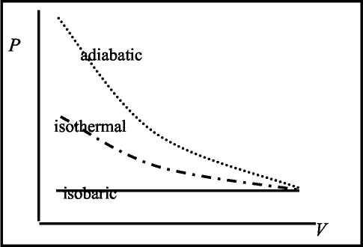
B. Activity Questions:

1. Bicycle pump
The air in the sealed off pump is compressed quickly, hence work is done on the air. There is little time for heat transfer to occur, so Q ~ 0, and the change undergone by the gas is a good approximation to an adiabatic process. The increase in internal energy is indicated by the rise in temperature, which is detected by a thermocouple inside the pump.

2. Ball bearings in a tube
When you shake the tube you do work on the ball bearings and give them kinetic energy.
The kinetic energy is lost as thermal energy as the ball bearings settle again, and this thermal energy increases the temperature of the ball bearings.
You could heat up a coffee this way, but it would take years of vigorous shaking!

3. Heat and Work
There are three processes: in the first system, the piston is pushed down into the insulated cylinder. This is adiabatic, as the insulation prevents heat exchange. In the second system, the gas inside the tin is heated with the lid on. This is isochoric – the volume is kept constant. In the third system the gas is heated with the sliding lid on, and a load on top – this is isobaric as the weight on top of the lid keeps the pressure constant.
 | process 1 | process 2 | process 3
Heat (+ is in) | 0 | + | +
Work (+ is out) | - | 0 | +
~U | + | + | +

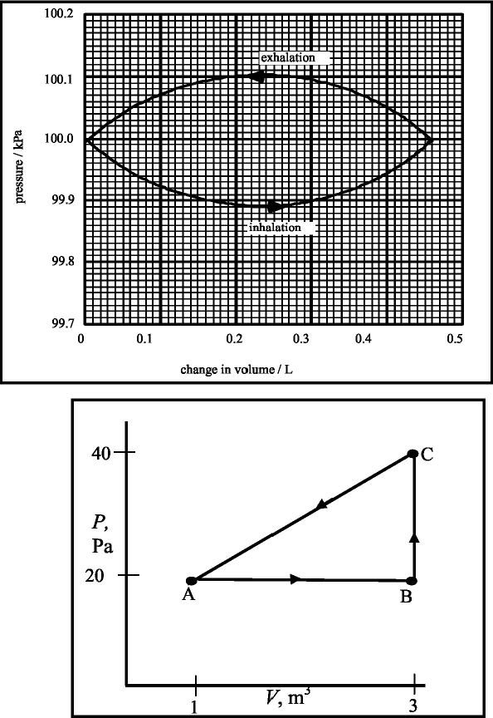
C. Quantitative Questions:

1. The diagram on the right shows a simple model
of the pressure as a function of volume for the air
in the lung during one cycle of breathing.
a. The area of one square represents
0.1 × 10-3 ^{m3} × 0.1 × 10³ Pa = 1.0 × 10⁻² N.m= 0.01 J. The area we want is the area beneath the
inhalation curve minus the area beneath the
exhalation curve. This is the same as the area
between the curves. There are approximately
7 large squares within the curve (shaded area),
hence the total work done per cycle by the lungs
is - 7 × 0.01 J = - 0.07 J. Note that the work done
is negative because the work is done on the
air by the lungs.

2. A sample of gas is taken from an initial thermodynamic state A to state B, then to state C and back to state A. The pressure at state A is equal to that at state B and is 20 Pa, while the pressure at state C is 40 Pa. The volume at state B is equal to that at state C and is equal to 3.0m³, while the volume at state A is 1.0m³.
a. See P-V diagram opposite.
b. See the table below.
c. See the table below.
Process | Q | W | ~Eint
A to B | + | + | +
B to C | + | 0 | +
C to A | - | - | -
ABCA | - | - | 0

d. The internal energy increases by 10 J in the process A to B and decreases by 15 J in process C to A. See table below for complete work, heat and internal energy changes. The work is the area under the PV curve, which is 40 J for the process A to B, 0 for the process B to C and 60 J for the process C to A. If the internal energy increased by 10 J in the process A to B and the work done is + 40 J, then using ~U = Q – W, gives Q = + 50 J for process A to B. Using this again for C to A gives Q = -75 J.We know that the total change in internal for a complete cycle is zero, so if the change from A to B is 10 J, and the change from B to C is –15 J, the change from B to C is the difference: + 5 J.

Process | Q | W | ~Eint
A to B | +50 J | +40 J | +10 J
B to C | +5 J | 0 J | +5 J
C to A | -75 | -60 | -15 J
ABCA | -20 | -20 | 0 J

Workshop Tutorials for Technological and Applied Physics
TR4T: First Law of Thermodynamics

A. Qualitative Questions:

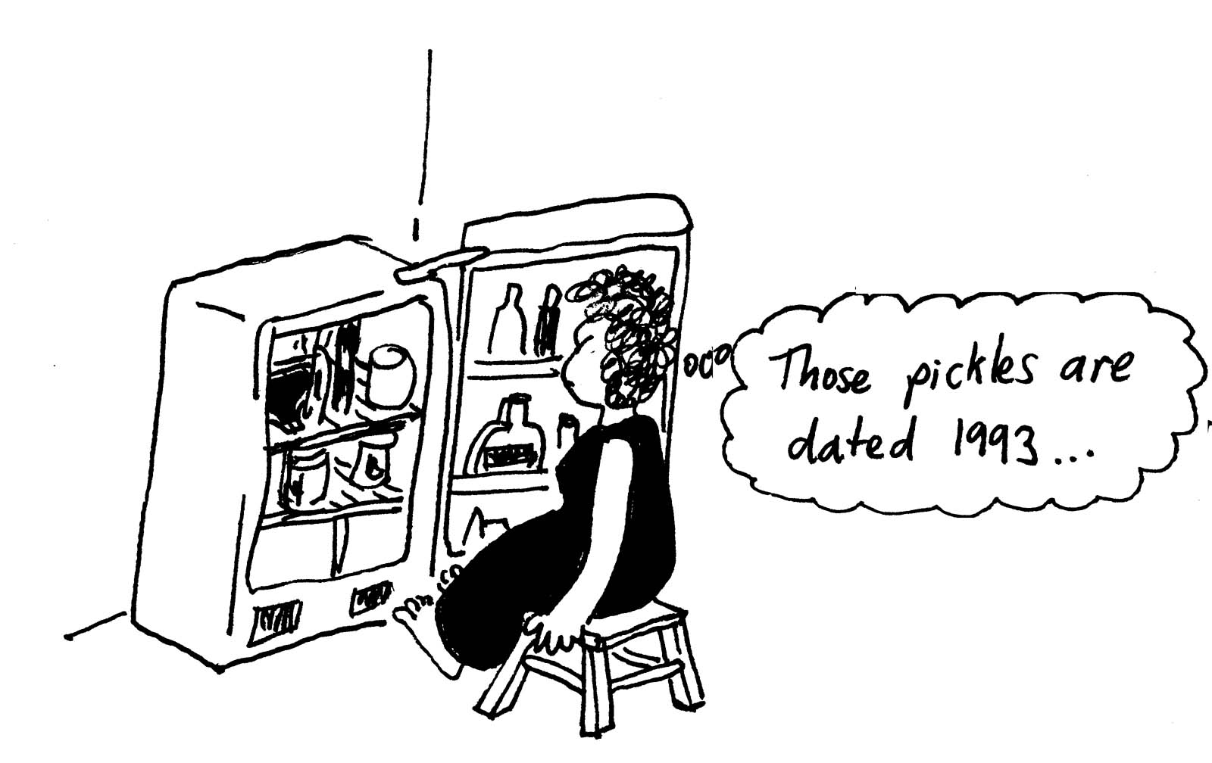
- On a very hot day Brent comes home and finds Rebecca sitting in front of the fridge with the door open. She explains that the air conditioner stopped working, so she’s using the fridge to cool the room instead.
  - Will this cool the kitchen? What will happen to the temperature of the kitchen?
  - What would happen if Rebecca tried to cool the kitchen with an ice box full of ice instead?
  - How does an air conditioner keep a room cool without violating the first law of thermodynamics?

- A certain quantity of an ideal gas is compressed to half its initial volume. The process may be adiabatic, isothermal or isobaric (constant pressure).
- Graph each of these processes on a P-V diagram.
- For which process is the greatest amount of mechanical work required? Explain your answer.

B. Activity Questions:

Bicycle pump
Put your finger at the end the nozzle so that the air in the pump is trapped.
Pump the bicycle pump and feel what happens to the cylinder.
Explain your observations using the first law of thermodynamics.

Ball bearings in a tube
Check the temperature of the ball bearings inside of the tube.
Now shake the tube vigorously for a minute or more.
What is the temperature of the ball bearings now?
Why has it changed?
Could you use this technique to reheat a cold cup of coffee?

Heat and Work
There are three processes to perform.
In the first system, the piston is pushed down into the insulated cylinder.
In the second system, the gas inside the tin is heated with the lid on.
In the third system the gas is heated with the sliding lid on, and a load on top.
force
gas
gas
heat
heat
gas
load
1.
2.
3.

Which, if any, of these processes is adiabatic?
Are any of them isochoric? What about isobaric?
Draw a table showing the heat, work and change in internal energy for each process.

C. Quantitative Questions:

- A bullet (made of lead) is fired into a heavy target. The bullet is at 30ºC just before impact, and melts upon striking the target. Assume 60% of the bullet’s kinetic energy has gone into internal energy of the bullet, and the other 40% has gone into making a hole in the target and heating the target. If the bullet melts on impact, as they sometimes do, what minimum speed was the bullet doing prior to impact?

- The compression ratio of an engine is the ratio of the volume of compressed gas in the cylinder to the volume of uncompressed – the difference in volume between the piston being at the top of the cylinder and at the bottom. For a particular diesel engine the compression ratio is 1:15. It draws in air at atmospheric pressure and temperature, about 1.0 × 10⁵ Pa and 300 K.
- Find the temperature and pressure of the air after the adiabatic compression, taking air to be a mixture of oxygen and nitrogen with γ = 1.4 with C_{v} =20.8 J.mol⁻¹.K⁻¹.
The high temperature at the end of compression causes the fuel to ignite when it is injected into the cylinder at the end of compression. This happens spontaneously. In a normal petrol engine a spark plug is used to ignite the fuel mix because such high temperatures are not obtained. A four cylinder diesel engine has a listed engine capacity of 2.2 l.
- How much work does the gas do during the compression in one cylinder?

Data:
Melting point of lead = 600 K,
Latent heat of fusion of lead = 24.7 kJ.kg⁻¹,

Heat capacity of lead = 0.13 kJ.kg⁻¹.K⁻¹.
R = 8.31 J.mol⁻¹.K⁻¹.
Workshop Tutorials for Technological and Applied Physics
Solutions to TR4T: First Law of Thermodynamics

A. Qualitative Questions:

1. Brent comes home and finds Rebecca sitting in front of the fridge with the door open.
- The temperature of the room will increase if Rebecca leaves the fridge door open. Energy is required to “move” the heat from the inside of the fridge to the coils at the back of the fridge. The energy comes from the electricity used to run the fridge, and the process is not perfectly efficient, some of the energy is lost as heat (for example due to resistance in the wiring). Even if the process was 100% efficient, the temperature would not drop because the total energy would be conserved, although directly in front of the door might be a little cooler than near the back of the fridge.
- An icebox full of ice would help to cool the flat. Thermal energy from the air is used to melt the ice, the amount of energy required is called the latent heat of transformation. So the air will lose energy to melt the ice, thus cooling the air.
- An air conditioner will keep a room cool without violating the first law of thermodynamics. It moves heat from the inside of a house to the outside. To do this uses energy. An air conditioner always has one side poking out of the house where hot air is pumped out, or a duct going to the outside.

2. A certain quantity of an ideal gas is compressed to half its initial volume. The process may be adiabatic, isothermal or isobaric (constant pressure).
adiabatic
isothermal
isobaric
P
V
- See diagram opposite.
- Since the work is being done on the system, the volume is reduced as the process goes to the left. The area under the PV diagram gives the work, W, done on the gas. This area is greatest for an adiabatic process, in which Q is zero.

B. Activity Questions:

1. Bicycle pump
The air in the sealed off pump is compressed quickly, hence work is done on the air. There is little time for heat transfer to occur, so Q ~ 0, and the change undergone by the gas is a good approximation to an adiabatic process. The increase in internal energy is indicated by the rise in temperature, which is detected by a thermocouple inside the pump.

2. Ball bearings in a tube
When you shake the tube you do work on the ball bearings and give them kinetic energy.
The kinetic energy is lost as thermal energy as the ball bearings settle again, and this thermal energy increases the temperature of the ball bearings.
You could heat up a coffee this way, but it would take years of vigorous shaking!

3. Heat and Work
In the first system, the piston is pushed down into the insulated cylinder. This is adiabatic, as the insulation prevents heat exchange. In the second system, the gas inside the tin is heated with the lid on. This is isochoric – the volume is kept constant. In the third system the gas is heated with the sliding lid on, and a load on top – this is isobaric as the weight on top of the lid keeps the pressure constant.
 | process 1 | process 2 | process 3
Heat (+ is in) | 0 | + | +
Work (+ is out) | - | 0 | +
ΔU | + | + | +

C. Quantitative Questions:

1. A bullet (made of lead) is fired into a heavy target. The bullet is at 30ºC just before impact, and melts upon striking the target. Assume 60% of the bullet’s kinetic energy has gone into internal energy of the bullet, and the other 40% has gone into making a hole in the target and heating the target. We want to find the minimum speed at which the bullet was travelling.
First we find the energy used to melt the bullet –
Q = energy to raise the bullet to melting point + energy to melt the bullet
= mcΔT + mL = m (0.13 kJ.kg⁻¹.K⁻¹) × 570 K + m × 24.7 kJ.kg⁻¹ = m × 98.8 kJ.kg⁻¹.
If the bullet was travelling just fast enough to melt on impact with 60% of its kinetic energy being converted to thermal energy, then: 0.6 × ½ mv² = m × 98.8 kJ.kg⁻¹.
so: v² = 98.8 kJ.kg⁻¹/ (0.6 × ½) = 3.29 × 10⁵ m².s⁻².
and the minimum velocity is v = 574 m.s⁻¹.

2. For a particular diesel engine the compression ratio is 1:15. It draws in air at atmospheric pressure and temperature, about 1.0 × 10⁵ Pa and 300 K.
  - Since the compression is adiabatic, we use T₂= $T_{1}\left(\frac{V_{1}}{V_{2}}\right) ^{γ−1}$= 300 K× (15)^{0.4} = 886 K = 613º C.
Similarly p₂ =$p_{1}\left(\frac{V_{1}}{V_{2}}\right) ^{γ}$ = 1.0 × 10⁵ Pa × (15)^{1.4} = 44 × 10⁵ Pa = 44 atmospheres.
A four cylinder diesel engine has a listed engine capacity of 2.2 l.
  - During an adiabatic process, we know from the first law of thermodynamics that Q = 0 and W = -Δi. For an ideal gas ΔU = nC_{v}(T₂-T₁).
We need to find the number of moles using pV = nRT: rearranging gives
n = pV/RT = (1.0 × 10⁵ Pa × 2.2× 10⁻³ m³ )/ (8.315 J.mol⁻¹.K⁻¹ × 300 K) = 0.089 mol.
ΔU = nC_{v}(T₂-T₁) = 0.089 mol × 20.8 J.mol⁻¹.K⁻¹(300 K – 886 K) = -1086 J.
The work is negative as work is being done on the gas – it is being compressed.

Workshop Tutorials for Biological and Environmental Physics
TR5B: Kinetic Theory

A. Qualitative Questions:

- Two equal-sized rooms communicate through an open doorway. However, the average temperatures in the two rooms are maintained at different values.
- In which room is there more air? Explain your answer.
- In which room will the average speed of the molecules be lower? Why?

- Most of the worlds Helium supply comes from the U.S.A where it is extracted from natural gas wells in Texas, Kansas and Oklahoma. Helium is used to fill balloons and airships because it makes them float, and is also used in refrigeration. When you have a helium balloon it gradually sinks and goes flat over a few days as the helium leaks out, and the helium actually leaves the Earths atmosphere.
The average speed of helium molecules at atmospheric temperatures is less than escape velocity, and yet there is no helium in the Earth’s atmosphere.
  - Explain why effectively all the helium escapes, even though most should not be going fast enough.
  - Why doesn’t the earths atmosphere leak out into space?

B. Activity Questions:

1. 2D model of gases
What happens when you increase the “temperature” of the gas?
How do the pressure and the volume change?

2. Water boiling at less than 100°C
Can you make the warm water in the syringe boil?
Why does it boil at this lower temperature?

Blowing
Blow on your hands as if it was a cold day and you were trying to warm them.
Now blow on them as if you were blowing a hot drink to cool it.
How can you both heat and cool by blowing?
What do you do differently in each case, and why does it work?

Dropper
Use the dropper to pick up some liquid.
What holds the liquid in the dropper?
Explain why it doesn’t fall out.

Boyle’s law.
Take four or five measurements of pressure and volume using the apparatus provide.
Plot these points. Do they agree with the gas laws?

C. Quantitative questions.

- Rebecca and Brent are setting off for a weekend away. Rebecca checks the tyres, oil and water while Brent packs Barry’s overnight kit. After driving for a few hours they stop for a break, and Brent checks the tyres. He gets a reading of 1.74 × 10⁵ Pa. He tells Rebecca that she’s over-inflated the tyres.
“But Brent, the tyres are warm now, so the pressure is higher.” she explains.
  - Why do the tyres get warm?
When they started out it was 20ºC and Rebecca filled the tyres to a pressure of 1.49 × 10⁵ Pa. When they stop and Brent measures the increased pressure, the volume has also increased by 3%.
  - What is the temperature of the air in the tyres?
(Hint – think about what you are measuring when you measure tyre pressure.)

- Dry air at atmospheric pressure (100 kPa) is 78.09% nitrogen, 20.95%oxygen, 0.93% argon and 0.03% carbon dioxide (by volume).
  - What is the partial pressure of each component?
When you breathe you typically inhale about a half litre or 0.5 × 10⁻³ m³ of air.
  - On a mild day at normal atmospheric pressure and a temperature of 25ºC, how much oxygen do you take into your lungs per breath?
Flight regulations usually require the provision of artificial oxygen supplies for operations above about 3000 m. Consider flying a light aircraft at 3000 m, where the total pressure is 70 kPa and the temperature is a chilly 6ºC.
  - How much oxygen is available per breath at this altitude if you continue to breathe in a relaxed way, taking in 0.5 l per breath?

Gas constant, R = 8.31 J.mol⁻¹.K⁻¹,
1 atmosphere = 100 kPa.
Workshop Tutorials for Biological and Environmental Physics
Solutions to TR5B: Kinetic Theory

A. Qualitative Questions:

1. Two equal-sized rooms communicate through an open doorway. However, the average temperatures in the two rooms are maintained at different values.
a. The rooms are of equal volume and must have equal pressures, otherwise air would rush from one room to the other. One room is being maintained at a higher temperature, so using PV = nRT, this room must have a smaller number of air molecules, n, if T is greater but PV is the same.
b. Temperature is a measure of average kinetic energy, hence the molecules in the room with lower temperature will have lower average kinetic energy and lower average speeds.

2. When you have a helium balloon it gradually sinks and goes flat over a few days as the helium leaks out. The helium leaves the Earth’s atmosphere and is lost into space.
- Although the average speed is less than the escape velocity, there is a distribution of speeds and so some molecules will have a speed great enough to escape. The remaining molecules will then redistribute themselves as we assume they will stay in thermal equilibrium with the atmosphere. Hence at any given time there are some with velocity great enough to escape, and those ones are lost, the amount in the atmosphere decreasing exponentially, similar to radioactive decay.
- The Earths atmosphere is predominately oxygen and nitrogen. Both these molecules have much greater mass than helium, around 10 times the mass. At atmospheric temperatures they will have the same average kinetic energy, ½ mv², and because the mass is 10 times as great, the speed will be only 1/100 as great for oxygen as for helium. Hence the probability of escape for oxygen or nitrogen is very tiny compared to that for helium.

B. Activity Questions:

1. 2D model of gases
When you increase the “temperature” of the gas the molecules move faster, they have an increased velocity. This means that when they collide with the lid (and walls) of the container they exert a greater pressure, as they can transfer more momentum to the lid. If the lid is not held in place, it will be pushed up, increasing the volume of the container.

2. Water boiling at < 100°C
Boiling happens when evaporation occurs beneath the surface of a liquid, forming bubbles of gas which rise to the surface and escape. The pressure inside a bubble has to be equal to the pressure outside for the bubble to exist. The pressure outside the bubble depends on the temperature of the water. So boiling depends not only on temperature, but pressure as well. If you decrease the atmospheric pressure then the pressure required inside the bubble lowers and the molecules in the liquid don’t need to move as fast to exert this pressure on the bubble. So the boiling point decreases.
When the syringe is pulled suddenly, the volume increases, so pressure decreases and boiling point decreases.

3. Blowing
When you blow on your hands to warm them you do so wit your mouth fairly open, and you puff on your hands, held close to your mouth. The air coming out of our mouth is at, or close to, body temperature, so it feels warm against your hands which are at a lower temperature.
When you blow on food or drink to cool it you purse your lips and blow a stream of air over it. As the air comes out of your mouth its volume can expand as the pressure around it drops. As the volume increases the air cools, so it is cooler than body temperature, and quite a lot cooler than hot drink temperature. The flow of air helps increase cooling by convection.

4. Dropper
When you squeeze the rubber top on the dropper you squeeze the air out. Then when you put the tip into the liquid and stop squeezing the top, the low pressure inside sucks up the liquid. In fact it is the higher pressure outside the dropper, in the liquid, that pushes the liquid up into the dropper. The liquid is held in by the lower pressure in the tube than the external atmospheric pressure.

Boyle’s law.
Hopefully your results agree with Boyle’s law, which states that volume varies inversely with pressure, (P ∝ $\frac{1}{V}$) however there may be small differences due to experimental error.

C. Quantitative questions.

1. Rebecca and Brent are setting off for a weekend away. After driving for a few hours they stop for a break, and Brent checks the tyres, which are now warm. He gets a reading of 1.74 × 10⁵ Pa.
Note: this is a gauge pressure- the pressure above atmospheric pressure. The absolute pressure, which we must use if we use the gas laws is 1.74 × 10⁵ Pa + 1.00 × 10⁵ Pa = 2.74 × 10⁵ Pa.
  - The tyres get warm because work is done on them by frictional forces between the tyre and road. There are also frictional forces acting within the tyres. The tyres are being continually flexed, and the rubber stretches and compresses. As it does so frictional forces act between the rubber molecules. These frictional forces all act to convert mechanical energy into heat, which increases the internal energy, and hence the temperature, of the tyres.
When they started out it was 20ºC = 293 K and Rebecca filled the tyres to a (gauge) pressure of 1.49 × 10⁵ Pa = 2.49 × 10⁵ Pa (absolute pressure). When they stop and Brent measures the increased pressure, the volume has also increased by 3%.
  - The number of moles of gas in the tyres has not changed, so we can use P₁V₁/T₁ = P₂V₂/T₂ to find the temperature, T₂ . We also know that V₂ = V₁ × 1.03. (a 3% increase in volume). So:
T₂ = P₂V₂T₁ / P₁V₁ = P₂ V₁ × 1.03× T₁ / P₁V₁ = 1.03 × P₂T₁ / P₁
= 1.03 × 2.74 × 10⁵ Pa × 293 K / 2.49 × 10⁵ Pa = 332 K = 59ºC.

2. Dry air at atmospheric pressure (100 kPa) is 78.09% nitrogen, 20.95% oxygen, 0.93% argon and 0.03% carbon dioxide (by volume).
a. The sum of the partial pressures is the total pressure, the partial pressures are therefore 78.09 kPa nitrogen, 20.95 kPa oxygen, 0.93 kPa argon and 0.03 kPa carbon dioxide.
When you breathe you typically inhale about a half litre or 0.5 × 10⁻³ m³ of air. On a normal day P = 1.0 × 10⁵ Pa and T = 25ºC = 298 K.
b. 20.95 % of the volume is oxygen, so the volume of oxygen per breath is 20.95% × 0.5 × 10⁻³ m³ = 1.04 × 10⁻⁴ m³ = 0.1 l. Then we use PV = nRT to find the number of moles, n:
n = PV / RT = 1.0 × 10⁵ Pa × 1.04 × 10⁻⁴ m³ / 8.31 J.mol⁻¹.K⁻¹ × 298 K = 4.2 × 10⁻³ mole.
Consider flying a light aircraft at 3000 m, where the total pressure is 70 kPa and the temperature is a chilly 6ºC = 279 K.
  - The oxygen available per breath is now only:
n = PV / RT = 0.70 × 10⁵ Pa × 1.04 × 10⁻⁴ m³ / 8.31 J.mol⁻¹.K⁻¹ × 279 K = 3.1 × 10⁻³ mole.
This is only around ¾ the normal amount of oxygen available. To maintain normal oxygen consumption, breathing would have to be more rapid and/or deeper.
Workshop Tutorials for Technological and Applied Physics
TR5T: Kinetic Theory

A. Qualitative Questions:

- According to the ideal gas law, the pressure of a volume of very heavy gas (for example xenon) at a particular temperature is the same as the pressure of very light gas (for example helium), if they both have the same number of molecules, temperature and volume. Given that the atomic mass of xenon is 131 and that of helium is only 4, why is it that the xenon molecules do not exert a greater pressure on the walls of the container than the helium molecules do?

- Brent has bought Rebecca a new pressure cooker for her birthday. Rebecca is a bit skeptical about the device, but decided to cook a casserole in it to test it out. The pressure cooker is a fancy one, and comes with a cookbook. One recipe lists the cooking time for a chicken casserole as only 20 minutes. “Wow!” says Rebecca “that usually takes at least 45 minutes to cook!”
  - Why does food cook so much faster in a pressure cooker than in a saucepan?
After cooking the casserole, Rebecca insists they let it cool a few minutes. She explains that its much hotter than if she’d cooked it in a saucepan, so they’d better let it cool a little before tucking in.
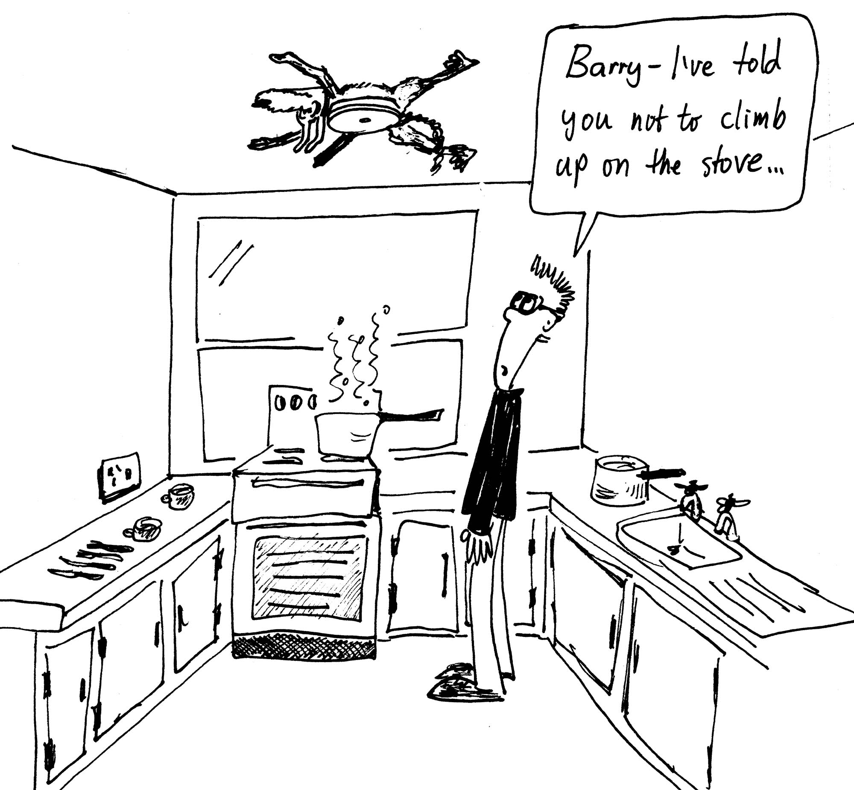
  - Is the casserole much hotter than one from a saucepan? What are the temperature limits of a normal saucepan and a pressure cooker?
Brent is enthusiastic about this new device and decides to make dessert. He takes a canned self-saucing pudding out of the cupboard, and sets it boiling in the pressure cooker. In the meantime Rebecca has settled down in front of the television. Shortly after Brent joins her, they hear a loud BANG from the kitchen. “Brent, did you open the pressure valve?” asks Rebecca.
  - Why is the pressure valve an important safety feature on pressure cookers?

B. Activity Questions:

1. Blowing
Blow on your hands as if it was a cold day and you were trying to warm them.
Now blow on them as if you were blowing a hot drink to cool it.
How can you both heat and cool by blowing?
What do you do differently in each case, and why does it work?

2. Dropper
Use the dropper to pick up some liquid.
What holds the liquid in the dropper?
Explain why it doesn’t fall out.

3. 2D model of gases
What happens when you increase the “temperature” of the gas?
How do the pressure and volume change?

4. Water boiling at less than 100°C
Can you make the warm water in the syringe boil?
Why does it boil at this lower temperature?

C. Quantitative questions.

1. Rebecca and Brent are setting off for a weekend away. Rebecca checks the tyres, oil and water while Brent packs Barry’s overnight kit. After driving for a few hours they stop for a break, and Brent checks the tyres. He gets a reading of 1.74 × 10⁵ N.m⁻². He tells Rebecca tat she’s over-inflated the tyres.
“But Brent, the tyres are warm now, so the pressure is higher.” she explains.
a. Why do the tyres get warm?
When they started out it was 20ºC and Rebecca filled the tyres to a pressure of 1.49 × 10⁵ N.m⁻². When they stop and Brent measures the increased pressure, the volume has also increased by 3%.
b. What is the temperature of the air in the tyres?
(Hint- consider what you are actually measuring when you measure tyre pressure.)

2. Valuable documents and artifacts are sometimes kept in an inert atmosphere to stop them from decomposing, for example the declaration of independence in the US is kept in a sealed vault under nitrogen. A local museum is setting up a display of early Australian flags, including the original flag from the Eureka Stockade in Ballarat. They have a glass case specially made in which to display the flag. The case has a volume of 8 litres. The flag is laid out and nitrogen (N₂ gas) is pumped into the case to displace the air, so that it contains only nitrogen gas at atmospheric pressure. This is done at night when the temperature is 8ºC, so that the display can be launched at a ceremony the next morning. The next day is very hot, and it gets up to 35ºC. During the ceremony someone notices a hissing sound coming from the case, and a leak is discovered. The leak is fixed, but not before enough nitrogen has escaped so that the pressure has reached equilibrium. That evening, when the temperature has dropped back to 8ºC again, the pressure inside the case is measured.
- How much nitrogen (in grams) remains in the case?
- How much nitrogen has been lost from the case? How much will need to be added to refill the case to atmospheric pressure?
- What is the pressure inside the case now, before it is refilled?

Data:
Gas constant R = 8.31 J.mol⁻¹.K⁻¹
Molar mass of nitrogen gas = 28 g.mole⁻¹.
Workshop Tutorials for Technological and Applied Physics
Solutions to TR5T: Kinetic Theory

A. Qualitative Questions:

- According to the ideal gas law, the pressure of a volume of very heavy gas (for example xenon) at a particular temperature is the same as the pressure of very light gas (for example helium), if they both have the same number of molecules, temperature and volume. The average kinetic energy depends only on temperature, hence the temperature is proportional to m(v_{ave})². The pressure is proportional to the momentum transferred from the molecules to the walls of the container. The momentum transferred when a molecule hits the wall is Δp = 2mv_{ave}. The number of molecules hitting the wall in a second is proportional to the particles average velocity because this determines many times per second they go back and forth between the container walls. So the pressure is proportional to Δp× v_{ave}, so P ∝ m(v_{ave})², as is the temperature. Hence for a given temperature of a gas, and the same volume and number of molecules, the pressure must be the same. What this means physically is that large atoms, like xenon with a mass of 131, travel much more slowly (on average) at a given temperature than light atoms like helium (mass 4). So while they are heavier, they are much slower, and still impart the same momentum transfer, giving the same force per unit area, which is the pressure.

2. Brent has bought Rebecca a new pressure cooker for her birthday.
a. Food cooks faster in a pressure cooker than in a saucepan because the pressure is much higher, hence the temperature can be higher. In a saucepan, even with the lid on, the pressure cannot exceed atmospheric pressure by very much. When a liquid boils, bubbles are formed beneath the surface of the liquid. The pressure within a bubble has to be equal to that of the atmosphere plus the water above for the bubble to exist. The pressure outside the bubble depends on the temperature of the water. So boiling depends on temperature, and pressure. If you increase the pressure then the pressure required inside the bubble increases and the temperature needed to make the liquid boil increases. So the boiling point increases, and the food is cooked at a higher temperature, hence it cooks faster.
b. The casserole will be hotter than one from a saucepan. A normal saucepan with water (or a water based food in it), can only get to 100ºC. At this temperature, any extra heat (thermal energy) that goes from the hotplate into the pan goes to changing the state of the water into steam. In a pressure cooker the temperature can get much hotter, as the water inside boils at a higher temperature, so much more heat can be added, increasing temperature rather than breaking bonds to change state.
c. The pressure valve is an important safety feature on pressure cookers. As heat is added, the temperature and pressure rise, but the volume cannot change. If the pressure gets large enough, the force acting on the lid may be enough to break the clips or other mechanism which seals the lid on, and the lid can come flying off at high velocity. This has been observed to leave a dent in the kitchen ceiling and cover the kitchen in hot food. The safety valve allows steam to vent from the cooker when the pressure is high enough, decreasing the quantity of water (n), and allowing the pressure to remain at safe levels.

B. Activity Questions:

1. Blowing
When you blow on your hands to warm them you do so wit your mouth fairly open, and you puff on your hands, held close to your mouth. The air coming out of our mouth is at, or close to, body temperature, so it feels warm against your hands which are at a lower temperature.
When you blow on food or drink to cool it you purse your lips and blow a stream of air over it. As the air comes out of your mouth its volumes can expand as the pressure around it drops. As the volume increases the air cools, so it is cooler than body temperature, and quite a lot cooler than hot drink temperature. The flow of air helps increase cooling by convection.

2. Dropper
When you squeeze the rubber top on the dropper you squeeze the air out. Then when you put the tip into the liquid and stop squeezing the top, the low pressure inside sucks up the liquid. In fact it is the higher pressure outside the dropper, in the liquid, that pushes the liquid up into the dropper. The liquid is held in by the lower pressure in the tube than the external atmospheric pressure.

3. 2D model of gases
When you increase the “temperature” of the gas the molecules move faster, they have an increased velocity. This means that when they collide with the lid (and walls) of the container they exert a greater pressure, as they can transfer more momentum to the lid. If the lid is not held in place, it will be pushed up, increasing the volume of the container.

4. Water boiling at less than 100°C
Boiling happens when evaporation occurs beneath the surface of a liquid, forming bubbles of gas which rise to the surface and escape. The pressure inside a bubble has to be equal to the pressure outside for the bubble to exist. The pressure outside the bubble depends on the temperature of the water. So boiling depends not only on temperature, but pressure as well. If you decrease the atmospheric pressure then the pressure required inside the bubble lowers and the molecules in the liquid don’t need to move as fast to exert this pressure on the bubble. So the boiling point decreases. When the syringe is pulled suddenly, the volume increases, so pressure decreases and boiling point decreases.

C. Quantitative questions.

1. Rebecca and Brent are setting off for a weekend away. After driving for a few hours they stop for a break, and Brent checks the tyres, which are now warm. He gets a reading of 1.74 × 10⁵ Pa.
Note: this is a gauge pressure- the pressure above atmospheric pressure. The absolute pressure, which we must use if we use the gas laws is 1.74 × 10⁵ Pa + 1.00 × 10⁵ Pa = 2.74 × 10⁵ Pa.
a. The tyres get warm because work is done on them by frictional forces between the tyre and road. There are also frictional forces acting within the tyres. The tyres are being continually flexed, and the rubber stretches and compresses. As it does so frictional forces act between the rubber molecules. These frictional forces all act to convert mechanical energy into heat, which increases the internal energy, and hence the temperature, of the tyres.
When they started out it was 20ºC = 293 K and Rebecca filled the tyres to a (gauge) pressure of 1.49 × 10⁵ Pa = 2.49 × 10⁵ Pa (absolute pressure). When they stop and Brent measures the increased pressure, the volume has also increased by 3%.
b. The number of moles of gas in the tyres has not changed, so we can use P₁V₁/T₁ = P₂V₂/T₂ to find the temperature, T₂ . We also know that V₂ = V₁ × 1.03. (a 3% increase in volume). So:
T₂ = P₂V₂T₁ / P₁V₁ = P₂ V₁ × 1.03× T₁ / P₁V₁ = 1.03 × P₂T₁ / P₁
= 1.03 × 2.74 × 10⁵ Pa × 293 K / 2.49 × 10⁵ Pa = 332 K = 59ºC.

- The case has a volume of 8 litres ( = 8 × 10⁻³ m³) of N₂ gas at atmospheric pressure, at T = 8ºC = 291 K. The next day T = 35ºC = 308 K and enough nitrogen escapes so that P = 1 atm = 100 kPa again. That evening, when the temperature has dropped back to 8ºC again, the pressure inside the case is measured.
- Using PV = nRT, we get:
n_{next day} = PV/RT = (1.0 × 10⁵ Pa × 8 × 10⁻³ m³ ) / (8.31 J.mol⁻¹.K⁻¹ × 308 K) = 0.31 mol
0.31 mole = 0.31 × 28 g.mole⁻¹ = 8.8 g of N₂ gas.
- We need to know how much was originally there to know how much was lost:
n_{initial} = PV/RT = (1.0 × 10⁵ Pa × 8 × 10⁻³ m³ ) / (8.31 J.mol⁻¹.K⁻¹ × 281 K) = 0.34 mol,
hence 0.34 mole – 0.31 mole = 0.03 moles was lost. This is equivalent to 0.84 g. This is how much will need to be put back in to refill the case.
- We know that n_{final} = n_{next day} because the leak was fixed, so we can now find P_{final} :
P = nRT/V = (0.31 mole × 8.31 J.mol⁻¹.K⁻¹ × 281 K) / (8 × 10⁻³ m³) = 9.0 × 10⁴ Pa = 90 kPa = 0.9 atm.
Workshop Tutorials for Physics
TR6: Heat Engines

A. Qualitative Questions:

- We use heat engines all the time. A refrigerator uses a heat engine, as does an air conditioner. A car engine is also a type of heat engine.
  - Draw a schematic energy flow diagram for a heat engine. Label the hot and cold reservoirs. Use arrows to show the transfer of energy Q_{H}, Q_{C} and W.
Consider a car engine.
  - What represents the hot and cold reservoirs, and the transfer of energy Q_{H}, Q_{C} and W?
  - Where in the engine does the cyclic thermodynamic process occur?
  - What is the working substance of the engine?

- With the cost of fuel constantly increasing, it is important that engines be as efficient as possible.
  - What limits the efficiency of an engine?
  - Why are diesel engines more efficient than petrol engines?
  - How could you go about increasing the efficiency of an engine? What drawbacks might this have?

B. Activity Questions:

1. Stirling engine
Examine the Stirling engine and compare the up and down strokes of the engine to the four stages of the Stirling cycle on the schematic below. Draw p-V diagrams for the four stages.
T_{H}
T_{C}
Q_{H}
T_{H}
T_{C}
gas flow
T_{H}
T_{C}
Q_{C}
T_{H}
T_{C}
gas flow
1. expansion stroke
2. constant volume
3. compression stroke
4. constant volume

2. Bar Fridge
Inspect the back of the bar fridge.
Identify the heat reservoirs.
Draw an energy flow diagram for fridge.
Could you cool a room by leaving the fridge door open?

C. Quantitative questions.

- Air is mostly a mixture of diatomic oxygen and nitrogen which can be approximated as an ideal gas with γ = 1.40 and C_{v} = 20.8 J.mol⁻¹.K⁻¹. The compression ratio of a diesel engine is 15 to 1; this means that air in the cylinders is compressed to 1/15 of its initial volume.
If the initial pressure is 1.01 × 10⁵ Pa and the initial temperature is 27°C (300K), find
- the final temperature after compression,
- the final pressure after compression.
- How much work does the gas do during the compression if the initial volume of the cylinder is 1.00 L = 1.00 ×10⁻³ m³?

- Brent is making some ice cubes for a cocktail party. He pours 2 litres of water at 15ºC into ice cube trays and puts them in the freezer.
  - How much thermal energy must be removed from the water to freeze it into ice cubes?
Brent’s freezer has a coefficient of performance of 4.8.
  - How much energy does the freezer use to freeze the water?
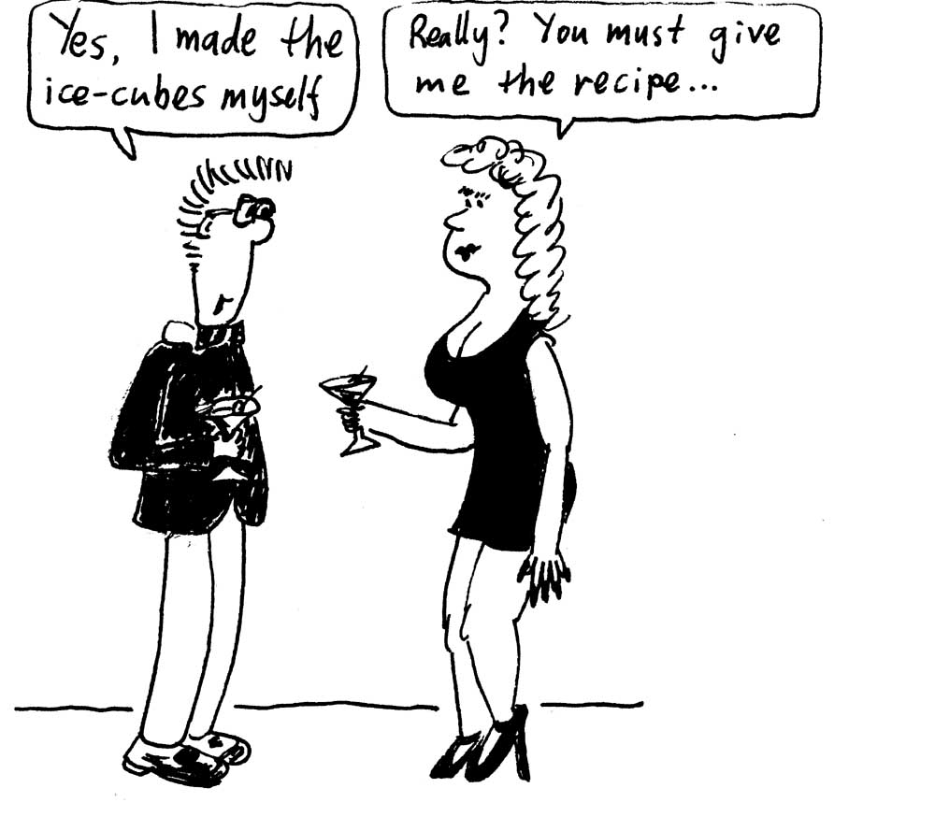
  - Would the freezer make the ice cubes more quickly if the coefficient of performance were larger, say 5.0 instead of 4.8?

data:
R= 8.315 J.mol⁻¹.K⁻¹
density of water = 1 kg.l⁻¹
heat capacity of water = 4.18 kJ.kg⁻¹.K⁻¹
latent heat of freezing = 333.5 kJ.kg⁻¹
Workshop Tutorials for Physics
Solutions to TR6: Heat Engines

A. Qualitative Questions:
Hot Reservoir
Cold Reservoir
engine
Q_{H}
Q_{C}
W
1. A car engine is a type of heat engine.
a. See diagram opposite.
b. The hot reservoir is the cylinder chamber where ignition occurs. The transfer of energy Q_{H} is from the combustion of the fuel. The cold reservoir is the water that circulates through the engine and loses the heat Q_{C} through the radiator eventually. The work done, W, is the work done in pushing the piston up, which turns the crankshaft.
c. The cyclic thermodynamic process occurs in the engine cylinders of the car.
  - The working substance of the engine is the fuel and air mix which is compressed and expands when ignited.

2. With the cost of fuel constantly increasing, it is important that engines be as efficient as possible.
- In an ideal engine the efficiency depends on the temperature difference between the hot and cold reservoirs. The greater the difference the greater the efficiency. The efficiency of a real engine is further limited by the amount of heat lost through friction and conduction convection and radiation.
- Diesel burns at a higher temperature, thus diesel engines operate with a greater temperature difference and hence a higher efficiency.
- In principle, by increasing the hot reservoir temperature you would increase engine efficiency, so you would want a hotter burning fuel, and a hotter engine. However this would be more dangerous with chance of fire. At higher temperatures there would be more expansion of pistons, cylinders etc. If there is differential expansion because of the use of different materials then the engine would not function as well.

B. Activity Questions:

1. Stirling engine
P
V
P
V
P
V
3
P
V
4
1. Isothermal expansion at T_{H}. Left piston moves down and heat Q_{H} is transferred to the gas from the left cylinder wall, which is kept hot by the heat reservoir at T_{H}.  2. Constant volume process – temperature decreases from T_{H} to T_{C} as hot gas passes through the wire mesh. The gas heats the mesh. The volumes change by equal amounts.  3. Isothermal compression at T_{C} back to original volume. Heat Q_{C} is lost from the gas on the right hand side to the cold reservoir.  4. Constant volume process – temperature increases from T_{C} to T_{H}, cold gas is pushed across the hot wire mesh and the changes in volume of the two cylinders are equal. | 1  2

2. Bar Fridge
Hot Reservoir
Cold Reservoir
refrigerator
Q_{H}
Q_{C}
W
The cold reservoir of a fridge is the inside of the fridge. The hot reservoir is the outside air at the back of the fridge. An energy flow diagram is shown opposite.
You could not cool a room by leaving the fridge door open, even if the fridge were 100% efficient, the temperature would be unchanged. The second law of thermodynamics says that it is impossible to transfer heat from a cold reservoir to a hot reservoir with no other effect. The other effect is that work must done, and some of this work is invariably dissipated as heat. The nett effect of leaving the fridge door open is to make the room hotter, although it may be slightly cooler directly in front of the fridge door.

C. Quantitative questions:

- Adiabatic compression in a diesel engine.
We know that p₁ = 1.01 × 10⁵ Pa, T₁ = and 300K and V₁/V₂ = 15.
a. The final temperature is
T₂ = T₁${\left(\frac{V_{1}}{V_{2}}\right)}^{γ−1}$= 300(15)^{1.4 - 1} = 886 K = 613 ºC
b. The final pressure is
P₂ = P₁${\left(\frac{V_{1}}{V_{2}}\right)}^{γ}$= 1.01 × 10⁵ (15)^{1.4} = 44.8 × 10⁵ Pa = 44 atm.
If the process had been isothermal the final pressure would have been lower, 15 atm, but because the temperature also increased the final pressure was higher. The greater pressure attained during the adiabatic compression causes the fuel to ignite spontaneously when it is injected into the cylinders near the end of the compression stroke, without the need for spark plugs.
c. In an adiabatic process we know that Q = 0, so therefore W = -ΔU.
For an ideal gas, ΔU = nc_{v}(T₂ – T₁) so W = -ΔU = nc_{v}(T₁ – T₂).
The number of moles, n, is
n =$\frac{p_{1}V_{1}}{{\text{RT}}_{1}}$=$\frac{(1\text{.}\text{01}×{\text{10}}^{5}\text{Pa})(1\text{.}\text{00}×{\text{10}}^{−3}m)}{(8\text{.}\text{315} J\text{.}{\text{mol}}^{−1}\text{.}K^{−1})(\text{300} K)}$ = 0.0405 mol.
so now we can find W:
W = nc_{v}(T₁ – T₂) = 0.0405 mol × 20.8 J.mol⁻¹. (300 K – 886 K) = -494 J.
Note that the work is negative because the gas is compressed, i.e. work is done on it.

- Brent is making some ice cubes for a cocktail party. He pours 2 litres of water at 15ºC into ice cube trays and puts them in the freezer.
  - The thermal energy to be removed is:
Q = mcΔT + mL = 2kg × 4.18 kJ.kg⁻¹.K⁻¹ × 15 K + 2kg × 333.5 kJ.kg⁻¹ = 125.4 kJ + 667 kJ = 792.4 kJ.
  - The coefficient of performance is n = heat removed/ work done by the system = Q/W.
Work done by freezer is W = Q/n = 792.4 kJ / 4.8 = 165 kJ.
  - If n were larger then for the same amount of heat removed, the work done by the freezer would be less. Therefore the ice cubes would freeze more quickly for the same amount of power supplied. The coefficient of performance is a measure of the efficiency of a refrigerator, the greater n, the more efficient the freezer.

Workshop Tutorials for Biological and Environmental Physics
TR7B: Entropy and the Second Law of Thermodynamics

A. Qualitative Questions:

- A growing plant creates a highly complex and organised structure out of simple materials such as air, water and carbon dioxide. Do plants violate the second law of thermodynamics?

- Cars are a major source of greenhouse gases, and are also one of the main consumers of fossil fuels. In 2001 Toyota released the “Prius”, a hybrid petrol-electric car with a petrol engine and an electric motor. It uses only half the fuel of a normal car and emits half the carbon dioxide. One of the reasons it is so efficient is that energy which is usually lost as heat during braking is used to run a generator charging the battery, which then runs the electric motor.
- Can a given amount of mechanical energy be transferred completely into heat? If so give an example.  - Can heat be transferred completely into mechanical energy? If so give an example.  - What are the implications of this for engines, and in particular for hybrid cars? | 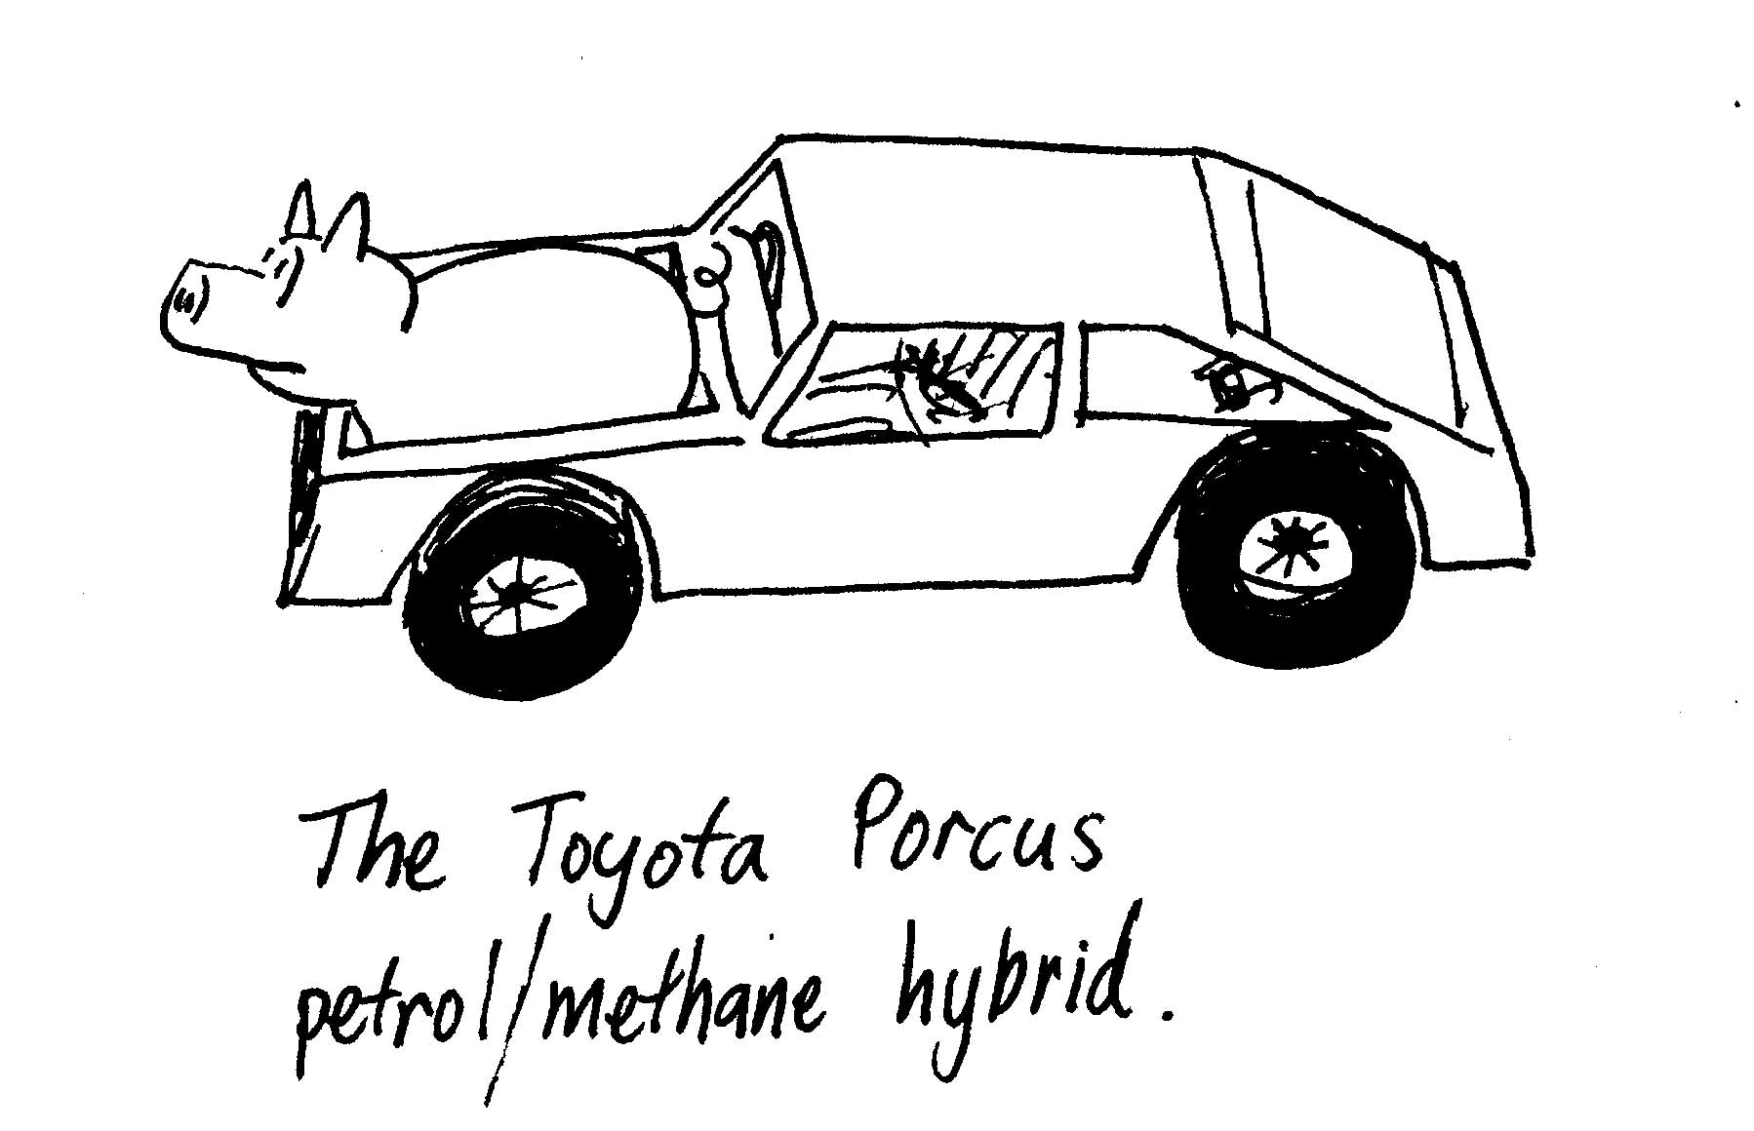

B. Activity Questions:

1. Macroscopic states and microscopic states
Take two discs from the container.
How many microstates are possible? List the microstates.
Consider the macroscopic state (also called simply a state) of half of the discs facing up to be blue and the other half to be green. What is the probability of this state?
Now take 4 discs instead of 2. How many microstates are possible? List the microstates?
What is the probability of half of the discs facing up to be blue and the other half to be green now?

What happens to the probability of finding this state as the number of discs increases?

2. Muliplicity
You have 6 identical “molecules” and a box with two parts.
What are the possible states (i.e. combinations of number of molecules in each half of the box)?
What is the multiplicity of each state? How many possible microstates are there altogether?
Which of these states would be the equilibrium condition? What can say about the order of this state?

C. Quantitative Questions:

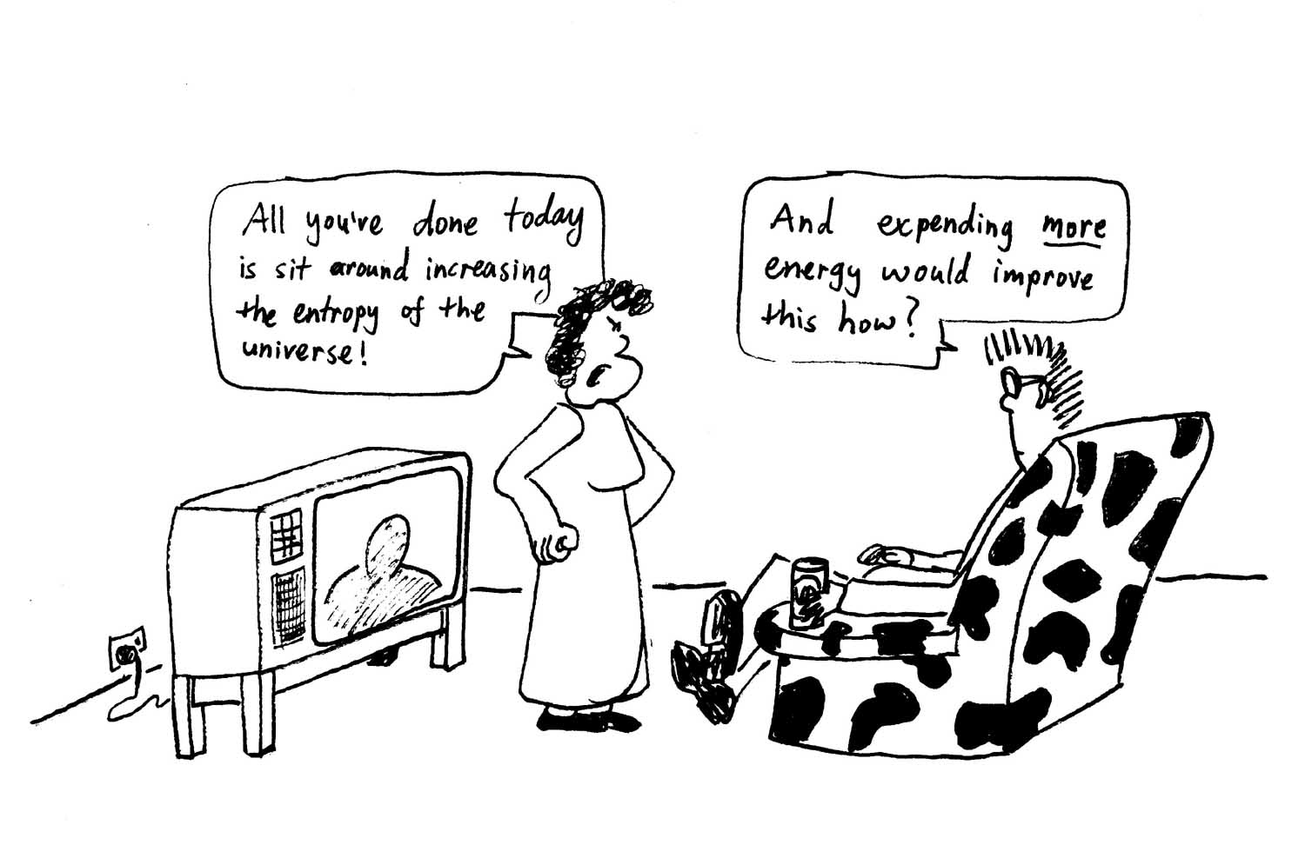
- A typical household is full of appliances that use energy – lights, TVs, computers, toasters, ovens etc. If the rate of energy usage is on average 1.5 kW, what is the average annual increase in entropy due to such a household?

- Rebecca and Brent have gone down to the beach on a hot summers day. They swim and relax for a bit, and then Brent goes to the car to get a drink. He discovers that Rebecca has packed a bottle of soft drink, but left it on the back seat of the car in full sun and it is hot. The 2 litre bottle of soft drink is at 50ºC, and the soft drink has a specific heat of 4.2 kJ.kg⁻¹ .K⁻¹. Brent puts it in the water to cool down and after a long wait it reaches 20ºC, which is reasonable for drinking. The soft drink has a density of 1 kg per l.
  - What is the change in entropy of the soft drink?
  - What is the change in entropy of the surrounding water that cools the drink?
  - What is the total entropy change for this process?
If Brent had an ice box full of ice, he could have cooled the soft drink much faster, and not melted all the ice.
  - If he had cooled the soft drink to 20ºC this way, what would be the change in entropy of the soft drink?
  - What would be the change in entropy of the surrounding ice and water?
  - What would the total entropy change for this process be?

Workshop Tutorials for Biological and Environmental Physics
Solutions to TR7B: Entropy and Second Law of Thermodynamics

A. Qualitative Questions:

- Plants do not violate the second law of thermodynamics. The plant uses energy from the sun to break down nutrients from the soil, and carbon dioxide from the air which are then used to build complex molecules. Even though locally (inside themselves) they increase order by making complex molecules, the overall entropy of the plant and its surroundings increases, as they use the light and produce oxygen.

- Cars are a major source of greenhouse gases, and are also one of the main consumers of fossil fuels.
- It is possible to convert a given amount of mechanical energy completely into heat. One such example is the slow braking of a car so that there is no screeching of the tyres. The mechanical energy is converted into thermal energy only. Another example is the stirring of coffee, again being careful that no sound energy is produced. The mechanical energy associated with stirring is converted into thermal energy of the coffee.
- The reverse describes a perfect engine and is not possible.
- Some energy will always be lost during braking as heat, which will limit the efficiency of the vehicle at turning heat from braking into usable energy for running the car.

B. Activity Questions:

1 .Macroscopic states and microscopic states
With two discs there are four possible microstates. B is blue side up, G is green side up. The possible stats are BB, BG, GB, GG.
The macroscopic state of half of the discs facing up to be blue and the other half to be green has a probability of ½, as two of the four possible microstates give this macrostate.
With four discs there are 2×2×2×2 = 16 possible microstates. These are BBBB, BBBG, BBGB, BBGG, BGBB, BGBG, BGGB, BGGG, GBBB, GBBG, GBGB, GBGG, GGBB, GGBG, GGGB, GGGG. The probability of half the discs green add half blue is now 6/16 = 3/8. The probability has decreased.
In general, the more possible microstates there are, the less probable a given macrostate becomes. As the number of components increases, so does the possible number of microstates, and so does the entropy of the system.

2. Muliplicity
You have 6 identical “molecules” and a box with two parts.
The possible states, written (X,Y) where X is the number in one side and Y is the number in the other are: (6,0) (5,1) (4,2) (3,3) (2,4) (1,5)(0,6). The multiplicity, W, of a state is the number of different ways in which that state can be achieved. It is equal to W=N!/n₁!n₂!. So in this case the multiplicities are: 1, 6, 15, 20, 15, 6, 1. There are 1 + 6 + 15 + 20 + 15 + 6 + 1 = 64 possible states in total.
The equilibrium condition is the most probable state – in this case the state with 3 molecules in each half of the box. This is also the most disordered state.

C. Quantitative Questions:

1. A typical household is full of appliances that use energy – lights, TV’s computers, toasters, ovens etc. If the rate of energy usage is on average 1.5 kW, the total energy used in a year is 1.5 × 10³ J.s × 3.2 × 10⁷ s.year⁻¹ = 4.7 × 10¹⁰ J.year⁻¹. These are effectively irreversible processes. The electrical energy used for heating, lighting and cooking eventually ends up as thermal energy, and is dispersed. The increase in entropy of the universe is given by ΔS = W_{lost} /T where T is the temperature and W_{lost} is the work lost due an irreversible process. The average temperature of the Earth is around 15ºC, so the entropy change due to this household is ΔS = W_{lost} /T = 4.7 × 10¹⁰ J / 288 K = 1.6 × 10⁸ J.K⁻¹ per year.

2. A 2 litre bottle of soft drink (with a mass of 2 kg) is at 50ºC. The soft drink has a specific heat of 4.2 kJ.kg⁻¹ .K⁻¹. Brent puts it in cold water to cool down and after a long wait it reaches 20ºC, which is reasonable for drinking.
The entropy of the soft drink and of the surroundings will both change. In each case we consider the system of interest (first the soft drink, second the surroundings) and look at the corresponding reversible change that takes the system from its initial to its final state. Note that we are not claiming that the change occurred reversibly, we are just imagining the reversible change so that we can calculate the entropy change in the real situation.
a. The change in entropy of the soft drink as it cools from 50ºC ( = 323 K) to 20ºC (= 293 K):
ΔS_{drink} = $\frac{Q}{T}$= $\int_{T_{1}}^{T_{2}}{\frac{\text{mc}ΔT}{T}}$ = mc ln$(\frac{T_{2}}{T_{1}})$ = 2 kg × 4.2 × 10³ J.kg⁻¹ .K⁻¹ × ln (293 K / 323 K) = - 820 J.K⁻¹.
b. The surrounding water, the sea, will not measurably change temperature. There is an irreversible heat flow from the soft drink into the water which remains at a constant 20ºC. The change in entropy of the water is:
ΔS_{water} = $\frac{ΔQ}{T}$where ΔQ is the heat lost by the soft drink and hence gained by the water.
ΔQ = mcΔT = 2 kg × 4.2 × 10³ J.kg⁻¹ .K⁻¹ × (293 K - 323 K) = - 252 kJ.
Note that the heat gained by the water is positive, so the entropy change is
ΔS_{water} = $\frac{ΔQ}{T}$= 252 × 10³ J / 293 K = 860 J.K⁻¹.
c. The total entropy change for this process is the sum of the entropy changes = - 820 J.K⁻¹ + 860 J.K⁻¹ = 40 J.K⁻¹. As for all natural processes, the total entropy change is positive.
If Brent had an ice box full of ice, he could have cooled the soft drink much faster, and not melted all the ice.
d. If he had cooled the soft drink this way, the change in entropy of the soft drink would be exactly the same at - 820 J.K⁻¹.
The change in entropy of the surrounding ice and water would be ΔS_{water} = $\frac{ΔQ}{T}$, where ΔQ is the heat lost by the soft drink and hence gained by the water, which will be the same if the soft drink is taken out when it reaches 20ºC, but the temperature of the ice water mix will be only 0ºC = 273 K, so the entropy change of the ice water is ΔS_{water} = $\frac{ΔQ}{T}$= 252 × 10³ J / 273 K = 920 J.K⁻¹.
e. The total entropy change for this process would be –820 J.K⁻¹ + 920 J.K⁻¹ = 100 J.K⁻¹, much more than cooling the soft drink in the sea water.

Workshop Tutorials for Technological and Applied Physics
TR7T: Entropy and the Second Law of Thermodynamics

A. Qualitative Questions:

1. Cars are a major source of greenhouse gases, and are also one of the main consumers of fossil fuels. In 2001 Toyota released the “Prius”, a hybrid petrol-electric car with a petrol engine and an electric motor. It uses only half the fuel of a normal car and emits half the carbon dioxide. One of the reasons it is so efficient is that energy which is usually lost as heat during braking is used to run a generator charging the battery, which then runs the electric motor.
a. Can a given amount of mechanical energy be transferred completely into heat? If so give an example.
b. Can heat be transferred completely into mechanical energy? If so give an example.
c. What are the implications of this for engines, and in particular for hybrid cars?

2. Real engines always discard substantial amounts of heat to their low-temperature reservoirs. It seems a waste to throw this energy away. Why not use the excess energy to run a second engine, the low-temperature reservoir of the first engine serving as the high temperature reservoir of the second?

B. Activity Questions:

1. Macroscopic states and microscopic states
Take two discs from the container.
How many microstates are possible? List the microstates.
Consider the macroscopic state (also called simply a state) of half of the discs facing up to be blue and the other half to be green. What is the probability of this state?
Now take 4 discs instead of 2. How many microstates are possible? List the microstates?
What is the probability of half of the discs facing up to be blue and the other half to be green now?

What happens to the probability of finding this state as the number of discs increases?

2. Muliplicity
You have 6 identical “molecules” and a box with two parts.
What are the possible states (i.e. combinations of number of molecules in each half of the box)?
What is the multiplicity of each state?
Use Boltzmann’s entropy equation to calculate the entropy of each state.
Which of these states would be the equilibrium condition? What can say about the order of this state?

C. Quantitative Questions:

- Rebecca and Brent have gone down to the beach on a hot summer’s day. They swim and relax for a bit, and then Brent goes to the car to get a drink. He discovers that Rebecca has packed a bottle of soft drink, but left it on the back seat of the car in full sun and it is hot. The 2 l bottle of soft drink is at 50ºC, and the soft drink has a specific heat of 4.2 kJ.kg⁻¹ .K⁻¹. Brent puts it in the water to cool down and after a long wait it reaches 20ºC, which is reasonable for drinking.
  - What is the change in entropy of the soft drink?
  - What is the change in entropy of the surrounding water that cools the drink?
  - What is the total entropy change for this process?
If Brent had an ice box full of ice, he could have cooled the soft drink much faster, and not melted all the ice.
  - If he had cooled the soft drink to 20ºC this way, what would be the change in entropy of the soft drink?
  - What would be the change in entropy of the surrounding ice and water?
  - What would the total entropy change for this process be?

- Consider the two engines shown below. The energies quoted are for one cycle of operation.
Hot
400K
Cold
300K
Cold
300K
Hot
400K
Heat
1000J
Heat
1000J
Work
200J
Work
300J

- Calculate the heat lost to the cold reservoir for each engine.
- For each engine, calculate the entropy changes in the hot reservoir, the cold reservoir and the engine.
- Which engine violates the second law of thermodynamics?
- What is the efficiency of the engine that does not violate the second law of thermodynamics?

Workshop Tutorials for Technological and Applied Physics

Solutions to TR7T: Entropy and Second Law of Thermodynamics

A. Qualitative Questions:
1. Cars are a major source of greenhouse gases, and are also one of the main consumers of fossil fuels.
a. It is possible to convert a given amount of mechanical energy completely into heat. One such example is the slow braking of a car so that there is no screeching of the tyres. The mechanical energy is converted into thermal energy only. Another example is the stirring of coffee, again being careful that no sound energy is produced. The mechanical energy associated with stirring is converted into thermal energy of the coffee.
b. The reverse describes a perfect engine and is not possible.
c. Some energy will always be lost during braking as heat, which will limit the efficiency of the vehicle at turning heat from braking into usable energy for running the car.

2. Real engines always discard substantial amounts of heat to their low-temperature reservoirs. It seems a waste to throw this energy away. Theoretically the low temperature reservoir of the first engine can be used as the high temperature reservoir of the second engine. However the efficiency of an engine increases with the temperature difference between the hot and cold reservoir. It may not be economical or practical to run an engine if this temperature difference is not great enough.

B. Activity Questions:

1. Macroscopic states and microscopic states
With two discs there are four possible microstates. B is blue side up, G is green side up. The possible stats are BB, BG, GB, GG.
The macroscopic state of half of the discs facing up to be blue and the other half to be green has a probability of ½, as two of the four possible microstates give this macrostate. With four discs there are 2×2×2×2 = 16 possible microstates. These are BBBB, BBBG, BBGB, BBGG,
BGBB, BGBG, BGGB, BGGG, GBBB, GBBG, GBGB, GBGG, GGBB, GGBG, GGGB, GGGG. The probability of half the discs green add half blue is now 6/16 = 3/8. The probability has decreased. In general, the more possible microstates there are, the less probable a given macrostate becomes. As the number of components increases, so does the possible number of microstates, and so does the entropy of the system.

2. Muliplicity
You have 6 identical “molecules” and a box with two parts.
The possible states, written (X,Y) where X is the number in one side and Y is the number in the other are: (6,0) (5,1) (4,2) (3,3) (2,4) (1,5)(0,6). The multiplicity, W, of a state is the number of different ways in which that state can be achieved. It is equal to W=N!/n1!n2!. So in this case the multiplicities are: 1, 6, 15, 20, 15, 6, 1. There are 1 + 6 + 15 + 20 + 15 + 6 + 1 = 64 possible states in total.
The equilibrium condition is the most probable state – in this case the state with 3 molecules in each half of the box. This is also the most disordered state.

C. Quantitative Questions:
1. A 2 litre ( = 2 kg) bottle of soft drink is at 50ºC, has a specific heat of 4.2 kJ.kg⁻¹ .K⁻¹. Brent puts it in water to cool down and after a long wait it reaches 20ºC, which is reasonable for drinking. The entropy of the soft
drink and the water will both change. In each case we consider the system of interest (first the soft drink, second
the surroundings) and look at the corresponding reversible change that takes the system from its initial to its final state. Note that we are not claiming that the change occurred reversibly, we are just imagining the reversible change so that we can calculate the entropy change in the real situation.
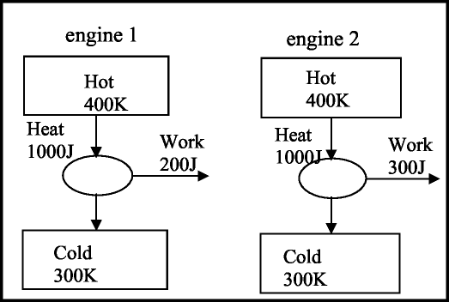

a. The change in entropy of the soft drink as it cools from 50ºC ( = 323 K) to 20ºC (= 293 K):
ΔS_{drink} = $\frac{Q}{T}$= $\int_{T_{1}}^{T_{2}}{\frac{\text{mc}ΔT}{T}}$ = mc ln$(\frac{T_{2}}{T_{1}})$ = 2 kg × 4.2 × 10³ J.kg⁻¹ .K⁻¹ × ln (293 K / 323 K) = - 820 J.K⁻¹.
b. The surrounding water, the sea, will not measurably change temperature. There is an irreversible heat flow from the soft drink into the water which remains at a constant 20ºC. The change in entropy of the water is:
ΔS_{water} = $\frac{ΔQ}{T}$where ΔQ is the heat lost by the soft drink and hence gained by the water.
ΔQ = mcΔT = 2 kg × 4.2 × 10³ J.kg⁻¹ .K⁻¹ × (293 K - 323 K) = - 252 kJ.
Note that the heat gained by the water is positive, so the entropy change is
ΔS_{water} = $\frac{ΔQ}{T}$= 252 × 10³ J / 293 K = 860 J.K⁻¹.
c. The total entropy change for this process is the sum of the entropy changes = - 820 J.K⁻¹ + 860 J.K⁻¹ = 40 J.K⁻¹. As for all natural processes, the total entropy change is positive.
If Brent had an ice box full of ice, he could have cooled the soft drink much faster, and not melted all the ice.
d. If he had cooled the soft drink this way, the change in entropy of the soft drink would be exactly the same at - 820 J.K⁻¹. The change in entropy of the surrounding ice and water would be ΔS_{water} = $\frac{ΔQ}{T}$, where ΔQ is the heat lost by the soft drink and hence gained by the water, which will be the same if the soft drink is taken out when it reaches 20ºC, but the temperature of the ice water mix will be only 0ºC = 273 K, so the entropy change of the ice water is ΔS_{water} = $\frac{ΔQ}{T}$= 252 × 10³ J / 273 K = 920 J.K⁻¹.
e. The total entropy change for this process would be –820 J.K⁻¹ + 920 J.K⁻¹ = 100 J.K⁻¹, much more than cooling the soft drink in the sea water.
2. Consider the two engines shown. The energies quoted are for one cycle of operation. a. Engine 1: QH – W = 1000 J – 200 J = 800 J, which goes into the cold reservoir. Engine2 : QH – W = 1000 J – 300 J = 700 J.
b. ∆S = Q/T.
engine 1: ∆S_{Hot} = Q/T = -1000 J / 400 K = - 2.50 J.K⁻¹ ∆S_{Cold} = Q/T = 800 J / 300 K = 2.67 J.K⁻¹
Total ∆S = ∆S_{Hot} + ∆S_{Cold} = 0.17 J
engine 2: ∆S_{Hot} = Q/T = -1000 J / 400 K = - 2.50 J.K⁻¹, ∆S_{Cold} = Q/T = 700 J / 300 K = 2.33 J.K⁻¹
Total ∆S = ∆S_{H} + ∆S_{C} = - 0.17 J
cEngine 2 violates the second law of thermo-dynamics, as the total entropy decreases.
- The efficiency of engine 1 is: e = (Q_{H} – Q_{C})/ Q_{H} = 1 - Q_{C} / Q_{H} = 1 – 800/1000 =0.2

Workshop Tutorials for Physics
TR8: Blackbody Radiation

A. Qualitative Questions:

1. Many objects such as hot metals, houses and even people behave at least partly like a black body, and this is useful when looking at the thermal properties of materials and ways to control heating and cooling.
- What is a perfect blackbody?
- What is the emissivity of a perfect black body? What does this mean physically?
- What is the coefficient of absorption of a perfect black body? What does this mean physically?
- Give an example of a good black body. Why is this a good black body?
- Give an example of a poor black body. Why is this a poor black body?

2. Consider the design of solar water-heating systems. Visible light from the sun is absorbed by the solar collector.
- What kind of radiation is re-emitted into the surroundings by the solar collector? Explain your answer.
Solar collectors are specially coated to improve their performance. The amount of radiation absorbed or emitted by a collector depends on the wavelength. The properties of one recently discovered coating are shown below.
- Explain why these properties make it a particularly suitable coating.

B. Activity Questions:

1. Thermal radiation – the Leslie Cube
Use the thermopile detector to look at the radiant heat from the different surfaces of the cube.
Which surface radiates the most? Which surface radiates the least?

2. The Black Box
Look into the hole. What colour do you see?
Now open the lid. What colour is the inside of the box?
Why is it so? How can you explain your observation?

3. Blackbody radiation
A pencil lead is heated by running a current through it.
Gradually turn up the power passing through the graphite.
What happens as you increase the power?
Explain your observations.

C. Quantitative questions:

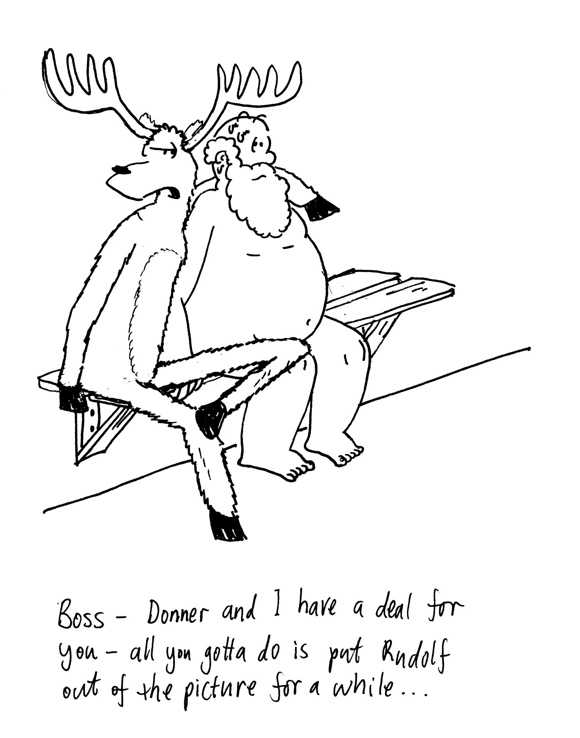
- In Finland saunas were traditionally used as a means of bathing. Now they are a popular form of relaxation. After a hard days work making toys and training reindeer, Santa Claus is sitting naked in his sauna with the temperature of the sauna at 70ºC. Assume that he has a surface area of 1.5 m² and his skin temperature is 37º C.
The emissivity of the human body in the infrared radiation range is close to one irrespective of the pigmentation of the skin, so even though Santa Claus is quite pale, he is a good approximation to a black body in the infrared region, if not in the visible region.
  - Calculate the net radiative rate of heat transfer to Santa Claus.
  - How does his body stop him from overheating and melting?

- Police and emergency workers often wear a bright yellow-green vest, especially when working around roads at night. They wear this colour because it is at or near the wavelength to which our eyes are the most sensitive. It is probably not a coincidence that our sun’s radiation output peaks at the same wavelength, around 550 nm.
- Estimate the surface temperature of the sun.
Cosmologists and astronomers often talk about cosmic background radiation, or the 2.7 K background radiation. This radiation is thought to be the result of the big bang, and it is referred to 2.7 K radiation because this is the temperature of an ideal radiator which emits radiation with the same peak in its distribution.
- What is the peak wavelength of such radiator? (Or, what is the wavelength of the cosmic background radiation?)

Workshop Tutorials for Physics
Solutions to TR8: Blackbody Radiation

A. Qualitative Questions:

1. Many objects such as hot metals, houses and even people behave at least partly like a black body, and this is useful when looking at the thermal properties of materials and ways to control heating and cooling.
a. A perfect blackbody is one which emits radiation characteristic of its temperature. More precisely, it is emitted at a rate given by P = εσA(T⁴ – T_{o}⁴ )A graph of energy against dλ for a perfect blackbody has no absorption bands, α = ε for all wavelengths.
b. The emissivity, ε, of a perfect black body is 1 (where ε can have a value between 0 and 1). This means that it is an efficient radiator, radiating the maximum amount of energy possible for a given temperature.
- The coefficient of absorption, α, of a perfect black body is also one, which means that it absorbs all radiation incident on it.
- Black velvet is a good black body. A cavity with a small hole, such as a keyhole in a closet door is almost a perfect black body. Any radiation incident on the keyhole enters and is trapped and absorbed by the closet walls. Hence any radiation emitted is characteristic of the temperature of the closet.
- Anything which reflects a lot of radiation, or has a low emissivity is a poor blackbody, for example a mirror or a white piece of paper.

2. Consider the design of solar water-heating systems. Visible light from the sun is absorbed by the solar collector.
a. The visible light absorbed by the solar collector causes the solar collector to heat up. It acts as a black body and emits infrared radiation to its surroundings. It cannot emit visible light because it does not get hot enough (unlike the sun), it emits at much higher wavelengths.
Solar collectors are specially coated to improve their performance. The amount of radiation absorbed or emitted by a collector depends on the wavelength. The properties of one recently discovered coating are shown below.
b. The solar radiation incident on the coating from the sun is mainly in the visible region. The coating absorbs well in that wavelength region, so it will absorb a lot of energy. The collector temperature is such that its radiation is in the infrared. The coating is a poor emitter in that wavelength region, so it cannot lose much energy compared to a perfect black body. Hence it will absorb energy well and radiate it poorly, and it will become very hot.

B. Activity Questions:

1. Thermal radiation – the Leslie Cube.
The greater the emissivity, ε, of the surface the more it will radiate for a given temperature. The quantity ε takes values between 0 and 1 depending on the nature of the surface radiating heat, a perfect radiator of heat has ε = 1 and is called a blackbody radiator. To a good approximation, all the sides (surfaces) of the cube are at the same temperature - the cube contains hot water and the cube’s sides are made of thin sheet metal, a good conductor of heat. The surfaces with the greater emissivity – matt black, shiny black (in that order) will radiate the most and have $e»1$ whereas shiny, polished metal (like a new stainless steel kettle) may have $e»0$.

2. The Black Box
When you look into the hole you see blackness, even though the inside of the box is white. This is because the hole is very small, and no light can get out of it to your eye. Black is an absence of light, and as there is no light in the box it appears black, just as a window to an unlit room is black regardless of the colours of the room. When the box is open light is reflected and you can see that it is white inside. A cavity or box with a small hole is a good approximation to a black-body because all light entering the hole is trapped, so the absorption is very high.

3. Blackbody radiation.
As you turn up the power supply the voltage across the graphite gets greater. This gives a bigger current through the graphite, and more power dissipated in it, hence it gets hotter. As it gets hot it begins to glow. Initially it glows red, and as it heats up more it glows orange and yellowish. If you could get it hot enough without melting it, it would glow white hot and eventually blue and ultraviolet.

C. Quantitative questions:

- Santa Claus is sitting naked in his sauna with the temperature of the sauna at 70ºC. Assume that he has a surface area of 1.5 m² and his skin temperature is 37º C. The emissivity of the human body in the infrared radiation range is close to one.
  - The power transferred by radiation is given by:
P = εσA(T⁴ – T_{o}⁴ ) = 1 × 5.67× 10⁻⁸ W.m⁻².K⁻⁴ × 1.5 m² × [(310 K) ⁴ – (343K)⁴] = - 392 W.
The negative sign indicates that the net flow of heat is into Santa Claus.
  - To stop him heating up too much, his body uses other mechanisms to get rid of the excess thermal energy. In particular the body perspires and the perspiration uses thermal energy from the body to evaporate. This is very effective for humans and other animals with sweat glands, but if he took his pet dog in with him it would be very dangerous for the dog as they are unable to sweat. His reindeer, however, could safely join him in the sauna.

- Our sun’s radiation output peaks at around 550 nm.
a. Estimating the surface temperature of the sun:
Using Wien’s law, λ_{max} = 2.90 mm.K / T, and a λ_{max} of 550 nm, the surface temperature of the sun is
T = 2.90 mm.K / 550 nm = 2.90 × 10⁻³ m.K/ 550 × 10⁻⁹ m = 5270 K.
b. Again using Wien’s law:
λ_{max} = 2.90 mm.K / T = 2.90 × 10⁻³ m.K/ 2.7 K = 1.07 × 10⁻³m or ~ 1.1 mm.

