William Anthony Hawthorn
(1906-1942)
and decendants

1930s: William Anthony (right) and brother Leonard Hawthorn

Notes from Joss Hawthorn (August 2017), jbh@aao.gov.au

With thanks:

Kathleen Hawthorn/Bland, née Helling (grandmother)
Carole Davis, née Austen
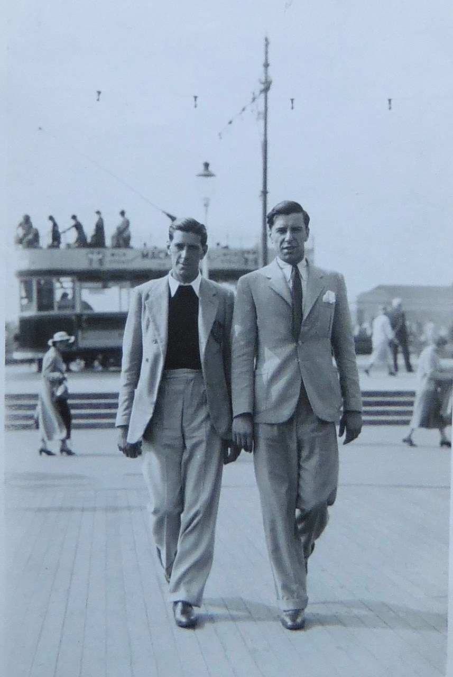
Family tree:

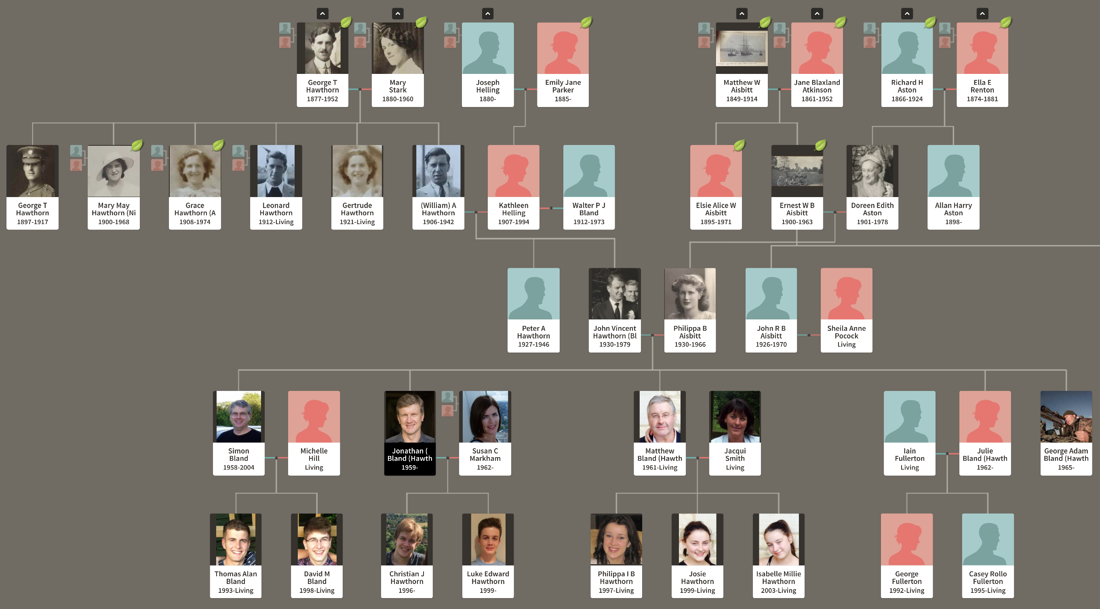

Much of what I know of the Hawthorn family comes from my grandmother Kathleen (née Helling) and very recently from Carole Davis (née Austen), daughter of Grace Hawthorn and Charles Austen. On the one hand, Kathleen was uncompromising and not an easy person to deal with; on the other hand, she had a remarkable memory and most “facts” I have been able to check to date appear to be true.

Kathleen grew up in Acton, London as an only child to a policeman Joseph Helling, whom she adored, and her mother Emily Jane Parker. I have a newspaper cutting from the early 1920s describing how Joseph saved the life of a drowning woman. Many times, Kathleen told me the story of how Joseph went under cover in Eire to capture or kill two Irishmen (Kennedy, Brown) who killed a British politician. She insists they lived in a boarded up house in Stratford upon Avon for 6 months after the killings. The Helling family descend from the Hellons, the Orangemen who came over with William of Orange in the 17th century. Kathleen was a staunch “protestant” her entire life. She would not attend the wedding of one of my brothers because it was held in a Catholic church, for example.

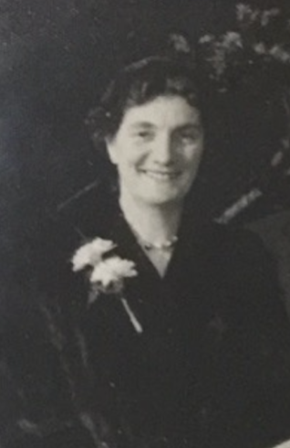
In December 1926, she married William Anthony Hawthorn (she referred to him as Bill or William) and had two sons, Anthony Peter (1927) and my father John Vincent Stanley Hawthorn (1930). At the outbreak of the war, my father John was shipped off to an aunt in Wales. Peter stayed in Acton only to die from “miliary” tuberculosis at 19 years of age in 1946 (see Appendix). Kathleen told me that he used to go fishing a lot and came back one night soaking wet and in a sorry state; she said that this was the prelude to his illness. John adored Peter and felt great sadness at his death; Peter was kind and looked out for John as a young boy. I have a beautiful photo of them together at the age of 10 and 7, or so. Peter’s death certificate (Appendix) identifies his occupation as photographer.

William (Anthony) was a good draughtsman and was a professional printer on Fleet Street. He died tragically in 16 January 1942 from lymphatic leukemia (see Appendix), a fact I have long known from Kathleen, i.e. he died from a blood disorder. Kathleen told me that he served as a gunner on merchant ships taking food and munitions to Russia. She claimed that he was given the wrong blood-type injections for this new role and this somehow triggered the leukemia; it doesn’t sound plausible to me unless the blood was tainted. A short while later he was screaming in agony and she went with him in an ambulance to Acton hospital during heavy aircraft bombing. She said it was the worst experience of her life: he was screaming and the bombs were dropping around them. He died in hospital.

William is buried in Acton Cemetery in or near this churchyard (see Appendix).

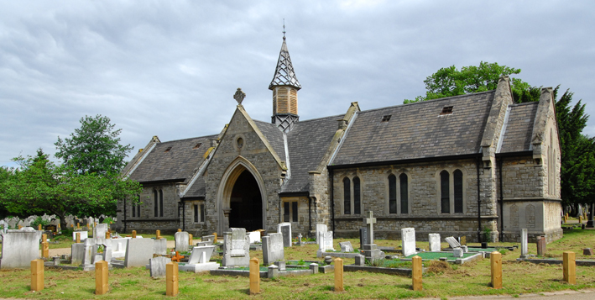

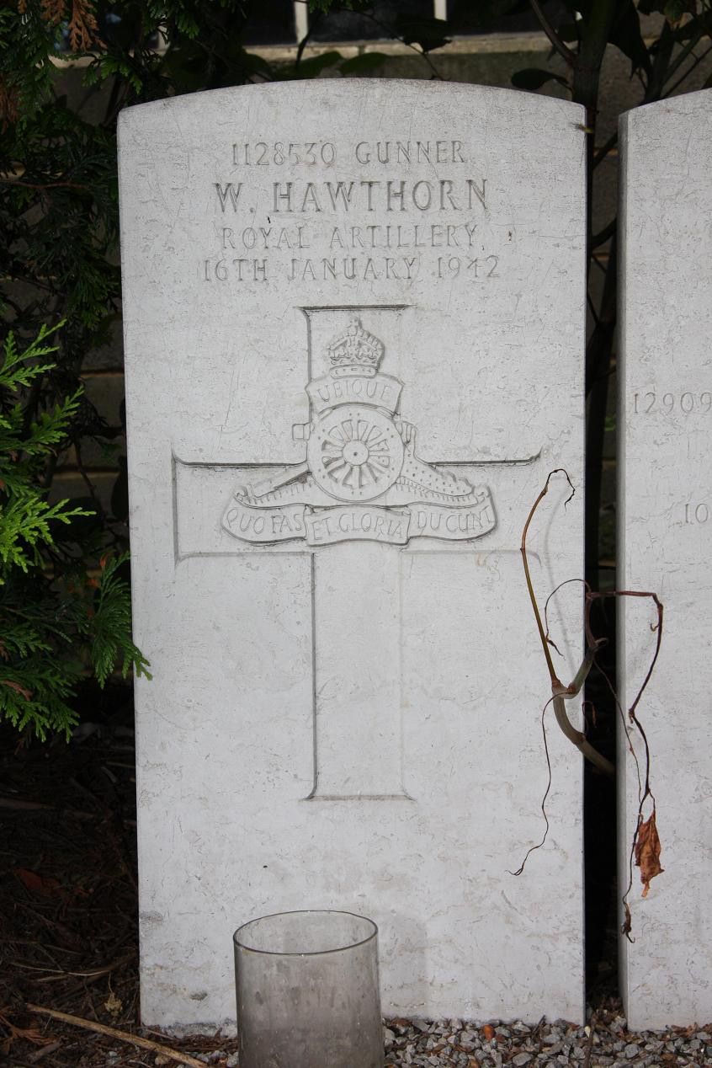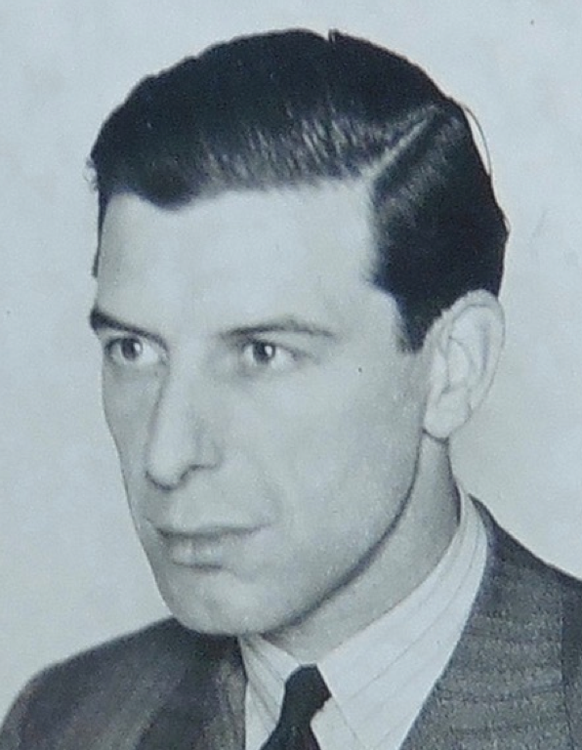

In March 1943, Kathleen married Walter Bland, a gentle chartered surveyor that I remember well at their Acton house. She informed John that he was to be adopted and should take the new name; this simple act is something he grew to regret because he sensed even as a teenager that the rest of the Hawthorn family were not impressed. After John died in 1979, we changed our names back to Hawthorn as he had wished. (I publish as Bland-Hawthorn because I was registered as J. Bland at the beginning of my PhD; in private, I am only Jonathan “Joss” Hawthorn.)

John joined HMS Ganges training centre in Portsmouth at 15 yrs of age, apparently by misreporting his age. He served in the navy until becoming blind in one eye from an SOS firework in Durban, South Africa in 1956. John had enhanced musculature (like his uncle George Hawthorn), did gymnastic rings, water polo and boxing for the navy. Impressively, he was in the Field Guns Crew at Earl’s Court in 1953 (coronation year) and 1954, and performed with the gymnastics team there also. We still have various photos and medals from those years.

In 1956, he was billeted out of the navy and trained as a farmer near Newdigate, Surrey. There he met Philippa Aisbitt who was working on a farm there. When I visited Newdigate in the 1980s, they remembered Philippa and her girlfriends well and said that she was due to marry one of the local eligible bachelors, a lawyer. I have wonderful photos of Philippa riding with the fox hunt; the local pub took the picture off the wall and said “You should have it.” They remember John appearing seemingly “out of nowhere” and marrying Philippa within a short time in 1957. One of the women, Diana Brooker, visited me in Sydney in about 2000 and confirmed these stories.

The wedding photo below shows John and Philippa, and my cousins Jane (left) and Jill Tassell. John’s mother Kathleen is to his right with her second husband Walter. Philippa’s mother and father are to her left, Doreen and Ernest. Philippa’s sister Judith is still alive (84) and living in Aldeburgh, Suffolk.

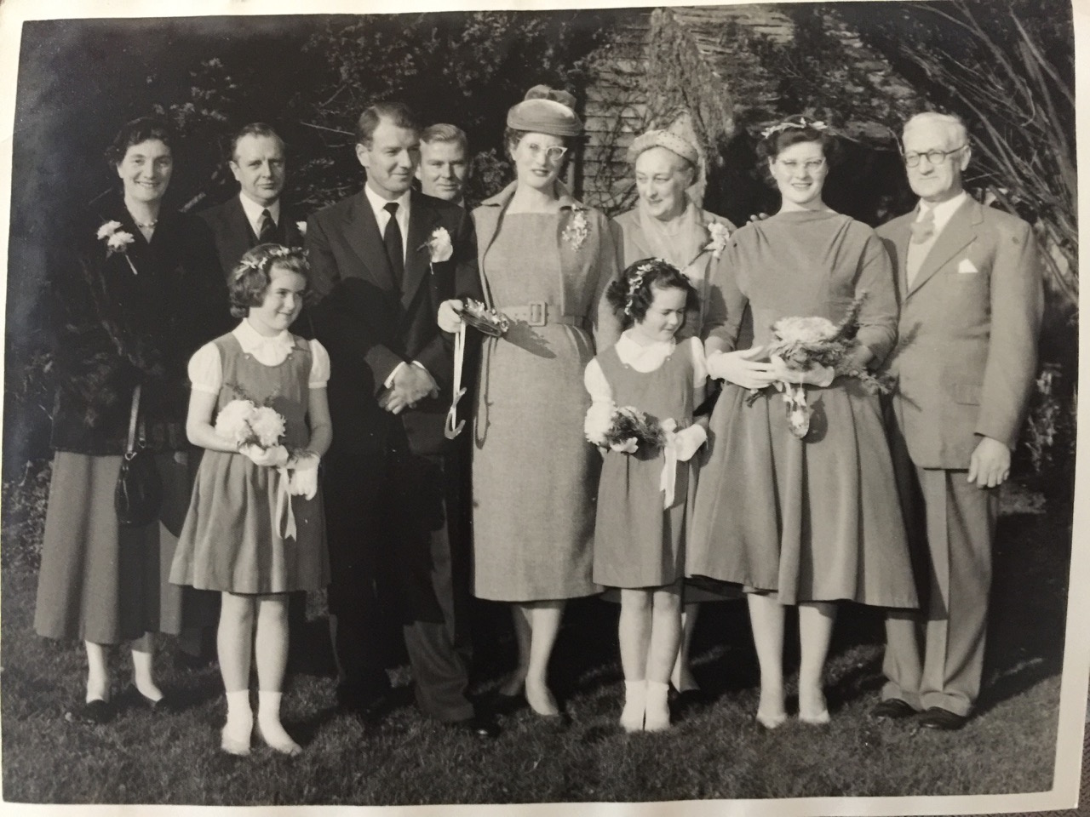

John and Philippa had five children (Simon, Jonathan – that’s me!, Matthew, Julie, George). After 1958, John worked at a series of farms. His first was in Wing, Buckinghamshire. Then we moved to Netherswell Manor Farm below Stow-on-the-Wold in 1964. This was the last period we were all together as a happy family – I remember those days so well. My father smoked heavily which was unfortunate for my asthmatic mother; I remember her unceasing coughing in her last months. I don’t know whether people understood the connection. Tragically, Philippa died of an extreme asthma attack on March 1st 1966 (Lady Day); she is buried today at the “cemetery at the top of the hill,” something of a site of pilgrimage even to this day for our family. She left behind a 7, 6, 4, 2 and 1 yr old. It is no exaggeration to say that Philippa was universally loved. She had a very sweet and loving disposition; people remember her very fondly even to this day. These photos from her time at the Rookery, Middleton Tyas, capture something of her spirit:

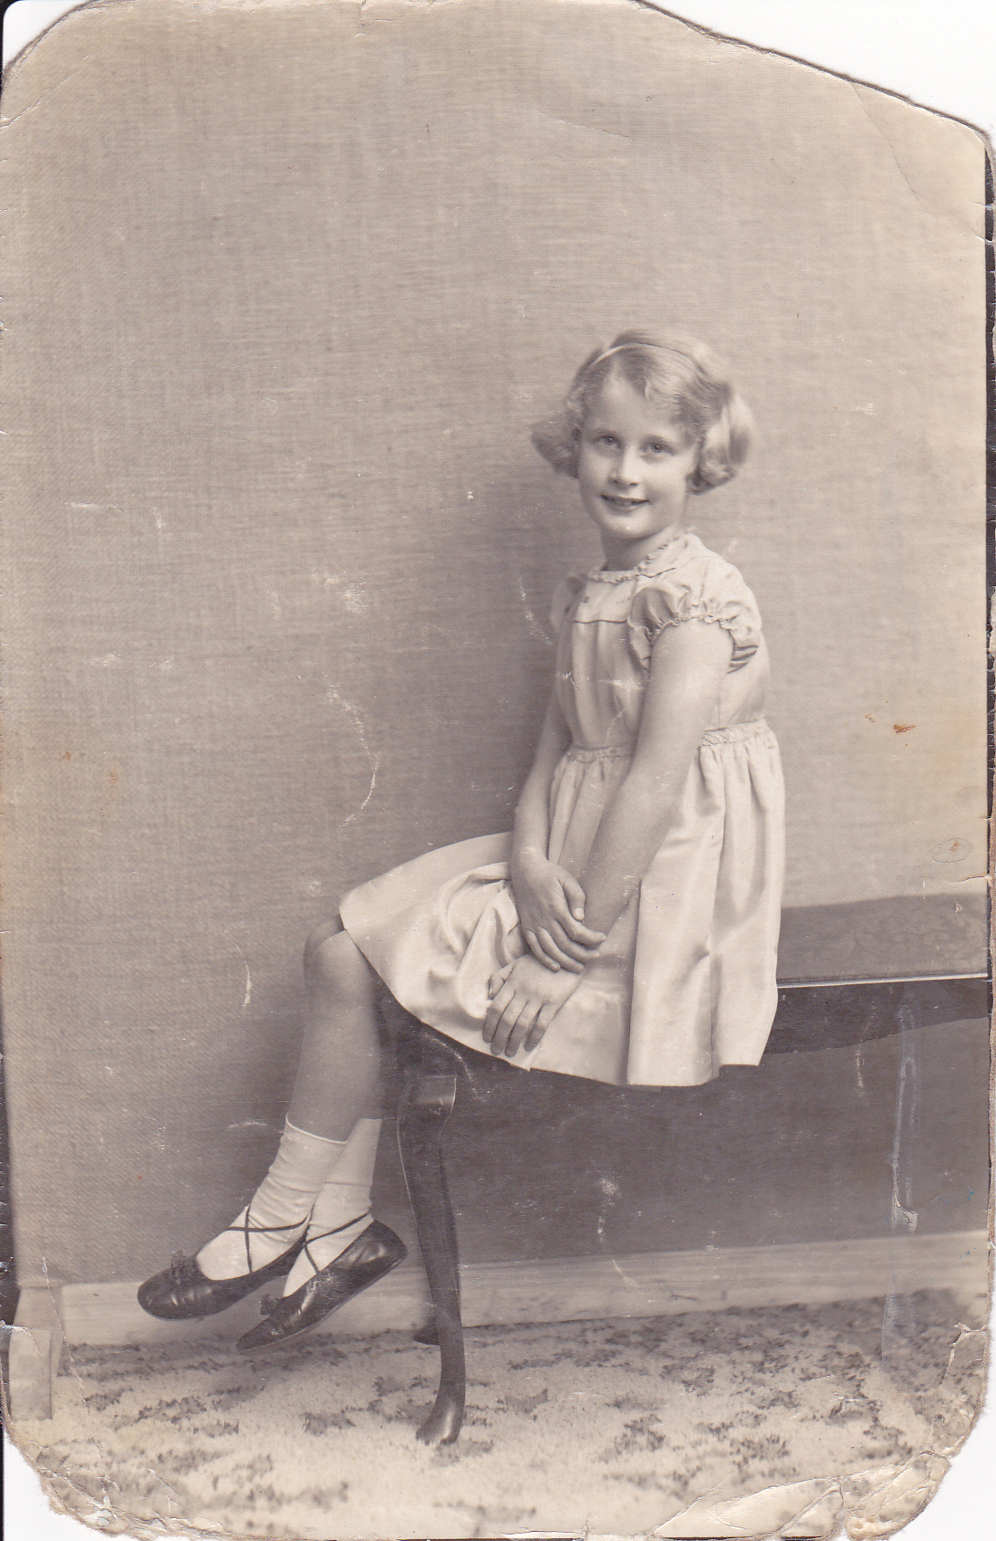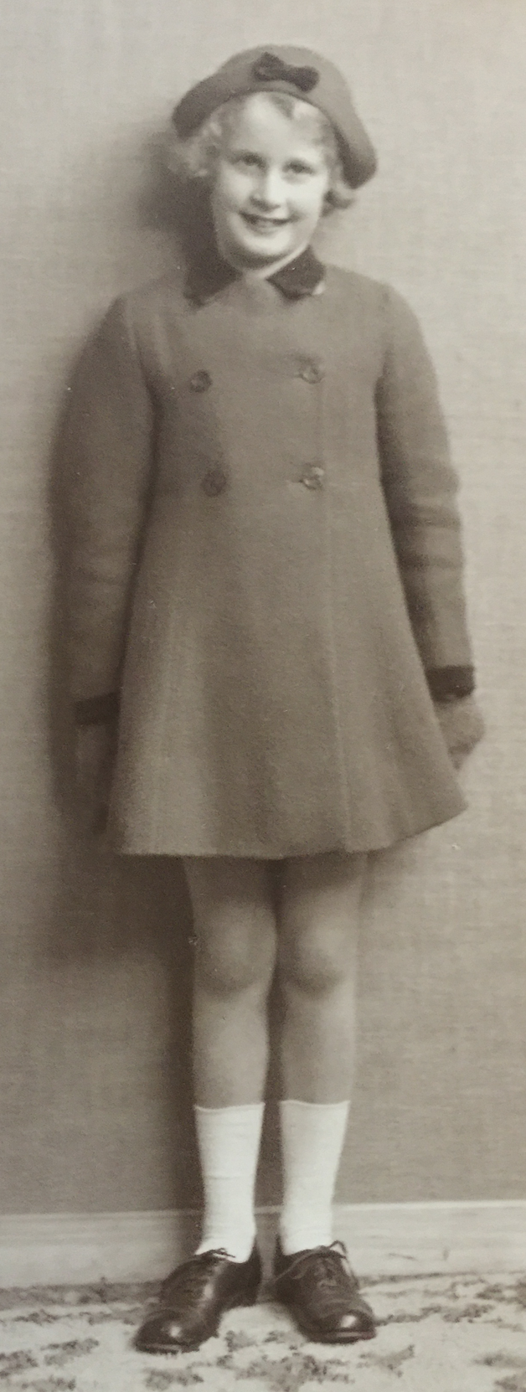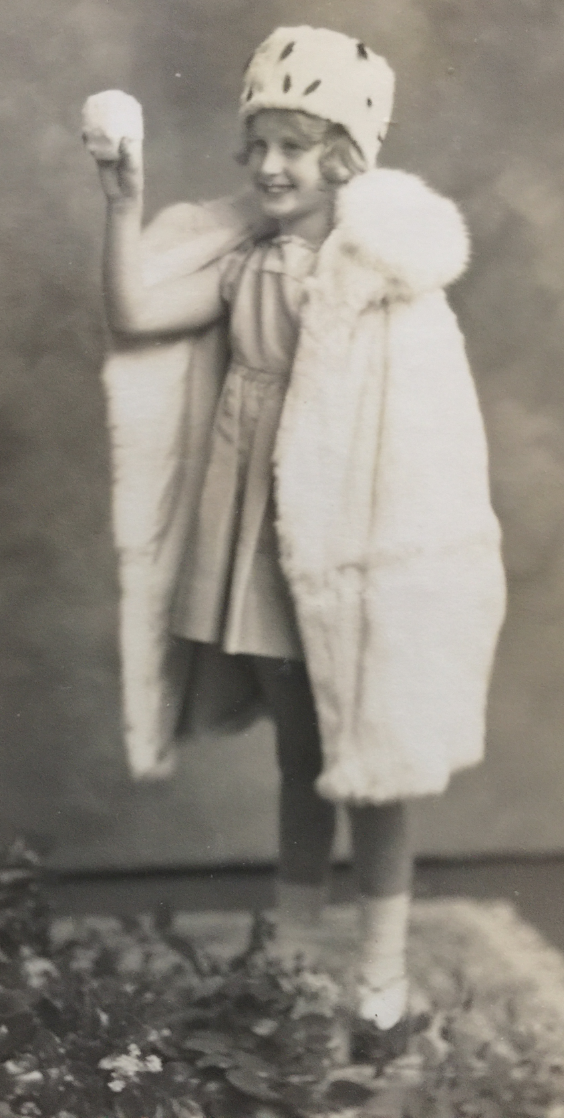

John was helped for a year with the children by his mother-in-law Doreen before Simon, Jonathan and Matthew were sent in 1967 to the Fegan’s childrens home in Broadstairs, Kent. Julie and George returned with Doreen to Canterbury, Kent where Doreen and her son Rollo cared for them. In 1970, Simon and I were sent to Kingham Hill Boarding School in the Cotswolds, coincidentally just 5 miles from the Netherswell Manor farm. Matthew joined us in 1972 and George followed in 1975. John continued to farm in places near to us, first in Kent then later in middle England and the Cotswolds.

Julie moved to Bury-St-Edmunds to attend a girl’s school and was cared for by Judith and her husband Canon Denis Payne. John died at 48 in 1979. We all went on to higher education and ultimately married. I spent a decade working in universities and observatories in the US (Hawaii, Texas) and most of my adult years in Australia. Today, I live in Sydney, Australia; Matthew lives in Kent; Julie lives in Poole, Dorset; and George lives in Kalispell, Montana after having spent many years in Honolulu, Hawaii. Simon died in 2004 but with his wife Michelle had two boys Tom and David. Matthew and his partner Jackie has three lovely girls, Pippa, Josie and Isabelle. Julie and Iain have sons Casey and George. I married Susan and have two boys Christian (21) and Luke (17). George does not have children. I am happy to report that all nine offspring (ages in the range 14 to 24) are just delightful. The oldest George will be the first to marry next Easter in 2018 (Salzburg, Austria). I get back to the UK two or three times a year so I maintain contact with them all.

Appendices
